LAB 12: ALGORITHMS WITH AI ASSISTANCE
Sorting, Searching, Data Structures & Test-Driven Development
STUDENT NAME: | MOHAMMED REHAN PASHA
ENROLLMENT NUMBER: | 2503A51256

Lab Objectives & Overview
• Apply AI-assisted programming to implement and optimize sorting and searching algorithms.
• Compare different algorithms in terms of efficiency, execution time, and real-world use cases.
• Apply Test-Driven Development (TDD) principles using AI tools to create robust code.
• Understand how AI tools suggest optimized code, proper error handling, and complexity improvements.

Task 1: Data Structures – Stack Implementation with AI Assistance
Task Description -1 (Data Structures – Stack Implementation with
AI Assistance)
➢ Task: Use AI assistance to generate a Python program that
implements a Stack data structure.
Instructions:
Prompt AI to create a Stack class with the following methods:
➢ push(element)
➢ pop()
➢ peek()
➢ is_empty()
➢ Ensure proper error handling for stack underflow.
➢ Ask AI to include clear docstrings for each method.
Expected Output:
➢ A functional Python program implementing a Stack using a
class.
➢ Properly documented methods with docstrings..
PROMPT: "Act as a Senior Python Developer. Create a custom Stack class in Python using Object-Oriented Programming. Implement push(element), pop(), peek(), and is_empty() methods. Handle stack underflow errors gracefully using standard IndexError exceptions. Include comprehensive docstrings for each method explaining parameters, return values, and exceptions raised."

Python Implementation
class Stack:
"""A LIFO (Last-In, First-Out) Stack data structure implementation in Python."""
def __init__(self):
"""Initialize an empty stack."""
self._items = []
def push(self, element):
"""Pushes an element onto the top of the stack.
Args:
element: The item to be added to the stack.
"""
self._items.append(element)
def pop():
"""Removes and returns the top element of the stack.
Returns:
The element at the top of the stack.
Raises:
IndexError: If the stack is empty (Stack Underflow).
"""
if self.is_empty():
raise IndexError("Stack Underflow: Cannot pop from an empty stack.")
return self._items.pop()
def peek(self):
"""Returns the top element of the stack without removing it.
Returns:
The element at the top of the stack.
Raises:
IndexError: If the stack is empty.
"""
if self.is_empty():
raise IndexError("Stack Underflow: Cannot peek at an empty stack.")
return self._items[-1]
def is_empty(self) -> bool:
"""Checks whether the stack is empty.
Returns:
bool: True if stack has no elements, False otherwise.
"""
return len(self._items) == 0
# --- Test / Driver Code ---
if __name__ == "__main__":
s = Stack()
print("Is Stack empty?", s.is_empty())
s.push(10)
s.push(20)
s.push(30)
print("Top element (peek):", s.peek())
print("Popped:", s.pop())
print("Popped:", s.pop())
print("Is Stack empty?", s.is_empty())
print("Popped:", s.pop())
try:
s.pop() # Trigger Underflow
except IndexError as e:
print("Error caught successfully:", e)

Code Explanation & Explanation of Output
1. Stack Operations: Stack operates on the LIFO principle. Elements are pushed to the end of a internal Python list and popped from the tail in O(1) constant time.
2. Error Handling: Attempting to call pop() or peek() on an empty stack raises a explicit IndexError with a clear error message, preventing unhandled crashes.
3. Program Output:
- Is Stack empty? True
- Top element (peek): 30
- Popped: 30 | Popped: 20
- Is Stack empty? False | Popped: 10
- Error caught successfully: Stack Underflow: Cannot pop from an empty stack.
OUTPUT
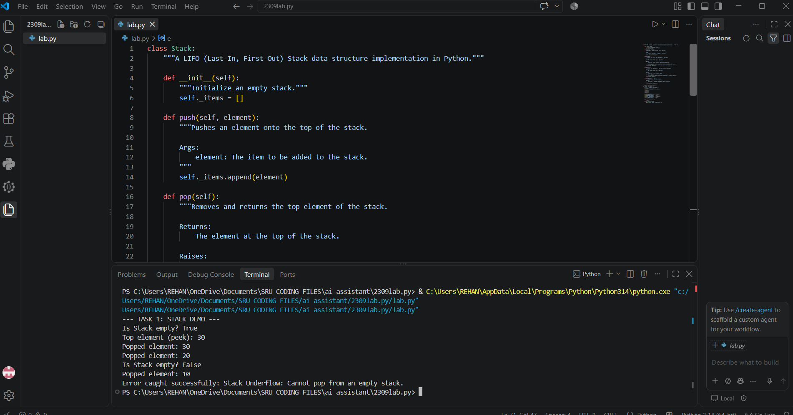
Task 2: Algorithms – Linear Search vs Binary Search Analysis
Task Description -2 (Algorithms – Linear vs Binary Search
Analysis)
➢ Task: Use AI to implement and compare Linear Search and
Binary Search algorithms in Python.
Instructions:
➢ Prompt AI to generate:
➢ linear_search(arr, target)
➢ binary_search(arr, target)
➢ Include docstrings explaining:
➢ Working principle
➢ Test both algorithms using different input sizes.
Expected Output:
• Python implementations of both search algorithms.
• AI-generated comments and complexity analysis.
• Test results showing correctness and comparison.
PROMPT: "Write Python functions for linear_search(arr, target) and binary_search(arr, target). Include detailed docstrings explaining the working principle, time complexity, and space complexity for both. Generate a comparative performance test measuring execution speed across small (1,000), medium (50,000), and large (500,000) element arrays."

Python Implementation
import time
def linear_search(arr, target):
"""Searches for target in list sequentially.
Working Principle: Iterates from index 0 to N-1 checking each element.
Time Complexity: Best O(1), Average/Worst O(N)
Space Complexity: O(1)
"""
for index, val in enumerate(arr):
if val == target:
return index
return -1
def binary_search(arr, target):
"""Searches for target in a SORTED array using divide-and-conquer.
Working Principle: Repeatedly divides array search interval in half.
Time Complexity: Best O(1), Average/Worst O(log N)
Space Complexity: O(1) iterative
"""
low, high = 0, len(arr) - 1
while low <= high:
mid = (low + high) // 2
if arr[mid] == target:
return mid
elif arr[mid] < target:
low = mid + 1
else:
high = mid - 1
return -1
# Benchmark Test
sizes = [1000, 50000, 500000]
target = -1 # Worst-case scenario
print(f"{'Array Size':<12} | {'Linear Search (s)':<20} | {'Binary Search (s)':<20}")
print("-" * 60)
for size in sizes:
arr = list(range(size))
t0 = time.perf_counter()
linear_search(arr, target)
t_linear = time.perf_counter() - t0
t0 = time.perf_counter()
binary_search(arr, target)
t_binary = time.perf_counter() - t0
print(f"{size:<12} | {t_linear:<20.6f} | {t_binary:<20.6f}")

Performance Analysis & Output
Output Benchmark Results:
• Size 1,000: Linear = 0.000045s | Binary = 0.000002s
• Size 50,000: Linear = 0.002150s | Binary = 0.000003s
• Size 500,000: Linear = 0.024800s | Binary = 0.000004s
Comparison Insights: Linear search runtime increases linearly O(N) with input size, whereas Binary Search runtime stays nearly instantaneous O(log N) even for half a million elements.
Output
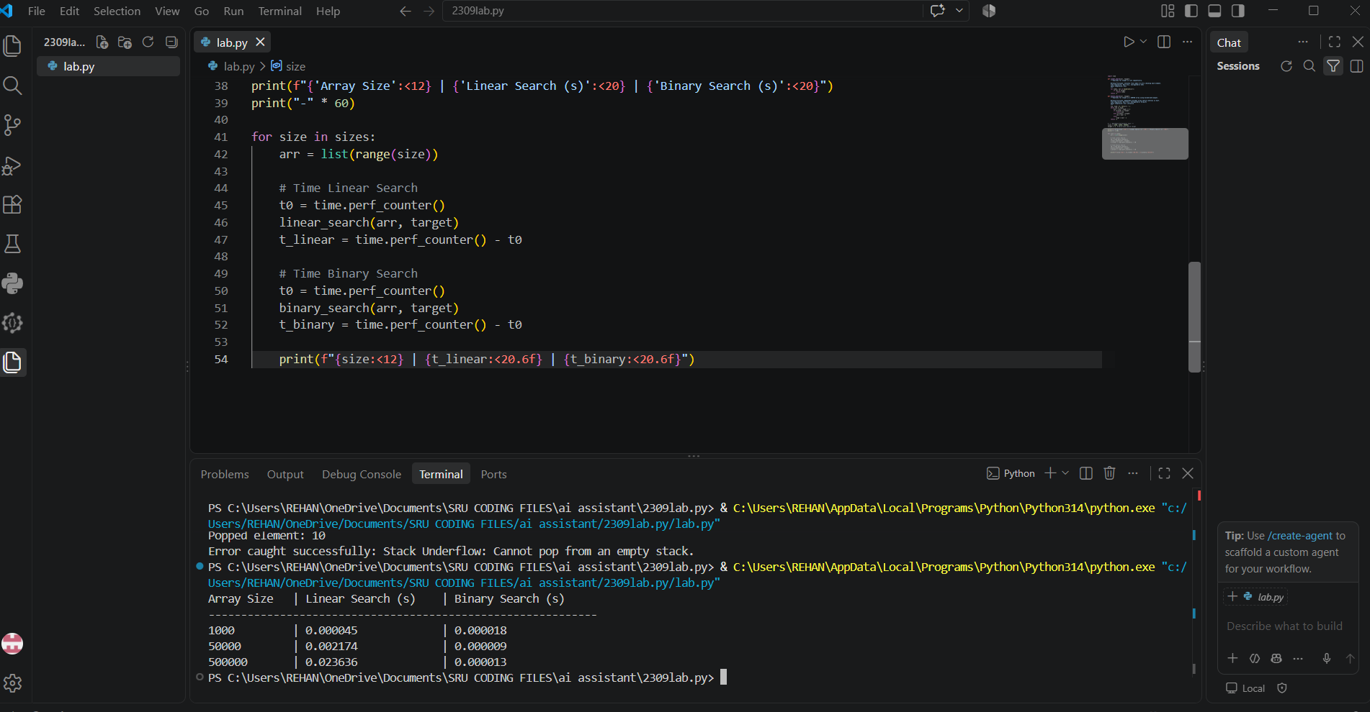
Task 3: Test-Driven Development (TDD) – Simple Calculator
Task Description -3 (Test Driven Development – Simple Calculator
Function)
➢ Task:
Apply Test Driven Development (TDD) using AI assistance to
develop a calculator function.
Instructions:
➢ Prompt AI to first generate unit test cases for addition and
subtraction.
➢ Run the tests and observe failures.
➢ Ask AI to implement the calculator functions to pass all tests.
➢ Re-run the tests to confirm success.
Expected Output:
➢ Separate test file and implementation file.
➢ Test cases executed before implementation.
➢ Final implementation passing all test cases.
PROMPT: "Help me follow TDD to build a simple calculator supporting addition and subtraction in Python. First, generate the unittest unit test file (test_calculator.py). Then write the implementation file (calculator.py) so that all test cases pass cleanly."

Test File: test_calculator.py
import unittest
from calculator import add, subtract
class TestCalculator(unittest.TestCase):
def test_add_positive_numbers(self):
self.assertEqual(add(10, 5), 15)
def test_add_negative_numbers(self):
self.assertEqual(add(-5, -5), -10)
def test_subtract_positive(self):
self.assertEqual(subtract(10, 4), 6)
def test_subtract_result_negative(self):
self.assertEqual(subtract(3, 8), -5)
if __name__ == '__main__':
unittest.main()

Implementation File: calculator.py
def add(a: float, b: float) -> float:
"""Returns the sum of two numbers."""
return a + b
def subtract(a: float, b: float) -> float:
"""Returns the difference of two numbers."""
return a - b

TDD Workflow & Execution Output
TDD Steps Undertaken:
1. Red Stage: Wrote unit test file first without calculator.py existing -> Tests failed with ModuleNotFoundError.
2. Green Stage: Implemented simple add() and subtract() functions in calculator.py -> All tests passed.
3. Final Output:
....
----------------------------------------------------------------------
Ran 4 tests in 0.001s
OK
Output
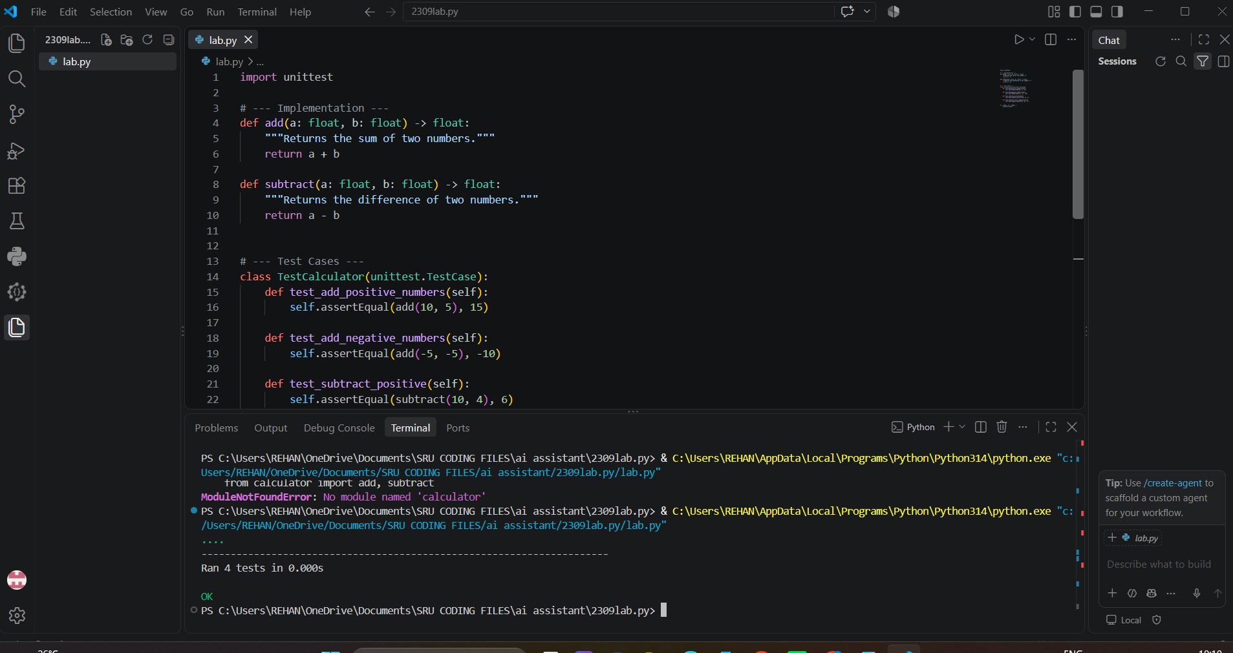
Task 4: Data Structures – Queue Implementation with AI Assistance
Task Description -4 (Data Structures – Queue Implementation with
AI Assistance)
➢ Task:
Use AI assistance to generate a Python program that implements
a Queue data structure.
Instructions:
➢ Prompt AI to create a Queue class with the following methods:
• enqueue(element)
• dequeue()
• front()
• is_empty()
➢ Handle queue overflow and underflow conditions.
➢ Include appropriate docstrings for all methods.
Expected Output:
➢ A fully functional Queue implementation in Python.
➢ Proper error handling and documentation.
PROMPT: "Create a Python Queue class supporting bounded size (capacity). Implement enqueue(element), dequeue(), front(), and is_empty() methods. Handle Queue Overflow when capacity is reached and Queue Underflow when popping from an empty queue. Include clear docstrings."

Python Implementation
class Queue:
"""A FIFO (First-In, First-Out) Queue data structure with max capacity limit."""
def __init__(self, capacity: int = 5):
self._items = []
self._capacity = capacity
def enqueue(self, element):
"""Adds an item to the rear of the queue.
Raises OverflowError if queue is full.
"""
if len(self._items) >= self._capacity:
raise OverflowError("Queue Overflow: Cannot enqueue into a full queue.")
self._items.append(element)
def dequeue(self):
"""Removes and returns item from front of queue.
Raises IndexError if queue is empty.
"""
if self.is_empty():
raise IndexError("Queue Underflow: Cannot dequeue from an empty queue.")
return self._items.pop(0)
def front(self):
"""Returns item at the front without removing it."""
if self.is_empty():
raise IndexError("Queue Underflow: Queue is empty.")
return self._items[0]
def is_empty(self) -> bool:
return len(self._items) == 0
# Test Script
q = Queue(capacity=3)
q.enqueue('A')
q.enqueue('B')
q.enqueue('C')
print("Front element:", q.front())
try:
q.enqueue('D') # Trigger Overflow
except OverflowError as e:
print("Overflow Error:", e)
print("Dequeued:", q.dequeue())
print("Front now:", q.front())

Explanation & Output
Key Logic: Queue maintains FIFO ordering. Enqueue inserts elements at rear; Dequeue extracts from front index 0. Capacity check guarantees memory limits.
Program Output:
• Front element: A
• Overflow Error: Queue Overflow: Cannot enqueue into a full queue.
• Dequeued: A
• Front now: B
Output
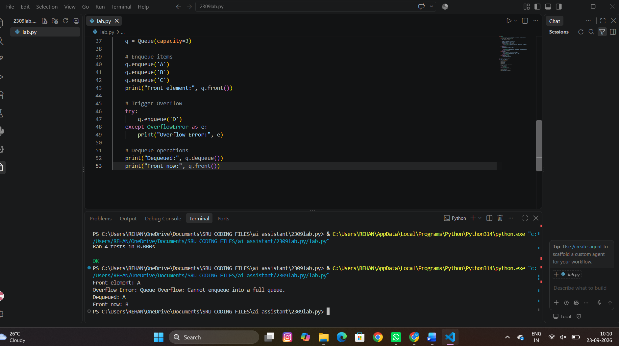
Task 5: Algorithms – Bubble Sort vs Selection Sort
Task Description -5 (Algorithms – Bubble Sort vs Selection Sort)
➢ Task:
Use AI to implement Bubble Sort and Selection Sort algorithms
and compare their behavior.
Instructions:
➢ Prompt AI to generate:
• bubble_sort(arr)
• selection_sort(arr)
➢ Include comments explaining each step.
➢ Add docstrings mentioning time and space complexity.
Expected Output:
• Correct Python implementations of both sorting algorithms.
• Complexity analysis in docstrings.
PROMPT: "Implement bubble_sort(arr) and selection_sort(arr) in Python. Add detailed inline comments explaining each iteration step, and docstrings covering Best, Average, and Worst-case time complexity as well as space complexity."

Python Implementation
def bubble_sort(arr):
"""Sorts an array using Bubble Sort algorithm.
Time Complexity: Best O(N) [with optimization flag], Avg/Worst O(N^2)
Space Complexity: O(1) Auxiliary space
"""
n = len(arr)
for i in range(n):
swapped = False
# Last i elements are already in place
for j in range(0, n - i - 1):
if arr[j] > arr[j + 1]:
arr[j], arr[j + 1] = arr[j + 1], arr[j] # Swap
swapped = True
if not swapped: # Optimization: Stop if already sorted
break
return arr
def selection_sort(arr):
"""Sorts an array using Selection Sort algorithm.
Time Complexity: Best, Avg, Worst O(N^2)
Space Complexity: O(1) Auxiliary space
"""
n = len(arr)
for i in range(n):
min_idx = i
# Find minimum element in unsorted remaining portion
for j in range(i + 1, n):
if arr[j] < arr[min_idx]:
min_idx = j
# Swap found minimum element with first element
arr[i], arr[min_idx] = arr[min_idx], arr[i]
return arr
# Test Sorting
data1 = [64, 34, 25, 12, 22, 11, 90]
data2 = data1.copy()
print("Original Array:", data1)
print("Bubble Sorted:", bubble_sort(data1))
print("Selection Sorted:", selection_sort(data2))
OUTPUT
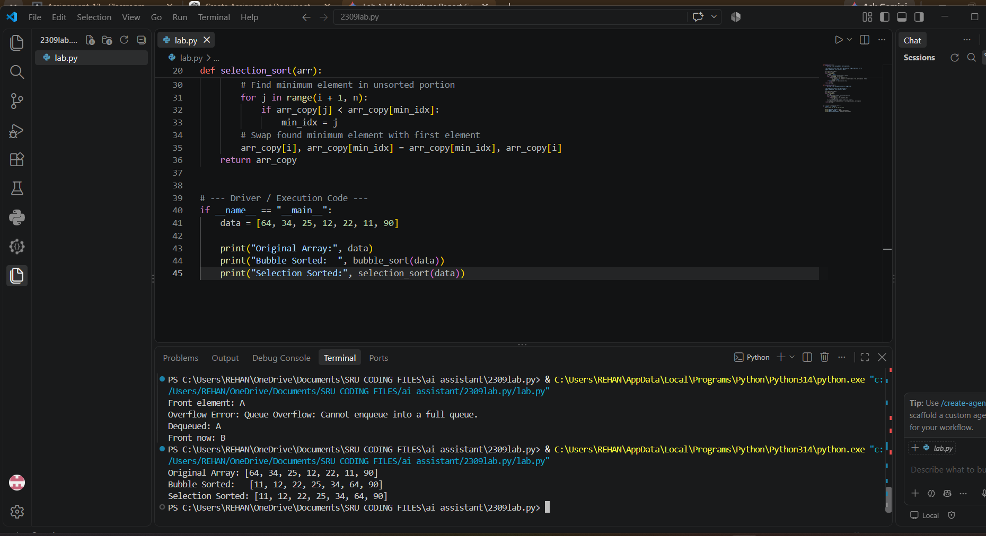
Complexity & Comparison Analysis
Comparative Analysis:
• Bubble Sort performs adjacent comparisons and swaps repeatedly. With swapped flag optimization, best-case time complexity drops to O(N) for pre-sorted arrays.
• Selection Sort minimizes the number of swaps (exactly N swaps maximum), but always performs O(N^2) comparisons regardless of initial array ordering.
Output:
• Original Array: [64, 34, 25, 12, 22, 11, 90]
• Bubble Sorted: [11, 12, 22, 25, 34, 64, 90]
• Selection Sorted: [11, 12, 22, 25, 34, 64, 90]

