LAB 11 – DATA STRUCTURES WITH AI
Implementing Fundamental Data Structures

NAME: MOHAMMED REHAN PASHA
ENROLLMENT NO: 2503A51256

Task Description #1 – Stack Implementation
Question: Use AI to generate a Stack class with push, pop, peek, and is_empty methods.
Prompt: Generate a Python Stack class using a list. Include push, pop, peek, and is_empty methods. Add clear docstrings and basic error handling. Explain the time complexity of each operation.
Code:
class Stack:
"""Implement a stack using a Python list."""
def __init__(self):
self.items = []
def push(self, item):
"""Add an item to the top of the stack."""
self.items.append(item)
def pop(self):
"""Remove and return the top item."""
if self.is_empty():
return "Stack is empty."
return self.items.pop()
def peek(self):
"""Return the top item without removing it."""
if self.is_empty():
return "Stack is empty."
return self.items[-1]
def is_empty(self):
"""Return True when the stack has no items."""
return len(self.items) == 0

output:
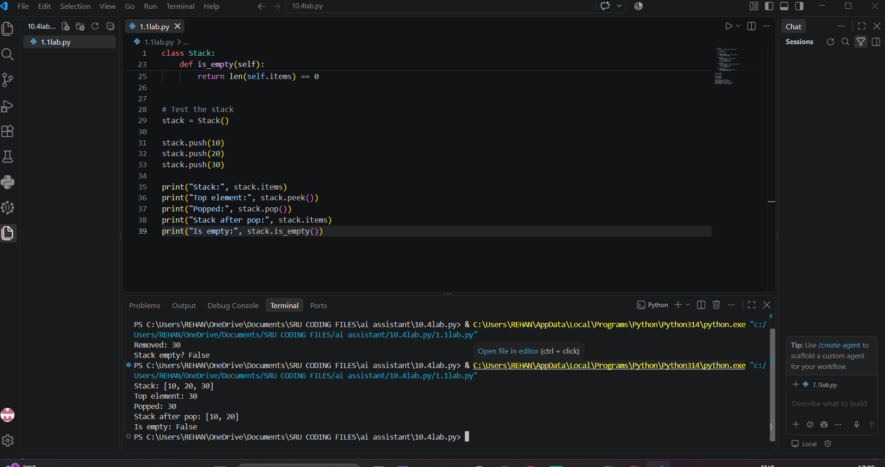

Task Description #2 – Queue Implementation
Question: Use AI to implement a Queue using Python lists.
Prompt: Generate a FIFO Queue class using a Python list. Include enqueue, dequeue, peek, and size methods, with docstrings and empty-queue handling.
Code:
class Queue:
"""Implement a FIFO queue using a Python list."""
def __init__(self):
self.items = []
def enqueue(self, item):
"""Add an item to the rear of the queue."""
self.items.append(item)
def dequeue(self):
"""Remove and return the front item."""
if not self.items:
return "Queue is empty."
return self.items.pop(0)
def peek(self):
"""Return the front item without removing it."""
if not self.items:
return "Queue is empty."
return self.items[0]
def size(self):
"""Return the number of items in the queue."""
return len(self.items)
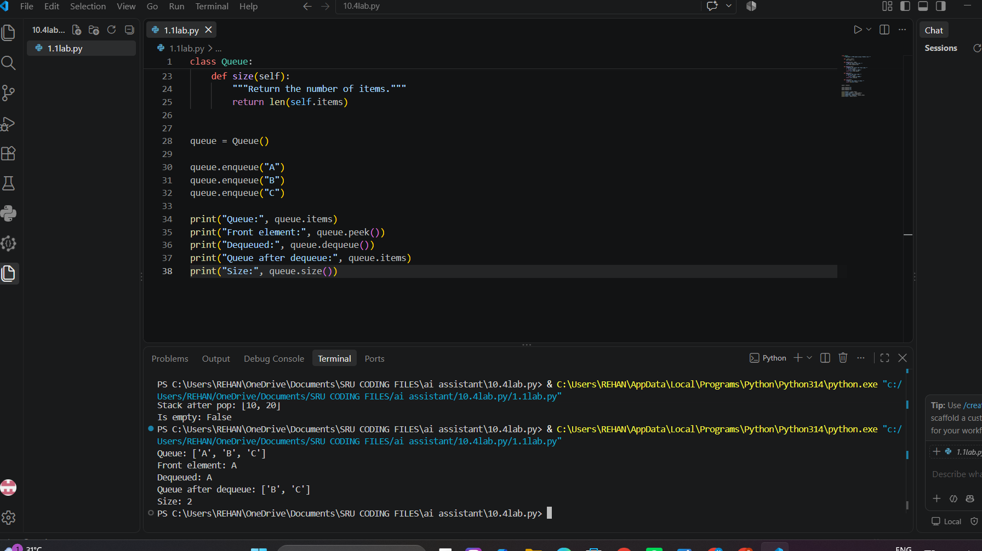

Task Description #3 – Linked List
Question: Use AI to generate a Singly Linked List with insert and display methods.
Prompt: Generate a Python singly linked list using Node and LinkedList classes. Implement insert and display methods and include clear method documentation.
Code:
class Node:
"""Store one linked-list node."""
def __init__(self, data):
self.data = data
self.next = None
class LinkedList:
"""Manage a singly linked list."""
def __init__(self):
self.head = None
def insert(self, data):
"""Insert a node at the end of the list."""
new_node = Node(data)
if self.head is None:
self.head = new_node
return
current = self.head
while current.next:
current = current.next
current.next = new_node
def display(self):
"""Display all nodes from head to end."""
current = self.head
while current:
print(current.data, end=" -> ")
current = current.next
print("None")
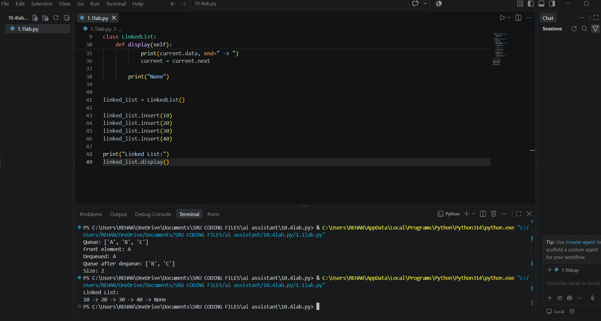

Task Description #4 – Binary Search Tree (BST)
Question: Use AI to create a BST with insert and in-order traversal methods.
Prompt: Generate a Python Binary Search Tree with a Node structure, recursive insert, and recursive in-order traversal. Add docstrings and comments.
Code:
class BSTNode:
def __init__(self, key):
self.key = key
self.left = None
self.right = None
class BST:
"""Binary Search Tree with recursive insertion and traversal."""
def __init__(self):
self.root = None
def insert(self, root, key):
"""Recursively insert a key into the BST."""
if root is None:
return BSTNode(key)
if key < root.key:
root.left = self.insert(root.left, key)
elif key > root.key:
root.right = self.insert(root.right, key)
return root
def inorder(self, root):
"""Print keys using in-order traversal."""
if root:
self.inorder(root.left)
print(root.key, end=" ")
self.inorder(root.right)
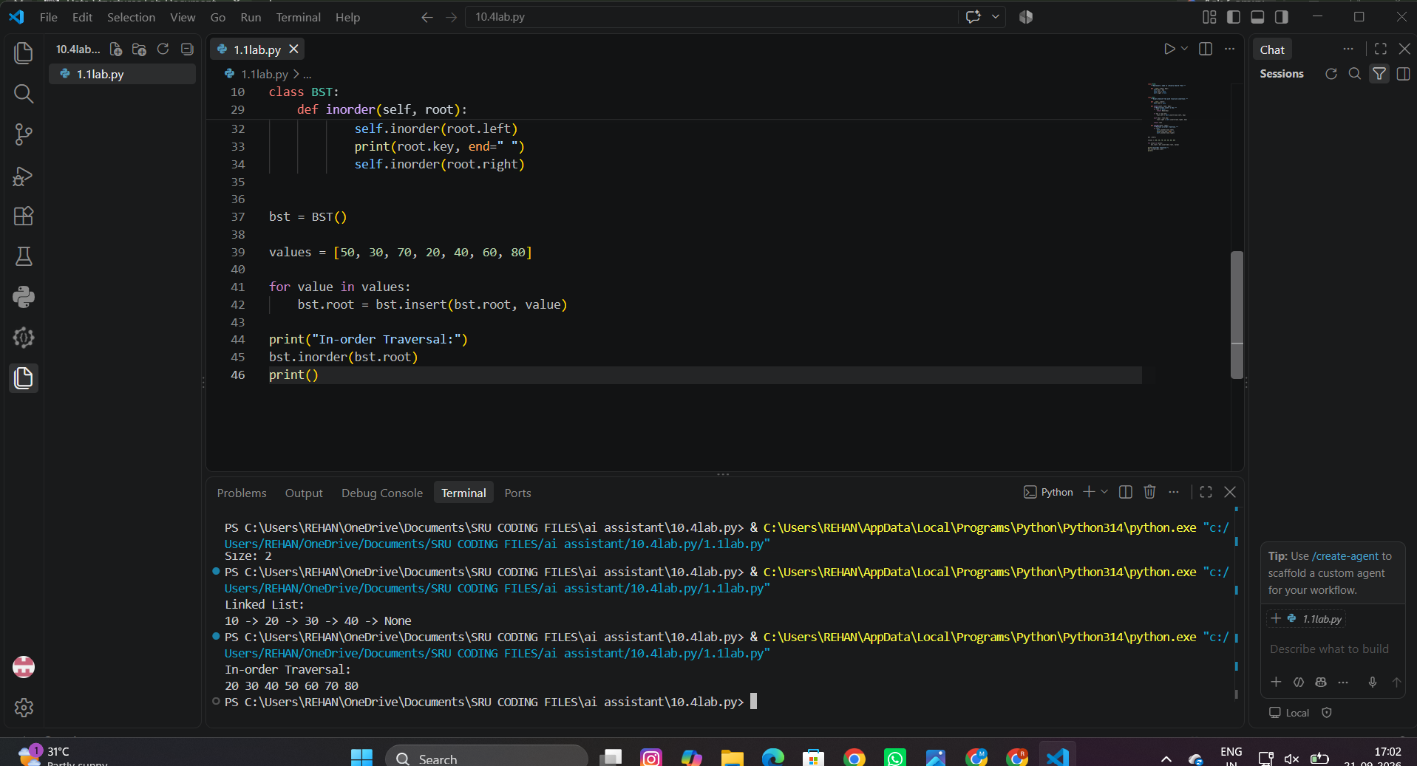

Task Description #5 – Hash Table
Question: Use AI to implement a hash table with basic insert, search, and delete methods.
Prompt: Generate a Python hash table with separate chaining for collision handling. Implement insert, search, and delete methods and explain how collisions are managed.
Code:
class HashTable:
"""Hash table using chaining for collision handling."""
def __init__(self, size=10):
self.table = [[] for _ in range(size)]
self.size = size
def _index(self, key):
return hash(key) % self.size
def insert(self, key, value):
"""Insert or update a key-value pair."""
bucket = self.table[self._index(key)]
for pair in bucket:
if pair[0] == key:
pair[1] = value
return
bucket.append([key, value])
def search(self, key):
"""Return the value for a key, or None if absent."""
for pair in self.table[self._index(key)]:
if pair[0] == key:
return pair[1]
return None
def delete(self, key):
"""Delete a key-value pair if it exists."""
bucket = self.table[self._index(key)]
for i, pair in enumerate(bucket):
if pair[0] == key:
bucket.pop(i)
return True
return False
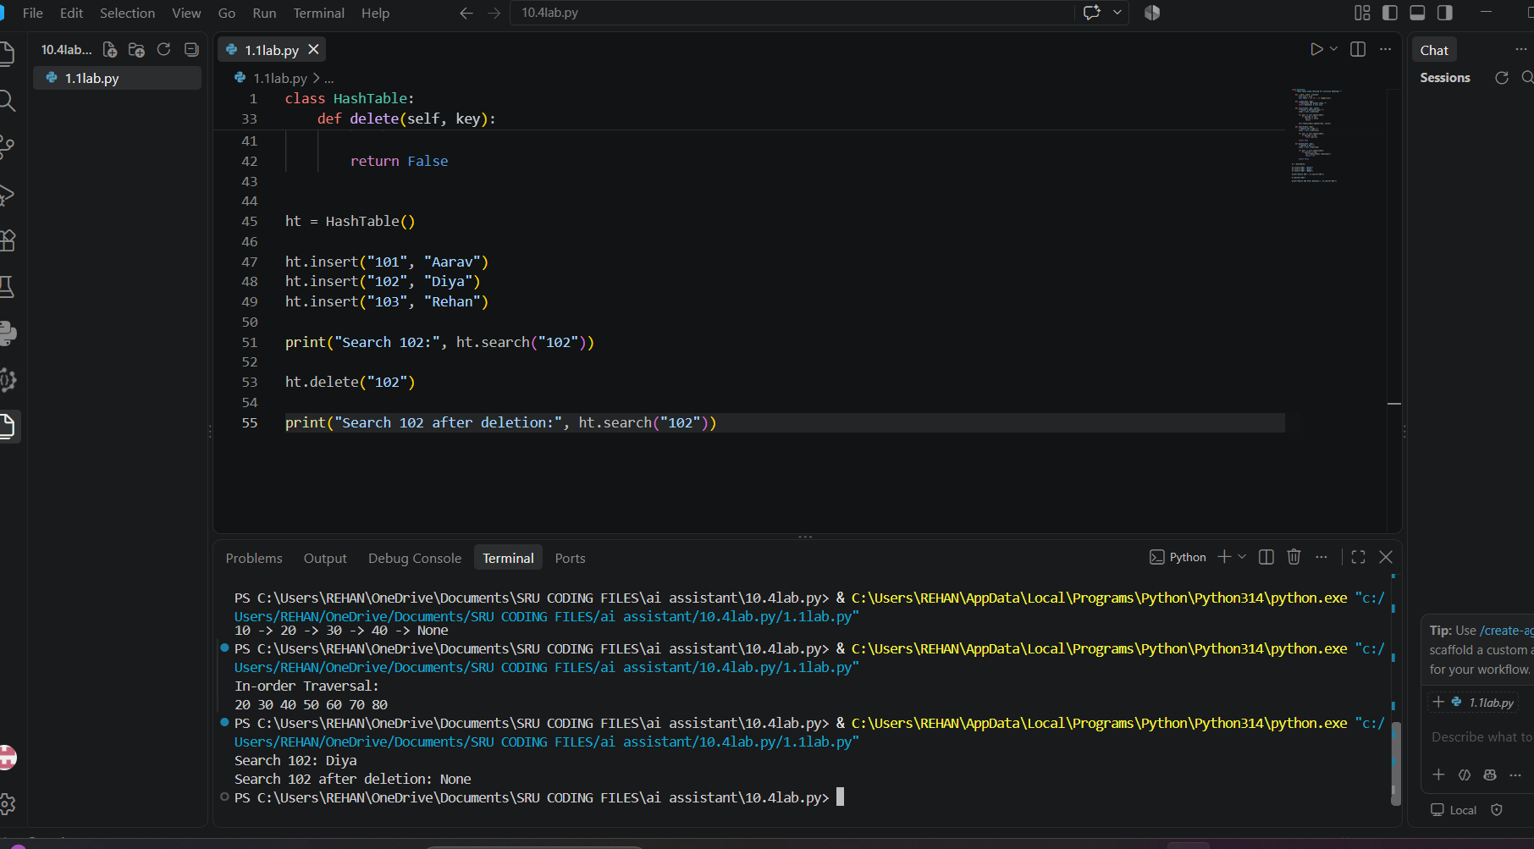

Task Description #6 – Graph Representation
Question: Use AI to implement a graph using an adjacency list.
Prompt: Generate a Python Graph class using an adjacency list. Include methods to add vertices, add edges, and display connections. Add docstrings.
Code:
class Graph:
"""Represent a graph using an adjacency list."""
def __init__(self):
self.adj_list = {}
def add_vertex(self, vertex):
"""Add a vertex if it does not already exist."""
self.adj_list.setdefault(vertex, [])
def add_edge(self, source, destination):
"""Add a directed edge from source to destination."""
self.add_vertex(source)
self.add_vertex(destination)
self.adj_list[source].append(destination)
def display(self):
"""Display each vertex and its connections."""
for vertex, neighbors in self.adj_list.items():
print(f"{vertex} -> {neighbors}")
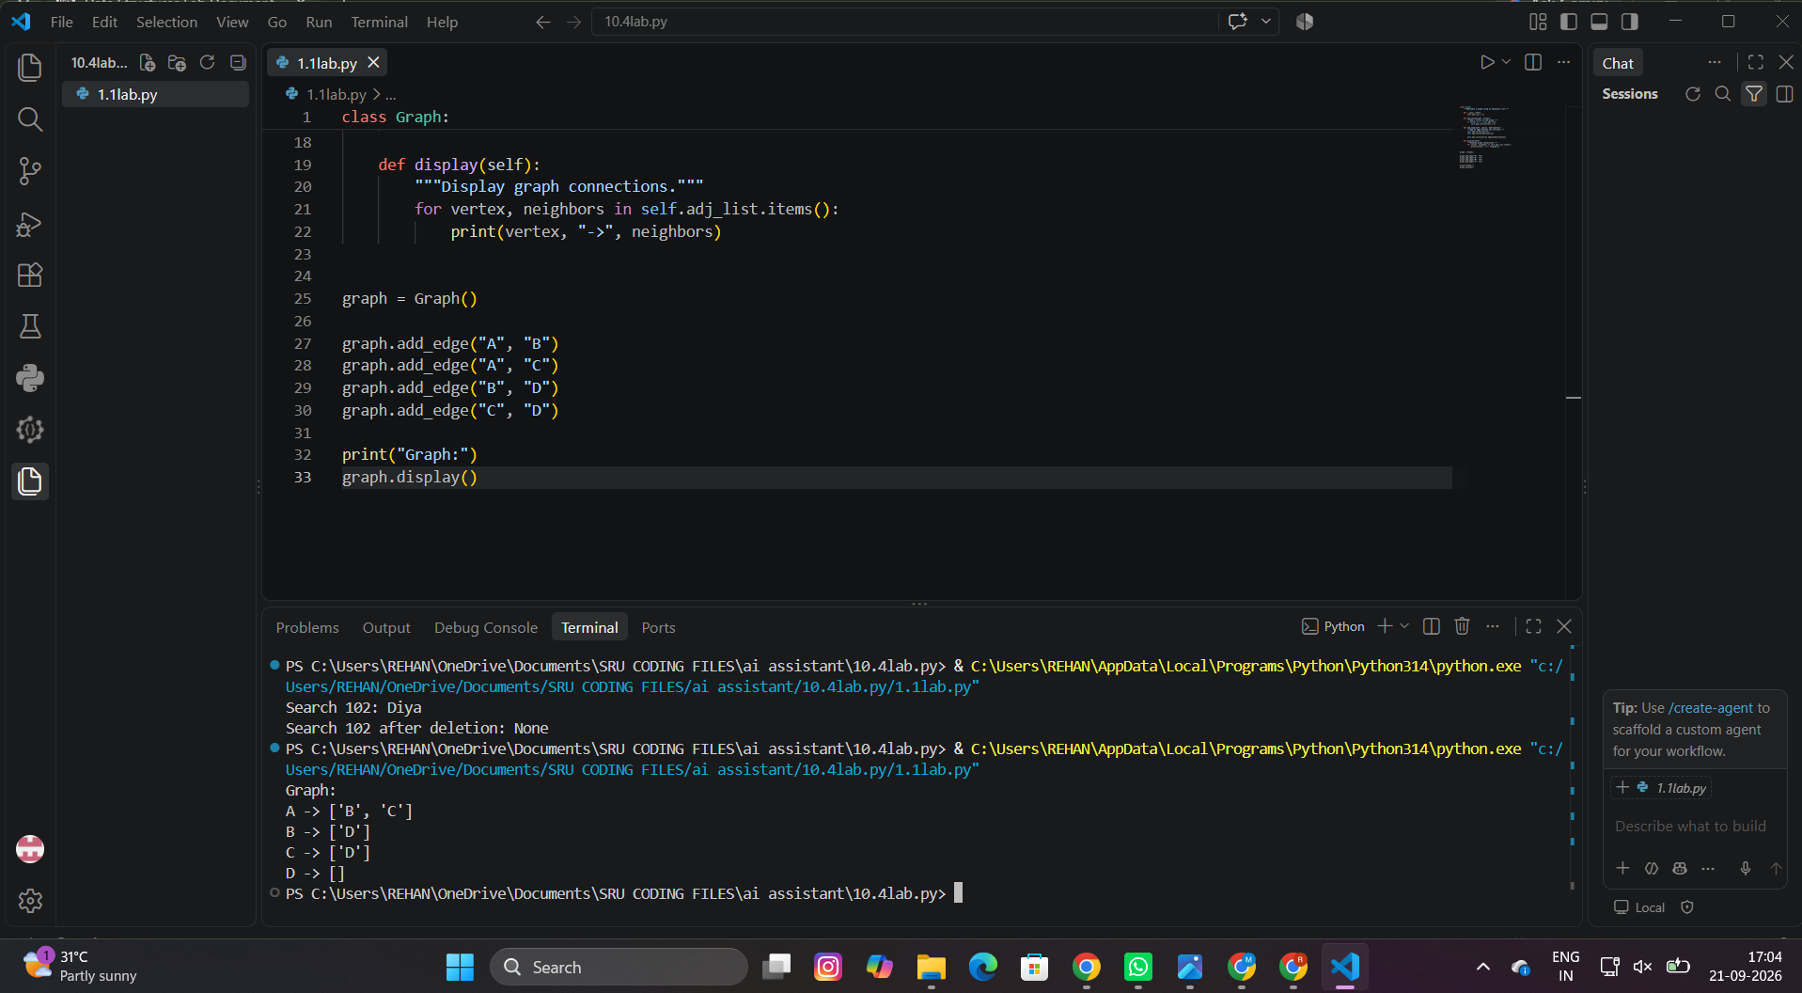

Task Description #7 – Priority Queue
Question: Use AI to implement a priority queue using Python’s heapq module.
Prompt: Generate a Python PriorityQueue class using heapq. Implement enqueue(priority, item), dequeue(), and display() methods. Treat a smaller priority number as a higher priority.
Code:
import heapq
class PriorityQueue:
"""Priority queue implemented with heapq."""
def __init__(self):
self.items = []
def enqueue(self, priority, item):
"""Add an item with its priority."""
heapq.heappush(self.items, (priority, item))
def dequeue(self):
"""Remove and return the highest-priority item."""
if not self.items:
return "Priority queue is empty."
return heapq.heappop(self.items)
def display(self):
"""Display items in priority order."""
for priority, item in sorted(self.items):
print(priority, item)
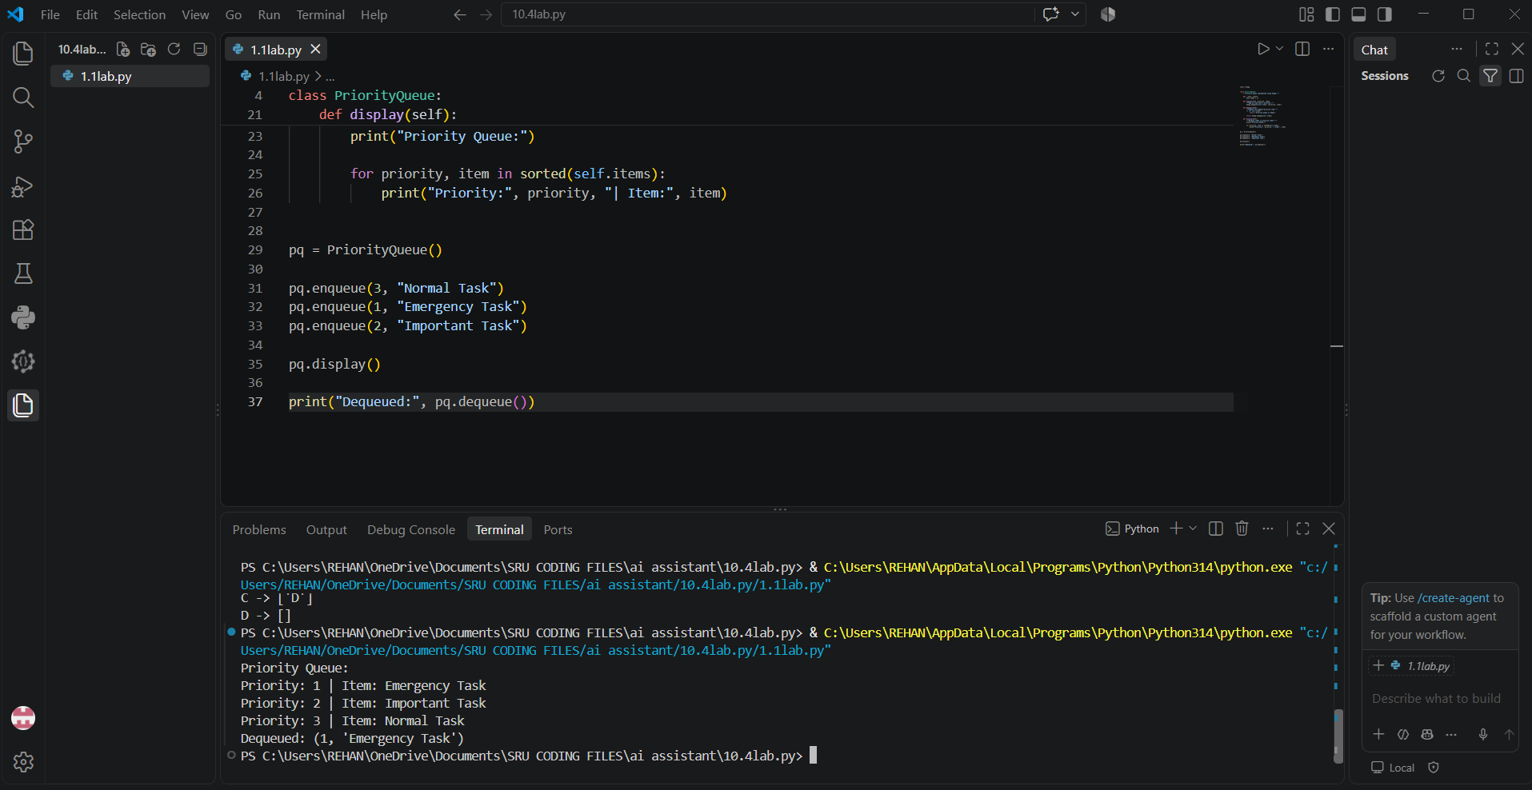

Task Description #8 – Deque
Question: Use AI to implement a double-ended queue using collections.deque.
Prompt: Generate a Python DequeDS class using collections.deque. Implement insertion and removal from both ends, with clear docstrings.
Code:
from collections import deque
class DequeDS:
"""Double-ended queue using collections.deque."""
def __init__(self):
self.items = deque()
def insert_front(self, item):
"""Insert an item at the front."""
self.items.appendleft(item)
def insert_rear(self, item):
"""Insert an item at the rear."""
self.items.append(item)
def remove_front(self):
"""Remove and return the front item."""
return self.items.popleft() if self.items else None
def remove_rear(self):
"""Remove and return the rear item."""
return self.items.pop() if self.items else None
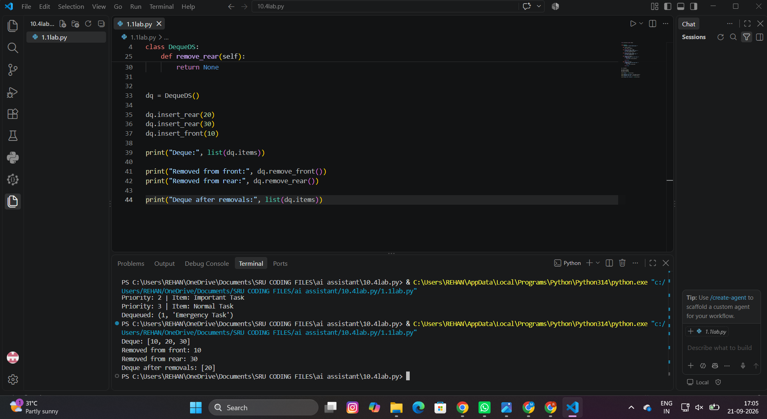

Task Description #9 – Real-Time Application Challenge
Question: Choose the right data structure for each Campus Resource Management System feature and justify the choice in 2–3 sentences.
Feature | Data Structure | Justification
Student Attendance Tracking | Deque | A deque supports adding and removing records efficiently from either end. It is useful when attendance logs may be processed from the newest or oldest end.
Event Registration System | Hash Table | A hash table provides fast average-case lookup and removal using a student or registration ID as the key. This suits quick participant search.
Library Book Borrowing | Binary Search Tree (BST) | A BST can keep books ordered by book ID or due date and support searching and ordered traversal. It is useful when records need to remain searchable and sorted.
Bus Scheduling System | Graph | A graph naturally represents bus stops as vertices and route connections as edges. It can model direct connections between stops.
Cafeteria Order Queue | Queue | A queue follows FIFO order, so the first student's order placed is the first order served. This matches normal cafeteria service.

Task #9 – Working Python Program
Prompt: Generate a Python cafeteria order management program using a queue. Use FIFO order, include enqueue and dequeue operations, add comments and docstrings, and demonstrate the program with three student orders.
Code:
from collections import deque
class CafeteriaQueue:
"""Manage cafeteria orders using FIFO order."""
def __init__(self):
"""Initialize an empty order queue."""
self.orders = deque()
def enqueue(self, student, order):
"""Add a student's order to the rear of the queue."""
self.orders.append((student, order))
def dequeue(self):
"""Serve and remove the order at the front of the queue."""
if not self.orders:
return "No orders in the queue."
student, order = self.orders.popleft()
return f"Serving {student}: {order}"
def display(self):
"""Display all pending orders."""
if not self.orders:
print("No pending orders.")
else:
print("Pending Orders:")
for i, (student, order) in enumerate(self.orders, 1):
print(f"{i}. {student} - {order}")
# AI-assisted test program
cafeteria = CafeteriaQueue()
cafeteria.enqueue("Aarav", "Veg Burger")
cafeteria.enqueue("Diya", "Masala Dosa")
cafeteria.enqueue("Rehan", "Chicken Biryani")
cafeteria.display()
print(cafeteria.dequeue())
cafeteria.display()

Output

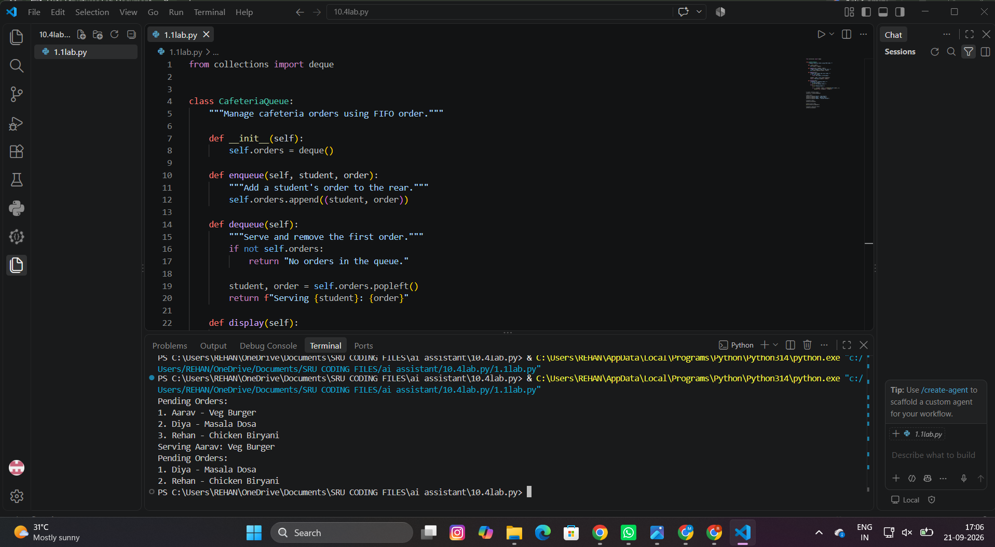

Task Description #10 – Smart E-Commerce Platform
Question: Choose the right data structure for each Smart Online Shopping System feature and justify the choice in 2–3 sentences.
Feature | Data Structure | Justification
Shopping Cart Management | Deque | A deque supports efficient insertion and removal at both ends. It is suitable for dynamically adding and removing products from a cart.
Order Processing System | Queue | Orders should be processed in the order they are placed. A FIFO queue directly models this requirement.
Top-Selling Products Tracker | Priority Queue | A priority queue can keep products ordered by sales count or another ranking value. The highest-ranked products can be retrieved efficiently.
Product Search Engine | Hash Table | A hash table provides fast average-case lookup using product ID as the key. This makes it appropriate for quick product retrieval.
Delivery Route Planning | Graph | Warehouses and delivery locations can be represented as vertices, while roads or routes are edges. A graph supports route and connectivity operations.

Task #10 – Working Python Program
Prompt: Generate a Python e-commerce order processing program using a FIFO queue. Include methods to add orders, process orders, and display pending orders, with comments and docstrings.
Code:
from collections import deque
class OrderQueue:
"""Manage online orders in FIFO order."""
def __init__(self):
self.orders = deque()
def add_order(self, order_id, customer):
"""Add a new order to the queue."""
self.orders.append((order_id, customer))
def process_order(self):
"""Process the oldest order."""
if not self.orders:
return "No pending orders."
return f"Processed order {self.orders.popleft()}"
def display(self):
"""Display pending orders."""
print("Pending Orders:")
for order in self.orders:
print(order)
shop = OrderQueue()
shop.add_order(101, "Aarav")
shop.add_order(102, "Diya")
shop.add_order(103, "Rehan")
shop.display()
print(shop.process_order())
shop.display()
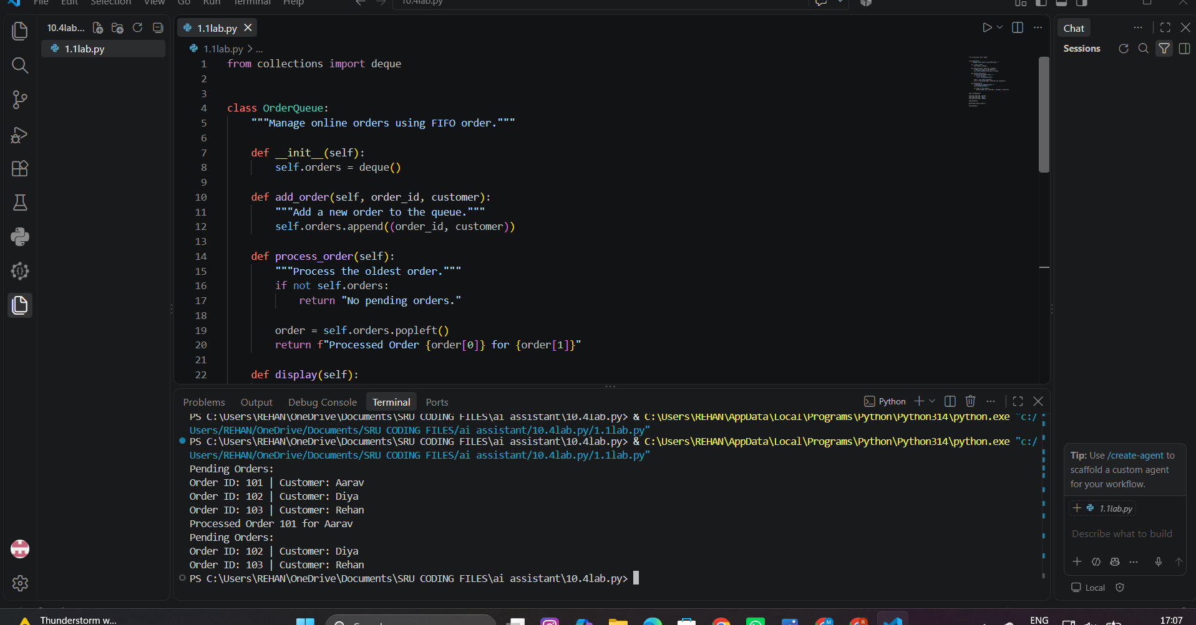

Conclusion
This lab demonstrates how AI can assist in designing, documenting, and implementing fundamental data structures in Python. The examples cover linear structures, trees, graphs, hashing, and priority-based processing, followed by real-time applications in campus resource management and e-commerce.

