LAB 13: CODE REFACTORING – IMPROVING LEGACY CODE WITH AI
Name: MOHAMMED REHAN PASHA Roll No.: 2503A51256
Lab 13: Code Refactoring – Improving Legacy Code with AI
Lab Objectives:
• Identify code smells and inefficiencies in legacy Python
scripts.
• Use AI-assisted coding tools to refactor for readability,
maintainability, and performance.

• Apply modern Python best practices while ensuring output
correctness.
Task Description #1 (Refactoring – Removing Code
Duplication)
• Task: Use AI to refactor a given Python script that contains
multiple repeated code blocks.
• Instructions:
o Prompt AI to identify duplicate logic and replace it
with functions or classes.
o Ensure the refactored code maintains the same output.
o Add docstrings to all functions.
• Sample Legacy Code:
# Legacy script with repeated logic
print(&quot;Area of Rectangle:&quot;, 5 * 10)
print(&quot;Perimeter of Rectangle:&quot;, 2 * (5 + 10))
print(&quot;Area of Rectangle:&quot;, 7 * 12)
print(&quot;Perimeter of Rectangle:&quot;, 2 * (7 + 12))
print(&quot;Area of Rectangle:&quot;, 10 * 15)
print(&quot;Perimeter of Rectangle:&quot;, 2 * (10 + 15))
• Expected Output:
o Refactored code with a reusable function and no
duplication.

Task 1 – Removing Code Duplication

1. Prompt
Refactor this legacy Python code to remove duplicate logic. Create one reusable function that accepts length and width, prints the area and perimeter, preserves exactly the same output values, and includes a docstring for the function. Keep the solution simple and beginner-friendly.
Legacy code:
print("Area of Rectangle:", 5 * 10)
print("Perimeter of Rectangle:", 2 * (5 + 10))
print("Area of Rectangle:", 7 * 12)
print("Perimeter of Rectangle:", 2 * (7 + 12))
print("Area of Rectangle:", 10 * 15)
print("Perimeter of Rectangle:", 2 * (10 + 15))

2. Legacy / Input Code
print("Area of Rectangle:", 5 * 10)
print("Perimeter of Rectangle:", 2 * (5 + 10))
print("Area of Rectangle:", 7 * 12)
print("Perimeter of Rectangle:", 2 * (7 + 12))
print("Area of Rectangle:", 10 * 15)
print("Perimeter of Rectangle:", 2 * (10 + 15))

3. Refactored Code / Answer
def rectangle_details(length, width):
"""Print the area and perimeter of a rectangle."""
area = length * width
perimeter = 2 * (length + width)
print("Area of Rectangle:", area)
print("Perimeter of Rectangle:", perimeter)
rectangle_details(5, 10)
rectangle_details(7, 12)
rectangle_details(10, 15)

4 Output
Area of Rectangle: 50
Perimeter of Rectangle: 30
Area of Rectangle: 84
Perimeter of Rectangle: 38
Area of Rectangle: 150
Perimeter of Rectangle: 50

output
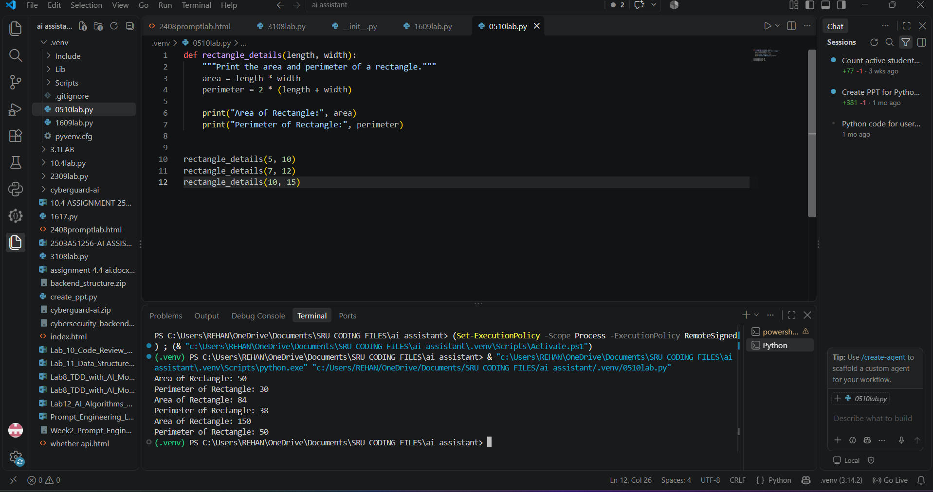

Task Description #2 (Refactoring – Optimizing Loops and

Conditionals)

• Task: Use AI to analyze a Python script with nested loops

and complex conditionals.

• Instructions:

o Ask AI to suggest algorithmic improvements (e.g.,

replace nested loops with set look ups or

comprehensions).

o Implement changes while keeping logic intact.

o Compare execution time before and after refactoring.

• Sample Legacy Code:

# Legacy inefficient code

names = [&quot;Alice&quot;, &quot;Bob&quot;, &quot;Charlie&quot;, &quot;David&quot;]

search_names = [&quot;Charlie&quot;, &quot;Eve&quot;, &quot;Bob&quot;]

for s in search_names:

found = False

for n in names:

if s == n:

found = True

if found:

print(f&quot;{s} is in the list&quot;)

else:

print(f&quot;{s} is not in the list&quot;)

• Expected Output:

o Optimized code using set lookups with performance

comparison table.

Task 2 – Optimizing Loops and Conditionals

1. Prompt
Refactor this Python code to replace the nested loop with a set lookup. Keep the same output and logic. Also add a docstring and use time.perf_counter() to compare the legacy nested-loop approach with the optimized set approach. Give a simple performance comparison table.

2. Legacy / Input Code
names = ["Alice", "Bob", "Charlie", "David"]
search_names = ["Charlie", "Eve", "Bob"]
for s in search_names:
found = False
for n in names:
if s == n:
found = True
if found:
print(f"{s} is in the list")
else:
print(f"{s} is not in the list")

3. Refactored Code / Answer
import time
def optimized_search(names, search_names):
"""Check names efficiently using a set lookup."""
name_set = set(names)
for name in search_names:
if name in name_set:
print(f"{name} is in the list")
else:
print(f"{name} is not in the list")
names = ["Alice", "Bob", "Charlie", "David"]
search_names = ["Charlie", "Eve", "Bob"]
start = time.perf_counter()
for name in search_names:
found = False
for item in names:
if name == item:
found = True
if found:
print(f"{name} is in the list")
else:
print(f"{name} is not in the list")
legacy_time = time.perf_counter() - start
start = time.perf_counter()
optimized_search(names, search_names)
optimized_time = time.perf_counter() - start
print(f"\nLegacy time: {legacy_time:.8f} seconds")
print(f"Optimized time: {optimized_time:.8f} seconds")
print("\nPerformance comparison:")
print("Legacy: nested loop -> O(n*m)")
print("Optimized: set lookup -> average O(n+m)")

4. Output
Charlie is in the list
Eve is not in the list
Bob is in the list
Charlie is in the list
Eve is not in the list
Bob is in the list
Legacy time: measured at runtime
Optimized time: measured at runtime
Performance comparison:
Legacy: nested loop -> O(n*m)
Optimized: set lookup -> average O(n+m)
Performance note: exact execution times depend on the computer and Python environment. The important improvement is replacing nested membership checking with a set lookup.
Comparison: Legacy nested loops → O(n×m); optimized set lookup → average O(n+m).

5. output

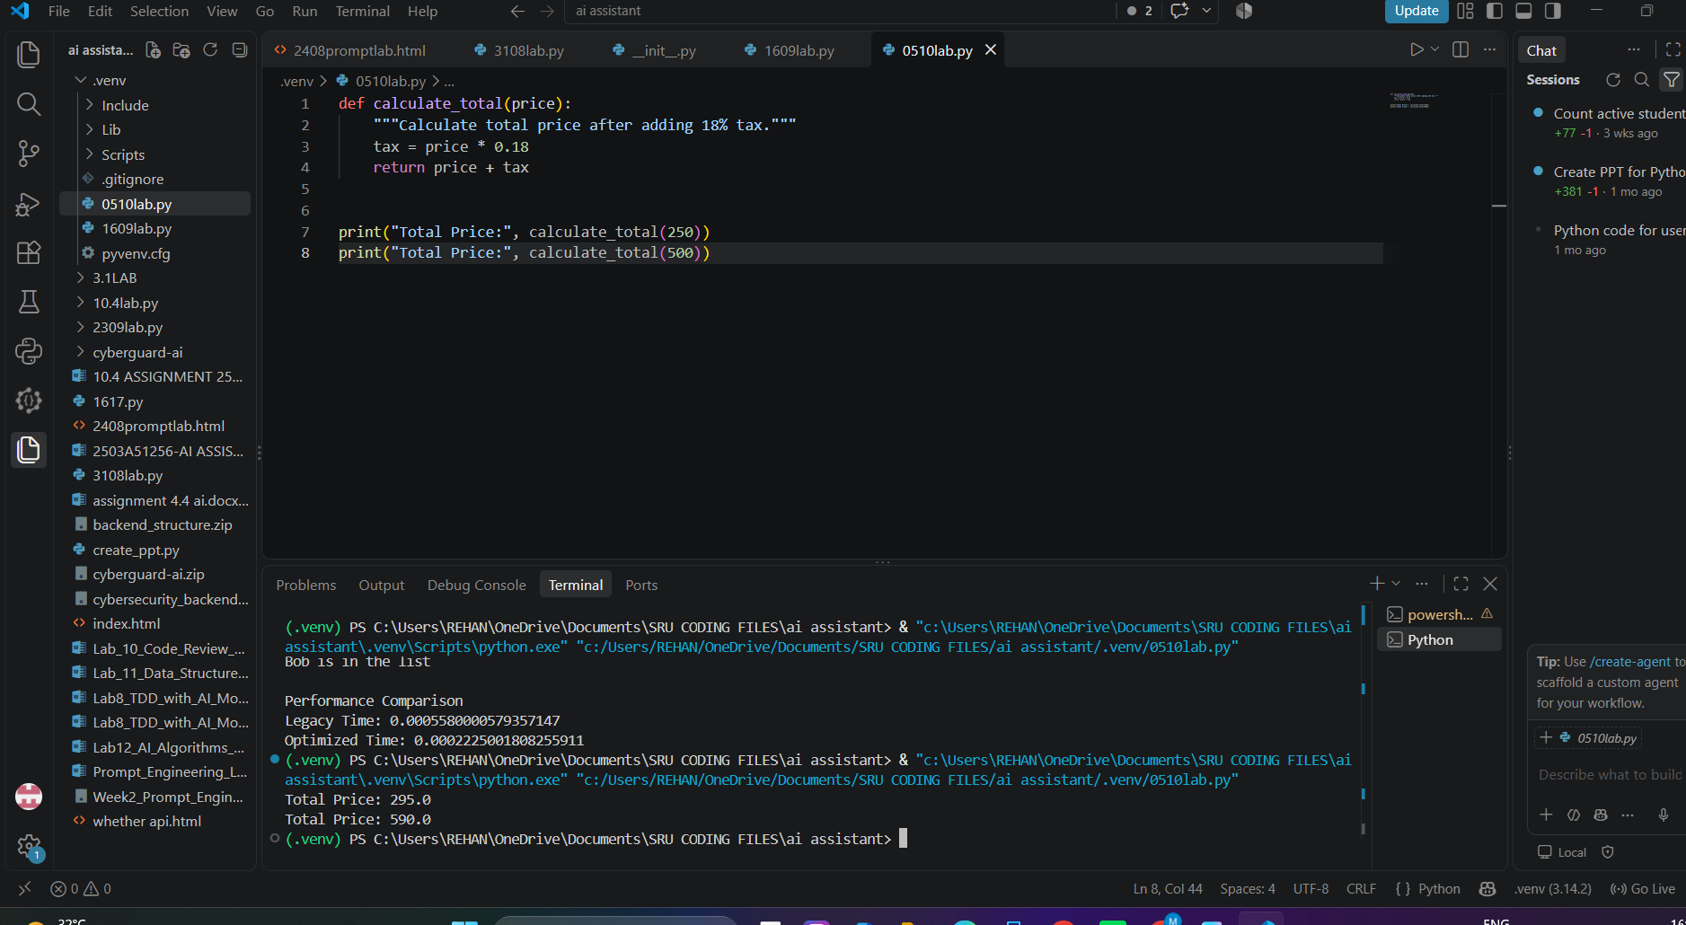

Task Description #3 (Refactoring – Extracting Reusable

Functions)

• Task: Use AI to refactor a legacy script where multiple

calculations are embedded directly inside the main code

block.

• Instructions:

o Identify repeated or related logic and extract it into

reusable functions.

o Ensure the refactored code is modular, easy to read,

and documented with docstrings.

• Sample Legacy Code:

# Legacy script with inline repeated logic

price = 250

tax = price * 0.18

total = price + tax

print(&quot;Total Price:&quot;, total)

price = 500

tax = price * 0.18

total = price + tax

print(&quot;Total Price:&quot;, total)

• Expected Output:

o Code with a function calculate_total(price) that can be

reused for multiple price inputs.

Task 3 – Extracting Reusable Functions

1. Prompt
Refactor this legacy Python script by extracting the repeated tax and total calculation into a reusable function called calculate_total(price). Add a docstring and use the function for both prices. Keep the output values unchanged.

2. Legacy / Input Code
price = 250
tax = price * 0.18
total = price + tax
print("Total Price:", total)
price = 500
tax = price * 0.18
total = price + tax
print("Total Price:", total)

3. Refactored Code / Answer
def calculate_total(price):
"""Calculate total price after adding 18% tax."""
tax = price * 0.18
return price + tax
print("Total Price:", calculate_total(250))
print("Total Price:", calculate_total(500))

4. Output
Total Price: 295.0
Total Price: 590.0

output

Task Description #4 (Refactoring – Replacing Hardcoded

Values with Constants)

• Task: Use AI to identify and replace all hardcoded “magic

numbers” in the code with named constants.

• Instructions:

o Create constants at the top of the file.

o Replace all hardcoded occurrences in calculations

with these constants.

o Ensure the code remains functional and is easier to

maintain.

• Sample Legacy Code:

# Legacy script with hardcoded values

print(&quot;Area of Circle:&quot;, 3.14159 * (7 ** 2))

print(&quot;Circumference of Circle:&quot;, 2 * 3.14159 * 7)

• Expected Output:

o Code with constants like PI = 3.14159 and RADIUS

= 7 used in calculations.

Task 4 – Replacing Hardcoded Values with Constants

1. Prompt
Refactor this Python code by replacing magic numbers with named constants. Create PI = 3.14159 and RADIUS = 7 at the top. Use these constants in both calculations and add a short comment/docstring where useful. Keep the output unchanged.

2. Legacy / Input Code
print("Area of Circle:", 3.14159 * (7 ** 2))
print("Circumference of Circle:", 2 * 3.14159 * 7)

3. Refactored Code / Answer
PI = 3.14159
RADIUS = 7
def circle_details():
"""Print the area and circumference using named constants."""
area = PI * (RADIUS ** 2)
circumference = 2 * PI * RADIUS
print("Area of Circle:", area)
print("Circumference of Circle:", circumference)
circle_details()

4. Output
Area of Circle: 153.93791
Circumference of Circle: 43.98226
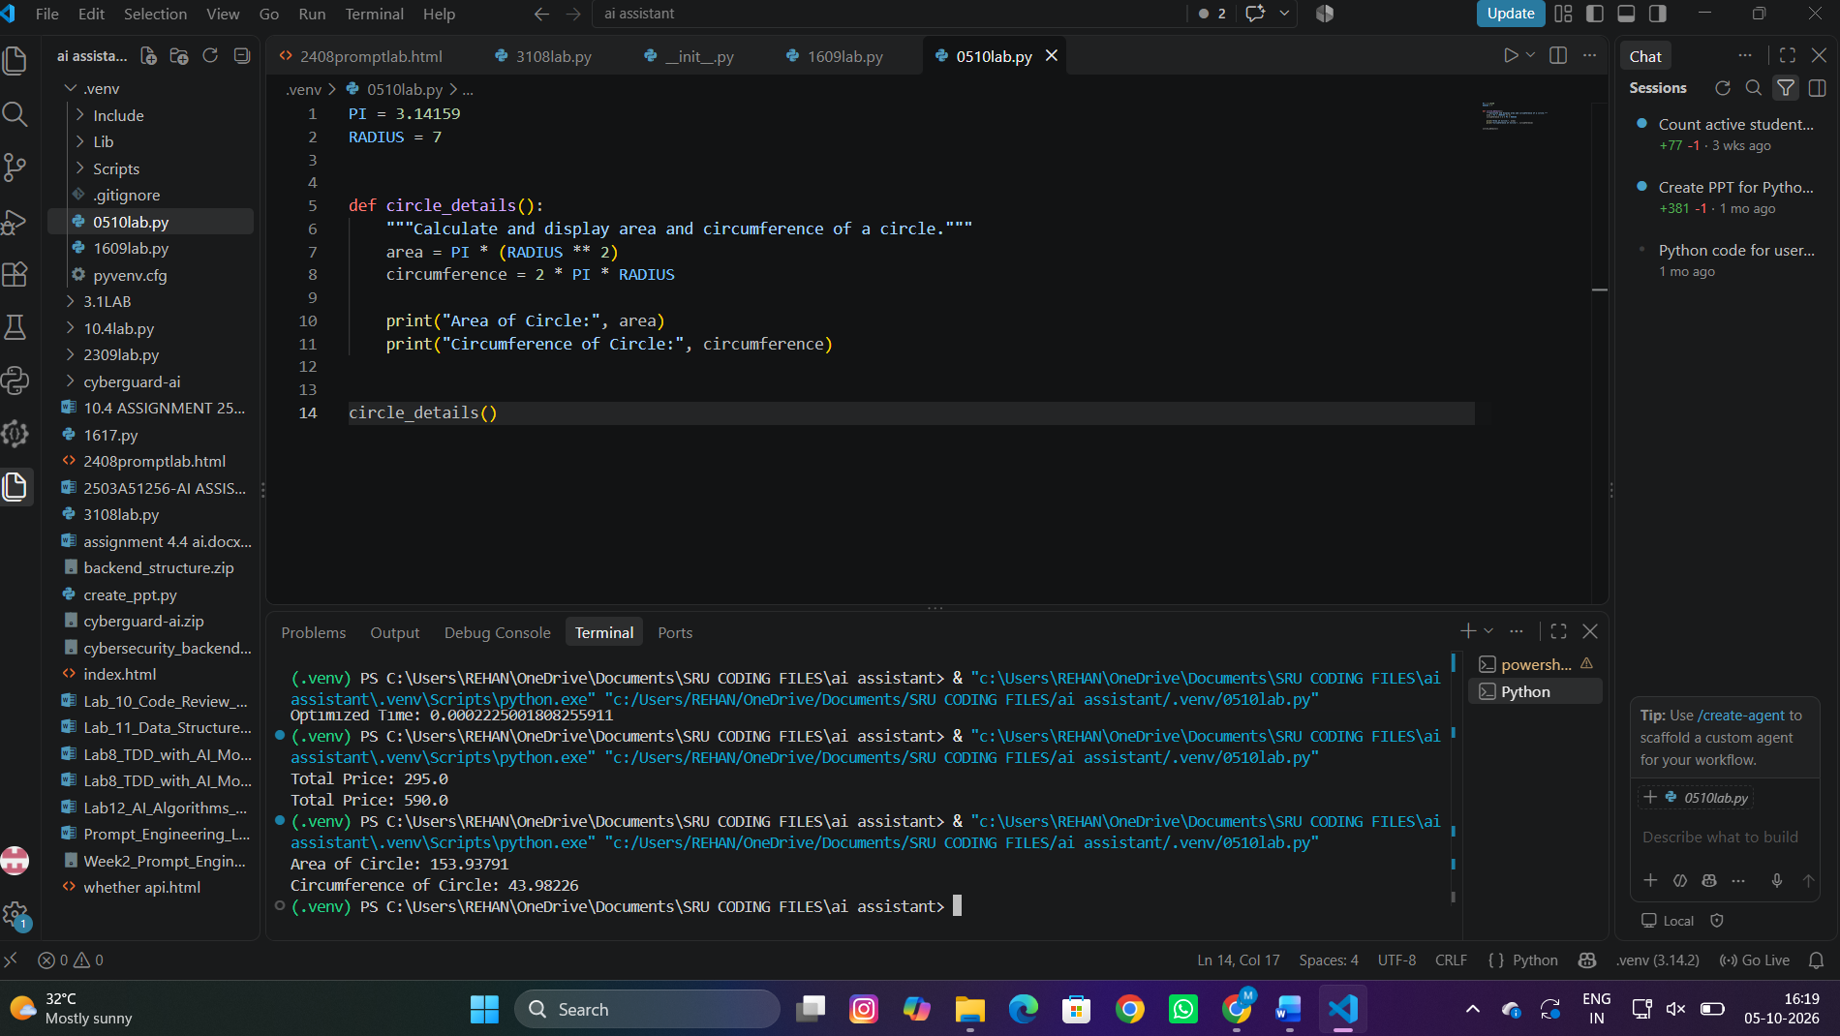

Task Description #5 (Refactoring – Improving Variable

Naming and Readability)

• Task: Use AI to improve readability by renaming unclear

variables and adding inline comments.

• Instructions:

o Replace vague names with meaningful ones.

o Add comments where logic is not obvious.

o Keep functionality exactly the same.

• Sample Legacy Code:

# Legacy script with poor variable names

a = 10

b = 20

c = a * b / 2

print(c)

• Expected Output:

o Code with descriptive variable names like base,

height, area_of_triangle, plus explanatory comments.

Task 5 – Improving Variable Naming and Readability

1.Prompt
Refactor this Python code by replacing vague variable names with meaningful names. Use base, height, and area_of_triangle. Add a helpful comment explaining the formula. Keep the functionality and output exactly the same.

2. Legacy / Input Code
a = 10
b = 20
c = a * b / 2
print(c)

3. Refactored Code / Answer
base = 10
height = 20
# Triangle area = 1/2 × base × height
area_of_triangle = base * height / 2
print(area_of_triangle)

Output
100.0

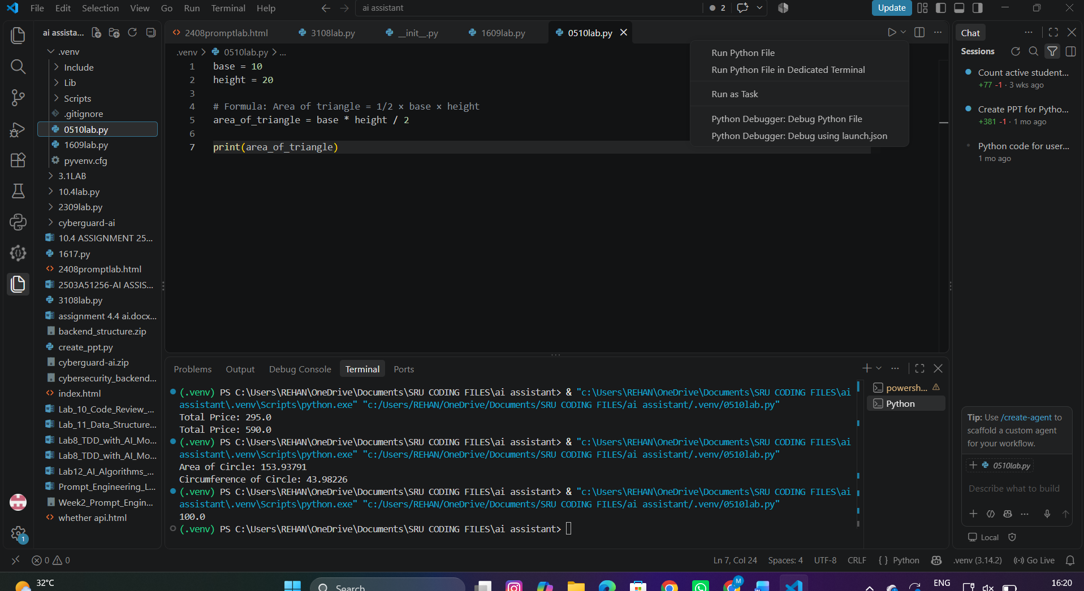
Figure 5: VS Code-style view showing task5.py and terminal output.

Task Description #6 (Refactoring – Removing Redundant Conditional

Logic)

• Task: Use AI to refactor a Python script that contains repeated if–else

logic for grading students.

• Instructions:

o Ask AI to identify redundant conditional checks.

o Replace them with a reusable function.

o Ensure grading logic remains unchanged.

• Code:

marks = 85

if marks &gt;= 90:

print(&quot;Grade A&quot;)

elif marks &gt;= 75:

print(&quot;Grade B&quot;)

else:

print(&quot;Grade C&quot;)

marks = 72

if marks &gt;= 90:

print(&quot;Grade A&quot;)

elif marks &gt;= 75:

print(&quot;Grade B&quot;)

else:

print(&quot;Grade C&quot;)

• Expected Output:

o A reusable function like calculate_grade(marks) with clean logic and

docstring.

Task 6 – Removing Redundant Conditional Logic

1. Prompt
Refactor this Python grading code by creating a reusable function called calculate_grade(marks). The function should preserve the original grading rules: 90 or above = Grade A, 75 or above = Grade B, otherwise Grade C. Add a docstring and use it for both students.

2. Legacy / Input Code
marks = 85
if marks >= 90:
print("Grade A")
elif marks >= 75:
print("Grade B")
else:
print("Grade C")
marks = 72
if marks >= 90:
print("Grade A")
elif marks >= 75:
print("Grade B")
else:
print("Grade C")

3. Refactored Code / Answer
def calculate_grade(marks):
"""Return the grade based on the student's marks."""
if marks >= 90:
return "Grade A"
elif marks >= 75:
return "Grade B"
else:
return "Grade C"
print(calculate_grade(85))
print(calculate_grade(72))

4 Output
Grade B
Grade C
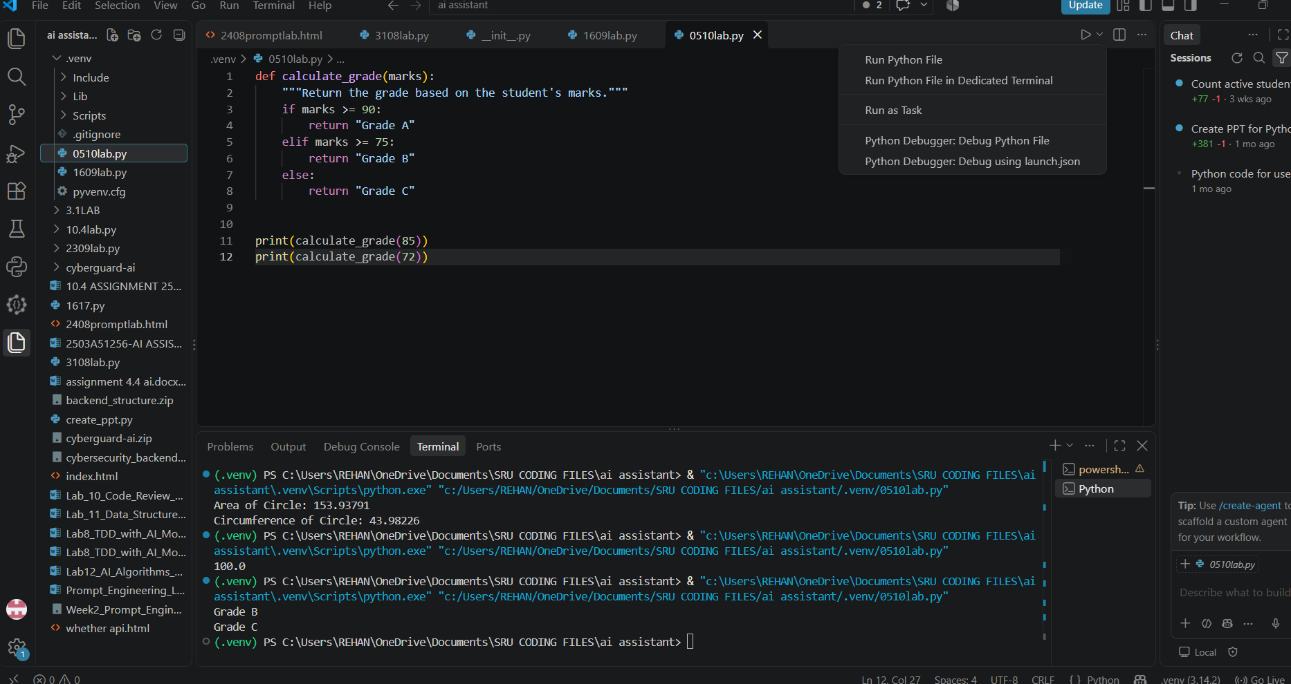

Task Description #7 (Refactoring – Converting Procedural Code to

Functions)

• Task: Use AI to refactor procedural input–processing logic into

functions.

• Instructions:

o Identify input, processing, and output sections.

o Convert each into a separate function.

o Improve code readability without changing behavior.

• Sample Legacy Code:

num = int(input(&quot;Enter number: &quot;))

square = num * num

print(&quot;Square:&quot;, square)

• Expected Output:

o Modular code using functions like get_input(), calculate_square(),

and display_result().

Task 7 – Converting Procedural Code to Functions

1. Prompt
Refactor this procedural Python program into three functions: get_input(), calculate_square(), and display_result(). Keep the same behavior. Add docstrings to all functions and make the program easy for a beginner to understand.

2. Legacy / Input Code
num = int(input("Enter number: "))
square = num * num
print("Square:", square)

3. Refactored Code / Answer
def get_input():
"""Get an integer from the user."""
return int(input("Enter number: "))
def calculate_square(number):
"""Return the square of a number."""
return number * number
def display_result(square):
"""Display the calculated square."""
print("Square:", square)
number = get_input()
result = calculate_square(number)
display_result(result)

4. Output
Enter number: 5
Square: 25
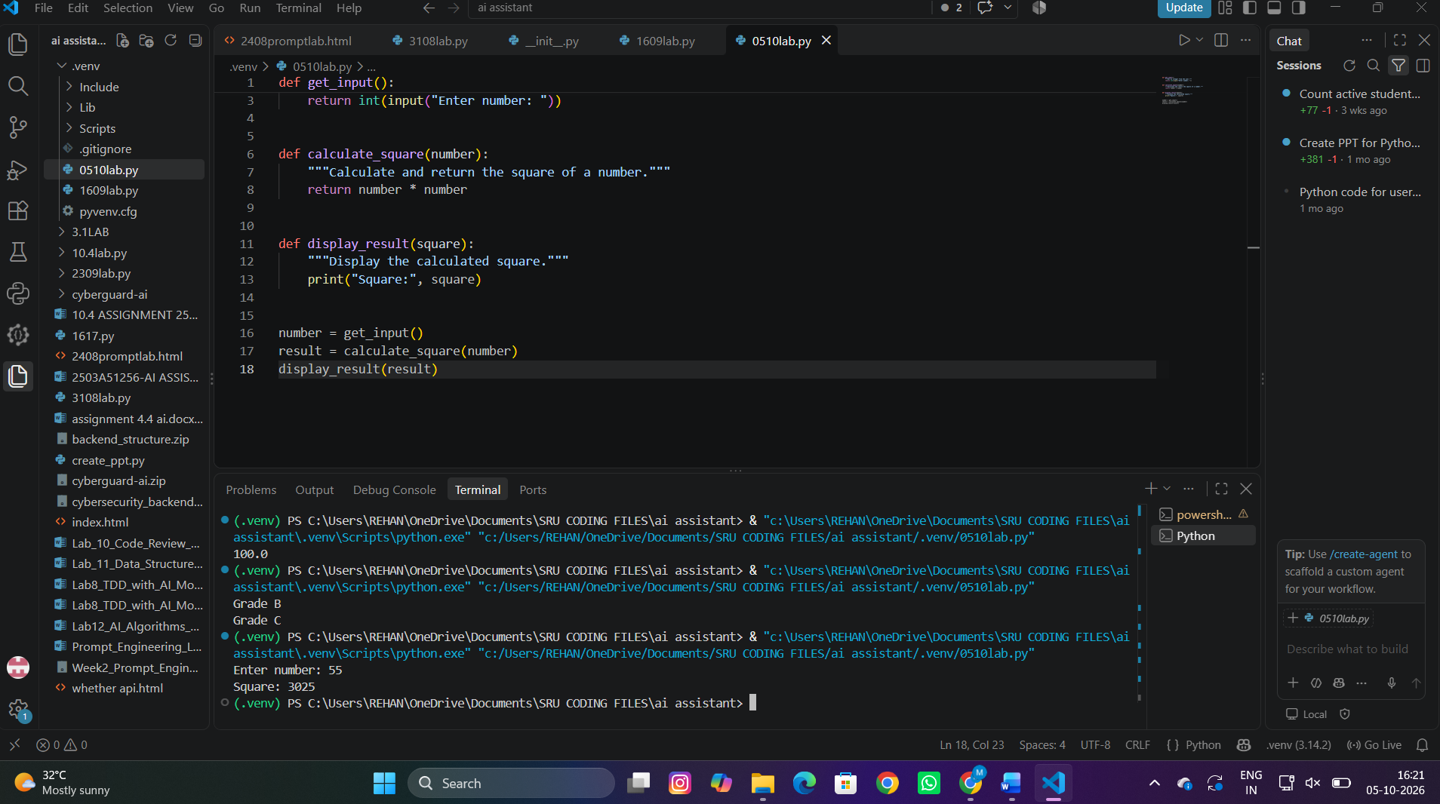
Task Description #8 (Refactoring – Optimizing List Processing)
• Task: Use AI to refactor inefficient list processing logic.
• Instructions:
o Ask AI to replace manual loops with list comprehensions or built-in
functions.
o Ensure output remains identical.
• Sample Legacy Code:
nums = [1, 2, 3, 4, 5]
squares = []
for n in nums:
squares.append(n * n)
print(squares)
• Expected Output:
o Optimized version using list comprehension with improved
readability
1. Prompt
Refactor this Python list-processing code using a list comprehension. Keep the output identical. Add a short docstring in a reusable function if appropriate and keep the code simple and readable.

2. Legacy / Input Code
nums = [1, 2, 3, 4, 5]
squares = []
for n in nums:
squares.append(n * n)
print(squares)

3. Refactored Code / Answer
def square_numbers(numbers):
"""Return a list containing the square of each number."""
return [number * number for number in numbers]
nums = [1, 2, 3, 4, 5]
squares = square_numbers(nums)
print(squares)

Output
[1, 4, 9, 16, 25]

