**SEATING ALLOCATIONS SUPPORT FILES**

* First, enable Execution permission of the **runthis.sh** file; by Right click on the **runthis.sh** file. Check “Allow executing file as program” then click on close.

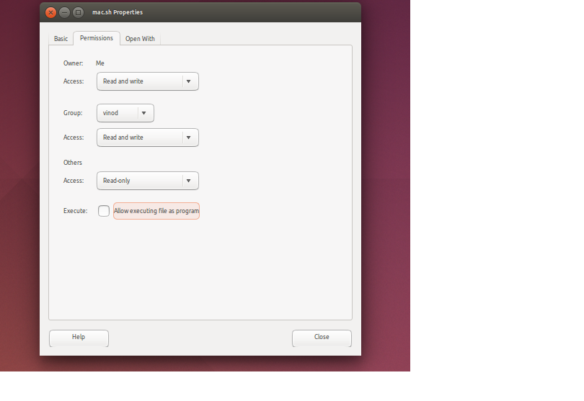

* Now, open Terminal and navigate to the location where files are downloaded.
* Execute **runthis.sh** file from the terminal. E.g.- **./runthis.sh**