Agile

for
Library Management System

Prepared by

Nourhan Ibrahim
Shahd Mohamed
Rehab Hamed
Rana Salem

Epics:
- Requirements & Documentation
- System Design (UML Diagrams)
- Core System Implementation
- Testing & Final Delivery
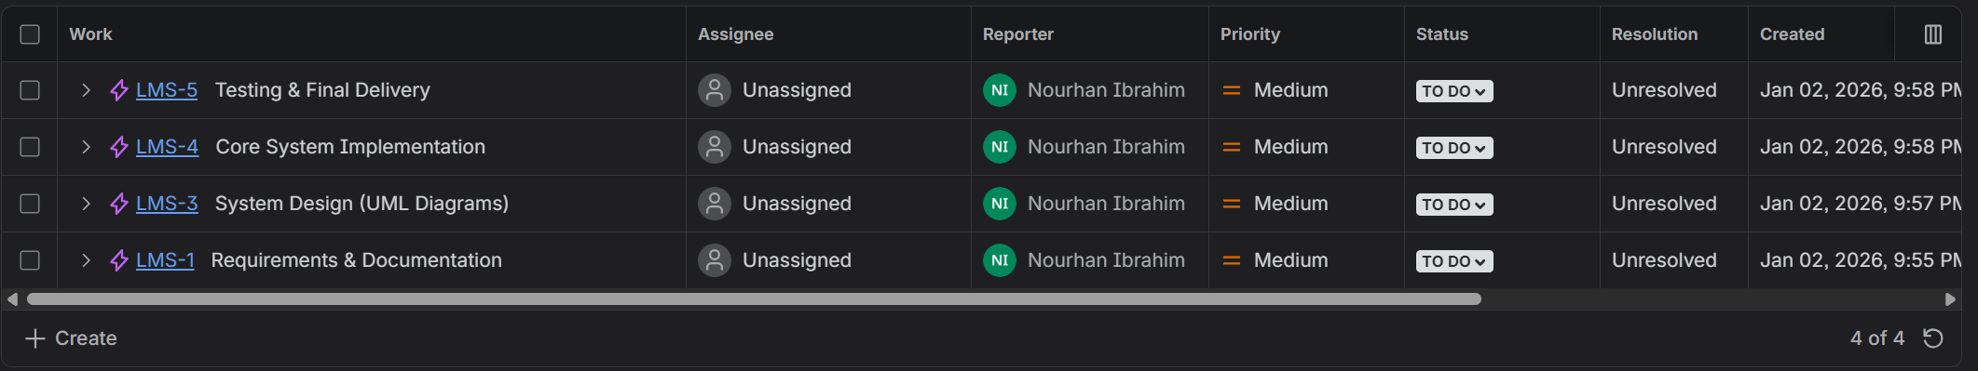

User stories:
- Requirements & Documentation
- Functional Requirements
- Non-Functional Requirements
- System Design (UML Diagrams)
- Class diagram
- Use case diagrams
- Activity diagrams
- Sequence diagram
- Core System Implementation
- Classes implementation
- Implement Book Management (Librarian)
- Implement Book Search Functionality
- Implement Borrow Book Feature
- Implement Return Book Feature
- Implement Console Menus & Navigation
- Testing & Final Delivery
- Test features
- Clean code
- Upload deliverables

Sprints:
- LMS Sprint 1 - Requirements
Goal: Clear understanding of what to build
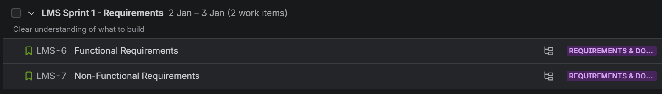
- LMS Sprint 2 - System Design
Goal: Visualize system structure & behavior
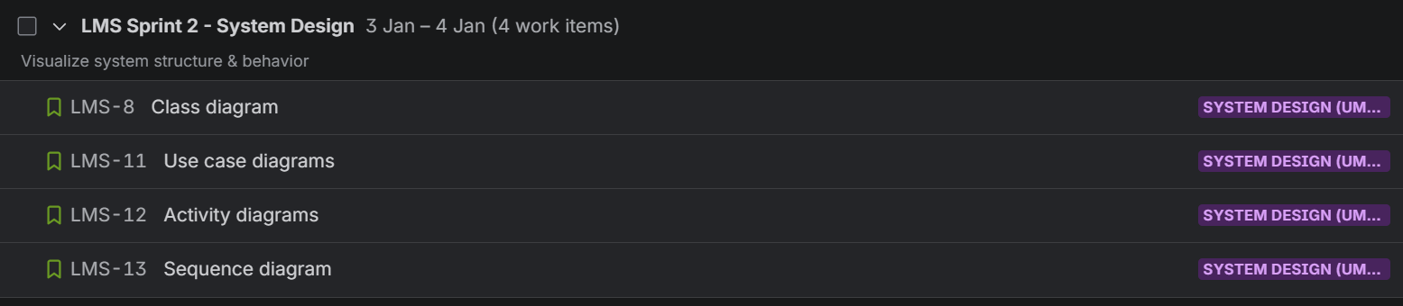
- LMS Sprint 3 - Core Implement
Goal: Working console application
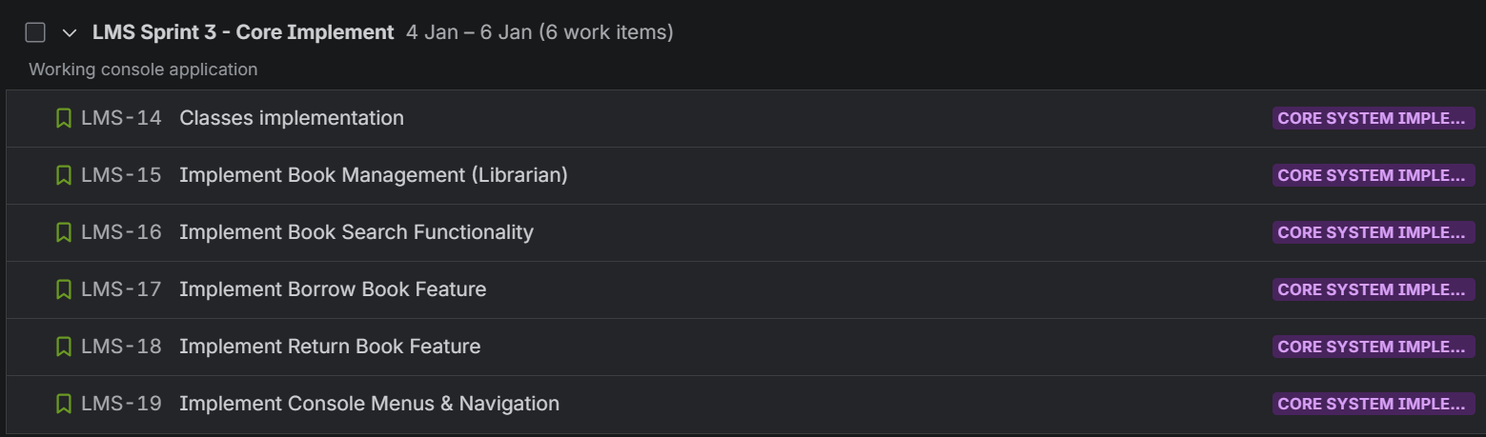
- LMS Sprint 4 – Testing
Goal: Finish & polish
