Name: - MOHD REHBAR KHAN

Batch: - A

PG-DAC

COP

Assignment-2

Answer-1

**package** day6LABAssignment;

**public** **class** Answer1Sumof10NaturaNum {

**public** **static** **void** main(String[] args) {

// **TODO** Auto-generated method stub

**int** a=0 ;

**for**(**int** i=1;i<=10;i++) {

a=a+i;

}

System.***out***.println("sum of first 10 integers is " + a);

}

}

Output-

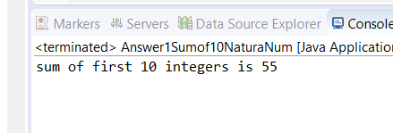

Answer-2

**package** day6LABAssignment;

**import** java.util.Scanner;

**public** **class** Answer2 {

**public** **static** **void** main(String[] args) {

// **TODO** Auto-generated method stub

**int** a;

Scanner s= **new** Scanner(System.***in***);

System.***out***.println("enter the num");

a=s.nextInt();

**if**(a>0)

{

**for**(**int** i=1;i<=10;i++)

{

System.***out***.println(a*i);

}

}

**else**

System.***out***.println("negative integer please enter positive num");

}

}

Output-

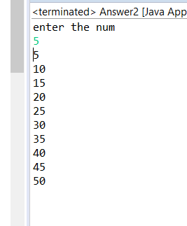

Answer-3

**package** day6LABAssignment;

**import** java.util.Scanner;

**public** **class** Answer3Reverse {

**public** **static** **void** main(String[] args) {

// **TODO** Auto-generated method stub

**int** num,rem;

**int** rev=0,sum=0;

Scanner s = **new** Scanner(System.***in***);

System.***out***.println("enter the num");

num=s.nextInt();

**while**(num>0)

{

rem=num%10;

//System.out.print(r);

num=num/10;

rev= (rev*10)+rem;

sum = sum+rem;

}

System.***out***.println("reverse num is "+rev);

System.***out***.printf("Sum is " +sum);

}

}

Output-

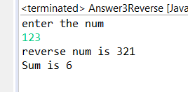

Answer-4

**package** day6LABAssignment;

**import** java.util.Scanner;

**public** **class** Answer4DoWhile {

**public** **static** **void** main(String[] args) {

// **TODO** Auto-generated method stub

**int** a,b,c;

**char** d;

Scanner s=**new** Scanner(System.***in***);

**do**

{

System.***out***.println("first num");

a=s.nextInt();

System.***out***.println("second num");

b = s.nextInt();

c= a+b;

System.***out***.println("sum is " + c);

System.***out***.print("do want to perform again Y/N ");

d= s.next().charAt(0);

}

**while**(d =='Y' || d=='y');

}

}

Output-

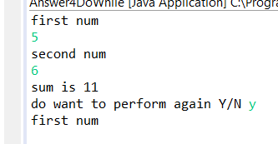

Answer-5

**package** day6LABAssignment;

**public** **class** Answer5Amstrong {

**public** **static** **void** main(String[] args) {

// **TODO** Auto-generated method stub

**int** i=1,a ,b,c;

**while**(i<=500) // eg- i = 153

{

a= i%10;// 153%10= 3

b= i%100;// 153%100 = 53

b = (b-a) /10; // 53-3 = 50/10 = 5

c= i/100; // 153/100= 1

**if**((a*a*a)+(b*b*b)+(c*c*c)==i)

{

System.***out***.println(i);

}

i++;

}

}

}

Output-

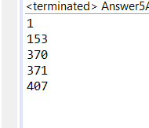

Answer-6

**package** day6LABAssignment;

**import** java.util.Scanner;

**public** **class** Answer6Fibonacci {

**public** **static** **void** main(String[] args) {

// **TODO** Auto-generated method stub

//int num, a=0, b=1, c;

Scanner s= **new** Scanner(System.***in***);

**int** num, a=0, b=1, c;

System.***out***.println("enter num");

num = s.nextInt();

**for**(**int** i=1; i<=num;i++)

{

System.***out***.println(a);

c = a+b;

a=b;

b=c;

}

}

}

Output-

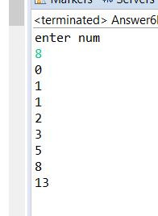

Answer-7(i)

**package** day6LABAssignment;

**public** **class** Answer7i {

**public** **static** **void** main(String[] args) {

// **TODO** Auto-generated method stub

**for**(**int** i=1;i<=4;i++)

{

**for**(**int** j=1;j<=10;j++)

{

System.***out***.print("*");

}

System.***out***.println();

}

}

}

Output-

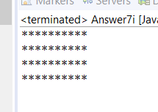

Answer-7(ii)

**package** day6LABAssignment;

**public** **class** Answer7iiPattern {

**public** **static** **void** main(String[] args) {

// **TODO** Auto-generated method stub

**for**(**int** i=1;i<=5;i++)

{

**for**(**int** j=1;j<=i;j++)

{

System.***out***.print("*");

}

System.***out***.println();

}

}

}

Output-

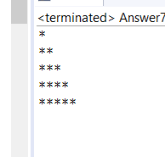

Answer-7(iii)

**package** day6LABAssignment;

**public** **class** Answer7Pattern33 {

**public** **static** **void** main(String[] args) {

// **TODO** Auto-generated method stub

**int** space=3;

//int k=1;

**for**(**int** i=1;i<=4;i++)

{

**for**( **int** l=1;l<=space;l++) System.***out***.print(" ");

**for**(**int** j=1;j<=i;j++)

{

System.***out***.print(" * "+ " ");

// k++;

}

System.***out***.println();

space--;

}

}

}

Output-

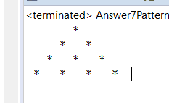

Answer-7(iv)

**package** day6LABAssignment;

**public** **class** Answer7Patter4 {

**public** **static** **void** main(String[] args) {

// **TODO** Auto-generated method stub

**for**(**int** i=1;i<=5;i++)

{

**for**(**int** j=5;j>i;j--)

{

System.***out***.print(" ");

}

**for**(**int** k=1;k<=2*i-1;k++)

{

System.***out***.print("*");

}

System.***out***.print("\n");

}

}

}

Output-

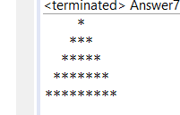

Answer-7(v)

**public** **static** **void** main(String[] args) {

// **TODO** Auto-generated method stub

**int** space=4;

**int** m=1;

**for**(**int** i=1;i<=5;i++)

{

**for**( **int** l=1;l<=space;l++) System.***out***.print(" ");

**for**(**int** j=1;j<=2*i-1;j++)

{

System.***out***.print(" "+ m+" ");

m++;

}

System.***out***.println();

space--;

}

}

}

Output-

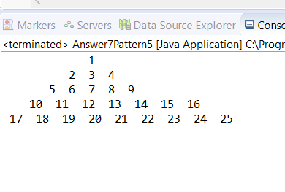

Answer-7(vi)

**package** day6LABAssignment;

**public** **class** Answer7Patter6 {

**public** **static** **void** main(String[] args) {

// **TODO** Auto-generated method stub

**char** a='A';

**for**(**int** i=0;i<6;i++)

{

**for**(**int** j=6;j>i;j--)

{

System.***out***.print(a);

a++;

}

**for**(**int** k=0;k<i;k++)

{

System.***out***.print(" ");

}

**for**(**int** m=6;m>i;m--)

{

a--;

System.***out***.print(a);

}

System.***out***.println();

}

}

}

Output-

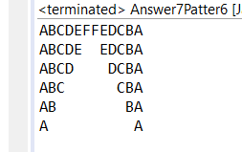

Answer-8

**package** day6LABAssignment;

**import** java.util.Scanner;

**public** **class** Answer8SumofEvenOdd {

**public** **static** **void** main(String[] args) {

// **TODO** Auto-generated method stub

**int** a, sum=0;

Scanner s= **new** Scanner(System.***in***);

System.***out***.println("Enter the num");

a = s.nextInt();

**if**(a%2==0)

{

**for**(**int** i=0;i<=a;i=i+2)

{

sum = sum+i;

}

System.***out***.println("Sum of even " + sum);

}

**else** {

**for**(**int** i=1;i<=a;i=i+2)

{

sum = sum+i;

}

System.***out***.println("Sum of odd " + sum);

}

}

}

Output-

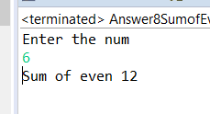 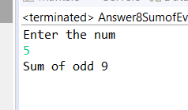

Answer-9

**package** day6LABAssignment;

**import** java.util.Scanner;

**public** **class** Answer9PrimeOrNOt {

**public** **static** **void** main(String[] args) {

// **TODO** Auto-generated method stub

**int** n, count=0;

Scanner s =**new** Scanner(System.***in***);

System.***out***.println("Enter the num");

n = s.nextInt();

**for**(**int** i=1;i<=n;i++)

{

**if**(n%i==0)

{

count++;

}

}

**if**(count==2)

System.***out***.println("Num is prime");

**else**

System.***out***.println("Num is Not Prime");

}

}

Output-

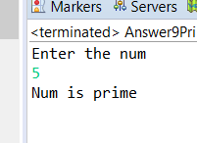 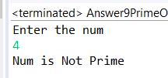

Answer-10

**package** day6LABAssignment;

**import** java.util.Scanner;

**public** **class** Answer10PrimeInRange {

**public** **static** **void** main(String[] args) {

// **TODO** Auto-generated method stub

**int** j,i;

**for**(i=2;i<=20;i++)

{

**for**( j=2;j<=i;j++)

{

**if**(i%j==0)

**break**;

}

**if**(i==j)

System.***out***.println(j);

}

}

}

Output-

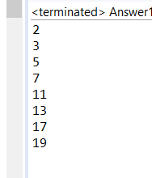

Answer-11

**package** day6LABAssignment;

**import** java.util.Scanner;

**public** **class** Answer11LargestAmong3 {

**public** **static** **void** main(String[] args) {

// **TODO** Auto-generated method stub

**int** a,b,c,d;

Scanner s= **new** Scanner(System.***in***);

System.***out***.println("Enter first num");

a=s.nextInt();

System.***out***.println("Enter second num");

b=s.nextInt();

System.***out***.println("Enter third num");

c=s.nextInt();

**if**(a>b && a>c )

{

d=a;

}

**else** **if**(b>a && b>c)

{

d=b;

}

**else**

{

d=c;

}

System.***out***.println("Greatest num is "+d);

}

}

Output-

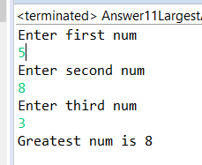

Answer-20

**package** day6LABAssignment;

**public** **class** Answer12SumOFintegers {

**public** **static** **void** main(String[] args) {

// **TODO** Auto-generated method stub

**int** sum=0, count=0;

**for**(**int** i=101;i<200;i++)

{

**if**(i%7==0)

{

sum = sum + i;

count++;

}

}

System.***out***.println("Sum of num between 100 and 200 which are divisible by 7 is "+sum);

System.***out***.println("Total of num between 100 and 200 which are divisible by 7 is "+count);

}

}

Output-

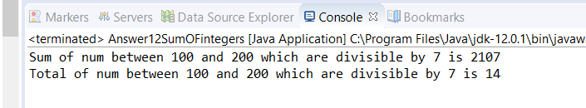

Answer-21

**package** day6LABAssignment;

**public** **class** Answer13Divisibleby35andBoth {

**public** **static** **void** main(String[] args) {

// **TODO** Auto-generated method stub

System.***out***.println(" Divided by 3 are ");

**for**(**int** i =1; i<100;i++)

{

**if**(i%3==0)

{

System.***out***.print(i+" , ");

}

}

System.***out***.println("\n\nDivided by 5 are ");

**for**(**int** i =1; i<100;i++)

{

**if**(i%5==0)

{

//System.out.println("\nDivided by 5 are " + i);

System.***out***.print(i+",");

}

}

System.***out***.println("\n\n Divided by 3 and 5 are ");

**for**(**int** i =1; i<100;i++)

{

**if**(i%3==0 && i%5==0)

{

// System.out.println("\n Divided by 3 are ");

System.***out***.print(i+",");

}

}

System.***out***.println("\n");

}

}

Output-

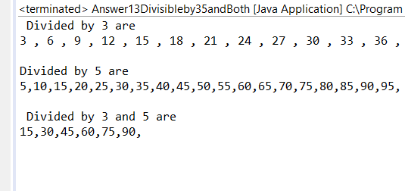

Answer-22

**package** day6LABAssignment;

**import** java.util.Scanner;

**public** **class** Answer14Switch {

**public** **static** **void** main(String[] args) {

Scanner s= **new** Scanner(System.***in***);

**int** a,b,c;

**int** choice;

**boolean** x= **true**;

**do**

{

System.***out***.println();

System.***out***.println("choices");

System.***out***.println("1- Addition");

System.***out***.println("2- Sbtraction");

System.***out***.println("3- Multiplication");

System.***out***.println("4- Exit");

choice=s.nextInt();

**switch**(choice) {

**case** 1:

System.***out***.println("first num");

a=s.nextInt();

System.***out***.println("second num");

b=s.nextInt();

c=a+b;

System.***out***.println("addition "+c);

**break**;

**case** 2:

System.***out***.println("first num");

a=s.nextInt();

System.***out***.println("second num");

b=s.nextInt();

c=a-b;

System.***out***.println("subtraction "+c);

**break**;

**case** 3:

System.***out***.println("first num");

a=s.nextInt();

System.***out***.println("second num");

b=s.nextInt();

c=a*b;

System.***out***.println("multiplication "+c);

**break**;

**case** 4:

System.***out***.println("terminate");

x=**false**;

**break**;

**default**:

System.***out***.println("enter valid choice");

}

}**while**(x!=**false**);

}

}

Output-

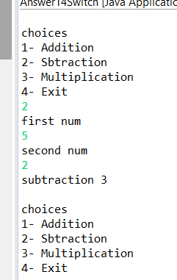

Answer-23

**package** day6LABAssignment;

**public** **class** Answer15 {

**public** **static** **void** main(String[] args) {

// **TODO** Auto-generated method stub

**for**(**int** i=1;i<=20;i++)

{

**if**(i%2==0)

{

System.***out***.println(i);

**if**(i==16)

**break**;

}

}

}

}

Output-

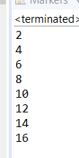

Answer-24

**package** day6LABAssignment;

**import** java.util.Scanner;

**public** **class** Answer16 {

**public** **static** **void** main(String[] args) {

// **TODO** Auto-generated method stub

**double** a,b;

Scanner s= **new** Scanner(System.***in***);

System.***out***.println("enter num one");

a=s.nextDouble();

System.***out***.println("enter num second ");

b=s.nextDouble();

**if**(a>0 && a<1 && b>0 && b<1)

{

System.***out***.println("Num is between range");

}

**else**

System.***out***.println("Num is not in Range");

}

}

Output-

