Name: - MOHD REHBAR KHAN

Batch: - A

PG-DAC

WebTech

Assignment- 3 CSS

Answer-1

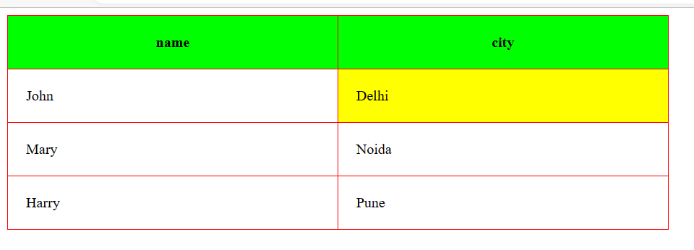

Code

<html>

<head>

<style>

table,td,th{

border:1px solid red;

border-collapse:collapse;

width:50%;

height:50px;

padding:20px;

/\*border-spacing:20px;\*/

}

th{

background-color:lime;

}

.color{

background-color:yellow;

}

</style>

</head>

<body>

<table>

<tr>

<th>name</th>

<th>city</th>

</tr>

<tr>

<td>John</td>

<td class="color">Delhi</td>

</tr>

<tr>

<td>Mary</td>

<td>Noida</td>

</tr>

<tr>

<td>Harry</td>

<td>Pune</td>

</tr>

</table>

</body>

</html>

Answer-2

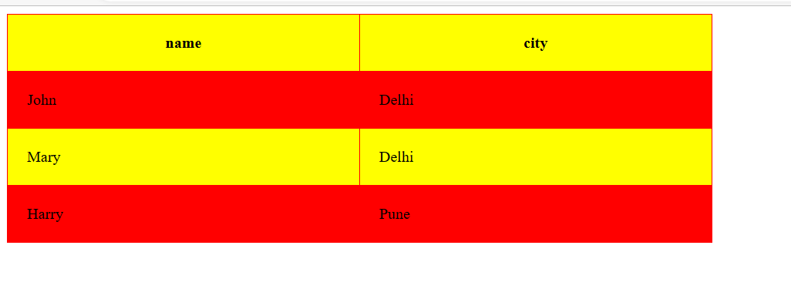

Code

<html>

<head>

<style>

table,td,th{

border:1px solid red;

border-collapse:collapse;

width:50%;

height:50px;

padding:20px;

/\*border-spacing:20px;\*/

}

tr:nth-child(even){

background-color:red;

}

tr:nth-child(odd){

background-color:yellow;

}

</style>

</head>

<body>

<table>

<tr>

<th>name</th>

<th>city</th>

</tr>

<tr>

<td>John</td>

<td>Delhi</td>

</tr>

<tr>

<td>Mary</td>

<td>Delhi</td>

</tr>

<tr>

<td>Harry</td>

<td>Pune</td>

</tr>

</table>

</body>

</html>