% Parameters for the problem
R0 = 0.1; % Constant resistance R0
m1 = 1; % Constant m1 for 1/R1(t)
t1 = 0.2; % Time offset for R1
tau1 = 1; % Period for R1
T = 10; % Final time
C = 5; % Capacitance C
V_s = 4.3; % Source voltage Vs
V_0 = 3.0; % Initial voltage V0
m_k = 0.4; % Magnitude for k(t) - different from m1
r = 2; % Exponent for the nonlinear term
% Time vector
t = linspace(0, T, 1000);
% 1/R1(t) - periodic pulse function
R1_inv = zeros(size(t));
for j = 0:floor(T/tau1)
idx = (t > (t1 + (j + 4/5) * tau1)) & (t <= (t1 + (j + 1) * tau1));
R1_inv(idx) = m1;
end
% k(t) - has same form as R1(t) but different magnitude
k_t = zeros(size(t));
for j = 0:floor(T/tau1)
idx = (t > (t1 + (j + 4/5) * tau1)) & (t <= (t1 + (j + 1) * tau1));
k_t(idx) = m_k;
end
% Total resistance 1/R(t)
R_total_inv = 1/R0 + R1_inv;
R_total = 1 ./ R_total_inv;
% Solve the modified ODE numerically using Euler method
% C*dV/dt + V(t)/R(t) = V_s/R(t) - k(t)*V(t)^r
V_t = zeros(size(t));
V_t(1) = V_0;
dt = t(2) - t(1);
for i = 2:length(t)
% Euler method to solve the ODE
dV_dt = (V_s/R_total(i) - k_t(i)*V_t(i-1)^r - V_t(i-1)/R_total(i)) / C;
V_t(i) = V_t(i-1) + dV_dt * dt;
end
% Calculate derivative dV/dt from the solution
dV_dt = gradient(V_t, dt);
% Plotting
figure;
% Subplot 1: 1/R1(t) and k(t) vs t
subplot(4, 1, 1);
plot(t, R1_inv, 'LineWidth', 2, 'DisplayName', '1/R_1(t)');
hold on;
plot(t, k_t, 'LineWidth', 2, 'DisplayName', 'k(t)');
ylabel('Conductance', 'FontSize', 12);
title('Graphs of 1/R_1(t) and k(t) vs t', 'FontSize', 14);
legend;
grid on;
% Subplot 2: R(t) vs t
subplot(4, 1, 2);
plot(t, R_total, 'LineWidth', 2, 'Color', 'm');
ylabel('R(t)', 'FontSize', 12);
title('Total Resistance R(t) vs t', 'FontSize', 14);
grid on;
% Subplot 3: V(t) vs t
subplot(4, 1, 3);
plot(t, V_t, 'LineWidth', 2, 'Color', 'b');
ylabel('V(t)', 'FontSize', 12);
title('Graph of V(t) vs t', 'FontSize', 14);
grid on;
% Subplot 4: dV/dt vs t (Periodic Peaks)
subplot(4, 1, 4);
plot(t, dV_dt, 'LineWidth', 2, 'Color', 'r');
xlabel('Time (s)', 'FontSize', 12);
ylabel('dV/dt', 'FontSize', 12);
title('Graph of dV/dt vs t (Periodic Peaks)', 'FontSize', 14);
grid on;
% Adjust plot layout
sgtitle('Modified Model with k(t) Term', 'FontSize', 16);
Model Parameters:
R0 = 0.1
m1 = 1.0
m_k = 0.4
r = 2.0
tau1 = 1.0
Fundamental frequency = 1.00 Hz
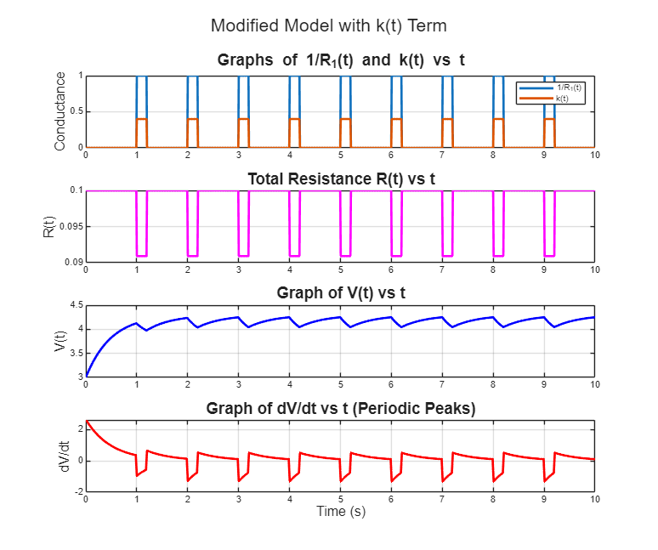

Published with MATLAB® R2025a

