*Q:1*

*Answer :*

* *Image Map tag is used to target and provide more information about that area of picture while clicking on specific area ,Image with clickable areas . There can be more than one clickable areas based on information need to be provided for that area.*

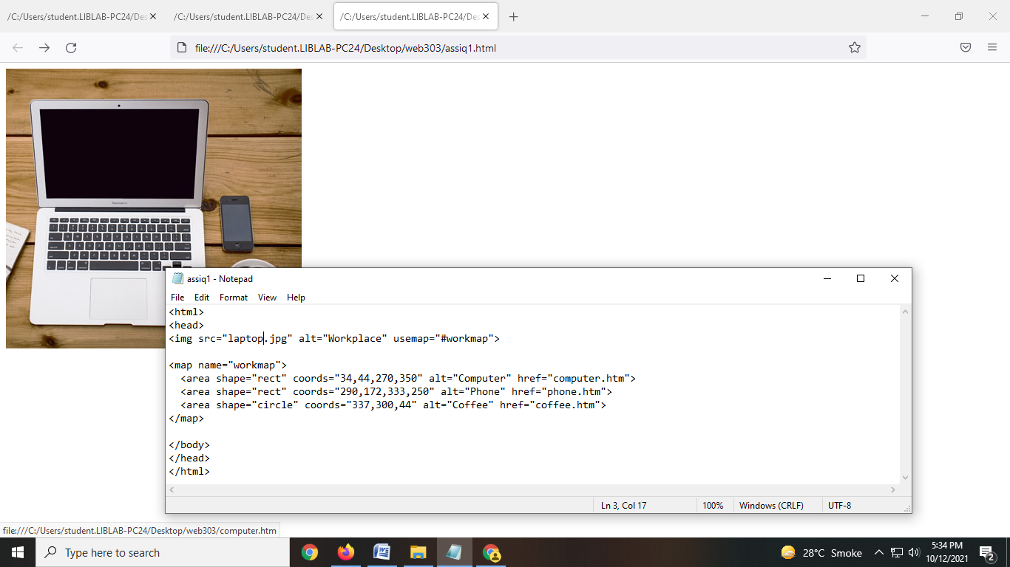

*Example with Picture*



*There are two different company cell phones in this picture(Iphone and Samsung) I can create clickable area for both if user click on IPHONE area he will be provided with IPHONE details and vice versa .*

* *The HTML picture element allows you to display different pictures for different devices or screen sizes.*

***The picture element contains one or more*** *srouce* ***elemrnts, each referring to different images through the screen attribute.This way the browser can choose the image that best fits the current view and /or device.***

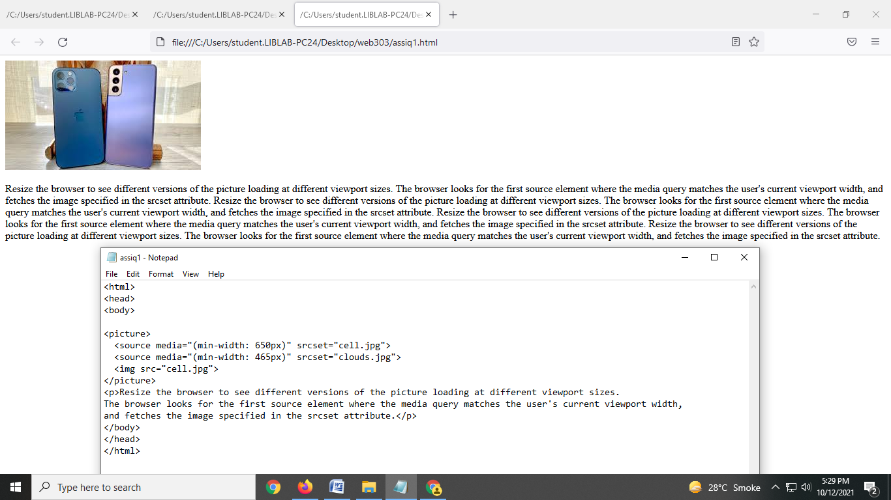

* *Adding background image*

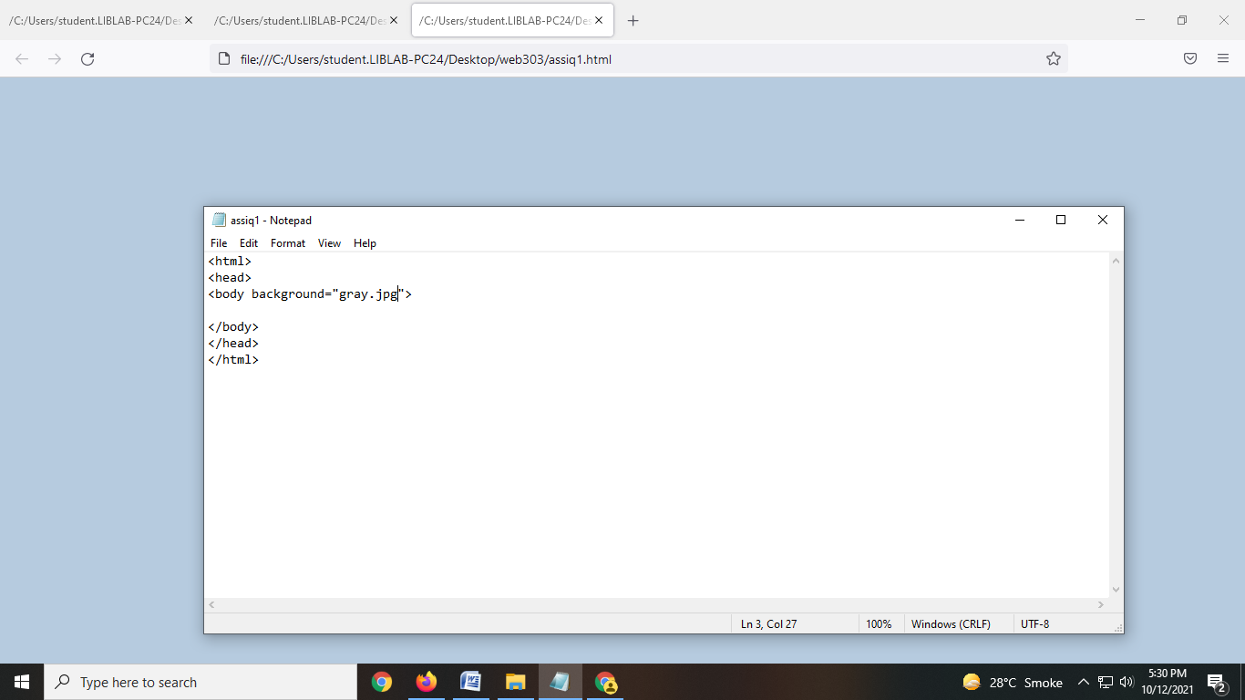

*Q2: Difference between HTML and XHTML ?*

*Answer:*

*HTML :*

*1.HTML tags are not extensible and are not case sensitive.*

*2.it can be run without ending properly like </p>*

*3.HTML can use open tags .*

*4.HTML is less expensive.*

*5.HTML is not mandatory for a single root element.*

*XHTML :*

*1.XHTML tags are extensible and it allows only lower case tags.*

*2.tags should be appear in pairs.*

*3.All unclosed tags must be closed in XHTML*

*4.XHTML is more expensive than HTML.*

*5.XHTML must contains at least one root element.*