

CYBER SECURITY INTERNSHIP & TRAINING PROGRAM

Name: M REHMAN IJAZ
Batch Start: 18-Feb-2026

Encrypted Chat App

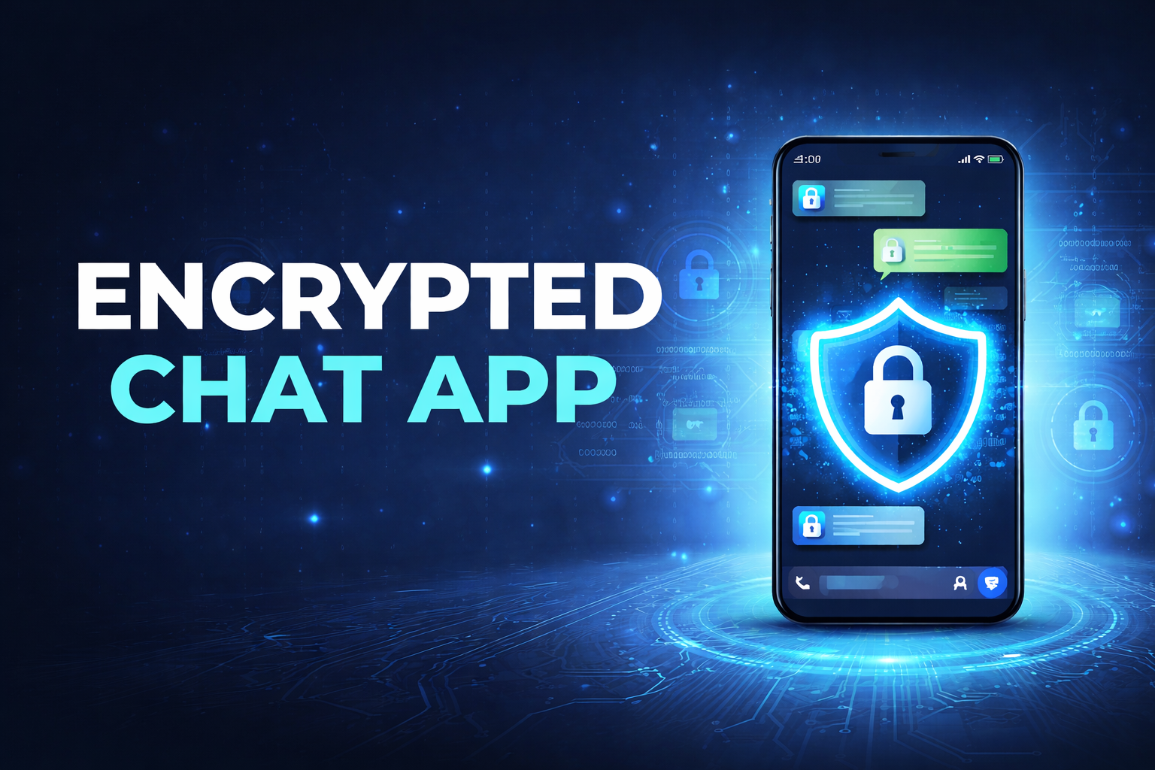
Contents
Abstract 2
1. Introduction 2
2. Objectives 2
3. Technologies Used 2
4. System Architecture 3
5. Working Principle 3
6. Security Implementation 3
7. Features of the Application 3
8. Advantages 4
9. Future Enhancements 4
10. Conclusion 4

Abstract
This project presents the design and implementation of a secure encrypted chat application using Python. The system allows multiple clients to communicate with a central server over TCP sockets while ensuring message confidentiality using AES-based symmetric encryption. Messages are encrypted before transmission and decrypted upon reception. The application also provides a graphical user interface built with Tkinter, enabling real-time chat communication in a user-friendly environment.

1. Introduction
With the rapid growth of digital communication, secure messaging systems have become essential to protect sensitive data from interception. Traditional chat systems may transmit data in plain text, making them vulnerable to network attacks such as packet sniffing or man-in-the-middle attacks. This project demonstrates how encryption techniques and socket programming can be combined to build a secure communication system.

2. Objectives
- To design a client-server chat application using Python.
- To implement TCP socket communication between multiple clients and a server.
- To secure messages using AES-based symmetric encryption.
- To display both encrypted and decrypted messages for demonstration purposes.
- To build an interactive GUI using Tkinter.

3. Technologies Used
Programming Language: Python
Libraries Used:
- socket – network communication
- threading – handling multiple clients
- cryptography – AES encryption using Fernet
- tkinter – graphical user interface
- datetime – message timestamps

4. System Architecture
The application follows a client-server architecture. The server listens for incoming connections from multiple clients. Once connected, clients can send encrypted messages to the server. The server decrypts the message, displays it, and broadcasts it to other connected clients.
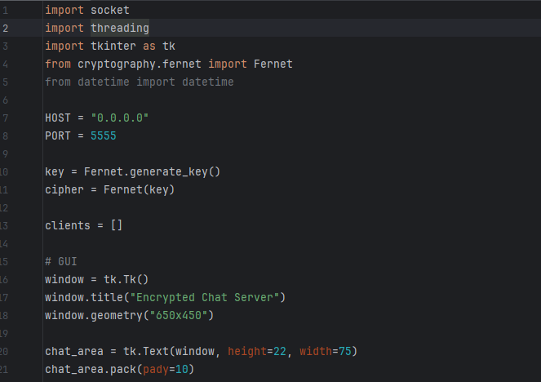

5. Working Principle
- The server starts and listens on a specific port.
- Clients connect to the server using TCP sockets.
- A symmetric encryption key is shared between server and client.
- Messages typed by the client are encrypted before transmission.
- The server receives encrypted data and decrypts it.
- The server broadcasts the encrypted message to other connected clients.
- Clients decrypt the received message and display it in the GUI.

6. Security Implementation
The application uses AES-based encryption through the Fernet module provided by the cryptography library. Fernet ensures that messages cannot be read or modified without the encryption key. Each message is encrypted before being transmitted across the network, preventing attackers from viewing sensitive data.
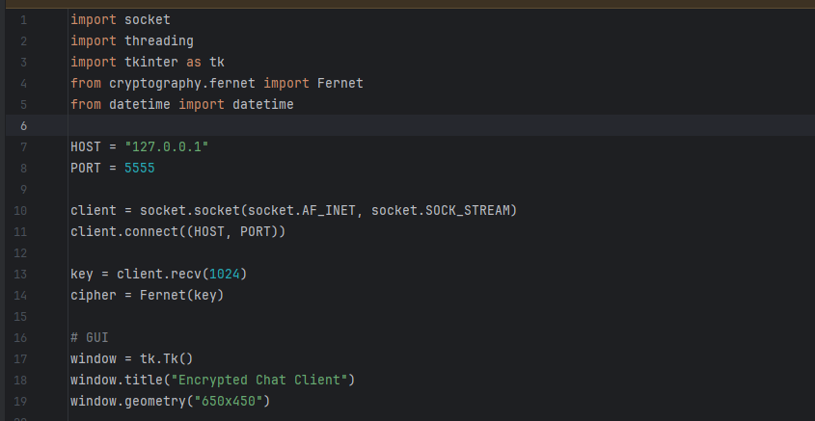

7. Features of the Application
- Secure message encryption
- Real-time communication
- Client-server architecture
- Multi-client support
- Graphical user interface
- Message timestamping
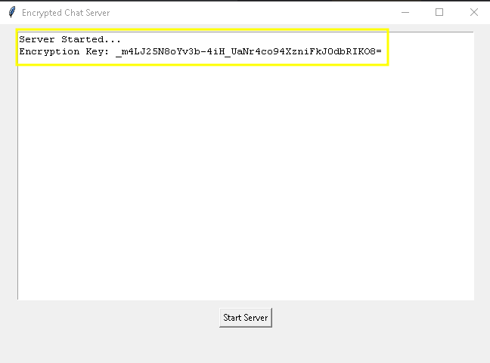
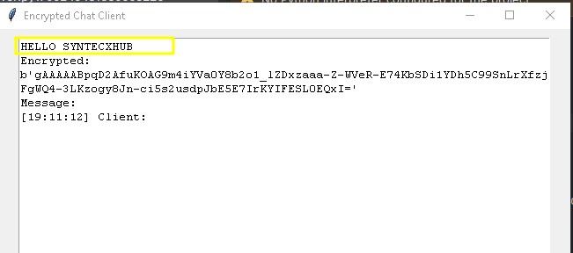

8. Advantages
- Secure communication
- Simple and lightweight design
- Easy to deploy on local networks
- Scalable to support multiple users
- Educational demonstration of encryption and networking
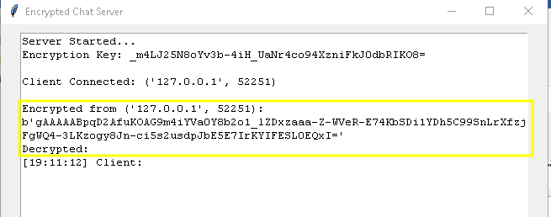

9. Future Enhancements
- User authentication system
- End-to-end encryption
- File sharing capability
- Group chat support
- Dark mode interface
- Cloud-based server deployment

10. Conclusion
The encrypted chat application demonstrates how Python can be used to implement secure network communication using socket programming and cryptographic techniques. The project successfully integrates encryption, multi-client communication, and graphical user interfaces into a single system. It provides a practical example of secure messaging applications and serves as a strong foundation for further development in cybersecurity and secure communication systems.

