

CYBER SECURITY INTERNSHIP & TRAINING PROGRAM

Name: M REHMAN IJAZ
Intern ID: ARCH-2602-2010

Keyboard Event Monitoring Tool (Keylogger)



Contents
1. Introduction 2
2. Project Objectives 2
3. Technologies Used 2
4. System Architecture 3
5. Implementation Details 3
5.1 Event Listener 3
5.2 Key Formatting 4
5.3 Timestamp Logging 4
5.4 Log Rotation 4
6. Execution Process 4
7. Screenshots 6
Running Script 6
Session Summary Output 7
8. Security & Ethical Considerations 8
9. Limitations 8
10. Future Enhancements 9
11. Learning Outcomes 9

1. Introduction
This project demonstrates the implementation of a controlled keyboard event monitoring tool developed in Python using the pynput library.
The objective of this task was to understand how operating systems capture keyboard input events and how malicious keylogging software operates at a technical level, strictly within a controlled lab environment.
The implementation logs keystrokes locally with timestamps and session metadata for educational and defensive cybersecurity analysis.

2. Project Objectives
- Understand keyboard input handling in operating systems
- Capture real-time key press events
- Log keystrokes in structured format
- Implement file handling and log rotation
- Demonstrate awareness of ethical implications

3. Technologies Used
- Programming Language: Python 3
- Library: pynput
- Operating System: Kali Linux
- Execution Mode: User-level execution
- Output: Local file logging

4. System Architecture

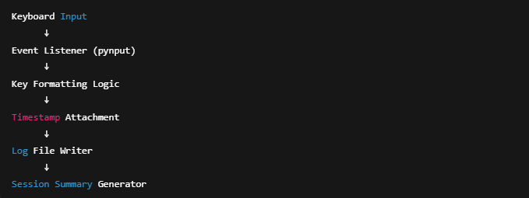

This system passively records keyboard events and does not transmit or conceal collected data.

5. Implementation Details

5.1 Event Listener
The program uses:
keyboard.Listener(on_press=..., on_release=...)
This attaches a listener to keyboard events at the OS level.

5.2 Key Formatting
Special keys (Enter, Space, Tab, Backspace) are formatted into readable text instead of raw object references.
Example:
- [ENTER]
- [BACKSPACE]
- [CTRL]

5.3 Timestamp Logging
Each keystroke is logged with:
YYYY-MM-DD HH:MM:SS | key
This improves traceability and log analysis capability.

5.4 Log Rotation
If log size exceeds threshold:
- Current log is archived
- New log file is created
This prevents uncontrolled file growth.

6. Execution Process
- Script executed from terminal
- Keyboard events captured in real-time
- Logs saved inside /logs directory
- Pressing ESC stops the session
- Summary statistics displayed

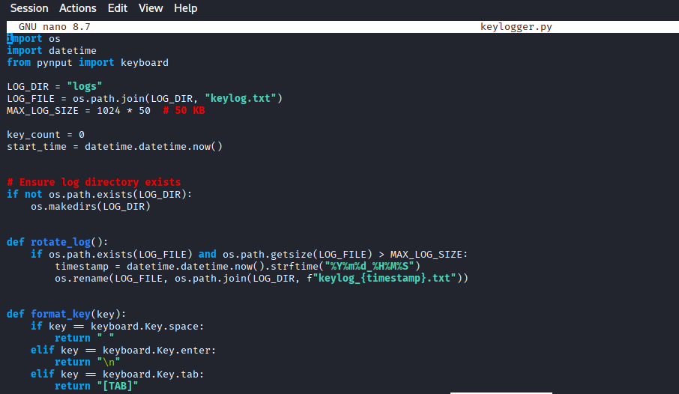
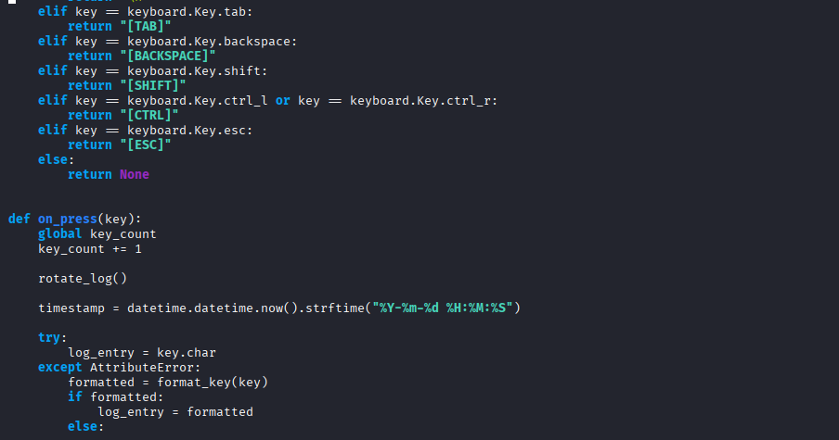
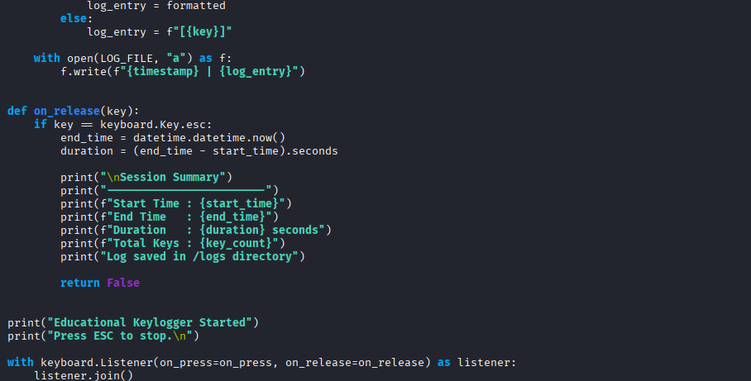

7. Screenshots

Running Script
Show:
- Terminal running python3 keylogger.py
- Message: “Educational Keylogger Started”
- “Press ESC to stop”
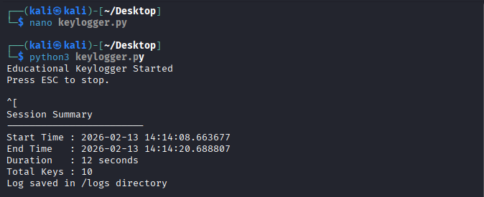

Session Summary Output
📌 Place screenshot here.
Show:
- Start time
- End time
- Duration
- Total keys
Show:
- keylog.txt or rotated file\
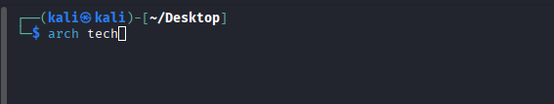
Command:
cat logs/keylog.txt
Show:
- Timestamped entries
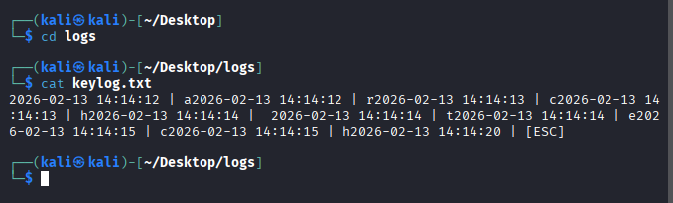

8. Security & Ethical Considerations
Keyloggers are commonly used in malware to steal credentials and sensitive data.
However, legitimate use cases include:
- Parental monitoring (with consent)
- Enterprise endpoint auditing
- Research in cybersecurity defense
This project was developed and executed:
- On a personal lab environment
- Without capturing third-party data
- Without persistence or concealment
- Strictly for educational understanding
Unauthorized deployment of keyloggers violates privacy laws and cybersecurity regulations.

9. Limitations
- No encryption of logs
- No GUI interface
- No anomaly detection
- No user authentication
- Runs visibly in terminal

10. Future Enhancements
- Encrypt log files
- Add detection alerts
- Integrate with SIEM tools
- Implement behavioral analysis
- Build defensive detection module

11. Learning Outcomes
This task provided practical understanding of:
- OS-level event handling
- Behavioral patterns of keylogging malware
- Security implications of input monitoring
- Responsible use of dual-use tools

