

CYBER SECURITY INTERNSHIP & TRAINING PROGRAM

Name: M REHMAN IJAZ
Batch Start: 18-Feb-2026

TCP Port Scanner
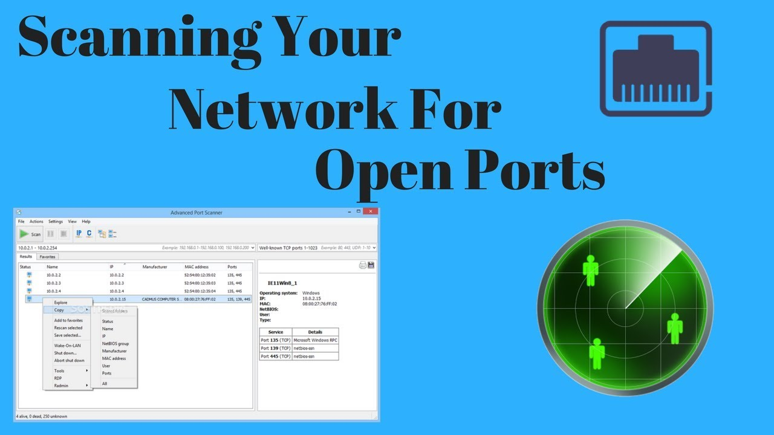

Contents
Abstract 3
1. Introduction 3
2. Project Objectives 3
3. System Architecture 3
4. Technical Implementation 4
4.1 Socket Programming 4
4.2 Multi-threading 4
4.3 Graphical User Interface 4
5. Features 4
6. Testing and Results 4
7. Security and Ethical Considerations 5
8. Future Enhancements 5
9. Conclusion 5

Abstract
This report presents the design and implementation of an Advanced TCP Port Scanner developed using Python. The project demonstrates practical knowledge of network programming, multi-threading, graphical user interface development, and cybersecurity fundamentals. The scanner identifies open and closed TCP ports within a specified range and provides real-time results through a professional graphical interface.

1. Introduction
Port scanning is a fundamental technique used in network administration and cybersecurity to identify active services running on a host. Each service on a computer system listens on a specific port number. By scanning these ports, administrators can detect open services, misconfigurations, and potential vulnerabilities.

2. Project Objectives
- Develop a multi-threaded TCP port scanner using Python.
- Design a professional GUI using Tkinter.
- Implement real-time progress tracking.
- Allow customizable port range scanning.
- Export scan results to a structured file.
- Demonstrate practical understanding of socket programming.

3. System Architecture
The system follows a modular architecture consisting of the following components:
• User Interface Module (Tkinter GUI)
• Network Scanning Module (Socket Programming)
• Multi-threading Module (Thread & Queue Management)
• Result Logging Module (File Export System)

4. Technical Implementation
The scanner utilizes the Python socket library to establish TCP connections using the connect_ex() method. If the method returns 0, the port is considered open. Multi-threading is implemented to improve scanning speed and efficiency. A queue structure ensures thread-safe task distribution.

4.1 Socket Programming
TCP scanning is performed using the socket.AF_INET and socket.SOCK_STREAM protocols. A timeout value ensures that the scanner does not hang while waiting for a response.

4.2 Multi-threading
The threading module is used to create concurrent scanning threads. This significantly improves performance compared to sequential scanning.

4.3 Graphical User Interface
The Tkinter library provides a professional dark-themed interface. Features include input validation, progress bar tracking, real-time result display, and structured layout design.

5. Features
- Multi-threaded TCP port scanning
- Custom target IP or domain input
- Customizable port range (1-65535)
- Real-time progress bar
- Open and closed port detection
- Start / Stop scanning control
- Result export to text file
- Professional dark GUI interface

6. Testing and Results
The application was tested on localhost and controlled lab environments. Open ports such as 80 (HTTP), 443 (HTTPS), and 22 (SSH) were successfully detected. The scanner maintained stable performance across multiple scanning sessions.

7. Security and Ethical Considerations
Port scanning should only be conducted on systems where explicit permission has been granted. Unauthorized scanning may violate legal and ethical guidelines. This project is strictly developed for educational and authorized testing purposes.

8. Future Enhancements
- SYN scanning using Scapy
- Service banner grabbing
- Operating system fingerprinting
- Export results in CSV/JSON formats
- Scan history database integration
- Vulnerability API integration

9. Conclusion
The Advanced TCP Port Scanner demonstrates a solid understanding of network communication, concurrent programming, and GUI application development. The project aligns with internship-level cybersecurity and networking skill requirements and serves as a strong portfolio-ready implementation.

