MOUNT ZION COLLEGE OF ENGINEERING

Kadammanitta – Pathanamthitta Kerala 689649
(Affiliated to APJ Abdul Kalam Technological University)


20MCA133 WEB PROGRAMMING LAB

LABORATORY RECORD

FIRST YEAR

Submitted by

REHNA MAJEED(MZC25MCA-2012)

Submitted in partial fulfillment of the requirement for the Award of the Degree of

MASTER OF COMPUTER APPLICATIONS (2025-2027)

Department of Computer Applications

MOUNT ZION COLLEGE OF ENGINEERING, KADAMMANITTA
MOUNT ZION COLLEGE OF ENGINEERING

Kadammanitta – Pathanamthitta Kerala 689649

(Affiliated to APJ Abdul Kalam Technological University)



CERTIFICATE

Certified that this is a Bonafide record of practical work done in Web Programming Lab (20MCA133) by REHNA MAJEED Reg No MZC25MCA-2012 of Mount Zion College of Engineering, Kadammanitta – Pathanamthitta during the academic year 2025- 2026

Head of the department Staff member in-charge

Submitted to the University Examination held on

External Examiner
INDEX
Sl.no | List Of Experiments | Date | Page No:
1 | Create a simple HTML file to demonstrate to use of different tags | 14/08 /2025 | 4
2 | Create an HTML file to link to different HTML page which contains images, tables, a and also link within a page. | 19/08/2025 | 11
3 | Create an Html page with different types of frames such as floating frame, navigation frame & mixed frame. | 21/08/2025 | 18
4 | Create an Html file by applying the different styles using inline, external and internal style sheets. | 16/09 /2025 | 21
5 | Create a registration form using html. | 20/09/2025 | 26
6 | Create an Html page to explain the use of various predefined functions in a string and math object in JavaScript. | 23/09/2025 | 30
7 | Generate the calender using JavaScript code and by getting the year from the user. | 07/10/2025 | 33
8 | Create HTML registration form and to validate the form using JavaScript. | 09/10/2025 | 39
9 | Create a html page to change the background color for every click of a button using JavaScript Event Handling. | 14/10/2025 | 43
10 | Create a html page to display a new image and text when the mouse comes over the existing content in the page using JavaScript Event Handling. | 21/10/2025 | 45
11 | Create html page to show online exam using JavaScript. | 28/10/2025 | 48
12 | Create a registration form using Php and do neccessary validation | 04/11/2025 | 52
13 | Compose electricity bill from user input based on a given tariff using Php. | 11/11/2025 | 56
14 | Build a Php code to store name of students in an array and display it usig print_r function .sort and display the same using assort and arsort functions. | 18/11/2025 | 59
15 | Build a Php code to store the name of Indian cricket players in an array and display the same in html table. | 20/11/2025 | 62
16 | Develop a Php program to connect to a database and retrieve data from a table and show the details in a neat format | 25/11/2025 | 65

REPORT ON LABORATORY WORK

Name : REHNA MAJEED | Roll No : 12 | Name of Lab: Web Programming Lab |  | Period : 1,2
Class: S1 , MCA | Nature of Lab Work : Practical |  | Batch : 2025-2027

Experiment - 1

Title: Creation of a database using DDL commands.

Aim:To creation of a database using DDL commands including integrity constraints.
Q1.Create an INVOICE database and show list of databases:

MySQL>create database INVOICE
MySQL>use INVOICE;
MySQL>show databases;

Output:
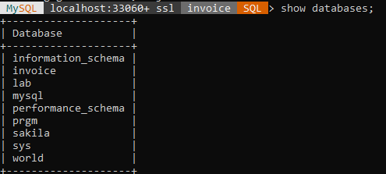

Q2.Create a tables STUDENT with following schema:(id,name,age,city) and describe the table.
MySQL>create table student(id int primary key auto_increment,name varchar(20),age int,city varchar(30));
MySQL>desc student;

Output:
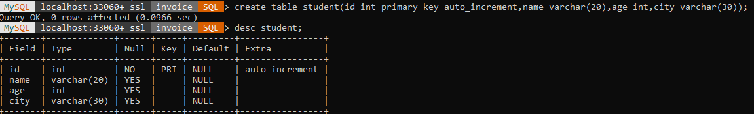

Q3.Add a new column;dob to the existing relation student
MySQL>alter table student add dob date;
MySQL>desc student;
Output:
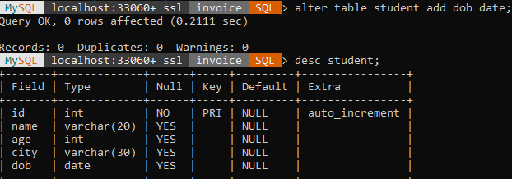

Q4.Modify the dataype of dob from date to year.
MySQL>alter table student modify dob year;
MySQL>desc student;
Output:

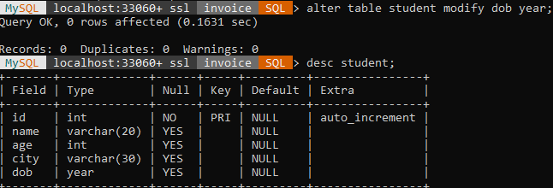

Q5.Delete the column city from the relation student.
MySQL>alter table student drop city;
MySQL>desc student;
Output:
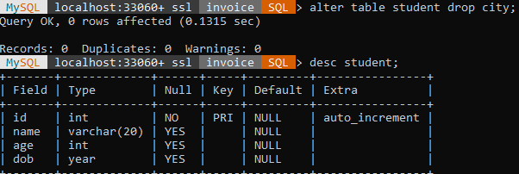

Q6.Create table CUSTOMER {cust_id,address,city,ph_no}
MySQL>create table customer(cust_id int primary key auto_increment,address varchar(30),city varchar(30),ph_no int);
MySQL>desc customer;
Output:
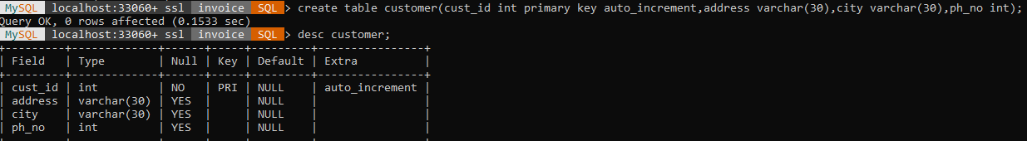

Q7.Create table PRODUCT {p_id,pname,price(default 0)}
MySQL>create table product(p_id int primary key auto_increment,p_name varchar(20),price int
default

Name : REHNA MAJEED | Roll No : 12 | Name of Lab: Web Programming Lab |  | Period : 1,2
Class: S1 , MCA | Nature of Lab Work : Practical |  | Batch : 2025-2027

Experiment - 5

Title:Implementing DCL & TCL Commands of SQL.

Aim:To apply DCL & TCL Commands to impose restrictions on databases.
(a)DCL COMMANDS

Q1.Create two users user1 and user2

MySQL>use invoice;
MySQL>create user user 1@’localhost’identified by’user 1’;
MySQL> create user user 2@’localhost’identified by’user 2’;

Q2.Write SQL Query to give insert and select privilege to user1 on customer table in the invoice database.

MySQL>grant insert,select on invoice.customer to user1@’localhost’;
MySQL>show grants for user1@’localhost’;

Output:
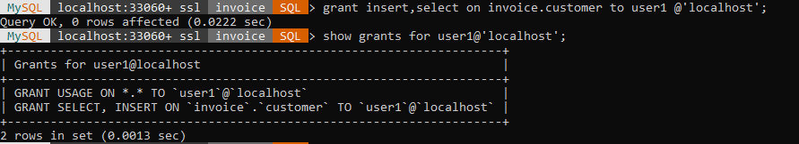

Q3.Write SQL query to give update and delete privilege to user2 on all tables in the invoice database.

MySQL>grant update,delete on invoice.* to user2@’localhost’;
MySQL> show grants for user2@’localhost’;

Output:
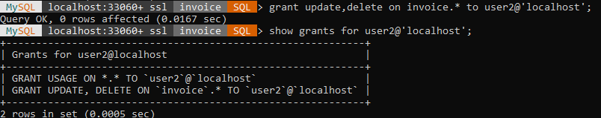

Q4.Write SQL query to remove delete privilege of user2

MySQL>revoke delete on invoice.* from user2@’localhost’;

(b)TCL COMMANDS

Q1.Create another database school and create a table student with attributes id,name and department.

MySQL>create database school;
MySQL>use school;
MySQL>show databases;

Output:

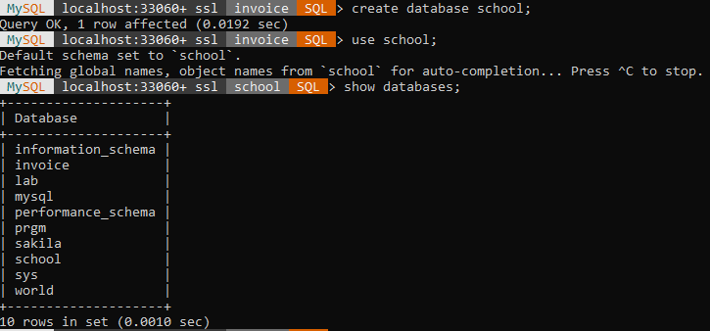

MySQL>Create table student(id int primary key auto_increment,name varchar(20),department varchar(30));
MySQL>desc student;

Output:

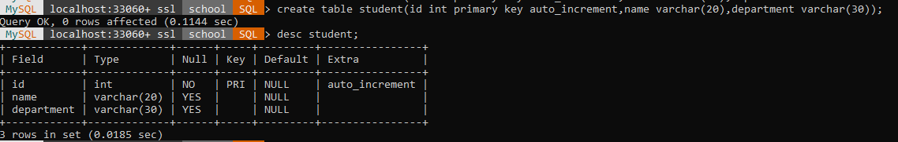

REPORT ON LABORATORY WORK

Name : RIZANA ALAM A | Roll No : 14 | Name of Lab: Web Programming Lab |  | Period :1,2
Class: S1 , MCA | Nature of Lab Work : Practical |  | Batch : 2025-2027

Program - 3

Title: Html Frames

Objectives: Create an Html page with different types of frames such as floating frame, navigation frame & mixed frame.

Input:
message.html
<html>
<body>
<h1> Welcome to iframe</h1>
</body>
</html>

frame.html

<!DOCTYPE html>
<html>
<body>
<h1> Simple iframe</h1>
<iframe src="calender.html" height="50%" width="70%"></iframe>
<h2>Iframe - Target for a Link</h2>
<iframe height="150px" width="60%" src="stringmath.html" name="iframe_a"></iframe>
<p><a href="image.html" target="iframe_a">View logo</a></p>
<h3>Video frame</h3>
<iframe width="550" height="315"
src="https://www.youtube.com/embed/qP23O70ve7k?si=BzAlRdEeLqq4zmB7" frameborder="0"
allow="accelerometer; autoplay; encrypted-media; gyroscope; picture-in- picture"
allow fullscreen style="padding:20px;"></iframe>
</body>
</html>

Output:

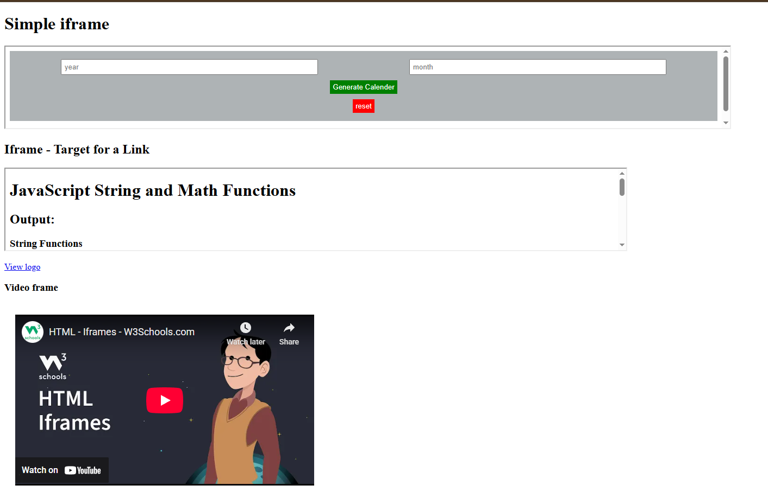

Result/Observations:

Successfully complete the program and output is obtained

Assessor:

REPORT ON LABORATORY WORK

Name : RIZANA ALAM A | Roll No : 14 | Name of Lab: Web Programming Lab |  | Period :5,6
Class: S1 , MCA | Nature of Lab Work : Practical |  | Batch : 2025-2027

Program - 4
Title: Html style sheets

Objectives: Create an Html file by applying the different styles using inline, external and internal style sheets.

Input:

Inline.html

<!DOCTYPE html>
<html>
<body>
<h1 style="color:blue;">A blue heading</h1>
<p style="color:red;">A red paragraph</p>
</body>
</html>

Internal.html

<!DOCTYPE html>
<html>
<head>
<style>
body{
background-color:powderblue;
}
h1 {
color:blue;
}
p{
color:red;
}
</style>
</head>
<body>
<h1>This is a heading</h1>
<p>This is a paragraph</p>
</body>
</html>

External.html

<!DOCTYPE html>
<html>
<head>
<link rel="stylesheet" href="style.css">
</head>
<body>
<h1>This is a heading</h1>
<p>This is a paragraph</p>
</body>
</html>
Style.css

body{
background-color:powderblue;
}
h1 {
color:blue;
}
D{
color:red;
}

Output:







Result/Observations:

Successfully complete the html program and result obtained

Assessor :

REPORT ON LABORATORY WORK

Name : RIZANA ALAM A | Roll No : 14 | Name of Lab: Web Programming Lab |  | Period :1,2
Class: S1 , MCA | Nature of Lab Work : Practical |  | Batch : 2025-2027

Program -5

Title : Registration using html

Objectives: Create a registration form using html.

Input:

<html lang="en">
<head>
</head>
<body>
<form>
<table>
<tr><th colspan="3"><u>Registration Form</u></th><tr>
<tr><td>NAME</td>
<td colspan="2"><input type="text"></td>
</tr>
<tr><td>AGE</td>
<td colspan="2"><select>
<option>SELECT</option>
<option>13</option>
<option>14</option>
<option>15</option>
<option>16</option>
<option>17</option>
<option>18</option>
<option>19</option>
<option>20</option>
<option>21</option>
<option>22</option>
<option>23</option>
<option>24</option>
</select></td></tr>
<tr><td>PASSWORD</td>
<td colspan="2"><input type="password"></td>
</tr>
<tr><td>RETYPE PASSWORD</td>
<td colspan="2"><input type="password"></td>
</tr>
<tr><td rowspan="4">SELECT YOUR SECURITY QUESTION</td>
<td colspan="2"><input type="radio" name="security">What is your pet name?</td>
</tr>
<tr><td colspan="2"><input type="radio" name="security">Who is your best friend?</td>
</tr>
<tr><td colspan="2"><input type="radio" name="security">What is your favourite color?</td>
</tr>
<tr><td colspan="2"><input type="radio" name="security">Who is your favourite teacher?</td>
</tr>
<tr><td>ANSWER OF SECURITY QUESTION</td>
<td colspan="2"><input type="text" ></td>
</tr>
<tr><td>EMAIL ID</td>
<td colspan="2"><input type="email" ></td>
</tr>
<tr><td>LANGUAGES KNOW</td>
<td colspan="2"><input type="checkbox" >MALAYALAM
<input type="checkbox" >ENGLISH
<input type="checkbox" >HINDI</td>
</tr>
<tr><td rowspan="2">PHONE NUMBER</td>
<td>HOME</td>
<td>OFFICE</td>
</tr>
<tr><td><input type="text"></td>
<td colspan="2"><input type="text"></td>
</tr>
<tr><td>UPLOAD CV</td>
<td colspan="2"><input type="file"></td>
</tr>
<tr><td style="text-align:center;"><input type="reset" style="background-color:red;color:white; padding 6px 12px; border:1px solid transparent;"></td>
<td colspan="2" style="text-align:center;"><input type="submit" style="background-
color:green;color:white;padding:6px 12px;border:1px solid transparent;"></td>
</tr>
</table>
</form>
</body>
</html>

Output :

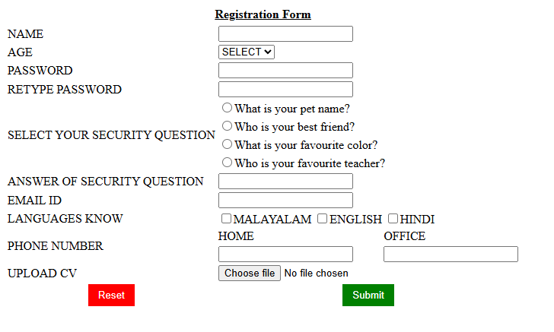

Result/Observations:

Successfully complete the program and output is obtained

Assessor:

REPORT ON LABORATORY WORK

Name : RIZANA ALAM A | Roll No : 14 | Name of Lab: Web Programming Lab |  | Period :5,6
Class: S1 , MCA | Nature of Lab Work : Practical |  | Batch : 2025-2027

Program - 6
Title: Html functions in string and math objects.

Objective: Create an Html page to explain the use of various predefined functions in a string and math object in JavaScript.

Input:

String.html

<!DOCTYPE html>
<html>
<head>
<title>String and Math Functions in JavaScript</title>
</head>
<body>
<h1>JavaScript String and Math Functions</h1>
<h2>Output:</h2>
<script>
// -------- String Functions ---------
var message = "Hello JavaScript";
document.write("<h3>String Functions</h3>");
document.write("Original String: " + message + "<br>");
document.write("Length: " + message.length + "<br>");
document.write("Uppercase: " + message.toUpperCase() + "<br>");
document.write("Lowercase: " + message.toLowerCase() + "<br>");
document.write("Character at index 6: " + message.charAt(6) + "<br>");
document.write("Index of 'Java': " + message.indexOf("Java") + "<br>");
document.write("Substring (6, 16): " + message.substring(6, 16) + "<br>");
document.write("Replace 'JavaScript' with 'World': " + message.replace("JavaScript", "World") + "<br>");
// -------- Math Functions ---------
var num = 9.7;
document.write("<h3>Math Functions</h3>");
document.write("Original Number: " + num + "<br>");
document.write("Round: " + Math.round(num) + "<br>");
document.write("Floor: " + Math.floor(num) + "<br>");
document.write("Ceil: " + Math.ceil(num) + "<br>");
document.write("Square root of 25: " + Math.sqrt(25) + "<br>");
document.write("2 to the power 3: " + Math.pow(2, 3) + "<br>");
document.write("Max of (10, 20, 5): " + Math.max(10, 20, 5) + "<br>");
document.write("Min of (10, 20, 5): " + Math.min(10, 20, 5) + "<br>");
document.write("Random number (0 to 1): " + Math.random() + "<br>");
</script>
</body>
</html>

Output:

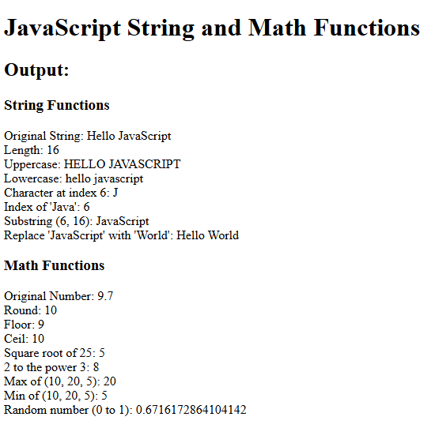

Result/Observations:

Successfully complete the program and output is obtained.

Assessor:

REPORT ON LABORATORY WORK

Name : RIZANA ALAM A | Roll No : 14 | Name of Lab: Web Programming Lab |  | Period :5,6
Class: S1 , MCA | Nature of Lab Work : Practical |  | Batch : 2025-2027

Program - 7
Title: Generate a calender using javascript

Objectives: Generate the calender using JavaScript code and by getting the year from the user.

Input:
<html lang="en">
<head>
<meta charset="UTF-8">
<meta name="viewport" content="width=device-width, initial-scale=1.0">
<title>Calender</title>
<style>
.selection {
text-align: center;
margin-bottom: 2em;
background-color: rgb(174, 179, 181);
width: 100%;
}
#year_get,
#month_get {
padding: 5px;
width: 75%;
}
input {
padding: 5px;
}
.tabselection {
margin-left: auto;
margin-right: auto;
width: 100%;
}
table {
padding: 5px;
}
.selrow {
border: none;
}
td,
th {
padding: 10px;
border: 1px solid black;
}
.selcol {
padding: 0px;
border: none;
text-align: center;
}
#calender {
border-collapse: collapse;
margin-left: auto;
margin-right: auto;
}
#resetbtn {
background-color: red;
border: none;
color: white;
}
#subtn {
background-color: green;
border: none;
color: white;
}
</style>
</head>
<body>
<div class="selection">
<table class="tabselection" cellspacing="10">
<tbody>
<tr class="selrow">
<td class="selcol"><input id="year_get" type="number" placeholder="year">
</td>
<td class="selcol"><input id="month_get" type="number" placeholder="month"> </td>
</tr>
<tr class="selrow">
<td colspan="2" class="selcol"><input onclick="generate()" type="button" id="subtn"
value="Generate Calender"> </td>
</tr>
<tr class="selrow">
<td colspan="2" class="selcol"><input type="reset" value="reset" id="resetbtn"
onclick="location.reload();"> </td>
</tr>
</tbody>
</table>
</div>
<div id="content"> </div>
</body>
<script>
function generate() {
var init_content = "<table BORDER=1 id='calender'><tr><th>SUN</th><th>MON</th><th>TUE</th><th>WED</th><th>THU</th><th>
FRI</th><th>SAT</th></tr>"
var year_get = document.getElementById("year_get").value;
var month_get = document.getElementById("month_get").value;
month_get -= 1;
var date = new Date(year_get, month_get);
var day = date.getDay();
for (var i = 0; i < day; i++) {
init_content += "<td></td>";
}
while (date.getMonth() == month_get) {
init_content += "<td>" + date.getDate() + "</td>";
if (date.getDay() % 7 == 6) {
init_content += "</tr><tr>";
}
date.setDate(date.getDate() + 1);
}
while (date.getDay() % 7 != 6 && date.getDay() % 7 != 0) {
init_content += "<td></td>";
date.setDate(date.getDate() + 1);
} if (date.getDay() % 7 > 0) {
init_content += "<td></td></tr>";
} init_content += "</table>"
document.getElementById("content").innerHTML = init_content;
}
</script>
</html>

Output:

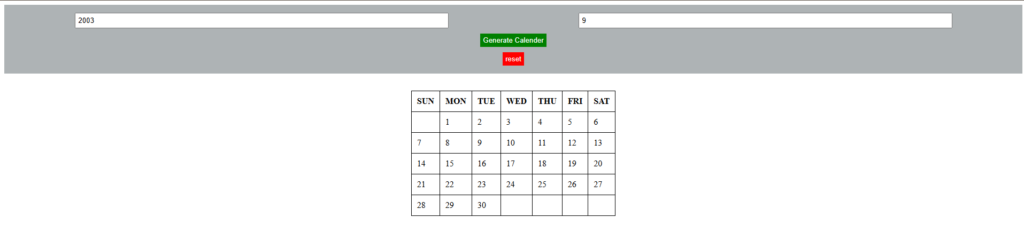

Result/Observations:

Successfully complete the program and output is obtained

Assessor :

REPORT ON LABORATORY WORK
Name : RIZANA ALAM A | Roll No : 14 | Name of Lab: Web Programming Lab |  | Period :1,2
Class: S1 , MCA | Nature of Lab Work : Practical |  | Batch : 2025-2027

Program - 8
Title : Html registration form with validation using JavaScript

Objectives : Create HTML registration form and to validate the form using JavaScript

Input :

<html>
<head>
<title>Welcome To Login Form</title>
<script>
function login()
{
var uname=document.getElementById("email").value;
var pwd=document.getElementById("pwd1").value;
var filter=/^([a-zA-Z0-9_\.\-])+\@(([a-zA-Z0-9\-])+\.)+([a-zA-Z0-9]{2,4})+$/;
if(uname =="")
{
alert("Please enter user name.");
}
else if(pwd=="")
{
alert("Enter the password");
}
else if(!filter.test(uname))
{
alert("Enter valid email id.");
}
else if(pwd.length<6||pwd.length>6)
{
alert("password min and max length is 6.");
}
else
{
alert("Login Success");
}
}
function clearFunc()
{
document.getElementById("email").value="";
document.getElementById("pwd1").value="";
}
</script>
</head>
<body>
<div id="main">
<div class="h-tag">
<h2 align="center">Welcome To My Account Login</h2>
</div>
<div class="login">
<table cellspacing="2" align="center" cellpadding="8" border="0">
<tr>
<td>Enter User Name:</td>
<td><input type="text" placeholder="Enter user name here." id="email"
class="tb"/></td>
</tr>
<tr>
<td>Enter Password:</td>
<td><input type="text" placeholder="Enter password here." id="pwd1"
class="tb"/></td>
</tr>
<tr><td></td>
<td>
<input type="submit" value="Reset" onClick="clearFunc()" class="btn"/>
<input type="submit" value="Login" class="btn" onClick="login()"/></td></tr>
</table>
</div>
</div>
</body>
</html>

Output :

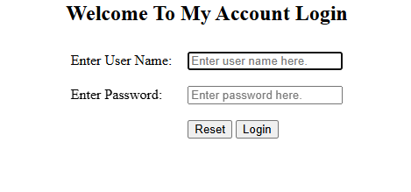

Result/Observations :

Successfully complete the program and output is obtained

Assessor :

REPORT ON LABORATORY WORK

Name : RIZANA ALAM A | Roll No : 14 | Name of Lab: Web Programming Lab |  | Period :5,6
Class: S1 , MCA | Nature of Lab Work : Practical |  | Batch : 2025-2027

Program - 9

Title : JavaScript program for background color change

Objectives : Create a html page to change the background color for every click of a button using JavaScript Event Handling.

Input :

<html>
<head>
<title>Change the Background Color with JavaScript</title>
<script>
function changeBodyBg(color)
{
document.body.style.background = color;
}
</script>
</head>
<body>
<h1>Welcome to my page</h1>
<label>Change Webpage Background To:</label>
<button type="button" onclick="changeBodyBg('yellow');">Yellow</button>
<button type="button" onclick="changeBodyBg('lime');">Lime</button>
<button type="button" onclick="changeBodyBg('orange');">Orange</button>
</body>
</html>

Output:

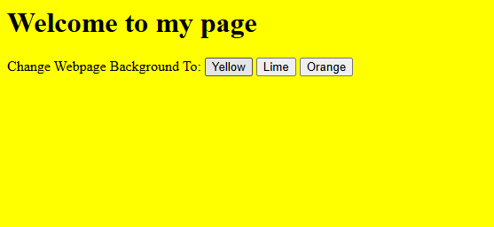

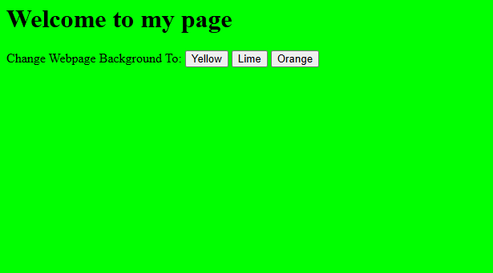

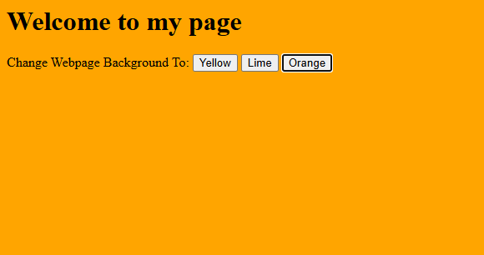

Result/Observations :

Successfully complete the program and output is obtained

Assessor

REPORT ON LABORATORY WORK

Name : RIZANA ALAM A | Roll No : 14 | Name of Lab: Web Programming Lab |  | Period :5,6
Class: S1 , MCA | Nature of Lab Work : Practical |  | Batch : 2025-2027

Program - 10

Title : JavaScript program for display image and text

Objectives : Create a html page to display a new image and text when the mouse comes over the existing content in the page using JavaScript Event Handling.

Input :

<html>
<body>
<div class="row">
<div class="content" id="content">
<img src="https://1.bp.blogspot.com/_YeRlr6-knEw/TNGlaLotLwI/AAAAAAAAAY8/Ns-oscDRN_o/s1600/flower-17.jpg" id="image"><br><br>
<div class="data"><hl id="heading1">Over mouse here.....</h1>
<h1 id="heading2">hi hello world...</h1>
</div>
</div>
</div>
<script>
document.getElementById("content").addEventListener("mouseover",changel);
document.getElementById("content").addEventListener("mouseout",change2);
function changel(){
document.getElementById("image").src="https://1.bp.blogspot.com/_YeRlr6-knEw/TNGlaLotLwI/AAAAAAAAAY8/Ns-oscDRN_o/s1600/flower-17.jpg";
document.getElementById("heading1").style.display="none";
document.getElementById("heading2").style.display="block";
}
function change2(){
document.getElementById("image").src="https://wallpapers.com/images/hd/flower-4m1wqixhpt6td6en.jpg";
document.getElementById("heading1").style.display="block";
document.getElementById("heading2").style.display="none";
}
</script>
</body>
</html

Output:




Result/Observations :

Successfully complete the program and output is obtained

Assessor :

REPORT ON LABORATORY WORK

Name : RIZANA ALAM A | Roll No : 14 | Name of Lab: Web Programming Lab |  | Period :5,6
Class: S1 , MCA | Nature of Lab Work : Practical |  | Batch :

Program - 11

Title : Online exam using JavaScript

Objectives : Create html page to show online exam using JavaScript.

Input :

<html>
<head>
<title>Exam</title>
<script language="javascript"> function exam(form)
{
var i=0;
if(form.one[2].checked) i=i+1;
if(form.three[0].checked) i=i+1;
if(form.four[0].checked) i=i+1;
if(form.five[1].checked) i=i+1;
window.alert("Thank You For Taking This Online Exam!!!! Your Score is: "+i);
}
</script>
</head>
<body bgcolor=silver>
<form onSubmit="exam(this)">
<center><h1><blink>WELCOME TO ONLINE EXAM FORM</blink></h1></center>
<p>
<h1>1)Which is platform independent language</h1>
<input type="radio" name="one" value="c++">
<label>c++</label>
<input type="radio" name="one" value="c">
<label>c</label>
<input type="radio" name="one" value="java">
<label>java</label>
<input type="radio" name="one" value="basic">
<label>BASIC</label>
</p>
<p>
<h1>2) Which is class of all class in java</h1>
<input type="radio" name="three" value="object">
<label>Object</label>
<input type="radio" name="three" value="math">
<label>Math</label>
<input type="radio" name="three" value="system">
<label>System</label>
<input type="radio" name="three" value="graphic">
<label>Graphic</label>
</p>
<p>
<h1>3)Frame package is in which package</h1>
<input type="radio" name="four" value="awt">
<label>AWT</label>
<input type="radio" name="four" value="applet">
<label>Applet</label>
<input type="radio" name="four" value="lang">
<label>Lang</label>
<input type="radio" name="four" value="swing">
<label>Swing</label>
</p>
<p>
<h1>4)Java does not support</h1>
<input type="radio" name="five" value="inheritance">
<label>Inheritance</label>
<input type="radio" name="five" value="multiple inheritance">
<label>Multilple inheritance</label>
<input type="radio" name="five" value="polymorphism">
<label>Polymorphism</label>
<input type="radio" name="five" value="encryption">
<label>Encryption</label>
</p>
<p>
<center>
<input type="submit" value="Submit">
<input type="reset" value="Reset">
</center>
</p>
</body>
</html>

Output:
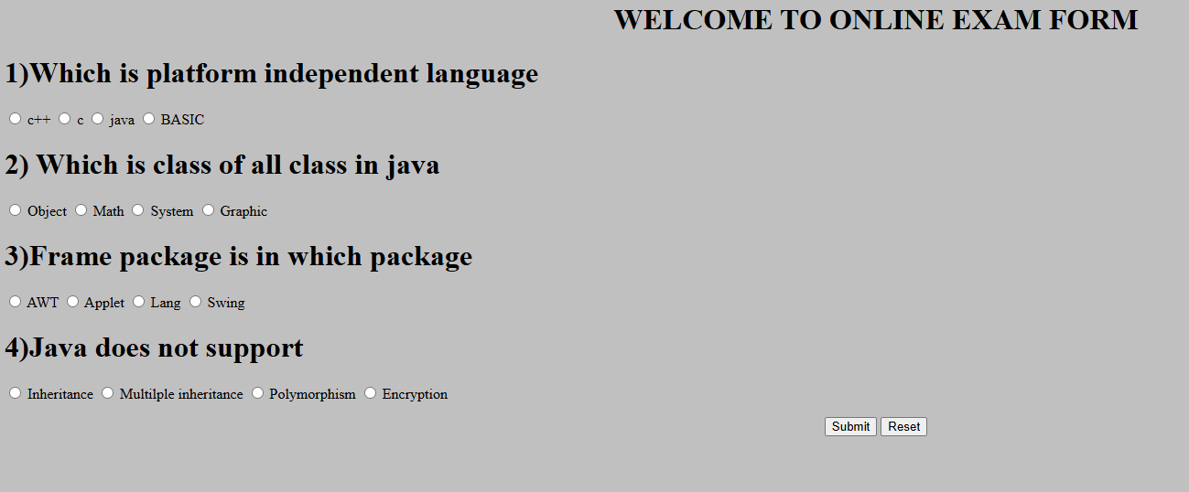

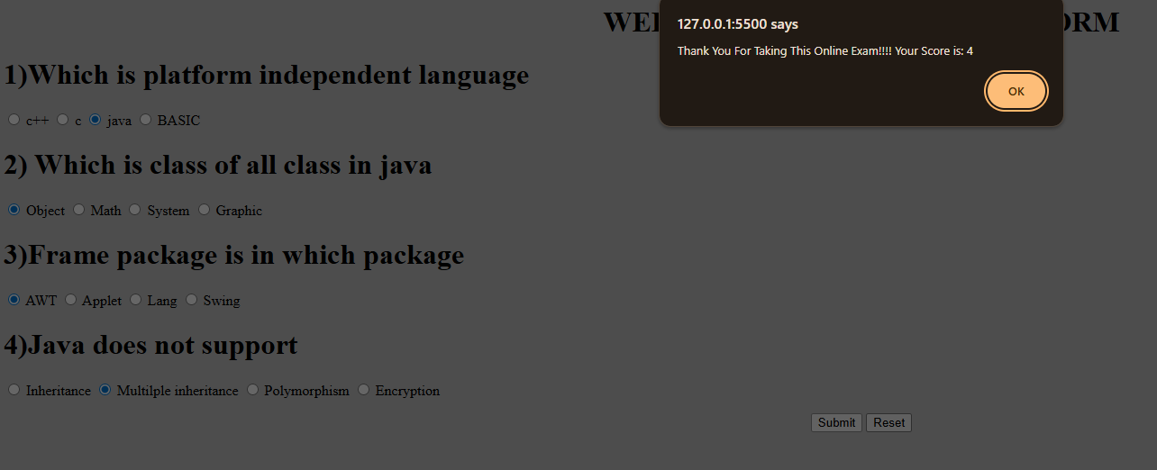

Result/Observations :

Successfully complete the program and output is obtained

Assessor :

REPORT ON LABORATORY WORK

Name : RIZANA ALAM A | Roll No : 14 | Name of Lab: Web Programming Lab |  | Period :5,6
Class: S1 , MCA | Nature of Lab Work : Practical |  | Batch :

Program - 12
Title : Create a registration form using Php and do neccessary validation

Input :

<!DOCTYPE html>
<html>
<head>
<title>Registration Form</title>
</head>
<body>
<h2>Registration Form</h2>
<?php
$name = $email = $password = $phone = "";
$nameErr = $emailErr = $passErr = $phoneErr = "";
if ($_SERVER["REQUEST_METHOD"] == "POST") {
if (empty($_POST["name"])) {
$nameErr = "Name is required";
} else {
$name = $_POST["name"];
}
if (empty($_POST["email"])) {
$emailErr = "Email is required";
} elseif (!filter_var($_POST["email"], FILTER_VALIDATE_EMAIL)) {
$emailErr = "Invalid email format";
} else {
$email = $_POST["email"];
}
if (empty($_POST["password"])) {
$passErr = "Password is required";
} elseif (strlen($_POST["password"]) < 6) {
$passErr = "Password must be at least 6 characters";
} else {
$password = $_POST["password"];
}
if (empty($_POST["phone"])) {
$phoneErr = "Phone number is required";
} elseif (!preg_match("/^[0-9]{10}$/", $_POST["phone"])) {
$phoneErr = "Phone number must be 10 digits";
} else {
$phone = $_POST["phone"];
}
if ($nameErr == "" && $emailErr == "" && $passErr == "" && $phoneErr == "") {
echo "<h3 style='color:green;'>Registration Successful!</h3>";
echo "Name: $name <br>";
echo "Email: $email <br>";
echo "Phone: $phone <br>";
}
}
?>
<form method="post" action="">
Name: <input type="text" name="name" value="<?php echo $name; ?>"><br>
<span style="color:red;"><?php echo $nameErr; ?></span><br>
Email: <input type="text" name="email" value="<?php echo $email; ?>"><br>
<span style="color:red;"><?php echo $emailErr; ?></span><br>
Password: <input type="password" name="password"><br>
<span style="color:red;"><?php echo $passErr; ?></span><br>
Phone: <input type="text" name="phone" value="<?php echo $phone; ?>"><br>
<span style="color:red;"><?php echo $phoneErr; ?></span><br>
<input type="submit" value="Register">
</form>
</body>
</html>

Output:

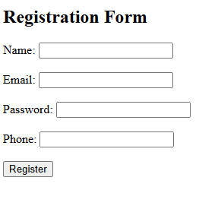
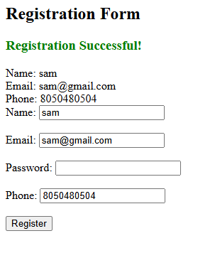

Result/Observations :

Successfully complete the program and output is obtained

Assessor :

REPORT ON LABORATORY WORK

Name : RIZANA ALAM A | Roll No : 14 | Name of Lab: Web Programming Lab |  | Period :5,6
Class: S1 , MCA | Nature of Lab Work : Practical |  | Batch :

Program - 13
Title : Electricity bill using Php

Objective : Compose electricity bill from user input based on a given tariff using Php.

Input :

<!DOCTYPE html>
<html lang="en">
<head>
<meta charset="UTF-8">
<meta name="viewport" content="width=device-width, initial-scale=1.0">
<title>Electricity Bill</title>
</head>
<body>
<h1>Electricity Bill</h1>
<form method="post" action="#">
Consumer ID: <input type="number" name="id" required><br>
Name: <input type="text" name="name" required><br>
Previous Reading: <input type="number" name="prev" required><br>
Present Reading: <input type="number" name="pres" required><br><br>
<input type="submit" value="Calculate">
</form>
<?php
if($_SERVER["REQUEST_METHOD"] == "POST"){
$id = $_POST["id"];
$name = $_POST["name"];
$prev = $_POST["prev"];
$pres = $_POST["pres"];
$units = $pres - $prev;
echo "<hr>";
echo "<h3>Kerala State Electricity Board (KSEB)</h3>";
echo "<p>Consumer ID: $id</p>";
echo "<p>Consumer Name: $name</p>";
echo "<p>Units Consumed: $units</p>";
if ($units <= 100) {
$amt = $units * 3;
}
elseif ($units > 100 && $units <= 200) {
$amt = $units * 4;
}
elseif ($units > 200 && $units <= 300) {
$amt = $units * 5;
}
else {
$amt = $units * 6;
}
echo "<h4>Total Amount: Rs. $amt</h4>";
}
?>
</body>
</html>

Output:

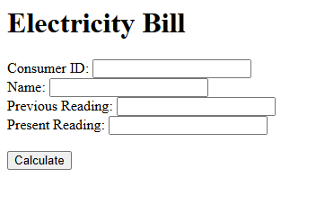

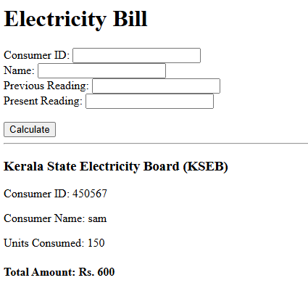

Result/Observations :

Successfully complete the program and output is obtained

Assessor :

REPORT ON LABORATORY WORK

Name : RIZANA ALAM A | Roll No : 14 | Name of Lab: Web Programming Lab |  | Period :5,6
Class: S1 , MCA | Nature of Lab Work : Practical |  | Batch :

Program – 14
Title : Php code to store name of students

Objectives : Build a Php code to store name of students in an array and display it usig print_r function .sort and display the same using assort and arsort functions.

Input :

<!DOCTYPE html>
<html lang="en">
<head>
<meta charset="UTF-8">
<!DOCTYPE html>
<html lang="en">
<head>
<meta charset="UTF-8">
<meta name="viewport" content="width=device-width, initial-scale=1.0">
<title>hello world</title>
</head>
<body>
<?php
$studentname=array("anandhu","joel","arjun","athul");
$studentmark=array("98","98","98","98");
$student=array_combine($studentname,$studentmark);
echo"<br>Displaying names in table format<br/>";
echo"<br>=================================<br/>";
echo"<br>Names of students are stored in an array:<br/>";
print_r($student);
echo"<br>Names of students are stored in a table:<br/>";
echo"<br><table border=2>";
echo"<tr><th>student names</th>";
echo"<td>$studentname[0]</td>";
echo"<td>$studentname[1]</td>";
echo"<td>$studentname[2]</td>";
echo"<td>$studentname[3]</td>";
echo"<tr><th>student mark</th>";
echo"<td>$studentmark[0]</td>";
echo"<td>$studentmark[1]</td>";
echo"<td>$studentmark[2]</td>";
echo"<td>$studentmark[3]</td>";
echo"</tr></table>";
?>
</body>
</html>

Output:

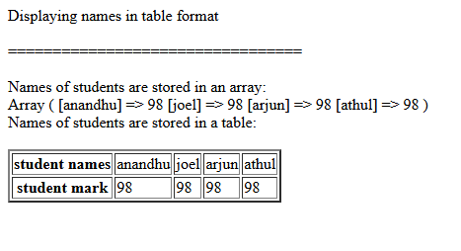

Result/Observations :

Successfully complete the program and output is obtained

Assessor :

REPORT ON LABORATORY WORK

Name : RIZANA ALAM A | Roll No : 14 | Name of Lab: Web Programming Lab |  | Period :1,2
Class: S1 , MCA | Nature of Lab Work : Practical |  | Batch :

Program - 15
Title : Php code to display the Cricket players name

Objectives : Build a Php code to store the name of Indian cricket players in an array and display the same in html table

Input :

<html lang="en">
<head>
<meta charset="UTF-8">
<meta name="viewport" content="width=device-width, initial-scale=1.0">
<title>hello world</title>
</head>
<body>
<?php
$cricket=array("Sachin Tendulkar", "Virat Kohli", "M S Dhoni", "Adam Gilchrist", "Brian Lara");
echo"<br>Displaying names in the table format<br/>";
echo"<br>================================<br/>";
echo"<br>Name of cricket players are stored in an array<br/>";
print_r($cricket);
echo"<br>Name of cricket players are stored in a table:<br/>";
echo"<br><table border='2'><tr><th>Player Names</th></tr>";
echo"<tr><td>$cricket[0]</td></tr>";
echo"<tr><td>$cricket[1]</td></tr>";
echo"<tr><td>$cricket[2]</td></tr>";
echo"<tr><td>$cricket[3]</td></tr>";
echo"</table>";
?>
</body>
</html>

Output:

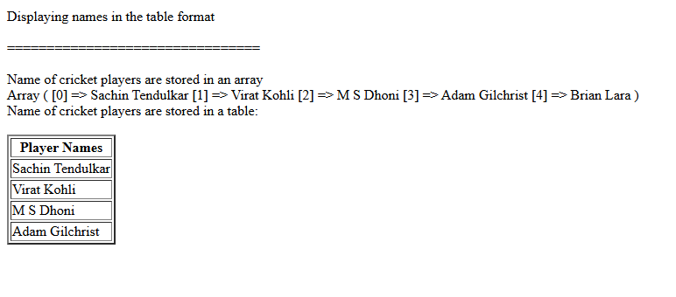

Result/Observations :

Successfully complete the program and output is obtained

Assessor :

REPORT ON LABORATORY WORK

Name : RIZANA ALAM A | Roll No : 14 | Name of Lab: Web Programming Lab |  | Period :5,6
Class: S1 , MCA | Nature of Lab Work : Practical |  | Batch :

Program - 16

Title : Php using database connection

Objectives : Develop a Php program to connect to a database and retrieve data from a table and show the

details in a neat format

Input :

Emp.php:

<!DOCTYPE html>
<html>
<head>
<title>Insert Page page</title>
</head>
<body>
<center>
<form name="newform" method="post" action="insert.php">
<h2>TO ADD DATA:<input type="submit" name="submit1" value="BACK"></h2>
</form>
<?php
$servername="localhost";
$username="root";
$password="";
$dbname="empdb";
$tbname="emp";
$conn = mysqli_connect($servername, $username, $password, $dbname);
if(!$conn)
{
die("Connection failed".mysqli_connect_error());
}
else
{
echo "<br><h2 align=center>EMPLOYEE DETAILS</h2><br/>";
}
$sql = "SELECT * FROM emp";
$res = mysqli_query($conn, $sql);
if(mysqli_num_rows($res) > 0)
{
echo "<table border='2' align='center'>";
echo "<tr><th>Employee ID</th>";
echo "<th>Employee Name</th>";
echo "<th>Department</th>";
echo "<th>Salary</th></tr>";
while($row = mysqli_fetch_assoc($res))
{
echo "<tr><td>".$row['eid']."</td>";
echo "<td>".$row['ename']."</td>";
echo "<td>".$row['dept']."</td>";
echo "<td>".$row['sal']."</td></tr>";
}
echo "</table>";
}
else
{
echo "0 results";
}
mysqli_close($conn);
?>
</center>
</body>
</html>

Insert.php:

<html>
<head>
<title>Employee form</title>
<meta http-equiv="Content-type" content="text/html;charset=UTF-8">
</head>
<body>
<center>
<form name="empform" method="post" action="add.php">
<h2 align="center">EMPLOYEE DETAILS</h2>
<table border="2" align="center">
<tr>
<td>Name:</td>
<th><input type="text" name="ename" value=""></th>
</tr>
<tr>
<td>ID:</td>
<th><input type="number" name="eid" value=""></th>
</tr>
<tr>
<td>Department:</td>
<td><input type="text" name="dept" value=""></td>
</tr>
<tr>
<td>Salary:</td>
<td><input type="number" name="sal" value=""></td>
</tr>
<tr>
<td><input type="submit" name="submit" value="SUBMIT"></td>
</tr>
</table>
</form>
<form name="newform" method="post" action="emp.php">
<h2>TO DISPLAY INSERTED DATA:
<input type="submit" name="submit" value="DISPLAY"></h2>
</form>
</center>
</body>
</html>

Add.php:

<!DOCTYPE html>
<html>
<head>
<title>Insert Page page</title>
</head>
<body>
<center>
<form name="newform" method="post" action="insert.php">
<h2>TO ADD DATA:<input type="submit" name="submit1" value="BACK"></h2>
</form>
<?php
$servername="localhost";
$username="root";
$password="";
$dbname="empdb";
$tbname="emp";
$conn = mysqli_connect($servername, $username, $password, $dbname);
if(!$conn)
{
die("Connection failed".mysqli_connect_error());
}
else
{
echo "<br><h2 align=center>EMPLOYEE DETAILS</h2><br/>";
}
$sql = "SELECT * FROM emp";
$res = mysqli_query($conn, $sql);
if(mysqli_num_rows($res) > 0)
{
echo "<table border='2' align='center'>";
echo "<tr><th>Employee ID</th>";
echo "<th>Employee Name</th>";
echo "<th>Department</th>";
echo "<th>Salary</th></tr>";
while($row = mysqli_fetch_assoc($res))
{
echo "<tr><td>".$row['eid']."</td>";
echo "<td>".$row['ename']."</td>";
echo "<td>".$row['dept']."</td>";
echo "<td>".$row['sal']."</td></tr>";
}
echo "</table>";
}
else
{
echo "0 results";
}
mysqli_close($conn);
?>
</center>
</body>
</html>

Output:

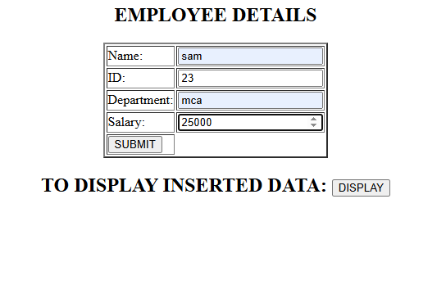
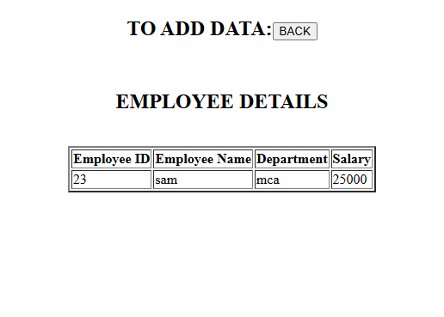

Result/Observations :

Successfully complete the program and output is obtained

Assessor :

