ADBMS 3rd Program Outputs
Output1
List all customer details
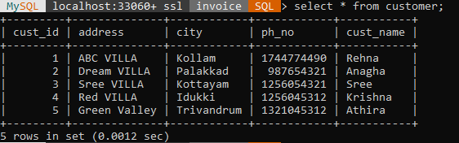
Output2
List p_name,price of all products
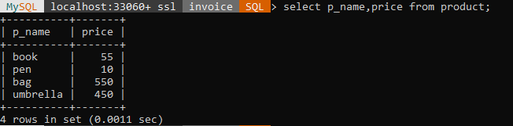
Output3
List all invoice_item,avoid duplicates
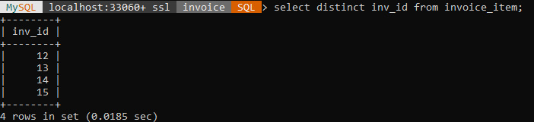
Output4
List product price between 400 rupees and 600 rupees
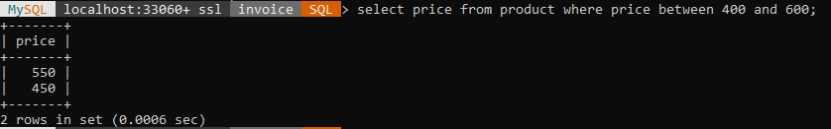
Output5
List the customer details who lives in ‘kollam’,’kottayam’
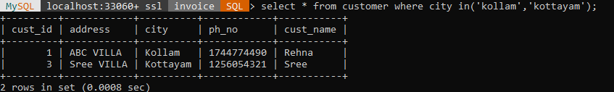
Output6
List the invoice details from 2021-02-22,2021-04-20
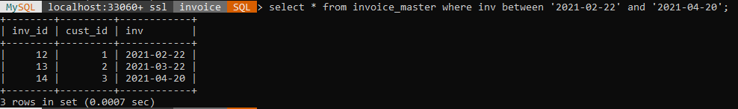
Output7
List the customer details who not live in ‘kollam’
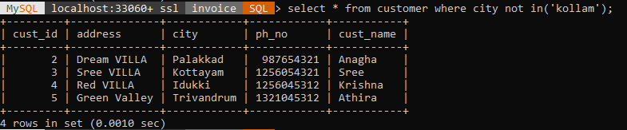
Output8
List the details of customer whose phone number is ‘1744774490’
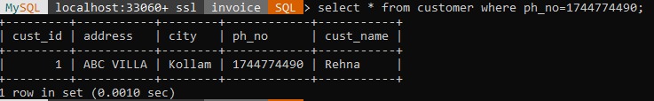
Output9
Display customer names in descending order
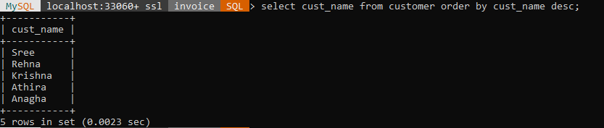
Output10
Display the customer details sorted in ascending by city
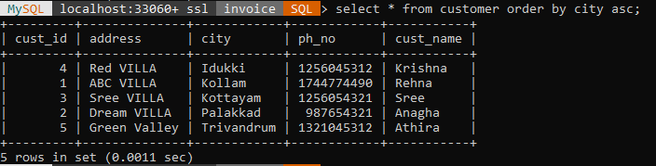
Output11
Find the customer names start with ‘S’
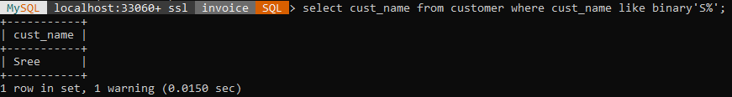
Output12
Find the customer name who have ‘i’ or ‘e’ in them
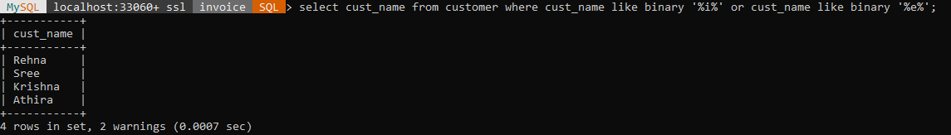

Output13
Find the customer names who have atleast 4 character
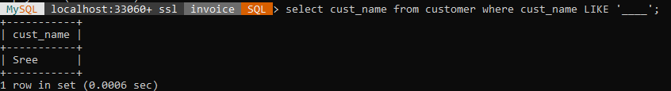
Output14
List the names of character their names have ‘t’ in second position
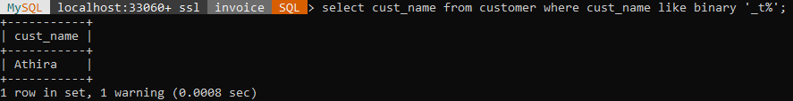
Output15
Find the customer name start with ‘R’ and are atleast 4 character in length
