ADBMS 4th Program Outputs
Output1
List product name,price except pen on price order
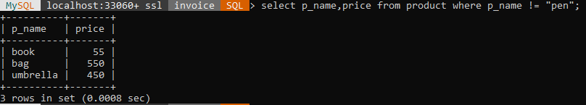
Output2
Find min,max and average price of product
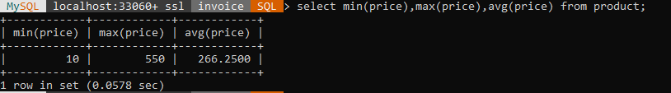
Output3
Find number of customers in each city
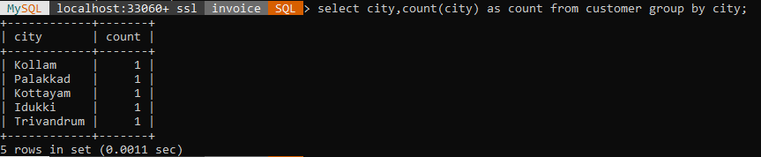
Output4
Show data as displayed ‘who,where’ eg:’customer1 lives in kollam’
