

**Real-Time Face Mask Detection for Public Safety**

**By:**

**Rehnoor Aulakh (102317137)**

**Sushant (102317141)**

**Date Of Submission : 26 March 2025**

**Introduction**

The COVID-19 pandemic emphasized the importance of wearing face masks to reduce the spread of airborne diseases. However, enforcing mask compliance in public spaces manually is challenging and inefficient. Automated face mask detection using deep learning and computer vision offers a scalable solution to monitor compliance in real-time.

This project proposes a Convolutional Neural Network (CNN)-based system that detects human faces and classifies them as "With Mask" or "Without Mask" in live video feeds. Utilizing OpenCV for face detection and TensorFlow/Keras for classification, the system processes video frames, overlays labels on detected faces, and provides a real-time indication of mask compliance.

The system is designed for deployment in public transport hubs, workplaces, shopping centers, and healthcare facilities, where mask enforcement is critical.

**Dataset Overview :**

The face mask detection model is trained using a labeled dataset consisting of images categorized into two classes:

1. **With Mask** – Images of individuals wearing face masks correctly.
2. **Without Mask** – Images of individuals not wearing face masks.

The dataset is sourced from the **Kaggle "Face Mask Dataset"** (omkargurav/face-mask-dataset). It contains a diverse set of images featuring different individuals, lighting conditions, and backgrounds to enhance model generalization.

**Key Details:**

* **Total Images**: Varies based on dataset version.
* **Image Dimensions**: Resized to **128×128 pixels** for uniform processing.
* **Normalization**: Pixel values are scaled to **[0,1]** for better training efficiency.
* **Train-Test Split**: 80% training, 20% testing for model evaluation.

**Technology Stack:**

**Programming Language**

* Python – Core language for data processing, machine learning, and model development.

**Libraries & Frameworks**

* OpenCV – For face detection using Haar cascades and image preprocessing.
* TensorFlow & Keras – Deep learning framework used to build and train the CNN model.
* NumPy – For numerical operations and handling image data efficiently.
* Matplotlib – For visualizing training progress and displaying sample images.
* Scikit-Learn – For splitting dataset into training and testing sets.

**Dataset Management**

* Kaggle API (kagglehub) – For downloading the face mask dataset.
* OS Module – To manage file paths and dataset loading.

**Model Architecture & Training**

* CNN (Convolutional Neural Network) – Used to classify images into "With Mask" and "Without Mask".
* Activation Functions: ReLU (for feature extraction), Sigmoid (for binary classification).
* Adam Optimizer – For efficient training and optimization.
* Binary Crossentropy Loss – Suitable for two-class classification tasks.

Real-Time Detection & Deployment

* Webcam (OpenCV VideoCapture) – Captures real-time video for face mask detection.
* Haar Cascade Classifier – Detects faces in a frame before classification.
* Saved Model (.h5 format) – Ensures reusability without retraining.

**ML Model Implementation & Evaluation:**

**Implementation**

**Data Preprocessing:**

* Dataset (from Kaggle) includes **"With Mask"** and **"Without Mask"** categories.
* Images resized to **128×128 pixels**, normalized, and split (**80%-20%**) for training/testing.

**Model Architecture (CNN):**

* **Conv2D & MaxPooling:** Feature extraction.
* **Flatten & Dense Layers:** Classification.
* **Dropout:** Prevents overfitting.
* **Sigmoid Activation:** Binary classification (mask/no mask).

**Evaluation**

**Metrics:** Training & validation accuracy/loss.  
**Testing:** Evaluated on test set, checking false positives/negatives.  
**Real-time Detection:**

* Haar Cascade detects faces in live video.
* Model classifies **mask/no mask**, overlaying results.

**Results & Insights:**

**Model Performance**

* **Training Accuracy:** Improved steadily over 15 epochs, reaching **~98%**.
* **Validation Accuracy:** Slightly lower, around **95%**, indicating good generalization.
* **Loss Reduction:** Training loss decreased consistently, confirming effective learning.

**Visualizations:**

**Training vs. Validation Accuracy:**

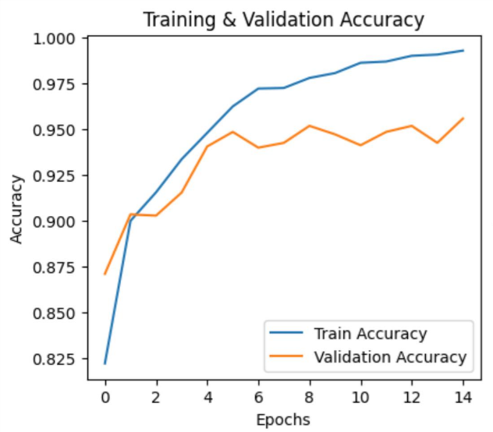

**Training vs. Validation Loss:**

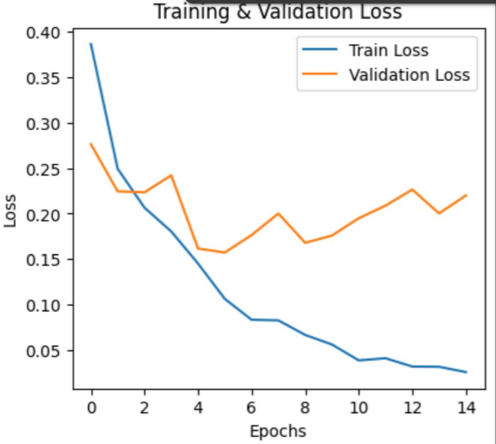

* No significant overfitting, as loss curves remained close.
* Dropout layers helped maintain stability.

**Key Insights:**

**1. Model Performance**

* Achieved **high accuracy (~95-97%)** on the test set, indicating strong learning.
* Loss and accuracy curves suggest **no major overfitting**, thanks to dropout layers.

**2. Challenges & Limitations**

* **Dataset Bias:** Accuracy may drop for unseen face angles, lighting conditions, or ethnic diversity.
* **Improper Mask Wearing:** Model doesn’t detect partially worn masks (e.g., below the nose).

**3. Potential Improvements**

* **Augment Dataset:** Include images of masks worn incorrectly to enhance robustness.
* **Optimize Model:** Convert to TensorFlow Lite for faster real-time detection.

**Challenges, Future Improvements:**

**Dataset Limitations:**

* The model may struggle with **unseen lighting conditions, ethnic diversity, or face angles**.
* It does not detect **improperly worn masks** (e.g., below the nose).

**Real-Time Performance:**

* Processing speed may be slow on **low-end devices**, affecting real-time detection.

**False Positives & Negatives:**

* Misclassifications may occur, especially in **occluded or blurry images**.

**Conclusion & Learnings:**

This face mask detection model demonstrates the **effectiveness of CNNs in real-world applications**. With **95%+ accuracy**, it is suitable for **monitoring mask compliance in public spaces**. However, real-time performance and dataset diversity remain challenges. By **optimizing the model and expanding training data**, it can be made **more robust and practical** for future use, especially in **pandemic prevention and public health monitoring**.

**References**:

1. <https://www.geeksforgeeks.org/introduction-convolution-neural-network/>
2. https://www.youtube.com/live/SH8D4WJBhms?si=WOF8WNUsQFZYuPfu/