

*"Your Gateway to Smarter Property Deals"*

Real Estate Platform

Feasibility Study Report

**Submitted to**

Sultana Tasnim Jahan

Assistant Lecturer

Dept. of CSE , IIUC

Course Title : Software Engineering Lab

Course Code ; CSE-3638

Semester : 6th Section : 6CF

**Submitted by**

* Nahian Subah Ishma_C223286
* Rehnuma Tasneem_C223288
* Saima Kawsar_C223297

**DEPARTMENT OF COMPUTER SCIENCE & ENGINEERING**

**INTERNATIONAL ISLAMIC UNIVERSITY CHITTAGONG**

|  |  |
| --- | --- |
|  |  |

**Table of Contents**

01.Introduction 1

02.Background 2

03.System Outline 2

04.Methodology: 5

05.Overview of Alternatives 6

5.1 Economic Feasibility Study for the alternatives : 7

5.2 Technical Feasibility Study for the alternatives : 11

5.3 Operational Feasibility Study for the alternatives : 11

06. Recommendation 12

07.Conclusion 13

## **01.Introduction**

In today's digital world, managing real estate properties has become more complicated. Property owners, managers, and tenants face challenges in handling tasks, communicating, and managing finances. A real estate management website can help solve these issues by making property-related processes easier, faster, and more organized.

The goal of this study is to determine whether developing a user-friendly, secure, and efficient real estate management website is possible. The website will include features like property listings, tenant communication, maintenance requests, online payments, and financial reports. By automating these tasks, it can help businesses save time, reduce costs, and improve tenant satisfaction. The study will also look at costs, maintenance, target users, competition, risks, and possible benefits.

This feasibility report is divided into seven sections. Section 2 explains the background of the study. Section 3 gives an overview of the platform and its features. Section 4 describes the methods used for the study. Section 5 discusses different solutions. Section 6 provides the conclusion, and Section 7 presents recommendations based on the findings.

# **02.Background**

A real estate management website is a platform that helps manage, buy, sell, and lease properties more easily. It usually includes features like property listings, tenant management, lease tracking, rent collection, and maintenance requests. The goal of the website is to make these processes faster, improve communication between property managers, tenants, and owners, and make the business run more smoothly. For a feasibility study, the focus is on checking the demand, financial viability, technical needs, and market competition. Important factors include cost-benefit analysis, user experience, scalability, and legal rules, to make sure the platform meets industry standards and adds value for everyone involved.

# **03.System Outline**

A real estate website system is an online platform designed to facilitate various activities related to buying, selling, renting, and managing properties. The complete outline of the project is described in Table 1.

Table 1 : System Outline

|  |  |  |
| --- | --- | --- |
| **Serial No.** | **Item** | **Description** |
| 01 | Users | 1. Home Buyers  2. Home Sellers  3. Real Estate Agents/Brokers  4. Investors  5. Renters  6. Property Managers  7. Developers  8. Visitors/Researchers |
| 02 | Existing Problems | 1. Land Scarcity and Price Inflation  2. Government Policies and Urban Planning  3. Lack of Infrastructure and Services  4. Transparency and Data Management Issues |
| 03 | Reason of Problems | 1. High demand for urban land due to population growth.  2..Ineffective land use regulations and zoning laws.  3. Insufficient investment in public infrastructure.  4. Lack of access to accurate and timely data for decision-making. |
| 04 | Performed Tasks | 1. Property Listings  2. Search Functionality  3. User Accounts  4. Contact Forms  5. Blog/Resource Section  6. User Reviews and Ratings |
| 05 | Required Data | 1. Property Listings  2. User Profiles  3.Agent/Broker Information  4. Financing Information  5. Reviews and Ratings  6. Contact and Support  7. Blog/Resources Section |

The logical model of the system is shown using DFD (Data Flow Diagram) :

Admin DFD

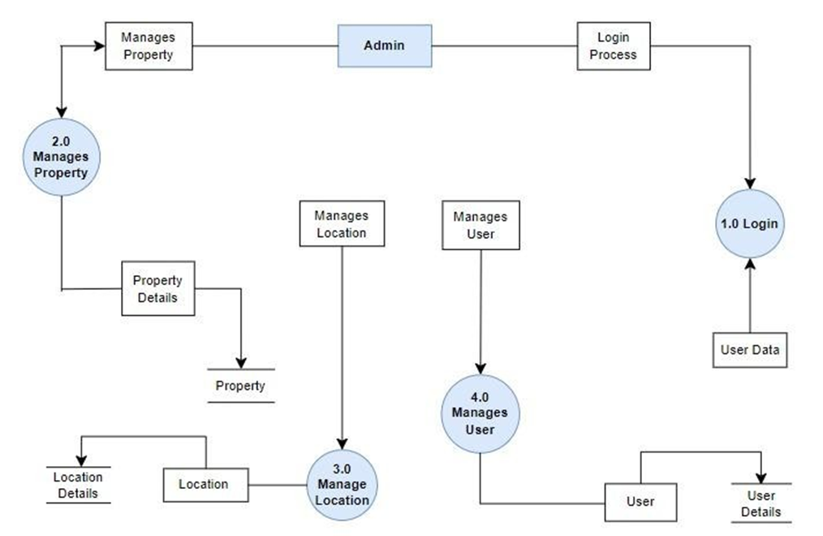

Users DFD

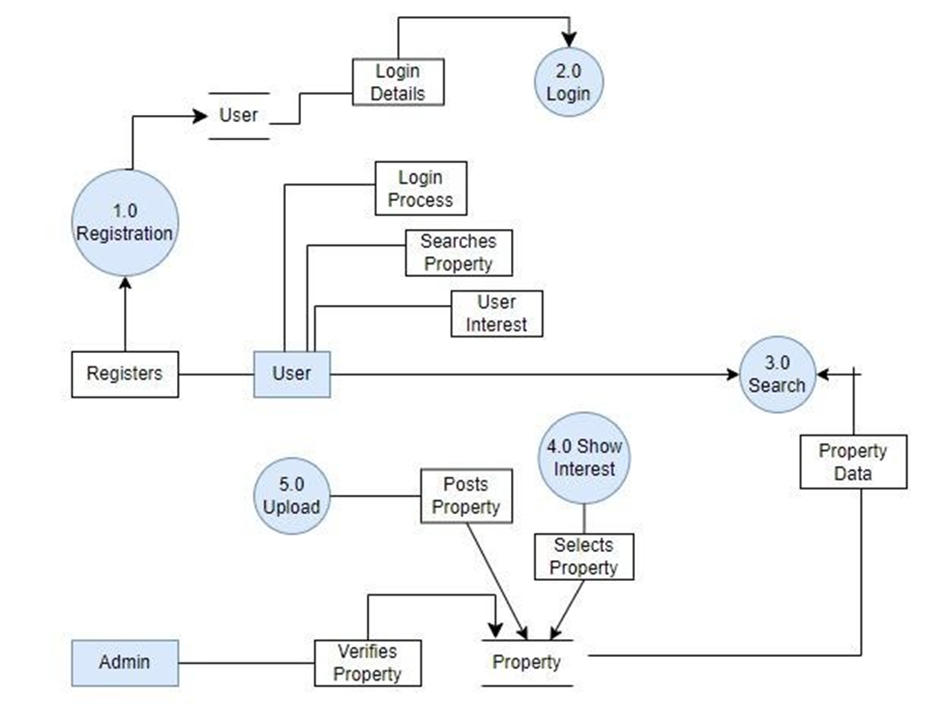

# **04.Methodology:**

The feasibility study is essential in determining whether to proceed with the development of the real estate website. It evaluates the project's worth by considering economic, technical, and operational aspects. The study will help identify the most beneficial alternatives, minimizing expenses while maximizing benefits. It also makes recommendations among proposed alternatives. The feasibility study consists of three key methods: **Economic Feasibility**, **Technical Feasibility**, and **Operational Feasibility**.

The **Technical Feasibility** study examines whether the required technologies are available to implement the alternatives. It also assesses whether the necessary human resources are available to operate the system. The **Operational Feasibility** study ensures that the system can be efficiently integrated into the existing environment, while the **Economic Feasibility** study predicts the return on investment based on the current and future financial outlook.

For the **Technical Feasibility** and **Operational Feasibility** studies, the following methods were used:

* A team of experts was sent to observe the current system and gather insights.
* Interviews were conducted with key stakeholders, including the department chairman.
* Observations were made of the available workstations and servers.
* Insights were collected on the culture, union agreements, and department rules.
* A survey was conducted with students using questionnaires to gather relevant data.

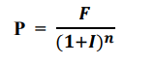For the **Economic Feasibility** study, a financial analysis was performed to compute the potential future benefit of the project using the following formula:

Here P, F, n, I are present value, future benefit, year of benefit & expected rate of return, respectively.

Based on the gathered data and analysis, alternative solutions are proposed, and the feasibility study evaluates the best approach to move forward with the real estate website project.

# **05.Overview of Alternatives**

There are three alternatives for the real estate management platform. The Off-the-Shelf Solution offers quick deployment and lower cost but with limited customization and scalability. The Custom-Built Solution (In-House) provides full control, scalability, and tailored features but comes with higher cost, more development time, and maintenance responsibility. Outsourced Development strikes a balance with moderate cost and flexibility, but its customization and scalability depend on the chosen vendor. Each option balances speed, control, and risk differently, allowing for strategic decision-making based on priorities. A brief description of the alternatives systems are shown in Table 2:

Table 2: Alternative System of Real State Management Platform

|  |  |  |  |
| --- | --- | --- | --- |
| **Item** | **Alternative 1** | **Alternative 2** | **Alternative 3** |
| Development Cost | Lower initial cost; subscription-based | Higher cost due to full development in-house | Medium cost; onetime payment or service-based |
| Time to Market | Fast; solution is pre-  built and ready to use | Slower; requires full development from  scratch | Medium; development timeline varies |
| Customization | Limited customization options | Fully customization based on needs | Customizable, but depends on vendor  flexibility |
| Scalability | May have limits depending on the platform | Highly scalable; built for growth | Scalable, but vendordependent |
| Maintenance & Support | Vendor-managed, low effort for your team | Requires dedicated inhouse support team | Vendor offers maintenance as part of  contract |
| Data Security | Security depends on the provider | Full control over security measures and protocols | Security managed by the outsourced vendor |
| Risk Level | Low | High | Medium |
| Advantages | Complete control & customization to fit specific needs . | Low initial cost with fast deployment. | Balanced costs with partial customization and faster setup. |
| Disadvantages | High upfront development cost. | Recurring high subscription fees and limited customization. | Limited flexibility compared to full custom solutions. |

# **5.1 Economic Feasibility Study for the alternatives :**

Investment that needed for the alternative 1, alternative 2 and alternative 3 are shown in table 3, table 4 , table 5 respectively :

Table 3: Summary of Costs for Alternative 1: Custom In-House Solution

|  |  |  |
| --- | --- | --- |
| **Serial No.** | **Cost Item** | **Estimated Cost(BDT)** |
| 01. | Initial Development Cost | 1,000,000 |
| 02. | Annual Maintenance Cost | 400,000 |
| 03. | Hosting & Server Costs | 150,000 |
| 04. | Customization/ Feature Updates | 300,000 |
| 05. | Security Upgrades (one-time setup) | 100,000 |
|  | Total First-Year Cost | 1,950,000 |
|  | Total Annual Recurring Cost | 550,000 |

Table 4: Summary of Costs for Alternative 2: Third-Party Platform Solution

|  |  |  |
| --- | --- | --- |
| **Serial No.** | **Cost Item** | **Estimated Cost (BDT)** |
| 01. | Initial Development Cost | 200,000 |
| 02. | Annual Maintenance Cost (vendor manages most) | 100,000 |
| 03. | Hosting & Server Costs | 50,000 |
| 04. | Licensing/ Subscription Fees | 400,000 |
| 05. | Security Upgrades | 50,000 |
|  | Total First-Year Cost | 800,000 |
|  | Total Annual Recurring Cost | 550,000 |

Table 5: Summary of Costs for Alternative 3: Third-Party Platform Solution :

|  |  |  |
| --- | --- | --- |
| **Serial No.** | **Cost Item** | **Estimated Cost(BDT)** |
| 01. | Initial Development Cost | 600,000 |
| 02. | Annual Maintenance Cost | 200,000 |
| 03. | Hosting & Server Costs | 100,000 |
| 04. | Customization/Feature Updates | 100,000 |
| 05. | Licensing/Subscription Fees | 200,000 |
| 06. | Security Upgrades | 75,000 |
|  | Total First-Year Cost | 1,325,000 |
|  | Total Annual Recurring Cost | 500,000 |

**Financial Analysis of Alternative 1 :**

The initial investment of Alternative 1 is 1,950,000 BDT. And the total annual recurring cost is 550,000 BDT. Benefit and cost on yearly basis is described in table 6 :

Table 6: Benefit and Cost analysis for Alternative 1

|  |  |  |  |  |  |
| --- | --- | --- | --- | --- | --- |
|  | **Benefits** | | **Cost** | |  |
| **No**. | **Particular** | **Amount (BDT)** | **No.** | **Particular** | **Amount (BDT)** |
| 01. | Increased Customer Retention | 8,00,000 | 01. | Development Cost | 25,00,000 |
| 02. | Brand Differentiation | 5,00,000 | 02. | Maintenance & Security | 5,00,000 |
| 03. | Long-Term Cost Savings | 4,00,000 | 03. | Hosting & Server Costs | 1,50,000 |
| 04. | Scalability | 2,00,000 | 04. | Customization Updates | 1,00,000 |
|  | Total | 19,00,000 | Total Costs (Year 1) | | 31,50,000 |
| Total Costs (Annual Recurring) | | 4,50,000 per year |
|  | Net return per year (19,00,000 - 4,50,000) | | | | 14,50,000  BDT/year |

On the basis of table 6 investment analysis for alternative 1 is shown in table 7

Table 7: Investment Analysis for Alternative 1 :

|  |  |  |  |
| --- | --- | --- | --- |
| **Year** | **Savings (BDT)** | **Present Value (10%)** | **Cumulative Value (BDT)** |
| 1 | 14,50,000 | 13,18,182 | 13,18,182 |
| 2 | 14,50,000 | 11,98,347 | 25,16,529 |
| 3 | 14,50,000 | 10,89,406 | 36,05,935 |
| 4 | 14,50,000 | 9,90,369 | 45,96,304 |
| 5 | 14,50,000 | 9,00,335 | 54,96,639 |
| 6 | 14,50,000 | 8,18,486 | 63,15,125 |
| 7 | 14,50,000 | 7,44,078 | 70,59,203 |
| 8 | 14,50,000 | 6,76,434 | 77,35,637 |
| 9 | 14,50,000 | 6,14,940 | 83,50,577 |
| 10 | 14,50,000 | 5,59,036 | 89,09,613 |

**Financial Analysis of Alternative 2:**

The initial investment of Alternative 2 is 800,000 BDT. And the total annual recurring cost is 550,000 BDT. Benefit and cost on yearly basis is described in Table 8.

Table 8: Benefit and Cost analysis for Alternative 2

|  |  |  |  |  |  |
| --- | --- | --- | --- | --- | --- |
|  | **Benefits** | | **Cost** | |  |
| **No.** | **Particular** | **Amount(BDT)** | **No.** | **Particular** | **Amount (BDT)** |
| 01. | Quick Launch | 2,00,000 | 01. | Platform Subscription (Annual) | 25,00,000 |
| 02. | Initial  Investment | 3,00,000 | 02. | Maintenance, Support & Security | 1,00,000 |
| 03. | Vendor Support | 1,00,000 | 03. | Hosting & Server Costs | 20,000 |
|  | Total | 6,00,000 | Total Costs (Year 1) | | 7,70,000 |
| Total Costs (Annual Recurring) | | 5,70,000 per year |
|  | Net return per year (6,00,000 - 5,70,000) | | | | 30,000  BDT/year |

On the basis of table 8 investment analysis for alternative 1 is shown in table 9.

Table 9 : Investment Analysis for Alternative 2

|  |  |  |  |
| --- | --- | --- | --- |
| **Year** | **Savings (BDT)** | **Present Value (10%)** | **Cumulative Value (BDT)** |
| 1 | 30,000 | 27,273 | 27,273 |
| 2 | 30,000 | 22,727 | 50,000 |
| 3 | 30,000 | 18,678 | 68,678 |
| 4 | 30,000 | 15,164 | 83,842 |
| 5 | 30,000 | 12,004 | 95,846 |
| 6 | 30,000 | 9,091 | 1,04,937 |
| 7 | 30,000 | 6,735 | 1,11,672 |
| 8 | 30,000 | 4,916 | 1,16,588 |
| 9 | 30,000 | 3,679 | 1,20,267 |
| 10 | 30,000 | 2,962 | 1,23,229 |

**Financial Analysis of Alternative 3:**

The initial investment of Alternative 2 is 1,325,000 BDT. And the total annual recurring cost is 500,000 BDT. Benefit and cost on yearly basis is described in Table 10.

Table 10 : Benefit and Cost analysis for Alternative 3

|  |  |  |  |  |  |
| --- | --- | --- | --- | --- | --- |
|  | **Benefits** | | **Cost** | |  |
| **No.** | **Particular** | **Amount(BDT)** | **No.** | **Particular** | **Amount (BDT)** |
| 01. | Moderate Customization | 5,00,000 | 01. | Development Cost | 10,00,000 |
| 02. | Initial Investment | 4,00,000 | 02. | Maintenance & Security | 450,000 |
| 03. | Vendor Support | 2,00,000 | 03. | Hosting & Server Costs | 80,000 |
|  | Total | 11,00,000 | 04. | Platform Subscription (Annual) | 2,00,000 |
| Total Costs (Year 1) | | 16,30,000 |
| Total Costs (Annual Recurring) | | 5,30,000 per year |
|  | Net return per year (11,00,000 - 5,30,000) | | | | 5,70,000 BDT/year |

On the basis of table 10 investment analysis for alternative 1 is shown in table 11 .

Table 11 : Investment Analysis for Alternative 3

|  |  |  |  |
| --- | --- | --- | --- |
| **Year** | **Savings (BDT)** | **Present Value (10%)** | **Cumulative Value (BDT)** |
| 1 | 5,70,000 | 5,18,182 | 5,18,182 |
| 2 | 5,70,000 | 4,71,074 | 9,89,256 |
| 3 | 5,70,000 | 4,28,074 | 14,17,505 |
| 4 | 5,70,000 | 3,89,317 | 18,06,823 |
| 5 | 5,70,000 | 3,53,925 | 21,60,748 |
| 6 | 5,70,000 | 3,21,750 | 24,82,498 |
| 7 | 5,70,000 | 2,92,500 | 27,75,000 |
| 8 | 5,70,000 | 2,65,909 | 30,40,909 |
| 9 | 5,70,000 | 2,41,736 | 32,82,645 |
| 10 | 5,70,000 | 2,19,760 | 35,02,405 |

# **5.2 Technical Feasibility Study for the alternatives :**

* **Alternative 1: Custom In-House Solution**

Requires advanced technical skills such as experienced developers, designers, and IT personnel to build, deploy, and maintain the website. The company needs access to hardware infrastructure, hosting, security protocols, and ongoing tech support. Feasible for businesses that have or can hire a strong technical team.

* **Alternative 2: Third-Party Platform**

Requires minimal technical skills. Most technical elements (hosting, security, and updates) are managed by the platform provider. Feasible for businesses with limited tech knowledge as it mostly involves using ready-made tools with basic customization.

* **Alternative 3: Hybrid Solution**

Requires moderate technical skills. The business can rely on a third-party platform for core operations but will still need some development expertise for custom features and integration. Feasible for businesses with moderate technical capability or access to external developers for partial customization.

# **5.3 Operational Feasibility Study for the alternatives :**

* **Alternative 1: Custom In-House Solution**

High operational complexity, as it requires an in-house team for daily operations, security management, updates, and troubleshooting. Businesses must have or develop strong IT management processes. Operationally feasible for organizations that can handle long-term internal operations and maintenance.

* **Alternative 2: Third-Party Platform**

Lower operational complexity. Most operations (security, updates, and backups) are managed by the platform provider, reducing the burden on the business. Feasible for businesses that want a simple, low-maintenance solution and can operate with minimal in-house IT staff.

* **Alternative 3: Hybrid Solution**

Moderate operational complexity. Core functions are managed by the third-party platform, but some degree of internal or outsourced management is required for custom features, integration, and security management. Feasible for businesses that can handle a mix of in-house operations and vendor support.

# **06. Recommendation**

Based on the analysis, Alternative 1: Custom In-House Solution is recommended for its long-term benefits, including full control, scalability, and cost efficiency. Although the initial investment is higher, the ability to tailor features and manage security provides a significant competitive advantage. This solution aligns with business growth and operational flexibility, ensuring sustained success. Therefore, it is the most strategic option for long-term returns.

Table 12 : Comparison between all the alternatives

|  |  |  |  |  |
| --- | --- | --- | --- | --- |
| **No.** | **Feature** | **Alternative 1** | **Alternative 2** | **Alternative 3** |
| 01. | Initial  Development Cost | 30,00,000 | 2,00,000 | 10,00,000 |
| 02. | Recurring  Costs (Per  Year) | 2,00,000 (maintenance and updates) | 10,00,000  (subscription, maintenance) | 5,00,000 |
| 03. | Net Return  (Per Year) | 1,45,00,000 | 30,000 | 5,70,000 |
| 04. | Savings Over 10 Years | 1,45,00,000 | 3,00,000 | 57,00,000 |
| 05. | Present Value (10% Discount  Rate) | 89,09,613 | 1,23,229 | 35,02,405 |
| 06. | Cumulative  Value (10  Years) | 89,09,613 | 1,23,229 | 35,02,405 |

Each alternative caters to different business needs, budget, and goals.

* **Alternative 1 (Custom In-House Solution)** has the highest initial investment but offers full control, flexibility, and scalability, making it the best option for long-term savings and customization.
* **Alternative 2 (Third-Party Platform)** has the lowest upfront cost but higher ongoing fees due to licensing or subscriptions. While budget-friendly initially, it lacks customization and incurs recurring costs, making it less efficient long-term.
* **Alternative 3 (Hybrid Solution)** offers a middle ground with moderate initial and ongoing costs. It provides some customization but still relies on third-party platforms for core functionalities, limiting flexibility and scalability.

After analysis, **Alternative 1**—Custom In-House Solution—is the most advantageous. Although it requires a higher initial investment, its ability to provide full customization, control over security and data, and avoid ongoing fees makes it the ideal choice for businesses that prioritize long-term cost efficiency and a competitive market edge.

# **07.Conclusion**

This feasibility study explored three alternative solutions for developing a real estate management platform:

**- Alternative 1:** Custom In-House Solution

- **Alternative 2:** Third-Party Platform

- **Alternative 3:** Hybrid Solution

While all three alternatives were found to be technically and operationally feasible, the economic analysis determined that Alternative 1 (Custom In-House Solution) is the most beneficial in terms of long-term cost efficiency and scalability. The study revealed that this approach ensures full control over the system, data security, and feature customization, making it the best choice for sustained growth.

Despite requiring a higher initial investment, Alternative 1 offers greater long-term savings and operational advantages. The financial projections indicate a significant return on investment, with a cumulative savings of **89,09,613 BDT** over ten years. This surpasses the other alternatives, making it the preferred choice for implementation.

Therefore, based on economic, technical, and operational feasibility, **Alternative 1 is the most suitable solution** for the real estate management platform, ensuring long-term sustainability and profitability.