

Problem Definition Document

Course Title : Software Engineering Lab

Course Code ; CSE-3638

**Submitted to**

Sultana Tasnim Jahan

Assistant Lecturer

Dept. of CSE , IIUC

Semester : 6th Section : 6CF

**Submitted by**

* Nahian Subah Ishma_C223286
* Rehnuma Tasneem_C223288
* Saima Kawsar_C223297

**DEPARTMENT OF COMPUTER SCIENCE & ENGINEERING**

**INTERNATIONAL ISLAMIC UNIVERSITY CHITTAGONG**

|  |  |
| --- | --- |
| Real Estate Platform  “Your Gateway to Smarter Property Deals” |  |

**Table of Contents**

01.Title 2

02.Introduction 2

03.Problem Statement 2

04.Project Objectives 3

05.Preliminary Solutions 4

06.Project Scope 5

07.Estimated Cost and Time for Feasibility Study 6

08.Repository Link 7

## 01.Title

Real Estate Platform.

## 02.Introduction

The real estate industry has witnessed a significant transformation with the rise of digital platforms that facilitate property buying, selling, and renting. This project focuses on developing a comprehensive **Real Estate Platform** aimed at simplifying the real estate transaction process. The platform will provide a seamless experience for property owners, buyers, renters, and real estate agents.

The goal of the project is to create an efficient, transparent, and user-friendly platform where users can easily navigate property listings, schedule viewings, and perform transactions. The platform will include advanced features such as property filters, payment gateways, secure user logins, and more, making it a one-stop solution for real estate needs.

## 03.Problem Statement

The real estate industry faces several challenges that hinder the seamless transaction between property buyers, sellers and renters.

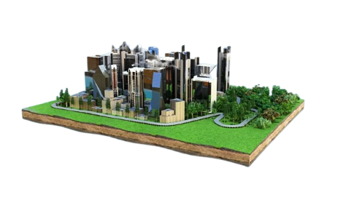

Some of the major problems include:

* **Inefficient Property Search:** Most existing real estate platforms have limited and non-intuitive search features, making it difficult for users to filter properties according to their needs.
* **Lack of Transparency:** Property listings often lack detailed information, leading to mistrust and confusion among users.
* **Fragmented Service Offering:** Many platforms provide a single service (e.g., property listings) without offering the full suite of services, such as renting, buying, and selling, in one place.

## 04.Project Objectives

1. **Develop a User-Friendly Platform:**

Create a responsive, web-based platform that provides an intuitive user experience, accessible from both desktops and mobile devices.

1. **Comprehensive Property Listings:**

Provide a database of properties available for sale, rent, or lease, with detailed descriptions, pricing, images, and video tours.

1. **Advanced Search and Filters:**

Implement a powerful search engine that allows users to filter properties based on location, price, type of property, size, and amenities.

1. **Secure Transaction System:**

Integrate a secure payment gateway for transactions such as property booking, deposits, or down payments.

1. **User Profiles and Customization:**

Allow users to create accounts and save their preferences, track listings, and manage transactions.

1. **Agent/Property Manager Dashboards:**

Provide real estate agents and property managers with their own dashboard to manage listings, communicate with clients, and track property sales/rentals.

## 05.Preliminary Solutions

To achieve the objectives outlined above, the following preliminary solutions will be implemented:

1. **Front-End Development (React JS):**

The platform's frontend will be developed using **React JS** to ensure a dynamic and interactive user interface. React’s component-based architecture will ensure that the platform is easy to scale and maintain.

1. **Back-End Development (PHP and MySQL with XAMPP):**

The back-end will be built using **PHP** and **MySQL**, with **XAMPP** as the local server environment. This stack will handle database management, user authentication, and server-side business logic.

1. **Cloud Integration:**

Cloud storage services such as **AWS** or **Google Cloud** will be used to handle image and video storage for property listings.

1. **Payment Gateway Integration:**

A secure payment system will be integrated for processing transactions, ensuring safe and seamless payments for users.

1. **Mobile Responsiveness:**

The website will be built to be fully responsive, ensuring that users can access the platform from any device—smartphone, tablet, or desktop.

## 06.Project Scope

#### **Functions:**

* **Property Listings:** Add, update, and delete property listings for users.
* **Property Categorization:** Categorize properties (e.g., residential, commercial, rent, for sale).
* **Search Filters:** Provide advanced search and filter options (e.g., price range, location, property type, size, etc.).
* **Transaction Management:** Facilitate booking, purchasing, or renting properties with secure payment options.
* **User Management:** Allow users to sign up, log in, and manage their profiles securely.
* **Property Inquiry:** Enable users to contact property agents or sellers directly via in-app messaging or email.

#### **Features:**

* **User Login:** Secure sign-up and login system to protect user data with password hashing and session management.
* **Property Management:** Track and organize listings with details such as images, descriptions, prices, and location.
* **Property Search & Filters:** Search for properties based on various criteria, such as price, location, and property type.
* **Visual Reports:** Generate visual reports (e.g., for agents or users) to show property views, transactions, and inquiries.
* **Responsive Design:** Ensure the platform works on desktops, tablets, and mobile phones.
* **Cloud Hosting:** Host the platform on cloud services like **AWS** and **Render** for scalability and reliability.

#### **Facilities:**

* **Quick Property Entry:** Enable agents or users to quickly add properties, including images, descriptions, and pricing details.
* **Property Analytics:** Generate reports on property views, inquiries, and transactions to help users make informed decisions.
* **Mobile-Friendly:** The platform will be optimized for mobile use, ensuring users can browse properties and manage their profiles from smartphones and tablets.

## ****07.Estimated Cost and Time for Feasibility Study****

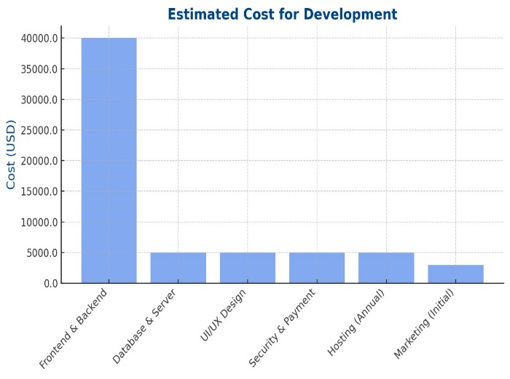**Estimated Cost:** The estimated cost of developing the real estate platform is as follows:

**Development Costs:**

* 1. Frontend and Backend Development: $40,000
  2. Database and Server Setup: $5,000
  3. UI/UX Design: $5,000
  4. Security and Payment Gateway Setup: $5,000

**Ongoing Costs:**

* 1. Hosting and Maintenance: $5,000 annually
  2. Marketing and Promotion: $3,000 initially

The total estimated cost for the project is **$50,000**, including initial development, deployment, and the first year of hosting and maintenance.

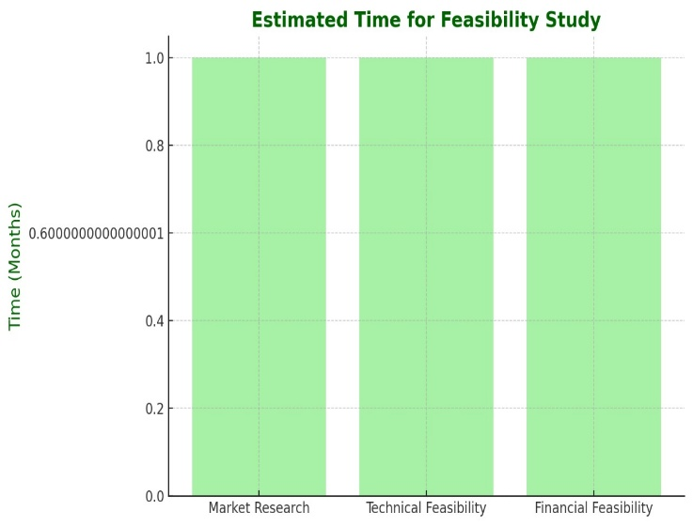**Estimated Time:** The feasibility study is expected to take approximately **3 months**, broken down as follows:

1. **Market Research (1 month):** Conducting surveys, understanding user needs, analyzing competitors, and identifying target demographics.
2. **Technical Feasibility (1 month):** Assessing the technological tools and resources (React JS, PHP, MySQL, XAMPP) and evaluating their integration capabilities.
3. **Financial Feasibility (1 month):** Estimating the costs, evaluating revenue models (advertising, transaction fees, etc.), and determining the overall financial viability of the project.

## 08.Repository Link

**https://github.com/RehnumaTasneem/Real_Estate_Platform_by_ternary**