Kubernetes
Table des matières
Overview 1
Kubernetes Explained in 6 Minutes | k8s Architecture 1
Comment apprendre Kubernetes en 2025 1
Cloud Native vs Cloud First vs Cloud Ready vs Born in the Cloud: The Ultimate Showdown 1
Migration 1
Migrating to Kubernetes + Best Practices for Cloud Native • T. Vitale & L. Højgaard • GOTO 2021 1
Migrating to Kubernetes 1
Learning 1
Kubernetes Tutorial for Beginners [FULL COURSE in 4 Hours] 1
Installer et configurer kubectl | Kubernetes 1

Overview

Kubernetes Explained in 6 Minutes | k8s Architecture
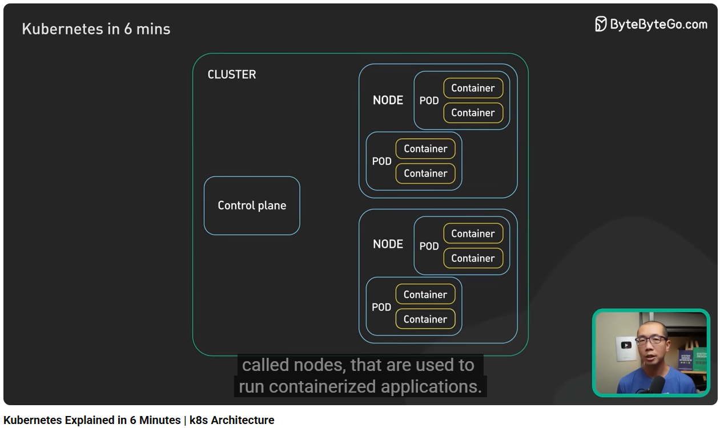
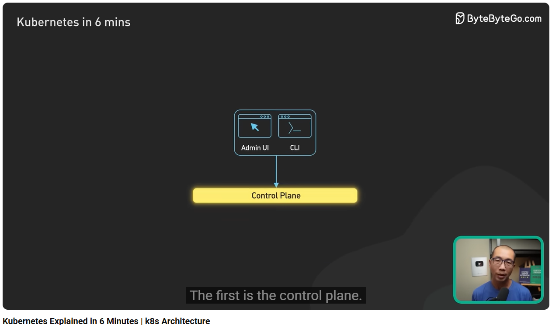
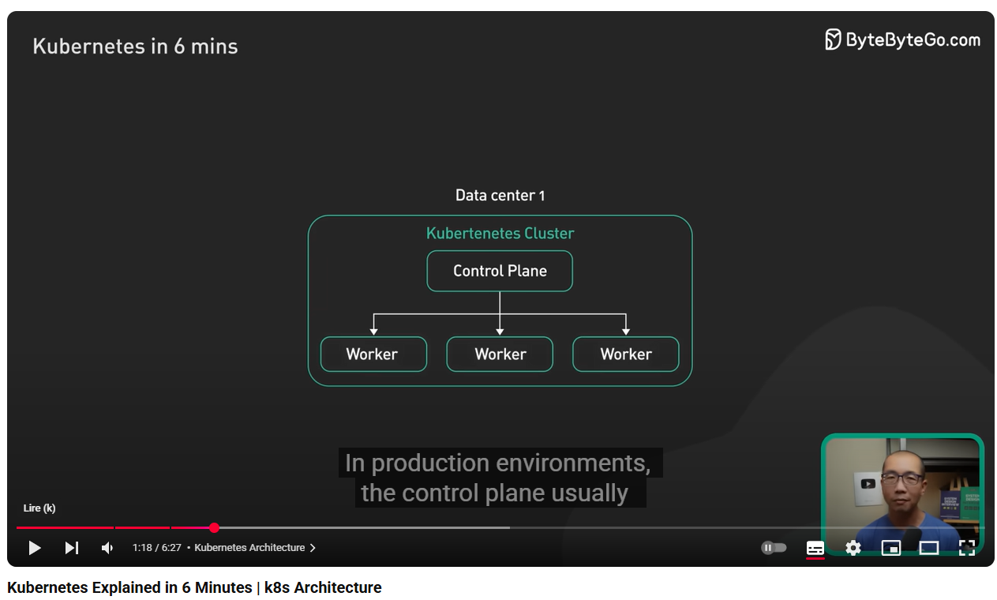
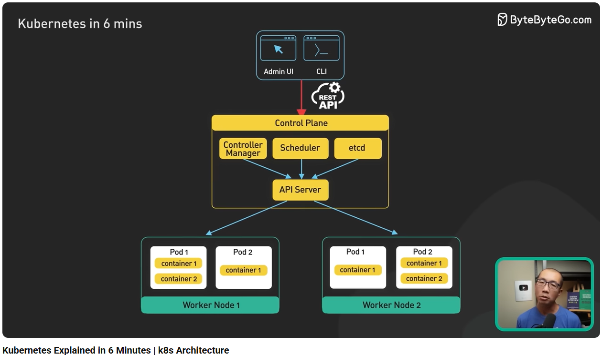
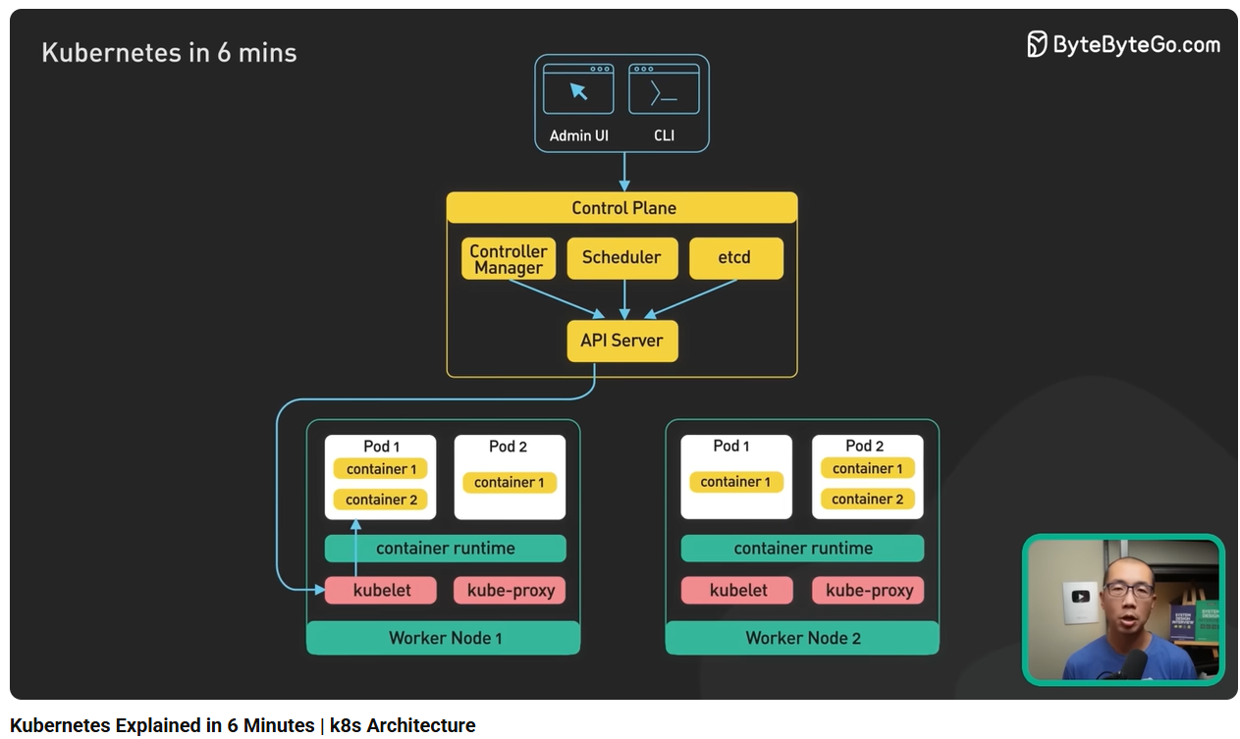
- etdc : stores key-value data
- highly scalable
- portable
- operating cost is high
- complex to manage
- costly

Comment apprendre Kubernetes en 2025
Common mistakes:
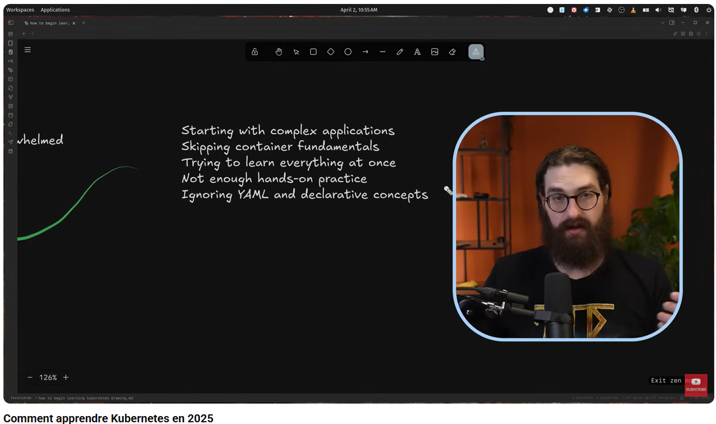
Prerequisites:
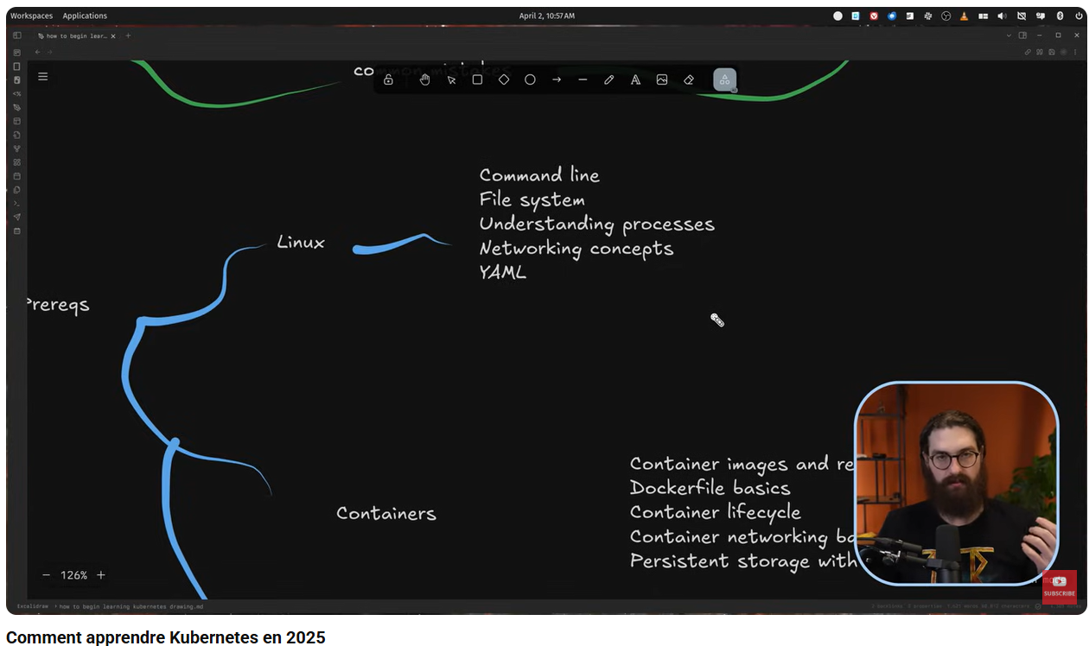
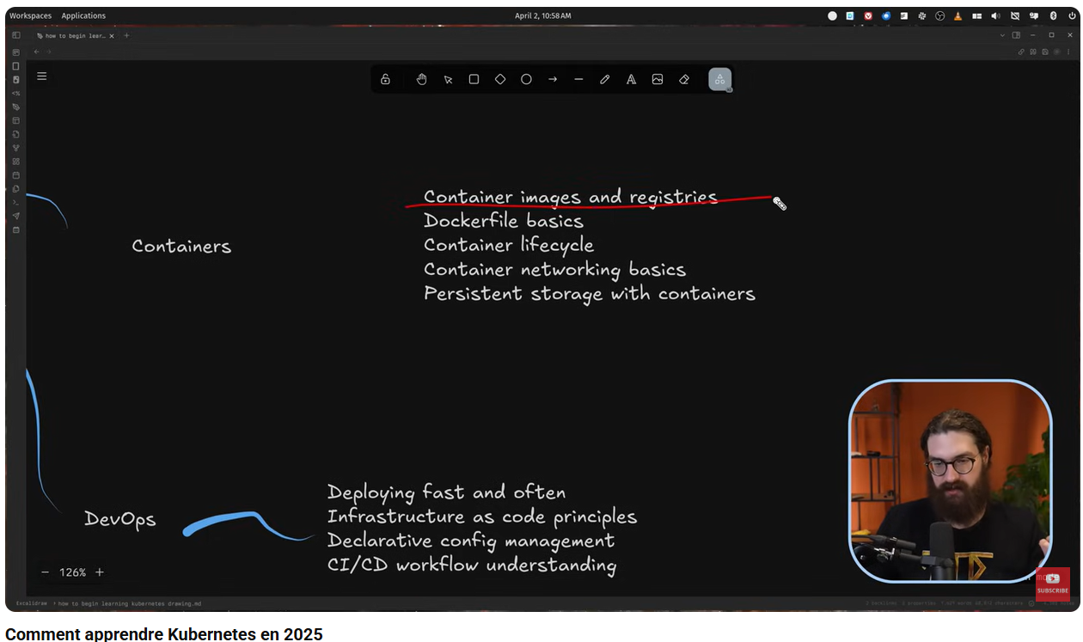
- Github: https://github.com/mischavandenburg
- Learn docker/container
- Learning:
  - https://labs.iximiuz.com/
  - https://www.skool.com/kubecraft/about
- Tools:
  - Ranger desktop (open source)
  - k3s
- isolated environment to train

Cloud Native vs Cloud First vs Cloud Ready vs Born in the Cloud: The Ultimate Showdown
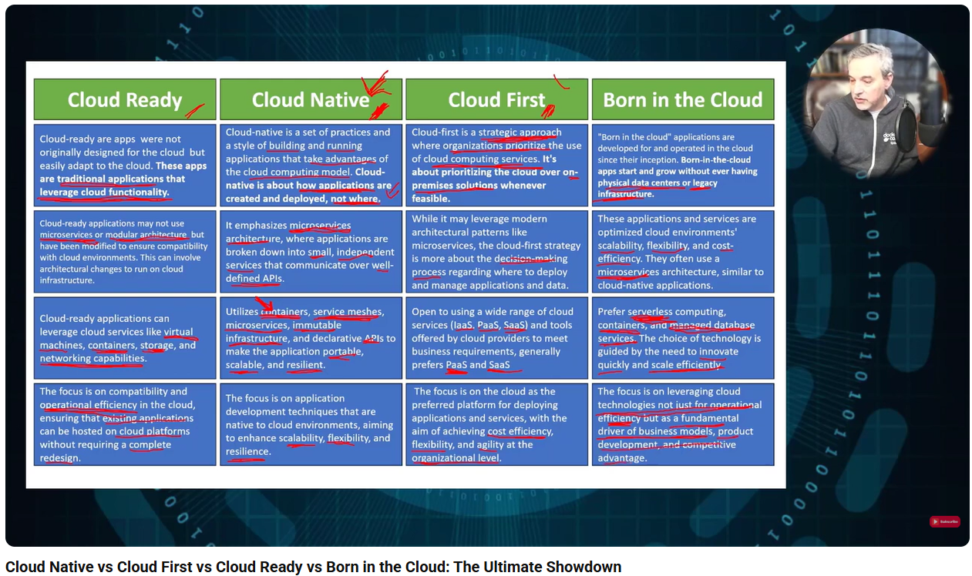

Migration

Migrating to Kubernetes + Best Practices for Cloud Native • T. Vitale & L. Højgaard • GOTO 2021
- k8s adds complexity, should be known before moving into k8s
- migration: make the application stateless/cloud native principles
- Ensure that the tests are complete/ready to ensure it is working once deployed
- Not always necessary to split a monolith into micro services if too much tangled/cobbled services, it would become a distributed monolith instead of micro-services
- With containers, sometimes DRY principle should not be too strict (e.g. copy paste into several micro-services for coupling)
- One application One container, Do Not migrate all at once
- Embrace the community and mindset

Migrating to Kubernetes

Learning

Kubernetes Tutorial for Beginners [FULL COURSE in 4 Hours]
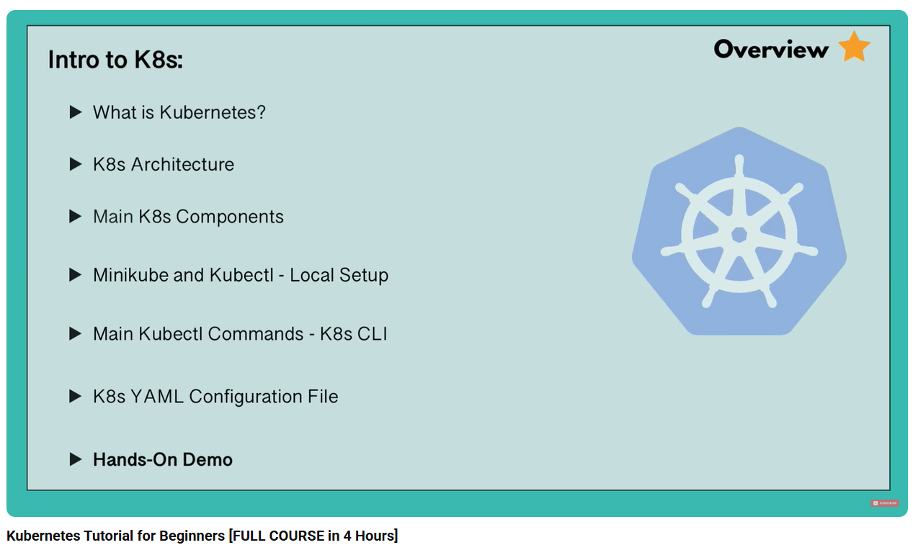
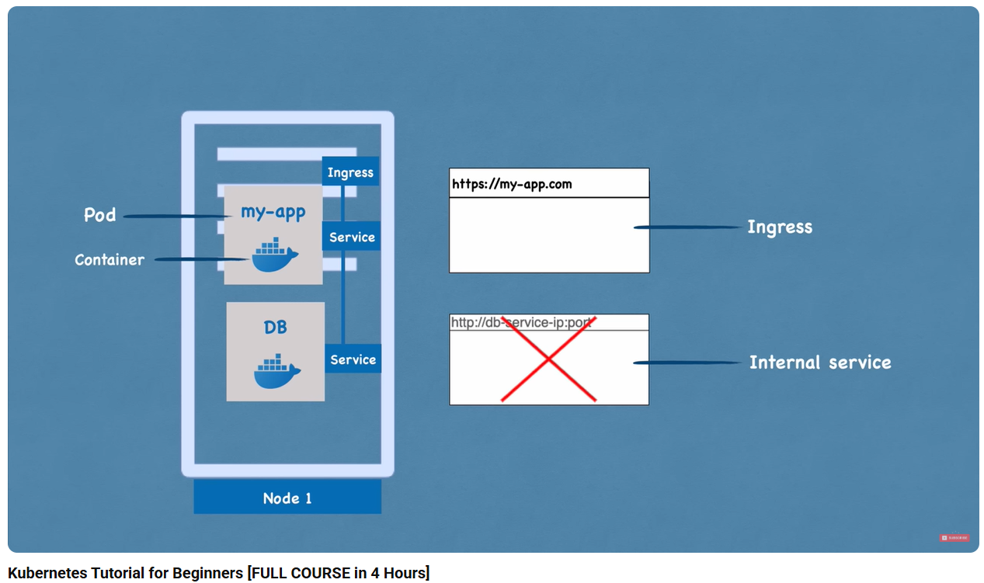
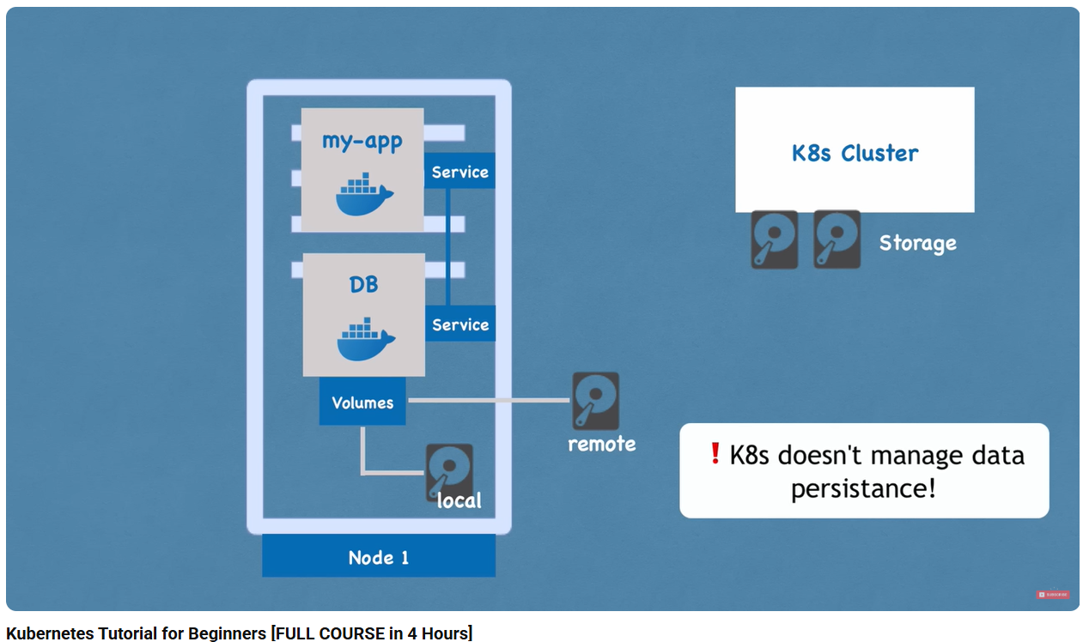
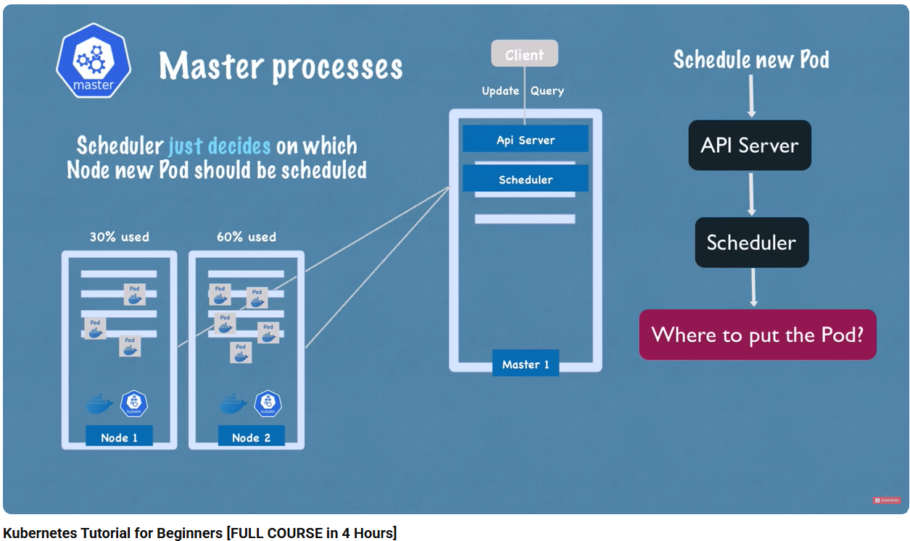

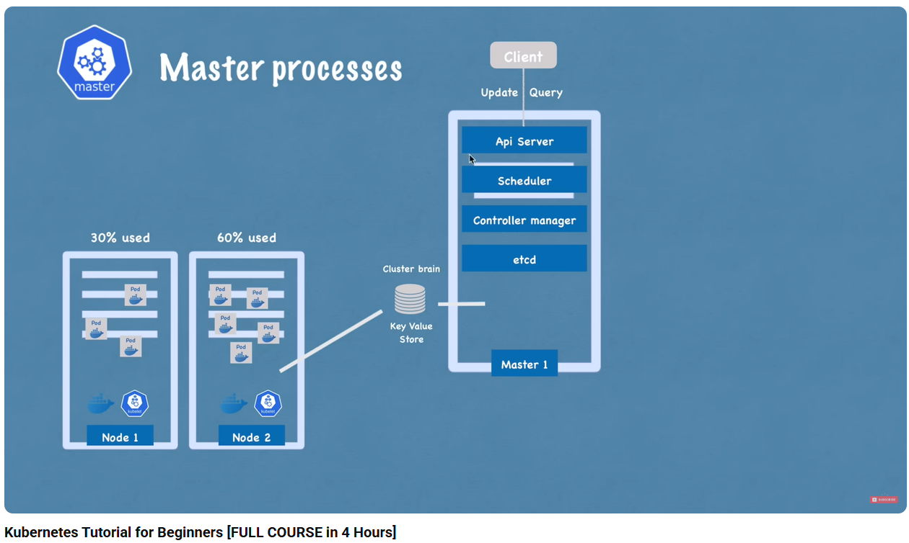
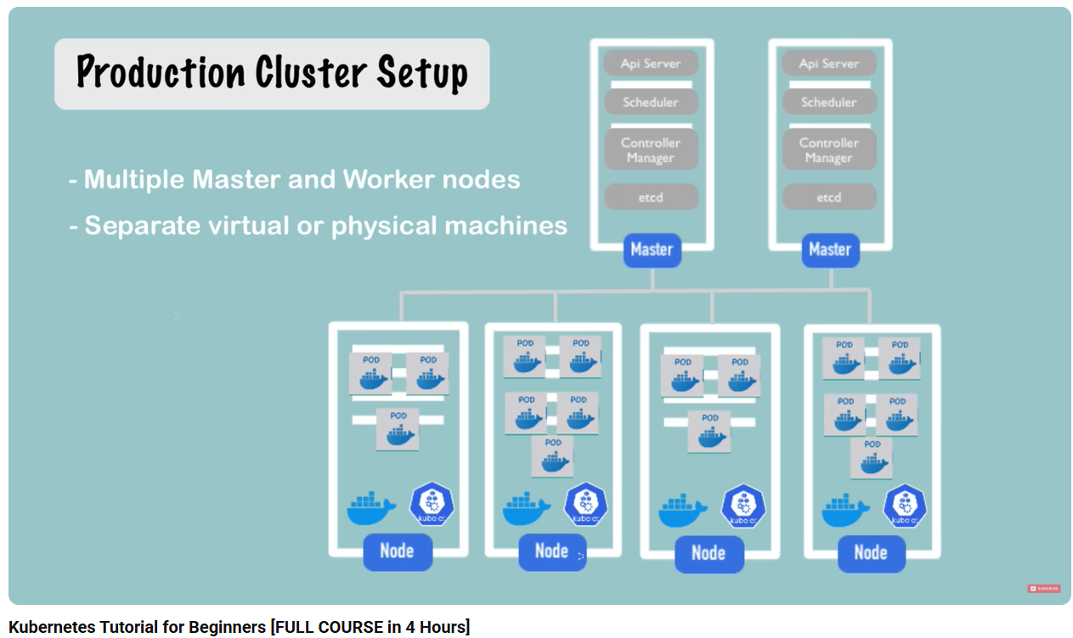
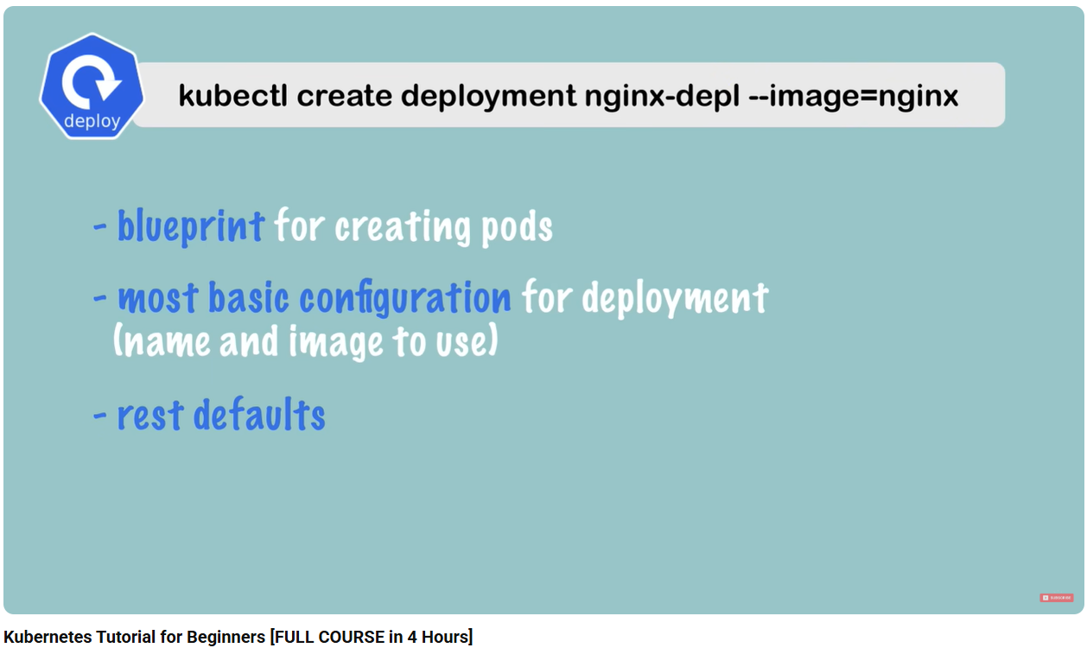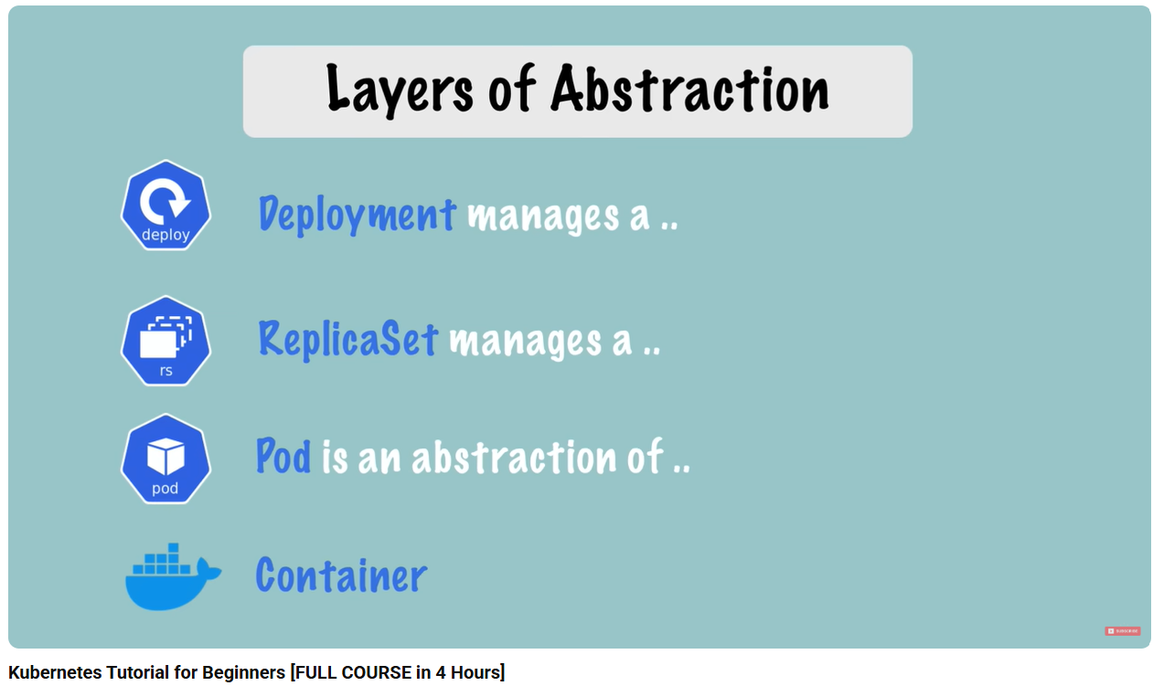
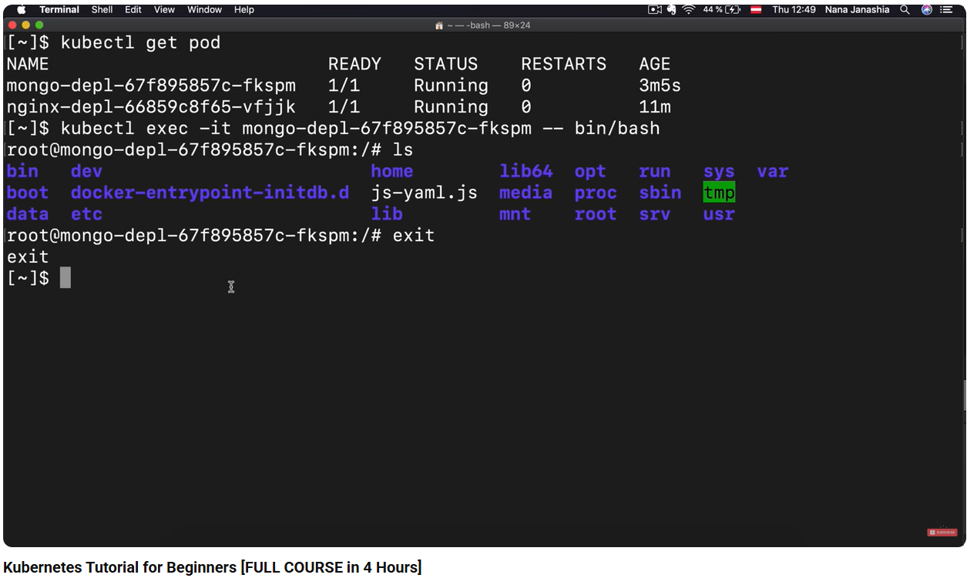
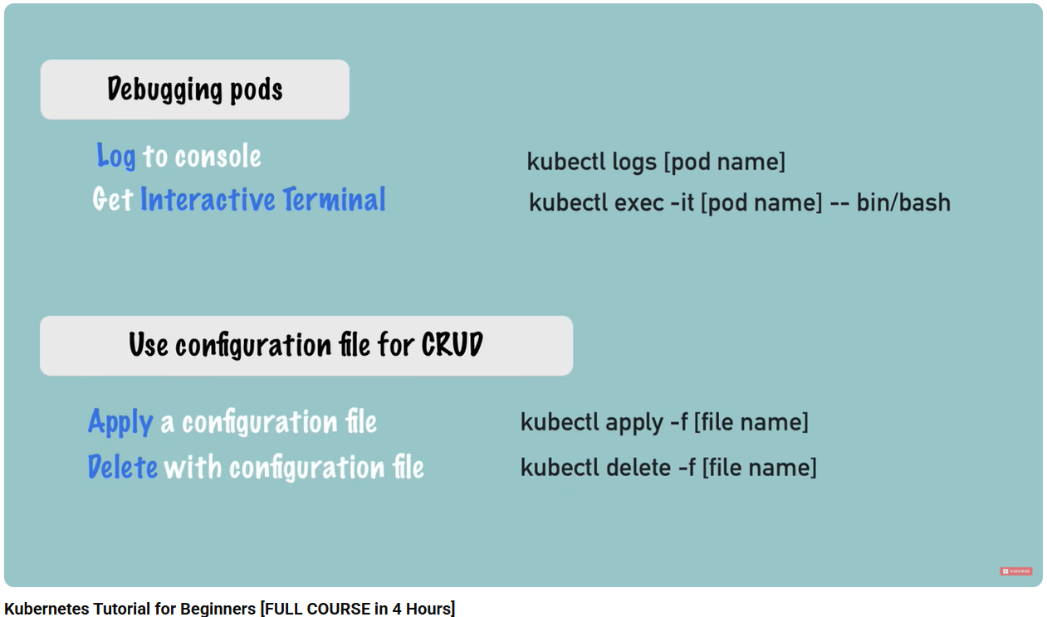
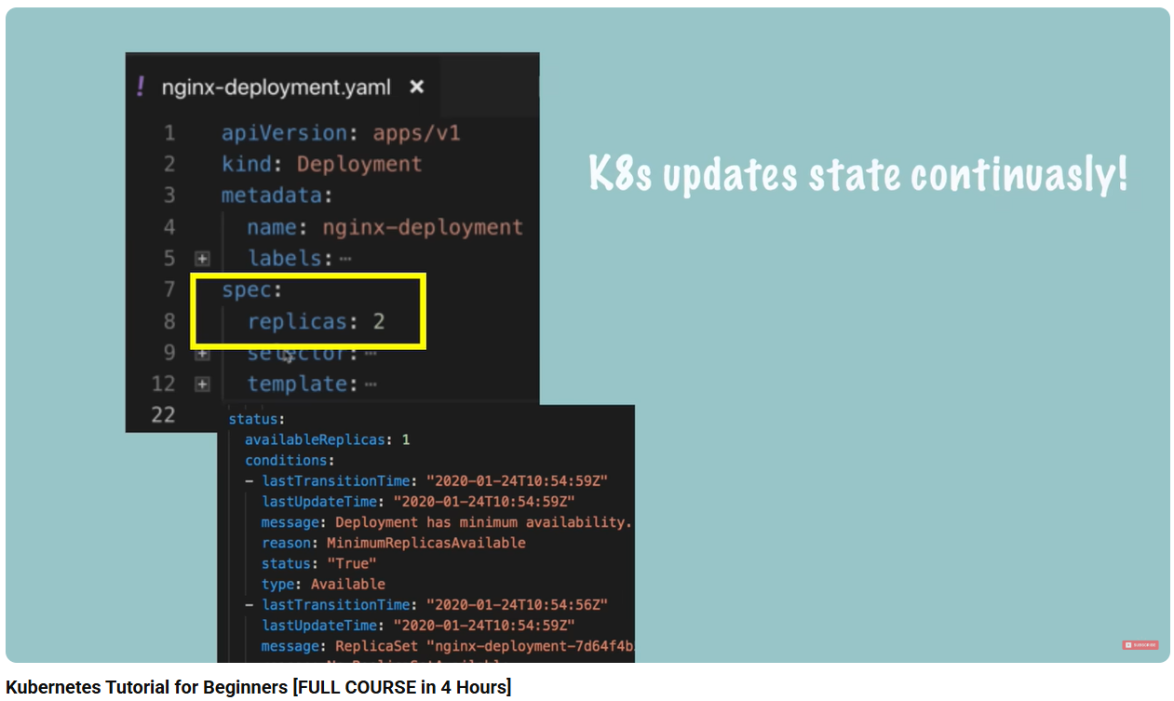
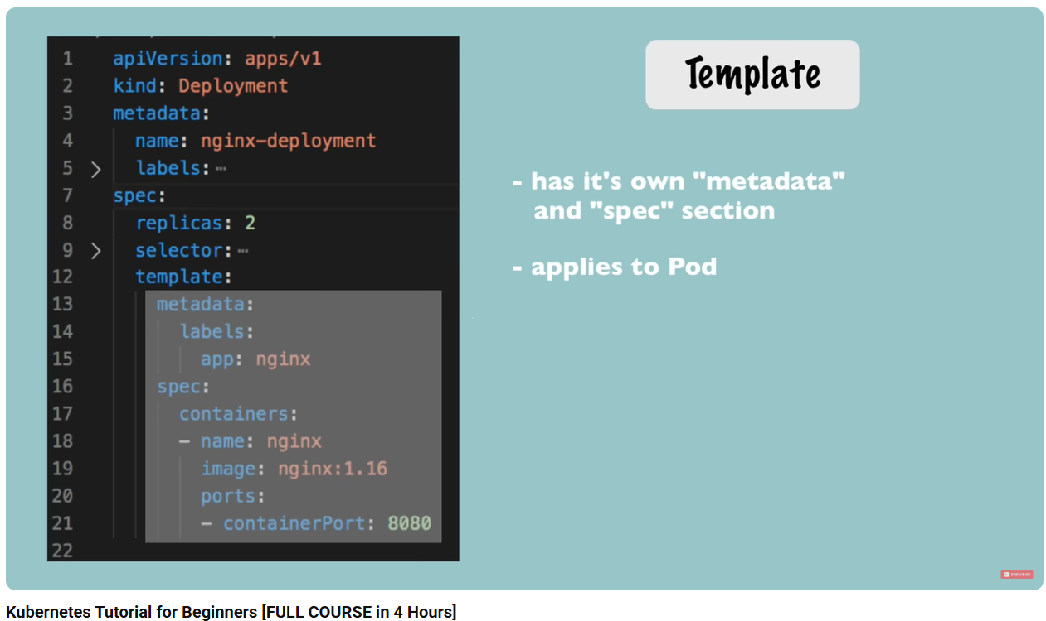
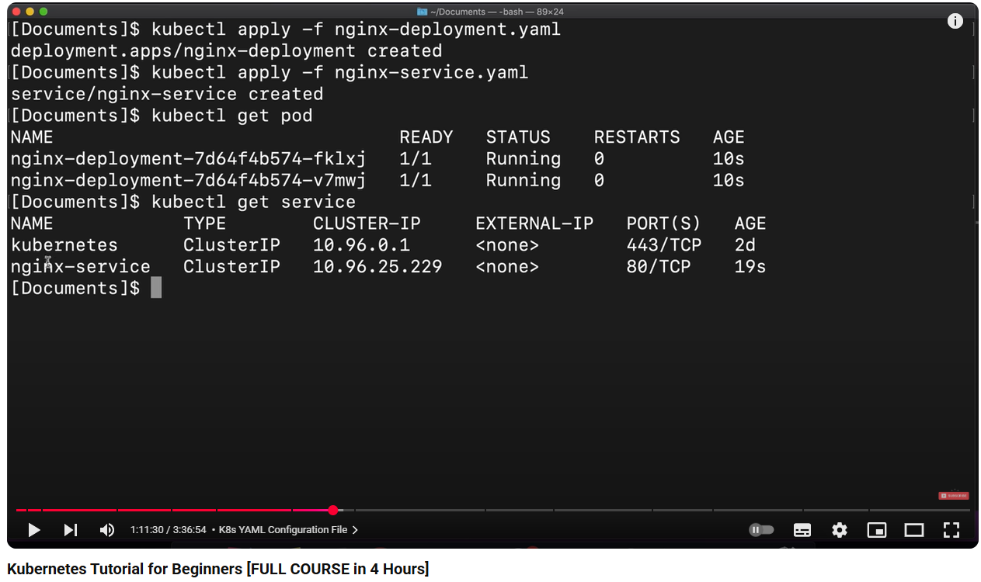
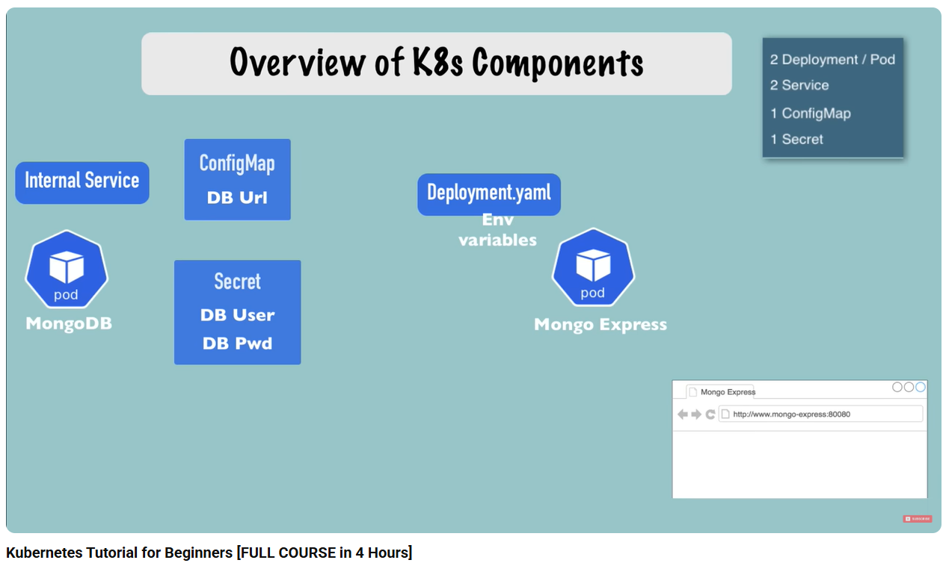
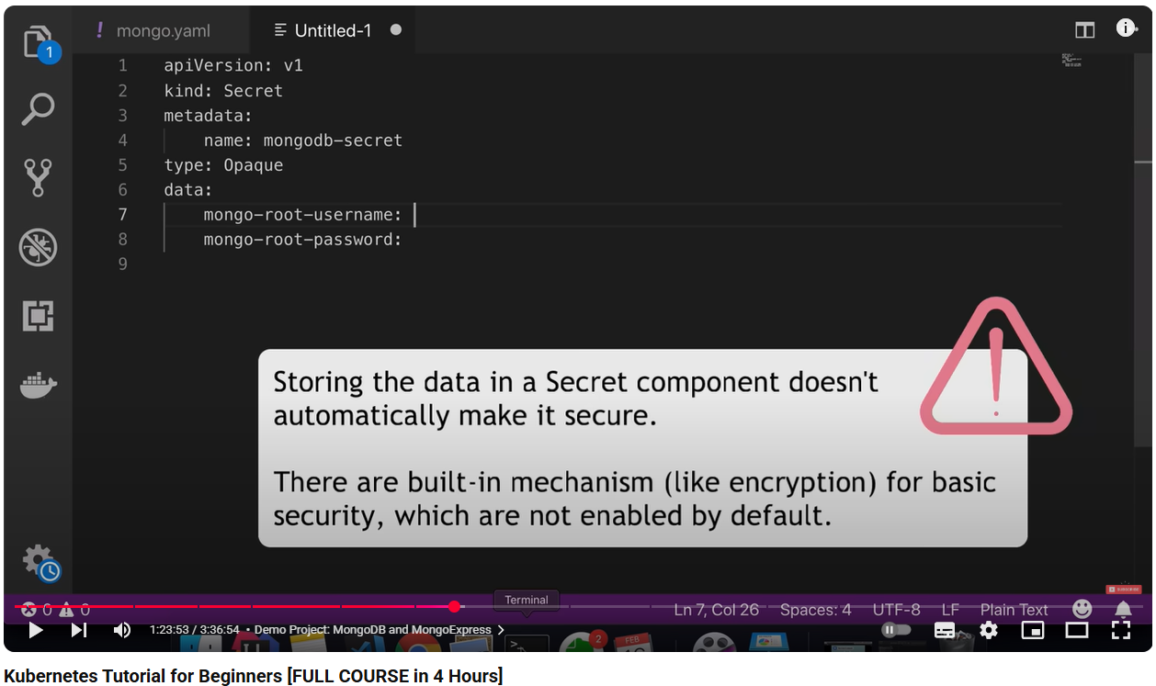
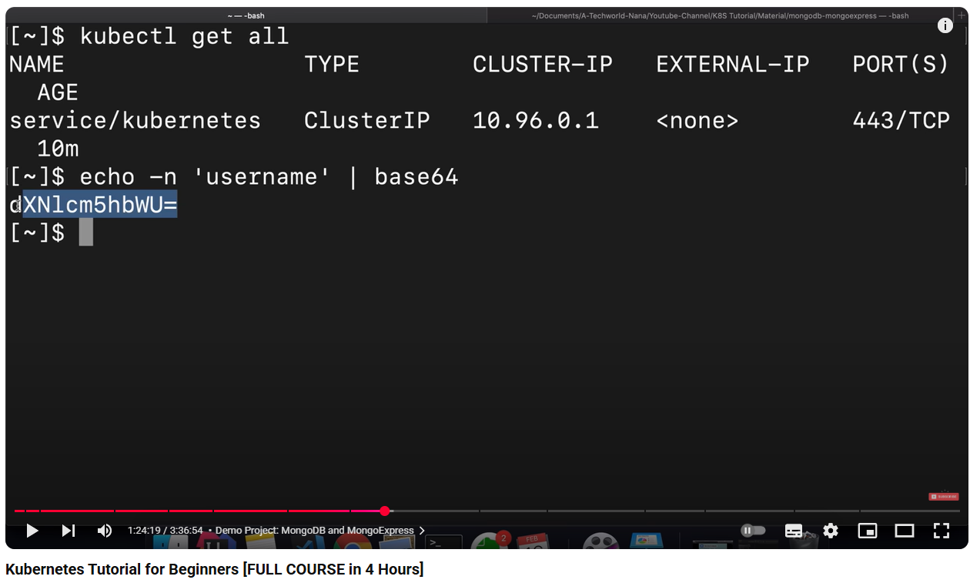
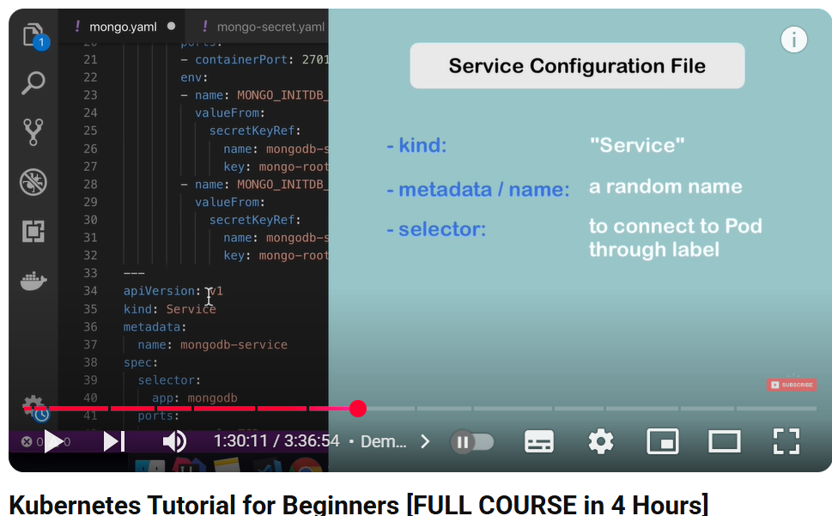
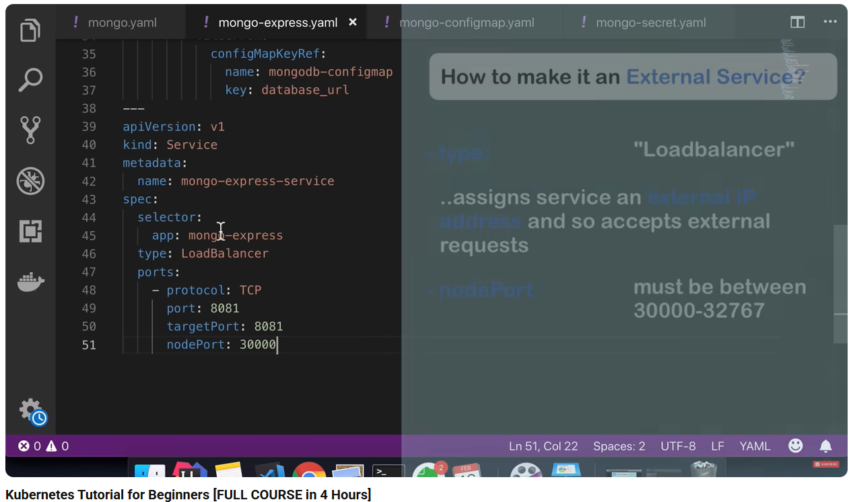
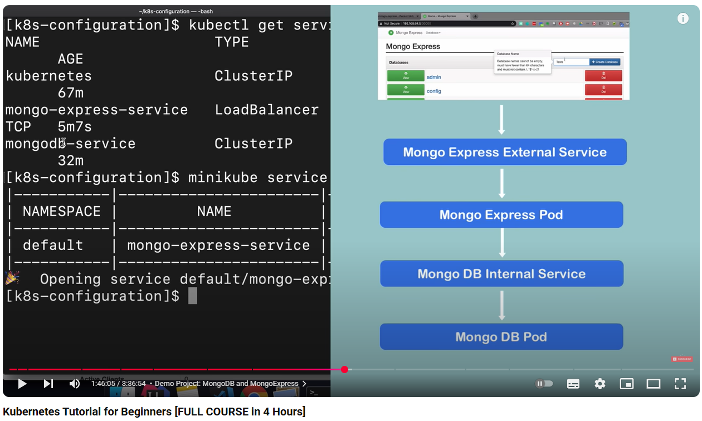
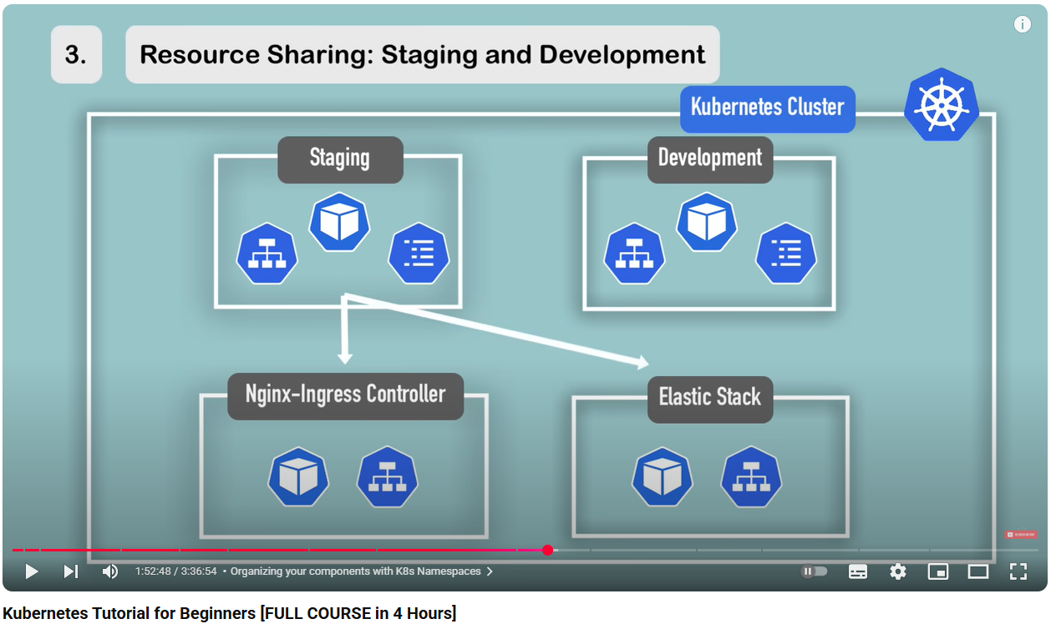
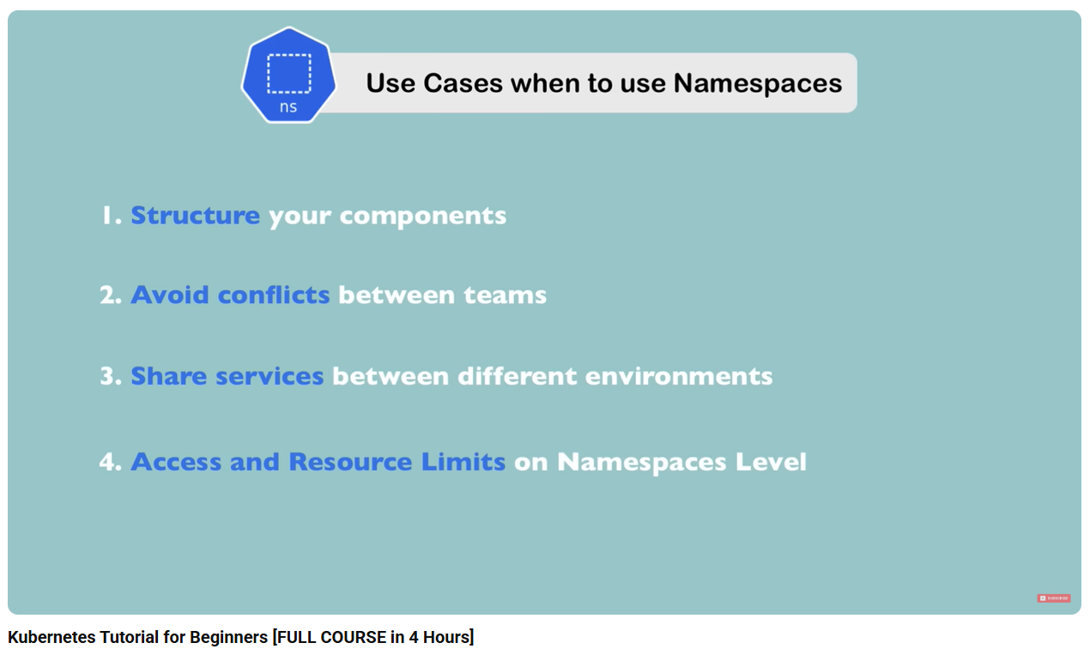
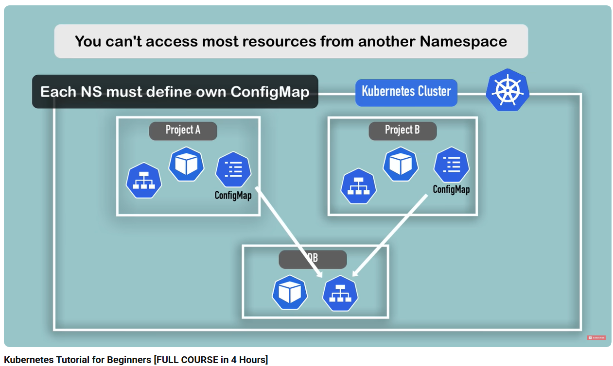
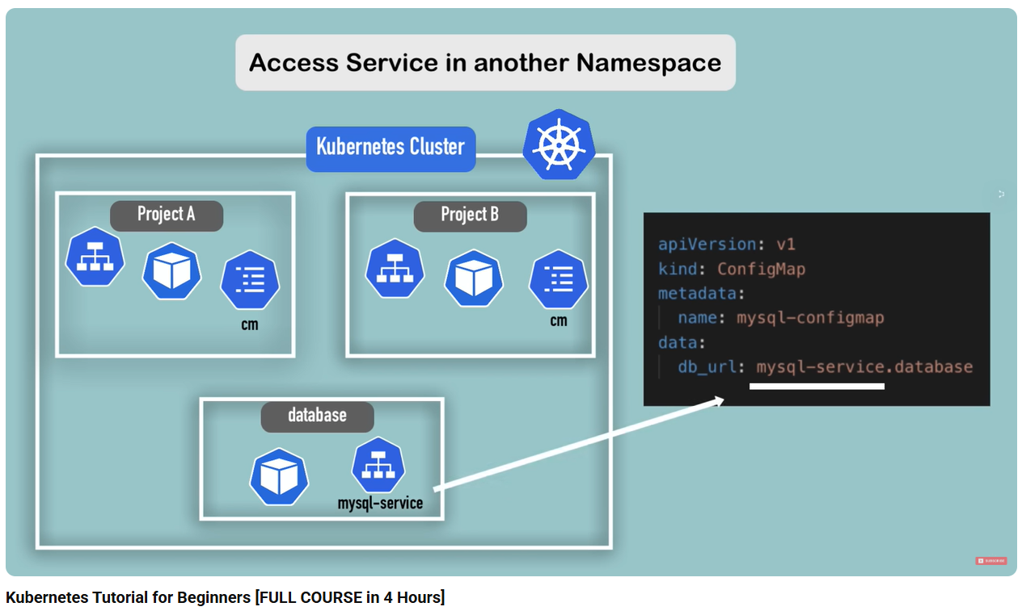
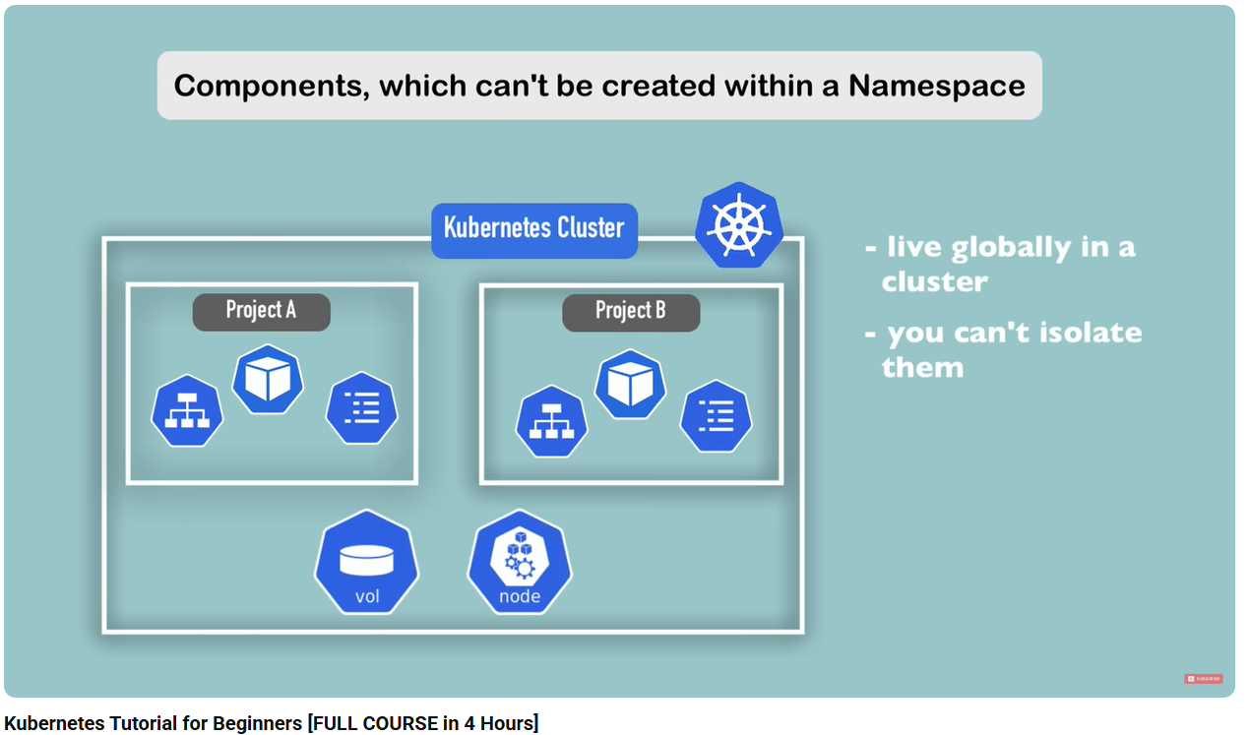
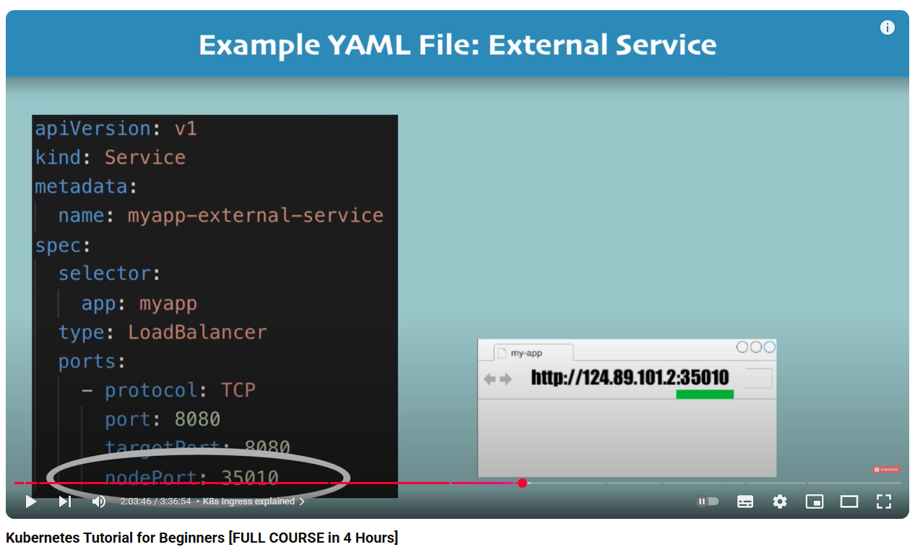
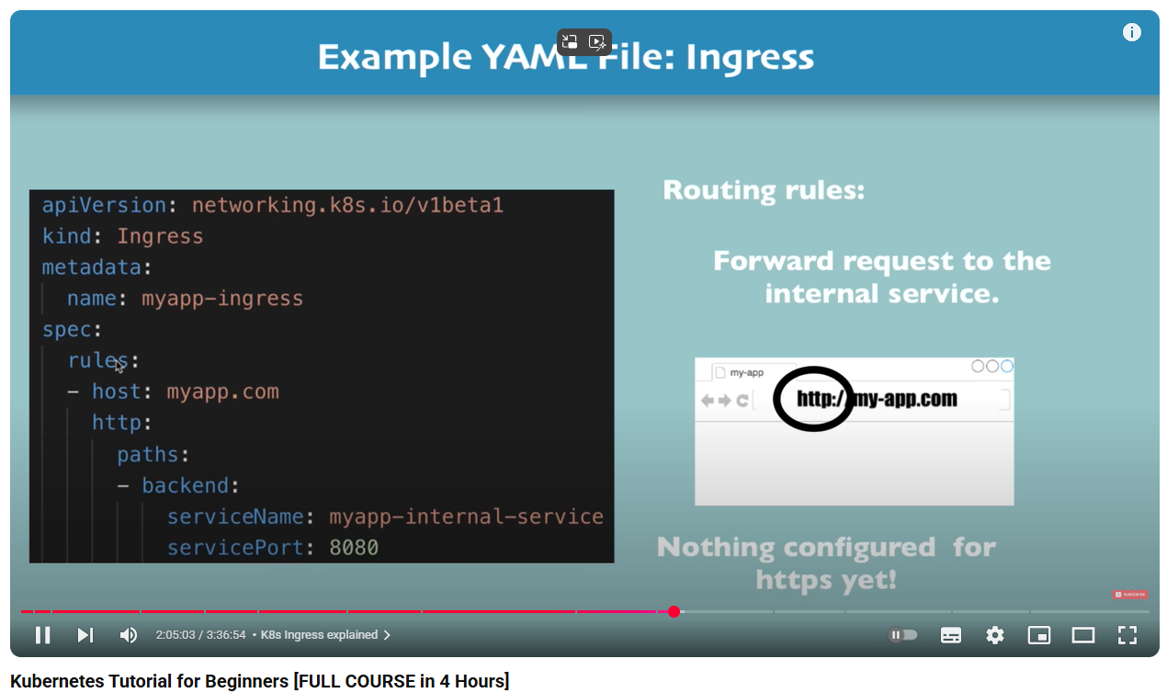
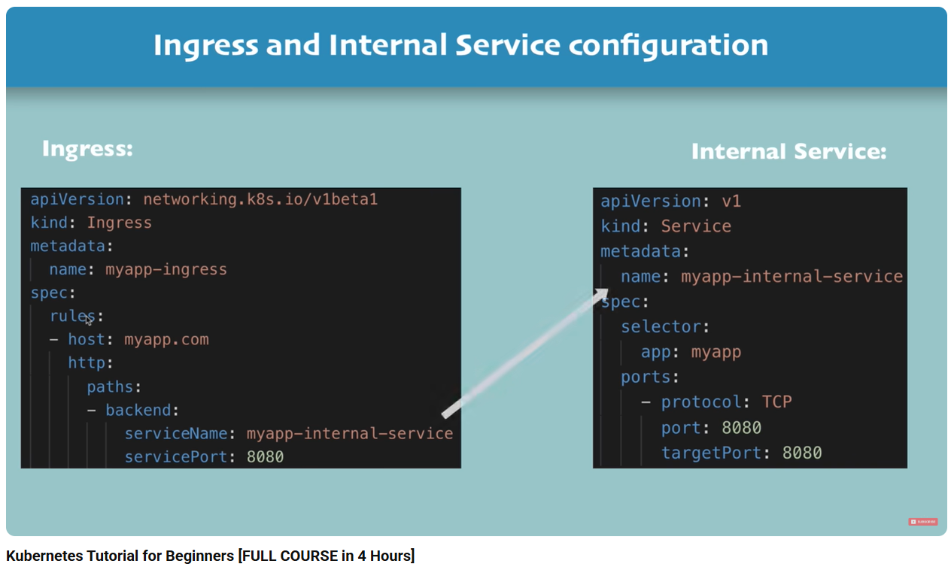
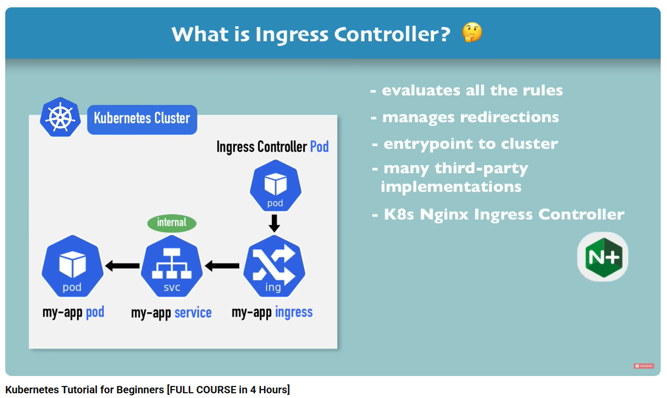
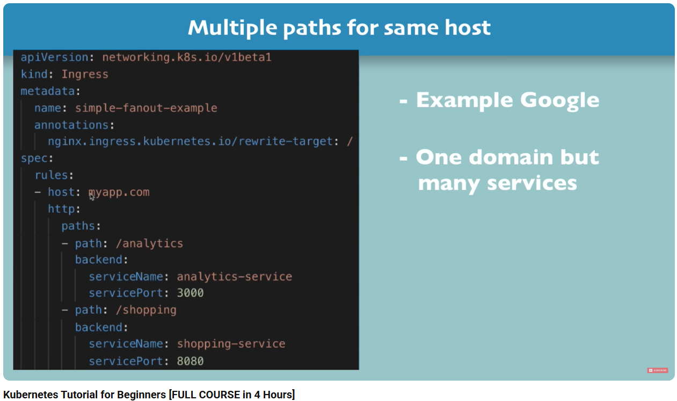
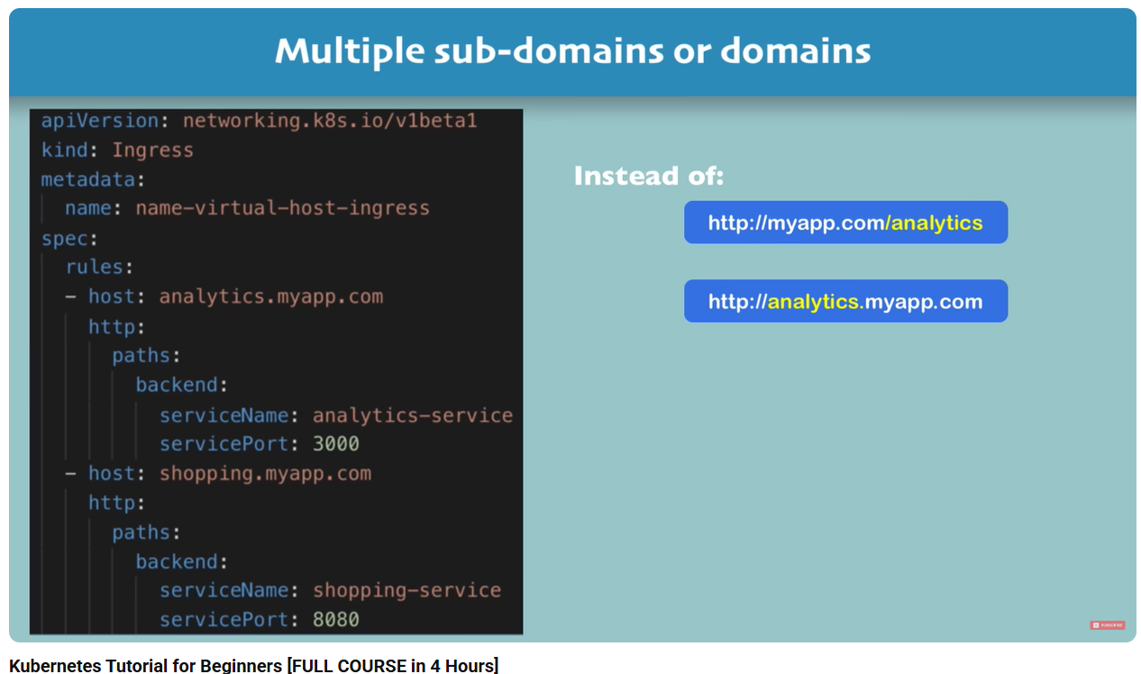
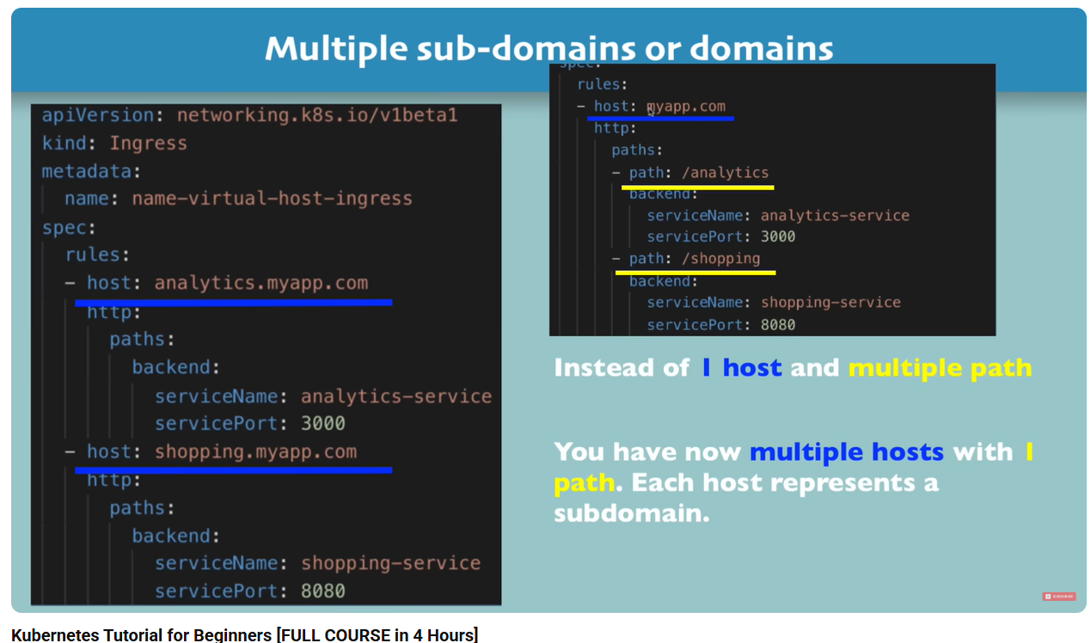
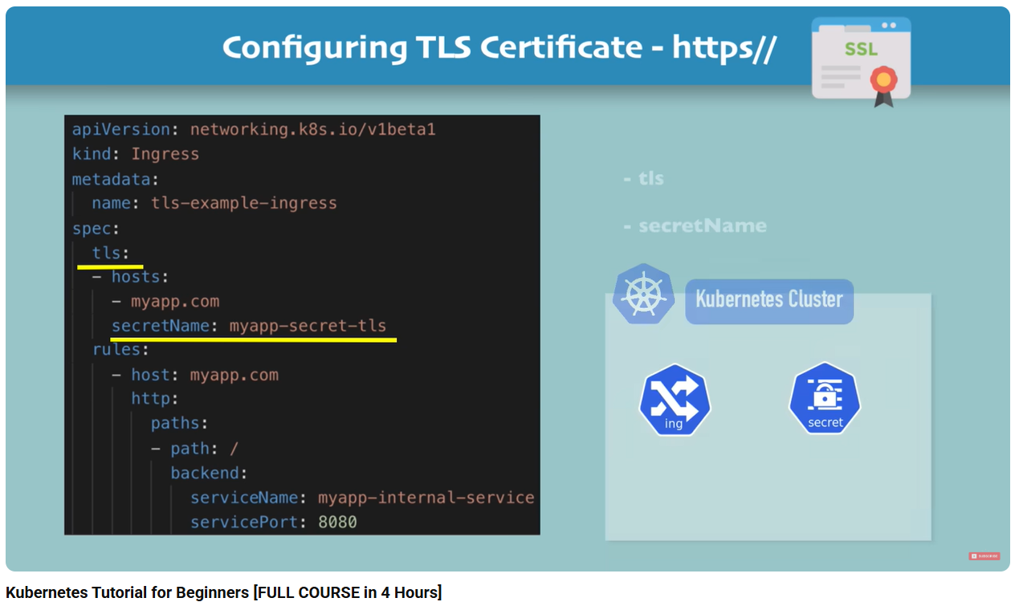
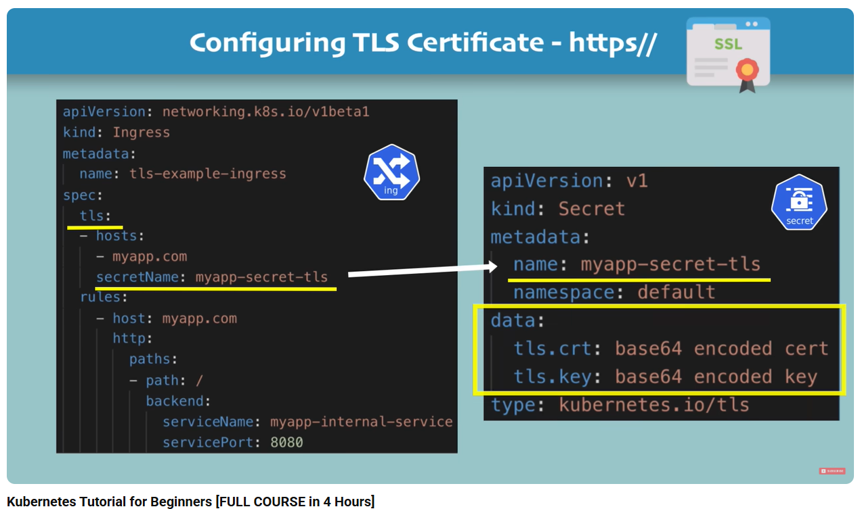
Helm: package management for Kubernetes
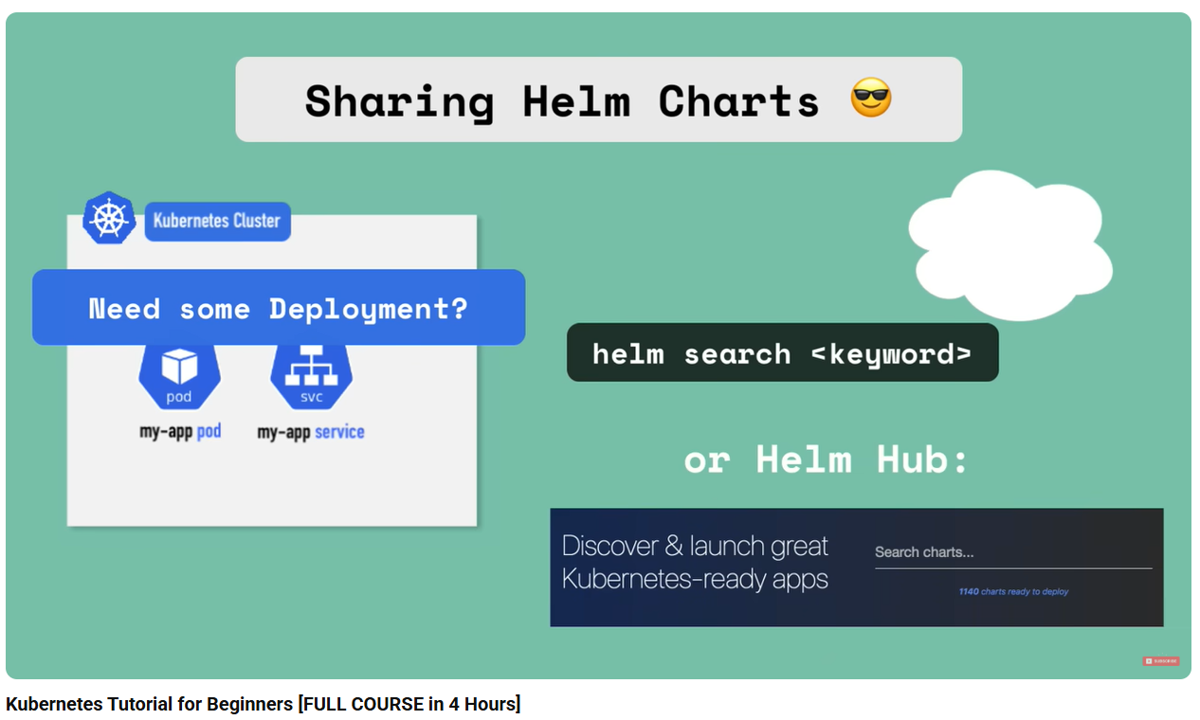
Helm is also a templating Engine
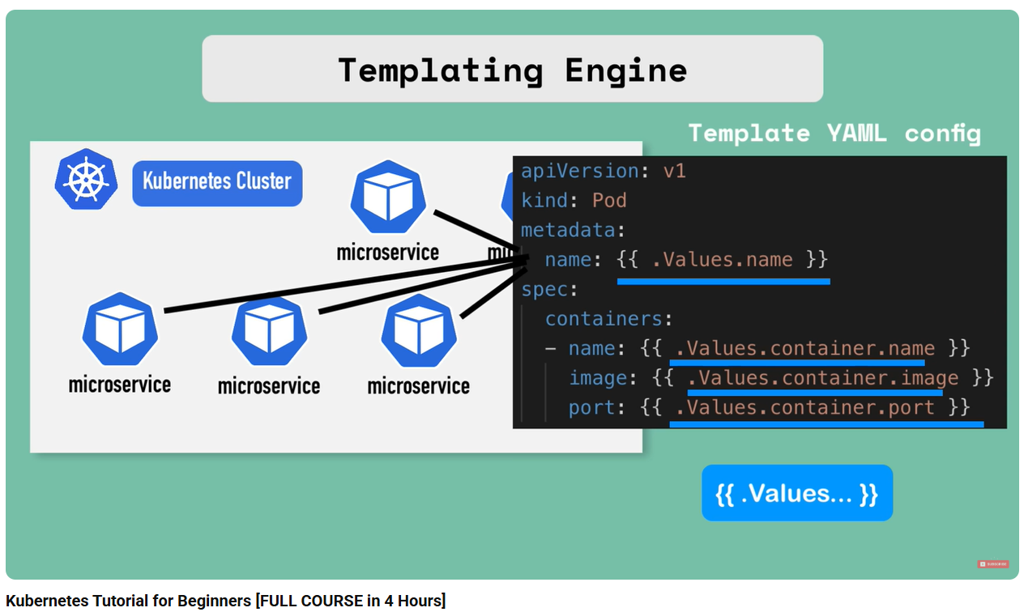
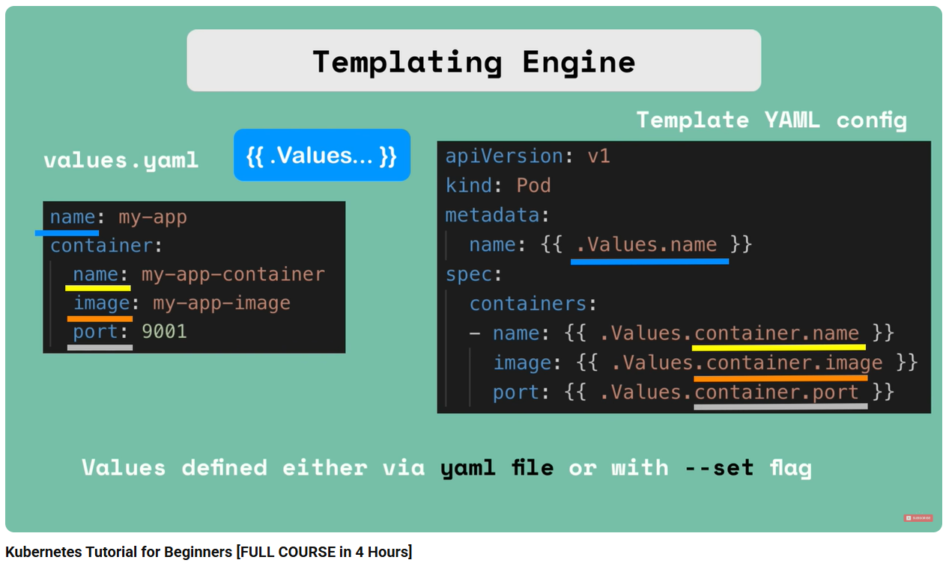
Helm: release management
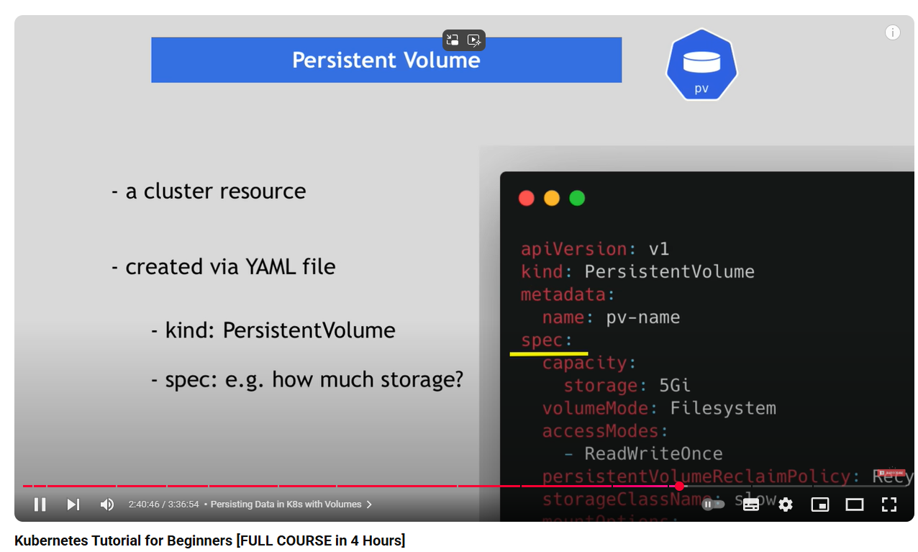
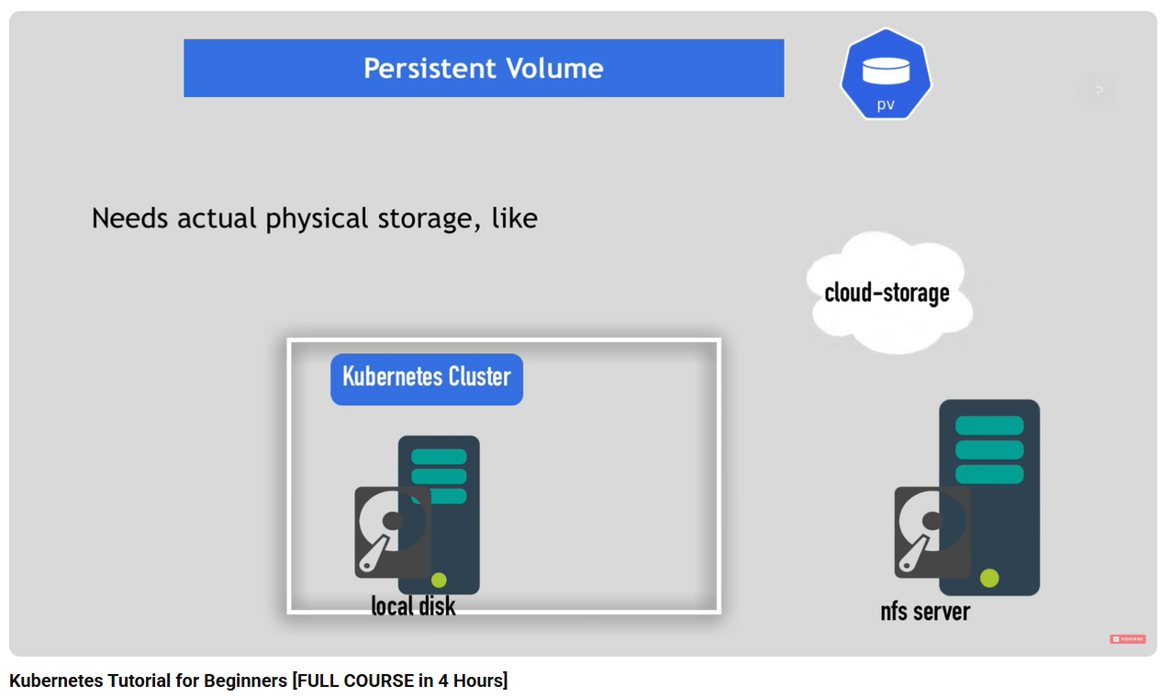
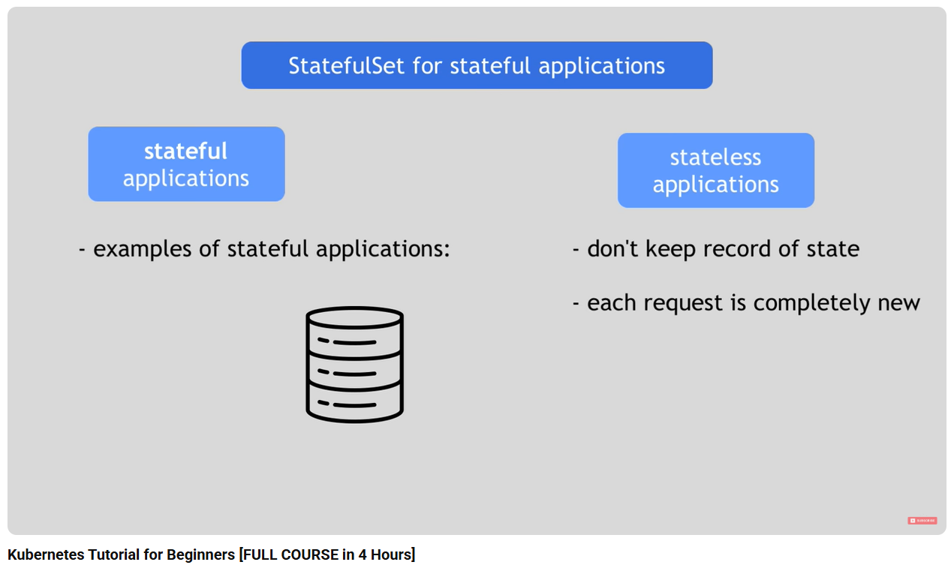
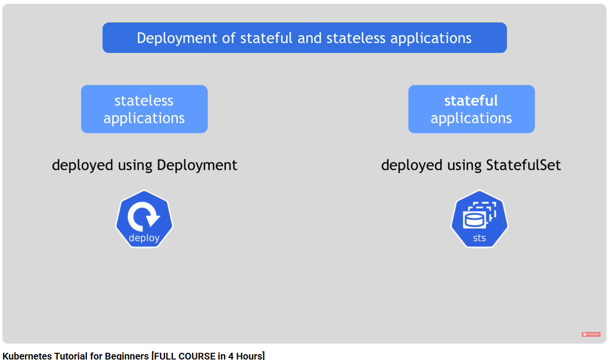
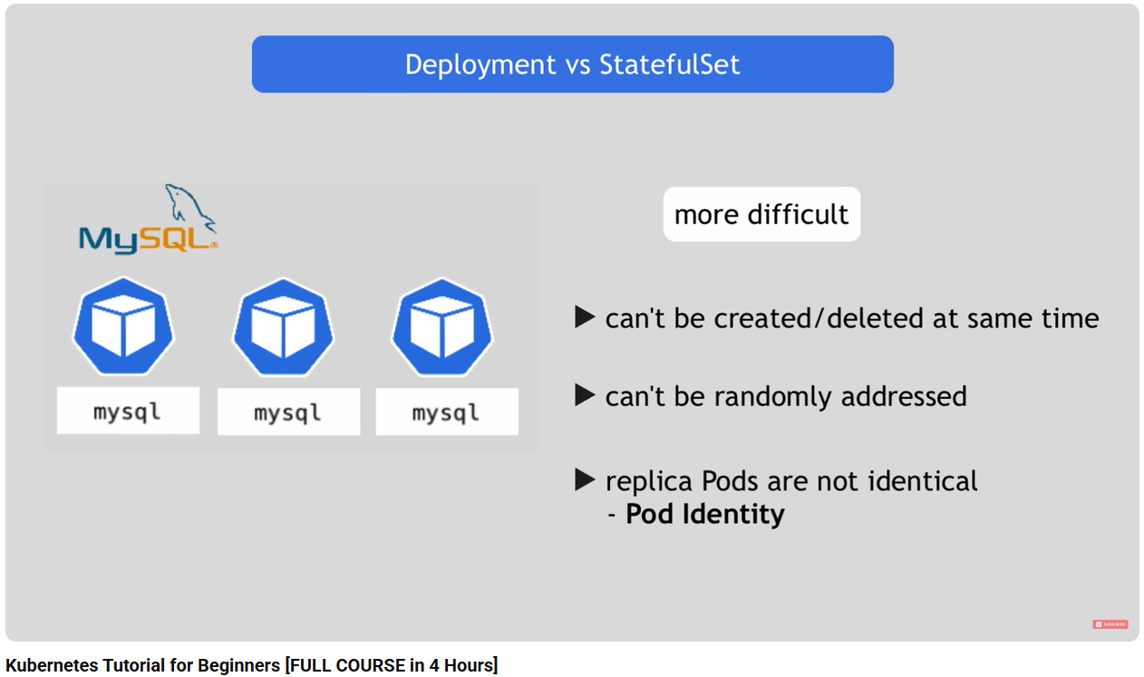
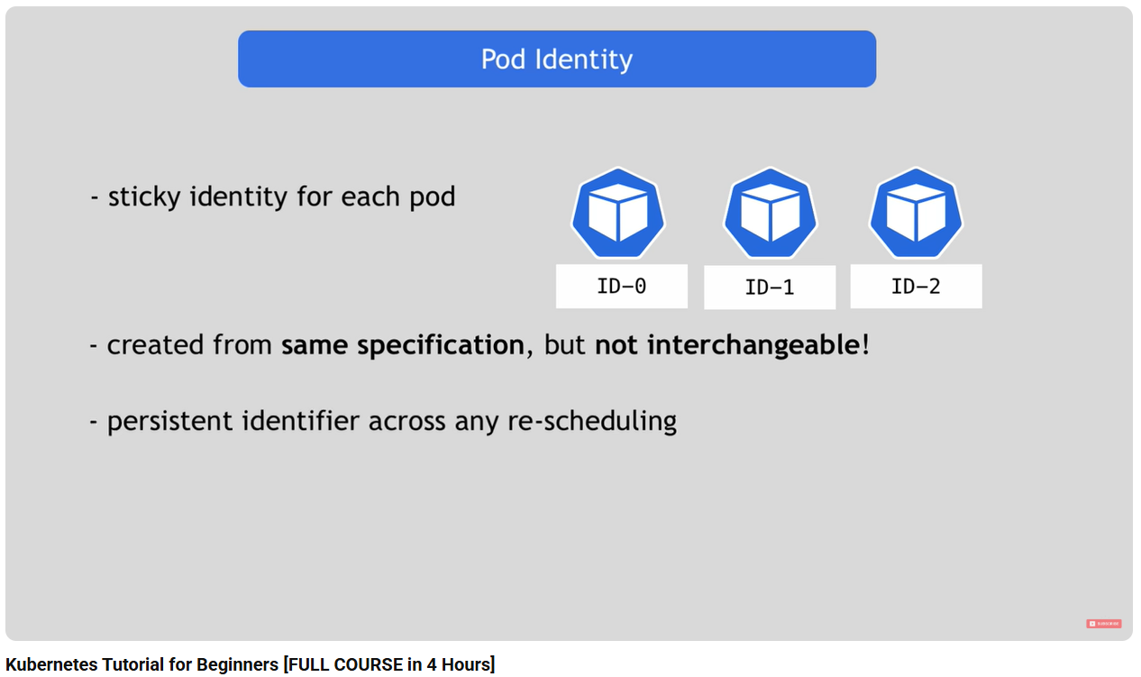
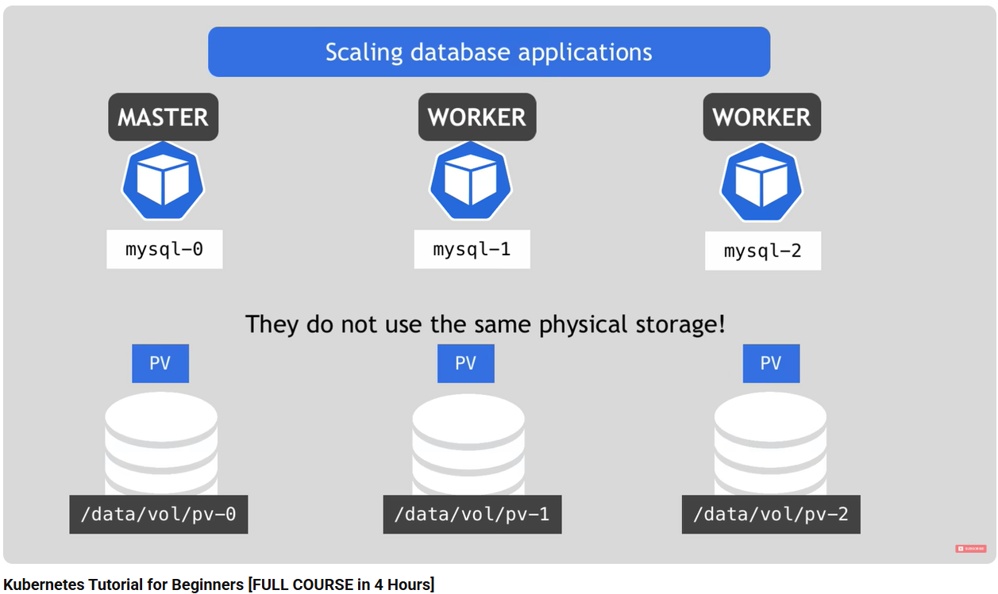
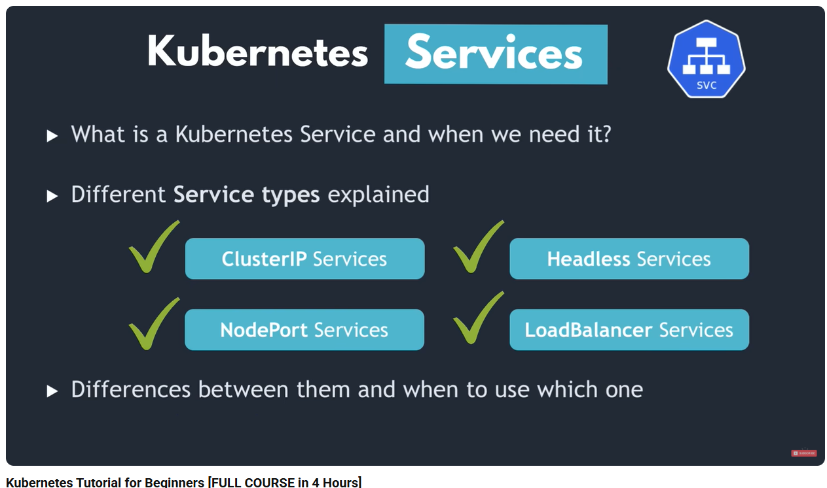
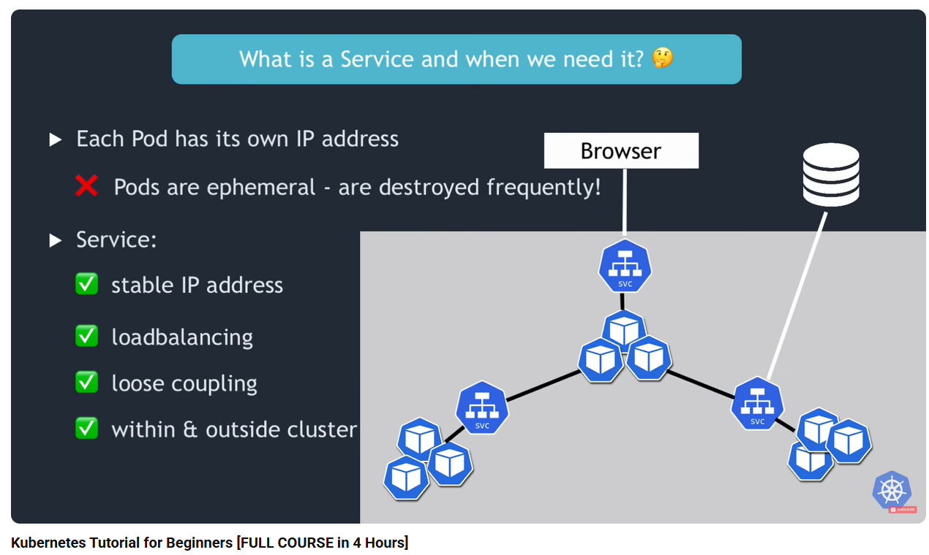
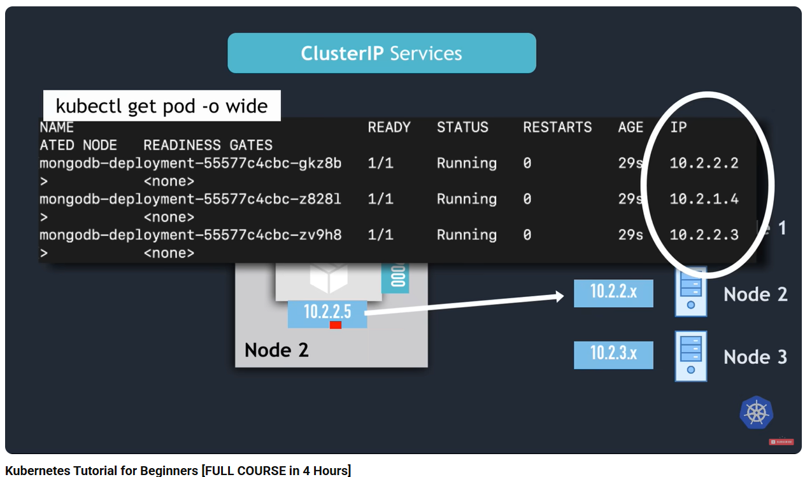
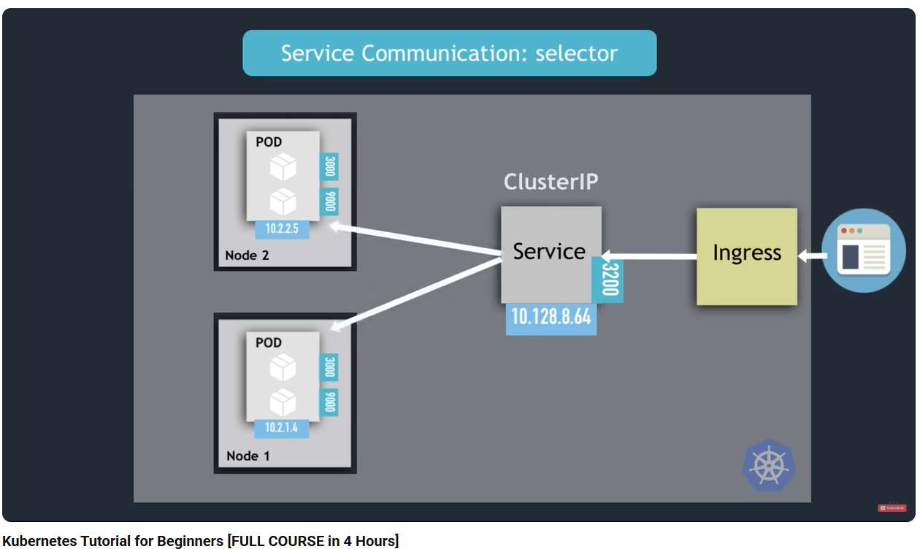
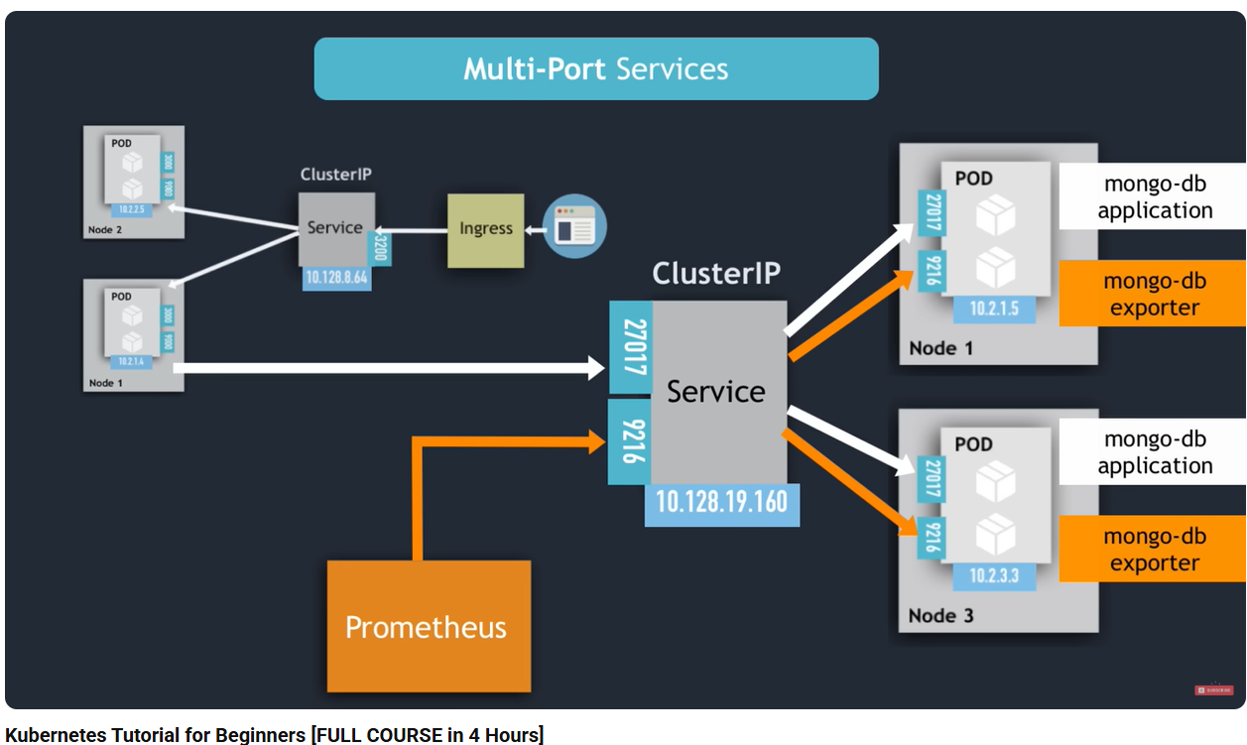
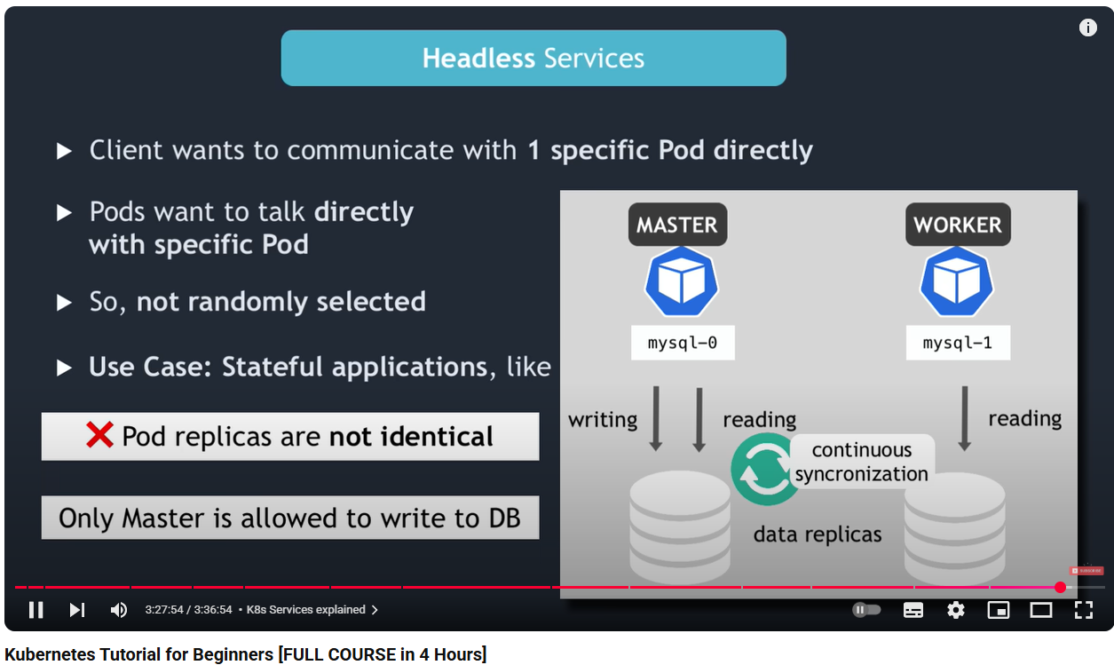
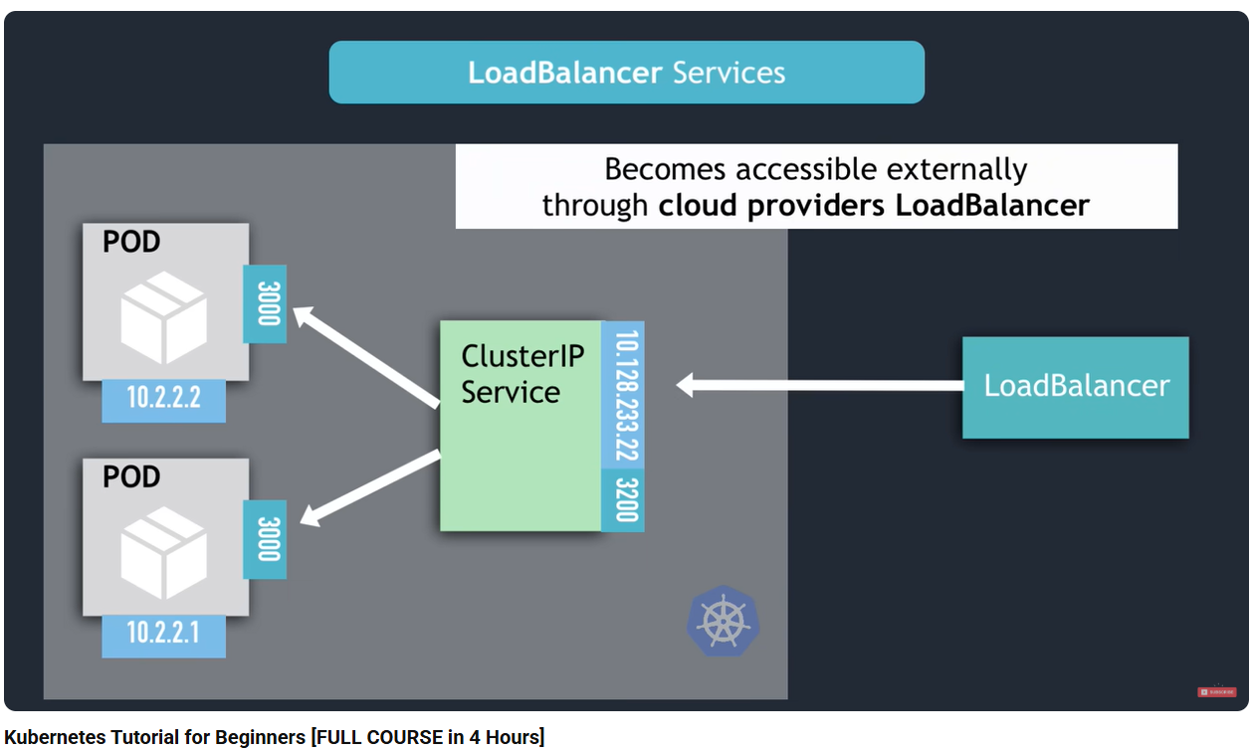
- https://gitlab.com/nanuchi/youtube-tutorial-series/-/tree/master
- Availability / Scalability / Restore & recover
- DB URL usually in the built application
- Data must be managed (backup, recover, etc.), k8s do Not manage them
- StatefulSet used for stateful application like database
- Worker Nodes are mandatory
- Must be installed in every node
  - Container runtime
  - Kubelet
  - Kube proxy
- Master Nodes
  - Api server (load balanced between all master nodes)
    - Through UI, API and/or CLI (kubectl)
  - Scheduler
  - Controller manager
  - etcd (distributed to all master nodes)
- on local machine, how to?
  - Use minikube
    - 1 node k8s cluster
    - Virtual box
    - Docker pre-installed
    - For testing purposes
- kubectl
- marter node ~ control-plane rôle ?
- 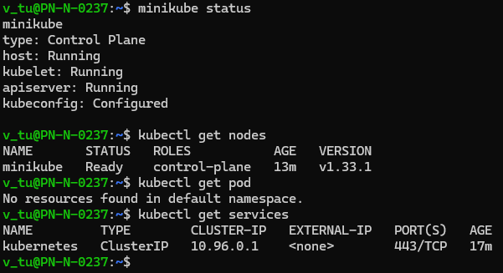
- In practice we do not handle pods directly
  - But its abstraction: deployment
- Need image, exemple nginx
- 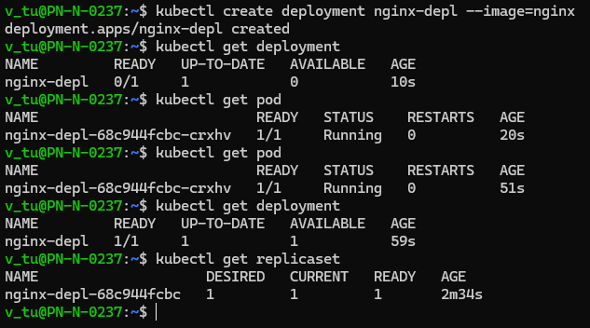
- Replicas are handled automatically; we don’t handle them at all
- 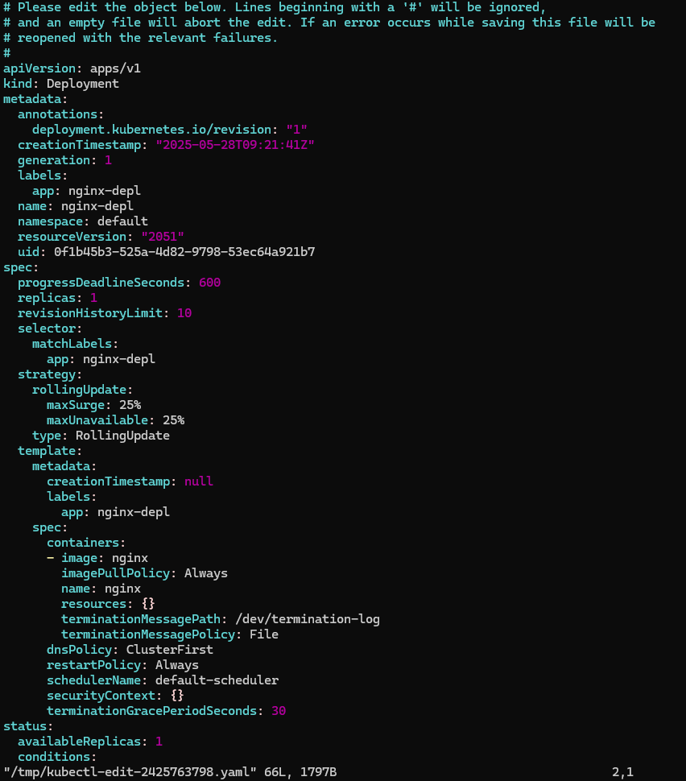
- Autogenerated file (default since we didn’t specify anything
  - kubctl create deployment <name of the deployment> --image=<name of the image>
  - kubctl get pod
  - kubectl logs
  - kubectl describe pod <name of the pod>
- delete deployment (delete pod and replicas)
- 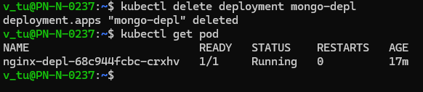
- Configuration
  - 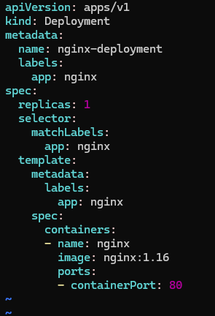
  - 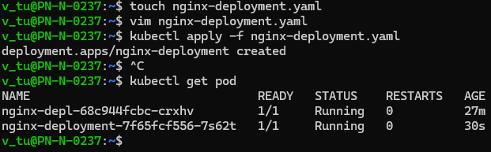
  - 3 parts
    - Metadata
    - Specification
    - Status (will be completed by k8s: Desired vs Actual)
- Service
  - 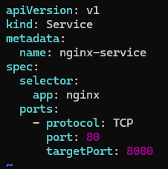
  - 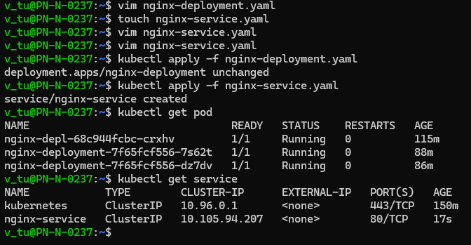
  - 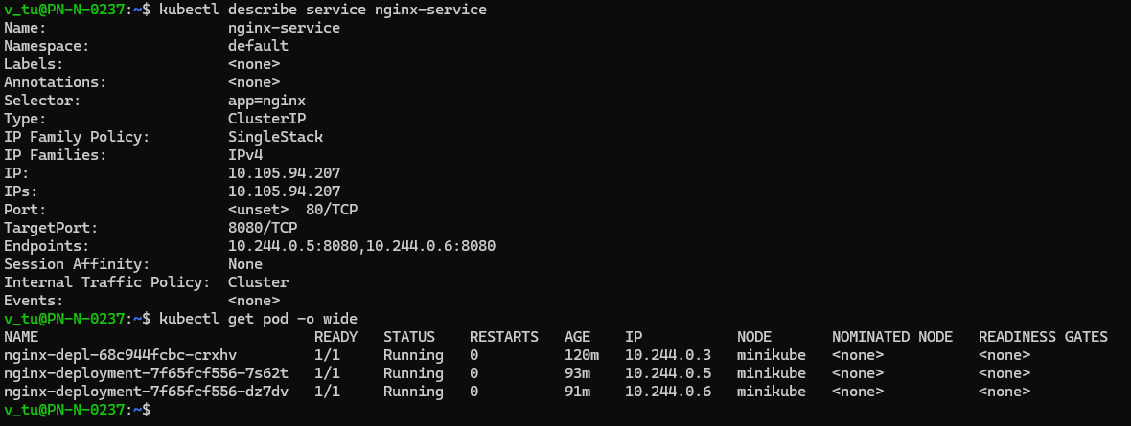
- kubectl get deployment nginx-deployment -o yaml
  - 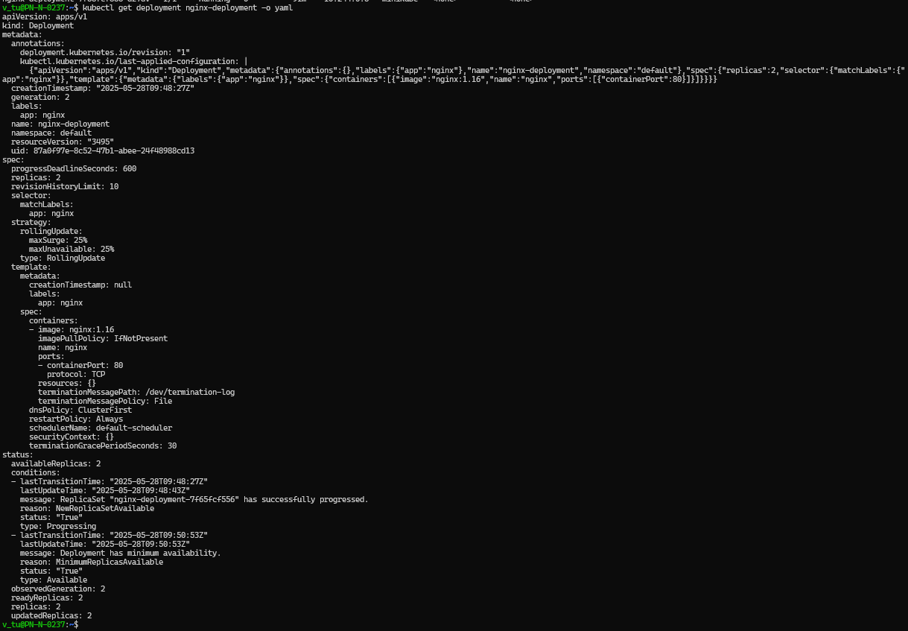
- Check containers configuration on https://hub.docker.com/
  - https://hub.docker.com/_/mongo
  - 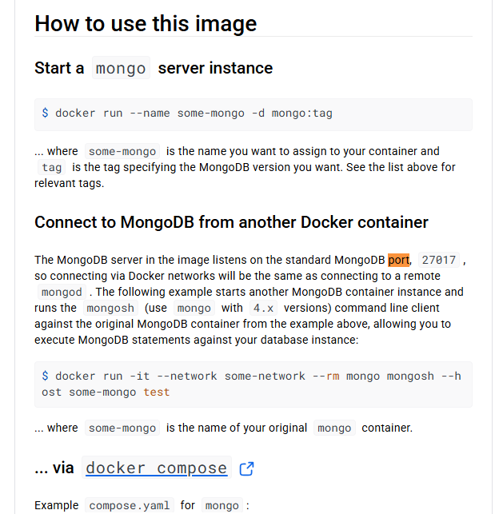
  - 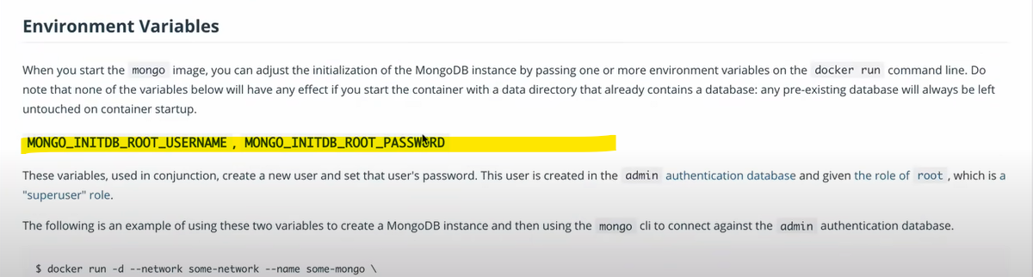
- New appli with secret
  - 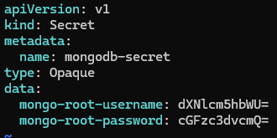
  - 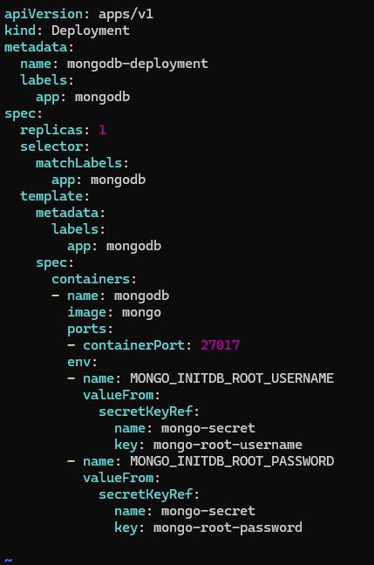
  - 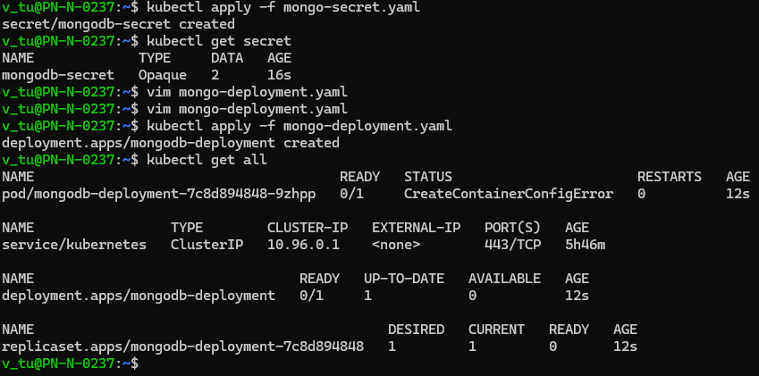
- Service
  - 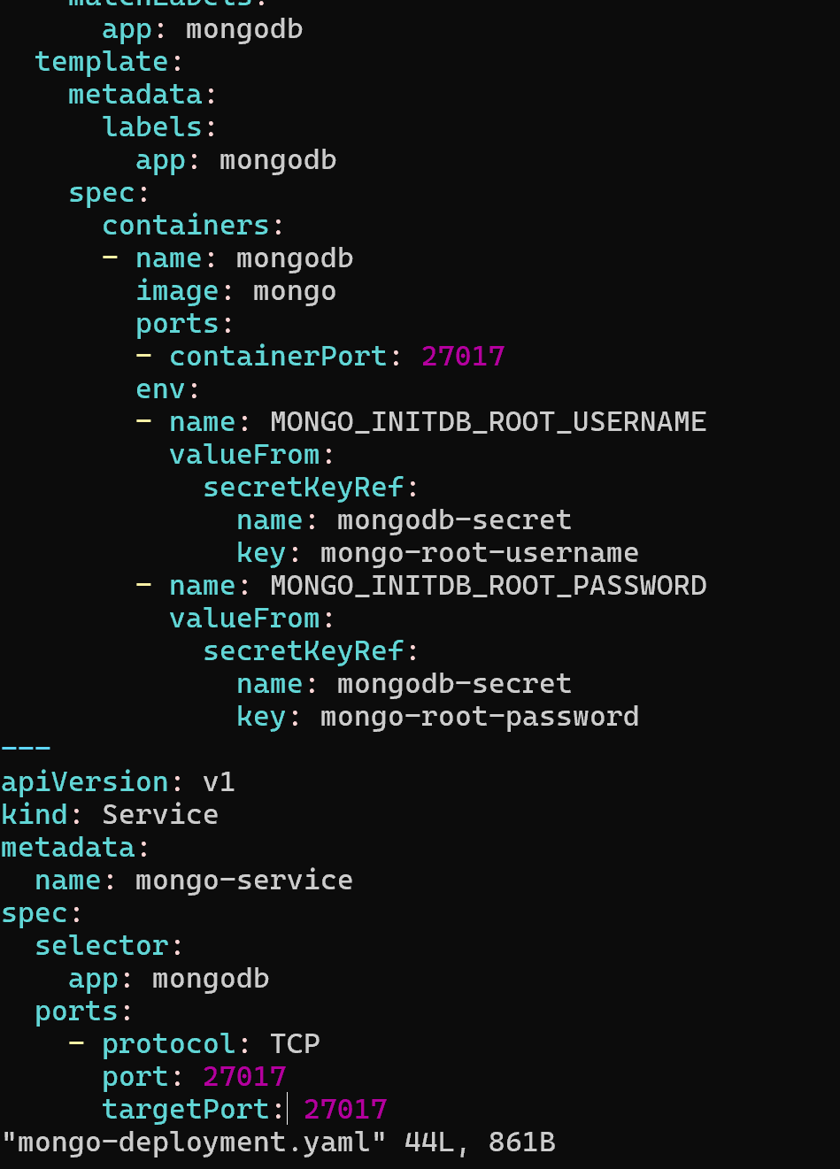
  - 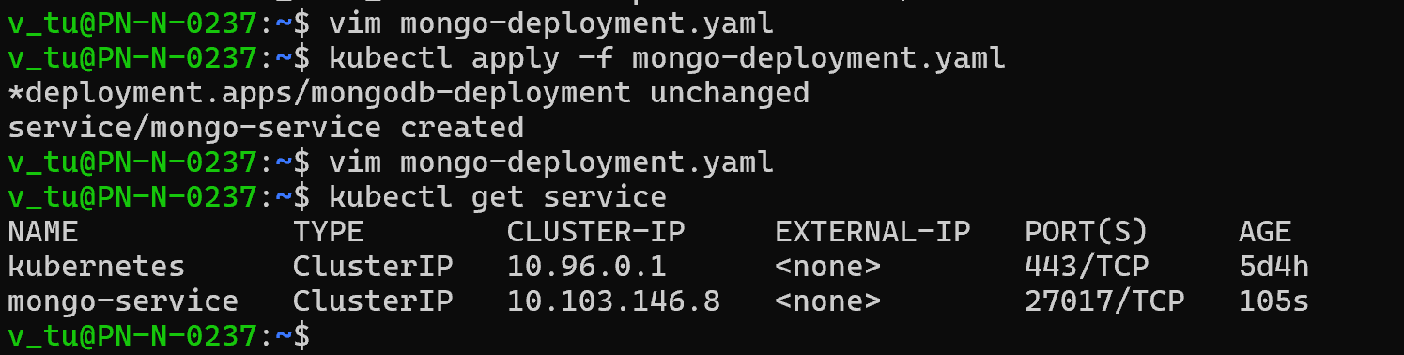
  - 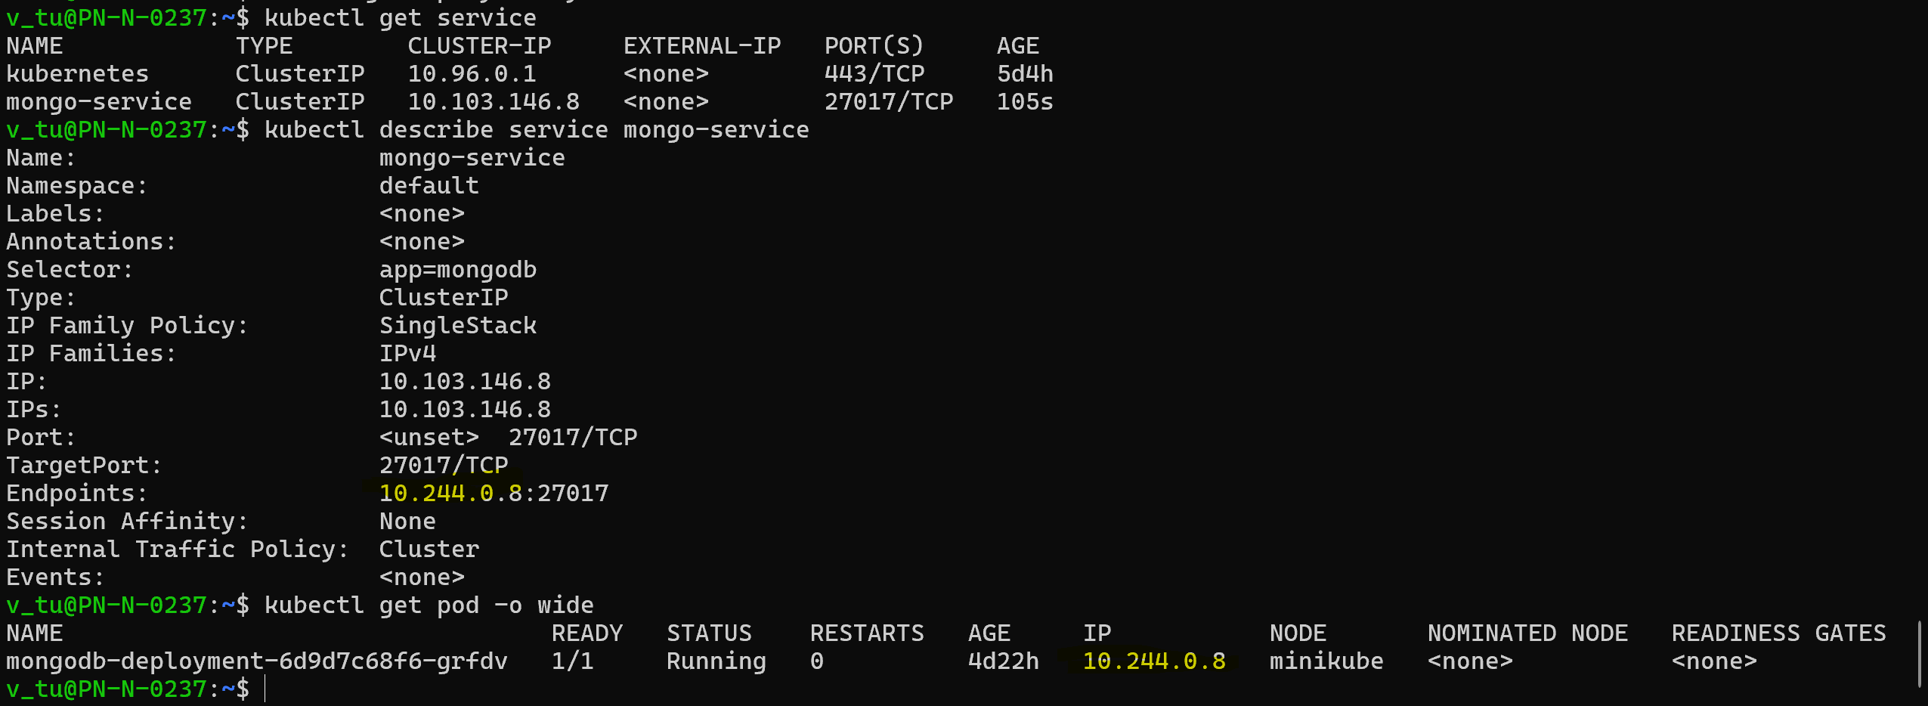
  - 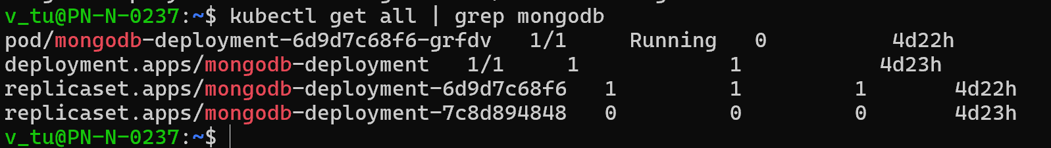
- Mongodb-express / configMap
  - database_url refers to the service:
  - 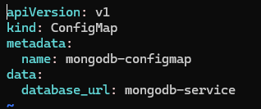
  - 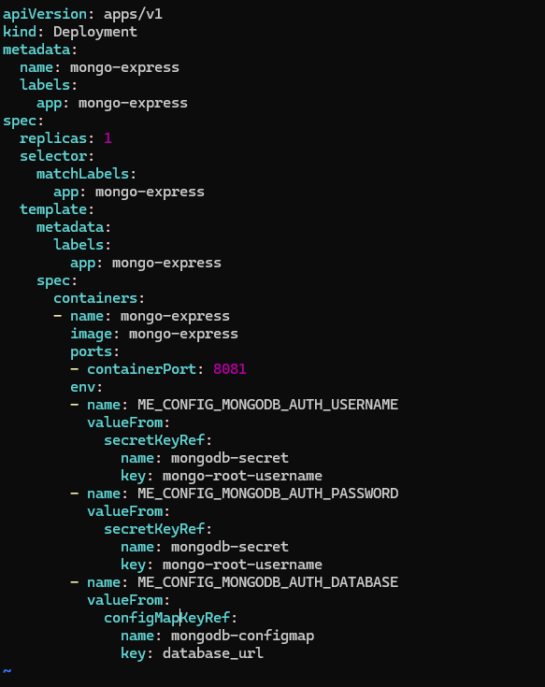
  - kubectl apply -f mongodb-configmap.yaml
  - kubectl apply -f mongo-express.yaml
- external service
  - 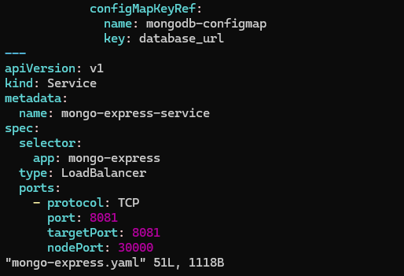
  - 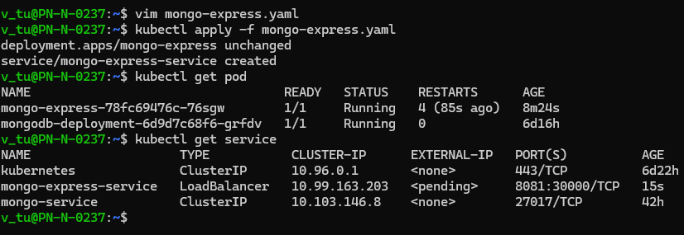
  - 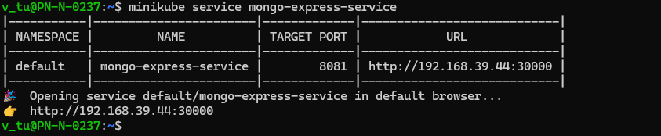
- Namespace
  - Virtual cluster inside the cluster
  - Example of namespace
    - Resources grouped: a namespace for DB, a namespace for mentoring, etc.
    - Teams grouped: for example, several teams use the same naming, creating conflict
    - Resource sharing:
      - Environment: staging, development + common resources (like elastic stack for example)
      - Blue/Green deployment: blue deploy, green deploy + common resources
    - Limit resources and/or access (example rights control, resource limitation, etc)
  - Cannot be shared between namespace: configMap or secret, even for a same resource, need to be duplicated for each resource needed
  - Can be shared between namespace: service
- External service VS Ingress: to access to the application
  - External service
    - Simple to use
    - useful for quick tests,
    - Expose port, example: 192.60.11.5:4123
    - Not secure (http)
  - Ingress
    - Expected result
    - Looks like a proper address: my-app/com
    - Can be secured (https), default http
- Ingress
  - https://dev-k8sref-io.web.app/docs/services/ingress-v1/#ingressspec
  - 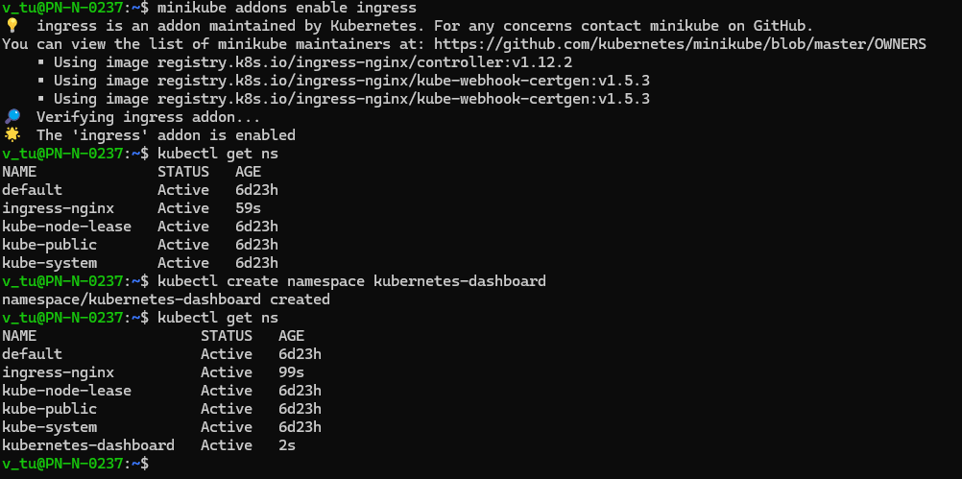
  - 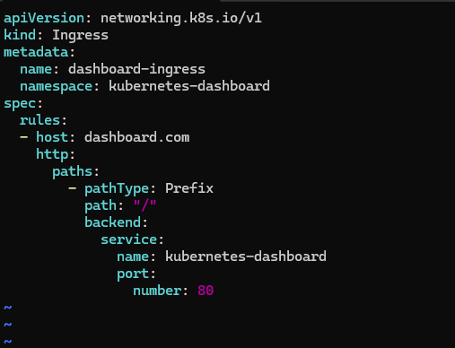
  - 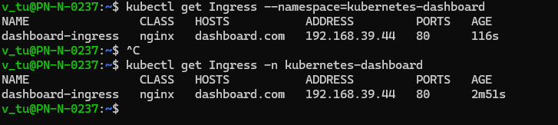
  - sudo vim /etc/hosts
  - 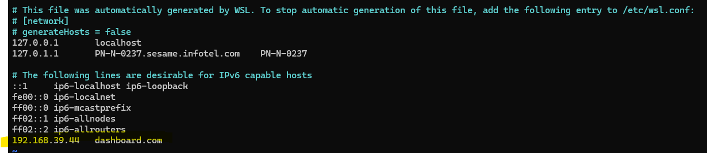
- Volume
  - Storage that doesn’t depend on the pod lifecycle (like a pod for mysql for e.g.)
- StatefulSet
  - for stateful application
  - can replicate pod
  - can run multiple replicates
- Service type
  - ClusterIP
    - Default
  - Headless
    - For statefull application (like db)
  - NodePort
    - Call the port directly
    - Not secure
  - LoadBalancer
    - Accessible and more secure than nodeport

Installer et configurer kubectl | Kubernetes
- Vous devez utiliser une version de kubectl qui diffère seulement d'une version mineure de la version de votre cluster. Par exemple, un client v1.2 doit fonctionner avec un master v1.1, v1.2 et v1.3. L'utilisation de la dernière version de kubectl permet d'éviter des problèmes imprévus.
- Installer KVM (hyperviseur) sur Ubuntu
  - https://computingforgeeks.com/install-kvm-virtualization-on-ubuntu-noble-numbat/
  - Configuration / Ajouter les permissions : https://help.ubuntu.com/community/KVM/Installation
  - 