**Written Report**

Based on the provided data, several conclusions can be drawn regarding crowdfunding campaigns. Firstly, live crowdfunding campaigns are the least probable events among all the outcomes and parent categories. Secondly, within the film and video category, the documentary subcategory exhibits the highest count of both successful and failed outcomes among all subcategories. Lastly, July stands out as the month with the highest count of successful crowdfunding campaigns and the highest grand total count of crowdfunding campaigns across all the years analyzed.

However, it's important to acknowledge the limitations of the dataset. The variations in the number of rows for each state make it challenging to determine which country might have the highest count. Furthermore, there is confusion regarding the units of measurement for the average donation, goal, and pledged columns, including whether they are based on home currencies. This uncertainty can impact the analysis of outcomes across different countries, introducing limitations to the dataset.

To enhance the analysis, several tables and graphs can be generated. A table presenting the duration of both successful and failed crowdfunding campaigns, along with statistical measures such as mean, median, minimum, maximum, standard deviation, and variance, can provide insights into how campaign outcomes may be influenced by the duration. Additionally, constructing a box plot using this data can visually depict the distribution and provide further understanding.

Other valuable tables and graphs could include a categorical bar chart showing the distribution of campaign outcomes across different categories or subcategories, a time series line chart to identify temporal trends in campaign activity, a geographic heatmap to visualize successful and failed campaigns across different regions, and a donut chart illustrating the percentage breakdown of funding goals within successful and failed campaigns.

By utilizing these additional visualizations and analyses, a more comprehensive understanding of the factors influencing crowdfunding campaign outcomes can be achieved.

**Statistical Analysis**

The data analysis reveals that, for both successful and failed campaigns, the median provides a better summary of the data due to the presence of skewness in the dataset. This conclusion is further supported by observing the boxplots, which clearly demonstrate the existence of outliers.

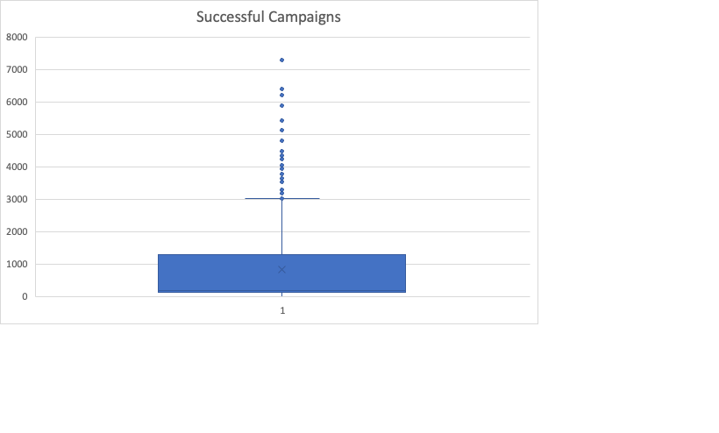

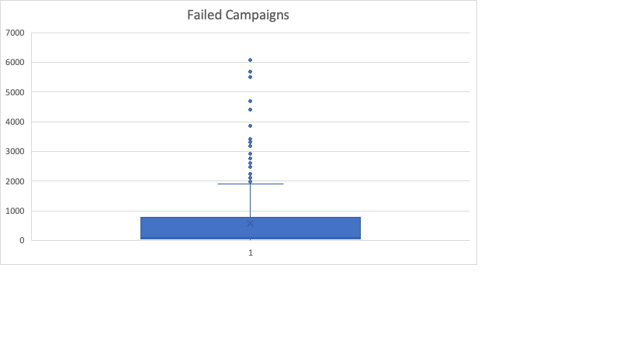

A higher variance signifies an increased level of variability or dispersion within the data. In the context of successful and unsuccessful campaigns, it can be observed that successful campaigns exhibit higher variability compared to unsuccessful campaigns. This observation is supported by the boxplots, which demonstrate a wider range of values for successful campaigns. Additionally, it is worth noting that the sample size of successful campaigns is also larger.

This conclusion makes sense because higher variability implies a greater spread of values, indicating a wider range of outcomes and potential successes in the case of successful campaigns. Conversely, lower variability suggests a more consistent or predictable pattern of outcomes, which aligns with the notion of unsuccessful campaigns having lower variability.

Therefore, based on the data and the aforementioned reasons, it is reasonable to conclude that there is more variability associated with successful campaigns compared to unsuccessful campaigns.