# Observability Implementation for OpenTelemetry-Demo

## 1. Introduction

The purpose of this project is to demonstrate a complete observability solution for the opentelemetry-demo application deployed on a Kubernetes cluster. The stack includes: - **OpenTelemetry Demo Application** (instrumented services for metrics, traces, logs) - **Prometheus** (metrics collection and alerting) - **Grafana** (dashboard visualization and alerting) - **Loki + Promtail** (centralized log collection and log-based alerts) - **Jaeger** (distributed tracing)

Infrastructure can be provisioned via **Terraform or via Command line** with **Helm** for Kubernetes deployments to ensure repeatable, automated deployments.

## 2. Deployment and Instrumentation

* The opentelemetry-demo application is deployed using Helm.
* Feature flags in the demo simulate service failures to validate alerting mechanisms.
* Supporting observability components (Prometheus, Grafana, Loki, Jaeger) are deployed as Helm releases using Terraform modules.



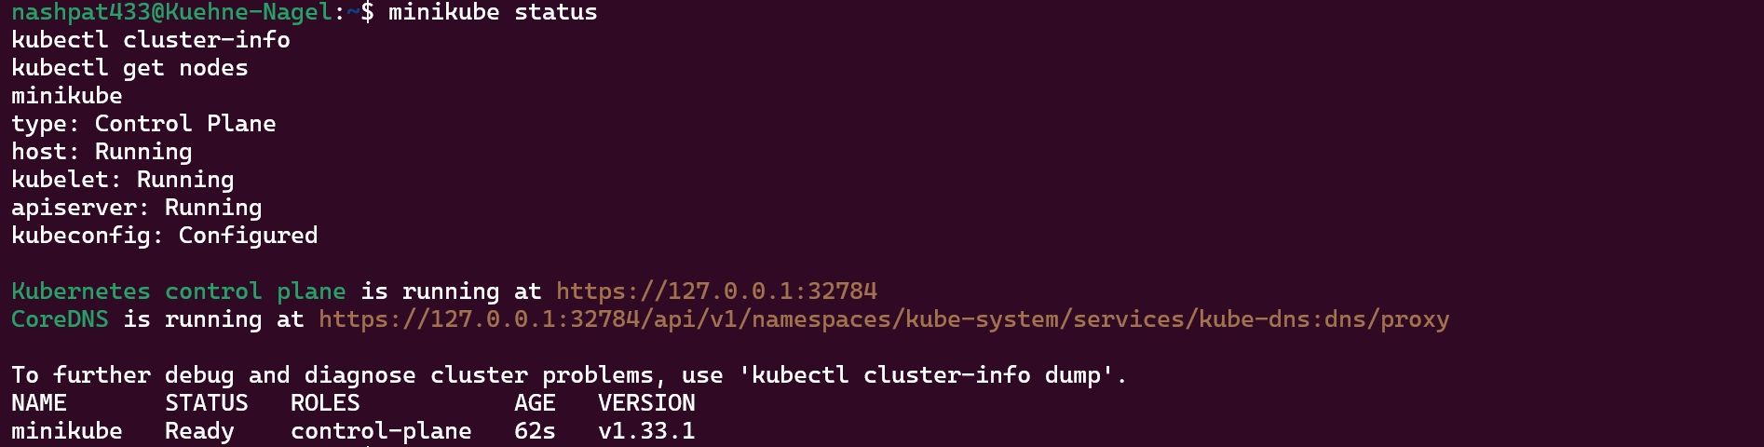

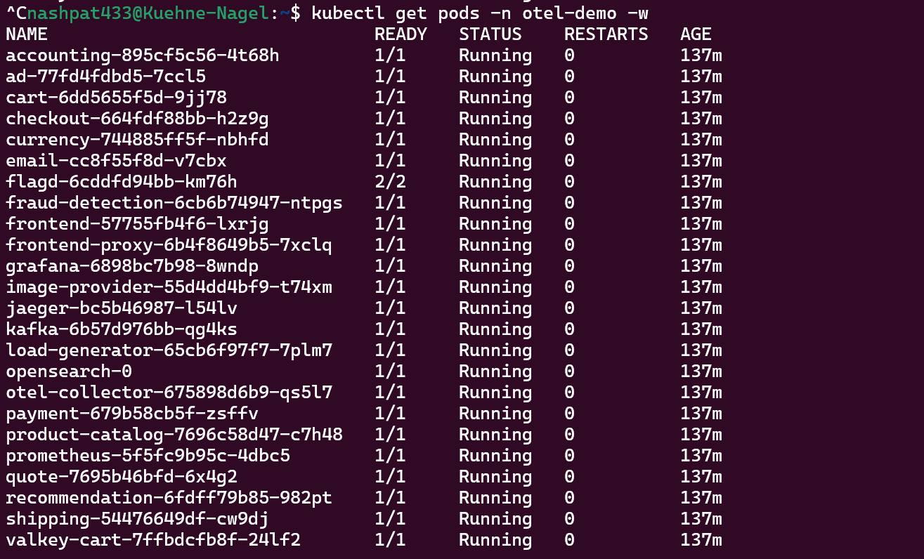

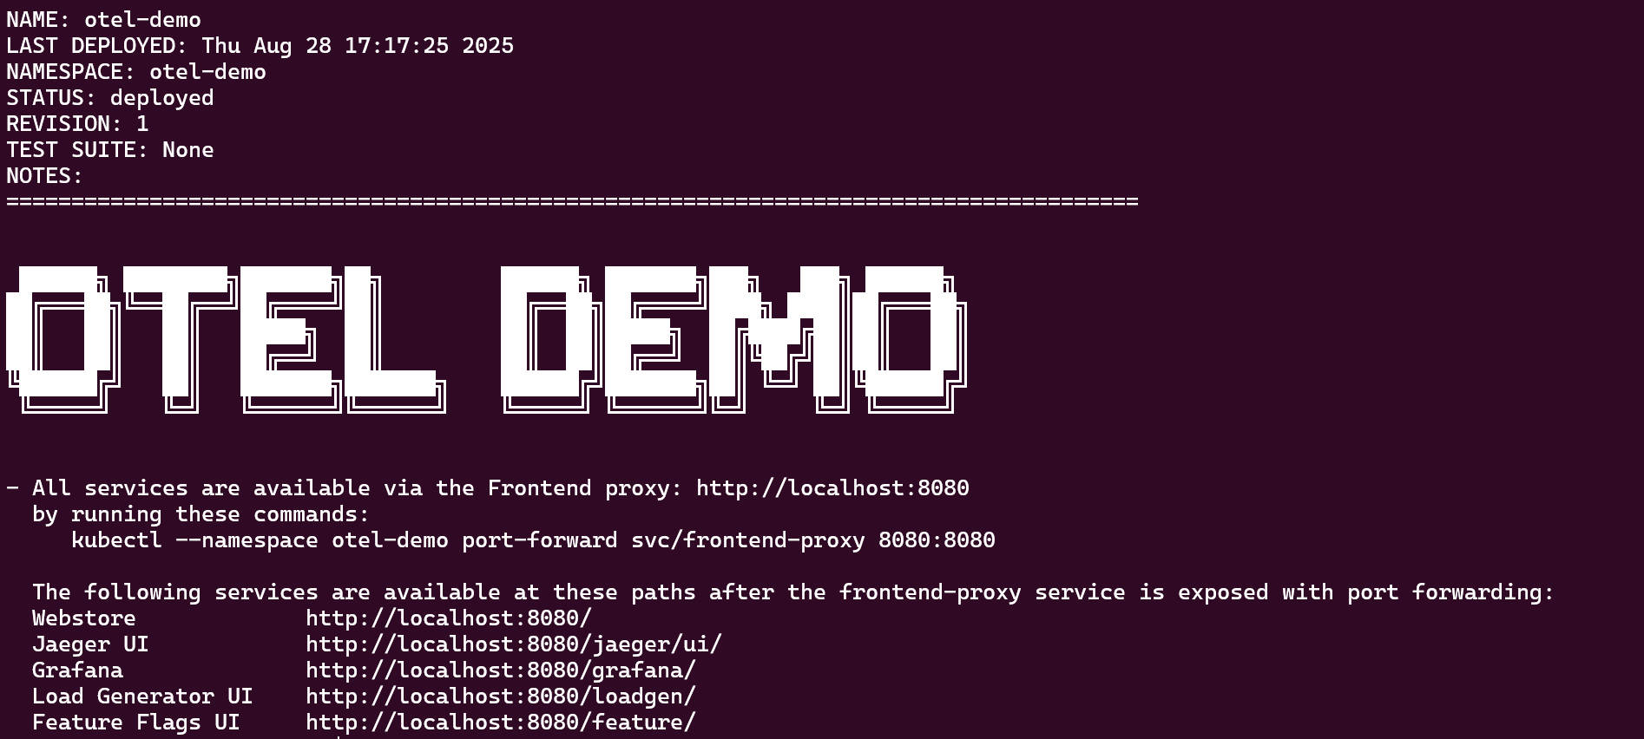

Access points were accessed via:



Services available:

* **Webstore UI** → <http://localhost:8080/>
* **Jaeger UI** → <http://localhost:8080/jaeger/ui/>
* **Grafana** → <http://localhost:8080/grafana/>
* **Load Generator** → <http://localhost:8080/loadgen/>
* **Feature Flags UI** → <http://localhost:8080/feature/>



## 3. Metrics Visualization and Dashboarding

A Grafana dashboard was created to monitor key KPIs:

|  |  |  |
| --- | --- | --- |
| Sr.no | Metric | Reasoning |
| 1. | Request Rate (RPS) – application throughput | Baseline for request volume; allows calculation of throughput, error rate, and success ratio. |
| 2. | Error Rate (%) – proportion of failed requests | High-level SLO/SLA indicator. Needed to detect outages, regressions, or feature flag failures. |
| 3. | Latency (p95, p99) – tail latency to capture worst-case scenarios | Captures user-perceived performance; p95/p99 are critical for customer-facing SLAs. |
| 4. | Checkout Success Rate | Directly tied to business KPIs (revenue impact). Critical to alert if payments fail. |
| 5. | Failed Orders Count | Complements checkout success; useful for understanding operational issues under feature flag failures. |
| 6. | Revenue per Minute | Business KPI – if revenue drops unexpectedly, it could indicate silent failures. |
| 7. | Service-Specific Latency | Breakdown latency per microservice (e.g., cart, checkout, currency). Helps isolate root cause. |
| 8. | Pod CPU Usage | Detects infrastructure bottlenecks and runaway processes. |
| 9. | Pod Memory Usage | Helps spot memory leaks or OOMKill scenarios. |
| 10. | Log Error Count | Complements metrics; detects failures not covered by HTTP status codes (e.g., currency conversion errors). |

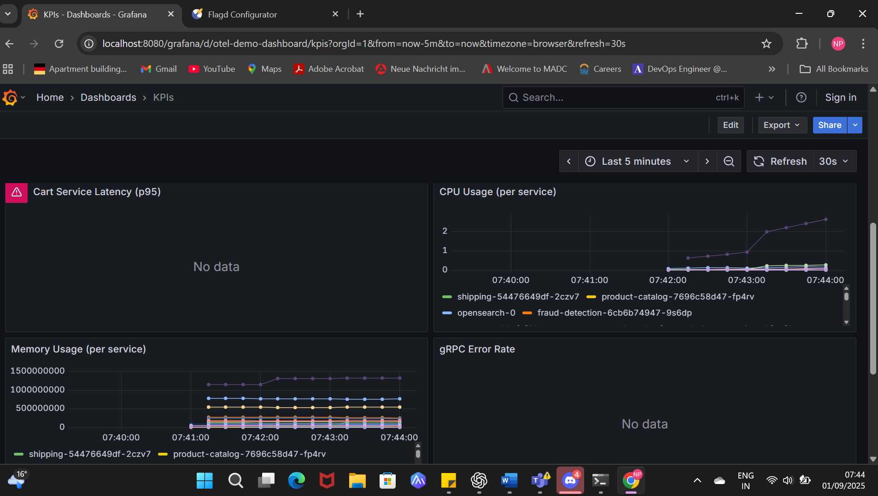

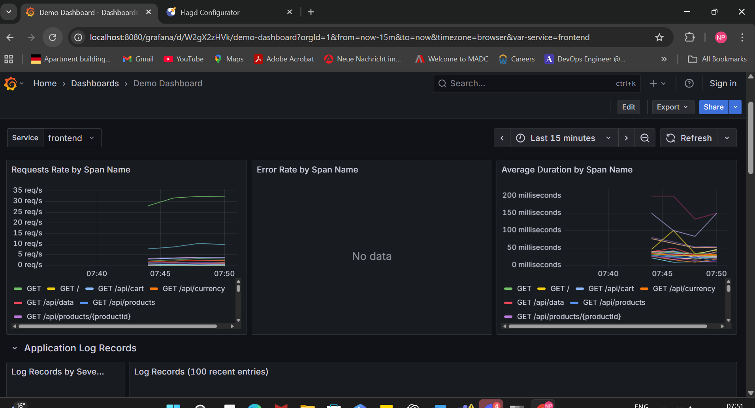



## 4. Metric-Based Alerting

Alerts Mapped to top metrics (Priority and Severtiy)

| **Alert name** | **Metric(s) used** | **Trigger (example)** | **For** | **Severity** | **Why** |
| --- | --- | --- | --- | --- | --- |
| HighErrorRate | http_requests_total{status=~"5.."} / http_requests_total | > 5% errors over 5m | 5m | critical | Primary signal of customer-visible failures |
| CheckoutSuccessLow | checkout success / checkout total | < 95% over 2m | 2m | critical | Business KPI — revenue impact |
| HighLatencyP95 | histogram_quantile(0.95, http_request_duration_seconds_bucket) | p95 > 2s | 5m | warning | UX degradation — tail latency |
| RevenueDrop | order_value_total rate | current 2m avg < 50% of 10m avg | 5m | critical | Silent loss of revenue |
| HighFailedOrders | order_failures_total rate | > 5 failures / min | 5m | warning | Operational issue with ordering |
| PodMemoryHigh | container_memory_usage_bytes / limit | > 80% | 3m | warning | Precursor to OOM / restarts |
| PodCPUThrottling | container_cpu_cfs_throttled_periods_total ratio | throttling > 20% | 5m | warning | Performance degraded due to throttling |
| CollectorDroppedTelemetry | otelcol_processor_dropped_spans or exporter failures | > 0 (or rising trend) | 5m | critical | Observability pipeline health (guardrail) |
| QueueBacklogHigh | queue_length (kafka/redis) | length > threshold (e.g., >1000) | 5m | warning | Worker backlog — delivery risk |
| NoTraffic | sum(rate(http_requests_total[5m])) | == 0 | 5m | critical | Outage or loadgen misconfig — investigate quickly |

## 