Hydra

Hydra is a graphical tool used to run sequential actions on multiple objects simultaneously. Objects are mostly machines but every kind of objects can be used, like Users, Folders, ... The biggest part of this document will focus on machine operations but other objects are handled in the same way.

Typical sequences can be:

* Perform remote deployments on multiple machines
* Run some batches
* Read or set registry keys
* List files versions
* Execute anything remotely
* List attributes or perform actions on AD users or groups
* ...

# Interface

Hydra is quite easy to use and its interface has been made as intuitive as possible: define objects, select a sequence, and run it.

The interface is composed of a main grid in the middle where the objects are defined, a list of pre-defined sequences on the left, a menu bar and a running overview on the bottom part:

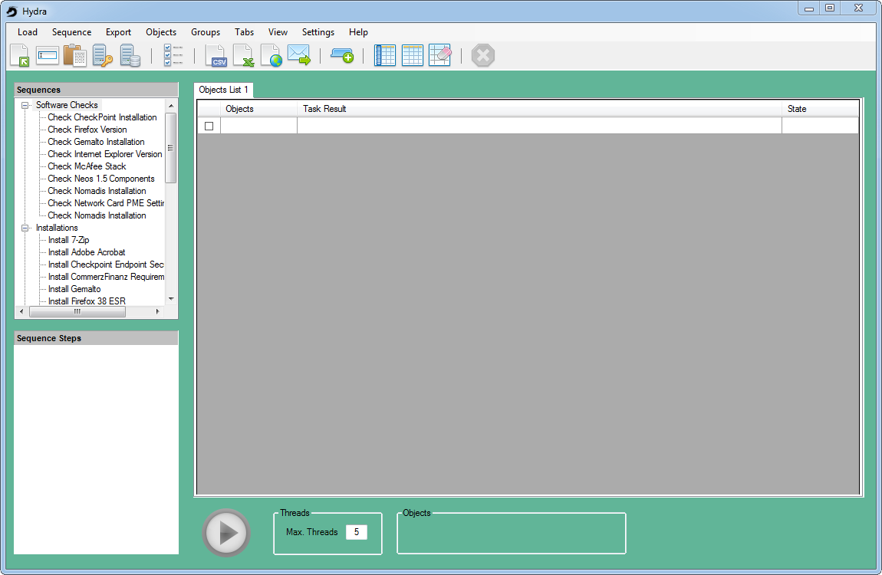

To run a pre-defined sequence on an object, enter your object in the grid, select the sequence you want to run on the left panel and click on the "Start" button:

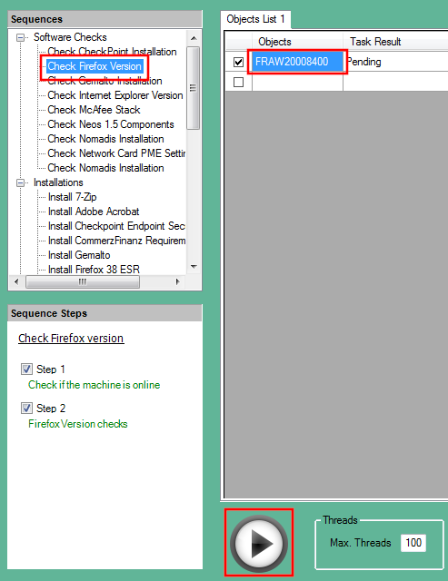

Once your sequence will have finished, you will get the result near the name of the object:

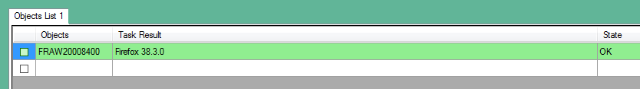

# Objects

There are several options to define or load objects: they can be entered manually in the grid, loaded with files, with SCCM or AD queries, or pasted from the clipboard. It is now possible to load objects successively form different sources and create a bigger list before starting a sequence.

All new added objects are automatically selected ("checked"), meaning that they will be used for the sequence. Every object can be selected or unselected as desired.

To load objects, use the menu “Load”, or click one of the 5 icons defined:

* Load from a file
* Load manually (enter or paste a list of objects separated by a coma, semicolon or pipe)
* Paste from the clipboard (CTRL+V is also supported)
* Query AD
* Query SCCM

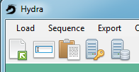

Once loaded, the objects are ready to receive the sequence you want to apply:

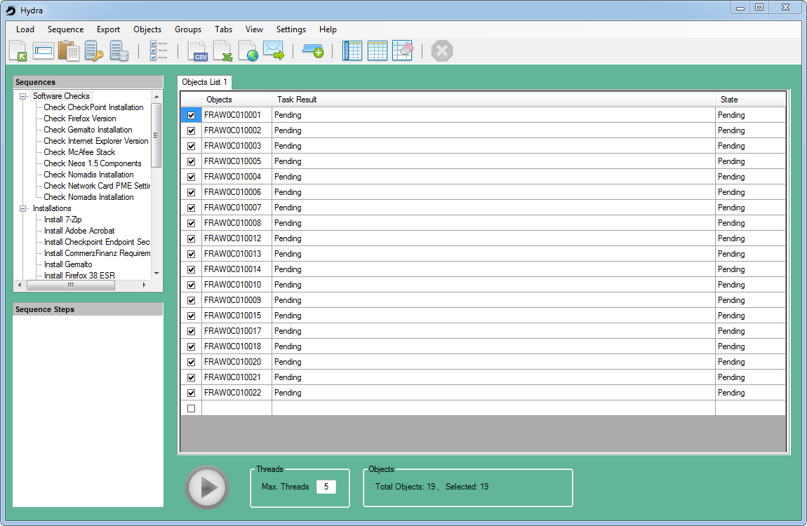

Objects can be manually renamed as well as removed from the grid.

# Sequences

## Default sequences

The default sequences are displayed as a tree on the left side of the interface. Selecting a sequence automatically loads and displays the associated steps:

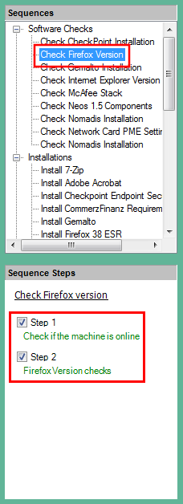

## Load a sequence manually

****If you want to use a sequence that is not in the sequence tree, you can use the menu “Sequence -> Load a sequence manually” or use the corresponding icon:

After you’ve selected and loaded a sequence manually, it is inserted in the sequence tree, in the node “Manually Loaded”:

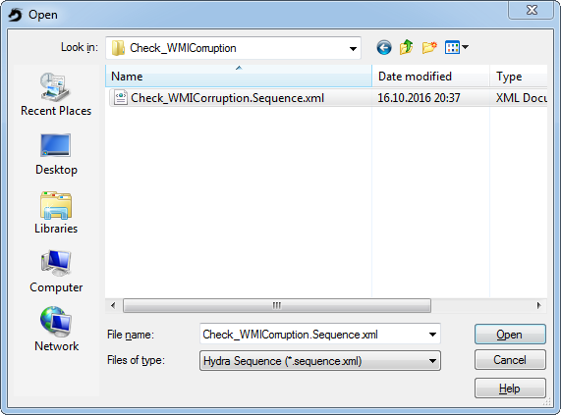

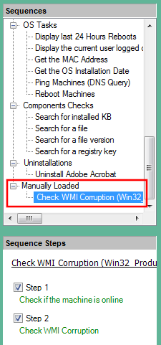

# Start a sequence

Once objects are defined and selected, and that a valid sequence has been chosen, the Start button is made available and the sequence can be launched. You may adjust the number of threads if needed:



The sequence is assigned to all objects checked and the number of threads defined will run in parallel:

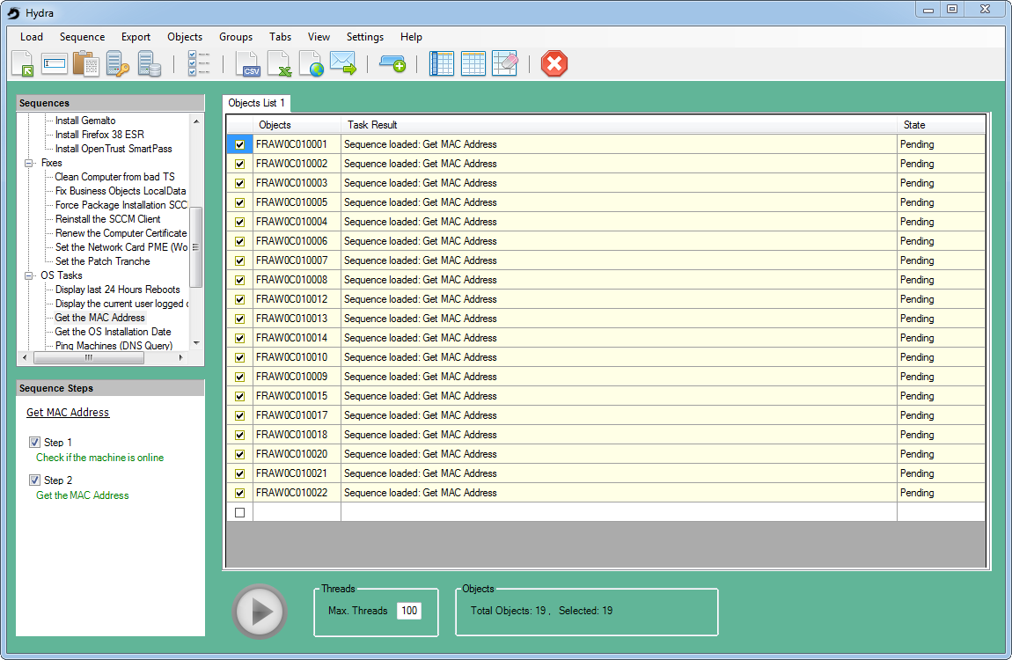

At the end of the execution, the state is displayed for every object treated:

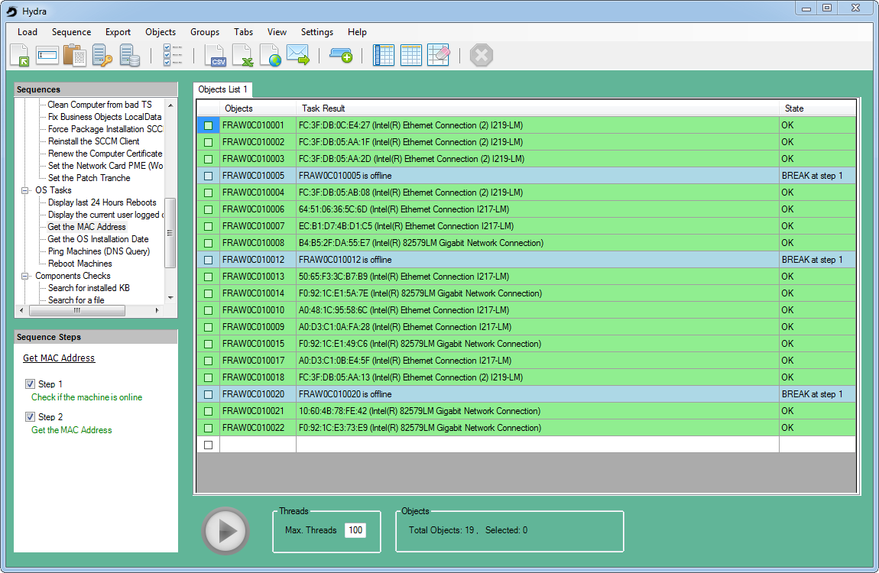

Depending on the sequence executed, you may receive different state like:

* OK: everything went fine
* STOP: one step has ended in a state estimated as critical enough to stop the sequence
* BREAK: one step has ended in a state estimated as not relevant for the object

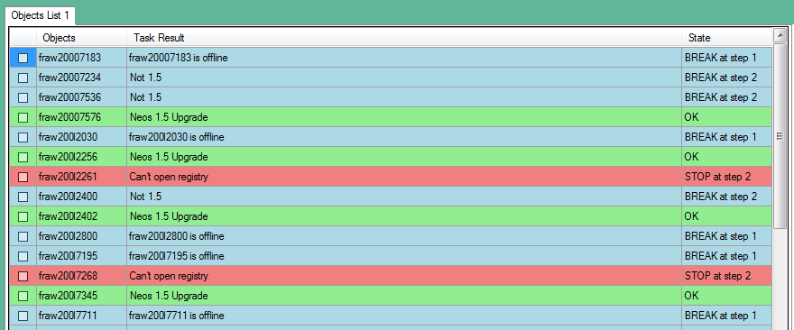

## Variables

Some sequences have variables defined: before the sequence can start, you have to enter values for these variables, or select some options. Some examples of variables types:

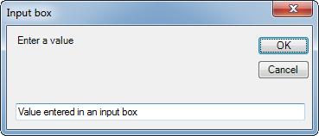

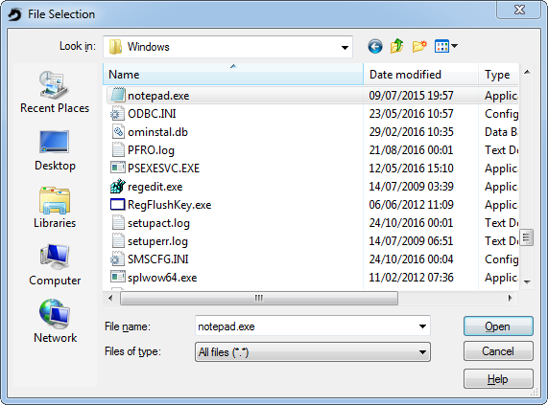

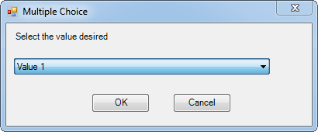

The variables set are displayed in blue in the sequence panel:

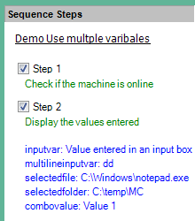

Variables are then used in some steps of the sequence: they make the sequences very flexible and modular. Sequence developers can use variables to write generic sequences instead of writing new ones when only a few parameters differ.

# Basic objects operations in the grid

You can manipulate the objects in the grid in different ways, like:

* Remove or select objects based on their status
* Display the protocol of every step executed

All objects operations can be done with a right click on the corresponding column.

## Tasks results

A right click on objects in the Task Results column allows you to display the steps protocol, for example:

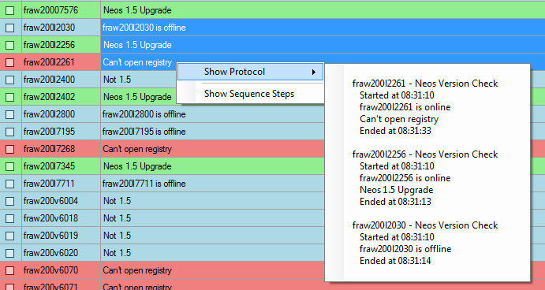

## State

A right click on the State column gives you the option to remove all objects in a specific state (like removing all in the state BREAK, for example).

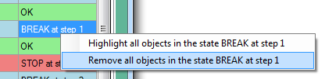

Choosing to highlight all objects in state OK will select all objects in this state:

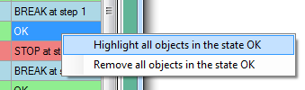

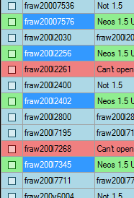

At this point, further operations can be made with a right click in the column Objects

## Objects

The right click option in the column Objects opens further options:

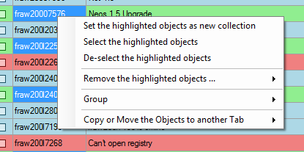

You can:

* Set the highlighted objects as new collection: this will remove all other objects from the grid
* Select the highlighted objects: this will enable the checkbox of the selected objects
* Remove highlighted objects from the grid, and/or remove them from their respective files if they have been loaded this way

Other options, like Group and Tab will be described later on.

To remove some objects, right click on in the column "Objects" and choose the option you wish in the menu *"Remove the highlighted objects …"*:

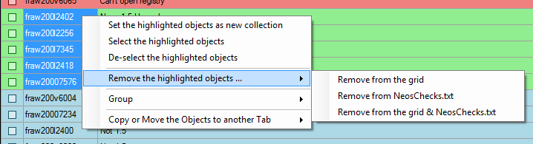

To run a new sequence on some objects, select them, choose the sequence to run, and start it. The example below shows how to display the current user logged on on machines where the last state was OK:

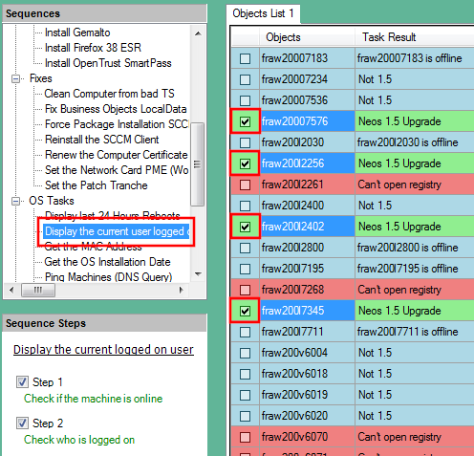

Once the sequence has finished, the state of the objects selected changes.

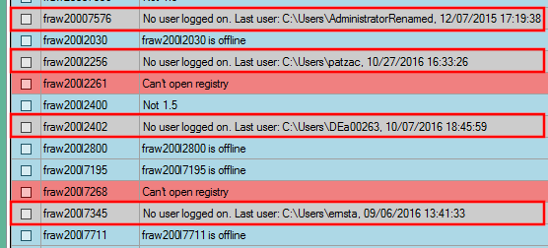

Depending on how the sequences are written, the colors used to display the results can vary. In the example above, grey has been chosen for the machines where nobody is logged on.

You can also select all machines at once, deselect all, or completely clear the grid using the menu "Objects":

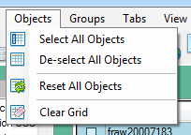

You can also use one of the icons:



The option "Reset all Objects", only accessible from the menu "Objects", resets all the state of all objects in the grid and put them in state pending again.

## Columns

Per default, the columns size is automatically set. In some cases, the text to display in the column "Task Results" is too long and part of it is not displayed:

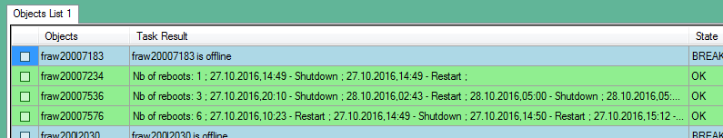

In such a case, you can choose the option *"Manually set the columns size"* in the menu *View*, or select the option *"Wrap Text"*:

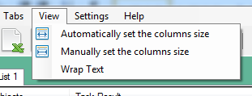

The option "Wrap Test" displays the results on several rows:

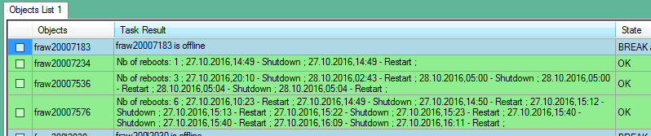

## Cancel

You can cancel sequences running on some or all objects. To cancel all next steps of all sequences currently running, select *"Cancel All"* in the menu *Sequence*, or click on the icon

To cancel operations only on some objects, select and right click on the states of the desired objects: choose then *Cancel*.

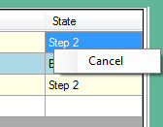

**Important:** cancelling a sequence doesn't kill the processes currently running. It is impossible, for example, to stop an installation currently running on a remote machine. Hydra will wait for the steps currently running to complete, will then set the state as "Cancelled" and will stop any further operations on the impacted objects.

You can get back the control in the grid, without waiting for the steps returning their state by cancelling a second time.

# Tabs

Hydra supports multiple grids using tabs. Per default, only one tab is created but you can create as much as you wish using the menu "Tab" or the icon

You can rename or remove a tab using the right click options:

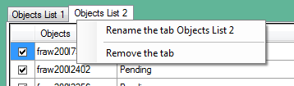

Each tab is independent from the others and starting a sequence only applies on the current selected tab. During the executions of sequences, you can switch to other tabs, start other sequences, add new objects, remove some…

You can also copy or move objects from one tab to a new one or an existing one. For this, select the objects, right click on one of them, and choose the option *"Copy or Move the Objects to another Tab"*:

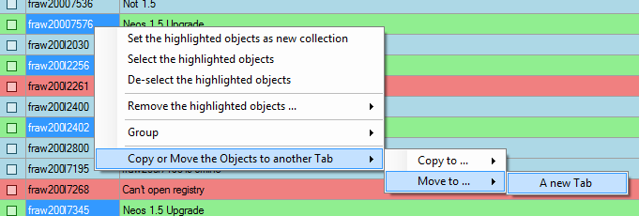

In the example above, the 4 machines are removed from the current grid and then put in a new one:

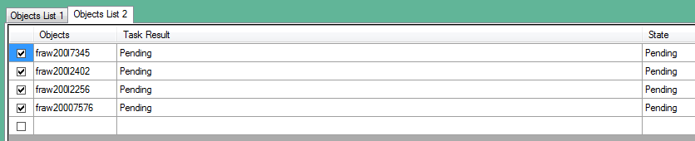

# Exports

You can export the state of objects, or some selected objects, to a csv file, in Excel, HTML or send it per mail. For this, use one of these options in the menu *Export* or one of the respective icons:



The Export window allows you to select what you want to export. The default paths are defined in the user's settings:

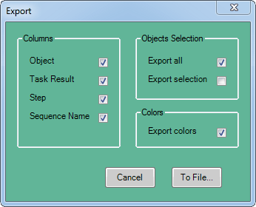

# Groups

Groups are collections of objects, with sequences assigned to all group members. Only the sequence assigned to a group will be executed: if you assign the sequence A to a group, this sequence A will always run when you click the Start button, no matter which other sequence is selected in the sequence tree.

Be careful: the sequence selected in the sequence tree will run on all objects not belonging to any group.

To create a group, select a sequence, a group of objects, right click on these objects and choose *Group -> Assign the Sequence to a New Group*:

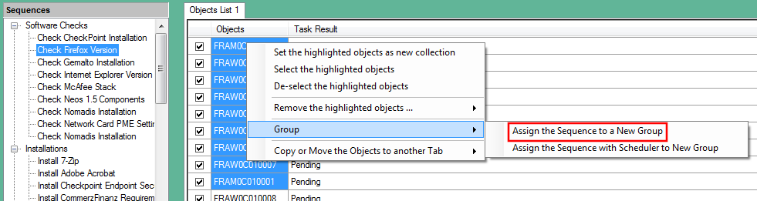

A pop-up window asks for the name of the group:

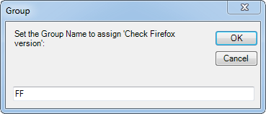

Once a group is created, a new column is displayed with the name of the group assigned, as well as the number of maximum threads defined for this group. This value can be hidden.

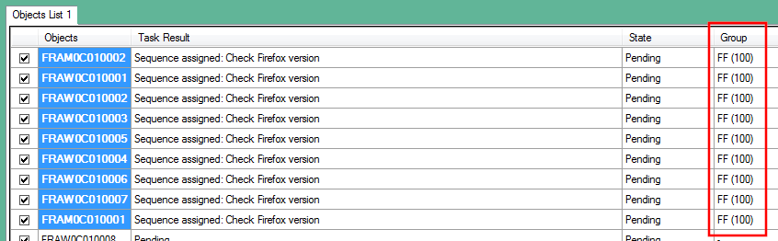

You can define as much as groups as you like.

The example below shows:

* One Group PME with 5 objects and the sequence "Retrieve the PME Settings"
* One Group FF with 9 objects and the sequence "Check Firefox version"
* Other machines, some checked, some unchecked, with the sequence "Get the MAC address" ready to be executed on these objects

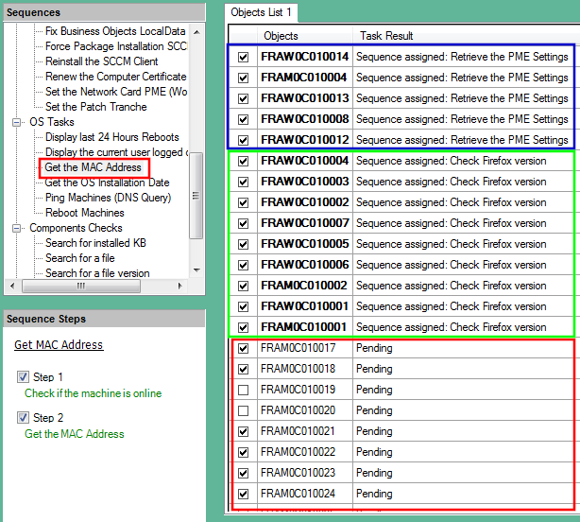

Clicking on the Start button executes all the tasks at once:

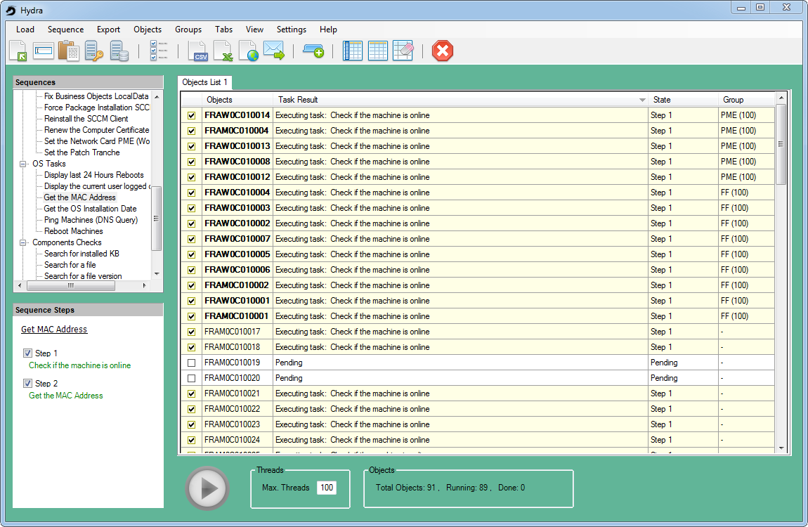

Once finished, the results are:

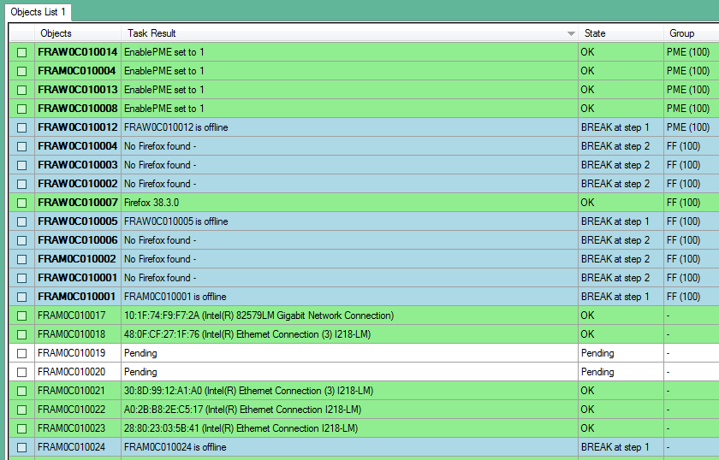

The Group PME has executed the PME check, the Group FF has executed the Firefox check and the Mac Address check has been assigned to the rest of the checked machines.

## Schedulers

Schedulers can be assigned to groups. At the assignments of a task, select the option *"Assign the Sequence with Scheduler to New Group"*:

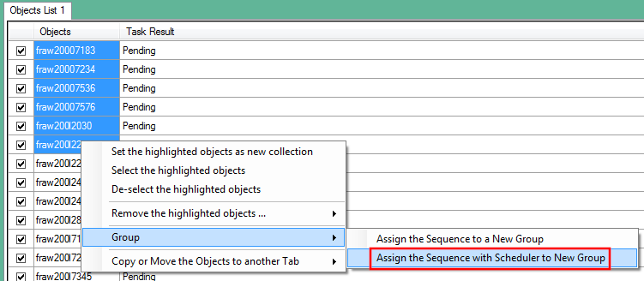

The name of the group is prompted:

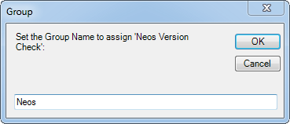

The start time of the sequence is then prompted:

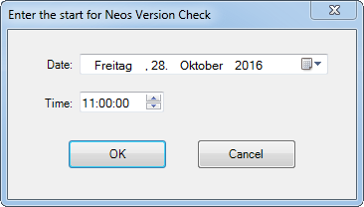

The time to start is then shown in the state column:

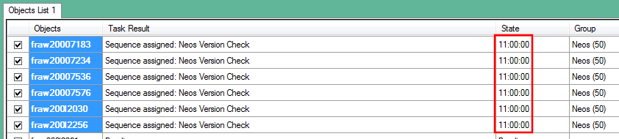

To start the countdown, click on the Start button: the time remaining is displayed in the column *State*. At the end of the countdown, the sequence starts automatically:

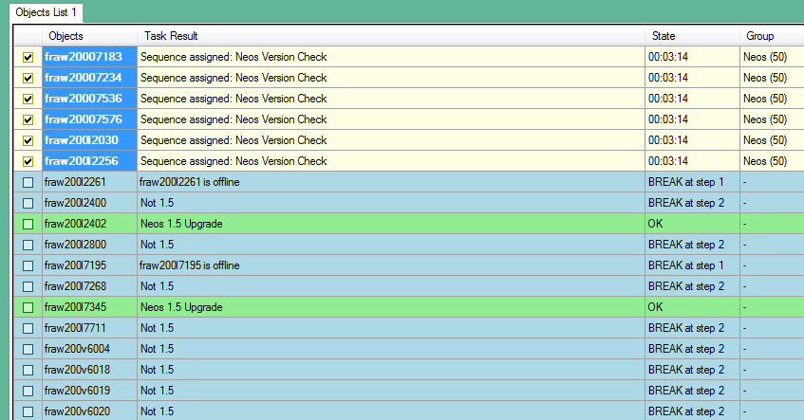

## Re-assignments

New sequences can be re-assigned at any time. For this, you can reuse a right click on the objects and choose "Assign the Sequence to a new Group", or use a right click on the new sequence you want to assign:

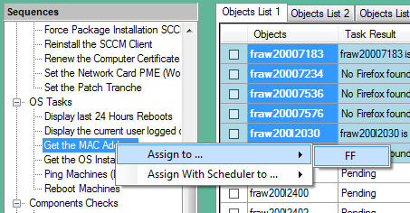

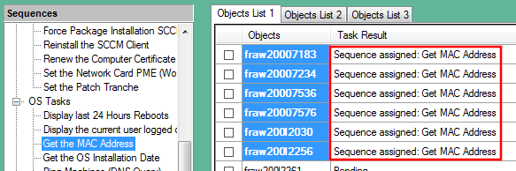

For sequences using variables, they are also prompted and stored for this group:

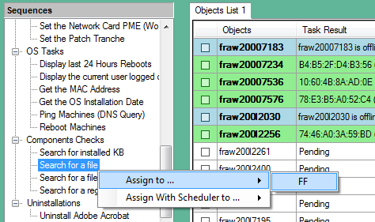

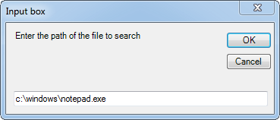

## Display the sequence steps

To display the steps of the sequence assigned to a group, use a right click in the column "Task Result" and choose "Show Sequence Steps". The steps, as well as potential variables, are displayed in magenta in the sequence panel:

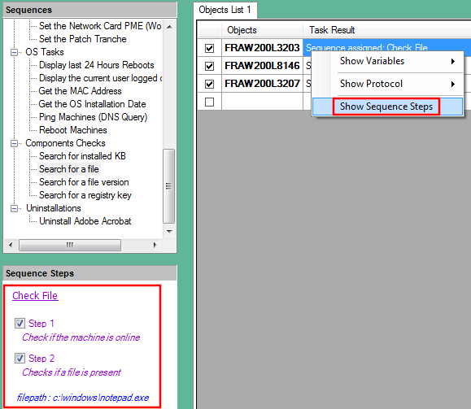

## Import/Export

Groups can be exported and imported. An exported group is an xml file containing all information relative to a group like its group members and its sequence associated.

To export one or several groups, click *on Groups -> Export Group*, and select the group to export.

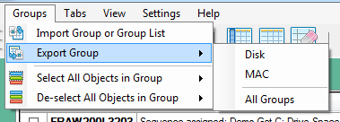

Single groups are saved in files with the extension group.xml.

Collections of groups are saved in files with the extension .grouplist: these files store the path of the corresponding group.xml files.

To import exported groups or list of groups, use the corresponding Import option.

# Queries

AD and SCCM queries can be performed to get lists of machines, users, groups…

## AD Queries

To perform an AD Query, use the option Query AD in the menu Load. You need to use a Powershell command like Get-ADComputer, or Get-ADUser, returning objects with single properties. For example:

Get-ADComputer -SearchBase 'OU=Workstations,OU=NEOS CIB 64,OU=VIE,OU=AT,dc=euro,dc=net,dc=intra' -Filter '*' | Select -Exp Name

To avoid having to search for the correct syntax, some queries can be predefined in the file .\Settings\Hydra_ADQueries.qry, (or Hydra_ADQueries_CC.qry, where CC is the country code).

The format of the lines in this file is:

*<Query name1 to display in the combobox>;<Powershell command1>*

*<Query name2 to display in the combobox>;<Powershell command2>*

Once defined, you can select the command in the list, modify it if needed, and also apply a pattern to filter only some objects:

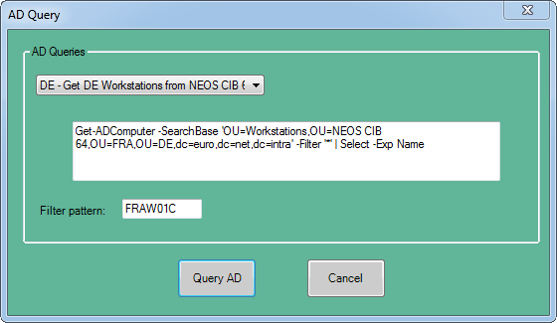

## Query SCCM

To perform SCCM queries, you need at least Read permissions on the SCCM database you want to query. SCCM queries only return machines as objects.

You need to know the name of the server you want to query, as well as its side code. This information can be entered manually, or selected in a predefined list. This list is located in .\Settings\Hydra_Countries.sccm (or Hydra_Countries_CC.sccm, where CC is the country code).

The format of the lines in this file is:

*<Country1>;<Servername1>;<Site code1>*

*<Country2>;<Servername2>;<Site code2>*

If you select a country in the dropdown list, its respective SCCM server name and site code are filled. You can then make a query based on machine name pattern, IP, or enter a manual query like:

SELECT DISTINCT *

FROM SMS_R_System

WHERE SMS_R_System.Name IS LIKE 'FRAW20008%'

