Claudia Trafton

ASTR103

3/4/15

**1.Solar Cycle**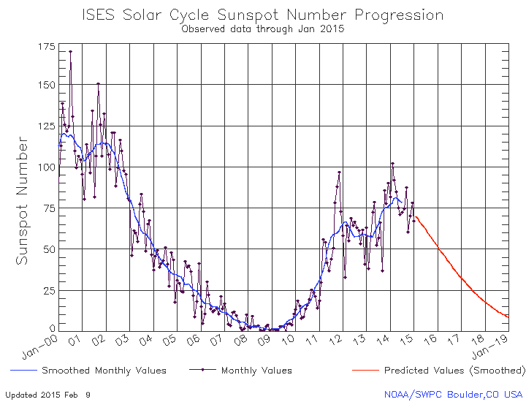

**a)**

**ISES Solar Cycle Progression (Jan. 2000 - Jan. 2015)**

Source: Space Weather Prediction Center (NOAA)

<http://www.swpc.noaa.gov/products/solar-cycle-progression>

(Accessed: 3/2/15)

**b)** The smaller intervals are in increments of five. We know this because there are five lines between each larger interval since 25/5 = 5.

**c)**The monthly value dot for January 2015 falls a little more than halfway between the tick marks for 65 and 70 sunspots meaning there were 68 sunspots.

**d)** The first double peak seems to appear right at the beginning of January 2000. Judging by the red prediction line, the next solar maxima did not appear until 2014. It is curious how much smaller it is than the peak in 2000…

**e)** By the graph, we in the year 2015, are going towards a solar minimum. We can see this because the overall trend after 2014 in red is predicting less sunspots for the next few years. This would indicate less solar activity. If we peak at the other graphs we can also see that the Radio Flux is also predicted to decrease which further backs up the fact that we can expect less overall solar activity.

**2. Length of the solar cycle:**

**a)** Solar minimums by SDIC graph (estimates):

1954.0

1964.5

1976.5

1987.0

1997.0

2009.0

**b)** Differences between each minimum (gives estimate of cycle length)

1964.5-1954.0 = 10.5 years

1976.5-1964.5 = 12.0 years

1987.0-1976.5 = 10.5 years

1997.0-1987.0 = 10.0 years

2009.0-1997.0 = 12.0 years

**c)** To take an average, add all results and divide by number of results:

(10.5 + 12 + 10.5 + 10 + 12)/5 = 11 years average cycle

**d)** On page 479 of the textbook, the average cycle length is about 11 years, which coincides perfectly with my estimate. The range of solar cycle length is between 7 and 15 years . All of the estimated values in 2a fall into this range.

**3. Magnetic Solar Cycle:**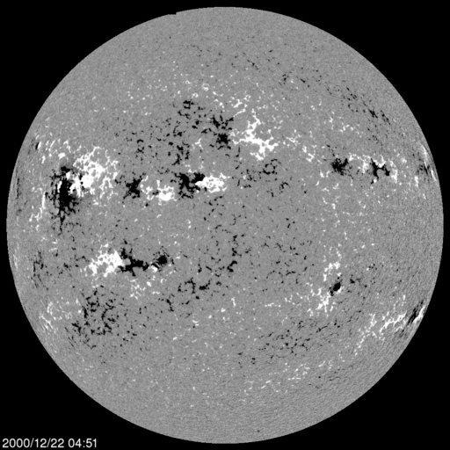

**a)**

**Solar MDI Image on 12/22/2000**

Source: NASA - Solar and Heliospheric Observatory

<http://sohowww.nascom.nasa.gov//data/REPROCESSING/Completed/2000/mdimag/20001222/20001222_0451_mdimag_512.jpg>

(Accessed: 3/2/2015)

**b)** The north magnetic pole leads into the northern hemisphere and the south magnetic pole leads into the southern hemisphere; however, in the picture we see that the general pattern is not like Earth’s magnetic field that uniformly surrounds the planet. This one appears to be bowing out to the right in the picture and are in the shape of crescents.

**c)**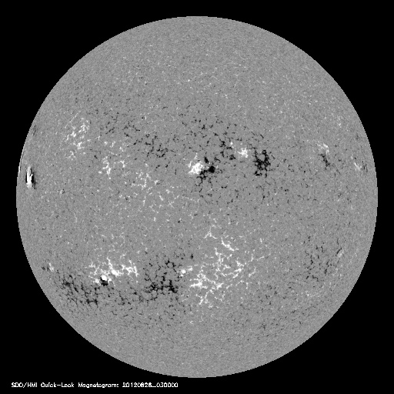

**Solar HMI Image on 08/26/2012**

Source: NASA - Solar and Heliospheric Observatory

<http://sohowww.nascom.nasa.gov//data/REPROCESSING/Completed/2012/hmimag/20120826/20120826_0300_hmimag_512.jpg>

(Accessed: 3/3/2015)

**d)** In this image the south pole also leads the sunspots in the northern hemisphere. Like in the previous image, the southern hemisphere’s sunspots are lead by the north pole.

**e)** It is obvious that the cycles are not exactly the same. From the pictures above, it can be seen that the amount of sunspots in the first image is clearly more than the second image; however, the magnetic field line patterns appear to be similar in that they are both bowing out to the right in the pictures. We can conclude the magnetic cycle of the sun is longer than the sunspot cycle from these observations. The textbook cites that the sun’s magnetic field cycle is about 22 years.

**4. Solar Wind:**

**a)** On 3/3/2015, at 2222 UT (5:22 pm EST) the solar wind speed was 439.2 km/sec

**b)** We know speed and distance, so we can use time = distance/rate

the sun is about 149,600,000 km from earth and the speed is 439.2 km/sec meaning:

time = 149,600,000 km/ 439.3 km/sec = 340619.3 seconds.

340619.3 seconds/(60 seconds * 60 minutes) = 94.6 hours

**5. Interaction of the solar wind with Earth’s atmosphere:**

**a)** The Kp index is 2 now. It is captioned as quiet.

**b)** The KP index is not predicted to be high tomorrow, on March 4th. Its predicted maximum is 3.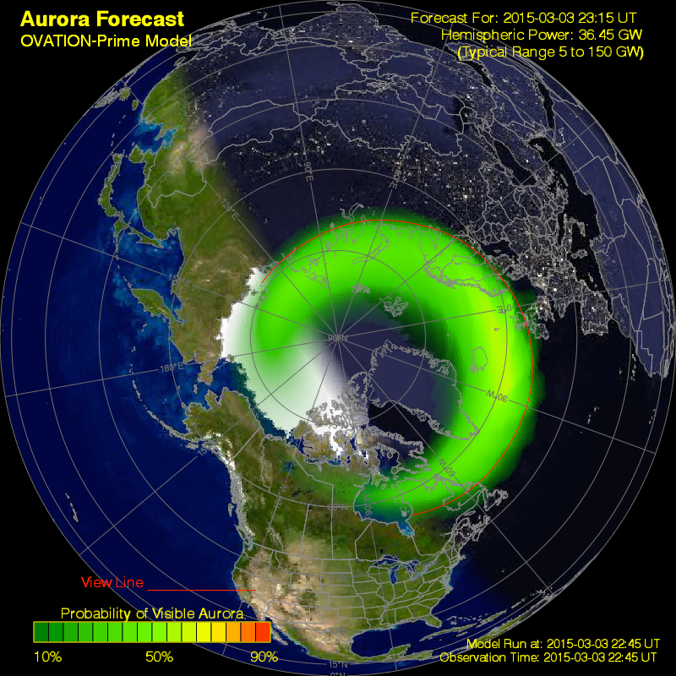

**c)**

**Auroral Forecast (March 3rd, 2015)**

Source: NASA - [spaceweather.com](http://spaceweather.com) (NOAA/Ovation)

<http://services.swpc.noaa.gov/images/aurora-forecast-northern-hemisphere.png>

(Accessed: 3/3/2015)

**d)** The video forecast shows that the farthest south the aurora will be visible is in the very northern part of Maine and the northern and central parts of the nordic countries.

**e)** Based on our knowledge of excited atoms, it would make sense that different color auroras depend on the amount of energy that arrives from the sun in geomagnetic storms. If we have a larger and more energetic storm, it would make sense that more energy is absorbed and reemitted as greens or even blues. If it is a weaker storm, we may see redder colors in the sky from lower energy photons being reemitted from the atoms in the atmosphere.

(as a side note, I’m glad this is being cleared up. I saw a red aurora when I was little and was confused because I thought they were always green…)