Claudia Trafton
3/7/2015
LACS-274 Midterm

1. Describe the Paleolithic lifestyle (diet, social importance of food, exercise) and relate it to the contemporary (today’s) world. What did we conclude about it?

The Paleolithic lifestyle revolved around survival. Before the Neolithic Revolution, early humans sustained themselves by hunting and gathering. This meant a considerable amount of work and strategic planning went into being able to eat; groups of people would band together to increase their chance of survival and roles would be delegated by sex: men would focus on hunting game to provide meat, whereas women would gather vegetables, fruits or whatever else was available. (Eaton et all, 32). Having to work for food required a very active lifestyle: men would be stalking or running after prey, while women would hike five or more miles carrying what they could find and often, their children with them. (Eaton et all 32) This active lifestyle was also complemented by nutritious meals of lean meat, fruits and vegetable, and complex carbohydrates.

In contrast with people today, the Paleolithic people ate diet much more conducive to a healthy body. They did not eat in excess, as they couldn’t, and did not partake in refined sugar or high amounts of salt and fat. Today, people constantly consume refined sugars, salty food and foods high in empty calories. Because of these very unbalanced diet, people today are at high risk for diseases foreign to paleolithic people such as diabetes, heart disease, hypertension and cancer. As the “Paleolithic Prescription” describes it, these part of a larger problem which the writers call the “disease of civilization.” (Eaton et all, 36) This “disease of civilization” is the consequence of a modern industrial society that pays little attention to regular exercise and balanced diets that our ancestors were forced to live by. Instead, people view their physical health as secondary to their economic health. Not only do these people individually suffer, but society also suffers when resources go into curing man-made diseases brought on by “dead” and empty food. Our ancestors never had these kinds of health concerns, though they were often made sick by microbial diseases and many of them died very young. (Eaton et all 36)

In our discussions, we concluded that the Paleolithic lifestyle has many aspects that can be applied to modern day living. Though we no longer have the need to hunt for our food and are not dependent on what is available, people today should generally be more conscious of what how they treat their bodies. We agreed that people should be more conscious of what they put into their bodies and that exercise should be an important part of one’s daily schedule. Though it is often hard to find time to exercise in a society where “time is money”, overall physical health can help one avoid excessive medication and debilitating disease. In this way, following the lessons of our paleolithic ancestors may help us prevent diseases that inhibit our ability to be productive.

3. How did existing beliefs about medicine, health, and humankind’s place in the world contribute to the eating practices of Italians in the late Middle Ages and in the Renaissance? Be sure to briefly describe Galen's "theory of humors" and its relationship to class structure and the universal order. Include the short stories and writings of Boccaccio, the Novellino, and Marco Polo's memoir.

The alimentary practices of the Renaissance and the Middle Ages were the result of a combination of medical and food philosophy as well as existing views of humankind’s “place” in their worldview. The world was divided into several hierarchical categories that revolved around God as the highest being. Humans were located between animals and angels in this “Great Chain of Being.” Each of these categories had their own individual hierarchies too. In the case of humans, kings and queens outranked peasants and working people. These subdivisions meant that each category was like its own small microcosm of the larger, God-driven world occupied. Each microcosm obeyed the rules of the larger universe but also stayed connected to it.

The human connection to the larger universe was the current medical science and philosophy. Galen’s theory of humours related the human body to the greater universe by matching the believed bodily fluids to the elements believed to be present. The graphic below shows how each bodily fluid was matched to one of the four universal elements. It also shows how each fluid and element was associated with two of four natural characteristics present in the body and the universe.
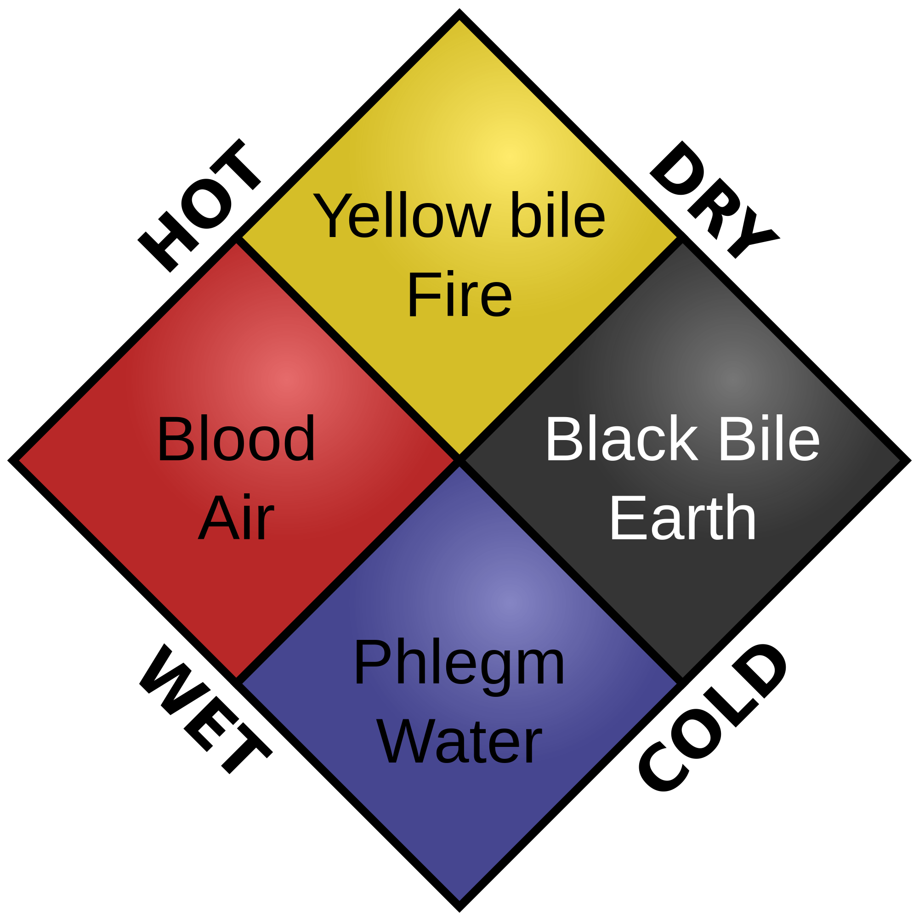

Galen’s medical philosophy also revolved around food, giving it a higher philosophical dimension. (Grant, 7) Galen believed that curing disease should be done by balancing out the humors in one’s body, since all disease was caused by imbalance rather than using violent surgeries. (Grant 6) To cure and prevent disease, Galen would prescribe diets that he believed would balance out the body.
These ideas contributed to the eating philosophy of the Renaissance in that food was seen as a multidimensional commodity that had properties other than nutritional value. An example of value can be seen in Novella IX of Novellino. In this story, a poor Saracen holds his bread over a pot of cooking food to receive the smoke flavor of the bread, much to the anger of the cook, who believes the peasant should “pay for what he has taken.” (Gualturezzi 31) It can be seen from this example that though the smoke had no nutritional properties, it exalted the bread to a higher dimension by adding the essence of the food cooking in the pot.
In Boccaccio’s Decamerone, the ninth story of the fifth day describes a situation where food’s spiritual properties are of utmost concern. In the story, Filomena, a widow, goes to Federigo Alberghi, a man who has become poor for his only prized possession, a falcon, to cure her son of deadly disease. Since Federigo is in love with Filomena, he has the falcon cooked and presented to her for breakfast. Despite her dismay upon realizing that she has eaten it and her son will die, she eventually marries Federigo, recognizing that despite not being rich, he sacrificed something great out of love for her. In this story the falcon is a being that dwells highly in its realm and by giving Filomena the falcon, Federigo exalted her.
Both of these examples show how eating habits in the Renaissance were profoundly affected by philosophy of the world and how food was a dynamic mechanism that could alter one’s status or relationship to other people. Food was the tool by which humans could better themselves through healthy balance and exultance.

6. Bartolommeo Sacchi (Il Platina) has a lot of advice for his readers in his book about On Right Pleasure and Good Health. What did we conclude about the significance of his book, especially as it pertains to the development of ideas about "eating right" and also "taste"?

On Right Pleasure and Good Health by Bartolomeo Sacchi demonstrates a philosophical shift with regards to how people should live. Sacchi’s book reads like a modern day instruction manual about how one can live a healthy and happy life. It provides guidance about where one should live, how one should exercise, and how one should eat. In explaining how one should eat, Platina introduces new notions of “taste” that are directly tied with one’s physical and intellectual health.

One of the important aspects of Platina’s Humanist notion of taste is that it is taken out of religious context and is instead, put into a historical one. In justifying his ideas, Platina makes several references to Greek philosophers. In his introduction to Right Pleasure, Platina writes: “Also important to me will be the authority of Seneca, Lucretius, and Laertius, who extoll Epicurius with wonderful praises as the holiest of men.” (Sacchi, 4) By referring to these ancient Greeks as “holy men”, Platina is directly defying the mainstream “Great Chain of Being” by proclaiming ancient Greek philosophers as is his holy authority figures, all the while making no mention of any divine higher power. Rather than being divine in power, Platina believes that ancient philosophers holder a high moral power that should be followed by the people of his time. It is this purpose that he believes Right Pleasure serves.

Platina’s notions of “taste” and “health” are directly tied with each other and into his moral philosophy. In the introduction to his book, Platina writes: “..pleasure that arises from right action leads to happiness as a doctor’s skill leads a sick man to health.” (Sacchi, 4). In his philosophy, Platina believes that by doing the things that make us happy, we are doing moral good. This moral good does not have to come from any dogmatic organization and should be found through exploring and refining one’s taste. In the context of eating right, this means feeding the body based on what feels and tastes good. Ultimately, Platina’s philosophy marks the beginning of Renaissance humanism and a move from a society focused on religious identity, to one that focused more on humanity and the individual.

Image credit: Tom Lemmens, work submitted to Wikipedia Source: http://upload.wikimedia.org/wikipedia/commons/thumb/a/a1/Humorism.svg/2000px-Humorism.svg.png

