Econ Exam 2 Review:

* Chapters 11-18
* Econ Growth and Math
  + Economic Growth
    - Growth rate of per capita GDP
    - GDP = gross domestic product
    - GDP = Y = C (private consumption) + I (investment) + G (government spending) + NX (net exports = exports – imports)
  + Per capita GDP matters, not for the sake of per capita GDP, but because per capita GDP is correlated with human conditions we all care about.
  + Overall, life expectancy in poor nations is just 57 years old, while it is 80 years in wealthy nations. Just being born in a wealthy nation adds almost a quarter century to your life.
  + Economic growth alleviates human misery and lengthens lives
  + Industrial Revolution
    - Less agriculture more manufacturing in 1800’s
    - Technical progress started to outpace population growth
    - Per capita GDP started to rise rapidly
    - Hockey stick graph (standard of living same for a long time until industrial revolution goes way up)
  + Poor are better off now than 200 years ago, so are rich
  + Growth rates grew a little bit each year
    - 1800-1900: .64% growth rate
    - 1900-1950: 1.04% growth rate
    - 1950-2000: 2.12% growth rate
  + economic growth
    - most important
    - change in person’s income adjusting for price changes
    - how an average person’s income changes over time
  + nominal gdp – prices change – population growth = per capital real gdp change
  + 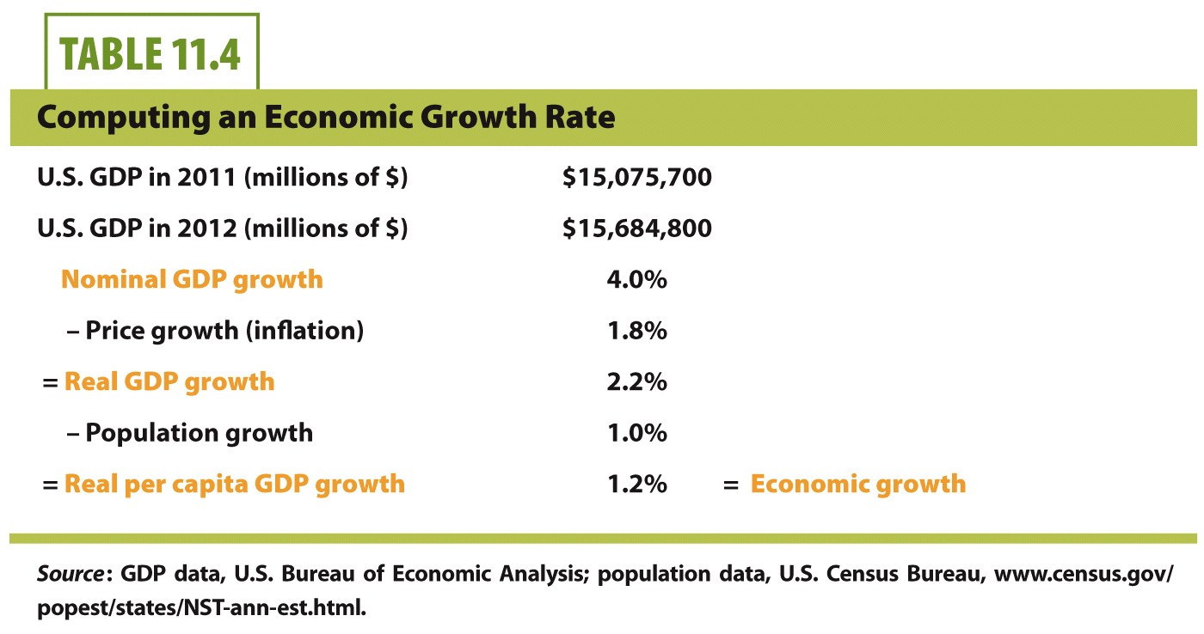
  + rule of 70
    - if annual growth rate is x%, the size of that variable will double every 70/x years
  + economic growth comes from:
    - resources
      * land
      * natural resources
      * i.e. coal in USA, oil in middle east
      * geography also important
      * land alone is not the only thing, i.e. Liberia has a bunch of diamonds, and mahogany and shit but they’re still Liberia
      * labor important
        + effective labor
        + more educated workforce is more effective
        + brain drain
      * capital
        + factories
        + computers
        + roads
        + aid in the construction of future output
        + capital by itself still not enough
    - technology
      * i.e. assembly line
      * agricultural advances
      * produce more for less
      * why do some places produce more innovations than other places: institutions
      * economic growth happens when resources and technology work together
    - institutions
      * laws, regulations, government
      * work habits, political behavior
      * significant practice, organization
      * political stability, private property, stable money, competitive markets, efficient taxes, international trade, flow of funds across borders
* Growth theory and institutions:
  + 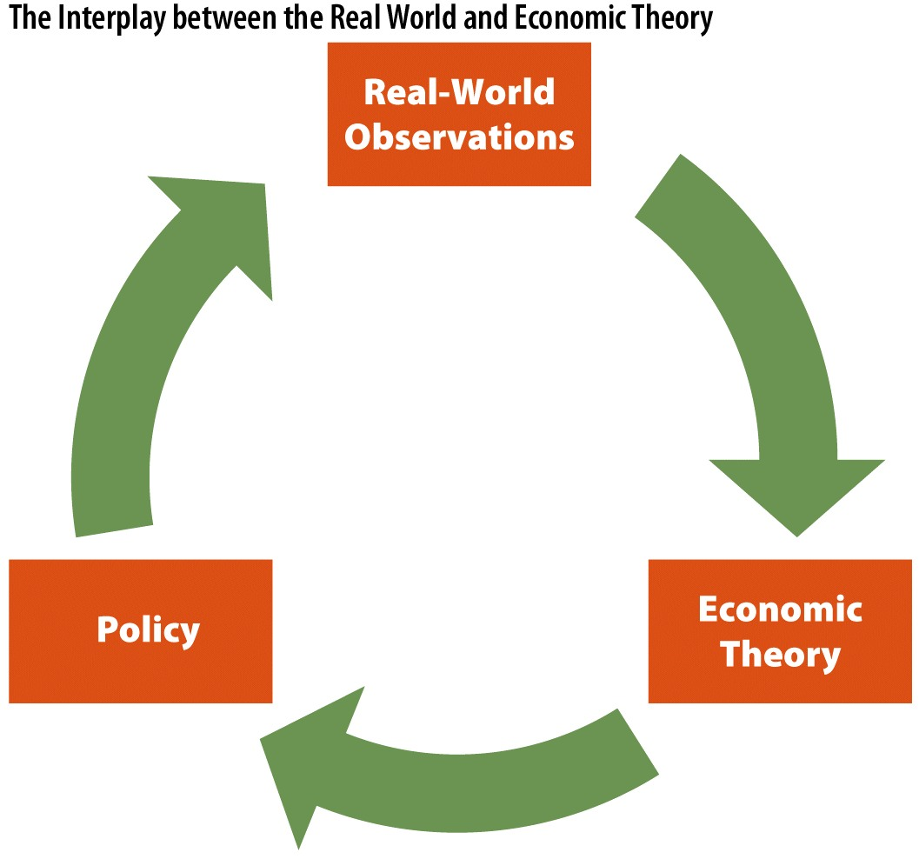
  + Solow growth model:
    - Resources, technology, institutions sources of economic growth
    - GDP is a function of land, labor, and capital inputs: production function
    - Marginal product
      * Change in output divided by change in an input
      * Increasing inputs will increase output
    - Steady-state:
      * Long-run equilibrium point reached
      * There is no incentive to invest if the cost of investment is greater than return on investment

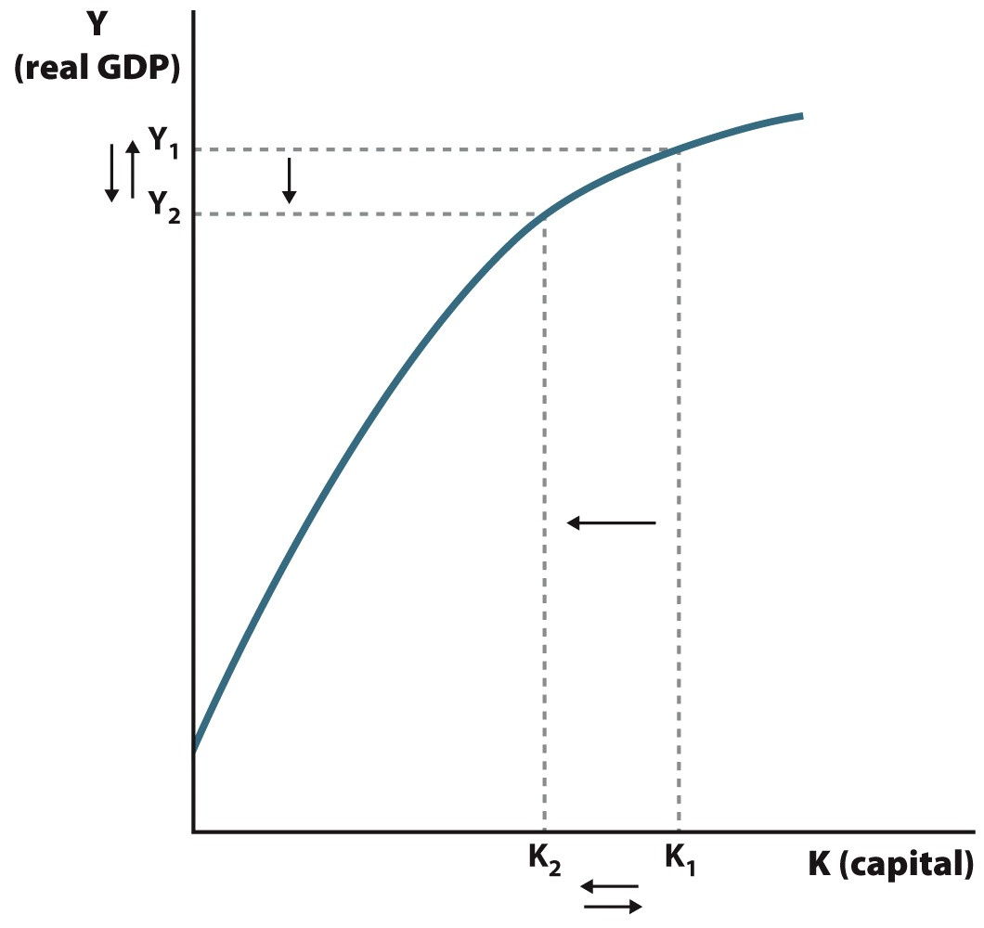

* Depreciation
  + Fall in value of resource over time
  + Net investment = investment – depreciation
  + In a steady-state there is no net investment
* Convergence:
  + Over time, per capita GDP levels across nations will equalize
* Problem is that doesn’t seem to be true, economic growth in wealthy nations often outpaces growth in poor ones, growth in developed nations hasn’t stopped
* Capital alone is not enough to explain sustained growth
  + Technology matters
  + Increases in technology allow for produce more output with each input
  + Fixes solow model, growth can continue and a zero-growth long-run equilibrium is avoidable
* Y = A x F (physical capital, human capital, resources capital)
  + Where A = scalar accounting for technological change
  + K is capital
* Wealth comes from capital and technology
  + Wealthy nations should funnel aid to poor countries for capital investment
  + But sometimes we do that and still no growth, why? Missing real world problems
* Modern growth theory tries to fix that
  + Some economies grow faster than others for reasons special to that specific economy
  + Technogical change is caused by factors inside the economy (endogenous)
  + Try to change the economy so that it fosters technological advances
* Institutions:
  + Positive: transparent, consistent government, private property
  + Negative: corrupt, instable
* Solow model assumes technological changes are exogenous (don’t rely on economy)
* Aggregate demand and aggregate supply model
  + AD: total demand for final goods and services in the economy
  + AS: total supply of final goods and services in the economy
  + Price level (P): nominal variable that reflects current price changes without adjusting for inflation
  + Real GDP (Y): economy’s output of goods and services
  + AD = C + I + G + NX
  + AD curve is negative sloping because
    - Wealth effect
      * When real wealth increases, people spend more, higher prices work in reverse
      * Related to C in the equation
    - Interest rate effect
      * Higher interest rates make loans more expensive and decrease economic activity
      * Related to I
    - International trade effect
      * If u.s. price levels increase, quantity of demanded goods falls, exports fall, imports rise so NX falls
      * Related to NX
  + Anything that changes major spending habits will shift AD
    - Stock market rise/fall
    - Change in real estate values
    - General expectations about the future
    - Change in consumer confidence
    - Exchange rate
    - Change in foreign income and wealth
  + Short-run AS is positive slope, depends on price level
  + Long-run AS is vertical
    - Prices have nothing to do with long-term output
    - Y\* = natural rate of output when unemployment (u) = natural rate of unemployment (u\*)
    - Shifts occur due to:
      * Changes in resources (i.e. new natural gas)
      * Changes in tech (i.e. the internet)
      * Changes in institutions (i.e. lower taxes)
  + Nominal price level affects real GDP in the short run
    - Leading to upward sloping SRAS
    - Sticky input prices
      * Resource prices set by contracts, not flexible
    - Menu prices
      * Costs a lot to reprint all the menus
      * If it is easy to change prices (i.e. chalk board and erase), prices change more often, else prices won’t change as often
    - Money illusion
      * People irrationally interpret nominal values as real values
    - Factors that only shift short run AS curve
      * Supply shock (temporary)
        + Drought, hurricane, oil shock
      * Expected future price levels
        + I.e. workers expect lower prices
      * Adjustments to past errors
        + Workers under-predict current conditions
  + Look at graphs for how changes in LRAS and AD affect things
* Applying AS-AD model
  + Great Recession
    - AD was affected by:
      * Decrease in wealth
        + Real estate usually biggest part of individual’s wealth
      * Decrease in expected income
        + People realized things getting bad, stopped spending
    - decease in LRAS and decrease in AD
  + Causes of the Great Depression
    - Faulty macroeconomic policy
      * Government acts to influence direction of economy as a whole
      * Fiscal policy
        + Use of government’s spending and taxes to influence economy
      * Monetary policy
        + Involves adjusting money supply to influence the economy
      * Stock market crashed, then expected future income declined which lowered AD
      * Banks failed
      * Tried to raise taxes lowering AD
  + Classical economicsts
    - Economy’s adjust toward long-run equilibrium will happen naturally
    - Economy is self-correcting
    - Laissez-faire
  + Keynsian economists
    - Call for government intervention
    - Market corrections can take a long time because of sticky wages (union agreements)
* Taxes and government spending
  + Government outlays:
    - Government spending + transfer payments
    - Transfer payment: payments made to individuals and no good or service in return
      * i.e. welfare, social security
  + government revenue through taxes
  + mandatory outlays
    - social security, medicare
  + discretionary outlays
    - roads, bridges, defense spending, payments to government workers
  + 36% of budget is discretionary
    - rest is mandatory outlays
    - social security is bigger than defense spending
  + baby boomers beginning to retire, fewer workers in program, cannot pay for all these people (unsustainable)
  + people are living longer now than ever before and draw post-retirement benefits longer
  + how to raise revenue
    - payroll taxes
    - corporate tax, custom taxes, excise taxes, etc.
  + social security and medicare have own taxes on employees pay
  + progressive tax system
    - more you make, bigger fraction you pay
  + marginal tax rate
    - tax rate paid on next dollar of income
  + average tax rate
    - total tax paid divided by taxable income
* Fiscal policy
  + Use of government spending and taxes to influence economy
  + Needs to be legistlated and approved by congress and president
  + In conjunction or instead of monetary policy
  + Expansionary fiscal policy
    - When economy is slowing, government increases spending or decreases taxes to stimulate economy
    - Leads to increase in deficit and debt during recessions
  + Contractionary fiscal policy
    - Slow down economy, decrease spending, increase taxes
    - Used to pay off government debt
    - Keep economy from expanding beyond long-run capabilities, slow down “overheated” economy
    - Paid for by borrowing
    - Bring AD back from shifting to the right back to where it was so underemployment isn’t less than natural underemployment
  + Activist policy
    - Government intervention to affect economy, changing short-run outcomes
    - As opposed to “passive” policy, which only focuses on long-run growth
  + Countercyclical fiscal policy
    - Expansionary during recessions, contractionary due expansions
    - Smooth out cycles
  + Multipliers
    - Spending by one person becomes income to others; true for government and private spending
    - Increases in income generally lead to increase in consumption
  + Marginal propensity to consume (MPC)
    - The portion of additional income that is spent on consumption
    - = change in consumption/change in income
    - long-run, mpc is 0.9
    - lower-income people have higher MPC
    - if you already have your basic needs met, you’re not as likely to spend that additional income
    - if we need a stimulus package, it makes more sense to increase income of people with higher MPC
  + Time lags
    - Recognition lag
      * Gdp data is released quarterly
      * Unemployment lags even more
      * Growth isn’t constant, one bad quarter might not mean anything
    - Implementation lag
      * Fiscal policy has to be passed by congress and president, usually lags more than monetary policy
    - Impact lag
      * Sometimes multipliers take time to feel impact
    - Could exacerbate cycles instead of smoothing if lags are big enough
    - Automatic stabilizers
      * Effective countercyclical policy that naturally occur
      * Immune to most biases, like recognition and implementation and political
      * i.e. progressive tax rates, corporate profit taxes, unemployment compensation, welfare programs
  + crowding out
    - occurs when private spending falls in response to government spending
    - overall spending might not increase, government now has higher defecit and debt
    - if the government buys something for you, you won’t have to buy it yourself
  + supply-side fiscal policy
    - r&d tax credits, incentive to work on technological advancement (one thing that shifts LRAS)
    - policies that focus on education (increase effective labor resources)
    - lower corporate profit tax rates (increase incentives to undertake activities that add more profit
    - lower marginal income tax rates (incentives for individuals to work harder and produce more because they get to keep larger portion of income)
    - all of these take time, focus on incentives
  + laffer curve shows relationship between tax rates and tax revenues collected
  + 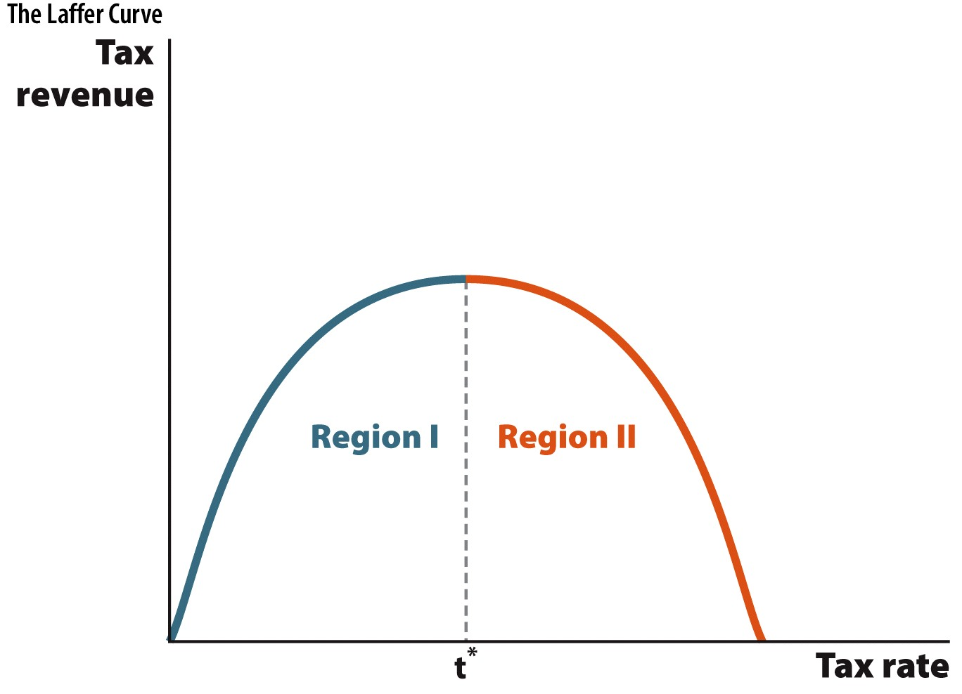
* Money and the Federal Reserve
  + Money supply
    - Checkable deposits: bank deposits that allow depositors to withdraw money by writing checks
    - M1 are currency and checkable deposits
    - M2 are M1 and savings deposits, mutual funds, and CDs
    - Includes currency and deposits!
  + Banks are middleman in market for loans
    - Take in deposits, extend loans
    - Interest rate on deposits consistently less than interest rate on loans, gap is the profit they gain from channeling funds to firms
  + Fractional reserve banking: banks usually keep 10% of deposits on reserve
  + The key reason why banks loan out most of their deposits is because reserves earn less interest than loans or securities. In fact, before 2008 bank reserves earned no interest at all. As such, there is an opportunity cost of holding reserves. The opportunity cost of holding reserves is the interest payments never collected on loans never made.
  + Why to hold reserves
    - Accommodate for customer withdrawls
    - Required reserve ratio by Fed, rnaf is 10%
  + FDIC
    - Insures your bank deposits
    - Increase bank stabililty, less bank runs
  + Banks are money multipliers
    - Multiply money into more deposits
  + The fed
    - Monetary policy
    - Central banking
      * Bank for banks
      * Support and stability for banking system
    - Bank regulation
    - Janet Yellen is chair
    - Federal funds
      * Private banks deposit at the federal reserve
      * Banks keep reserves at Fed so Fed can clear loans between banks, usually short-term loans
    - Federal funds rate
      * Interest rate on loans between private banks
      * Negotatiated between private banks, not determined by Fed
    - Discount loans
      * Loans from Fed to private banks
      * “lender of last resort” is Fed
    - discount rate
      * interest rate on discount loans
    - Sets reserve requirements, limits risk
      * Moral hazard in banking industry
        + One party gets involved in a risky event knowing that it is protected against the risk and other party will incur the cost
      * Depositors and banks have reduced incentives to monitor the banks assets, the Fed does that
    - Open market operations
      * Keep market conditions the same as they were yesterday
      * Purchase and sales of bonds by a central bank
      * Buys securities to increase money supply
        + expansionary
      * Sells securities to decrease money supply
        + contractionary
      * Treasury securities because they can buy and sell a lot without affecting the market (i.e. bagels), gets funds into loanable funds market quickly
    - Quantitative easing
      * Targeted use of open market operations where central bank buys securities specifically targeted in certain markets
      * Targeted housing market
      * Fed prints trillions of dollars and puts it in targeted sectors, unprecedented
    - Reserve requirements, discount rates are secondary tools
      * Fed can change money multiplier by changing reserve requirement
      * M^m = 1/rr
      * Increase discount rate to discourage borrowing by banks and decrease money supply, vice versa
* Short-run effects of monetary policy
  + Short-run
    - Some prices are inflexible and don’t adjust
    - Some wages and other resource prices are set by contract
  + Long-run
    - A period of time long enough for all prices to adjust
  + Expansionary monetary policy
    - Open market purchases, central bank buys bonds
    - Puts money in loanable funds market
    - Lowers interest rates, firms take more loans out
    - Supply shifts to right in loanable funds graph, interest rate goes down
    - AD shifts to right in AD/AS graph, price level goes up
* Monetary neutrality
  + Money supply does not affect real economic variables
* Phillips curve
  + Higher inflation leads to lower unemployment
  + Lower inflation leads to higher unemployment
* Long-run
  + All prices adjust
  + No real effects from monetary policy
  + Long-run Phillips curve is vertical
  + Effects of monetary policy wear off
  + Only affects price level
* Spending multiplier = 1/(1 – MPC)
* Foreign direct investment
  + Controlling ownership in a business enterprise in one country by an entity based in another country
* Production function:
  + Real GDP on y Axis, K (capital on x axis)
  + Upward sloping marginally smooths out
* Y = Function (physical capital, human capital, natural resources)
* Y = A x Function (physical capital, human capital, natural resources)
* Increase AD with increasing G
* Decrease G to pay off debt or slow down “overheated” economy