Innhold

Installation 1

CodeProject.AI 1

Possible installation problems 1

PhotoOrgz 1

Installation

The **PhotoOrgz** AI detection of faces, objects and scenes depend on a service delivered by [CodeProject.AI](https://www.codeproject.com/Articles/5322557/CodeProject-AI-Server-AI-the-easy-way). If your main purpose for using PhotoOrgz is to use the AI components, ensure that you can install **CodeProject.AI** on your computer before installing PhotoOrgz.

## CodeProject.AI

Follow the installation procedures given [here](https://www.codeproject.com/Articles/5322557/CodeProject-AI-Server-AI-the-easy-way).

After a successful installation of CodeProject.AI, install the **FaceProcessing**, **ObjectDetection** and **Scene Classification** modules.

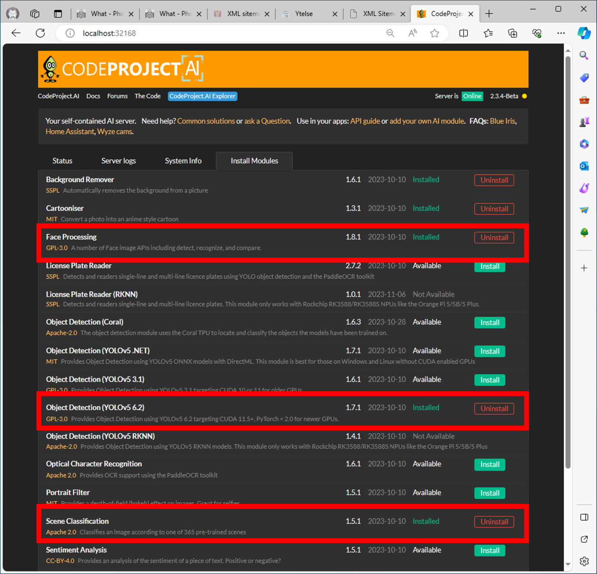

When installed, check that they work in the Vision panel as shown below.

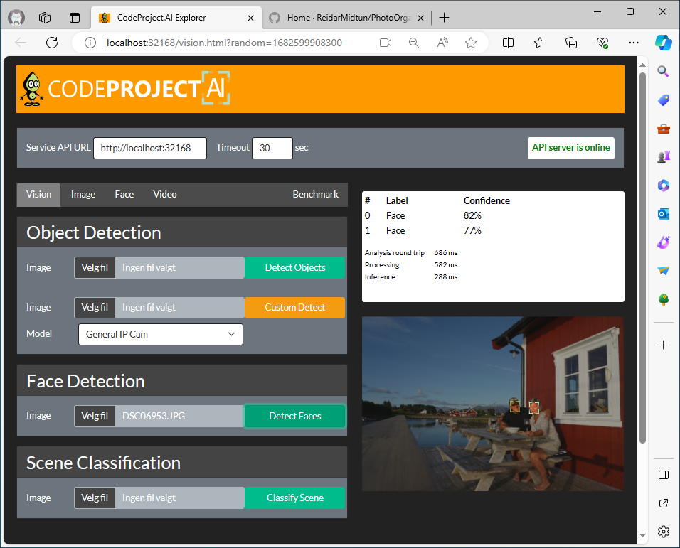

### Possible installation problems

1. An error message like the following can appear:

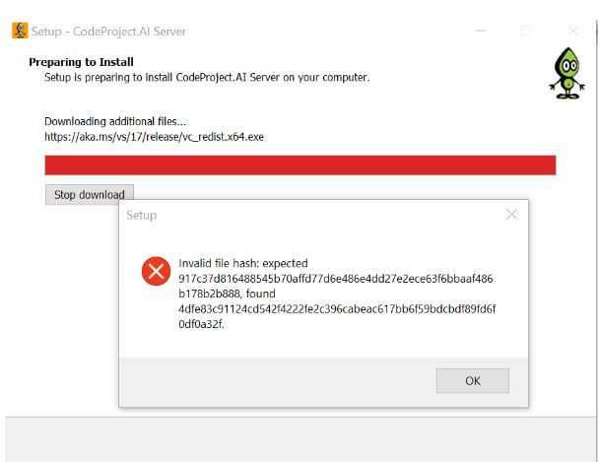  
This particular error can be solved by manually installing [C++ redistributable](https://learn.microsoft.com/en-us/cpp/windows/latest-supported-vc-redist?view=msvc-170). After the manual install, redo the Codeproject.AI install procedure.

1. If the AI server web page fails to launch, it might be caused by a failure to install the CodeProject.AI service. Check if the CodeProject.AI Server is on the windows service list. If not, try to install the following frameworks using the given command in a DOS command window:
   1. .NET 7 Desktop Runtime  
      > winget install Microsoft.DotNet.DesktopRuntime.7
   2. ASP.NET Core Runtime  
      > winget install Microsoft.DotNet.AspNetCore.7

After a successful install of the above-mentioned frameworks, redo the CodeProject.AI installation.

## PhotoOrgz

The install procedure is simply to download the installation zip archive to your computer and unpack it. After unpacking the archive, the app is opened by starting the one and only exe file in the unpacked folder.

#### Possible installation problems

The PhotoOrgz app is built on the .NET 8 Desktop framework. If not already installed, you can install it by the following command in a DOS command window:

* winget install Microsoft.DotNet.DesktopRuntime.8