1. Introduction

Basic Architecture
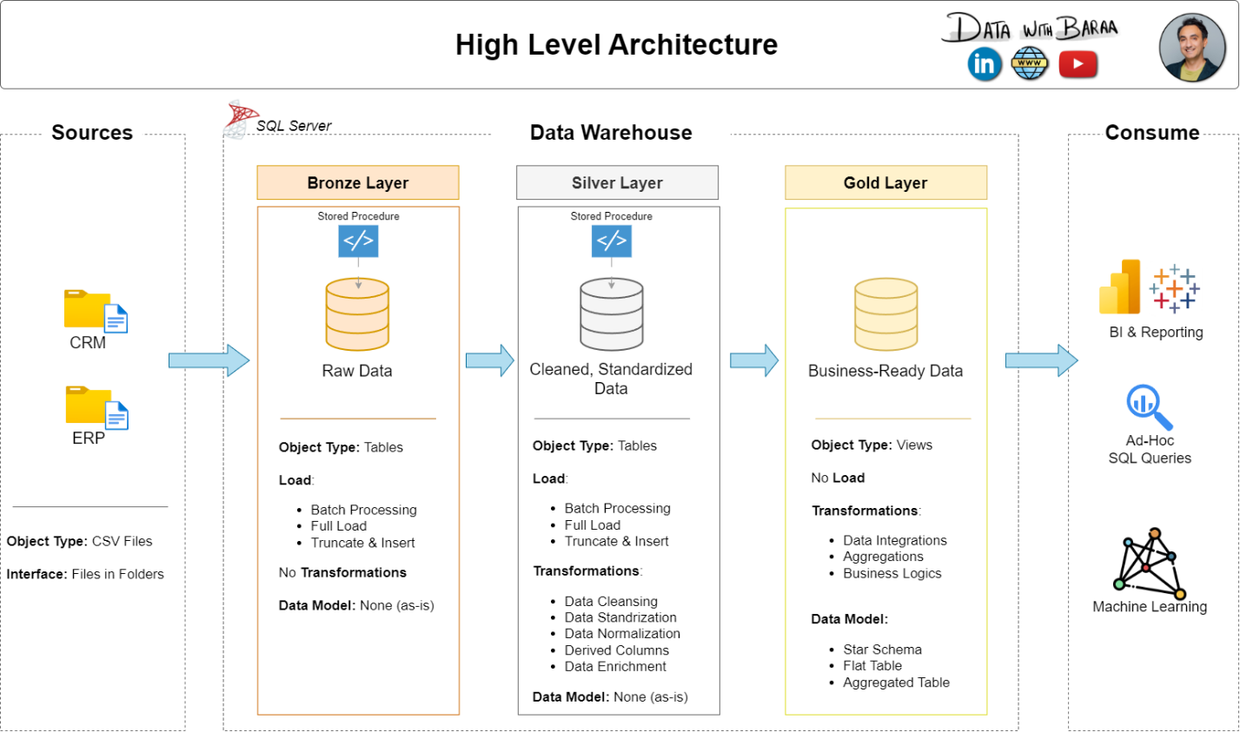
The diagram below shows the overall architecture of this data warehouse - how the two source systems feed into three progressive layers, and how the final Gold layer is exposed for analytics and reporting.
Figure 1. Medallion Architecture — Bronze, Silver, and Gold layers

Each layer has a clearly defined role that builds on the one before it:
- Bronze Layer: Stores raw data exactly as received from the source systems. Data is ingested from CSV files into SQL Server tables with no changes. This layer serves as a faithful, auditable record of what the source systems actually sent.
- Silver Layer: Applies data cleansing, standardization, and normalization. All known data quality problems are resolved here — duplicates removed, codes expanded, dates converted, and keys aligned — to produce clean, consistent tables ready for modeling.
- Gold Layer: Houses business-ready data modeled into a star schema for reporting and analytics. This is the layer that analysts and BI tools query directly.

The key design principle is that each layer is independent and reprocessable. If a transformation rule is wrong, the Silver layer can be rebuilt from the untouched Bronze data without any changes to the source. Nothing ever writes back upstream.

1.2 Project Scope
- Design and build a 3-layer data warehouse on SQL Server using the Medallion Architecture
- Ingest raw data from two source systems (CRM and ERP) provided as CSV files
- Implement ETL pipelines using T-SQL stored procedures to clean and transform the data
- Model the cleaned data as a star schema optimized for analytical queries
- Validate data quality at each layer using automated SQL test scripts
- Document the architecture, transformations, naming conventions, and data catalog

2. Business Problem Definition
The organization operates two separate data systems - a CRM (Customer Relationship Management) system and an ERP (Enterprise Resource Planning) system. Each captures different aspects of the business but they were never designed to communicate with each other. This creates a fundamental gap: there is no single place where analysts can combine customer information, product data, and sales transactions to answer business questions.

2.1 The Core Problem
Sales data is fragmented across two disconnected systems that use incompatible formats, inconsistent coded values, and mismatched key structures. Analysts cannot run queries that combine customer demographics, product categories, and sales figures without slow, error-prone manual merging of exported files.

2.2 Source System Inventory
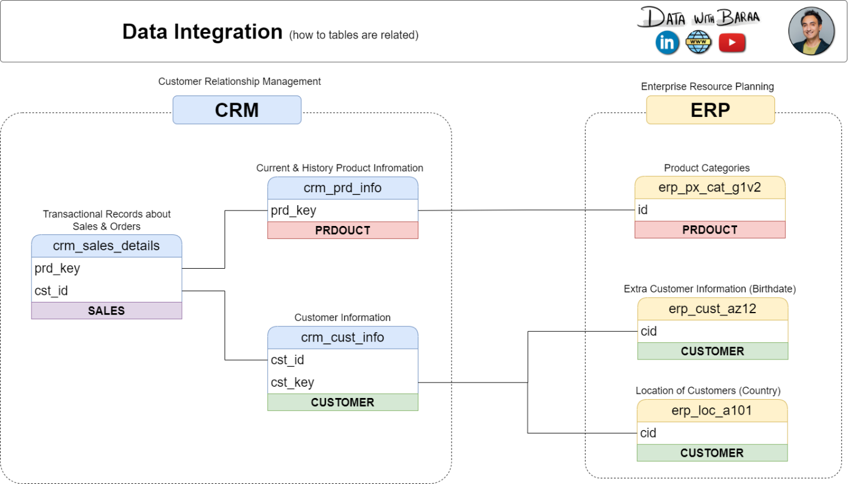
The diagram below illustrates how the two source systems relate to each other — which tables exist in each system, and which fields are used to connect records across the CRM and ERP:

Figure 2. Source system integration — CRM and ERP table relationships and shared keys

2.3 Identified Data Quality Problems
A review of the source files reveals eight categories of problems that must be resolved before any analysis can be performed:
Problem | Detail
Duplicate customer records | The CRM contains multiple rows for the same customer ID with different dates. Only the most recent record should be used.
Dates stored as integers | Sales dates (order, ship, due) are stored as 8-digit integers (e.g. 20130101) not DATE values. Some are 0 or have wrong digit counts.
Coded field values | Gender stored as 'M'/'F'. Marital status as 'M'/'S'. Product line as single letters (M, R, S, T). Country as abbreviations (DE, US, USA). None are readable.
Inconsistent gender encoding | The ERP stores gender as 'M', 'Male', 'F', or 'Female' — four variants — while CRM uses only 'M' or 'F'. Both must map to the same standard values.
Mismatched customer keys | ERP customer IDs have a 'NAS' prefix (e.g. NASABC123) absent from CRM IDs. The location table also adds hyphens not present in CRM keys.
Invalid birthdates | Some ERP birthdate values are future dates — clear data entry errors. These must be nullified.
Inconsistent sales figures | Some rows have sales_amount values that do not equal quantity x price. The correct value must be derived from the component fields.
Product category not in CRM | The product category label (Bikes, Components, etc.) exists only in the ERP. The CRM product key embeds a category ID prefix that must be extracted and joined to the ERP.

3. Proposed Solution

3.1 Architecture Design
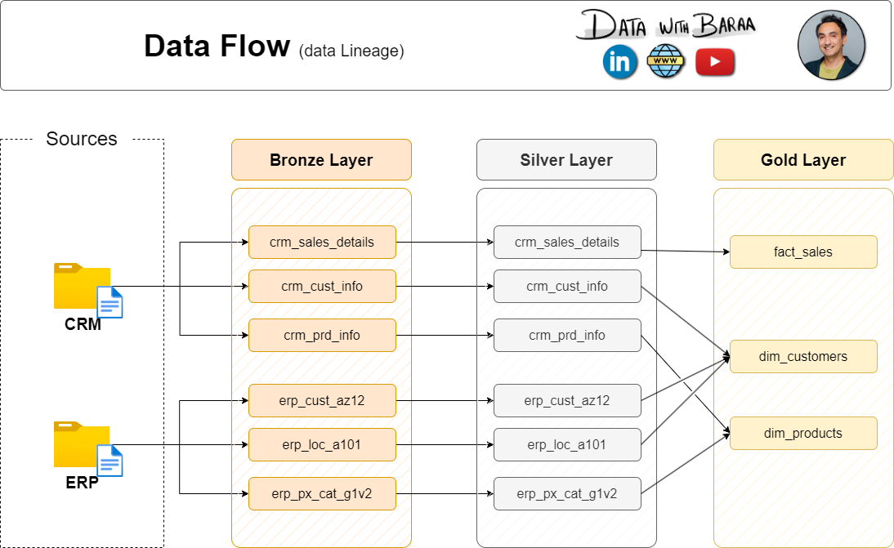
The warehouse uses three SQL Server schemas - one per layer. The diagram below shows how data flows through the architecture, from the raw source CSV files through each schema, and into the final analytical model:

3.2 Star Schema Design
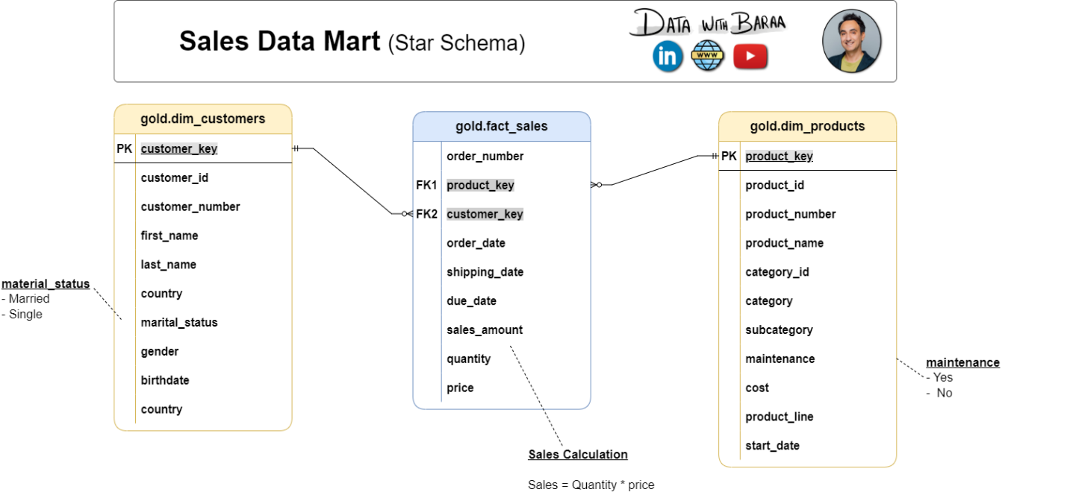
The Gold layer implements a star schema — the industry standard for analytical data models, compatible with BI tools such as Power BI and Tableau. It has one central fact table surrounded by two dimension tables. The diagram below shows the full column-level model:

4. Warehouse Development

4.1 Database and Schema Setup

The foundation of the project involves a one-time manual configuration to establish the necessary containers.

Database Creation: A dedicated SQL Server database is initialized to host the warehouse.

Schema Isolation: Three distinct SQL Server schemas—Bronze, Silver, and Gold—are created to enforce the separation of concerns between layers

4.2 Bronze Layer — Raw Ingestion

The Bronze layer acts as the primary landing zone, maintaining a faithful record of data as it exists in the source systems.

Table Structure: Six tables are defined to mirror the structure of the incoming CRM and ERP CSV files exactly.

Data Integrity: Fields such as sales dates are preserved as integers to avoid ingestion failures caused by corrupt source formatting.

Automated Loading: A stored procedure, bronze.load_bronze, manages the pipeline by truncating existing data and performing bulk inserts from the source files.

4.3 Silver Layer — Transformations

The Silver layer is responsible for refining raw data into a consistent, clean format suitable for enterprise modeling.

Centralized Logic: The silver.load_silver stored procedure executes all transformation rules and includes robust TRY/CATCH error handling and execution logging.

Key Transformations:

Deduplication: Filters CRM records to retain only the most recent customer entry.

Normalization: Resolves inconsistent encodings, such as standardizing gender variants ('Male', 'M') and expanding country abbreviations.

System Integration: Aligns mismatched keys, specifically stripping prefixes and hyphens to allow for reliable cross-system joins.

Calculations: Derives valid sales amounts by multiplying quantity and price to override inconsistent source figures.

4.4 Gold Layer — Star Schema Views
The Gold layer delivers business-ready data through an analytically optimized star schema.
Dynamic Modeling: Instead of physical tables, SQL views are utilized to ensure that the Gold layer automatically reflects the most current Silver data without manual reloading.
Core Components:
- gold.dim_customers: Integrates CRM customer data with ERP-sourced birthdates and country information.
- gold.dim_products: Merges product records with category labels, filtering for active products.
- gold.fact_sales: A central fact table connecting transactions to dimension views via surrogate keys.

5. Data Quality Validation
5.1 Silver Layer Quality Checks
CRM Source System
- Primary Key Integrity: Groups by cst_id and prd_id to ensure no duplicates or NULL values exist after deduplication.
- Whitespace Check: Compares fields like cst_key and prd_nm against their TRIM() versions to flag unwanted leading or trailing spaces.
- Value Normalization: Verifies that material status ('M', 'S') and product lines ('M', 'R', 'S', 'T') have been fully expanded to readable values like 'Married' or 'Mountain'.
- Financial Validation: Filters for prd_cost values that are negative or NULL to ensure pricing accuracy.
- Temporal Logic: Ensures that the prd_end_dt calculated via the LEAD() window function is not earlier than the prd_start_dt.
- Sales Accuracy: Validates that raw integer dates are within the valid 8-digit range (1900–2050) and confirms that sales_amount correctly equals quantity * price.
ERP Source System
- Birthdate Range: Ensures all bdate values are realistic, filtering for dates earlier than 1924-01-01 or any future-dated entry errors.
- Gender Consolidation: Confirms that variant encodings (e.g., 'Male', 'M', 'FEMALE') are consolidated into a single standard format.
- Regional Standardization: Validates that country abbreviations such as 'DE' or 'US' have been expanded to full country names.
- Category Cleanliness: Scans cat, subcat, and maintenance fields for trailing spaces and ensures the maintenance flag uses only expected standardized values.
5.2 Gold Layer Quality Check:
Dimension Uniqueness
- gold.dim_customers: Verifies that the surrogate customer_key is unique across the entire view.
- gold.dim_products: Confirms that the surrogate product_key contains no duplicates, ensuring a "one row per product" grain.
Referential Integrity:
- gold.fact_sales: Performs a LEFT JOIN between the fact table and both dimensions to identify "orphan" records.
- Foreign Key Validation: Specifically flags any transaction where the customer_key or product_key is NULL, indicating a broken relationship in the data model.

