Multidisciplinary Project Final Report

SnowFLOWS: Generative Spatio-Temporal Modelling of Snow Cover Dynamics Using Satellite Imagery

By:
Carla Youness (232771)
Nour el Saghir (230520)
Reina Taher (230134)
Ali Mansour (231039)
Hassan Dakhlallah (222814)

Supervisors:
Dr. Laurent Drapeau
Dr. Youssef El Bakouny

27/04/2026

Ecole Supérieure d’Ingénieurs de Beyrouth
Université Saint-Joseph de Beyrouth

Abstract

Snow cover dynamics play a critical role in water resource management, climate monitoring, and environmental risk assessment in mountainous regions. In Lebanon, where seasonal snow represents an important natural water reservoir, accurate monitoring and forecasting of snow evolution is essential for understanding long-term hydrological behavior and supporting decision-making processes. This project investigates the modeling and prediction of snow cover variability using multi-source satellite imagery combined with deep learning techniques.
The main objective of this work is to develop a data-driven framework capable of analyzing and forecasting weekly snow surface dynamics over Lebanon between 2016 and 2025. To achieve this, satellite data from Sentinel-2 and MODIS were processed using Google Earth Engine, where snow cover was extracted using the Normalized Difference Snow Index (NDSI). The resulting time-series were further enriched with altitude information derived from a Digital Elevation Model (DEM) and meteorological variables obtained from the ERA5 reanalysis dataset. A structured multi-source dataset was then constructed and transformed into sequential inputs suitable for time-series learning.
A Long Short-Term Memory (LSTM) neural network was designed to model temporal dependencies in snow evolution. The model was trained using engineered temporal features, including seasonal encodings, lag-based snow persistence variables, and altitude-dependent aggregates. A custom peak-weighted Huber loss function was introduced to improve sensitivity to extreme snowfall events while maintaining training stability. In addition, multiple experimental configurations were evaluated, including different sequence lengths and a long-term MODIS-based dataset spanning 25 years.
The results show that the proposed LSTM model consistently outperforms a persistence-based baseline model, reducing prediction error while capturing seasonal snow patterns. Experimental analysis also reveals that medium-length temporal windows provide the best trade-off between predictive accuracy and stability. Furthermore, the comparison between Sentinel-2 and MODIS datasets highlights the trade-off between spatial resolution and temporal coverage, confirming the importance of multi-source integration for robust modeling.
Overall, this study demonstrates the effectiveness of combining satellite remote sensing and deep learning for snow cover analysis and forecasting. While the proposed framework achieves promising results, it also highlights the limitations of using single-source data and standard evaluation metrics. Future improvements include the development of hybrid multi-source models and enhanced evaluation strategies capable of capturing peak timing and extreme snow events more accurately.

Acknowledgements

It is our great pleasure to express our sincere gratitude to the Dean of the Faculty of Engineering at Saint Joseph University of Beirut, Dr. Wassim Raphael, for his leadership and for providing a stimulating academic environment that supported the realization of this work.
We would also like to thank the Head of the Computer and Communications Engineering Department, Dr. Chantal Saad Hajjar, for her continuous support throughout our academic journey, as well as Dr. Melhem El Helou, former Head of the Preparatory Cycle, whose role contributed to building the foundations of our engineering education.
We owe our deepest gratitude to our supervisor, Dr. Laurent Drapeau, for his exceptional guidance, constant availability, and continuous support during all stages of this project. His advice and technical expertise played a major role in the successful completion of this work.
We also thank our co-supervisor, Dr. Youssef El Bakouny, for his valuable remarks, support and availability throughout the development of this project.
We are sincerely grateful to Dr. Juliana El Rayess for her guidance and support throughout the different steps of this project and Dr. Khalil Hariss for his assistance throughout our academic journey.
We would like to express our appreciation to all the professors of the Computer and Communications Engineering Department and the Preparatory Cycle whose teaching contributed significantly to our academic formation.
We also acknowledge the support of the platforms providing access to Sentinel-2 and MODIS datasets through Google Earth Engine.
Finally, we express our deepest gratitude to our families for their continuous encouragement and support throughout our studies.

Contents
Abstract 2
Acknowledgements 3
List of Figures 6
List of Tables 7
1 Introduction 8
2 Problem requirements and constraints 10
2.1 Functional requirements 10
2.2 Constraints 12
2.2.1 Technical constraints 12
2.2.2 Non-technical constraints 13
2.2.3 Standards / codes / regulations / policies 15
3 Background / Research / Related work / Literature review 16
4 Solution Design 18
4.1 Multiple Design Alternatives Comparison 18
4.2 Problem Formulation 20
4.3 Required resources 21
4.4 Conceptual model 21
5 Project Management 23
5.1 Planning 23
5.2 Project Facts and Figures 24
5.3 Conflict management 24
6 Solution Implementation 26
6.1 Implementation 26
6.1.1 Initial Data Exploration and Study Area Setup 26
6.1.2 Snow Extraction using Sentinel-2 27
6.1.3 Time-Series Generation and Early Visualization 30
6.1.4 MODIS vs Sentinel-2 Snow-Cover Comparison 31
6.1.5 Altitude-Based Snow Analysis 32
6.1.6 Dataset Construction and Multi-Source Integration 35
6.1.7 Baseline Forecasting and Initial Modeling Attempts 40
6.1.8 LSTM Model Implementation 41
6.2 Testing, Evaluation and Iterative Improvements 43
6.2.1 Evaluation Strategy and Performance Indicators 43
6.2.2 Test Scenarios and Experimental Setup 44
6.2.3 Results Analysis and Iterative Improvement 47
6.2.4 Long-Term Dataset Experiment (MODIS 25-Year Analysis) 53
6.2.5 Project Limitations and Future Extensions 56
7 Impact of the Proposed Solution 57
8 Conclusion 58
9 References 59

List of Figures

Figure 1 - Solution diagram 21
Figure 2 - Project Timeline and Task Distribution (Gantt Chart) 23
Figure 3 - Study area location displayed in Google Earth Engine. 26
Figure 4 - MODIS dataset visualization in Google Earth Engine. 27
Figure 5 - Study area and Sentinel-2 dataset visualization in Google Earth Engine. 29
Figure 6 - Example of exported weekly snow dataset in CSV format. 29
Figure 7 - MODIS weekly snow-covered area time series (2016–2025) generated in Python 30
Figure 8 - Sentinel-2 combined weekly snow-covered area time series (2016–2025) 31
Figure 9 - Comparison between Sentinel-2 and MODIS snow-cover datasets. 31
Figure 10 - Snow-cover variation as a function of altitude (weekly time series). 32
Figure 11 - Snow-covered area above 1200 meters. 33
Figure 12 - Snow-covered area between 1200 and 1800 meters. 34
Figure 13 - Snow-covered area above 1800 meters. 34
Figure 14 - Structure of the multi-source weekly dataset before normalization 35
Figure 15 - Example winter-period observations across elevation levels 35
Figure 16 - Data Pipeline Overview 36
Figure 17 - Example of feature construction 37
Figure 18 - Example of dataset variables after Z-score normalization 37
Figure 19 - Final set of 20 predictive features used for sequence construction 38
Figure 20 - Example of Input Sequences 39
Figure 21 - Final LSTM input tensor dimensions after sequence generation 40
Figure 22 - Final structured dataset 40
Figure 23 - Baseline persistence prediction error 41
Figure 24 - Summary of the stacked LSTM architecture 42
Figure 25 - Implementation of the peak-weighted Huber loss function 42
Figure 26 - Training and validation loss curves 43
Figure 27 - Full timeline 1-week sequence prediction 45
Figure 28 - Full timeline 4-week sequence prediction 45
Figure 29 - Full timeline 12-week sequence prediction 46
Figure 30 - Full timeline 8-week sequence prediction 47
Figure 31 - Model Performance Comparison for 8-week sequences 48
Figure 32 - Observed vs LSTM Predicted Snow Cover (8-Week Window) 48
Figure 33 - Sequence Length vs Prediction Error: MAE and RMSE Comparison 50
Figure 34 - Full timeline 6-week sequence prediction 51
Figure 35 - Full timeline 8-week sequence prediction 51
Figure 36 – Zoomed-in Validation and Testing period 6-week sequence prediction 52
Figure 37 - Zoomed-in Validation and Testing period 8-week sequence prediction 52
Figure 38 - Observed vs Predicted Snow Cover Using MODIS (25-Year Timeline) 54
Figure 39 - Zoomed Observed vs Predicted Snow Cover MODIS (25-Year Dataset) 54

List of Tables

Table 1 - Members Responsibilities 24
Table 2 - Final Feature Vector 38
Table 3 - Dataset Splitting 39
Table 4 - Sequence Length Comparison Results 49

Introduction
Snow cover in Lebanese mountainous regions plays an essential role in hydrology, water resource management, agriculture, and seasonal climate regulation. As Lebanon relies heavily on winter snow accumulation for groundwater recharge and spring river flow, monitoring and forecasting snow surface evolution has become increasingly important in the context of strong inter-annual climate variability.
Accurate prediction of snow surface evolution using satellite imagery represents a complex engineering problem. Snow dynamics depend on multiple interacting environmental factors including temperature variability, precipitation patterns, altitude distribution, and terrain exposure. In addition, optical satellite observations such as Sentinel-2 imagery are frequently affected by cloud cover and irregular acquisition frequency, which introduces discontinuities in the temporal signal. These constraints make the construction of reliable long-term snow time series challenging.
The complexity of this problem arises from several technical characteristics:
- the need to process and structure multi-year satellite time-series datasets (Sentinel-2 and MODIS) for machine learning applications,
- the absence of a direct physical model capable of accurately predicting weekly snow surface evolution at national scale,
- the requirement to transform remote sensing observations into sequential datasets suitable for deep learning forecasting,
- the presence of strong short-term variability in snow coverage over Lebanon,
- the integration of multiple processing stages including data extraction, cleaning, normalization, temporal structuring, modeling, and validation,
- and the involvement of multiple application stakeholders such as environmental monitoring institutions, water-resource planners, and climate-impact analysts.
Because of these challenges, forecasting snow surface evolution cannot rely on a single standard method and requires the design of a dedicated data-driven engineering pipeline combining remote sensing processing and time-series deep learning techniques.
Project objectives and outcomes:
The objective of this project is to design and evaluate a deep learning based forecasting pipeline capable of predicting weekly snow surface evolution over Lebanese mountainous regions using satellite-derived time-series observations. To achieve this objective, the project focuses on the following tasks:
- extracting multi-year snow surface datasets from MODIS and Sentinel-2 imagery using Google Earth Engine,
- constructing a structured weekly time-series dataset suitable for machine learning training,
- preprocessing and normalizing satellite-derived indicators,
- preparing supervised learning sequences using sliding temporal windows,
- implementing an LSTM-based forecasting model for snow surface prediction,
- evaluating model performance using MAE and RMSE indicators,
- comparing multiple sequence lengths to determine the optimal temporal input configuration,
- analyzing prediction realism through graphical comparison with observed snow evolution,
- and validating model behavior using an extended MODIS dataset to assess the impact of temporal coverage on forecasting performance.
The expected outcome of this work is a validated forecasting pipeline capable of predicting weekly snow surface evolution with consistent accuracy, together with a quantitative and qualitative evaluation of the limits and capabilities of satellite-based snow prediction in the Lebanese environmental context.
Report outline:
This report is organized as follows:
Section 2 presents the functional requirements, technical constraints, and standards associated with the proposed system.
Section 3 reviews related work on satellite-based snow monitoring and time-series forecasting using machine learning and deep learning approaches.
Section 4 describes the solution design, including alternative approaches, problem formulation, required resources, and the conceptual model.
Section 5 presents project management aspects, including planning, team organization, and conflict management strategies.
Section 6 details the solution implementation. It covers data acquisition using Sentinel-2 and MODIS satellite imagery, snow extraction using Google Earth Engine, dataset construction, feature engineering, and the development of the LSTM-based forecasting model. It also presents testing, evaluation, and iterative improvements, including performance metrics, baseline comparison, sequence length analysis, and additional experiments using long-term MODIS data.
Section 7 discusses the broader impact of the proposed solution in environmental, societal, and economic contexts.
Section 8 concludes the report and outlines future perspectives for improving the forecasting framework.
Section 9 lists the references used throughout the project.

Problem requirements and constraints

Functional requirements
This section defines the functional requirements that must be satisfied in order to successfully address the problem of forecasting weekly snow surface evolution using satellite-derived time-series observations.
The proposed system is designed as a structured processing and prediction pipeline transforming remote sensing data into reliable temporal forecasts.
The following functional requirements were identified based on project objectives and implementation feasibility.

1 – Satellite Time-Series Data Extraction and Structuring
The system shall extract multi-year snow surface observations from satellite datasets using the Google Earth Engine platform and convert them into structured time-series datasets suitable for machine learning applications.
More specifically, the system shall:
- extract weekly snow surface indicators from MODIS satellite observations,
- extract weekly snow surface indicators from Sentinel-2 observations,
- export processed observations into structured CSV datasets,
- organize the extracted data into chronological time-series format,
- prepare datasets covering approximately 10 years of Sentinel-2 observations,
- prepare extended MODIS datasets for comparative long-term analysis.
This requirement ensures the availability of consistent historical observations necessary for training forecasting models.

2 – Data Preprocessing and Machine Learning Preparation Pipeline
The system shall preprocess satellite-derived time-series data to ensure compatibility with deep learning forecasting models.
More specifically, the system shall:
- clean and verify extracted datasets,
- normalize snow surface indicators prior to model training,
- construct supervised learning datasets using sliding temporal sequence windows,
- define prediction targets corresponding to future weekly snow surface values,
- split datasets into training, validation, and testing subsets.
This requirement ensures that satellite observations can be transformed into structured learning inputs suitable for sequence-based prediction models.

3 – LSTM-Based Snow Surface Forecasting Model
The system shall implement a deep learning time-series prediction model capable of forecasting weekly snow surface evolution using historical satellite observations.
More specifically, the system shall:
- implement an LSTM neural network architecture for temporal prediction,
- train the model using Sentinel-2 time-series datasets,
- evaluate prediction performance on unseen testing data,
- generate weekly snow surface forecasts based on historical sequence inputs.
This requirement represents the core predictive component of the proposed engineering solution.

4 – Model Performance Evaluation and Sequence-Length Optimization
The system shall evaluate forecasting performance and determine the most suitable temporal input configuration.
More specifically, the system shall:
- compute prediction accuracy using MAE and RMSE performance indicators,
- compare multiple sequence lengths ranging from short to extended temporal windows,
- analyze prediction stability across different sequence configurations,
- identify the sequence length providing the best balance between numerical accuracy and temporal prediction realism.
This requirement ensures that the forecasting model operates under an optimized configuration adapted to the characteristics of the dataset.

5 – Long-Term Dataset Validation Experiment Using Extended MODIS Observations
The system shall evaluate the impact of dataset temporal coverage on prediction performance using extended historical observations.
More specifically, the system shall:
- construct an additional forecasting experiment using approximately 25 years of MODIS observations,
- compare prediction behavior obtained with extended historical data,
- assess whether prediction limitations observed with Sentinel-2 datasets are related to data availability.
This requirement supports interpretation of model performance limits within the Lebanese snow variability context.

Constraints
The proposed system operates under several technical constraints related to data availability, computational resources, and modeling limitations. These constraints directly influence the design choices and performance of the forecasting pipeline.

Technical constraints
1 – Limited Temporal Coverage of Sentinel-2 Data
- Sentinel-2 data covers approximately 10 years, which restricts the amount of training data available for the forecasting model.
- This limitation impacts the model’s ability to generalize long-term temporal patterns.
2 – High Variability of Snow Surface Signal
- Snow surface evolution in Lebanon exhibits strong week-to-week variability.
- This introduces noise in the time-series and limits prediction stability.
- As a result, even well-trained models may struggle to achieve very low error values.
3 – Data Quality and Temporal Irregularities
- Satellite-derived observations may contain inconsistencies due to:
  - irregular acquisition frequency,
  - residual noise after preprocessing.
- These factors affect the continuity of the time-series used for training.
4 – Computational Resource Limitations
- Model training must be performed within limited computational resources.
- LSTM training with multiple sequence lengths increases:
  - training time,
  - memory usage.
- This constrains the complexity of the model architecture and the number of experiments that can be performed.
5 – Sequence Length Trade-off Constraint
- Increasing sequence length improves temporal context but:
  - increases model complexity,
  - may lead to overfitting or unstable training.
- Shorter sequences are more stable but may miss long-term patterns.
- This creates a design trade-off between accuracy and temporal representation.
6 – Model Optimization Limitations
- Despite tuning (learning rate, architecture depth, loss function), the model tends to converge to similar RMSE values (~0.6–0.7).
- This suggests:
  - either a local minimum during training, or
  - an inherent limitation due to data variability and noise.
7 – Dependence on External Platform (Google Earth Engine)
- Data extraction relies on Google Earth Engine:
  - requires correct API usage,
  - depends on platform availability and processing limits.
- This introduces external dependency in the data pipeline.

Non-technical constraints
The following non-technical constraints were considered during the development of the snow forecasting system. These constraints are related to project execution conditions, academic requirements, and practical limitations rather than system architecture.

1 – Academic Schedule Constraint
- The project must be completed within the academic semester timeline, including implementation, experimentation, and final reporting.
- This constraint limited the number of experiments and iterations that could be performed, particularly for:
  - sequence length tuning,
  - model architecture adjustments,
  - long-term validation using MODIS (25-year dataset).
2 – Project Scope Constraint
- The system scope is limited to weekly snow surface forecasting using satellite-derived time-series data.
- Advanced features such as:
  - real-time deployment,
  - full geospatial mapping systems,
  - operational forecasting systems
were excluded due to time and resource constraints.
3 – Interpretability Constraint
- Results must remain interpretable for academic evaluation.
Therefore, model evaluation was restricted to:
  - MAE and RMSE metrics,
  - visual comparison of predicted vs actual time-series,
  - sequence length performance analysis.
- This ensured that outputs remain understandable and defensible during evaluation.
4 – Iteration and Experimentation Constraint
- Due to training time and computational cost, only a finite number of experiments could be conducted. This influenced:
  - the number of sequence lengths tested (1–12 weeks),
  - limited hyperparameter tuning iterations,
  - selection of a single final model architecture for comparison.
5 – Data Dependency Constraint
- Model performance is fully dependent on the quality and availability of:
  - Sentinel-2 time-series data (~10 years),
  - MODIS long-term dataset (~25 years for validation only).
- No external ground-truth snow measurements were available for direct validation, limiting evaluation to satellite-derived consistency.
6 – Reproducibility Constraint
- All experiments were designed to remain reproducible using:
  - Python-based environment,
  - consistent dataset preprocessing pipeline,
  - fixed evaluation metrics.
This ensures that results can be re-generated for academic review.
These constraints directly impact the functional requirements of the system. In particular, limitations in Sentinel-2 data availability and cloud contamination affect the reliability of the data extraction process (Requirement 1) and the quality of time-series modeling (Requirement 3). Similarly, computational constraints in Google Earth Engine influence the design of the data processing workflow, requiring segmentation of the analysis period and affecting system efficiency.

Standards / codes / regulations / policies

Although full compliance with engineering standards is beyond the scope of this academic project, the system design acknowledges and follows relevant data usage policies and good engineering practices related to satellite data processing and machine learning workflows.
- Copernicus Sentinel Data Policy: Sentinel-2 data is used under the official open-access policy, ensuring proper and ethical usage.
- NASA MODIS Data Policy: MODIS data is used according to NASA Earth Data guidelines, supporting transparency and scientific reliability.
- Google Earth Engine (GEE): Data extraction and processing comply with GEE platform usage rules and API standards.
- Reproducibility Practices: The project follows standard data science practices, including structured datasets, consistent preprocessing, and repeatable experiments.
- Python & ML Frameworks: Implementation is based on widely accepted tools (Python, TensorFlow/Keras), ensuring standard model development and evaluation practices.
In addition to referencing these standards, they were directly incorporated into the system design. The use of the NDSI threshold (0.4) follows established remote sensing practices for snow detection, ensuring consistency with existing scientific methodologies. Furthermore, the data preprocessing and model evaluation pipeline were designed following standard machine learning practices to ensure reproducibility, comparability, and robustness of the results.

Background / Research / Related work / Literature review
Snow monitoring using satellite imagery has evolved significantly since the launch of early Earth observation missions by the National Aeronautics and Space Administration (NASA). A major advancement came with the Moderate Resolution Imaging Spectroradiometer (MODIS), which enabled daily global snow mapping.
One of the most widely used snow detection techniques is the Normalized Difference Snow Index:

$$NDSI =\frac{Green - SWIR}{Green + SWIR}$$

This index leverages the high reflectance of snow in the visible spectrum and its absorption in the shortwave infrared range. It is commonly used with datasets such as MODIS and Sentinel-2 to derive snow coverage indicators.

Limitations Identified in Literature
Despite its effectiveness, satellite-based snow monitoring presents several limitations:
- sensitivity to atmospheric conditions and data noise,
- temporal irregularities in observations,
- difficulty capturing rapid changes in snow coverage.
These challenges are particularly relevant in regions such as Lebanon, where snow cover exhibits strong short-term variability.

Snow Forecasting Approaches
In addition to detection, forecasting snow evolution has been explored using different modeling approaches:
- Statistical models (e.g., ARIMA)
  - simple and interpretable,
  - limited ability to model nonlinear temporal dynamics.
- Machine learning models (e.g., Random Forest, LSTM)
  - capable of capturing nonlinear relationships,
  - better suited for time-series forecasting.
- Deep learning models (e.g., LSTM-based approaches)
  - designed for sequential data,
  - able to learn temporal dependencies from historical observations.
Compared to classical statistical models such as ARIMA, the LSTM approach is better suited for this study as it can capture nonlinear temporal dependencies and complex seasonal patterns in snow evolution. In contrast to traditional machine learning models such as Random Forest, which treat observations independently, LSTM networks explicitly model sequential dependencies, making them more appropriate for time-series forecasting of environmental variables. This justifies the selection of LSTM as the primary modeling approach for this project.

Identified Gaps and Project Positioning
From the literature, the following limitations were identified:
- limited focus on small mountainous regions such as Lebanon,
- lack of studies addressing high weekly variability in snow coverage,
- limited analysis of how temporal window size (sequence length) impacts prediction performance,
- limited investigation of data availability effects on forecasting accuracy.

Proposed Approach
To address these limitations, this project adopts a time-series forecasting approach based on LSTM models, focusing on:
- using Sentinel-2 data (~10 years) as the main dataset,
- structuring the data into temporal sequences of varying lengths,
- evaluating performance using MAE and RMSE,
- analyzing both numerical performance and visual prediction quality,
- conducting an additional experiment using 25 years of MODIS data to assess the impact of data availability.
Unlike many approaches that focus only on detection, this work emphasizes forecasting performance analysis and model behavior under different temporal configurations, with a specific focus on the Lebanese context.

Solution Design

Multiple Design Alternatives Comparison
Several modeling approaches were considered for snow surface forecasting before selecting the final design. These alternatives were evaluated based on accuracy, ability to model temporal dynamics, and computational feasibility.

Alternative 1: Statistical Time-Series Models (ARIMA)
Description
Classical statistical models such as ARIMA were considered to model snow evolution using historical values only.
Advantages
- Simple and interpretable
- Low computational cost
Limitations
- Limited ability to model nonlinear patterns
- Poor performance with highly variable data
- Not suitable for complex environmental signals
Evaluation
This approach was not suitable due to the strong variability and nonlinearity of snow surface dynamics.

Alternative 2: Machine Learning Models (e.g., Random Forest)
Description
Machine learning models using engineered features were considered for predicting snow values.
Advantages
- Ability to capture nonlinear relationships
- Flexible feature integration
Limitations
- Requires extensive feature engineering
- Does not explicitly model temporal dependencies
- Limited performance on sequential data
Evaluation
While more powerful than statistical models, these approaches do not fully exploit the temporal nature of the problem.

Alternative 3: LSTM-Based Time-Series Forecasting (Selected Design)

Description
Long Short-Term Memory (LSTM) networks were selected to model temporal dependencies in snow surface evolution using sequential input data.
Advantages
- Designed for sequential/time-series data
- Captures temporal dependencies across multiple time steps
- Suitable for nonlinear and dynamic patterns
Limitations
- Requires careful tuning (sequence length, learning rate)
- Sensitive to data variability
- Moderate computational cost
Evaluation
This approach best satisfies the project requirements by providing a balance between modeling capability and computational feasibility. It allows learning temporal patterns directly from historical data without requiring complex feature engineering.

Final Key Design Choices
- Model type: LSTM selected for time-series forecasting
- Sequence-based learning: multiple window sizes tested (1–12 weeks)
- Loss function: peak-weighted Huber loss to better capture extreme values
- Evaluation metrics: MAE and RMSE for quantitative assessment
- Validation approach: comparison of numerical performance and visual prediction quality

Design Trade-offs
A key design trade-off was identified between:
- Numerical performance (RMSE/MAE)
- Visual prediction quality (peak detection and temporal behavior)
Shorter sequences (e.g., 6 weeks) achieved better numerical performance,
while longer sequences (e.g., 8 weeks) provided more realistic temporal patterns.
This trade-off played a central role in selecting the final model configuration.

Problem Formulation
The objective of this project is to forecast weekly snow surface values over Lebanon using satellite-derived time-series data.
Let:
- $X_{t}∈ R^{d}$: feature vector at time $t$(satellite-derived indicators such as snow coverage, temperature, precipitation, etc.)
- $y_{t}∈ R$: snow surface value at time $t$
- $n$: sequence length (number of past weeks used as input)

Forecasting Problem
Given a historical sequence:
$$\left\{X_{t-n},X_{t-n+1},…,X_{t}\right\}$$

predict the snow surface at the next time step:

$${\hat{y}}_{t+1}=f(X_{t-n:t})$$
where:
- $f$ is a nonlinear function learned by an LSTM model
- the model captures temporal dependencies across past observations

Assumptions
- The time-series data is sufficiently cleaned and normalized
- Past observations contain enough information to predict future snow values
- The relationship between inputs and output is nonlinear and time-dependent

Constraints
- Limited dataset size (Sentinel-2 ~10 years)
- High variability in weekly snow values
- Limited computational resources for model training

Required resources

The SnowFLOWS project requires a combination of software, data, and hardware resources to handle multi-sensor satellite imagery, perform preprocessing, train spatio-temporal models, and generate visual outputs.

Software
- Python 3.x
- Libraries: NumPy, Pandas, TensorFlow/Keras
- Visualization: Plotly
- Google Earth Engine (for data extraction)
Data
- Sentinel-2 time-series dataset (~10 years)
- MODIS dataset:
  - initial dataset (10 years)
  - extended dataset (25 years for comparison)
Hardware
- Personal computer (8–16 GB RAM)
- CPU-based training (no heavy GPU required)
- Stable internet connection for data access

Conceptual model

The SnowFLOWS conceptual model represents the end-to-end workflow of the system and illustrates the interaction between data, processing, modeling, and visualization components.

System Workflow:

Figure 1 - Solution diagram

1. Data Extraction
- Satellite data retrieved using Google Earth Engine
- MODIS and Sentinel-2 datasets collected over multiple years

2. Preprocessing
- Cleaning and normalization of data
- Feature preparation and structuring into tabular time-series

3. Sequence Construction
- Data transformed into sequences of length $n$
- Each input contains past observations used to predict the next value

4. Modeling
- LSTM-based neural network
- Learns temporal dependencies from historical data

5. Prediction
- Output: predicted snow value for the next week

6. Evaluation & Visualization
- Metrics: MAE and RMSE
- Visual comparison of predicted vs actual values
- Analysis across different sequence lengths

Project Management

Planning
The project was managed using an iterative workflow combining data processing, model development, and evaluation phases. The objective was to progressively refine both the dataset and the predictive model through multiple experimental cycles.
The work was organized into major stages, each aligned with specific deliverables and milestones:
Phase 1 – Data Acquisition & Exploration
Collection and initial visualization of satellite data (MODIS and Sentinel-2) to understand temporal behavior and validate data availability.
Phase 2 – Data Preparation
Cleaning, normalization, and structuring of datasets into consistent time-series formats suitable for modeling.
Phase 3 – Dataset Construction
Definition of input-output relationships, creation of prediction targets, and preparation of sequence-based datasets.
Phase 4 – Model Development
Implementation of the LSTM architecture, including selection of model parameters, loss functions, and evaluation metrics.
Phase 5 – Training & Evaluation
Model training, performance evaluation using quantitative metrics, and comparison with baseline approaches.
Phase 6 – Iterative Improvement
Exploration of different sequence lengths, tuning of hyperparameters, and analysis of trade-offs between numerical accuracy and visual realism.
Phase 7 – Extended Experimentation
Application of the model to a long-term MODIS dataset to evaluate the impact of data availability on forecasting performance.
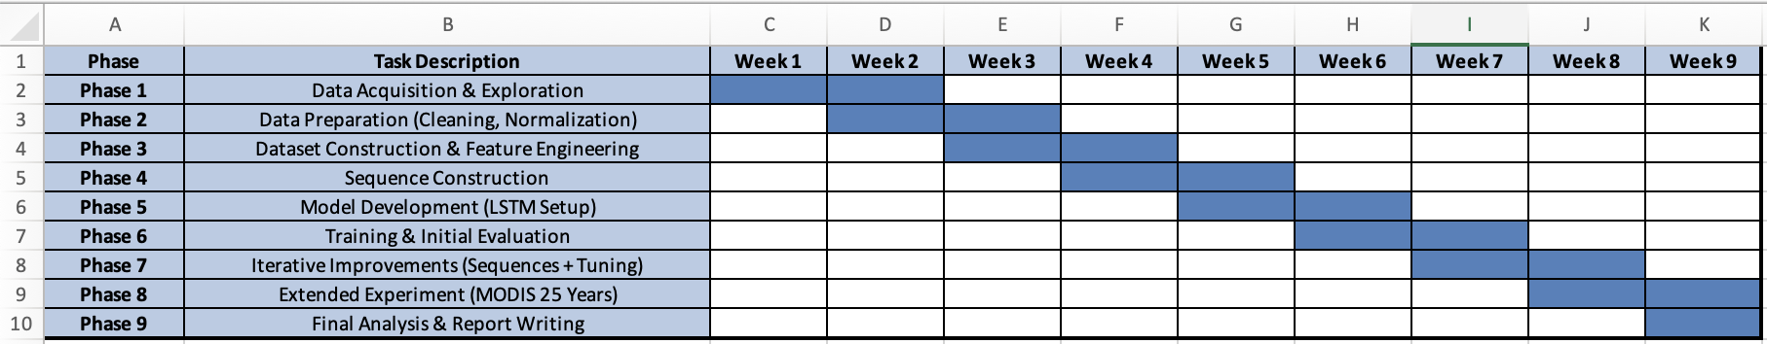
Figure 2 - Project Timeline and Task Distribution (Gantt Chart)

Project Facts and Figures

Team Members and Responsibilities
The project was conducted by a team of Computer and Communications Engineering (CCE) students. While responsibilities were distributed across different tasks, the work was highly collaborative, with all members contributing to multiple stages of the project.
Name | Affiliation | Main Contributions
Reina Taher | CCE | LSTM model development, sequence length experiments, performance evaluation (MAE/RMSE), and visualization of results
Hassan Dakhlallah | CCE | Data extraction (MODIS & Sentinel-2), preprocessing, normalization, and dataset preparation
Carla Youness | CCE | Data visualization (Python & Plotly), graph generation, support in preprocessing, analysis and performance evaluation
Nour Saghir | CCE | Data preparation for modeling (feature selection, normalization, target definition, dataset structuring)
Ali Mansour | CCE | Data collection and integration (MODIS, Sentinel-2, ERA5), preprocessing, and support in analysis and evaluation

Table 1 - Members Responsibilities

Collaborative Work Approach
Although each member had primary responsibilities, the project was carried out collaboratively:
- All members contributed to data preparation and validation
- Model results were jointly analyzed and interpreted
- Visualization and comparison of results were discussed as a team
- Iterative improvements were reviewed collectively
- Report writing and documentation were shared among team members
This collaborative approach ensured consistency and allowed continuous improvement throughout the project.

Conflict management
During the project, a few technical and organizational challenges were encountered. These were managed through continuous communication and collaborative problem-solving.

1. Variability in Model Results
One of the main challenges was the instability of model performance. Running the same model multiple times produced slightly different results, which created uncertainty when comparing configurations.
Solution:
- Multiple runs were performed for each experiment
- Mean and standard deviation (MAE and RMSE) were computed
- Decisions were based on averaged results rather than single runs

2. Trade-off in Model Performance
A disagreement arose when selecting the optimal sequence length:
- sequence length = 6 gave the best numerical results
- sequence length = 8 produced better visual predictions
Solution:
- Both numerical metrics and visualization were analyzed
- Results were discussed collectively
- Both options were documented and justified in the report before making a final decision

3. Data Preparation Challenges
Preparing consistent datasets from different sources (MODIS and Sentinel-2) required significant preprocessing and alignment efforts.
Solution:
- Tasks were distributed among team members
- Data preparation steps were reviewed collectively
- Iterative corrections ensured consistency before model training

4. Work Distribution and Coordination
Since multiple members were working on similar tasks, coordination was necessary to avoid redundancy and ensure consistency.
Solution:
- Regular discussions were held to align progress
- Work was shared and reviewed collaboratively
- Final decisions were made collectively to maintain coherence

Solution Implementation

Implementation

Initial Data Exploration and Study Area Setup
The project began with an initial exploration phase using the Google Earth Engine (GEE) platform to define the study area and examine available satellite datasets. The region of interest was defined using FAO/GAUL administrative boundaries corresponding to Lebanon, which was used to spatially filter all data throughout the project.
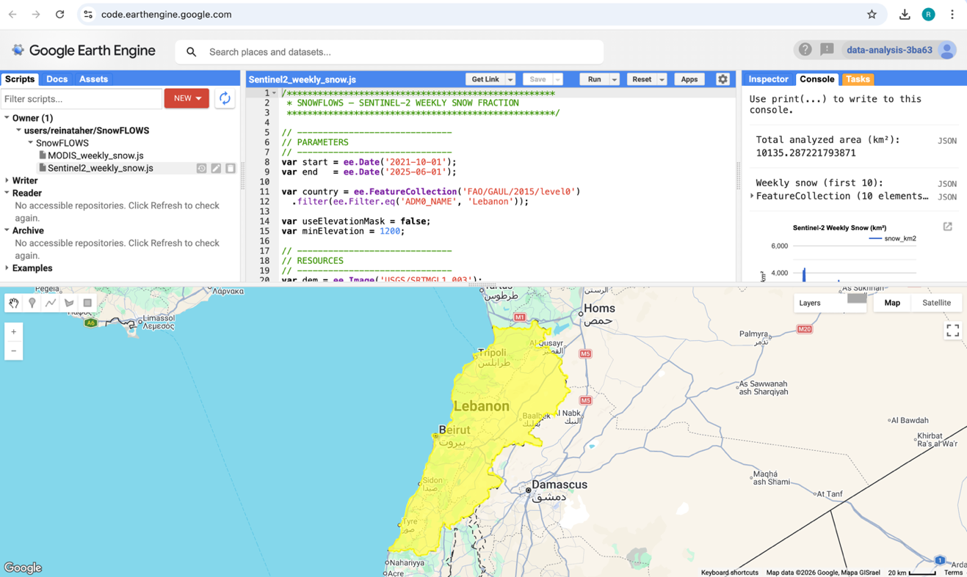

Figure 3 - Study area location displayed in Google Earth Engine.

Both Sentinel-2 and MODIS datasets were explored to assess their suitability for snow monitoring. Sentinel-2 offers high spatial resolution (10 m), enabling detailed snow detection, while MODIS provides lower spatial resolution (~500 m) but higher temporal frequency, making it suitable for long-term analysis.
Initial visual inspections were performed within GEE to evaluate seasonal snow coverage, data availability, and temporal consistency over the study region. This step confirmed the reliability of both datasets and validated their suitability for automated snow-cover extraction using spectral indices in later stages of the project.

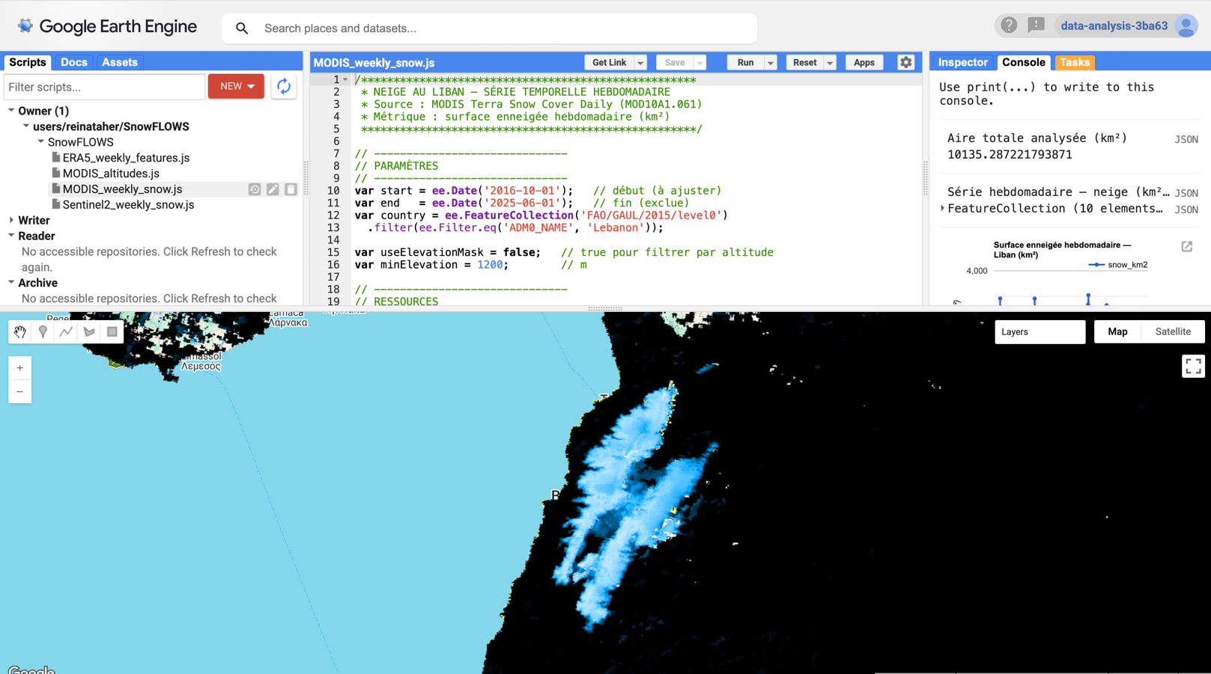

Figure 4 - MODIS dataset visualization in Google Earth Engine.

Snow Extraction using Sentinel-2
Snow cover extraction was performed using Sentinel-2 Surface Reflectance imagery (COPERNICUS/S2_SR) within the Google Earth Engine (GEE) platform. The dataset was filtered spatially over Lebanon and temporally over the study period (2016–2025). To improve data quality, images with high cloud coverage were excluded, and only scenes with acceptable cloud conditions were retained for processing.
Cloud contamination was handled using the Sentinel-2 Scene Classification Layer (SCL). This layer was used to mask out clouds and cloud shadows while preserving valid land surface pixels. Only relevant classes such as vegetation, bare soil, water, and snow-related pixels were kept for further processing.
Snow detection was performed using the Normalized Difference Snow Index (NDSI), computed using the green band (B3) and the shortwave infrared band (B11). A threshold value of 0.4 was applied to classify pixels as snow-covered or non-snow-covered, producing a binary snow mask for each observation.
The resulting snow masks were aggregated on a weekly basis in order to reduce noise from daily variability and cloud interruptions. For each week, the snow-covered area was computed by averaging snow pixels and converting them into surface area (km²), as well as percentage coverage of the study region.
All weekly snow statistics were exported from Google Earth Engine in CSV format for further processing and analysis in Python.
Key Processing Steps in the Google Earth Engine Script:

Definition of the study area using FAO/GAUL administrative boundaries.

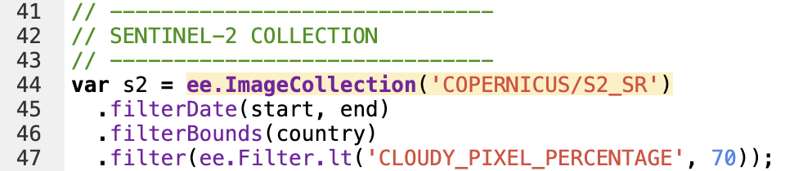
Selection of Sentinel-2 Surface Reflectance imagery from the COPERNICUS/S2_SR dataset.

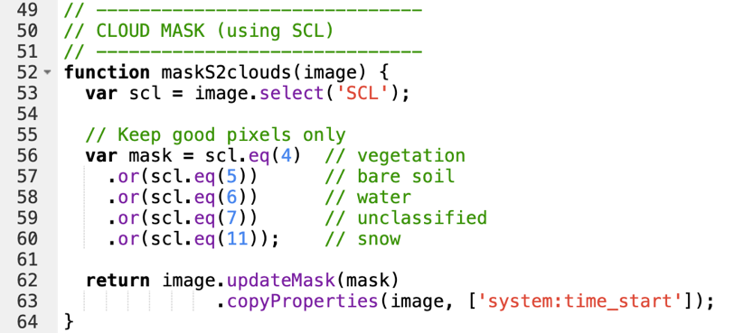
Cloud masking using the Sentinel-2 Scene Classification Layer (SCL).
Computation of the Normalized Difference Snow Index (NDSI).

Application of the NDSI threshold (0.4) for snow classification.

Weekly aggregation of snow-covered surface area.
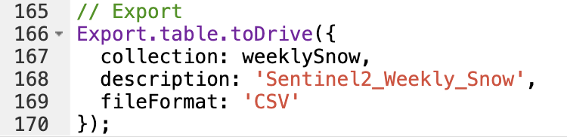
Export of weekly snow statistics to CSV format.
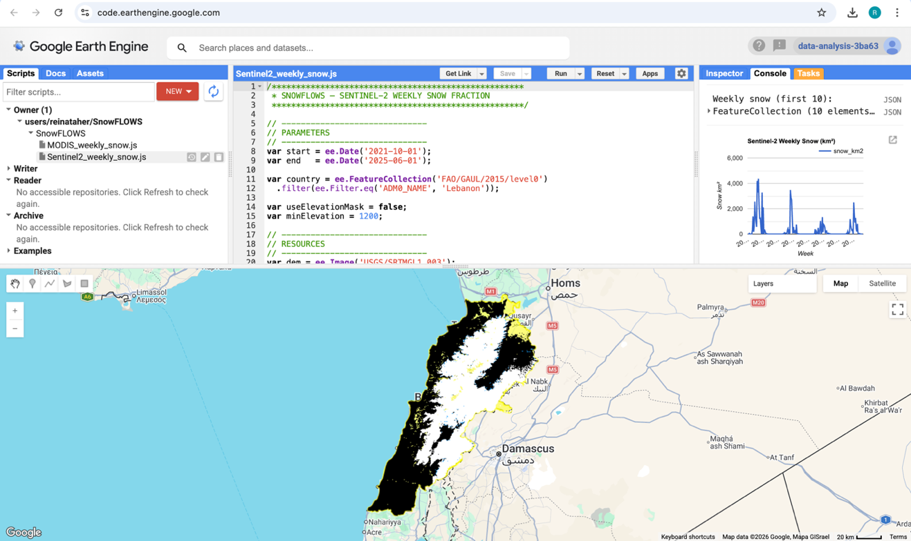

Figure 5 - Study area and Sentinel-2 dataset visualization in Google Earth Engine.

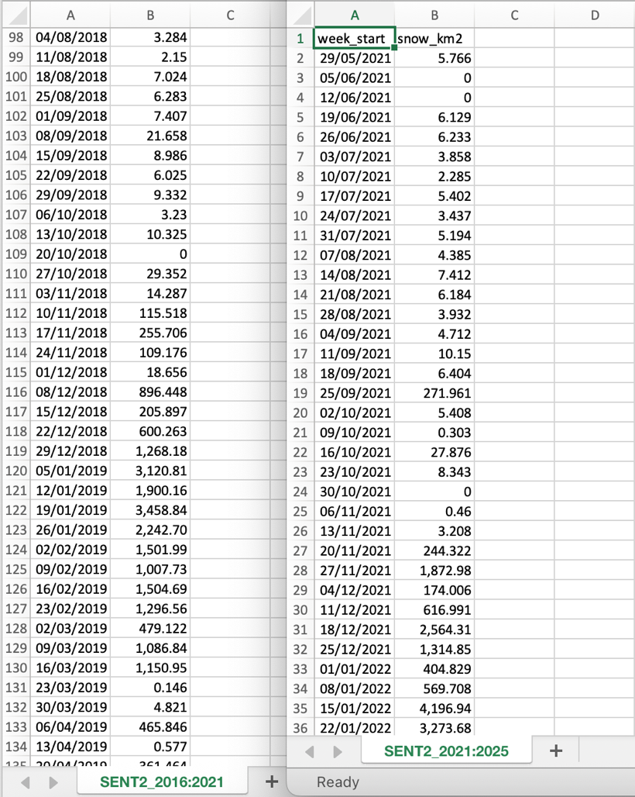
Figure 6 - Example of exported weekly snow dataset in CSV format.

Time-Series Generation and Early Visualization

After exporting the weekly snow-cover statistics from Google Earth Engine, the datasets were processed in Python to construct continuous time-series representations of snow dynamics over the study region.
The exported CSV files were first loaded and cleaned to ensure temporal consistency and correct formatting of weekly observations. Since the processing in Google Earth Engine was performed in separate intervals due to computational limitations, the resulting datasets were merged to form a continuous weekly time series covering the full study period.
Initial exploratory analysis was then conducted using Python libraries such as Matplotlib and Plotly. These early visualizations were used to verify the consistency of the extracted snow signal and to observe the seasonal behavior of snow cover over time.
The first generated plots clearly showed a strong seasonal pattern, with snow coverage increasing during winter months and decreasing during spring and summer. These initial results confirmed the correctness of the NDSI-based extraction pipeline and validated the temporal structure of the dataset.
At this stage, preliminary comparisons between MODIS and Sentinel-2 snow-cover signals were also initiated to assess the consistency between the two satellite products in terms of seasonal trends and variability.

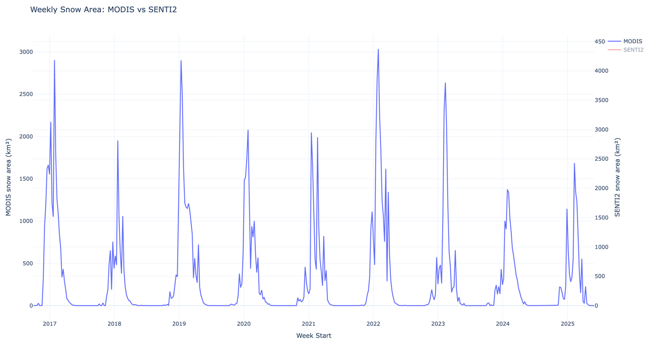
Figure 7 - MODIS weekly snow-covered area time series (2016–2025) generated in Python

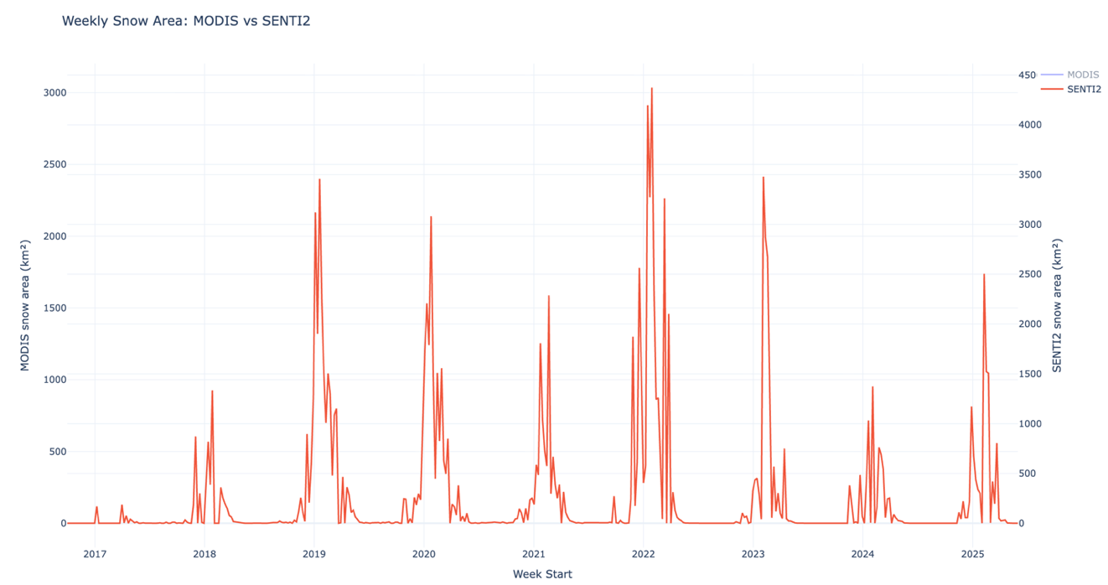

Figure 8 - Sentinel-2 combined weekly snow-covered area time series (2016–2025)

MODIS vs Sentinel-2 Snow-Cover Comparison
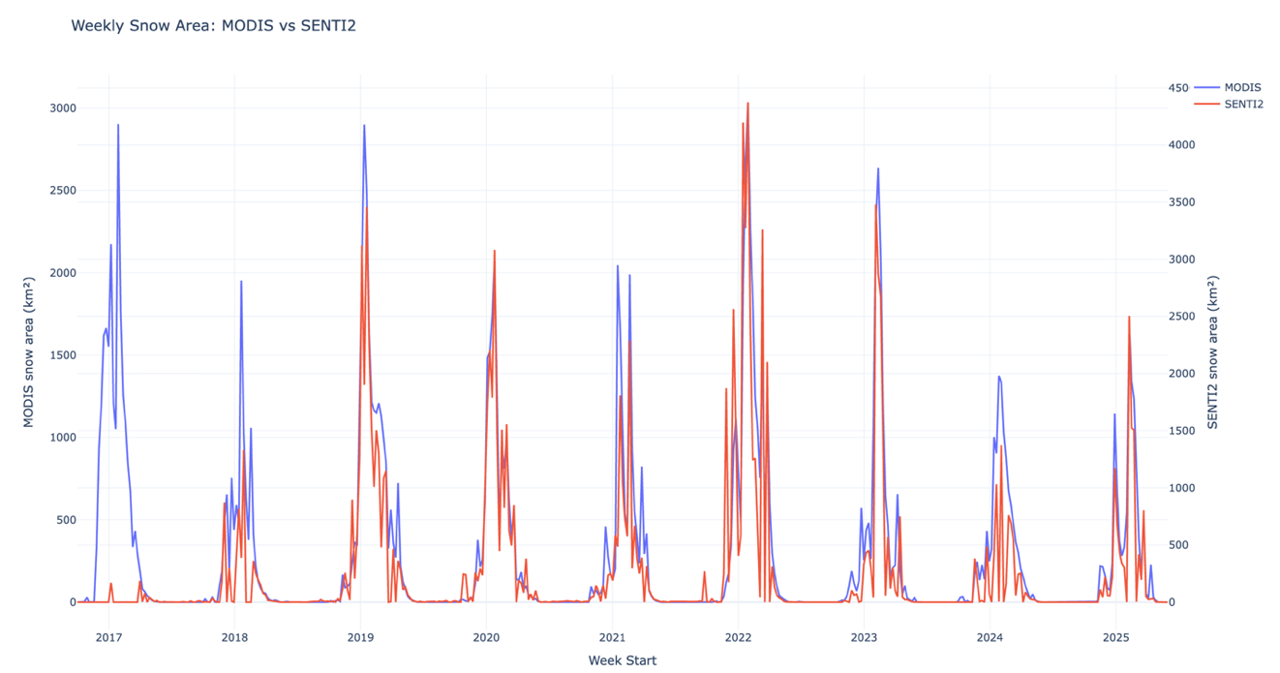
Figure 9 - Comparison between Sentinel-2 and MODIS snow-cover datasets.

The results show that both Sentinel-2 and MODIS datasets follow the same general seasonal pattern, with higher snow coverage during winter months and lower values during summer. This confirms that both sensors capture the same underlying snow dynamics despite their differences in spatial and temporal resolution.
However, noticeable differences were observed between the two datasets. MODIS produces a smoother curve due to its higher temporal frequency (daily observations), which reduces short-term variability. In contrast, Sentinel-2 shows more fluctuations, mainly due to its higher spatial resolution (10 m) and lower revisit frequency (~5 days), which makes it more sensitive to cloud gaps and short-term atmospheric conditions.
Despite these differences, the overall agreement between both datasets validates the robustness of the snow extraction methodology and confirms that Sentinel-2 and MODIS are consistent in capturing long-term snow evolution trends.

Altitude-Based Snow Analysis
An altitude-based analysis was conducted to investigate the influence of elevation on snow-cover persistence within the study region. This step was performed using the SRTM Digital Elevation Model (DEM) integrated within Google Earth Engine.
The study area was classified into three elevation ranges in order to analyze snow behavior across different mountainous zones:
- Above 1200 m
- Between 1200 m and 1800 m
- Above 1800 m
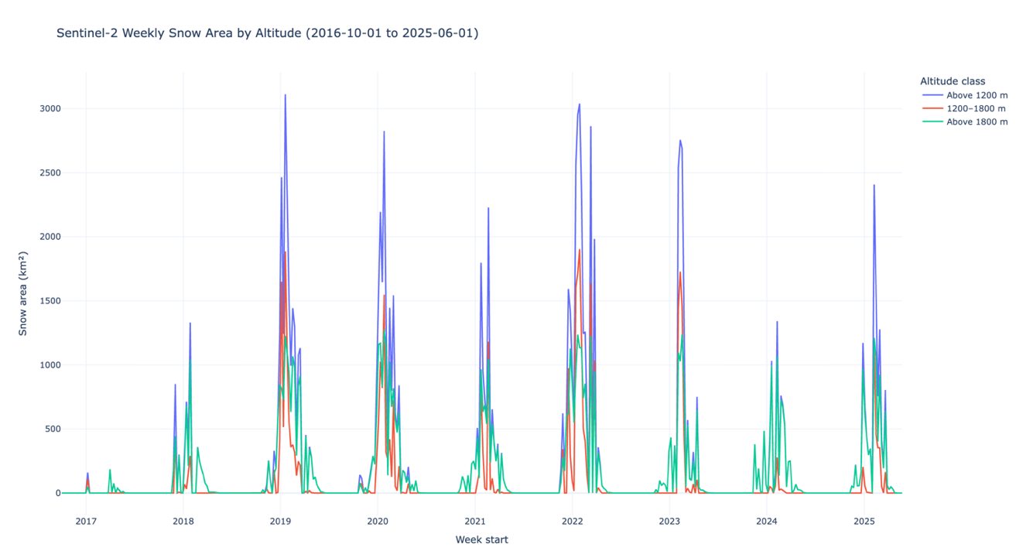
Figure 10 - Snow-cover variation as a function of altitude (weekly time series).

For each altitude class, the Sentinel-2 snow extraction workflow was repeated independently. Weekly snow-covered area values were then computed and exported as separate time-series datasets for each elevation range.
The resulting time series were visualized in Python to compare snow dynamics across altitude levels.
The analysis clearly shows that higher elevation zones maintain snow cover for longer periods, with more stable and prolonged accumulation during winter and early spring seasons. In contrast, lower elevation areas exhibit shorter snow duration and faster melting cycles.
This confirms that altitude is a key controlling factor in snow distribution and persistence in the study region. These results also justify the inclusion of elevation-derived features in the dataset used for subsequent predictive modeling stages.

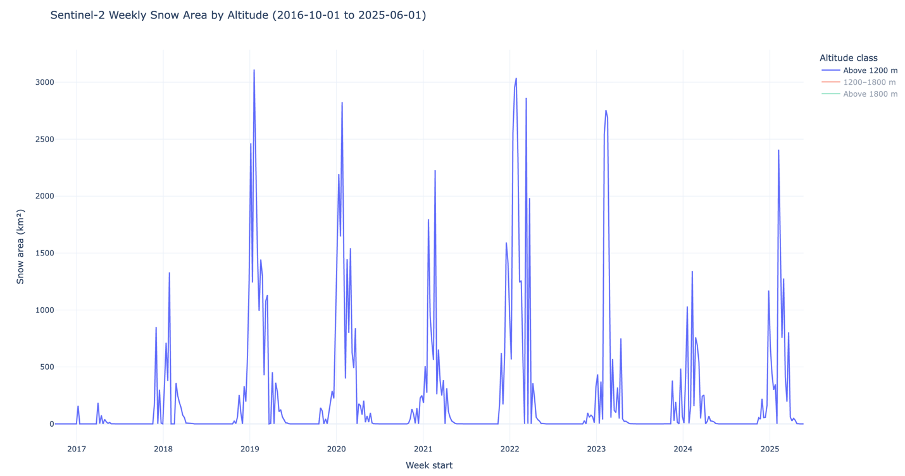

Figure 11 - Snow-covered area above 1200 meters.

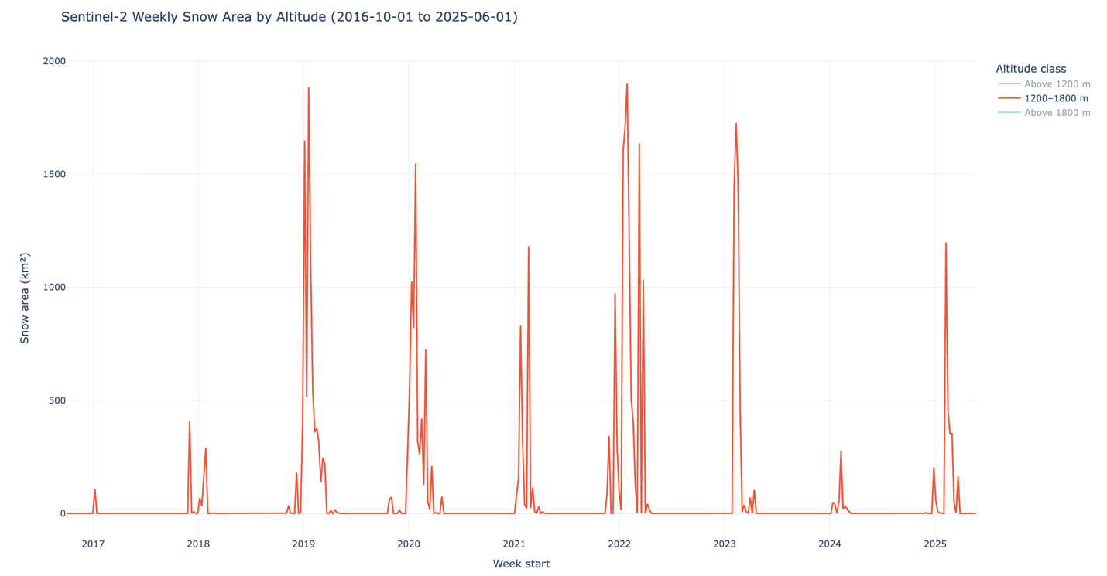

Figure 12 - Snow-covered area between 1200 and 1800 meters.

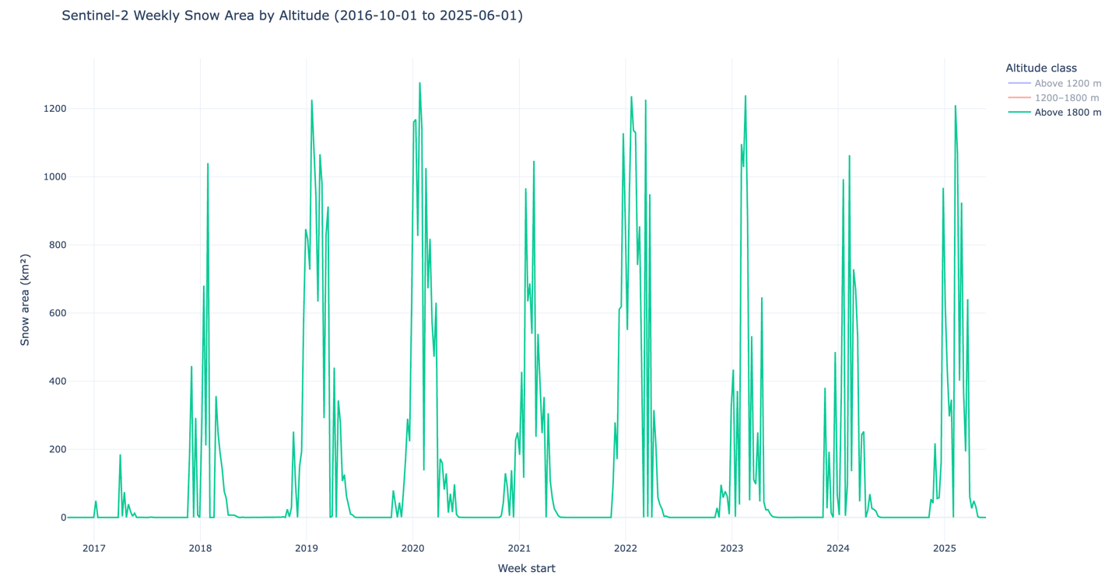
Figure 13 - Snow-covered area above 1800 meters.

Dataset Construction and Multi-Source Integration
Following the extraction of snow-cover time series and altitude-based analysis, the dataset was consolidated into a unified multi-source structure to support predictive modeling.
The weekly snow-cover observations derived from Sentinel-2 and MODIS were aligned temporally using the week_start reference variable. This ensured consistency across all datasets and allowed direct comparison between satellite-derived snow measurements over the same time intervals.
In addition to satellite data, meteorological variables from the ERA5 reanalysis dataset were integrated into the framework. These include air temperature and precipitation, which were aggregated on a weekly basis and aligned with the same temporal structure as the snow observations. This integration allows the dataset to capture both surface conditions and atmospheric drivers influencing snow accumulation and melting processes.
The final dataset was organized such that each weekly observation contains:
- Sentinel-2 snow-cover values (across altitude ranges)
- MODIS snow-cover values (same spatial aggregation)
- ERA5 temperature
- ERA5 precipitation
This multi-source structure enables a more comprehensive representation of snow dynamics by combining optical satellite observations, radar-based long-term monitoring, and meteorological forcing variables. At this stage, the dataset is fully structured as a supervised learning input and serves as the foundation for the time-series modeling phase of the project.
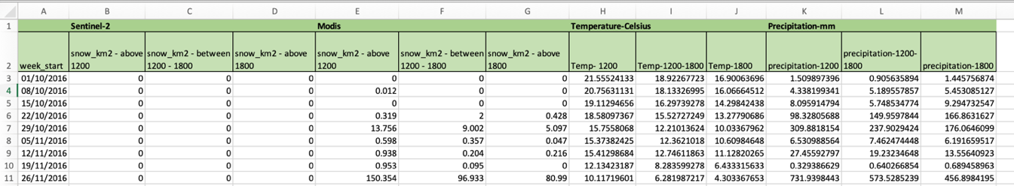

Figure 14 - Structure of the multi-source weekly dataset before normalization showing Sentinel-2, MODIS, ERA5 temperature, and precipitation variables across altitude bands

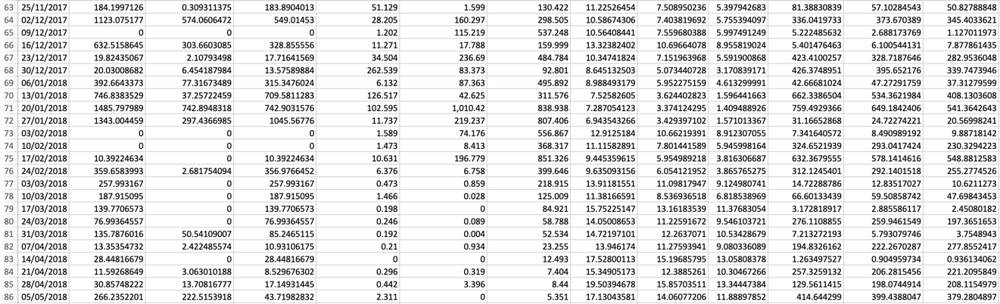

Figure 15 - Example winter-period observations illustrating the relationship between precipitation increase and snow surface expansion across elevation levels
Data Preprocessing and Feature Engineering

Figure 16 - Data Pipeline Overview

Before training any predictive model, the dataset underwent a preprocessing phase to ensure consistency, numerical stability, and suitability for time-series learning.
First, the temporal structure of the dataset was refined by decomposing the week_start variable into two explicit features: year and week_of_year. This transformation preserves chronological ordering while allowing the model to better capture seasonal patterns across multiple years.
Since snow dynamics exhibit strong seasonality, the week_of_year variable was further transformed using cyclical encoding. Sine and cosine transformations were applied to represent the circular nature of time, ensuring that week 52 and week 1 are treated as temporally close values rather than distant numerical values.
To improve model performance and prevent feature dominance due to scale differences, a Z-score normalization procedure was applied using the StandardScaler function from the scikit-learn library.
This transformation standardizes each feature according to:
$$Z=\frac{X-μ}{σ}$$
where:
- $X$ is the original feature value
- $μ$ is the feature mean
- $σ$ is the feature standard deviation

This was applied to snow-cover variables, temperature, and precipitation. This step ensures that all features contribute equally during model training.
In addition to temporal structuring, several engineered features were introduced to capture both short-term dependencies and physical snow dynamics. These include lag-based variables, multi-source satellite observations, meteorological inputs, and altitude-dependent indicators.
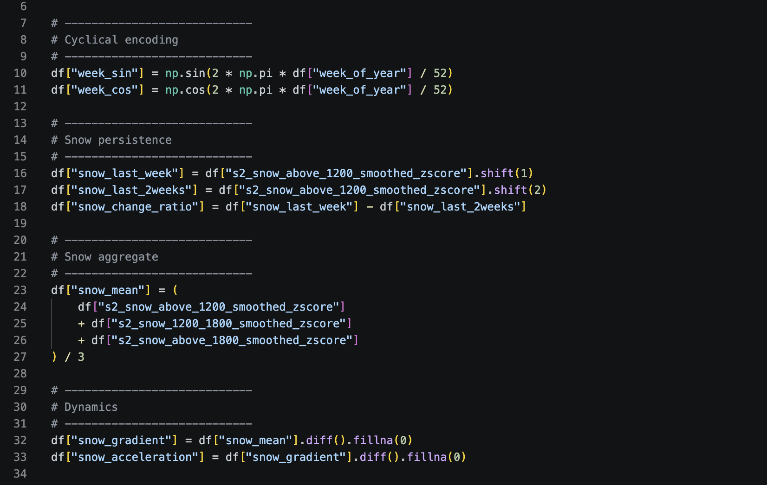

Figure 17 - Example of feature construction

At the end of this stage, the dataset was fully cleaned, normalized, and enriched with temporal and physical features, making it suitable for sequence-based deep learning models.
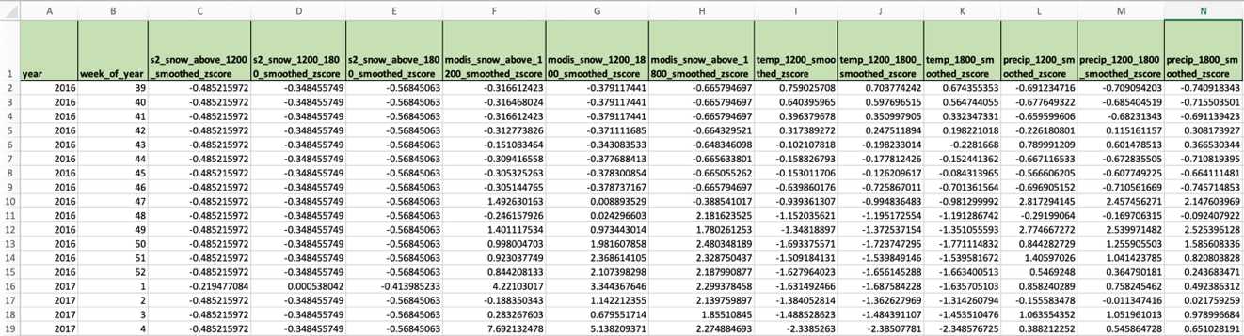

Figure 18 - Example of dataset variables after Z-score normalization

Final Feature Vector Construction
The final input vector used for sequence construction included:
Feature Category | Variables
Seasonal encoding | week_sin, week_cos
Persistence | snow_last_week, snow_last_2weeks
Change dynamics | snow_change_ratio
Aggregated snow signal | snow_mean
Temporal derivatives | snow_gradient, snow_acceleration
Sentinel-2 snow coverage | 3 altitude bands
MODIS snow coverage | 3 altitude bands
Temperature | 3 altitude bands
Precipitation | 3 altitude bands

Table 2 - Final Feature Vector
In total: 20 predictive features were used as input variables for the LSTM model.
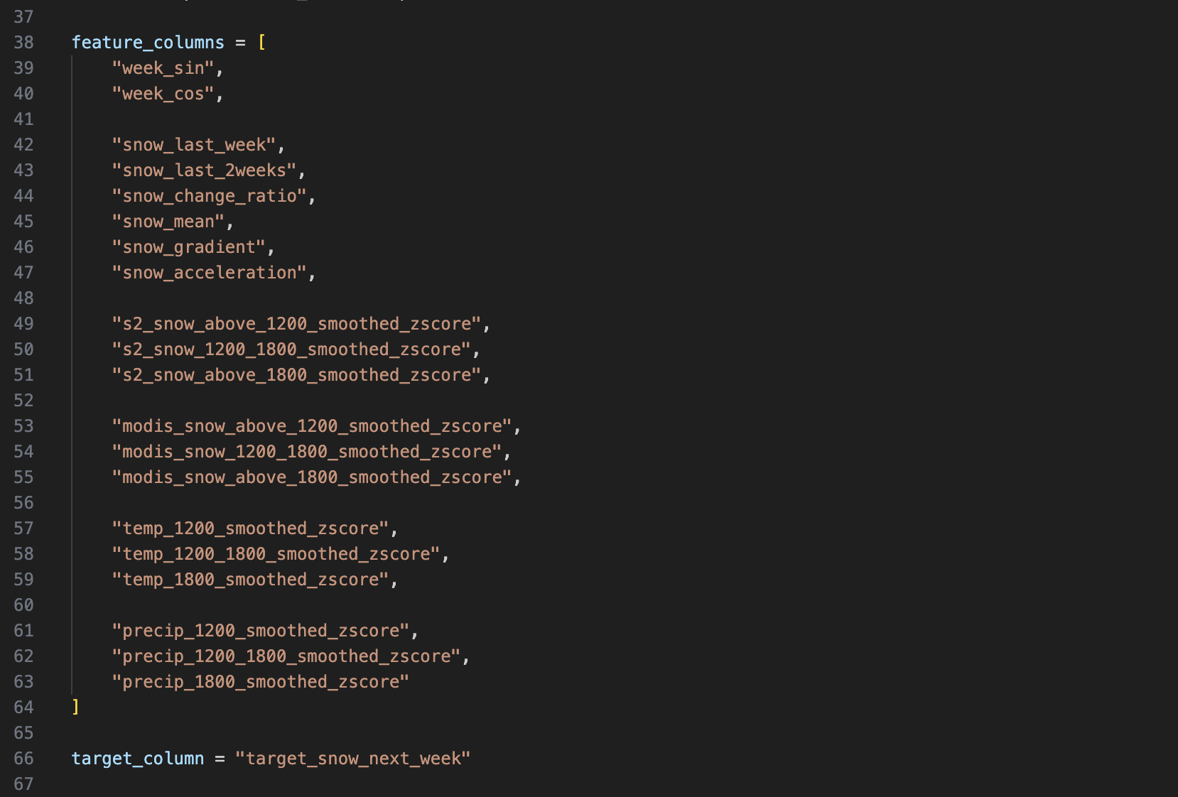
Figure 19 - Final set of 20 predictive features used for sequence construction
Sequence Construction for LSTM Modeling
To enable time-series forecasting, the dataset was transformed into supervised learning sequences suitable for Long Short-Term Memory (LSTM) models.
Since LSTM networks require sequential inputs rather than independent observations, a sliding window approach was applied. Each input sample was constructed for example using 4 consecutive weeks of historical data, representing the temporal context used to predict future snow conditions.

Figure 20 - Example of Input Sequences

Take 8-week sequence as an example, each training sample consists of:
- Input: 8 consecutive weekly observations
- Output: Snow cover of the following week
Mathematically:
$$X_{t}=\left[ week_{t-7}, …, week_{t} \right]$$
$$y_{t}=snow_{t+1}$$
This formulation allows the model to learn temporal dependencies between past meteorological conditions and future snow evolution.
The dataset was therefore reshaped into 3D tensors with the following structure:
- (samples, time steps, features)
- Time steps = 8 weeks
- Features = 20 engineered variables
After sequence generation, the dataset was split into training, validation, and testing sets to ensure proper evaluation of model generalization. The final dataset distribution was:
Dataset | Percentage
Training set | 70%
Validation set | 15%
Test set | 15%

Table 3 - Dataset Splitting
This transformation is essential as it converts the original tabular time-series data into a format compatible with deep learning sequence models.
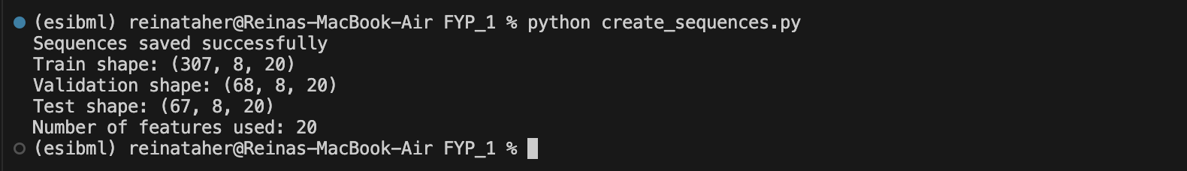
Figure 21 - Final LSTM input tensor dimensions after sequence generation
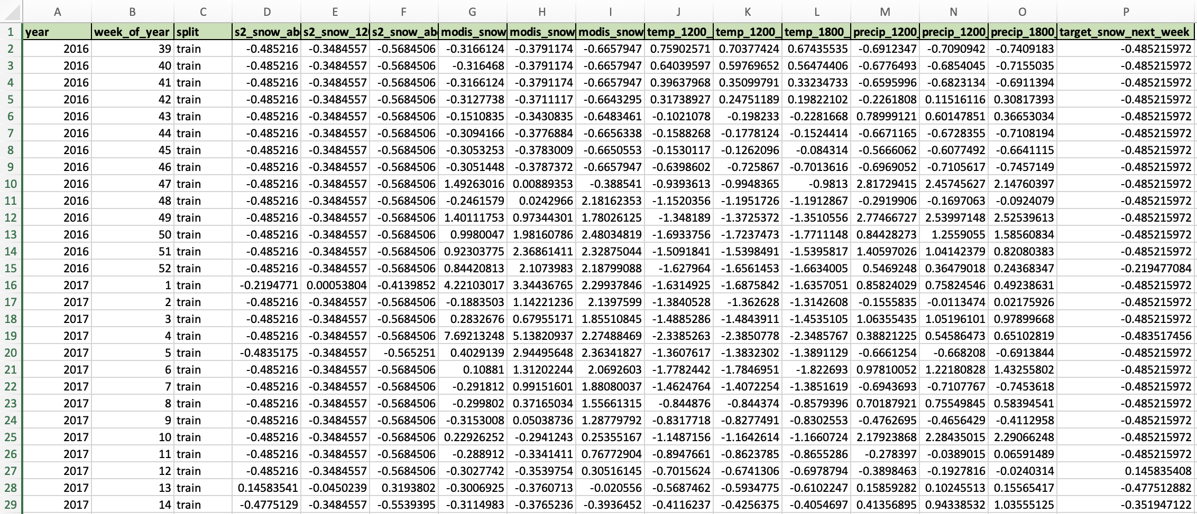
Figure 22 - Final structured dataset after temporal feature extraction, Z-score normalization, target variable creation, and train–validation–test splitting ready for LSTM modeling

Baseline Forecasting and Initial Modeling Attempts
Before implementing the final deep learning architecture, a simple baseline forecasting model was established to provide a reference performance level for comparison.
The baseline model assumes temporal persistence, meaning that future snow conditions are considered equal to the most recent observed value. In practice, this approach uses the last available weekly snow-cover observation as the prediction for the following week. This provides a simple but meaningful benchmark for evaluating the added value of more complex models.
$$snow_{t+1} ≈ snow_{t}$$
The performance of this baseline was evaluated using the Mean Absolute Error (MAE) metric on the test dataset. This allowed us to quantify the minimum error level achievable without learning complex temporal relationships.
In parallel, initial modeling experiments were conducted using simpler time-series approaches before moving to deep learning architectures. These early attempts helped validate the structure of the dataset and confirmed that meaningful temporal patterns exist in the data.
These preliminary steps established a clear performance reference and justified the transition toward more advanced sequence-based models such as LSTM, which are capable of capturing nonlinear temporal dependencies in snow evolution.
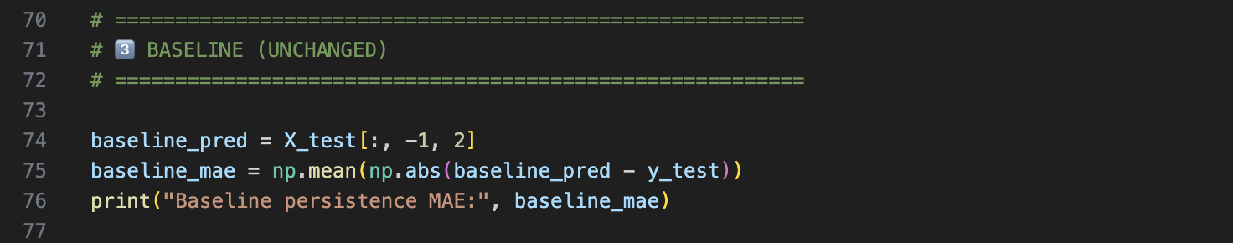
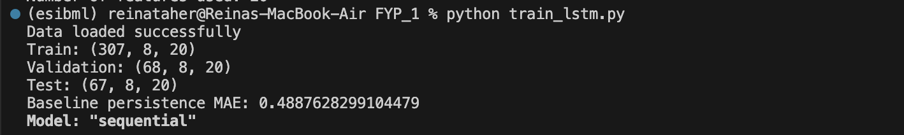
Figure 23 - Baseline persistence prediction error used as reference benchmark for LSTM evaluation

LSTM Model Implementation
After completing data preprocessing and sequence construction, a Long Short-Term Memory (LSTM) neural network was implemented to perform weekly snow surface forecasting.
The model was developed using TensorFlow and Keras, and designed to capture both short-term and long-term temporal dependencies in snow evolution across mountainous regions.
The final architecture consists of a stacked LSTM structure:
- First LSTM layer: 96 units (captures long-range temporal dependencies)
- Second LSTM layer: 64 units (refines intermediate temporal patterns)
- Dropout layers (0.15) applied after each LSTM layer to reduce overfitting
- Dense layers (32 → 16 neurons) for nonlinear feature mapping
- Output layer: single neuron for regression (snow surface prediction)
This stacked design allows hierarchical learning of temporal features, where early layers capture broad seasonal trends and deeper layers refine local variations.
The model was trained using the Adam optimizer with a learning rate of 0.0003, selected to ensure stable convergence on time-series environmental data.

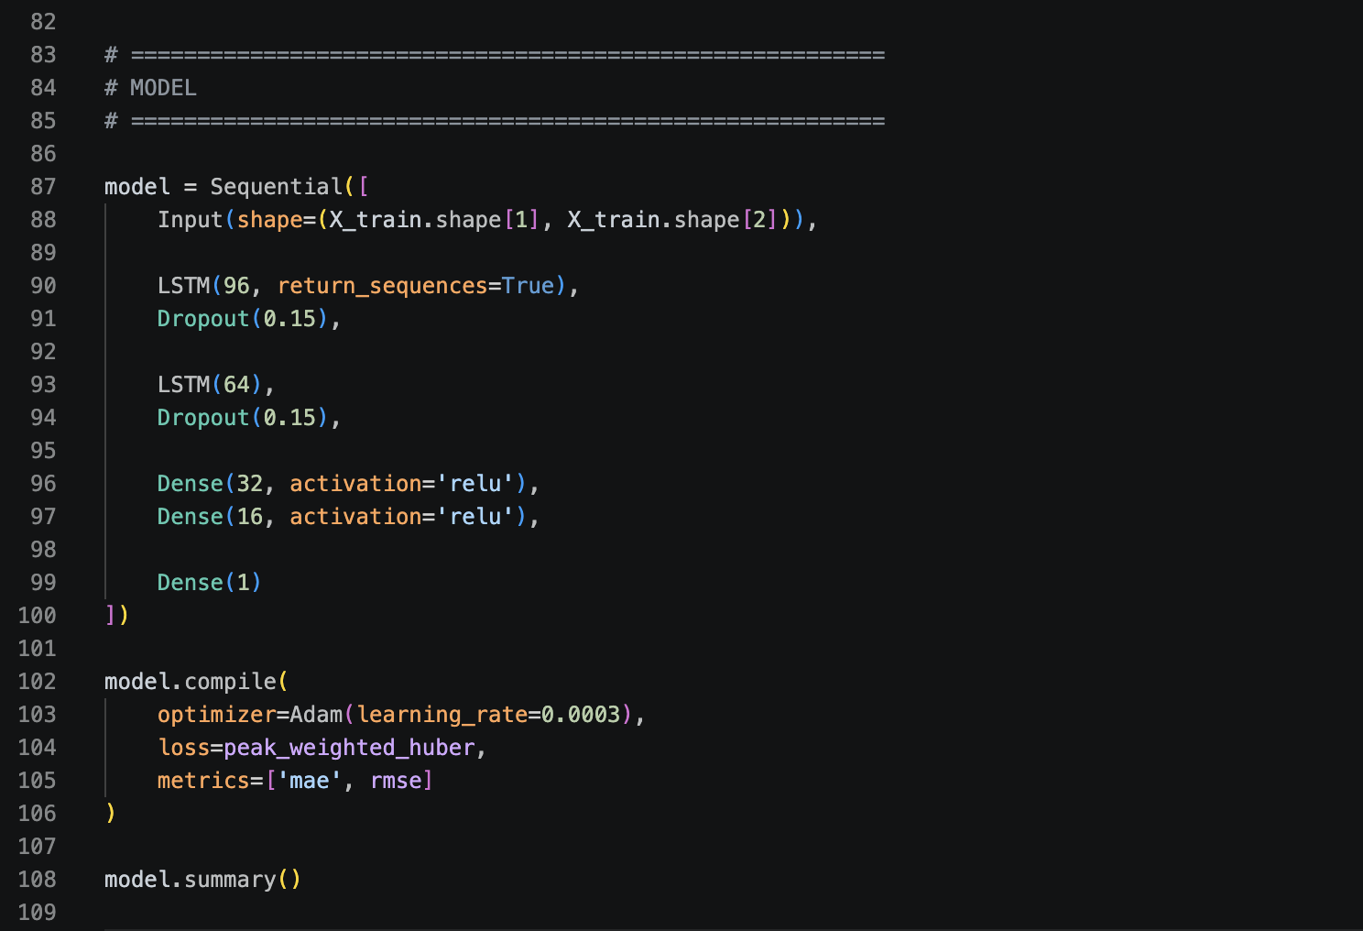
Figure 24 - Summary of the stacked LSTM architecture used for weekly snow surface forecasting

Loss Function Design
Instead of using standard Mean Squared Error (MSE), a Peak-Weighted Huber Loss function was introduced. This choice was motivated by the nature of snow data, where extreme snow accumulation events are rare but physically important. The Huber loss combines:
- robustness of MAE for outliers
- sensitivity of MSE for smooth optimization
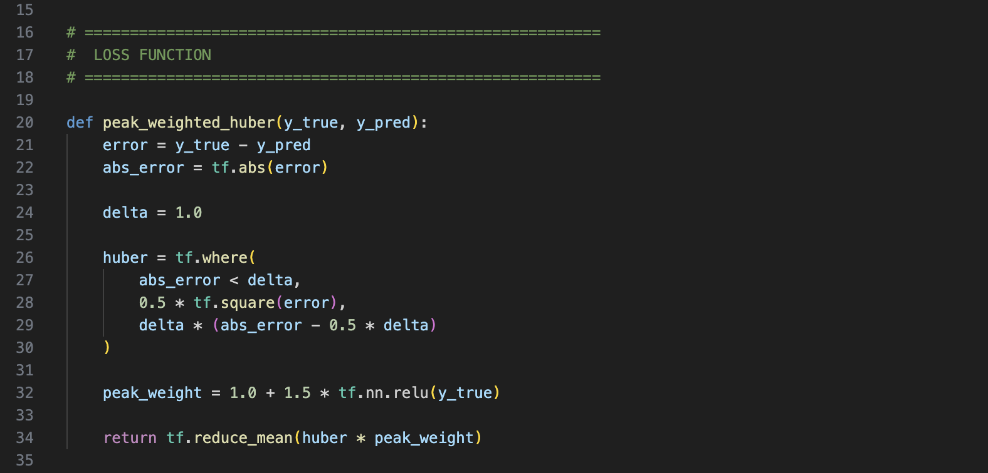
Additionally, a weighting mechanism was applied to emphasize high snow values, ensuring better learning of peak snow events during winter seasons.
Figure 25 - Implementation of the peak-weighted Huber loss function used to improve prediction stability while emphasizing high snow-accumulation events

Training Strategy
To ensure stable and efficient training, the following strategies were applied:
- Batch size: 8
- Epochs: up to 150
- Optimizer: Adam
- Learning rate scheduler: ReduceLROnPlateau (reduces learning rate when validation loss stagnates)
- Early stopping: used to restore best model weights
Training was performed using sequential data without shuffling to preserve temporal order, which is essential for time-series learning.
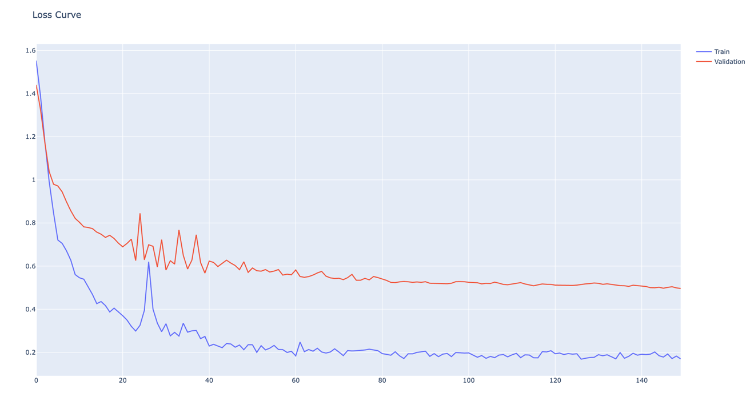
Figure 26 - Training and validation loss curves showing convergence behavior of the LSTM model using the peak-weighted Huber loss function

Testing, Evaluation and Iterative Improvements

Evaluation Strategy and Performance Indicators
To evaluate the performance of the proposed snow forecasting system, a structured testing strategy was designed combining quantitative metrics and qualitative visual analysis. Two primary performance indicators were used:
- Mean Absolute Error (MAE): measures the average magnitude of prediction errors, providing an interpretable estimation of deviation between predicted and actual snow surface values.
- Root Mean Squared Error (RMSE): gives higher weight to large errors, making it particularly suitable for evaluating the model’s ability to capture extreme snowfall events.
The combination of MAE and RMSE allows evaluation of both:
- overall prediction accuracy (MAE)
- sensitivity to peak errors and extreme events (RMSE)
However, these metrics do not fully capture all aspects of time-series forecasting quality. In particular, snow forecasting requires accurate representation of:
- peak amplitude (snow accumulation intensity)
- peak timing (temporal alignment of snowfall events)
For this reason, additional evaluation indicators are identified as potential improvements for future work, including:
- peak amplitude error (difference between predicted and actual peak values)
- peak timing error (difference in weeks between predicted and actual peaks)
These additional indicators would provide a more comprehensive assessment of forecasting performance, especially for hydrological and environmental applications.

Test Scenarios and Experimental Setup
To ensure a robust evaluation of the proposed forecasting system, multiple test scenarios were designed to assess model performance under different configurations and data conditions.

Sequence Length Experiments
A series of experiments was conducted to evaluate the impact of temporal input length on forecasting performance. Multiple LSTM models were trained using different historical window sizes:
- 1 week
- 2 weeks
- 4 weeks
- 6 weeks
- 8 weeks
- 10 weeks
- 12 weeks
For each configuration:
- the same dataset and preprocessing pipeline were used
- the same model architecture and hyperparameters were maintained
- only the input sequence length was modified
This experimental setup ensured that performance differences were directly attributable to the amount of temporal context provided to the model.
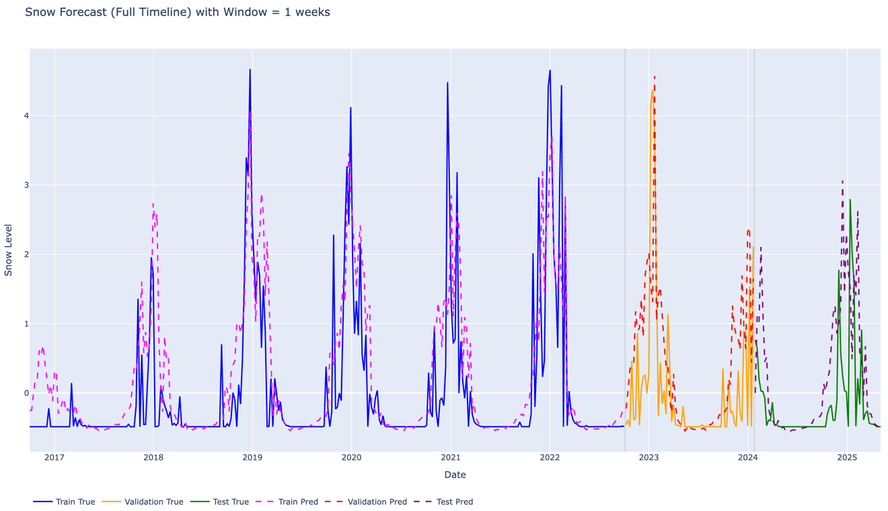
1-Week Sequence Forecast
Figure 27 - Full timeline 1-week sequence prediction

The 1-week sequence shows high variability and captures some peak occurrences with roughly correct timing. However, the overall fit remains poor, and numerical performance (high MAE and RMSE) confirms that the model does not generalize well. The predictions are unstable and do not accurately represent the true snow evolution.
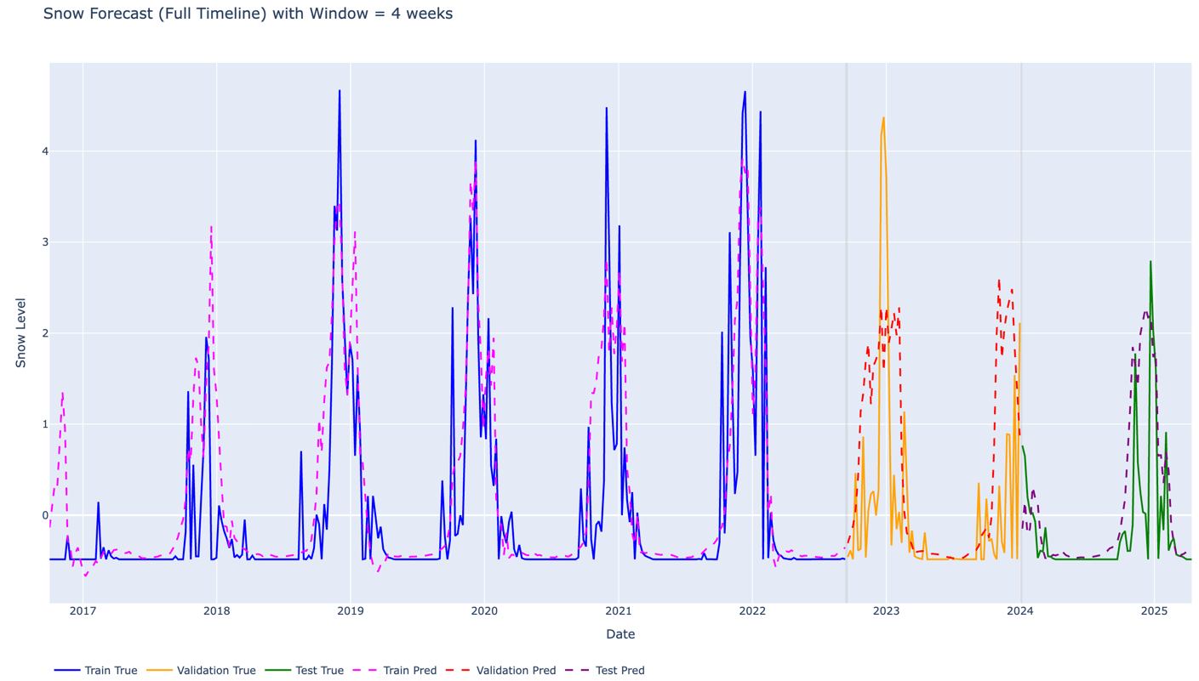
4-Week Sequence Forecast

Figure 28 - Full timeline 4-week sequence prediction
The 4-week sequence results are overly smoothed, with clear underestimation of peak snow events. Although a general seasonal pattern is visible, the model fails to capture important variations and intensity changes. This indicates insufficient temporal context for accurate snow dynamics modeling.

12-Week Sequence Forecast
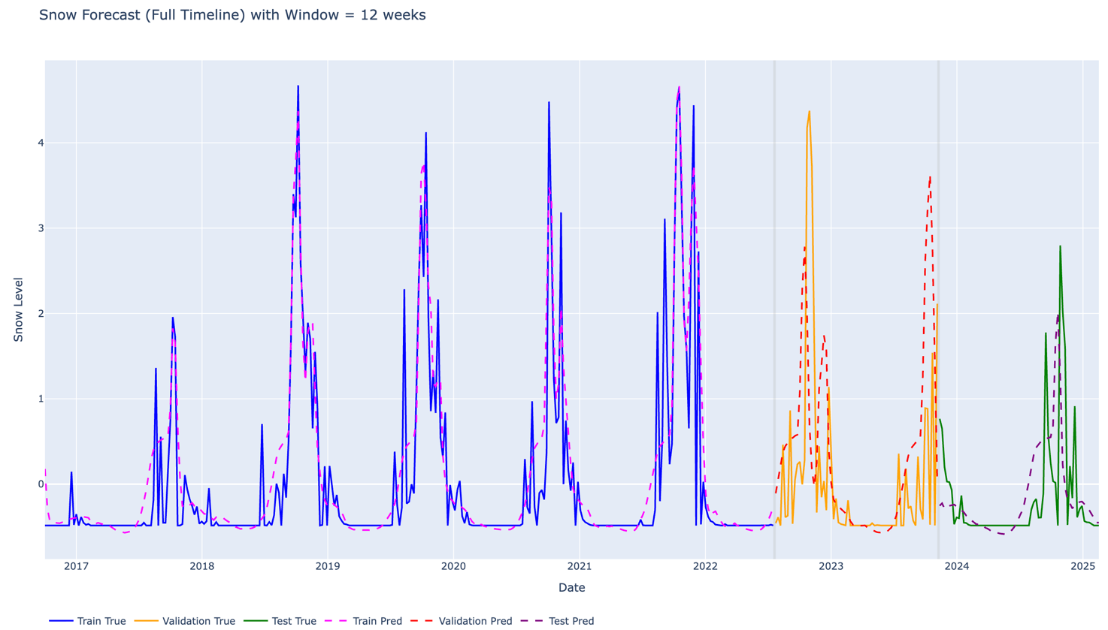

Figure 29 - Full timeline 12-week sequence prediction

The 12-week sequence also produces smoothed predictions with reduced variability. Peak events are not accurately captured, showing both underestimation and occasional overestimation. This suggests that excessive temporal input introduces noise and reduces the model’s responsiveness to changes.

8-Week Sequence Forecast
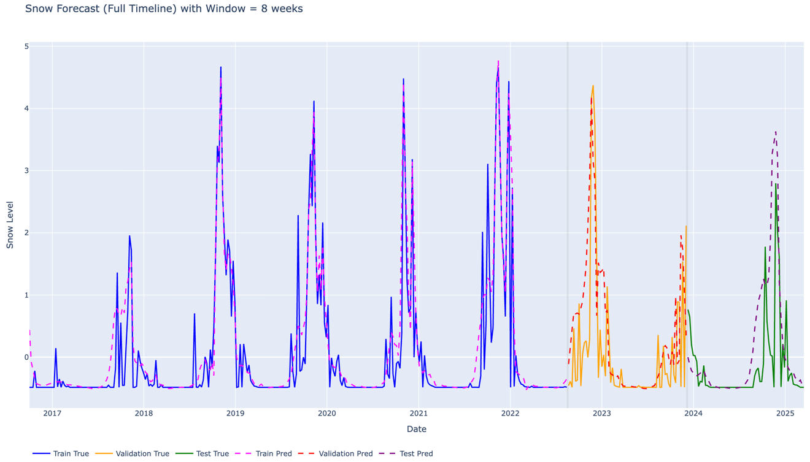

Figure 30 - Full timeline 8-week sequence prediction

The 8-week sequence provides the best overall balance between visual realism and numerical performance. Peak events are captured with relatively accurate timing and amplitude, and the model maintains good temporal consistency. This configuration represents the most reliable compromise between stability and predictive accuracy.

Results Analysis and Iterative Improvement
The experimental results show that forecasting performance is highly dependent on the amount of temporal context provided to the model. Rather than identifying a single optimal configuration, the study highlights a range of plausible sequence lengths that balance prediction accuracy and temporal realism.
An initial intuition suggests that very short sequences (e.g., 1 week) should perform well, since snow conditions are strongly dependent on the immediately preceding week. While this assumption is partially valid, experimental results show that such short sequences lead to unstable predictions and high error values. This indicates that snow evolution cannot be accurately modeled using only short-term memory, as it is influenced by cumulative environmental processes over multiple weeks.
As the sequence length increases, the model progressively improves its ability to capture snow persistence and seasonal behavior. Medium-length sequences (around 6 to 8 weeks) provide the most consistent results, both numerically and visually. In particular, the 6-week configuration achieves strong numerical performance, while the 8-week configuration offers better visual stability and more realistic representation of peak snow events.

Longer sequences (e.g., 10–12 weeks), however, introduce excessive temporal information, leading to smoothing effects and reduced sensitivity to rapid changes in snow cover. This suggests that including too much historical data can dilute relevant signals and negatively impact model responsiveness.
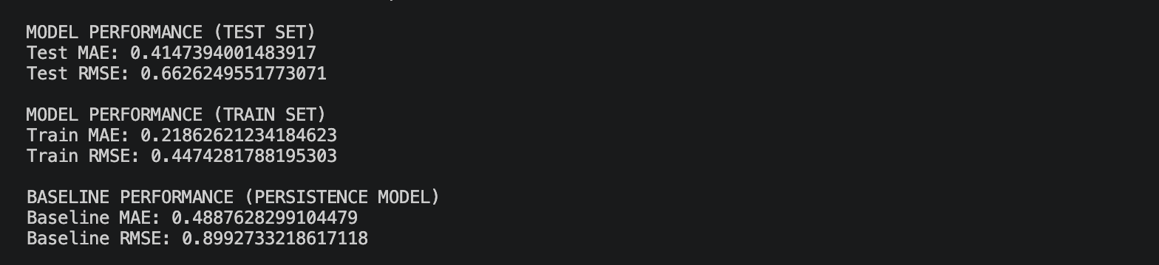
Figure 31 - Model Performance Comparison (Train, Test, and Baseline Persistence Model) for 8-week sequences

The performance of the LSTM model was first evaluated using an 8-week input sequence and compared against a persistence-based baseline model. The results show that the LSTM model achieves lower prediction errors (Test MAE ≈ 0.415, RMSE ≈ 0.663) compared to the baseline (MAE ≈ 0.489, RMSE ≈ 0.899), confirming its ability to capture temporal dependencies beyond simple persistence.

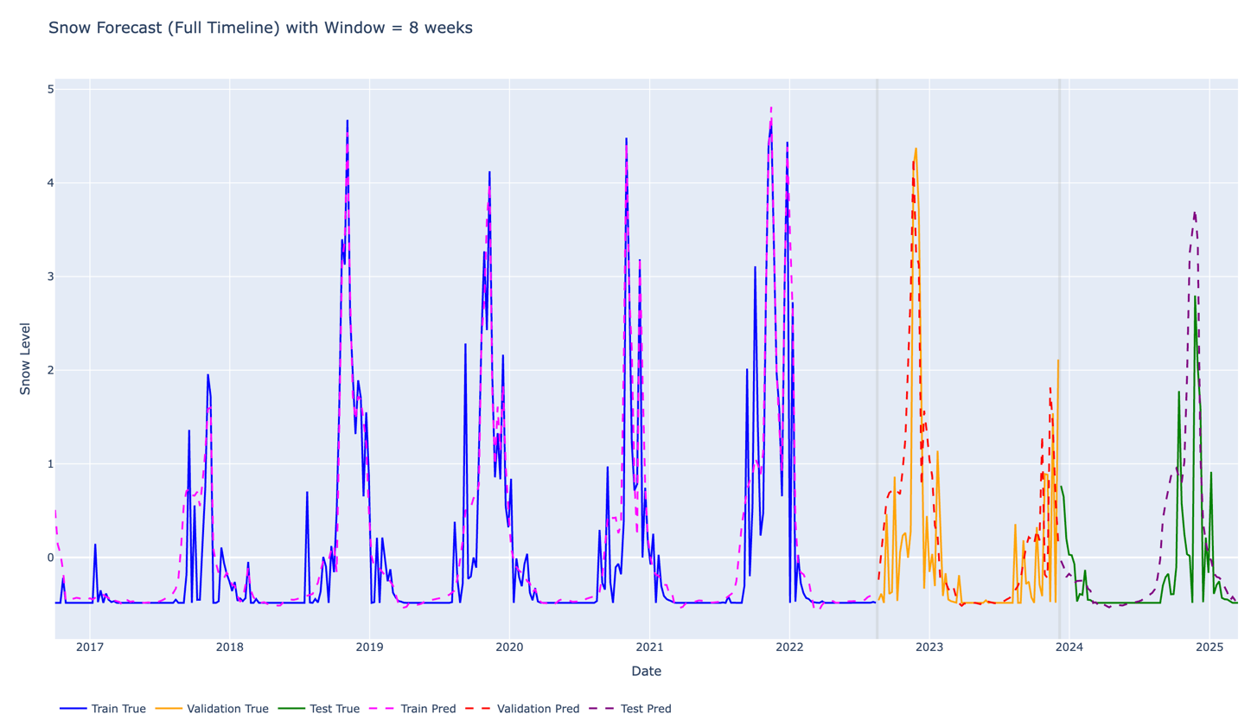

Figure 32 - Time-Series Forecasting Results: Observed vs LSTM Predicted Snow Cover (8-Week Window)

In addition to the numerical improvement, the corresponding time-series visualization shows a strong alignment between predicted and observed snow-cover values, with both curves closely superimposed across most of the timeline. This indicates that the model successfully reproduces the overall seasonal patterns and variations in snow dynamics. These encouraging results motivated further experimentation, particularly the analysis of different sequence lengths, to better understand the impact of temporal context on model performance.

Sequence Length Impact on Forecasting Performance
To study the effect of temporal context on forecasting accuracy, multiple LSTM models were trained using different input sequence lengths. Each configuration used the same architecture, dataset split, and training parameters, while only the number of historical weeks was modified.
The tested sequence lengths include 1, 2, 4, 6, 8, 10, and 12 weeks. This allows evaluation of how much historical information is required for optimal snow prediction performance in mountainous environments.
Results show that shorter sequences (1–2 weeks) provide insufficient temporal context, leading to higher prediction errors. Medium sequence lengths (4–6 weeks) significantly improve performance by capturing short-term snow persistence and meteorological influence. However, longer sequences (8–12 weeks) do not consistently improve results and may introduce noise and redundancy in the learning process.
Overall, the experiments highlight a trade-off between temporal memory depth and model stability, confirming that optimal performance is achieved within a limited historical window rather than maximum sequence length.

Sequence Length Comparison Results

Sequence (weeks) | MAE (mean) | MAE (std) | RMSE (mean) | RMSE (std)
1 | 0.530 | 0.011 | 0.811 | 0.010
2 | 0.514 | 0.014 | 0.813 | 0.014
4 | 0.454 | 0.018 | 0.715 | 0.018
6 | 0.380 | 0.012 | 0.616 | 0.015
8 | 0.438 | 0.046 | 0.673 | 0.047
10 | 0.452 | 0.046 | 0.687 | 0.048
12 | 0.474 | 0.057 | 0.702 | 0.058

Table 4 - Sequence Length Comparison Results

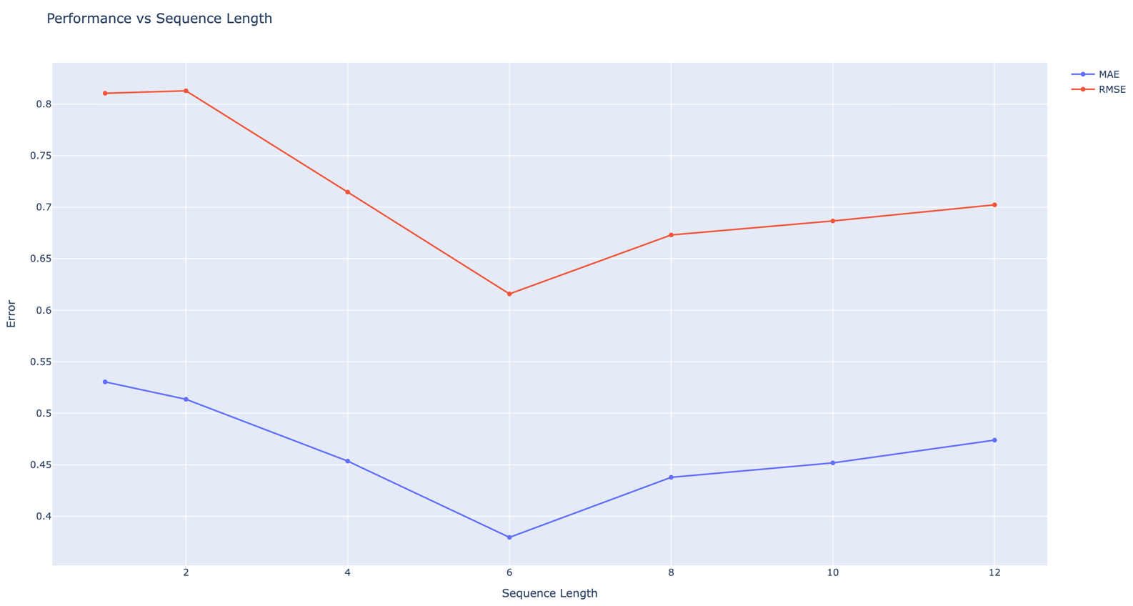

Figure 33 - Sequence Length vs Prediction Error: MAE and RMSE Comparison

Best Performing Configuration

The 6-week sequence length achieved the best overall trade-off:
- Lowest MAE: 0.380
- Lowest RMSE: 0.616

6-week sequence: best numerical performance
8-week sequence: better visual stability and peak realism

There is no single dominant configuration; instead, a trade-off exists between numerical accuracy and temporal realism.

Stability vs Performance Trade-off

- Although 6 weeks gives the best mean performance, it is not always the most visually stable model across runs.
- Some variability appears in longer sequences (higher std values), indicating:
- sensitivity to training initialization
- possible overfitting to longer temporal dependencies.

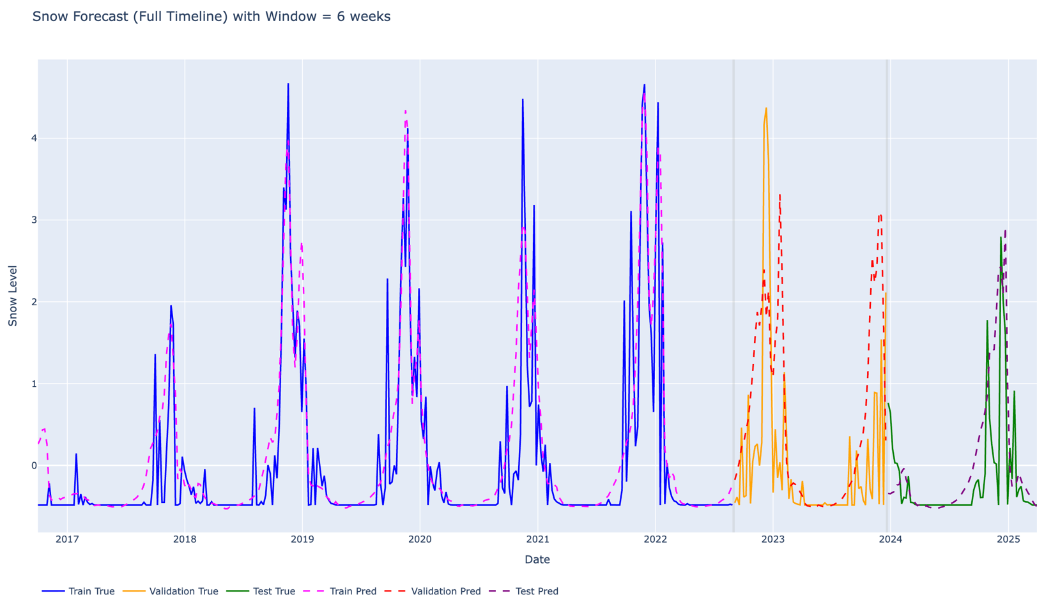

Figure 34 - Full timeline 6-week sequence prediction
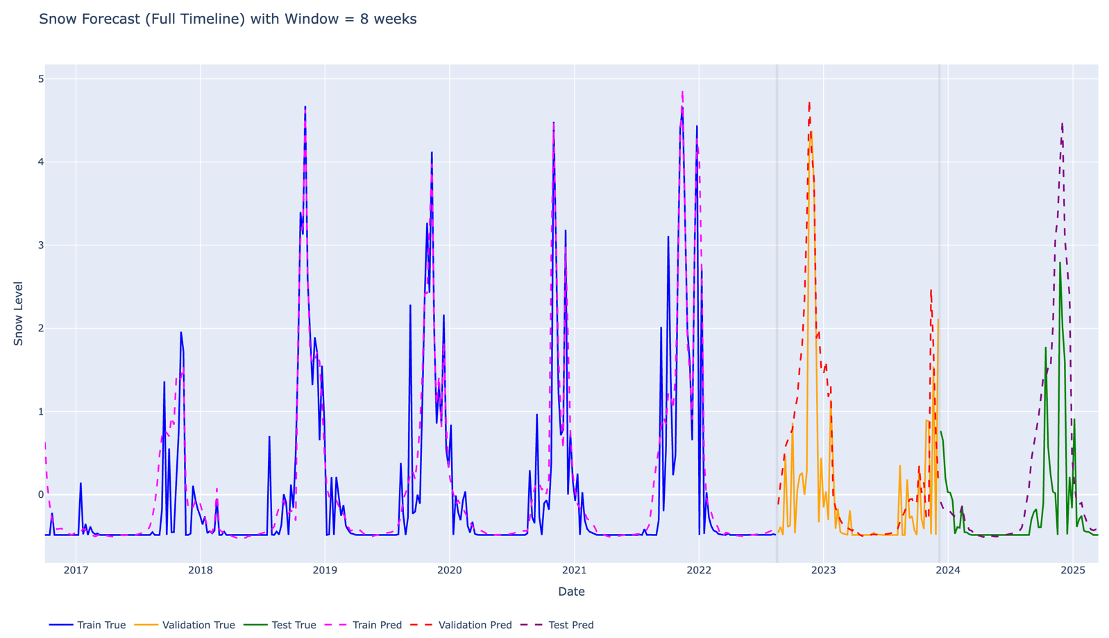
Figure 35 - Full timeline 8-week sequence prediction

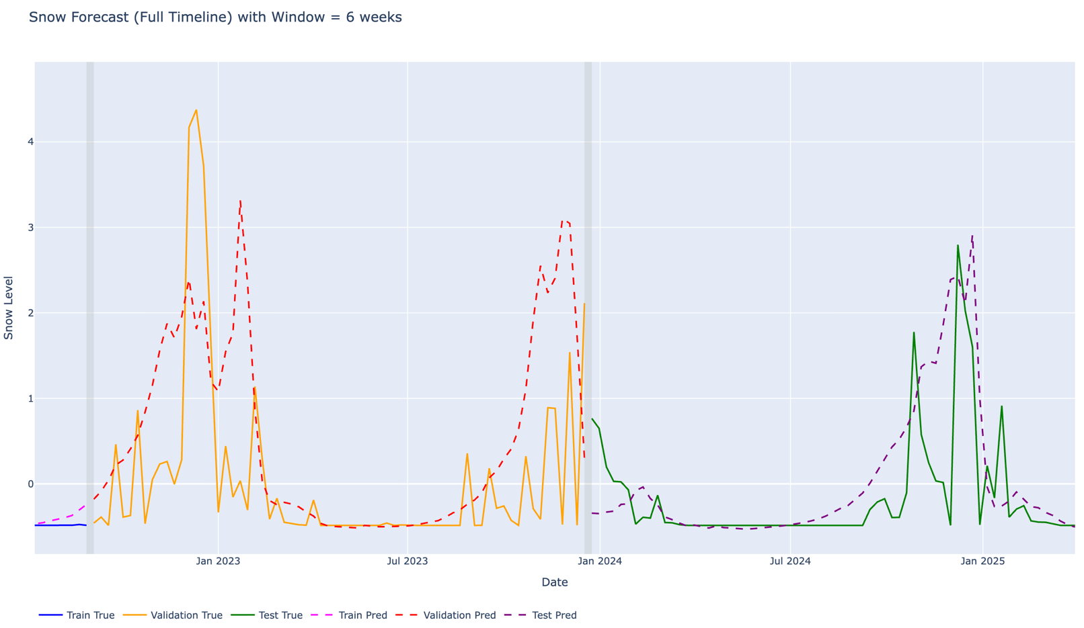
Figure 36 – Zoomed-in Validation and Testing period 6-week sequence prediction

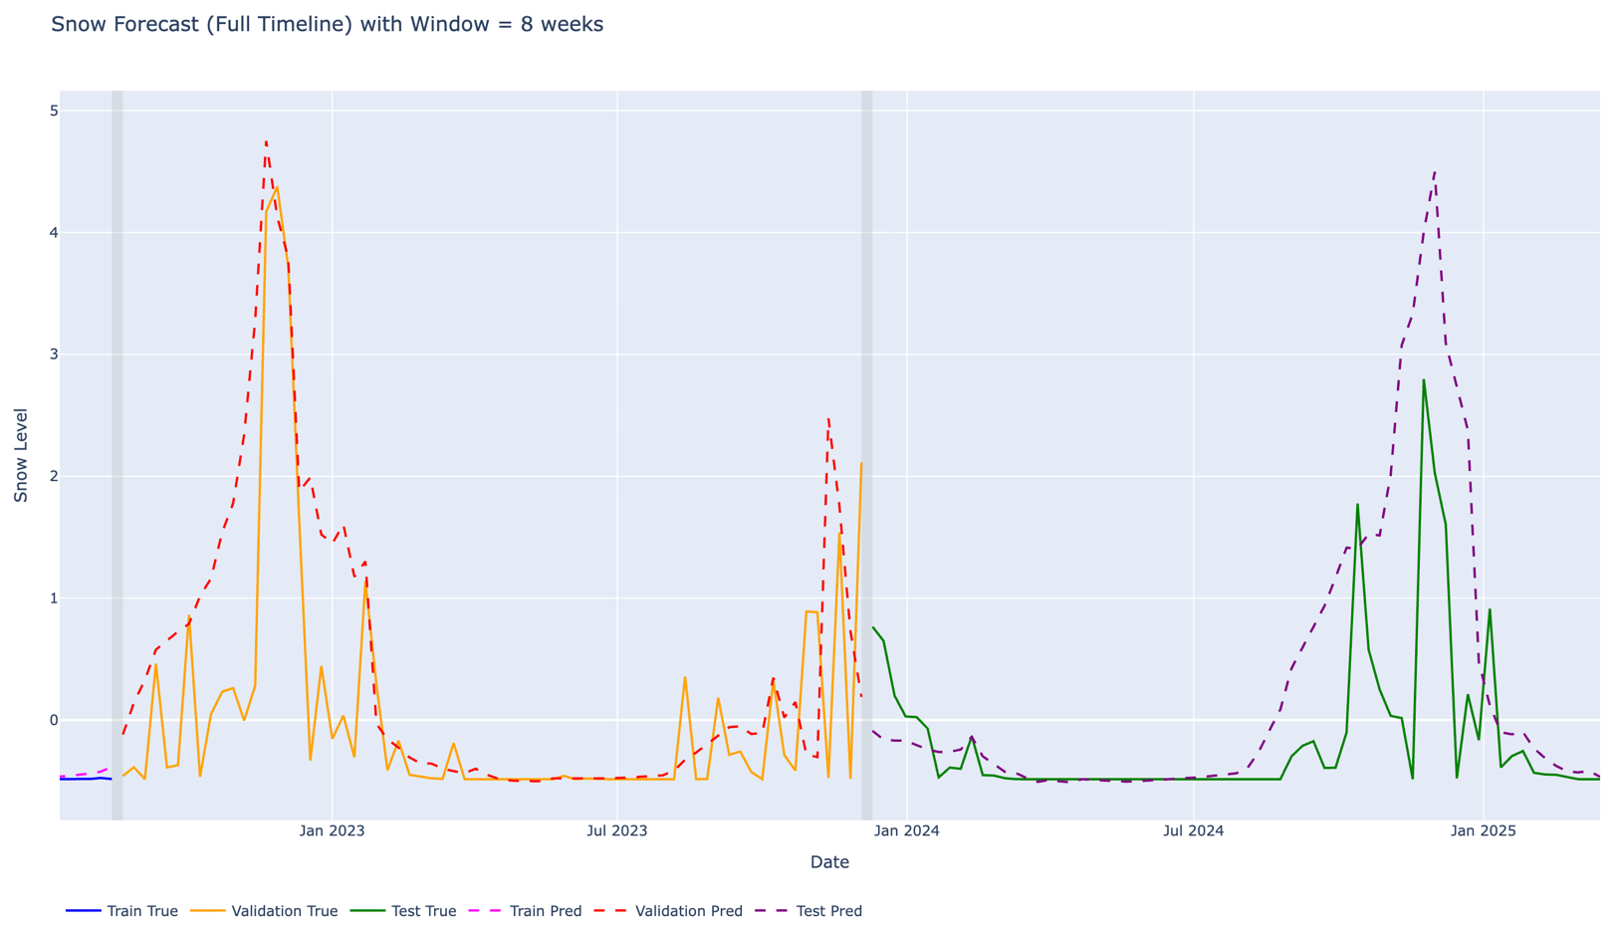
Figure 37 - Zoomed-in Validation and Testing period 8-week sequence prediction

Visual vs Numerical Consistency

Visual inspection of prediction plots showed that:
- Some sequence lengths produce smoother curves (better visual realism)
- while others achieve lower RMSE but less visually meaningful peaks.

This highlights an important trade-off between:
- numerical accuracy (MAE/RMSE)
- forecast interpretability (peak behavior and realism)

Long-Term Dataset Experiment (MODIS 25-Year Analysis)
To further investigate the limitations observed in the Sentinel-2 based forecasting models, an additional experiment was conducted using a long-term MODIS dataset covering approximately 25 years of observations.
The objective of this experiment was to determine whether model performance constraints were primarily due to:
- limited temporal coverage of Sentinel-2 data, or
- inherent complexity of snow dynamics in mountainous environments
The same LSTM architecture, preprocessing pipeline, and training strategy were applied to ensure consistency and fair comparison with previous experiments.
Results obtained from the MODIS dataset showed:
- improved temporal stability in predictions
- smoother alignment with long-term seasonal trends
- better generalization across multiple years
However, despite the longer dataset, prediction errors (RMSE ≈ 0.6) remained significant. This indicates that snow evolution in mountainous regions such as Lebanon is inherently complex and influenced by highly variable environmental conditions.
This experiment confirms that:
- increasing dataset length improves stability and trend learning
- but does not completely eliminate forecasting uncertainty
Therefore, both data availability and environmental variability play a key role in model performance.

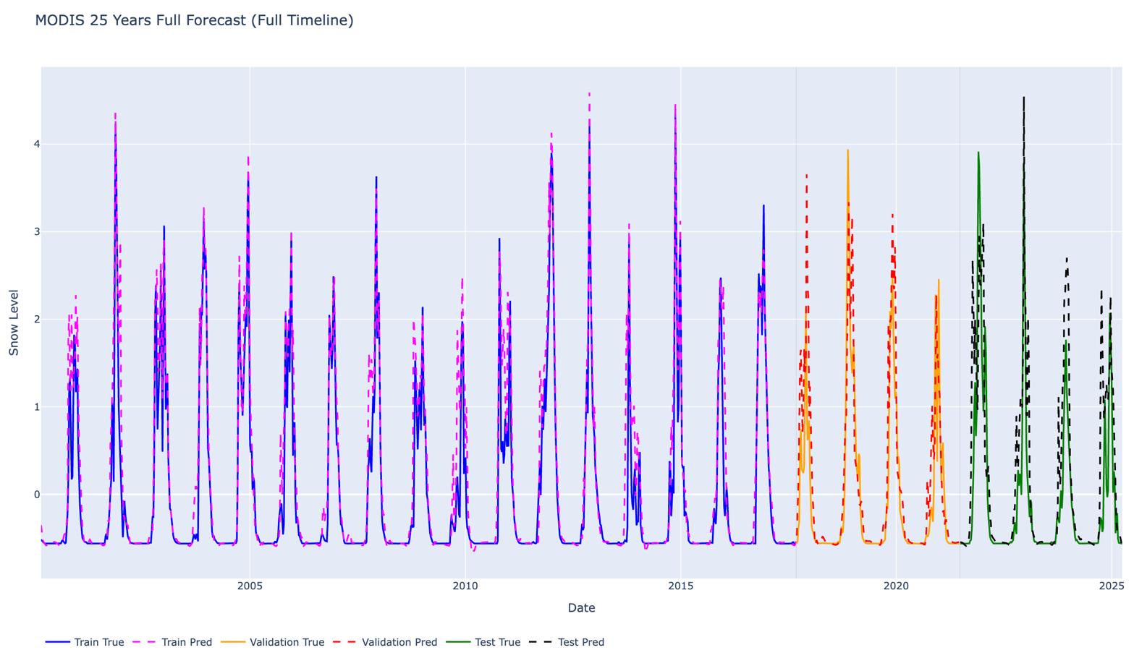
Figure 38 - Observed vs Predicted Snow Cover Using MODIS (25-Year Timeline)

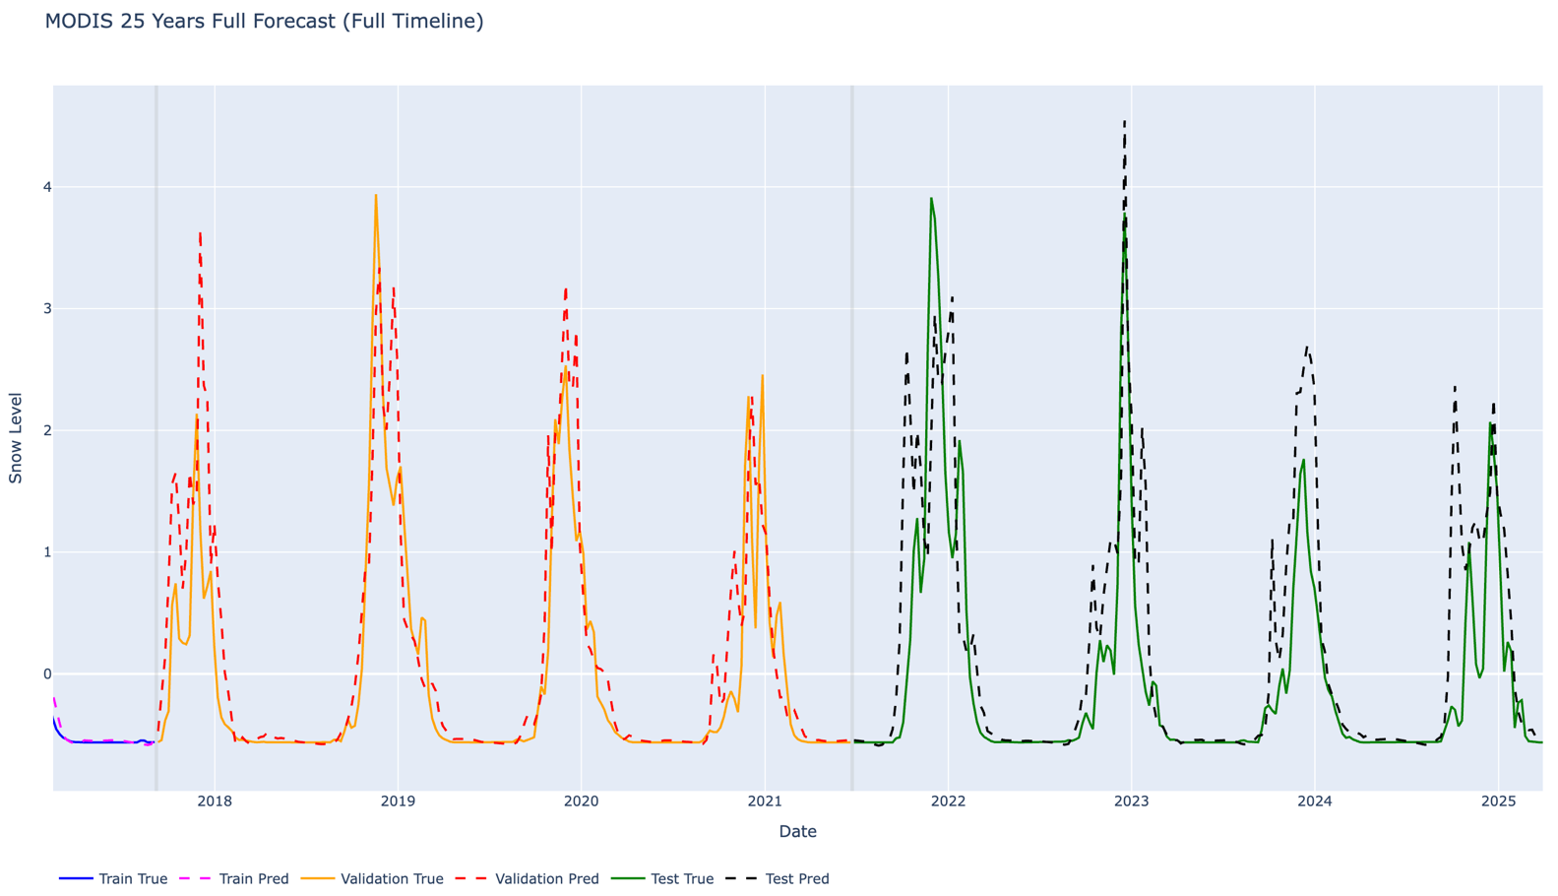

Figure 39 - Zoomed Evaluation of Forecasting Performance: Observed vs Predicted Snow Cover (Validation and Test Periods, MODIS 25-Year Dataset)

Physical Interpretation of the Optimal Temporal Window
The observed performance of medium-length sequences (6–8 weeks) can be explained by the physical nature of snow dynamics in mountainous regions such as Lebanon.
Snow accumulation and melting are not instantaneous processes but depend on cumulative effects of temperature, precipitation, and terrain conditions over several weeks. Snowpack typically builds progressively during winter and melts gradually in spring, creating a natural temporal dependency that extends beyond short-term fluctuations.
An 8-week temporal window appears to capture this balance effectively:
- it includes enough historical context to represent snow accumulation cycles
- it captures delayed effects of meteorological conditions (e.g., temperature trends, precipitation events)
- it avoids excessive noise from distant past observations
This aligns with the seasonal behavior of snow in Lebanon, where accumulation periods and melting transitions occur over multi-week intervals rather than abrupt changes.

Critical Evaluation
The proposed approach demonstrates several strengths:
- ability to capture temporal dependencies beyond simple persistence
- integration of multi-source data (satellite, meteorological, terrain)
- improved performance compared to baseline models
- realistic representation of seasonal snow evolution
However, several limitations remain:
- no single sequence length provides optimal performance across all criteria
- numerical metrics and visual realism may lead to different conclusions (e.g., 6 vs 8 weeks)
- prediction errors remain due to environmental variability
- evaluation metrics (MAE, RMSE) do not fully capture peak behavior and temporal alignment
These observations highlight that the problem is inherently complex and that model performance depends on both data quality and environmental variability.

Project Limitations and Future Extensions
It is important to note that the current implementation represents an intermediate stage of the project rather than a fully completed system. Due to time and computational constraints, the study focused on separate modeling approaches using either high-resolution Sentinel-2 data or long-term MODIS datasets.
These two approaches highlight a fundamental trade-off in the problem:
- Sentinel-2 provides high spatial resolution, enabling detailed snow detection, but suffers from limited temporal coverage and data gaps.
- MODIS provides long-term temporal consistency, improving stability in time-series learning, but lacks spatial precision due to lower resolution.
Experimental results confirm this trade-off. The MODIS-based models benefit from longer historical context and show improved temporal stability, while Sentinel-2 models provide more detailed spatial information but remain limited in predictive performance due to shorter time series.
This suggests that an improved solution would involve combining both spatial and temporal strengths into a unified framework. A hybrid multi-source model integrating Sentinel-2 and MODIS data could allow the system to simultaneously capture:
- fine spatial variability
- long-term temporal dependencies
Such an approach represents a natural extension of the current work and could significantly improve forecasting performance.
In addition, the evaluation of model performance remains limited to standard regression metrics such as MAE and RMSE. While these indicators provide a general measure of prediction error, they do not fully capture important aspects of snow dynamics, such as:
- peak amplitude accuracy
- timing of peak events
- temporal alignment between predicted and observed snow evolution
Future work could therefore include the development of additional evaluation metrics specifically designed for time-series environmental data, enabling a more comprehensive assessment of model performance.

Impact of the Proposed Solution

The proposed snow detection and forecasting system has several impacts at environmental, societal, and economic levels, particularly in mountainous regions such as Lebanon.

Environmental Impact
The system enables better monitoring of snow cover dynamics, which plays a critical role in water resource management. In Lebanon, snowpack acts as a natural reservoir that contributes significantly to groundwater recharge and river flow. Accurate snow forecasting can help improve understanding of seasonal water availability and support sustainable environmental planning.
Additionally, long-term snow monitoring can contribute to climate change studies by providing insights into variations in snowfall patterns and snow persistence over time. This is particularly important in Lebanon, where water resources are highly dependent on seasonal snowmelt due to limited natural freshwater reserves.

Societal Impact
Reliable snow forecasting can benefit local communities by improving preparedness for winter conditions. This includes better anticipation of heavy snowfall events, road accessibility issues, and potential risks associated with extreme weather.
Such a system could also support public authorities in decision-making related to infrastructure management, emergency response, and winter road maintenance.

Economic Impact
Snow conditions directly influence several economic sectors, particularly tourism and agriculture. In Lebanon, winter tourism (e.g., ski resorts) depends heavily on snow availability, while water resources derived from snowmelt impact agricultural productivity.
Accurate forecasting of snow cover can therefore help optimize resource planning, reduce economic uncertainty, and support decision-making in these sectors.

Limitations and Broader Perspective
While the proposed solution provides valuable insights, its impact is currently limited by data availability and model performance constraints. However, with further improvements such as multi-source data integration and enhanced modeling techniques, the system could be extended to larger geographical regions and applied in other mountainous environments.
Overall, the project demonstrates the potential of combining satellite data and machine learning to address real-world environmental challenges, with both local and broader implications.

Conclusion
This project presented a complete workflow for analyzing and modeling snow cover dynamics over Lebanon using multi-source satellite data (Sentinel-2 and MODIS) combined with meteorological and terrain information. The study covered data acquisition, preprocessing, feature engineering, time-series construction, and deep learning-based forecasting.
The methodology was built on fundamental principles of remote sensing, time-series analysis, and machine learning. Snow cover was first extracted using the Normalized Difference Snow Index (NDSI) within Google Earth Engine, followed by temporal aggregation and integration with altitude and meteorological variables. This allowed the construction of a structured dataset capable of representing both spatial and temporal snow variability.
A Long Short-Term Memory (LSTM) model was then implemented to capture temporal dependencies in snow evolution. Through iterative experimentation with different sequence lengths, feature engineering strategies, and training configurations, the model was progressively improved. The results demonstrated that snow dynamics cannot be accurately modeled using short-term dependencies alone, and that an intermediate temporal window provides the most reliable representation of seasonal behavior.
The comparison between different configurations, as well as between Sentinel-2 and MODIS-based approaches, highlighted the trade-off between spatial resolution and temporal coverage. While Sentinel-2 provides fine spatial detail, MODIS offers long-term consistency, confirming the importance of multi-source data integration for improved modeling.
Although the final model shows improved performance compared to a simple persistence baseline, the results also reveal limitations linked to environmental variability, data resolution differences, and the complexity of snow processes in mountainous regions.

Perspectives and Future Work
Future improvements of this work could focus on:
- developing a unified multi-source model combining Sentinel-2 and MODIS data
- integrating more advanced architectures such as attention-based or transformer models
- introducing additional evaluation metrics to better capture peak timing and amplitude errors
- extending the dataset with longer and higher-resolution time series
- incorporating physical constraints to improve model interpretability and realism
Overall, this project demonstrates the potential of combining satellite remote sensing and deep learning for environmental monitoring and highlights promising directions for more advanced spatio-temporal modeling of snow dynamics.

References

- European Space Agency (ESA). Sentinel-2 Mission Overview and MSI Products Documentation, ESA/Copernicus documentation.
- Hall, D. K., Riggs, G. A., & Salomonson, V. V.,
“Development of methods for mapping global snow cover using MODIS data,”
Remote Sensing of Environment, vol. 83, no. 1–2, pp. 181–194, 2002.
- Riggs, G. A., Hall, D. K., & Salomonson, V. V.,
“MODIS Snow Products User Guide,”
NASA Goddard Space Flight Center, 2016.
- Gascoin, S., et al.,
“Snow cover distribution in mountainous areas from Sentinel-2 imagery,”
Remote Sensing, vol. 11, no. 10, 2019.
- Dozier, J.,
“Spectral signature of alpine snow cover from satellite data,”
Remote Sensing of Environment, vol. 28, pp. 9–22, 1989.
- Hall, D. K., Riggs, G. A., & Salomonson, V. V.,
“Algorithm Theoretical Basis Document (ATBD) for MODIS snow and ice mapping,”
NASA, 2001.
- Hersbach, H., et al.,
“The ERA5 global reanalysis,”
Quarterly Journal of the Royal Meteorological Society, vol. 146, no. 730, pp. 1999–2049, 2020.
- Hochreiter, S., & Schmidhuber, J.,
“Long Short-Term Memory,”
Neural Computation, vol. 9, no. 8, pp. 1735–1780, 1997.
- Gers, F. A., Schmidhuber, J., & Cummins, F.,
“Learning to forget: Continual prediction with LSTM,”
Neural Computation, vol. 12, no. 10, pp. 2451–2471, 2000.
- Shi, X., et al.,
“Convolutional LSTM Network: A Machine Learning Approach for Precipitation Nowcasting,”
Advances in Neural Information Processing Systems (NeurIPS), 2015.
- Fang, K., Shen, C., Kifer, D., & Yang, X.,
“Prognostic modeling of the snow water equivalent using machine learning techniques,”
Hydrology and Earth System Sciences, vol. 21, pp. 4027–4041, 2017.
- Bair, E. H., & Dozier, J.,
“Remote sensing of snow properties in complex terrain,”
Remote Sensing of Environment, vol. 149, pp. 82–96, 2014.
- Hamedianfar, A., et al.,
“Deep learning for snow cover estimation from satellite data,”
IEEE Journal of Selected Topics in Applied Earth Observations and Remote Sensing, vol. 13, pp. 460–472, 2020.
- Paszke, A., et al.,
“PyTorch: An Imperative Style, High-Performance Deep Learning Library,”
Advances in Neural Information Processing Systems (NeurIPS), 2019.

