

Multidisciplinary Project Report (Technical Progress Report)

SnowFLOWS: Generative Spatio-Temporal Modelling of Snow Cover Dynamics Using Satellite Imagery

By:
Carla Youness (232771)
Nour el Saghir (230520)
Reina Taher (230134)
Ali Mansour (231039)
Hassan Dakhlallah (222814)

Supervisor(s):
Dr. Laurent Drapeau
Dr. Youssef El Bakouny

27/03/2026

École Supérieure d’Ingénieurs de Beyrouth
Université Saint-Joseph de Beyrouth

- Introduction
The objective of this project is to analyze snow-cover dynamics in the study region from 2016 to 2025 using satellite imagery. Weekly snow-covered areas were extracted using the NDSI index in Google Earth Engine and visualized as time-series datasets in Python.
The study includes:
- A comparison between Sentinel-2 and MODIS to assess dataset consistency.
- An altitude-based analysis to explore snow distribution across elevation ranges.
The resulting datasets will be used for time-series modeling with LSTM and DIA approaches, splitting the data into 60% training, 20% validation, and 20% prediction subsets.

- Study Area and Datasets
The study focuses on monitoring snow cover over the selected study region using multi-source satellite imagery. The analysis was conducted using images from the Sentinel-2 and MODIS satellite missions within the Google Earth Engine platform.
- Sentinel-2: high spatial resolution (10 m) for detailed snow detection.
- MODIS: high temporal frequency for long-term monitoring.
In addition to satellite imagery, a Digital Elevation Model (DEM) was used to analyze the distribution of snow cover according to altitude classes. This allowed the generation of snow-cover time-series for different elevation ranges and helped evaluate the influence of altitude on snow persistence.
All datasets were processed using the Google Earth Engine platform, which enabled efficient filtering, computation of snow indices, and export of weekly snow-cover statistics for further analysis in Python.
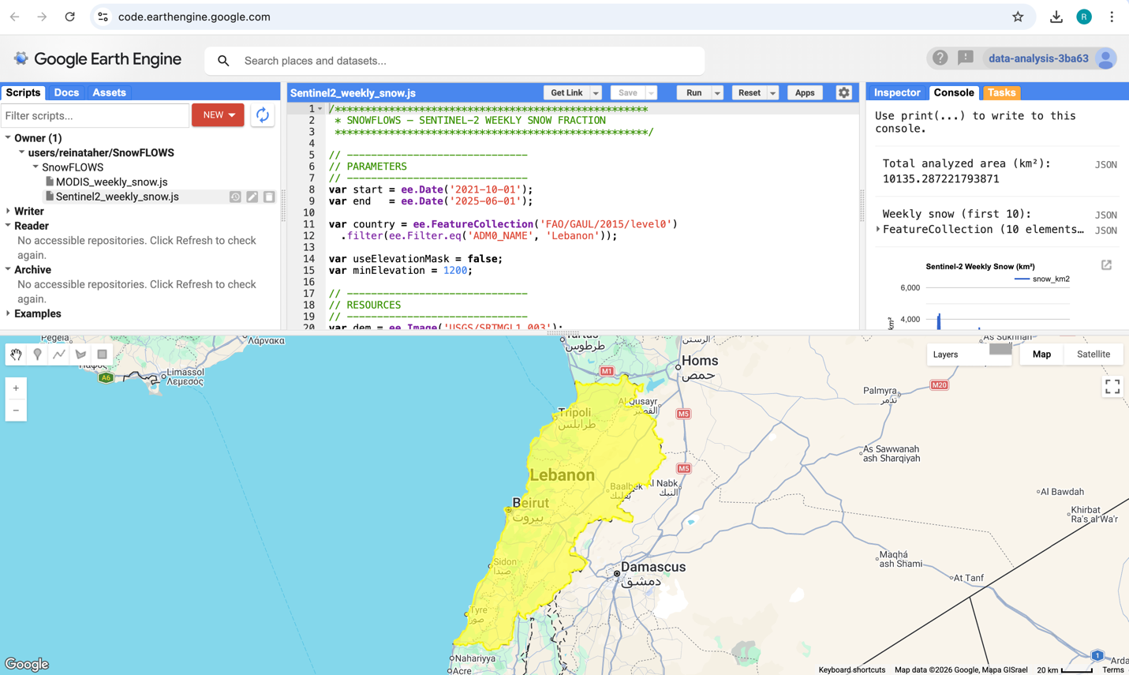
Figure 1 — Study area location displayed in Google Earth Engine.
- Methodology

Snow-cover extraction was performed using the Google Earth Engine platform based on Sentinel-2 Surface Reflectance imagery (COPERNICUS/S2_SR). The study area was defined using the FAO/GAUL administrative boundary dataset for Lebanon, and the analysis period was selected between October 2021 and June 2025.
The Sentinel-2 image collection was filtered spatially over Lebanon and temporally over the selected study period. To improve image quality, scenes with more than 70% cloud coverage were excluded from the analysis.
A cloud-masking procedure was then applied using the Scene Classification Layer (SCL) provided with Sentinel-2 Level-2A products. Only valid surface classes (vegetation, bare soil, water, unclassified pixels, and snow) were retained, while cloud-contaminated pixels were removed before snow detection.
Snow detection was performed using the Normalized Difference Snow Index (NDSI), calculated from the green band (B3) and the shortwave infrared band (B11). A threshold value of 0.4 was applied to identify snow-covered pixels and generate a binary snow mask for each image.
The detected snow pixels were aggregated weekly by computing the mean snow fraction within each weekly interval. Snow-covered area was then calculated by multiplying snow pixels by pixel surface area and converting the result into square kilometers. The snow-covered surface was also expressed as a percentage of the total analyzed territory.
An optional elevation mask based on the SRTM digital elevation model was integrated into the workflow to allow snow analysis above a specified elevation threshold if required. This functionality enables future investigation of altitude-dependent snow distribution.
Due to computational quota limitations within Google Earth Engine, the processing workflow had to be executed in multiple shorter temporal segments rather than as a single continuous run. Additionally, Sentinel-2 imagery availability is lower during the early years of the mission (2016–2017), which affects temporal consistency in long-term snow monitoring.
Finally, the weekly snow statistics were exported as CSV files for further processing, visualization, and statistical analysis using Python.

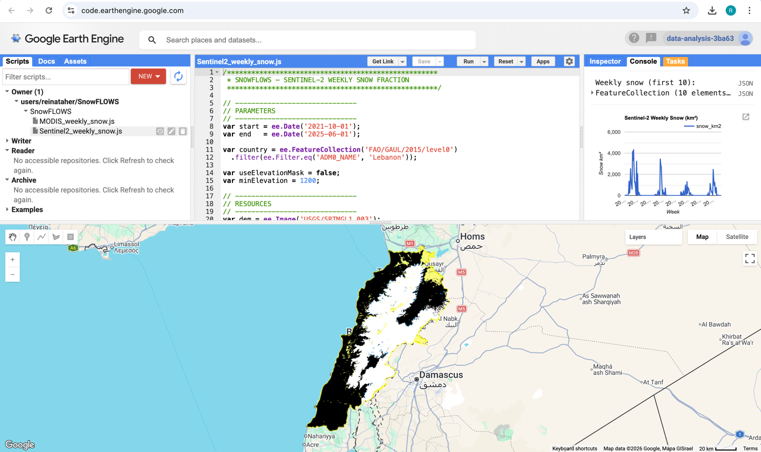
Figure 2 — Study area and Sentinel-2 dataset visualization in Google Earth Engine.

Key Processing Steps in the Google Earth Engine Script:

Definition of the study area using FAO/GAUL administrative boundaries.

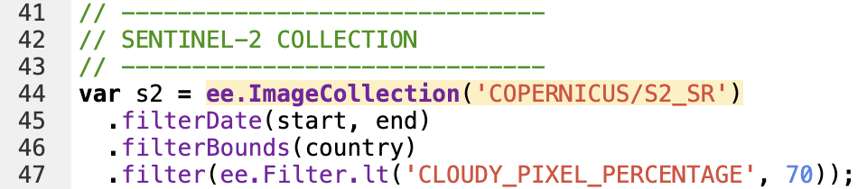
Selection of Sentinel-2 Surface Reflectance imagery from the COPERNICUS/S2_SR dataset.

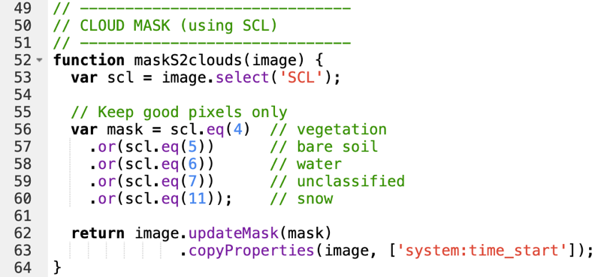
Cloud masking using the Sentinel-2 Scene Classification Layer (SCL).
Computation of the Normalized Difference Snow Index (NDSI).

Application of the NDSI threshold (0.4) for snow classification.

Weekly aggregation of snow-covered surface area.

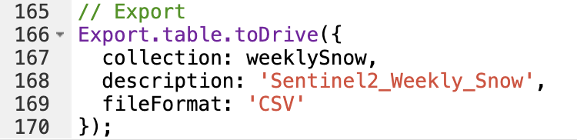
Export of weekly snow statistics to CSV format.

Some limitations:

Despite applying SCL-based cloud masking, residual cloud contamination may still affect some observations. In addition, Google Earth Engine processing quotas required splitting the workflow into multiple execution intervals. Finally, Sentinel-2 data availability is lower during the first years of the mission (2016–2017), which limits temporal continuity for long-term snow monitoring.

- Sentinel-2 Snow Extraction and Results
This section presents the main outputs generated from the snow extraction workflow, including intermediate and final datasets, as well as visualizations produced in both Google Earth Engine and Python.
The initial outputs were generated directly within Google Earth Engine in the form of weekly snow-covered area time series. Due to computational limitations, the processing was performed in two separate periods (2016–2021 and 2021–2025), resulting in two independent datasets and corresponding charts.
These datasets were exported as CSV files and subsequently merged to produce a continuous time series covering the full study period. The combined dataset was then visualized in Python to generate a unified snow-cover evolution graph.

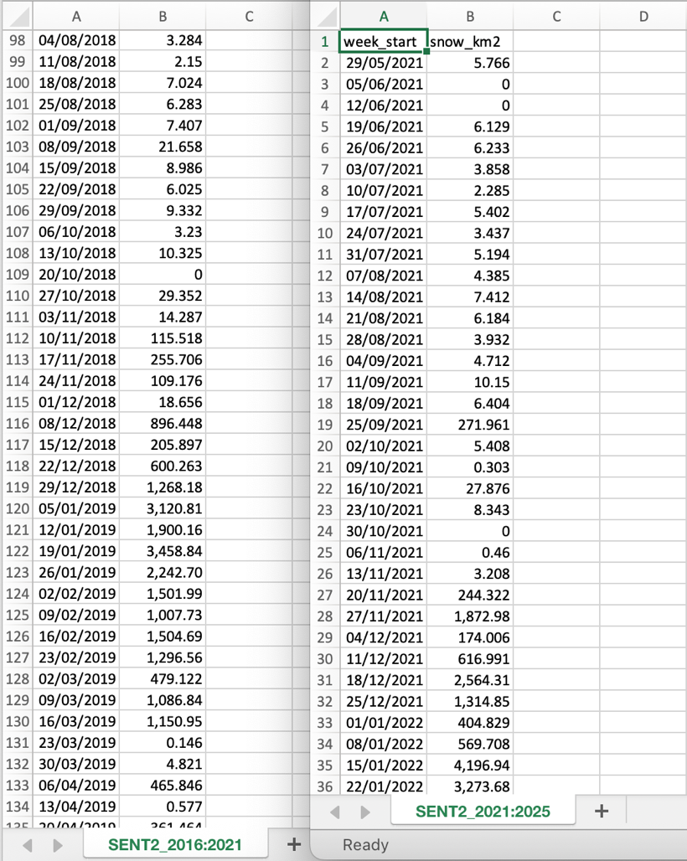
Figure 3 — Example of exported weekly snow dataset in CSV format.

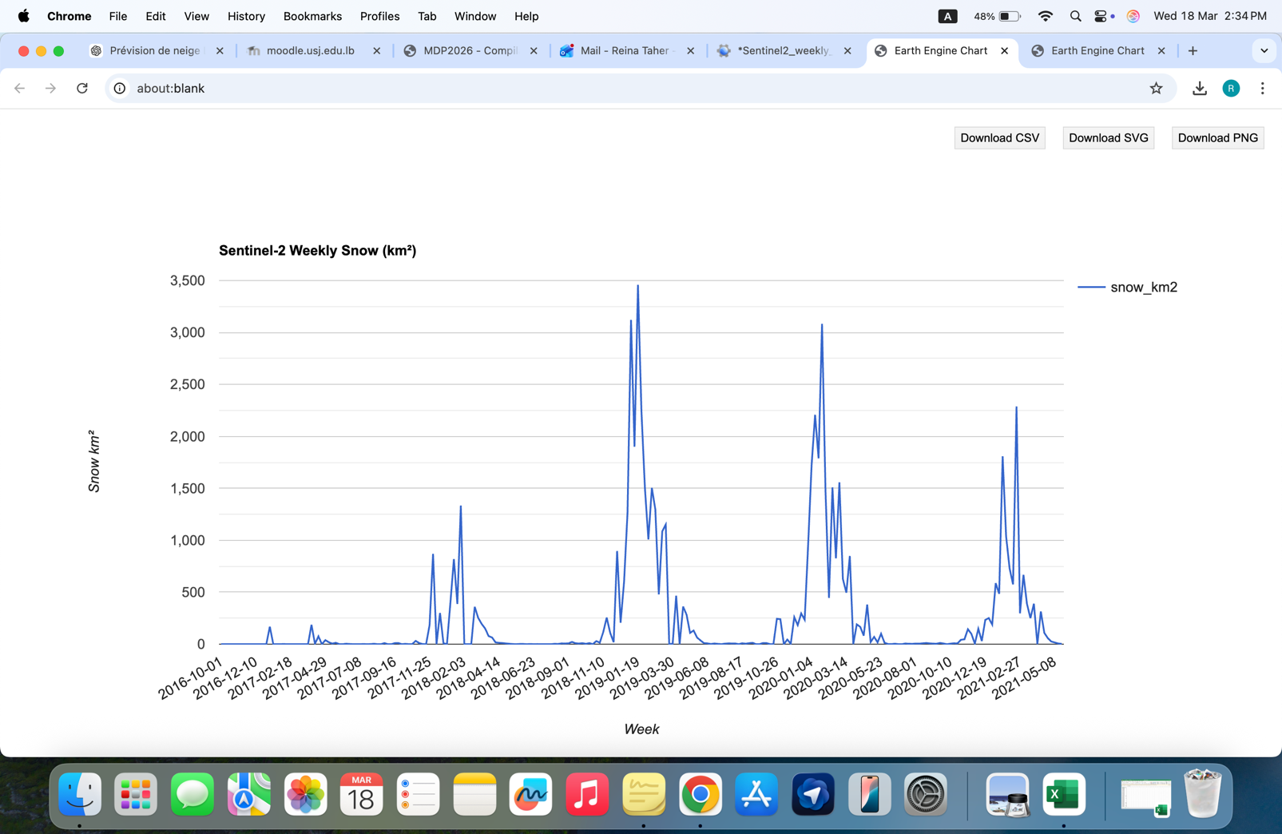

Figure 4 — Weekly snow-covered area (2016–2021) generated in Google Earth Engine.

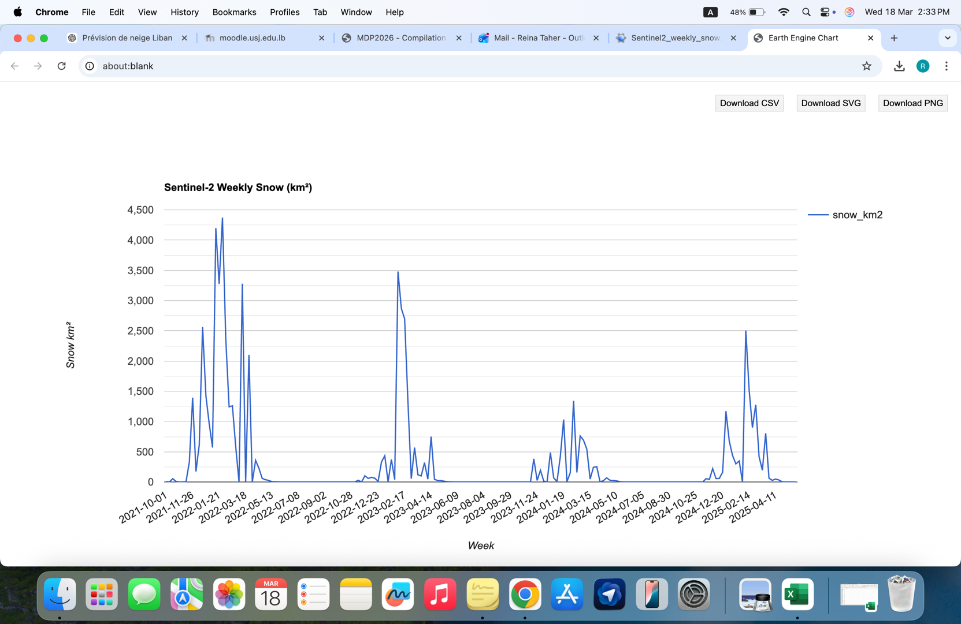

Figure 5 — Weekly snow-covered area (2021–2025) generated in Google Earth Engine.
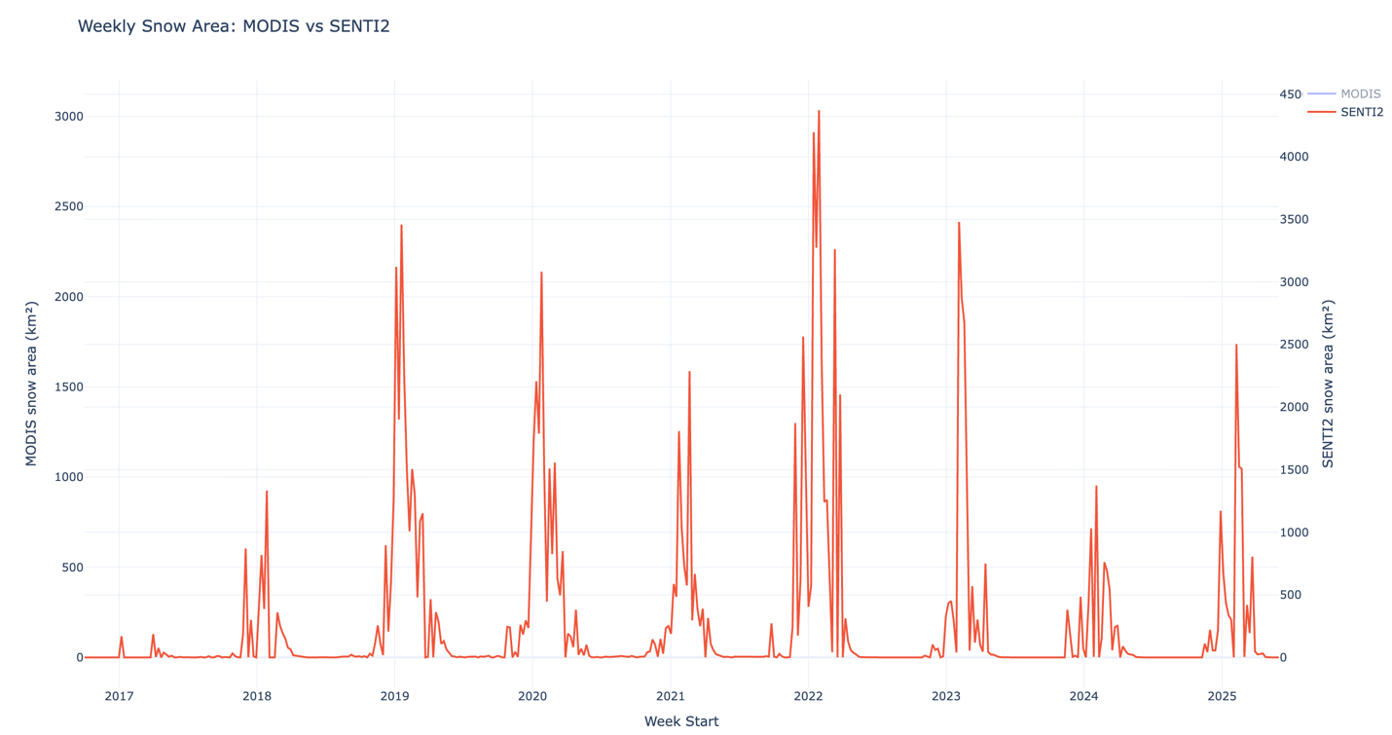
Figure 6 — Combined weekly snow-covered area time series (2016–2025) generated in Python.

The results show a clear seasonal snow cycle, with peaks in winter and strong decreases during spring and summer, confirming the consistency of the Sentinel-2 snow extraction process.

- MODIS vs Sentinel-2 Snow-Cover Comparison

Additional analyses were conducted in Python, including comparison between Sentinel-2 and MODIS snow datasets. Figure 7 below compares weekly snow-covered area extracted from these two datasets over the same study period.
Both datasets show consistent seasonal dynamics, with synchronized winter maxima and summer minima. This confirms that the NDSI-based snow-detection workflow produces reliable temporal trends across sensors.
Differences between the curves are mainly explained by sensor characteristics:
- MODIS spatial resolution: ~500 m
- Sentinel-2 spatial resolution: 10 m
- MODIS revisit frequency: daily
- Sentinel-2 revisit frequency: ~5 days
Because MODIS observations are more frequent, its time series appears smoother and more continuous. In contrast, Sentinel-2 captures finer spatial snow variability but shows stronger short-term fluctuations due to lower temporal sampling and cloud sensitivity.
Overall, the strong agreement between both datasets validates the extracted snow-cover time series and supports their use for altitude-dependent analysis and future predictive modeling.

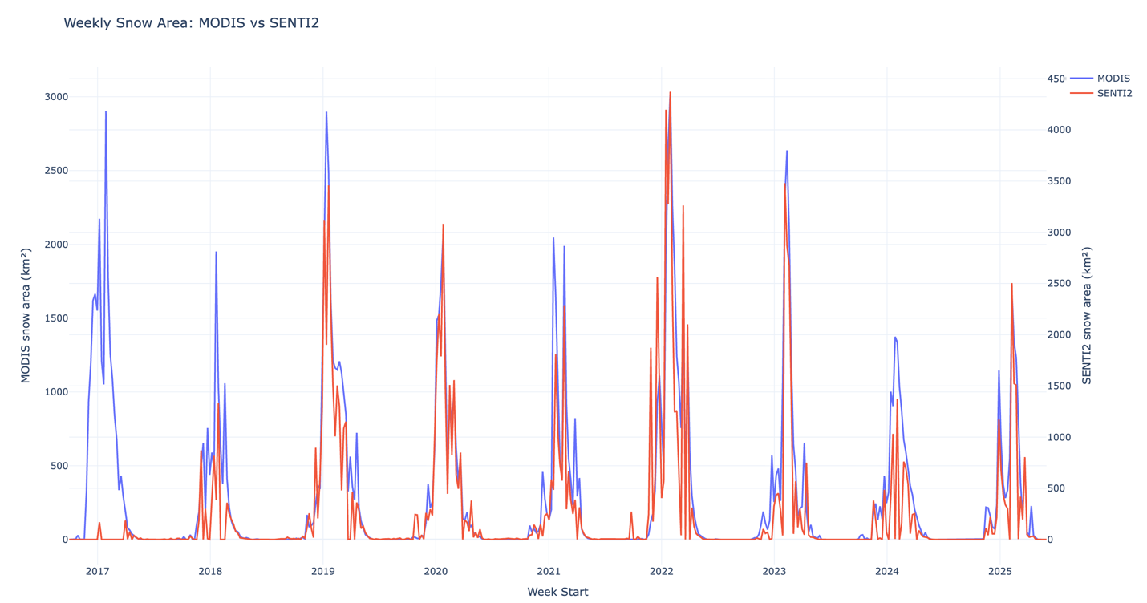
Figure 7 — Comparison between Sentinel-2 and MODIS snow-cover datasets.

- Altitude-Based Snow Analysis

An altitude-based analysis was performed to evaluate how snow-cover distribution varies across different elevation ranges within the study area. Using the SRTM Digital Elevation Model in Google Earth Engine, the snow-extraction workflow was repeated for three elevation classes:
- above 1,200 m
- between 1,200 m and 1,800 m
- above 1,800 m
Weekly snow-covered area was computed separately for each altitude range and exported as CSV datasets. These datasets were then visualized in Python to generate the comparative time-series shown in Figure 8 below.
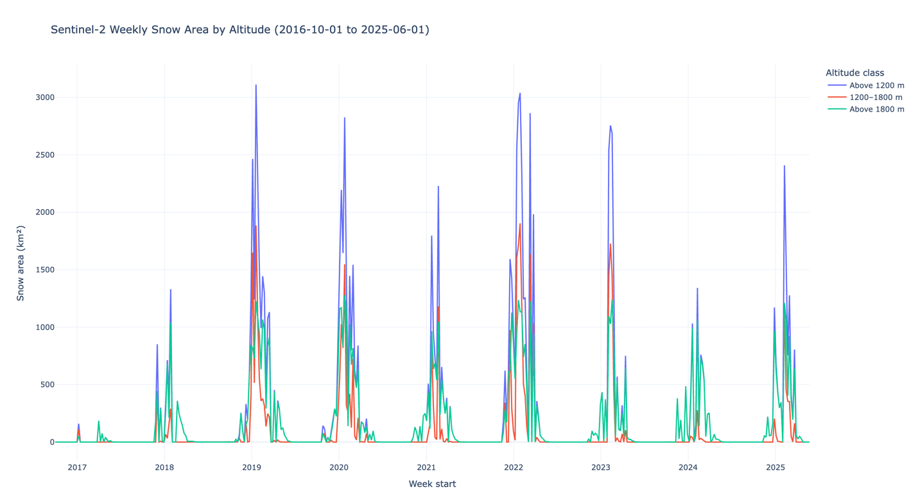
Figure 8 — Snow-cover variation as a function of altitude.

The results show a clear relationship between altitude and snow persistence. Higher elevation zones maintain snow cover for longer periods during the winter and spring seasons, while lower elevation areas experience earlier melting and shorter snow duration. This behavior is consistent with expected mountain snow dynamics.
This analysis confirms that altitude plays a significant role in controlling snow-cover variability in the study region. Therefore, elevation-dependent snow information represents an important feature for the next stage of the project, where time-series prediction models such as LSTM will be applied.

- Data Preparation for Time-Series Modeling
To support the next modeling stage of the project, the generated snow-cover time-series datasets were structured for use in predictive analysis.
A continuous weekly dataset covering the full study period (2016–2025) was prepared and aligned across Sentinel-2, MODIS, and altitude-filtered snow-cover observations. The integration of altitude-dependent snow variables allows the dataset to capture elevation-related variability in snow persistence.
This structured temporal dataset provides multiple complementary inputs describing snow evolution across space and time. Such variables are essential for training sequence-based prediction models such as LSTM, where both temporal continuity and physical drivers (e.g., altitude) improve prediction performance.
The dataset is therefore suitable for the implementation of supervised learning approaches using a 60% training, 20% validation, and 20% prediction split in the next stage of the project.

- Next Step: Time-Series Prediction Using LSTM / DIA Models
The next stage of the project consists of applying time-series prediction methods to model the temporal evolution of snow cover over the study region.
A Long Short-Term Memory (LSTM) approach is being considered due to its ability to learn long-term temporal dependencies in sequential environmental data. In parallel, DIA-based methods are also being evaluated as an alternative framework for generative spatio-temporal modeling.
The prediction workflow will use the weekly Sentinel-2 snow-cover time series above 1,200 m as the primary input signal, complemented by MODIS observations and altitude-dependent snow-cover variables. These additional variables are expected to improve the model’s ability to capture elevation-driven snow dynamics.
The dataset will be divided into:
- 60% training data
- 20% validation data
- 20% prediction data
This structure will allow evaluation of model performance and support the development of a reliable snow-cover prediction framework for future analysis.

- Conclusion
This report presented the main steps completed for the extraction and analysis of snow-cover time-series using Sentinel-2 and MODIS satellite imagery between 2016 and 2025. The generated datasets allowed identification of consistent seasonal snow patterns and highlighted the influence of altitude on snow persistence across the study region.
The comparison between satellite observations and the altitude-based analysis confirmed the reliability of the processing workflow and the relevance of the extracted variables for time-series modeling.
The project will now proceed with the implementation of predictive approaches based on LSTM and DIA models to analyze and forecast the temporal evolution of snow cover.
- Appendix
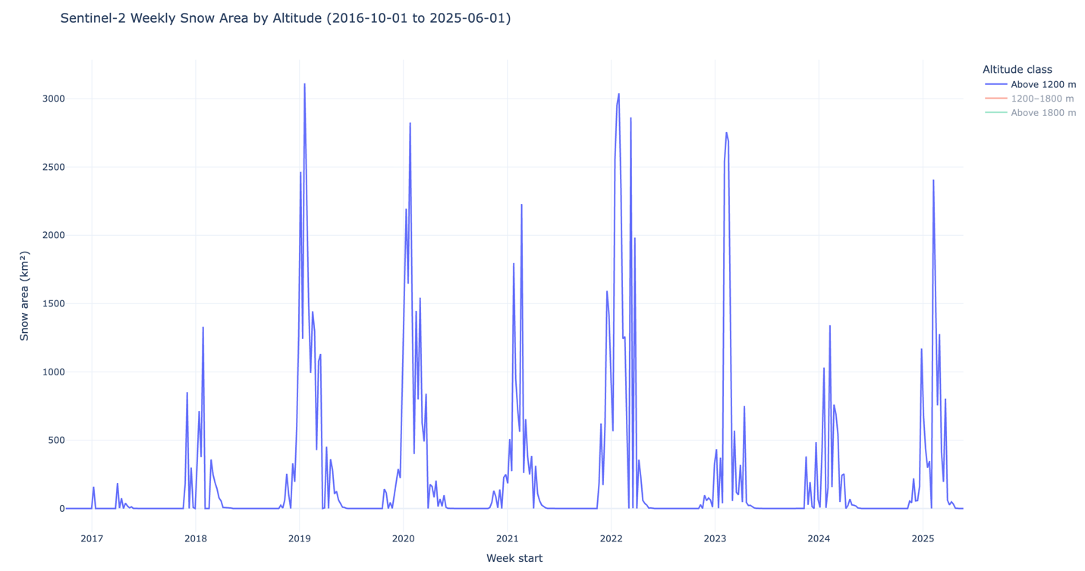
Figure 9 — Snow-covered area above 1200 meters.

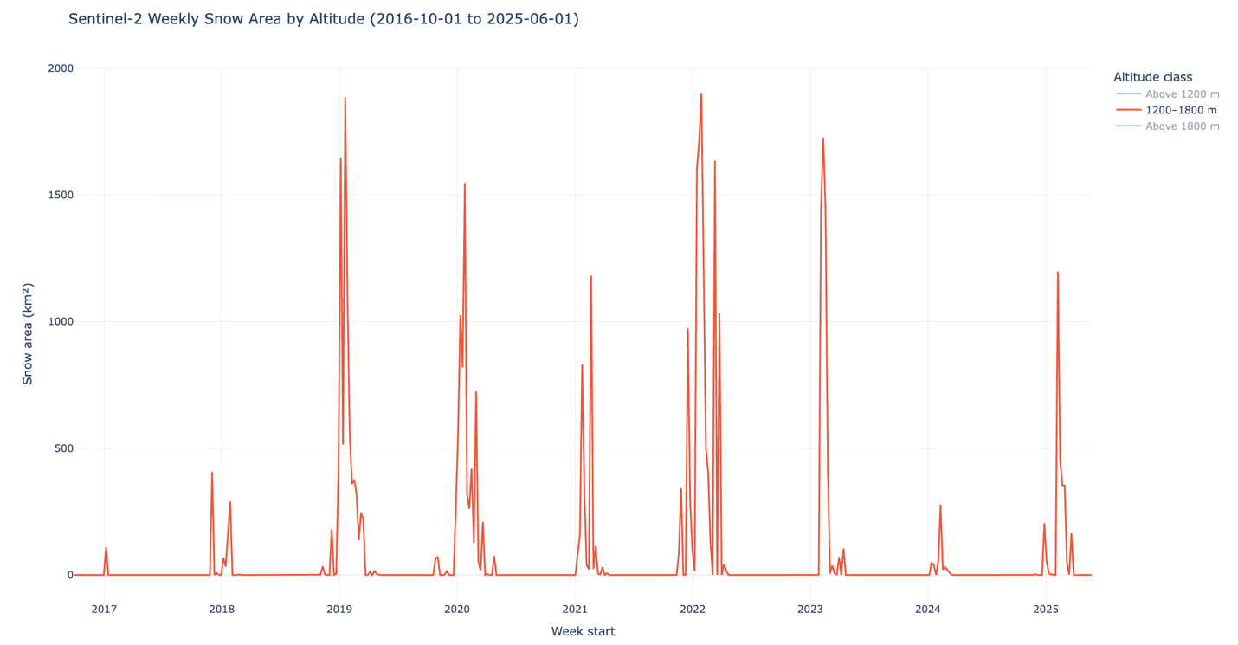
Figure 10 — Snow-covered area between 1200 and 1800 meters.

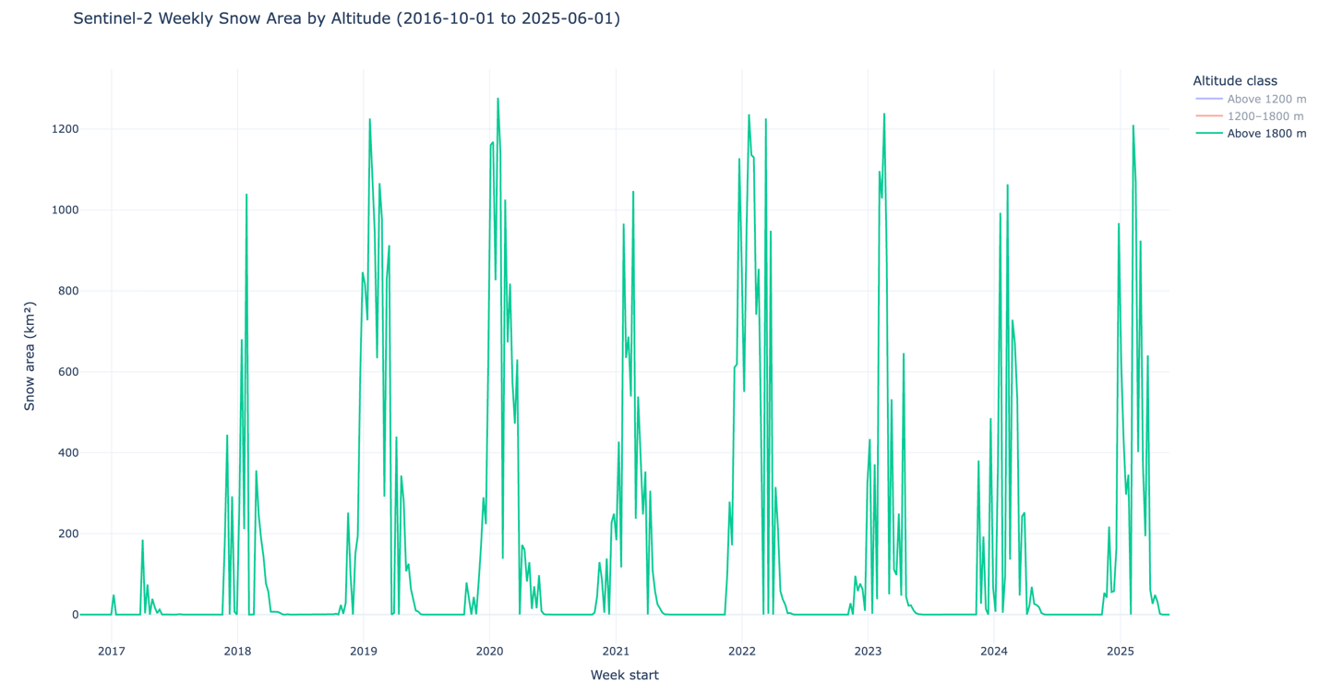
Figure 11 — Snow-covered area above 1800 meters.

