

Multidisciplinary Project Report (Second Technical Progress Report)

SnowFLOWS: Generative Spatio-Temporal Modelling of Snow Cover Dynamics Using Satellite Imagery

By:
Carla Youness (232771)
Nour el Saghir (230520)
Reina Taher (230134)
Ali Mansour (231039)
Hassan Dakhlallah (222814)

Supervisor(s):
Dr. Laurent Drapeau
Dr. Youssef El Bakouny

11/04/2026

École Supérieure d’Ingénieurs de Beyrouth
Université Saint-Joseph de Beyrouth

- Recap of Previous Progress Phase

During the previous phase of the project, we focused on building the initial version of the snow prediction dataset and establishing a baseline modeling workflow. Satellite-derived snow coverage data from Sentinel-2 and MODIS were collected and processed across multiple altitude ranges in Lebanon. These datasets were cleaned, structured into weekly observations, and aligned temporally to create a consistent time-series format suitable for machine learning applications.

- Construction of the Multi-Source Snow Prediction Dataset
Following the preparation of the initial satellite snow coverage dataset in the previous phase, the dataset was extended by integrating additional meteorological variables obtained from the ERA5 climate reanalysis database. The objective of this step was to improve the model’s ability to capture environmental conditions influencing snow accumulation.
The final dataset was organized in a weekly time-series format using the week_start variable as the temporal reference. For each week, snow coverage values derived from both Sentinel-2 and MODIS were included across three altitude ranges:
- Above 1200 m
- Between 1200 m and 1800 m
- Above 1800 m
To improve predictive performance, additional atmospheric variables were incorporated from ERA5:
- Air temperature (°C)
- Total precipitation (mm)
These meteorological variables were also structured according to the same altitude ranges to ensure spatial consistency with the satellite-derived snow observations.
As a result, each weekly observation contains synchronized information describing:
- Snow surface area from Sentinel-2
- Snow surface area from MODIS
- Temperature conditions
- Precipitation levels
across multiple elevation bands. This multi-source structure allows the predictive model to better learn the relationship between terrain elevation, seasonal atmospheric behavior, and snow cover evolution.

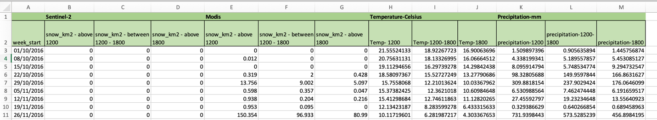
Structure of the multi-source weekly dataset before normalization showing Sentinel-2, MODIS, ERA5 temperature, and precipitation variables across altitude bands

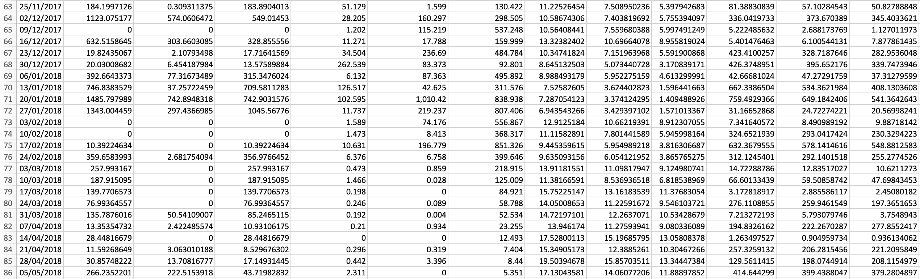
Example winter-period observations illustrating the relationship between precipitation increase and snow surface expansion across elevation levels

- Temporal Structuring and Feature Standardization

To prepare the dataset for sequence-based machine learning modeling, the original week_start column was transformed into two separate temporal variables:
- year
- week_of_year
This transformation allows the model to better capture seasonal snow behavior patterns across multiple winters while preserving chronological ordering of observations. Representing time explicitly in this format improves the learning capacity of recurrent neural networks such as LSTM models, which rely on sequential temporal dependencies.
After extracting these variables, the original week_start column was removed and replaced by the newly generated time indicators positioned at the beginning of the dataset.


Conversion of week_start into year and week_of_year temporal features

- Feature Scaling Using Z-Score Standardization
Because the dataset integrates variables originating from different physical sources and measurement units (snow surface area, temperature, and precipitation), feature scaling was required before training the predictive model.

A Z-score normalization procedure was applied using the StandardScaler function from the scikit-learn library. This transformation standardizes each feature according to:

$$Z=\frac{X-μ}{σ}$$
where:
- $X$ is the original feature value
- $μ$ is the feature mean
- $σ$ is the feature standard deviation
This ensures that all variables share the same statistical scale, preventing features with larger numeric ranges (such as precipitation values) from dominating the learning process.

The normalization was applied to all satellite and meteorological variables across altitude bands, including:
- Sentinel-2 snow coverage
- MODIS snow coverage
- Temperature measurements
- Precipitation measurements
The standardized dataset was then saved as: DataSet_after_zscore.csv
and used as the main input dataset for the predictive modeling phase.

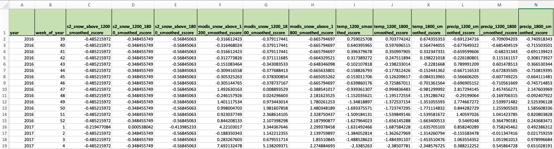
Example of dataset variables after Z-score normalization

- Definition of the Prediction Target Variable
The objective of the predictive model is to estimate weekly snow surface evolution in mountainous regions. For this purpose, the variable:
Sentinel-2 snow surface above 1200 m
was selected as the prediction target.
This variable was chosen because:
- Elevations above 1200 m represent the primary snow accumulation zone in Lebanon
- Sentinel-2 provides higher spatial resolution compared to MODIS
- Snow persistence above this altitude strongly reflects seasonal snowfall dynamics
- This altitude band is the most relevant for hydrological monitoring and winter-season analysis
To enable one-week-ahead forecasting, a shifted target column was created: target_snow_next_week
This column contains the snow surface value of the following week relative to each observation. The shift operation allows the LSTM model to learn temporal relationships between current atmospheric conditions and future snow accumulation behavior.
The final row of the dataset was removed because it does not contain a valid next-week observation.
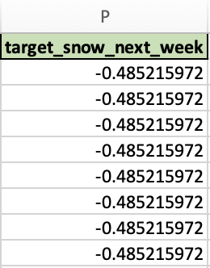
Creation of next-week prediction target column for snow surface above 1200 m

6. Train-Validation-Test Dataset Partitioning
To evaluate model performance reliably and prevent information leakage between training phases, the dataset was divided into three subsets:
Dataset | Percentage
Training set | 70%
Validation set | 15%
Test set | 15%
A new column named: split
was introduced to explicitly label each observation according to its role in the modeling pipeline.
This structure allows:
- model training on historical sequences
- hyperparameter tuning using validation data
- final performance evaluation on unseen test observations
Such a partitioning strategy ensures that the predictive performance assessment remains unbiased and representative of real forecasting conditions.
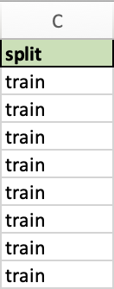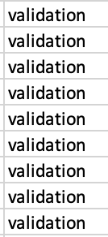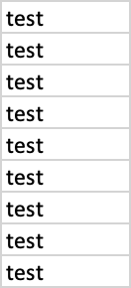
Dataset partitioning into training, validation, and testing subsets

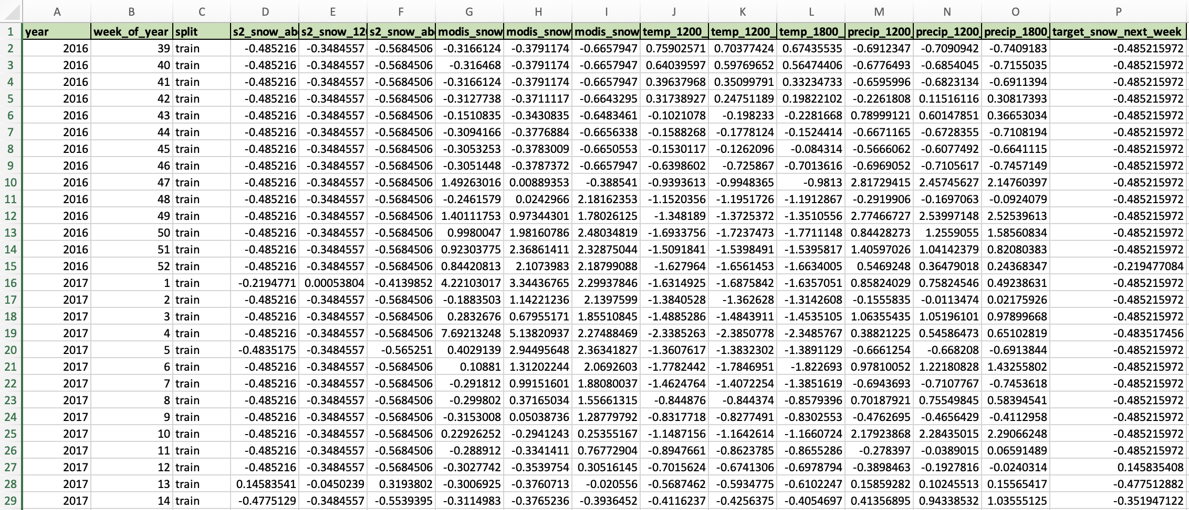

Final structured dataset after temporal feature extraction, Z-score normalization, target variable creation, and train–validation–test splitting ready for LSTM modeling

7. Preparation of Sequential Input Windows
Since Long Short-Term Memory (LSTM) networks operate on ordered temporal sequences rather than independent observations, the dataset was transformed into sliding input windows representing multiple consecutive weeks of meteorological and snow-cover evolution.
Each training sample was constructed using 8 consecutive weeks of observations, allowing the model to learn short-term temporal dependencies between atmospheric conditions and snow accumulation behavior.
The selected sequence length: sequence_length = 8
was determined experimentally after testing multiple temporal window sizes. An 8-week observation window provided the best balance between capturing recent snowfall persistence and avoiding unnecessary noise from distant past observations.
Thus, each model input sample contains:
8 weeks × 20 features
while the output corresponds to:
snow surface above 1200 m during the following week
This transforms the prediction task into a one-week-ahead temporal forecasting problem.
Construction of 8-week sliding temporal windows for LSTM sequence learning

- Cyclical Representation of Week-of-Year Information
Seasonality plays a critical role in snow accumulation processes. However, the variable:
week_of_year
cannot be used directly as a linear feature because week 52 and week 1 are temporally adjacent but numerically distant.
To solve this issue, cyclical encoding was applied using sine and cosine transformations:
$${week}_{sin}=\sin\left( \frac{2π . week}{52} \right)$$
$${week}_{cos}=\cos\left( \frac{2π . week}{52} \right)$$

This transformation preserves the circular nature of seasonal time progression and allows the LSTM model to correctly interpret transitions between years.
As a result, the model can learn recurring winter snow accumulation patterns across multiple seasons.
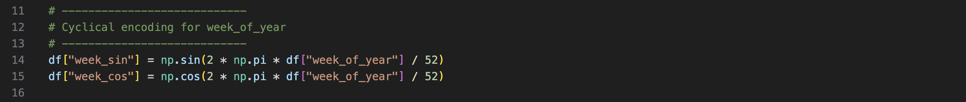
Cyclical encoding of seasonal weekly information using sine and cosine transformations

- Snow Memory Representation Through Lag Features
Snow accumulation is strongly dependent on previous snow presence. Unlike rainfall, snow does not disappear immediately after formation and therefore exhibits persistence over time.
To capture snow persistence behavior, three lag-based temporal memory indicators were introduced:
snow_last_week
snow_last_2weeks
snow_change_ratio
where:
snow_change_ratio = snow_last_week − snow_last_2weeks
This additional variable provides information about whether snow accumulation is increasing or decreasing between recent weeks.
Including lagged snow features allows the LSTM model to learn:
- delayed melting behavior
- accumulation continuity
- short-term snowpack memory effects

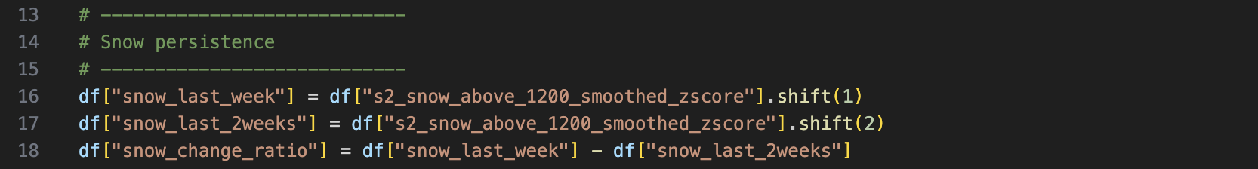
Snow persistence feature construction using one-week, two-week and change ratio lag variables

- Multi-Altitude Snow Aggregation Feature
Snow distribution varies across elevation ranges due to temperature gradients and precipitation differences.
To provide the model with a generalized representation of snow surface behavior across all altitude bands, a new feature was computed:
snow_mean
This variable represents the average snow surface area across:
- above 1200 m
- between 1200 m and 1800 m
- above 1800 m
It helps the model capture large-scale snowpack evolution rather than relying exclusively on individual elevation signals.
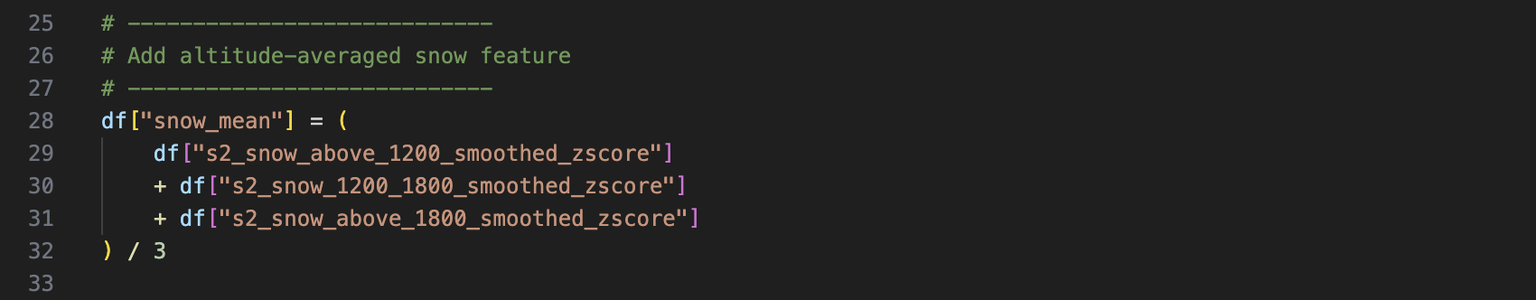
Altitude-averaged snow surface feature capturing global snowpack evolution

- Snow Surface Change Rate Features
To help the LSTM model detect whether snow accumulation is increasing or decreasing over time, two temporal derivative-based indicators were introduced:
snow_gradient
snow_acceleration
The snow gradient represents the first-order variation of altitude-averaged snow signal (snow_mean) between consecutive weeks:
$$gradient=snow_{t}-snow_{t-1}$$
The snow acceleration represents the second-order variation:
$$acceleration=gradient_{t}-gradient_{t-1}$$
These features allow the model to detect:
- onset of snowfall events
- rapid melting periods
- stabilization phases in snow coverage
Including derivative-based indicators improves the model’s ability to anticipate short-term snow evolution trends.

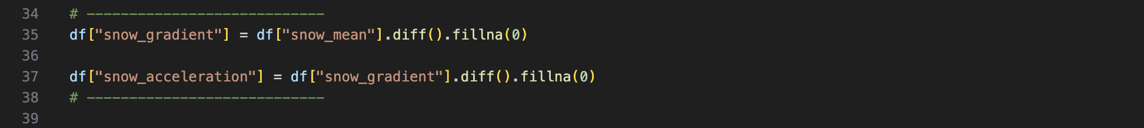
First-order and second-order temporal altitude-averaged snow signals

- Final Feature Vector Construction
The final input vector used for sequence construction included:
Feature Category | Variables
Seasonal encoding | week_sin, week_cos
Persistence | snow_last_week, snow_last_2weeks
Change dynamics | snow_change_ratio
Aggregated snow signal | snow_mean
Temporal derivatives | snow_gradient, snow_acceleration
Sentinel-2 snow coverage | 3 altitude bands
MODIS snow coverage | 3 altitude bands
Temperature | 3 altitude bands
Precipitation | 3 altitude bands
In total: 20 predictive features were used as input variables for the LSTM model.

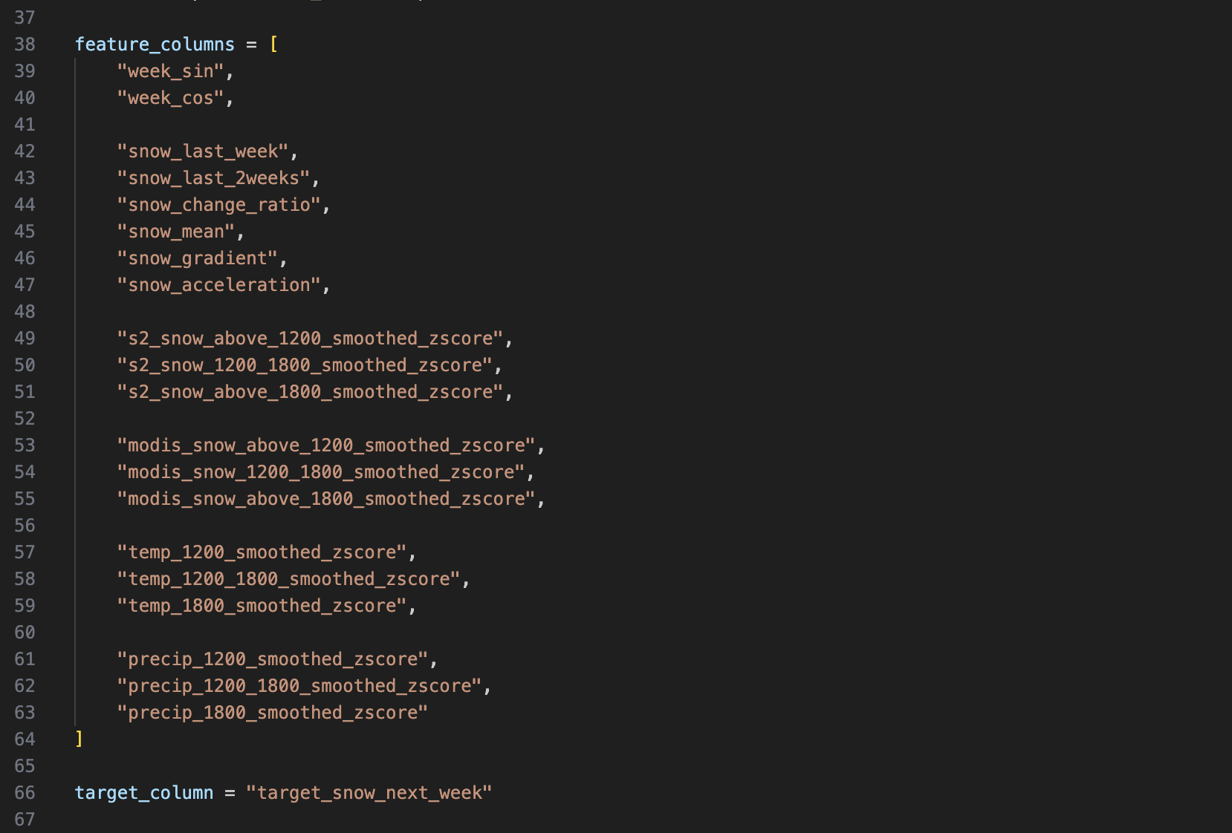
Final set of 20 predictive features used for sequence construction

- Sliding Window Dataset Construction
A sliding-window approach was applied to transform the dataset into supervised learning sequences.
Each training sample contains: 8 consecutive weeks of input observations
mapped to: snow surface value during the following week
Mathematically:
$$X_{t}=\left[ week_{t-7}, …, week_{t} \right]$$
$$y_{t}=snow_{t+1}$$
This formulation enables the LSTM network to learn temporal dependencies between past environmental conditions and future snow surface evolution.
After sequence generation, the dataset shapes became:
Train: (307, 8, 20)
Validation: (68, 8, 20)
Test: (67, 8, 20)
confirming correct preparation of the 3-dimensional tensors required for LSTM training.
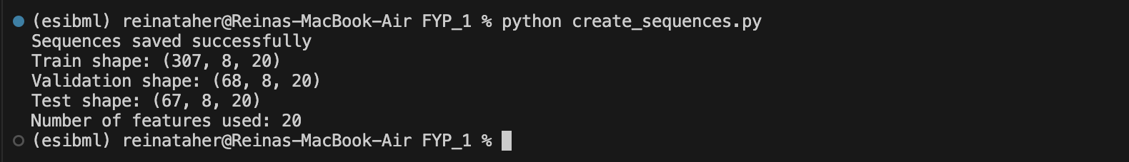
Final LSTM input tensor dimensions after sequence generation

- Deep Learning Model Selection
To predict weekly snow surface evolution above 1200 m altitude, a Long Short-Term Memory (LSTM) neural network was implemented using TensorFlow and Keras.
LSTM networks were selected because they are specifically designed for temporal sequence modeling and can capture:
- delayed meteorological effects
- seasonal accumulation cycles
- persistence of snowpack conditions
- nonlinear relationships between temperature, precipitation, and snow surface evolution
Unlike classical regression methods, LSTMs maintain a memory of previous observations through internal gating mechanisms, making them particularly suitable for weekly environmental forecasting.

- Baseline Forecast Benchmark
Before training the neural network, a persistence-based baseline forecasting model was implemented in order to define a minimum performance threshold for the prediction task.
This baseline assumes that snow surface conditions remain unchanged between two consecutive weeks:
$$snow_{t+1} ≈ snow_{t}$$
Within the sequence-based modeling framework, this persistence estimate corresponds to the most recent snow observation contained in each input window. Therefore, the baseline prediction was computed using the feature: snow_last_week
which represents snow surface conditions observed during the final time step of each sequence.
Mathematically: baseline_pred = X_test[:, -1, 2]
Baseline performance was evaluated using the Mean Absolute Error (MAE) metric on the independent test dataset.
This reference score provides a minimum benchmark that the LSTM model must outperform in order to demonstrate meaningful predictive capability beyond simple temporal persistence.
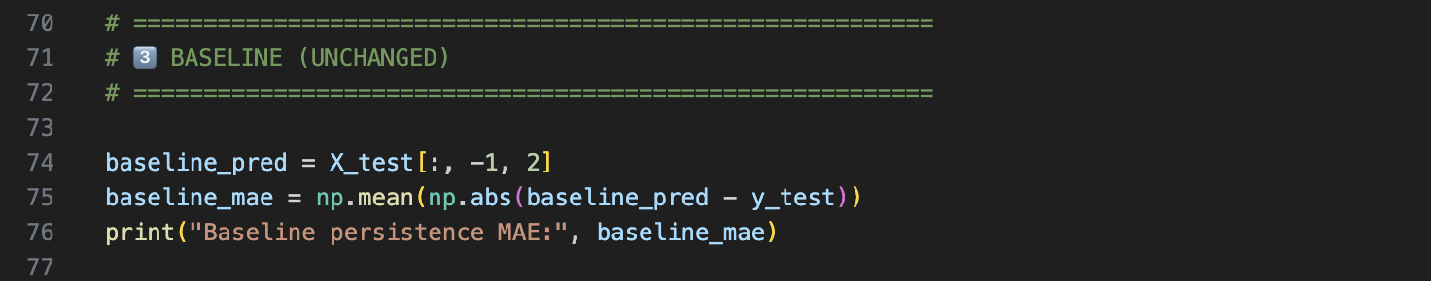
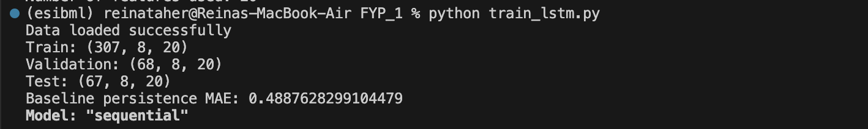
Baseline persistence prediction error used as reference benchmark for LSTM evaluation

- Peak-Weighted Huber Loss Function
Instead of using classical Mean Squared Error (MSE), the model was trained using a peak-weighted Huber loss function designed to improve forecasting stability while preserving sensitivity to extreme snowfall events.
The Huber loss function combines the advantages of:
- Mean Squared Error (sensitive to large deviations)
- Mean Absolute Error (robust to outliers)
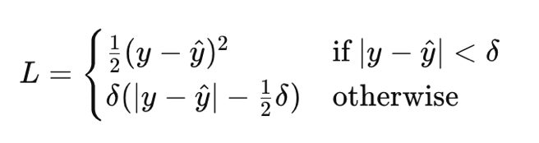
while preventing excessive penalization of rare extreme prediction errors.
The loss formulation follows:

where: delta = 1.0
To improve prediction accuracy during high snow-accumulation periods, an adaptive peak-weighting mechanism was introduced:
weight = 1 + 1.5 × max(0, y_true)
This weighting strategy increases the contribution of large snow-surface observations during optimization while maintaining stable training convergence.
As a result, the model prioritizes learning:
- winter storm accumulation behavior
- snowpack growth episodes
- high-impact hydrological events
without introducing instability associated with aggressive threshold-based weighting strategies.

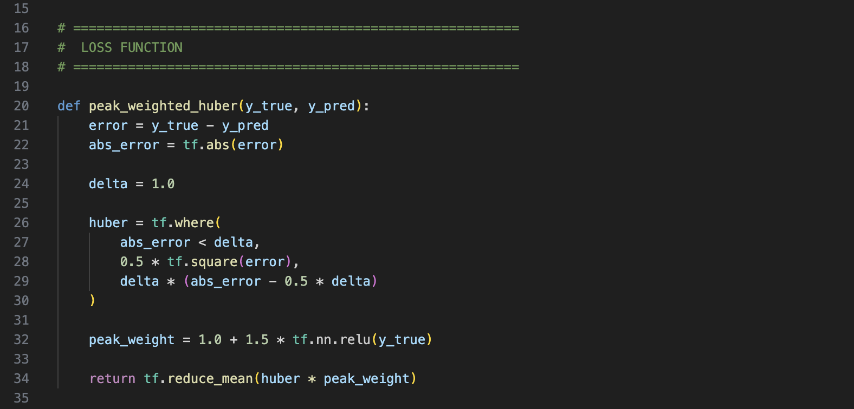

Implementation of the peak-weighted Huber loss function used to improve prediction stability while emphasizing high snow-accumulation events
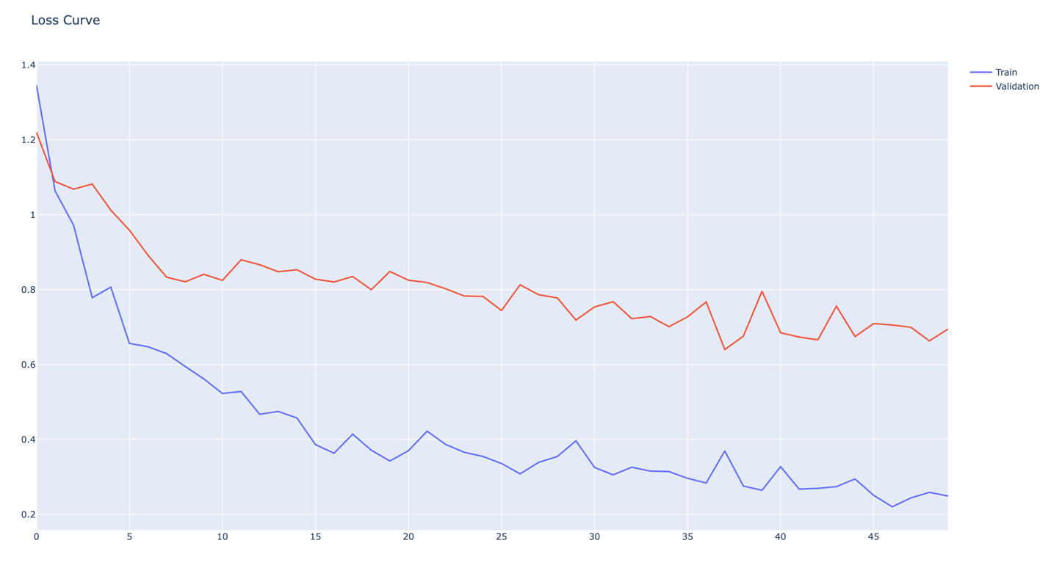
Training and validation loss curves showing convergence behavior of the LSTM model using the peak-weighted Huber loss function

- Multi-Layer Temporal Feature Extraction Network
To predict weekly snow surface evolution above 1200 m altitude, a stacked Long Short-Term Memory (LSTM) neural network architecture was implemented using TensorFlow and Keras.
The final architecture consists of two sequential LSTM layers followed by dense nonlinear regression layers:

Input (8 weeks × 20 features)
LSTM(96)
Dropout(0.15)
LSTM(64)
Dropout(0.15)
Dense(32)
Dense(16)
Dense(1)

Architecture rationale:
Layer | Role
LSTM(96) | capture broad seasonal dependencies
LSTM(64) | refine intermediate temporal structures
Dense layers | nonlinear regression mapping
Stacking multiple LSTM layers improves hierarchical learning of temporal patterns across different temporal scales while maintaining training stability on a moderate-sized environmental dataset.
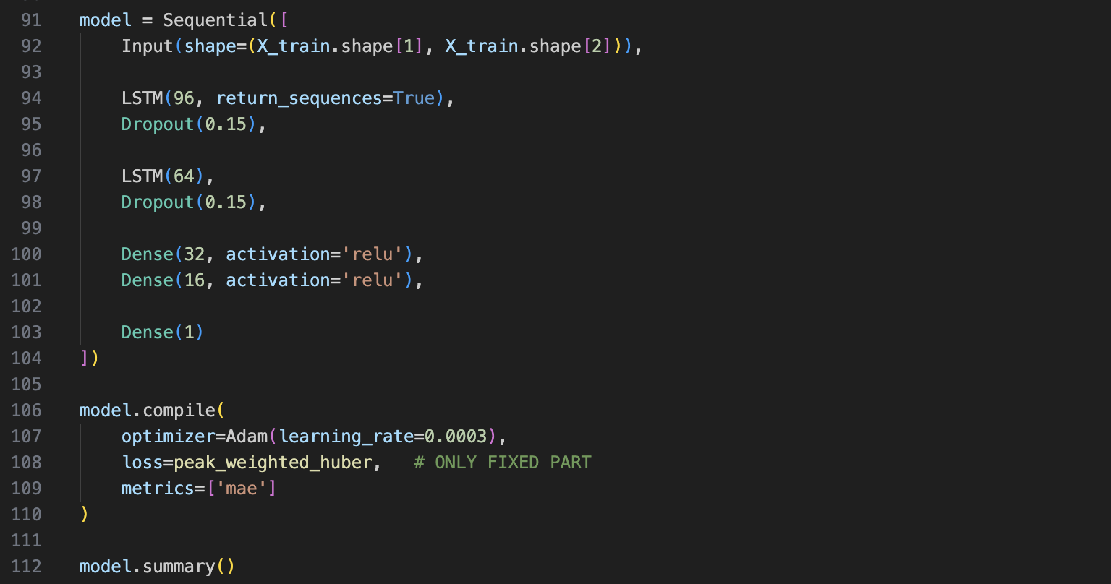
Summary of the stacked LSTM architecture used for weekly snow surface forecasting

- Overfitting Prevention Strategy
To prevent overfitting due to limited dataset size and strong temporal correlations between observations, dropout regularization was applied after each LSTM layer:
Dropout(0.15)
Dropout randomly disables 15% of neurons during each training iteration, forcing the network to learn more robust feature representations rather than memorizing training sequences.
This improves generalization performance on validation and test datasets.
- Learning Rate Adjustment During Training
Training stability was improved using the ReduceLROnPlateau callback:
factor = 0.5
patience = 6
If validation performance stops improving, the learning rate is automatically reduced by half.
This allows the model to:
- converge faster initially
- fine-tune parameters during later training stages
- avoid oscillation near local minima
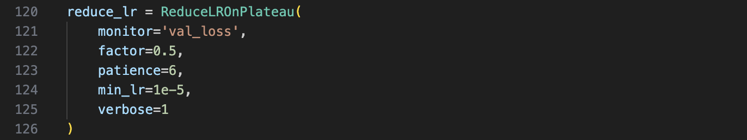
Adaptive learning-rate scheduling using ReduceLROnPlateau callback

- Training Termination Strategy
To prevent unnecessary training beyond convergence and avoid overfitting, early stopping was applied:
patience = 12
restore_best_weights = True
Training stops automatically when validation performance no longer improves, and the best-performing parameter configuration is restored.
This ensures optimal model generalization without manual tuning.
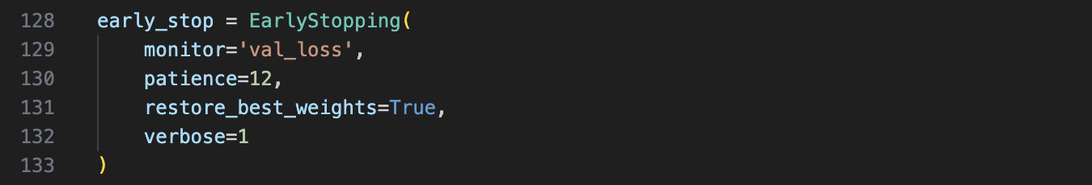
Early stopping strategy restoring best validation-performance model weights
- Optimization Parameters
The model was trained using:
Parameter | Value
Optimizer | Adam
Learning rate | 0.0003
Batch size | 8
Epoch limit | 150
Shuffle | Disabled
Shuffling was intentionally disabled:
shuffle = False
to preserve chronological ordering of temporal sequences during training.
This is essential for sequence-based forecasting models such as LSTMs.

- Forecast Accuracy Measurement
Model performance was evaluated using:
Mean Absolute Error (MAE)
MAE was selected because it:
- provides interpretable prediction error magnitude
- is robust to outliers
- reflects real forecasting deviation in snow surface estimation
Evaluation was performed on the independent test dataset after training completion.
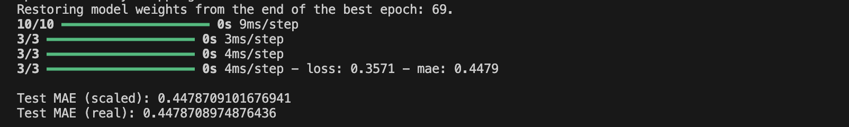
Test Mean Absolute Error (MAE) obtained by the LSTM model on the unseen testing dataset
- Full Timeline Prediction Visualization
To evaluate the temporal consistency of the forecasting model across the entire observation period, a full-timeline prediction visualization was generated using Plotly.
This visualization displays:
- ground-truth snow surface values for the training dataset
- ground-truth snow surface values for the validation dataset
- ground-truth snow surface values for the test dataset
- predicted snow surface values for validation sequences
- predicted snow surface values for test sequences
The timeline representation allows visual assessment of the model’s ability to reproduce seasonal snow accumulation patterns across multiple winters.
Unlike isolated statistical metrics such as MAE, this visualization provides qualitative insight into:
- seasonal prediction accuracy
- peak snowfall tracking capability
- melting-period behavior reproduction
- long-term temporal consistency
To clearly separate the different learning phases, vertical transition bands were inserted between:
- training period
- validation period
- test period
This prevents misinterpretation of prediction continuity across dataset boundaries and ensures transparency in model evaluation.

The resulting visualization confirms that the LSTM model successfully captures the main temporal structure of snow surface evolution across the observation window.

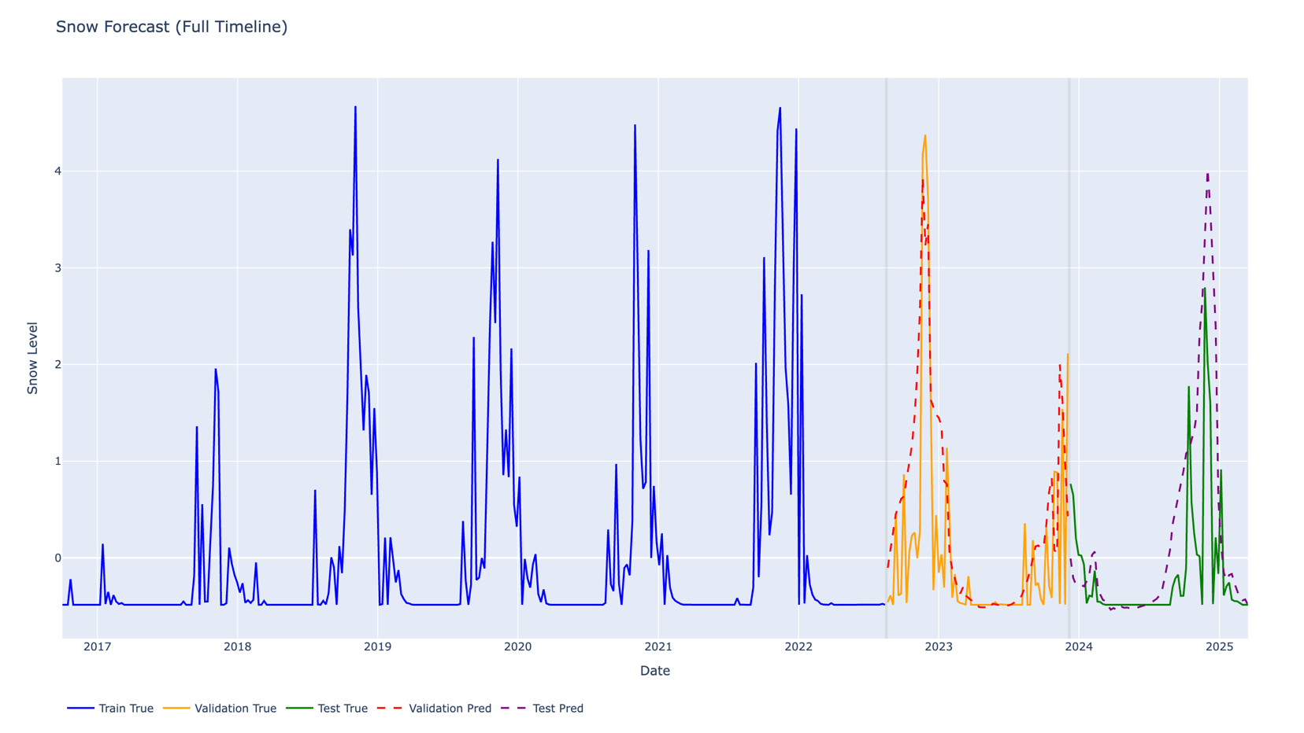

Full-timeline visualization comparing observed and predicted snow surface evolution across training, validation, and testing periods

- Trade-Off Between Global MAE and Peak Snow Event Prediction
Although Mean Absolute Error (MAE) is commonly used to evaluate regression performance, it does not fully reflect the ability of a forecasting model to reproduce extreme snowfall events.
In the context of weekly snow surface prediction, correctly capturing seasonal accumulation peaks is particularly important because these periods correspond to the highest snow storage conditions and therefore have stronger hydrological and environmental significance.
During model tuning, it was observed that configurations producing the lowest MAE values tended to smooth the predicted signal and underestimate major snow accumulation peaks. Conversely, models trained using the peak-weighted Huber loss function slightly increased the overall MAE but significantly improved the reproduction of high-magnitude snowfall events.
This behavior reflects a known trade-off in time-series forecasting between:
- minimizing average prediction error across all weeks
- preserving accurate prediction of extreme seasonal events
Since the objective of this study is to model realistic snow surface evolution rather than only optimize a global statistical indicator, priority was given to configurations that improved peak detection performance.
As a result, a slightly higher MAE value was accepted in exchange for better reconstruction of seasonal snow accumulation dynamics, especially during winter maxima.
This choice improves the physical interpretability and operational relevance of the forecasting model.
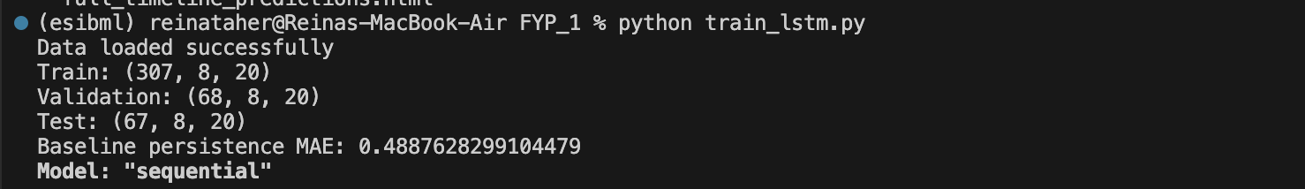

Test Mean Absolute Error (MAE) obtained by the LSTM model (Baseline and Test)

- Exploratory Multi-Altitude Output Prediction
In addition to the single-output forecasting model, an exploratory experiment was conducted to evaluate the feasibility of predicting snow surface evolution simultaneously at three altitude levels using a multi-output LSTM architecture.
In this configuration, the network was trained to produce three predictions per time step corresponding to snow surface values at different elevations. The objective of this experiment was to investigate whether joint learning across altitudes could improve prediction consistency along the vertical snow profile.
However, the resulting predictions showed reduced interpretability compared to the single-output configuration, particularly in terms of peak reconstruction accuracy and temporal stability. While the model was able to capture general seasonal trends, the predictions were less precise for individual altitude levels.
For this reason, the single-output LSTM configuration was retained as the primary forecasting model, as it provided clearer and more reliable prediction performance.
Nevertheless, this exploratory experiment confirms the potential of multi-altitude joint prediction as a direction for future model improvement.
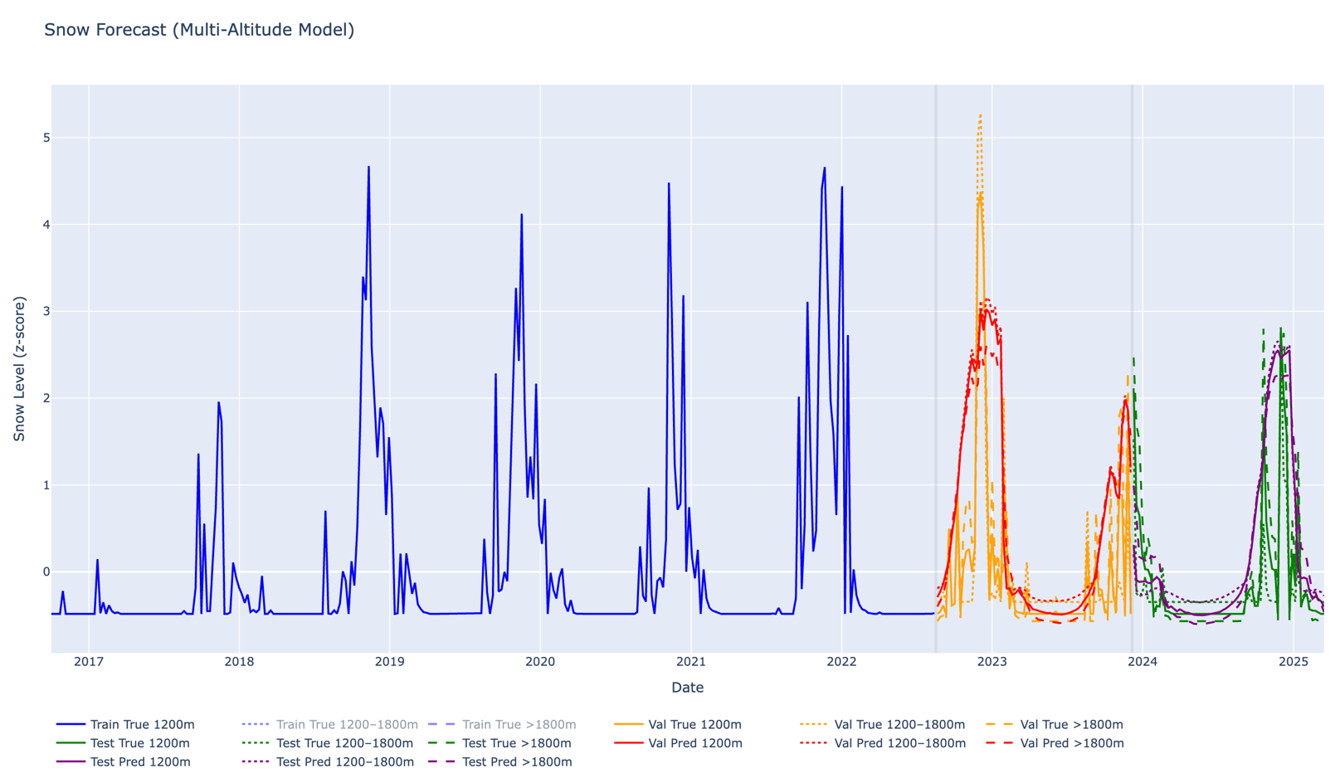

Example prediction results obtained using the exploratory multi-output LSTM model for simultaneous forecasting at three altitude levels

- Conclusion
In this phase of the project, we developed a complete LSTM-based framework for weekly snow surface forecasting using multi-source satellite and meteorological data. The dataset was enhanced with temporal, persistence, and altitude-based features, and structured into 8-week input sequences for supervised learning. A stacked LSTM model was trained using a custom peak-weighted Huber loss and evaluated against a persistence baseline.
The final model achieved a test MAE of approximately 0.44, slightly outperforming the baseline MAE of 0.48, confirming the added predictive value of the proposed approach. An additional exploratory multi-output model for simultaneous altitude prediction was also tested, but the single-output configuration was retained due to its clearer and more stable performance.

