|  |
| --- |
| Nanyang Technological University |
| Lab 4 Report: Implicit Solids |
| CZ2003 Computer Graphics and Visualization |

Fang Ran (U1521819L)

SSP4

Rough description of this creature:

This creature is made up of ellipsoids (for the body and wings), cylinders (for the eyes and antenna), a cone for its tail and a sphere for its head. Additionally, when creating the tail and the eyes, I used min/max on four plane halfspaces (z=0; z=-2; z=1.2; z=-0.5). In the FMaterial field, I also defined a variable diffuse colour for the whole shape. The creature changes colours as well and here are a few screenshots (not all colours it can change into are shown).

Screenshots:

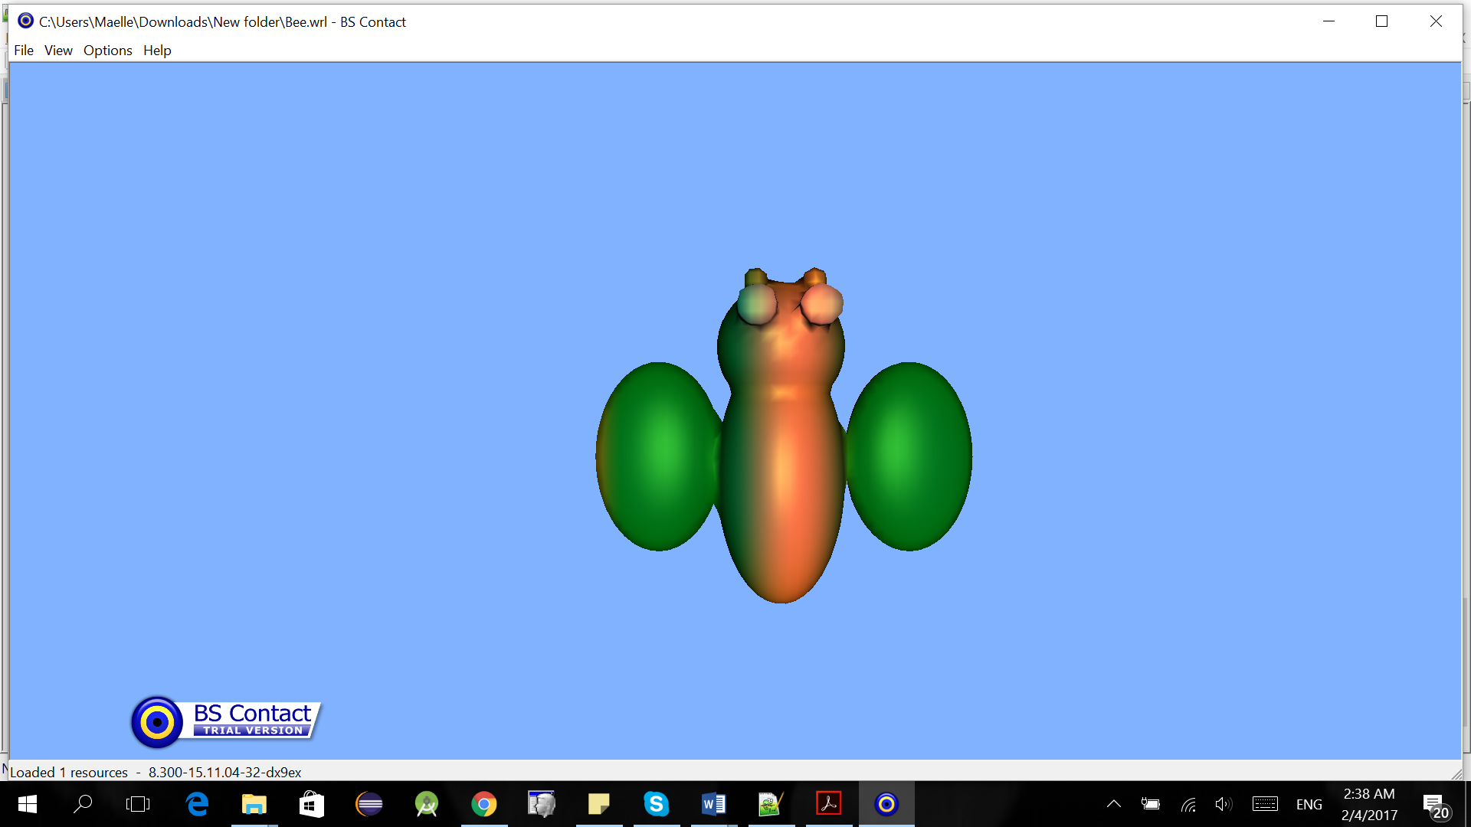 Front View

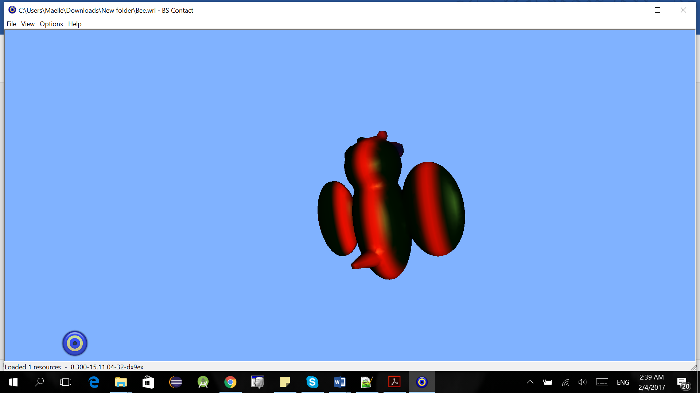 Back View

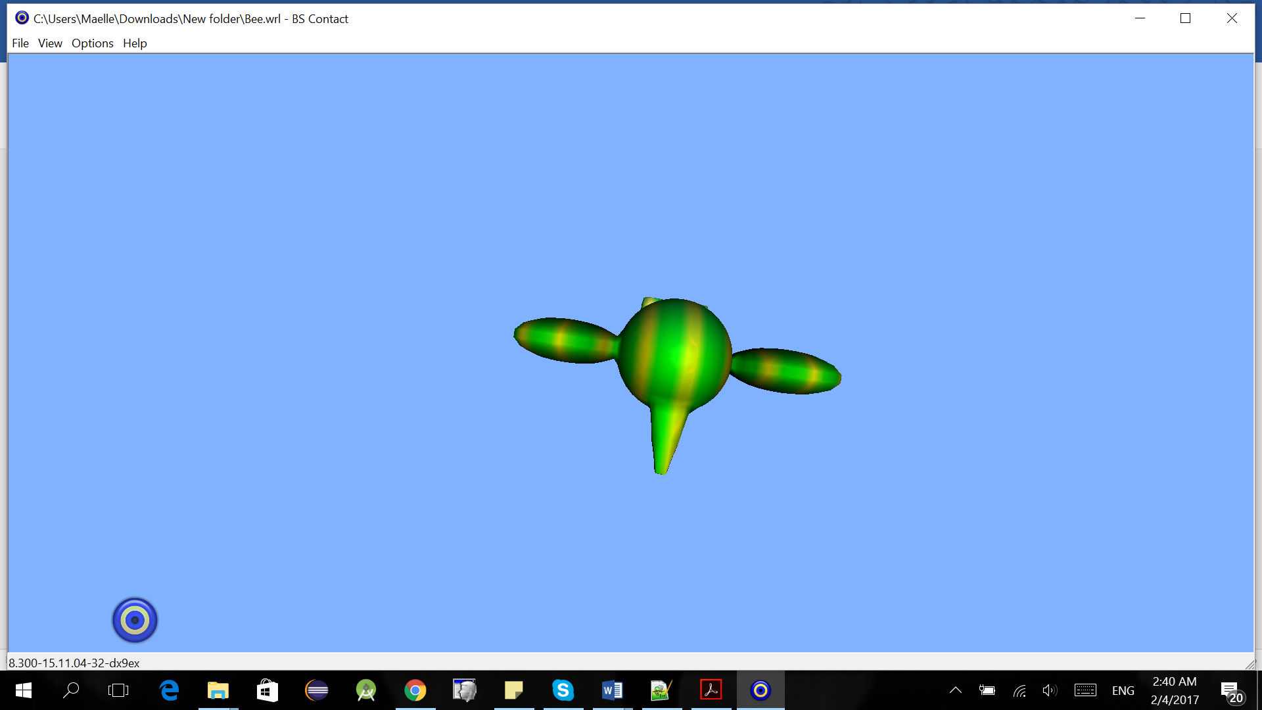 Bottom View

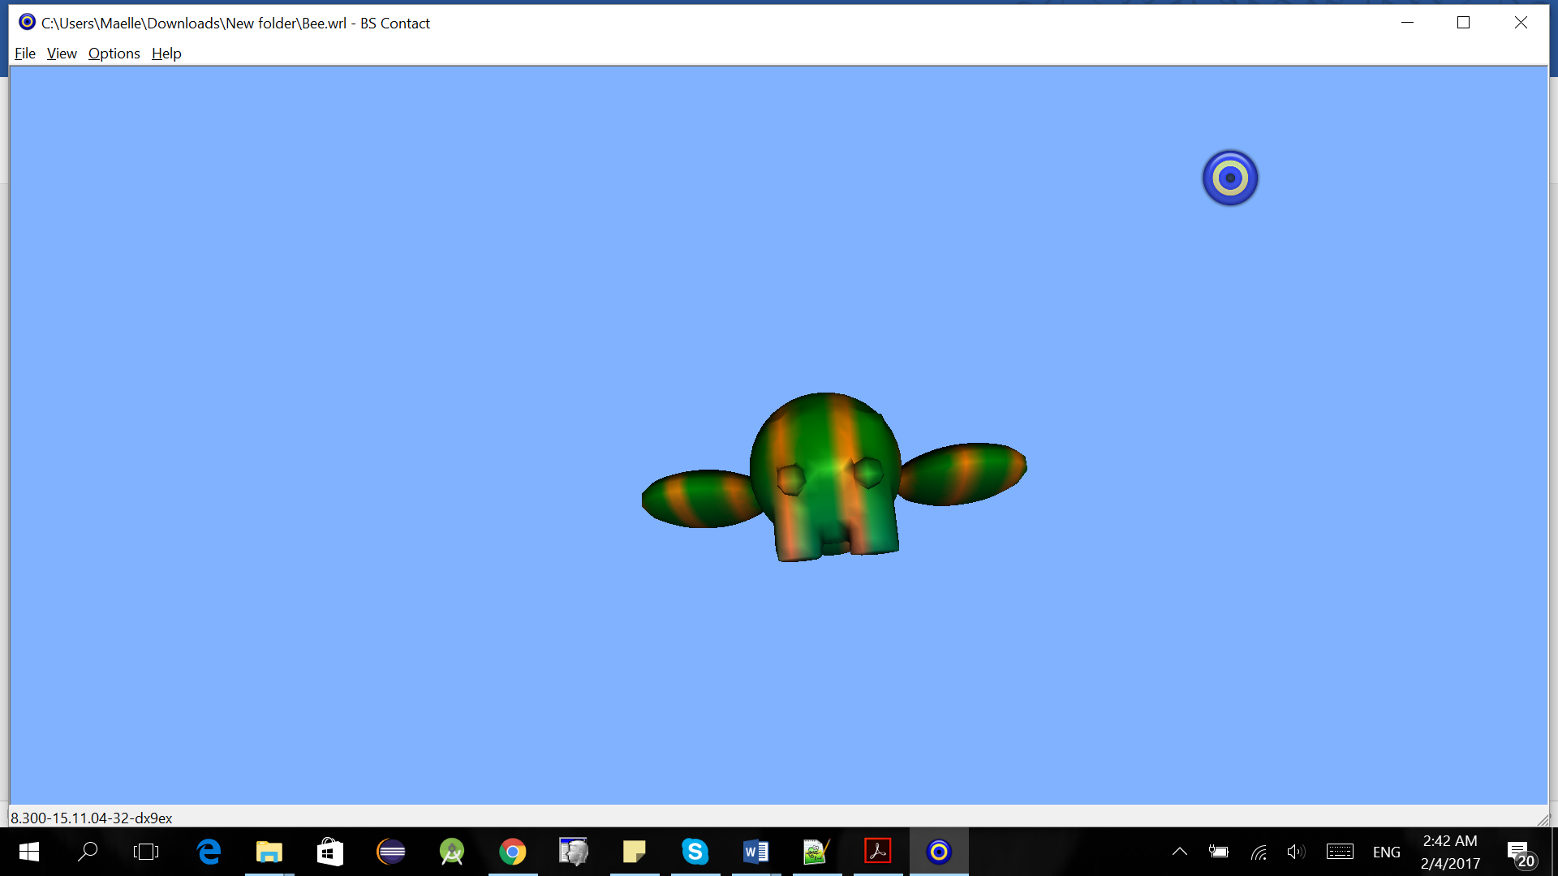 Top View