|  |
| --- |
| Nanyang Technological University |
| Lab 5 Report: Parametric Metamorphoses |
| CZ2003 Computer Graphics |

Done by: Fang Ran (U1521819L)

Class: SSP4

Formula_number_1 = 4

From Lab Manual:

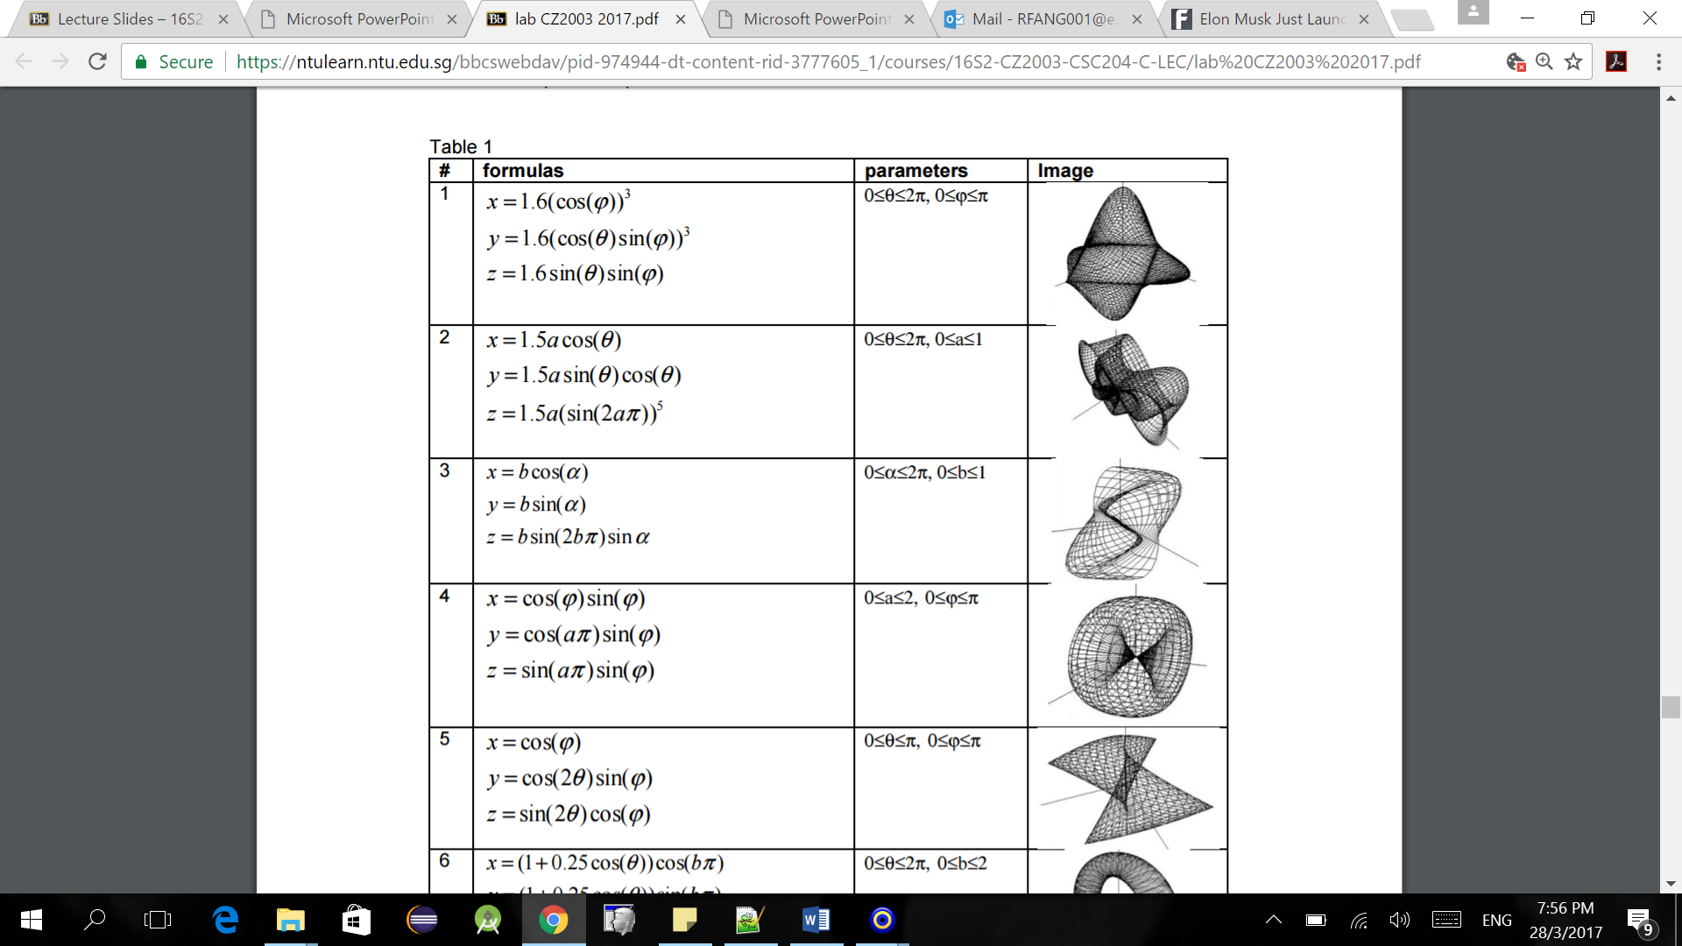

Formula_number_2 = 8

From Lab Manual:

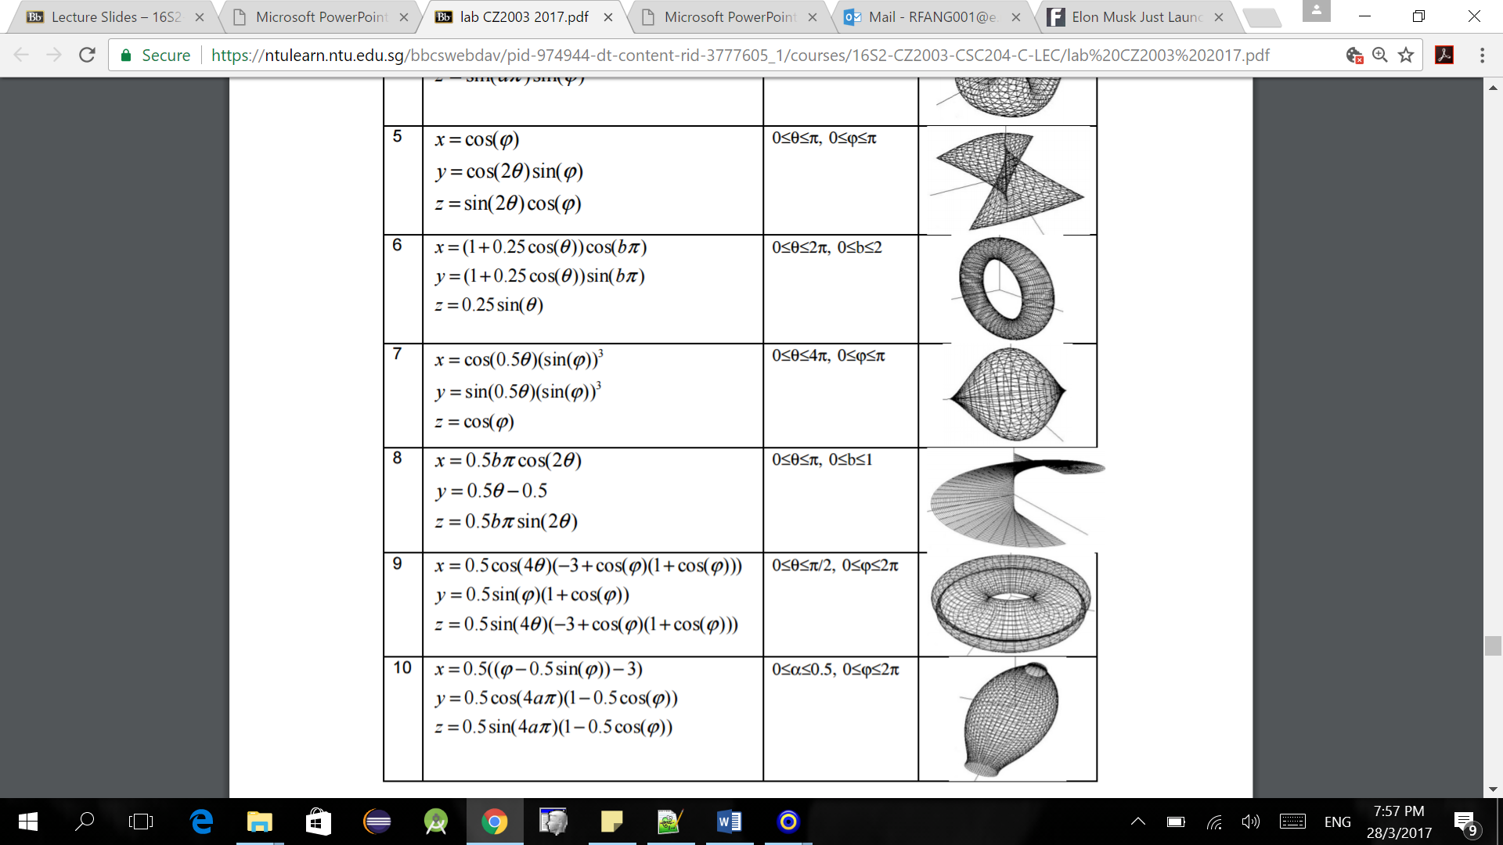

|  |  |  |
| --- | --- | --- |
| **Shape/ Figure** | **Screenshot** | **Comments** |
| Solid (This is figure 4 from the lab manual) |  | definition "  x=cos(u*pi) * sin(u*pi);  y=cos(v*pi*pi) * sin(u*pi);  z=sin(v*pi*pi) * sin(u*pi);"  To ensure that both parameters u and v starts from 0 and ends at 1, the definition was changed from the one defined in the lab manual to the one shown here.  Here are three screenshots of the same figure viewed from different angles. |
| solidA (This is figure 8 from the lab manual) |  | definition "x=0.5*v*pi*cos(2*u*pi);  y=(0.5*u*pi) - 0.5;  z=0.5*v*pi*sin(2*u*pi);"  To ensure that both parameters u and v starts from 0 and ends at 1, the definition was changed from the one defined in the lab manual to the one shown here.  Here are three screenshots of the same figure viewed from different angles. |
| morphing | Before morphing starts:    Before the morphing starts (another angle):        After morphing: | This is the required morphing from Figure 4 to Figure 8.  definition "  function parametric_x(u,v,w,t)  { x1=cos(u*pi) * sin(u*pi);  x2=0.5*v*pi*cos(2*u*pi);  return x1+(x2-x1)*t; }  function parametric_y(u,v,w,t)  { y1=cos(v*pi*pi) * sin(u*pi);  y2=(0.5*u*pi) - 0.5;  return y1+(y2-y1)*t; }  function parametric_z(u,v,w,t)  { z1=sin(v*pi*pi) * sin(u*pi);  z2=0.5*v*pi*sin(2*u*pi);  return z1+(z2-z1)*t; }" |
| morphingA  (Something extra for fun) |  | Over here I try to create a ripple-like effect by using figure 21 and then adding the time variable into the y parametric definition.  definition "x=1.5*(2*u-1);  y=0.15*sin(5*sqrt(((4*u - 2)^2) + ((4*v - 2)^2))*(**1-t)**);  z=1.5*(2*v-1);" |