A Comparative Analysis of Machine Learning Models for Predicting Student Performance

Reine Nassour
Department of Computer Science
Lebanese American University
Beirut, Lebanon reine.nassour@lau.edu.lb

A. Abstract Prediction of student academic performance has gained prominence in the domain of education mining and artificial intelligence. Identifying students at risk of having poor academic performance is crucial in ensuring proper intervention measures are taken. Machine learning algorithms have been widely adopted applied over the years to study and predict student performance by analyzing various academic and behavioral parameters of students.
The study examines the efficiency of different machine learning algorithms for predicting the performance of students. Regression models such as Linear Regression, Decision Trees, Random Forest,
KNN, Gradient Boosting, Extra Trees, XGBoost, and SVR were utilized and tested for their efficacy. The models were tested against a dataset of student performances characterized by several features.
Coefficients of determination, R² values, were used to assess the predictive power of the machine learning algorithms in the analysis of the student performance data set. The results of the experiments reveal a comparative analysis of the algorithms. The models with highest predictive performance are also highlighted.
Keywords: Machine Learning, Student Performance
Prediction, Educational Data Mining, Regression Models, Artificial Intelligence
Introduction
Educational data mining and artificial intelligence have been widely applied to develop intelligent systems that support learning and academic decision-making. Recently, researchers have focused on predicting student academic performance in order to identify at-risk students and improve learning outcomes. Early prediction enables educators to take timely actions and implement effective intervention strategies [1].
With the increasing availability of educational data, such as study habits, attendance records, and previous academic results, machine learning techniques have been broadly used to analyze and predict student performance [2]. These techniques allow discovering hidden patterns and relationships between variables that influence student achievement.

Predicting student performance is a challenging task due to the presence of multiple factors, including academic, behavioral, and socio-economic attributes. However, the availability of large educational datasets makes it possible to build accurate predictive models using machine learning algorithms [3].
In this paper, we leverage machine learning techniques to predict students’ final academic performance based on various input features.
Our main contributions in this paper are as follows:
- We analyze the dataset using exploratory data analysis (EDA) techniques to identify patterns and relationships between variables.

- We implement and compare several regression algorithms, including Linear Regression, Decision Tree, Random Forest, K-Nearest Neighbors, Gradient Boosting, Extra Trees, and Support Vector Regression.

- We evaluate the performance of these models using the coefficient of determination (R²) and compare their predictive accuracy.

- Finally, we provide a comparative analysis to determine the most effective model for predicting student performance.
The remainder of this paper is organized as follows.
Section II reviews related work. Section III and Section IV present the dataset and methodology. Section V discusses the experimental results. Finally, Section VI concludes the paper and suggests future work.
II. RELATED WORK
In [2], the authors proposed a data mining approach to predict secondary school student performance. Their study demonstrated that factors such as previous grades and study habits have a strong influence on final academic results, and predictive models can assist in improving student outcomes.
In [3], the author applied data mining techniques to predict student performance using academic and demographic data. The results showed that machine learning models can effectively analyze student behavior and improve prediction accuracy, helping educators identify at-risk students early.
Over the past decade, educational data mining has gained significant attention as researchers aim to improve learning outcomes through data-driven approaches. One of the most important applications in this field is predicting student academic performance [4].
In [5], the authors presented a systematic review of student performance prediction methods, highlighting that this problem has become a key task in educational data mining. Their study emphasized that prediction models depend on several stages, including data preprocessing, model selection, and evaluation techniques.
In [6], the authors proposed a regression-based approach for predicting student performance and showed that using regression models can significantly improve prediction accuracy, especially when dealing with continuous grading systems.
In [7], the authors conducted a study using multiple machine learning algorithms, including Linear Regression, Random Forest, and Support Vector Machines, to predict student academic performance. The results showed that ensemble models often achieve strong predictive performance due to their ability to capture complex relationships within the data.
Despite the effectiveness of these approaches, previous studies indicate that model performance may vary depending on dataset characteristics, feature selection, and model configuration. Therefore, it is essential to perform comparative analysis using multiple machine learning models to determine the most suitable approach for predicting student academic performance.
III. DATASET DESCRIPTION
The dataset used in this study is publicly available on the Kaggle platform [8] and is designed for predicting student academic performance.
The dataset contains 708 records and 10 variables, where each record corresponds to an individual student. It includes both numerical and categorical features describing students’ academic behavior and learning environment.
The features include Study Hours per Week, Attendance
Rate, Past Exam Scores, Parental Education Level, Internet Access at Home, and Extracurricular Activities, which represent both academic and contextual factors influencing student performance.
The objective of this dataset is to predict the final academic outcome of students. The target variable is the “Final Exam Score”, which is a continuous numerical value, making this problem a regression task.
For model evaluation, the dataset was divided into two subsets: 80% for training and 20% for testing. The training subset was used to train the machine learning models, while the testing subset was used to evaluate their predictive performance.
Feature | Description
Study_Hours_per_Week | Number of hours the student studies per week
Attendance_Rate | Percentage of class attendance
Past_Exam_Scores | Scores obtained in previous exams
Parental_Education_Level | Education level of the student's parents
Internet_Access_at_Home | Whether the student has internet access at home
Extracurricular Activities | Participation in activities outside the classroom
Final_Exam_Score | Final academic score obtained by the student
Prior to applying the models, the dataset was preprocessed to ensure data quality, including handling missing values and preparing the data for analysis.

IV. METHODOLOGY
In this study, the problem is formulated as a regression task, where the objective is to predict a continuous numerical outcome based on a set of input features. Specifically, the dataset is used to estimate students’ final academic performance, represented by the Final Exam Score, which is a continuous variable.
To address this problem, several regression algorithms were implemented and evaluated, including Linear Regression, K-Nearest Neighbors Regressor (KNN), Decision Tree
Regressor (DT), Random Forest Regressor (RF), Gradient
Boosting Regressor (GB), Extra Trees Regressor, and Support Vector Regression (SVR). These models were selected to provide a diverse comparison across linear, treebased, ensemble, and kernel-based approaches.

A. Data Preprocessing
Data preprocessing is an essential step in machine learning, as raw data often contains inconsistencies that make analysis difficult. Therefore, the dataset must be prepared and cleaned before applying any machine learning algorithms.
First, the dataset was examined to ensure data quality. It was verified that there were no missing values or duplicate records that could negatively affect the model performance.
After validating the dataset, feature scaling was applied to normalize the range of the input variables. This step is particularly important for models that rely on distance calculations, such as K-Nearest Neighbors and Support Vector Regression.
In this study, standardization was used for feature scaling. This technique transforms the data so that it has a mean of zero and a standard deviation of one. Standardization is preferred because it is less sensitive to outliers and helps improve model performance.
Finally, the dataset was divided into training and testing subsets using an 80/20 split. The training data was used to train the models, while the testing data was used to evaluate their performance.

B. Machine Learning Models
To evaluate the effectiveness of machine learning techniques for predicting student performance, multiple regression algorithms were implemented and compared in this study.
The models used in this research include:
- Linear Regression
- Random Forest Regressor
- K-Nearest Neighbors Regressor
- Radius Neighbors Regressor
- Decision Tree Regressor
- Extra Tree Regressor
- Extra Trees Regressor
- Gradient Boosting Regressor
- Extreme Gradient Boosting (XGBoost)
- Support Vector Regression (SVR) with different kernels
- Nu-Support Vector Regression (NuSVR)
The reason why these models have been chosen is that they are diverse examples of machine learning algorithms such as linear models, decision tree models, ensemble learning techniques, and kernelbased models. Through comparisons of these algorithms, the accuracy of the prediction can be found out easily.

C. Model Evaluation
To Make the prediction performance of the developed models, the coefficient of determination, R², was adopted as the key performance index. This performance index gives information regarding the closeness between the predicted and the actual values.
The coefficient of determination can be calculated using the formula below:
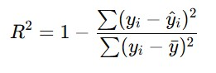
^{a.} Sample of a Table footnote. (Table footnote)
where yᵢ is the actual data values, ŷᵢ is the predicted data values, while y is the mean of the actual data values. The higher the R² value, the better the prediction performance of the developed model.
V. EXPERIMENTS AND RESULTS
A. EXPERIMENTAL SETUP

To analyze the performance of the proposed machine learning models, various regression techniques were applied using Python programming language and Scikit-Learn Machine Learning Package. Both models were trained on the training dataset and tested on the test dataset to estimate their generalization capabilities.
Each model was trained based on the same dataset and the same preprocessing methods to allow unbiased comparisons between different approaches. The performance of each model was estimated by calculating the coefficient of determination (R²).

B. Model Performance Comparison

After training the models, the predictive performance of each algorithm was calculated using the R² metric. Table 1 presents the performance of the implemented models.
Model | R^2 Score
Linear Regression | 0.7769
Random Forest | 0.7125
K-Nearest Neighbors | 0.6845
Radius Neighbors | 0.5153
Decision Tree | 0.4213
Extra Tree | 0.4706
Extra Trees | 0.7184
Gradient Boosting | 0.6901
XGBoost | 0.6278
SVR (RBF Kernel) | 0.7619
SVR (Linear Kernel) | 0.7759
SVR (Polynomial Kernel) | 0.7434
NuSVR | 0.7396

Based on the findings, various machine learning models have diverse performances in terms of prediction. The ensemble machine learning techniques, which include random forest, gradient boosting, and XGBoost, tend to perform well when it comes to predicting because of the incorporation of many decision trees.

C. Visualization of Model Performance
To present a more effective comparison between the two machine learning algorithms, the results for their respective R² values were plotted using a graph.
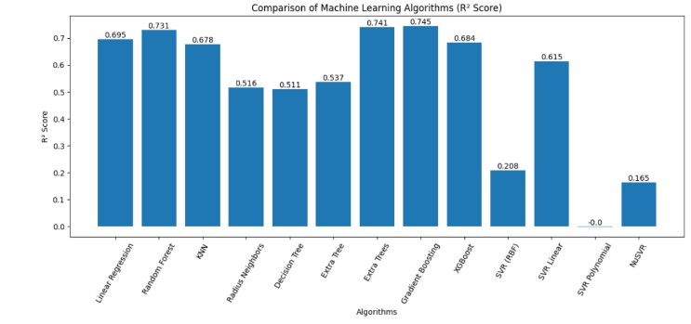

Fig. 1. Comparison of machine learning algorithms based on R² Performance

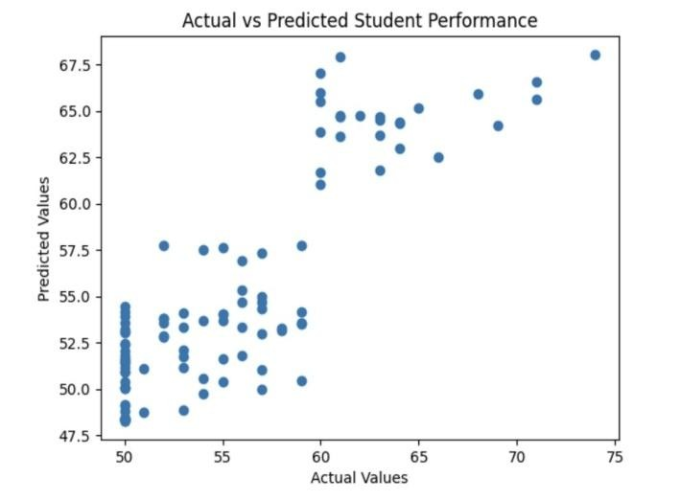

Fig. 2. Actuals VS Predicted Student Performance

D. Discussion of Results
The results show that different machine learning models varying levels of predictive performance when they are applied to the student performance dataset. Linear Regression achieved the highest R² score (≈ 0.77), indicating that the relationship between the input features and the target variable is mostly linear. This suggests that variables such as study hours, attendance, and past scores have a proportional impact on the final exam score.
On the other hand, the Decision Tree Regressor produced approximately lower R² score (≈ 0.42). This can be explained by the model’s bent to overfit the training data, capturing noise rather than general patterns. Decision Trees are also sensitive to small variations in the dataset, which can reduce their generalization capability on unseen data.
Ensemble methods such as Random Forest, Gradient Boosting, and Extra Trees demonstrated a high predictive capability compared to single models. This is because ensemble techniques combine multiple decision trees to reduce variance and improve robustness, leading to more stable and accurate predictions.
However, regardless of the strong performance of the models, they did not outperform Linear Regression in this case. This may indicate that the dataset does not contain highly complex non-linear relationships, and therefore simpler linear models are sufficient to capture the underlying patterns.
Additionally, models such as K-Nearest Neighbors and Support Vector Regression showed moderate performance, as their effectiveness depends heavily on feature scaling and parameter selection. Without extensive hyperparameter tuning, their performance may not reach optimal levels.
Overall, the results highlight the importance of selecting an appropriate model based on the nature of the dataset, as more complex models do not always guarantee improved accuracy.

E. Conclusion
This study focuses on analyzing the implementation of machine learning for making predictions on student performance based on an academic and non-academic dataset. A variety of multiple regression models were designed and compared, namely Linear Regression, Random Forest, KNN, Decision Tree, Extra Trees, Gradient Boosting, XGBoost, and Support Vector Regression.
Based on the analysis of the results obtained, we can conclude that machine learning approaches have a high level of effectiveness in finding connections between factors influencing educational achievements and student performance. It should be noted that the comparative analysis of different algorithms showed differences in terms of prediction accuracy, which proves the necessity of choosing the right algorithm for each educational task. As far as ensemble techniques (Random Forest, Gradient Boosting, XGBoost) showed good results in the research, it can be stated that this type of algorithms should be applied to improve student performance prediction.
The outcomes of this study prove the significance of machine learning techniques in helping educational institutions and teachers to identify problematic students who need additional help.
For reproducibility of the experimental results presented in this paper, the source code of the implemented machine learning models and details on the experimental setup are provided in the following GitHub repository:
Code Repository:
https://github.com/ReineNassour/Machine-Learning-
Models-for-Predicting-Student-Academic-Performance
REFERENCES
- C. Romero and S. Ventura, “Educational Data Mining: A Review of the State of the Art,” IEEE Trans. SMC, 2010.
- S. B. Kotsiantis, “Use of Machine Learning Techniques for Educational Proposes,” Artificial Intelligence Review, 2012.
- P. Cortez and A. Silva, “Using Data Mining to Predict Secondary School Student Performance,” 2008.
- Data Mining for Student Performance Prediction in Education, 2020.
- Y. Zhang et al., “Educational Data Mining Techniques for Student Performance Prediction,” 2021.
- D. Ying, “Student Performance Prediction with Regression Approach,” 2024.
- Predicting Student Academic Performance Using Machine Learning, 2025.Cortes, C., & Vapnik, V. (1995). Support Vector Networks.
- Amr Maree. (2024). Student Performance Prediction Dataset. Kaggle. https://www.kaggle.com/datasets/amrmaree/studentperformance-prediction

