Book My Call Out

FM Botes 27139433

R Miller 26097338

CMPG 212

2019/05/18

Contents

1. Introduction 3

2. How the system works 3

3. Screenshots 3

4. Source Code: 8

5. What we learned 20

6. References 20

# 1. Introduction

Book My Call Out is a web application that we designed that has the functionality of a ticket booking system. We especially use it to book call outs for a service providing company. The front-end is done with HTML, Bootstrap and .css tags to add responsiveness ( for mobile browsers ) and style to our web application. The back-end is done in Asp.net.

# 2. How the system works

First of all to be able to use our service you must first be registered as a user. After you successfully registered you will be able to book a ticket. The ticket consist of a TicketID that is unique for each ticket booked. As a user you will be further able to view your Active Tickets as well as you Ticket History. As a user you will also be able to cancel a current Active ticket. Admin functionality allows the admin to log into a “admin panel”. What this admin panel does is it allows the admin to see all active tickets of all the users. The users will not be able to see the Active tickets of other users as the admins is the only ones that has this privaledge.

# 3. Screenshots

**Home Page:**

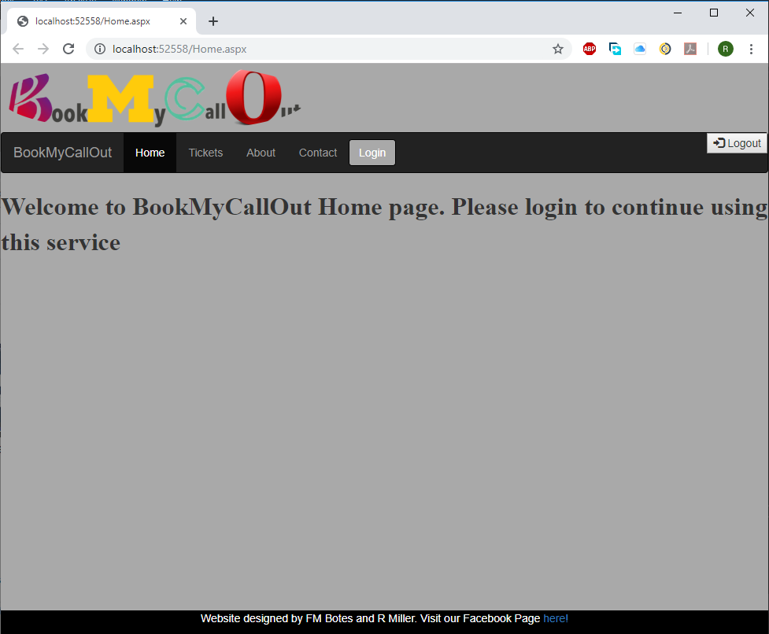

**Login Model:**

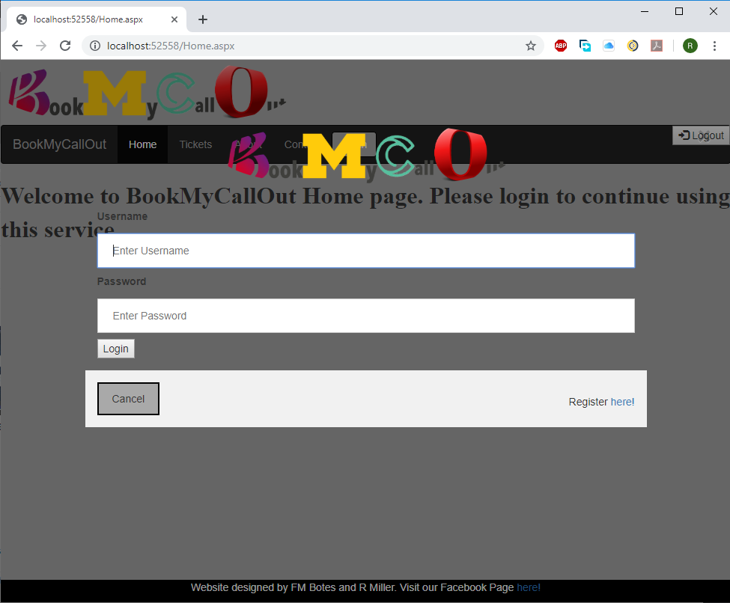

**Register Page:**

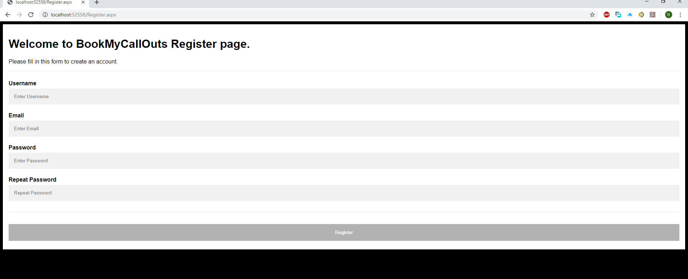

**Tickets Page:**

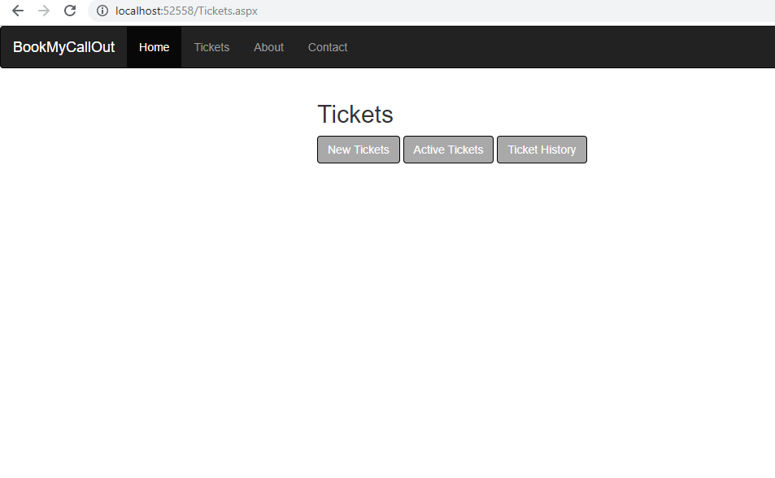

**New Tickets:**

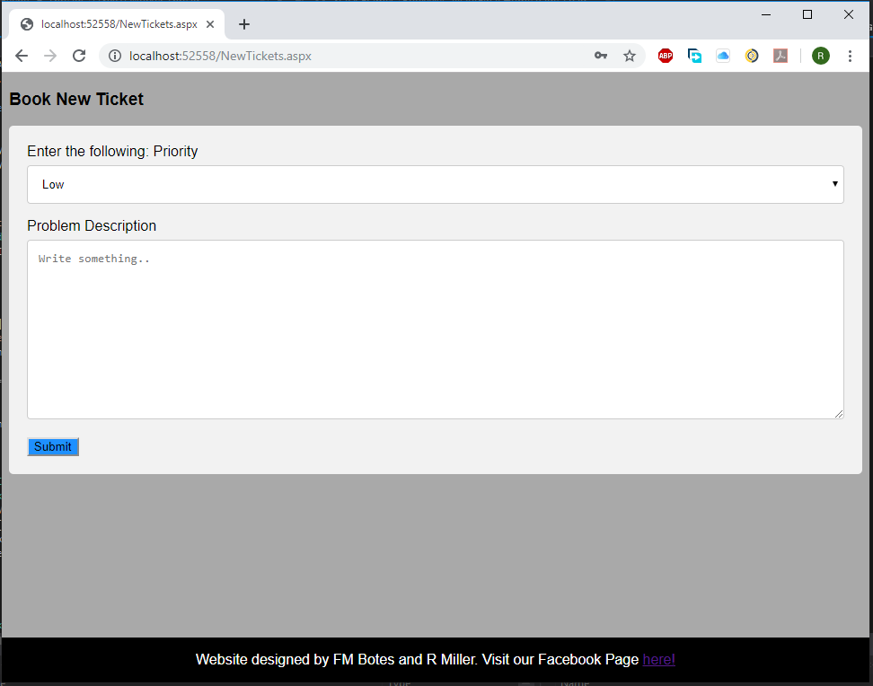

**Active Tickets (for Admin):**

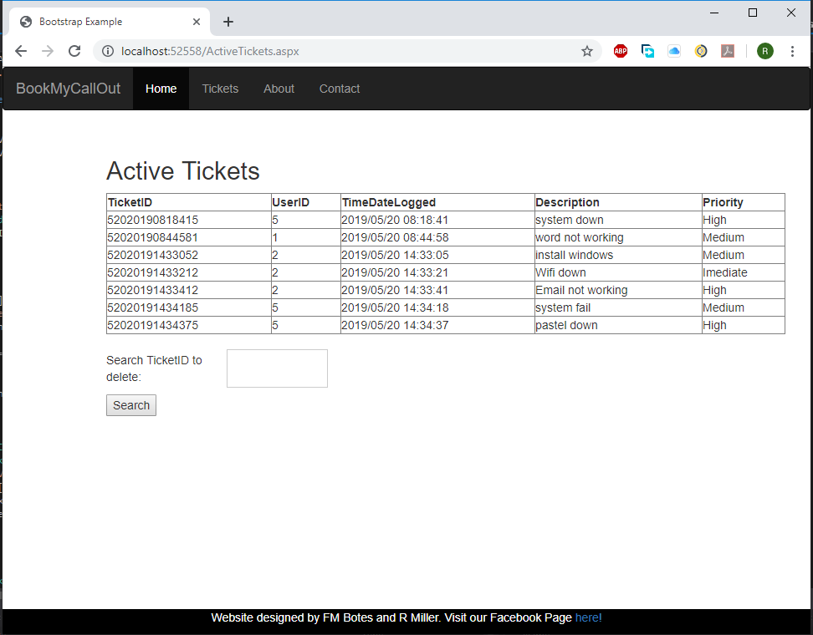

**Active Tickets ( for a User ):**

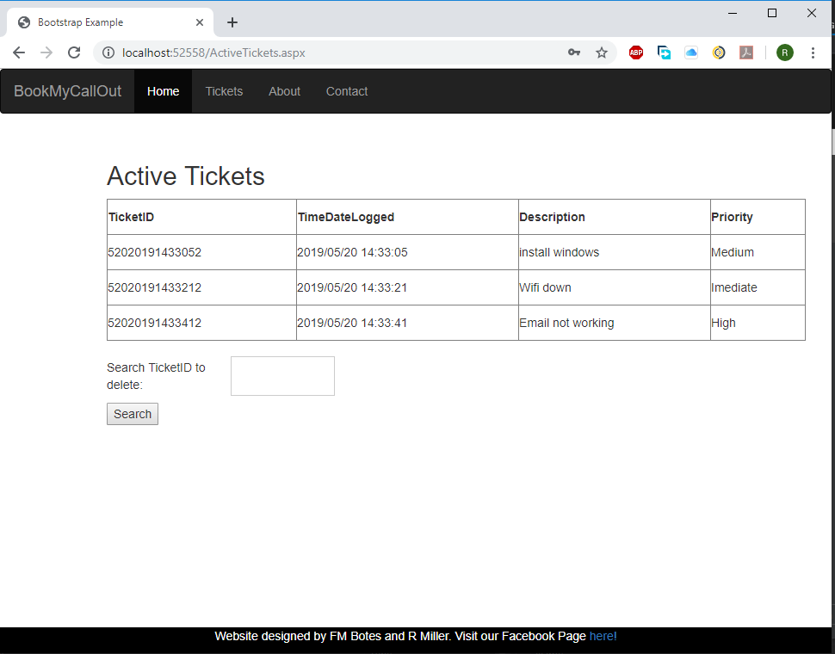

**Ticket History:**

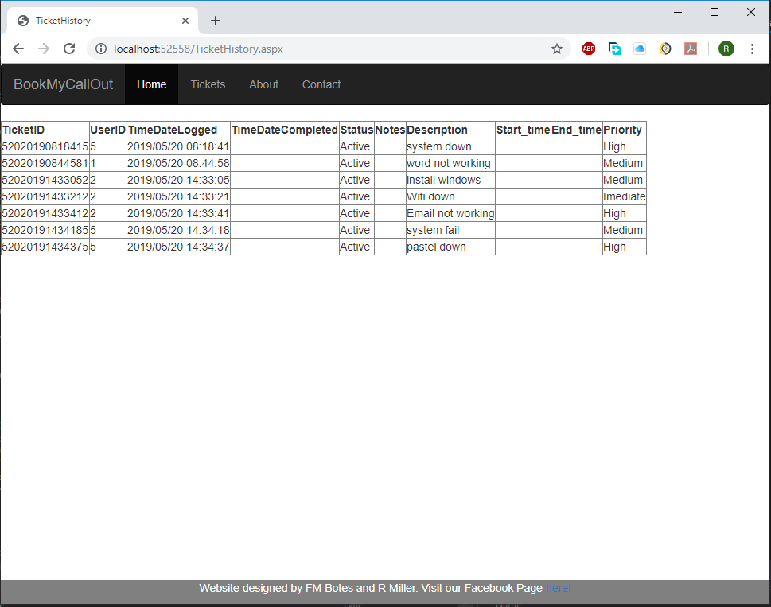

# 4. Source Code:

**Home:**

using System;

using System.Collections.Generic;

using System.Linq;

using System.Web;

using System.Web.UI;

using System.Web.UI.WebControls;

using System.Data.SqlClient;

using System.Data;

namespace BookMyCallOutFinal

{

public partial class Home : System.Web.UI.Page

{

protected void Page_Load(object sender, EventArgs e)

{

// Label1.Text = "Welcome to BookMyCallOut Home page. Please login to continue using this service";

if (Session["UserID"] != null)

{

loginBtn2.Style.Add("visibility", "hidden");

Label1.Text = "Welcome " + Session["Username"].ToString() + " to BookMyCallOut. You will now be able to use the Tickets Service!! " + Session["cookieSup"];

}

else

{

Label1.Text = "Welcome to BookMyCallOut Home page. Please login to continue using this service";

}

/* if (Convert.ToInt32(Session["UserID"]) > 0)

{

string id = Session["UserID"].ToString();

int inkr;

HttpCookie hits = Request.Cookies[id];

//int len = koekies.Count;

if (hits != null)

{

inkr = Convert.ToInt32(hits["Val"]) + 1;

HttpCookie koek1 = new HttpCookie(id);

koek1["Val"] = inkr.ToString();

Label1.Text = Label1.Text + "and you have visited this site " + hits["Val"].ToString() + " times.";

koek1.Expires = DateTime.Now.AddMonths(1);

Response.Cookies.Add(koek1);

}

else

{

int tel = 2;

HttpCookie hits1 = new HttpCookie(id);

hits1["Val"] = tel.ToString();

Label1.Text = Label1.Text + "and you have visited this site " + hits1["Val"].ToString() + " times.";

hits1.Expires = DateTime.Now.AddMonths(1);

Response.Cookies.Add(hits1);

}

}*/

}

SqlConnection conn = new SqlConnection(@"Data Source=(LocalDB)\MSSQLLocalDB;AttachDbFilename=C:\Users\mille\source\repos\BookLNjvUhA1HFHkvo5cxPGPKQbjVZurQQS83tZNsCGGda\BookMy.mdf;Integrated Security=True");

SqlCommand cmd;

protected void Logout1(object sender, EventArgs e)

{

Session.Contents.RemoveAll();

Response.Redirect("Home.aspx");

}

protected void BtnLogin(object sender, EventArgs e)

{

int id1;

string user = textUser.Value.ToString(); ;

string pass = textPass.Value.ToString();

try

{

conn.Open();

string sql = "Select Id from Users where UserName = '" + user + "' and PassWord ='" + pass + "'";

cmd = new SqlCommand(sql, conn);

int id = Convert.ToInt32(cmd.ExecuteScalar());

id1 = id;

if (id > 0)

{

Session["UserID"] = id;

Session["Username"] = user;

if (Convert.ToInt32(Session["UserID"]) > 0)

{

string id2 = Session["UserID"].ToString();

int inkr;

HttpCookie hits = Request.Cookies[id2];

//int len = koekies.Count;

if (hits != null)

{

inkr = Convert.ToInt32(hits["Val"]) + 1;

HttpCookie koek1 = new HttpCookie(id2);

koek1["Val"] = inkr.ToString();

Session["cookieSup"] = "and you have visited this site " + hits["Val"].ToString() + " times.";

koek1.Expires = DateTime.Now.AddMonths(1);

Response.Cookies.Add(koek1);

}

else

{

int tel = 2;

HttpCookie hits1 = new HttpCookie(id2);

hits1["Val"] = tel.ToString();

Session["cookieSup"] = "and you have visited this site " + hits1["Val"].ToString() + " times.";

hits1.Expires = DateTime.Now.AddMonths(1);

Response.Cookies.Add(hits1);

}

//Response.Redirect(Request.Url.ToString());

Response.Redirect("Home.aspx");

}

//Label1.Text = "Welcome " + Session["Username"].ToString() + " to BookMyCallOut. You will now be able to use the Tickets Service!! ";

}

else

{

Label1.Text = "Login failled, Username or Password is incorrect!!!";

//errorLabel.InnerText = "Username or password is incorrect!";

textPass.Value = null;

textUser.Value = null;

}

}

catch (SqlException err)

{

Response.Write(err.Message);

}

}

}

}

**Tickets:**

using System;

using System.Collections.Generic;

using System.Linq;

using System.Web;

using System.Web.UI;

using System.Web.UI.WebControls;

namespace BookMyCallOutFinal

{

public partial class Tickets : System.Web.UI.Page

{

protected void Page_Load(object sender, EventArgs e)

{

if (Session["UserID"] == null)

{

Response.Redirect("NotLoggedIn.aspx");

}

}

protected void NewTickets(object sender, EventArgs e)

{

Response.Redirect("NewTickets.aspx");

}

protected void ActiveTickets(object sender, EventArgs e)

{

Response.Redirect("ActiveTickets.aspx");

}

protected void TicketHistory(object sender, EventArgs e)

{

Response.Redirect("TicketHistory.aspx");

}

protected void Logout1(object sender, EventArgs e)

{

Session.Contents.RemoveAll();

Response.Redirect("Home.aspx");

}

}

}

**New Ticket:**

using System;

using System.Collections.Generic;

using System.Linq;

using System.Web;

using System.Web.UI;

using System.Web.UI.WebControls;

using System.Data;

using System.Data.SqlClient;

namespace BookMyCallOutFinal

{

public partial class NewTickets : System.Web.UI.Page

{

protected void Page_Load(object sender, EventArgs e)

{

}

SqlConnection conn = new SqlConnection(@"Data Source=(LocalDB)\MSSQLLocalDB;AttachDbFilename=C:\Users\mille\source\repos\BookLNjvUhA1HFHkvo5cxPGPKQbjVZurQQS83tZNsCGGda\BookMy.mdf;Integrated Security=True");

SqlCommand cmd;

protected void Submits(object sender, EventArgs e)

{

Label1.Text = "test";

Session["TicketLogged"] = DateTime.Now.ToString();

Session["TicketID"] = (DateTime.Now.ToString("MMddyyyyHHmmss") + Session["UserID"]).ToString();

Session["Description"] = problemDescription.Value ;

string sql = "insert into Tickets(TicketID,UserId,TimeDateLogged,Status,Description,Priority) values (@TicketID,@UserId,@TimeDateLogged,@Status,@Description,@Priority)";

cmd = new SqlCommand(sql, conn);

//Session["TicketID"] = ((int)Session["TicketID"]);

long ticketId = Convert.ToInt64(Session["TicketID"].ToString());

int userID = Convert.ToInt32(Session["UserId"].ToString());

cmd.Parameters.AddWithValue("@TicketID", ticketId);

cmd.Parameters.AddWithValue("@UserID", userID);

cmd.Parameters.AddWithValue("@TimeDateLogged", Session["TicketLogged"]);

cmd.Parameters.AddWithValue("@Status", "Active");

cmd.Parameters.AddWithValue("@Description", Session["Description"].ToString());

cmd.Parameters.AddWithValue("@Priority", priority.Value);

try

{

conn.Open();

cmd.ExecuteNonQuery();

Response.Redirect("ActiveTickets.aspx");

conn.Close();

}

catch (SqlException err)

{

Response.Write(err.Message);

}

}

}

}

**Active Tickets:**

using System;

using System.Collections.Generic;

using System.Linq;

using System.Web;

using System.Web.UI;

using System.Web.UI.WebControls;

using System.Data;

using System.Data.SqlClient;

namespace BookMyCallOutFinal

{

public partial class AvtiveTickets : System.Web.UI.Page

{

SqlConnection conn = new SqlConnection(@"Data Source=(LocalDB)\MSSQLLocalDB;AttachDbFilename=C:\Users\mille\source\repos\BookLNjvUhA1HFHkvo5cxPGPKQbjVZurQQS83tZNsCGGda\BookMy.mdf;Integrated Security=True");

SqlDataAdapter adap;

DataSet ds;

protected void Page_Load(object sender, EventArgs e)

{try

{

if (Session["UserID"].ToString() == "1")

{

string sql;

conn.Open();

sql = "select TicketID, UserID, TimeDateLogged, Description, Priority from Tickets where Status ='Active'";

SqlCommand cmd = new SqlCommand(sql, conn);

adap = new SqlDataAdapter();

ds = new DataSet();

cmd = new SqlCommand(sql, conn);

adap.SelectCommand = cmd;

adap.Fill(ds);

GridView1.DataSource = ds;

GridView1.DataBind();

conn.Close();

}

else

{

conn.Open();

string sql = "select TicketID, TimeDateLogged, Description, Priority from Tickets where UserID ='" + Session["UserID"].ToString() + "' and Status ='Active'";

SqlCommand cmd = new SqlCommand(sql, conn);

adap = new SqlDataAdapter();

ds = new DataSet();

cmd = new SqlCommand(sql, conn);

adap.SelectCommand = cmd;

adap.Fill(ds);

GridView1.DataSource = ds;

GridView1.DataBind();

conn.Close();

}

}

catch (SqlException err)

{

Response.Write(err.Message);

}

}

protected void GridView1_SelectedIndexChanged(object sender, EventArgs e)

{

//Panel1.Visible = true;

// GridViewRow gr = GridView1.SelectedRow;

// Session["SelectedTickID"] = gr.Cells[1].Text;

// string sql = "Delete * From Tickets Where TicketID = '" + Session["SelectedTickID"].ToString() + "'";

// Label1.Text = "Selected ticket ID: " + Session["SelectedTickID"].ToString();

}

protected void Button1_Click(object sender, EventArgs e)

{

try

{

string sql;

conn.Open();

sql = "DELETE FROM Tickets WHERE TicketID = '" + Label2.Text + "'";

SqlCommand cmd = new SqlCommand(sql, conn);

adap.DeleteCommand = cmd;

adap.DeleteCommand.ExecuteNonQuery();

if (Session["UserID"].ToString() == "1")

{

sql = "select TicketID, UserID, TimeDateLogged, Description, Priority from Tickets where Status ='Active'";

}

else

{

sql = "select TicketID, TimeDateLogged, Description, Priority from Tickets where UserID ='" + Session["UserID"].ToString() + "' and Status ='Active'";

}

adap = new SqlDataAdapter();

ds = new DataSet();

cmd = new SqlCommand(sql, conn);

adap.SelectCommand = cmd;

adap.Fill(ds);

GridView1.DataSource = ds;

GridView1.DataBind();

conn.Close();

this.Response.Redirect("ActiveTickets.aspx");

}

catch (SqlException err)

{

Response.Write(err.Message);

}

}

protected void Button2_Click(object sender, EventArgs e)

{

Panel1.Visible = true;

}

protected void Button2_Click1(object sender, EventArgs e)

{

try

{

if (TextBox1.Text != null)

{

string sql;

if (Session["UserID"].ToString() == "1")

{

sql = "Select TicketID From Tickets where TicketID like '" + TextBox1.Text + "' or Description like '" + TextBox1.Text + "' or Priority like '" + TextBox1.Text + "'";

}

else

{

sql = "Select TicketID From Tickets where UserID = '" + Session["UserID"].ToString() + "' and (Description = '" + TextBox1.Text + "' or Priority like '" + TextBox1.Text + "')";

}

conn.Open();

SqlCommand cmd = new SqlCommand(sql, conn);

cmd = new SqlCommand(sql, conn);

double id = Convert.ToInt64(cmd.ExecuteScalar());

if (id <= 0)

{

Label3.Text = "Error";

Label2.Text = "ID not found";

}

else

{

Label3.Text = "Delete ticket with ID: ";

Label2.Text = id.ToString();

Button1.Visible = true;

Button2.Visible = false;

}

}

}

catch (SqlException err)

{

Response.Write(err.Message);

}

}

}

}

# 5. What we learned

FM Botes:

Being the one more responsible for the front-end I learned a lot new things regarding HTML, CSS, Bootstrap and Script. I mainly used HTML do design the web pages and the Css to style them. I used Bootstrap to make our website responsive to mobile browsers. Working alongside my partners I also learned about the back-end side and the asp.net environment.

R Miller:

Being the one more responsible for the back-end I learned a lot more in-depth about using asp.net with normal buttons, objects and css but also referencing and using bootstrap related objects and getting a better grasp of the asp.net way of programming. I also learn a lot more about html, css and bootstrap and how it all comes together while working with my partner on the front end as well.

# 6. References

W3 Schools: [www.w3schools.com](http://www.w3schools.com)

Stack Overflow: [www.stackoverflow.com](http://www.stackoverflow.com)

C-sharp Corner: [www.s-sharpcorner.com](http://www.s-sharpcorner.com)