# *Introduction*

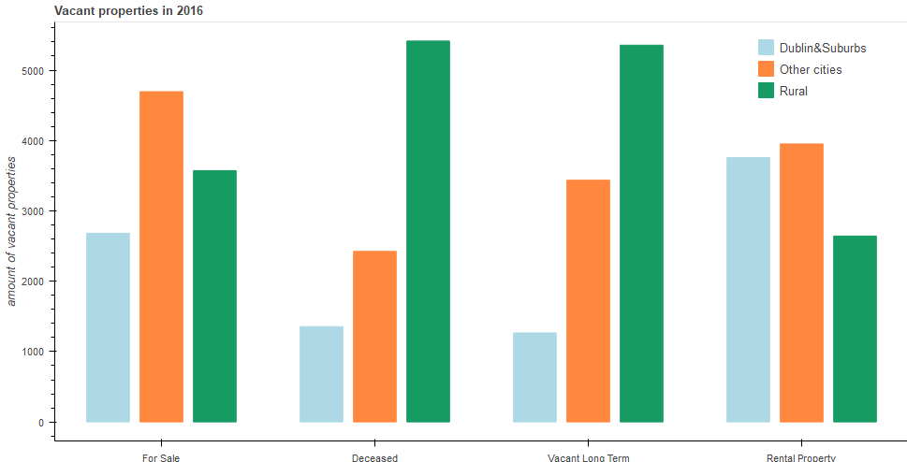The housing market in Ireland has been facing very distinct curves in the past two decades along with a big recession that reached its peak in 2008 to a descending curve since, by 2013 the housing market started to reverse to a positive growth, although this positive variance has not been strong enough to solve the crisis as the analyses has shown, yet this is not a real portrait of the issue, as a majority of the tenants are not officially registered in The Private Tenancies Board(PRTB). From the analyses of the Census of 2016 the CSO has concluded that there are 2.48 people per private property in Dublin City, although news as “Fifteen people sharing one room in house with 70 tenants” in Dublin City from the Independent.ie in 2017 are actually not as alarming.

As it is a market the analyses and visualization will be divided between supply and demand using Python 3 with Jupyter Notebook, pandas, numpy, Bokeh, Matplotlib, Seaborm among others to find insights to support a solution to the issue.

## *Analyses*

## *Supply*

## *House Stock*

The CSO has been providing an extensive amount of data of the house stock in Ireland from the insights taken of Census in over two decades.

The house stock in Ireland had a consistent growth until to 2011 when it shift to a very passive period, in contrast Dublin had a low growth throughout the years.

***Vacant properties***

The number of vacant properties in Ireland grew 85.7% from 2002 to 2006 to a negative growth of 15.2% from 2011 to 2016.

In 2016 12.25% of the house stock was vacant, from those vacant properties 47.85% were rural, the long term properties and the deceased properties reached over 5,000 vacant properties each, and from an urban perspective it shifts to a majority of properties for sale or rent, 22.84%. Proportionally Dublin had a considerable amount of vacant properties for rental compared to the rest of the country, when you consider that Dublin had 26.5% of the properties in Ireland in 2016, despite of this amount Dublin had nearly half of the properties for sale in market in 2016. These numbers shift to a negative growth as the housing market had significant growth of existing properties registered in the new transactions.

***Properties Transactions***

The overall number of transactions of properties in Ireland had a variance of 190% from 2010 to 2018.

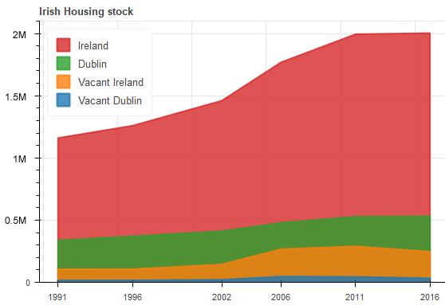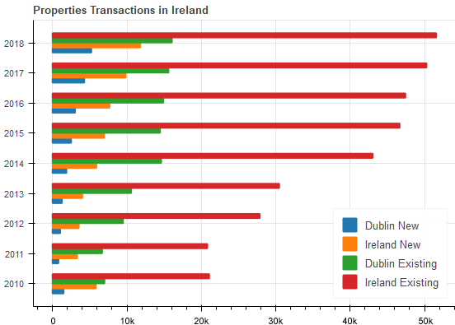

The existing house transactions had a variance of 216.9%, as there were still a considerable number of vacant properties available in the market, while the transactions of new properties variance was not as prominent with 54.6%.

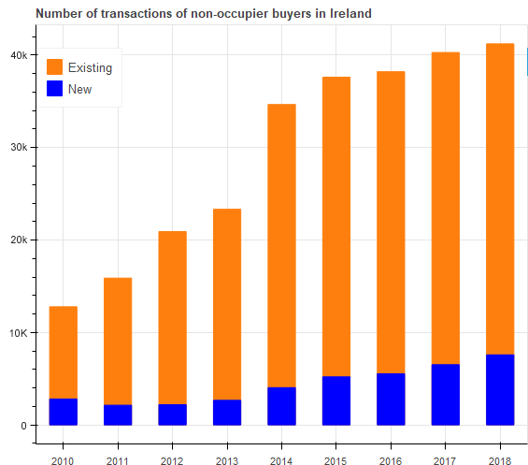Dublin did follow a different path with a variance of 284.7% for new properties transactions and 162.9% for existing properties, mostly reflexes of a saturated housing market.

***New properties registered***

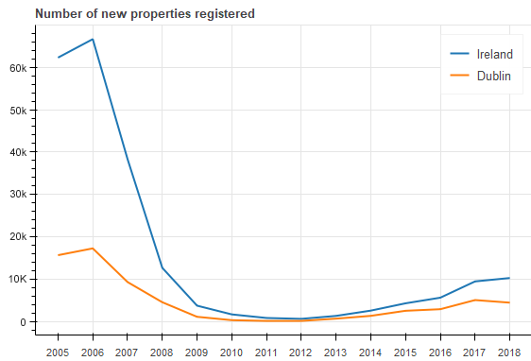The Irish housing market has been troubling since the recession to reach a sustainable growth, as the chart below verifies.

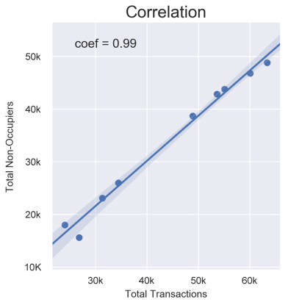In 2011 Dublin had only 140 new properties registered reaching its lowest point since from the data available, while Ireland reached its lowest point in 2012 with only 627 new properties registered. There was no significant variance until 2016 when the government along with other bodies launched numerous projects with possible “solutions”.

***New non-occupier buyers***

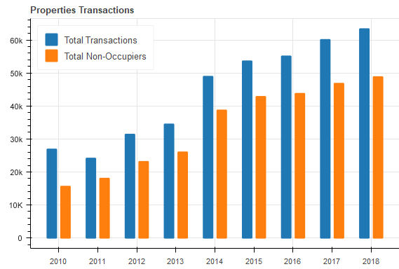

Another relevant insight this dataset provides is the high correlation between new and existing properties transactions.

There are various articles published that stressed the growth of cash-only sales in Ireland, although there is not enough data available to verify this tendency, despite that the CSO also provided data on the number of buyers that are non-occupier, non-householder or former owner occupier(2nd mortgage) throughout the years, i.e., those are utilizing the housing market as an investment and influencing the rental and sales prices to increase. UN has sent a letter to the Irish government describing the situation as *“moderately unaffordable”.*

The number of non-occupier buyers in fact propelled the Irish Housing Market, with a high deviation from 2013 with 8478 transactions to 12799 in 2014(50.7%).

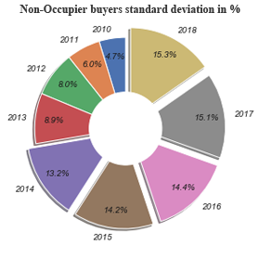In the chart on the right is noticeable how the standard deviation has a consistent growth that is more accentuated from 2014 onwards, these buyers are more focused in the existing properties, that will mostly be redesigned to accommodate more people, which will allow those investments to be capitalized in a shorter time. The total of transactions registered and the total of non-occupier transactions registered had a strong correlation between them, as the correlation chart on the left verifies, which supports the fact that those investments are inflating the housing market.

## *Demand*

***Population***

The CSO using data from Census 2016 produced a dataset of the Irish population by counties. In 2016 Ireland had a population of 4,761,865 people. With panda's groupby, Bokeh and GeoJson(GIS), it is possible to visualize how the Irish population is divided, and the most density populated areas. Dublin had 1,461 people per km2, and consisted 28.3% of the Irish population in 2106, while comprising only 1.09% of the country's territory, followed by Cork with 11.4% of the country's population although with a demographic density of 72.4 people per km2.

***Population by age and gender***

The proportions between genders in Ireland were very balanced in 2016 with 2,354,428(49.44%) males and 2,407,437(50.56%) females.

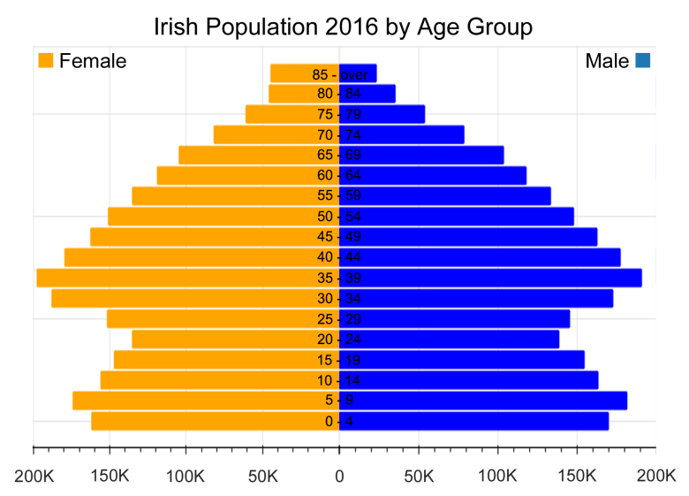

From the age groups perspective people from 30 years old to 44 years old comprised 23.3% of the Irish population; this group was also the majority of the householders (31.68%) in Ireland in 2016.

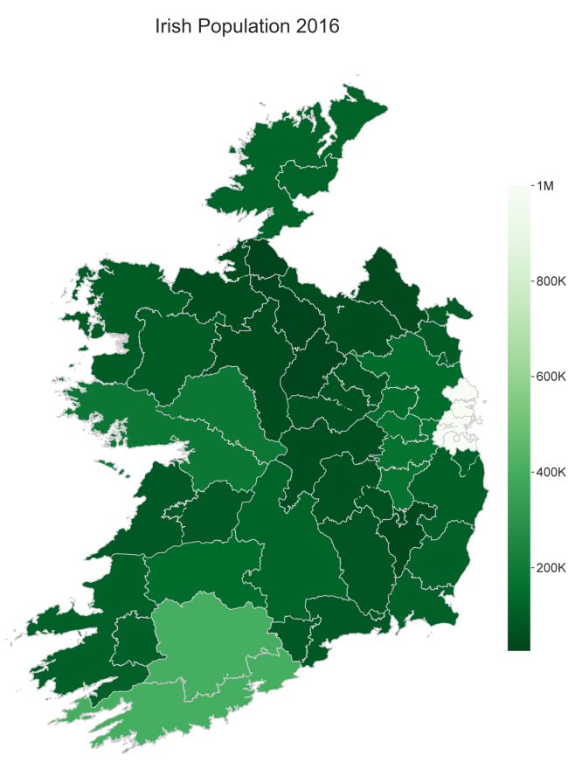Working age population are those from 15 years old to 64 years old, Ireland had 3,104.300(65.5%) of its population in this age range, thus 2,008,482(64.7%) were employed in 2016, according to the CSO.

***Population Growth***

The CSO provided a dataset with the migration net, along with few other relevant data related to the population growth, which allowed a relatively accurate dataset for the population growth in Ireland. 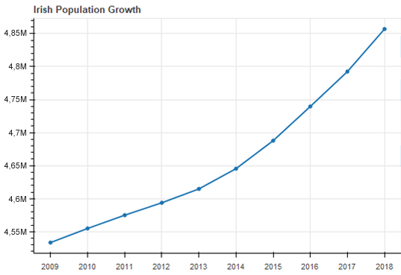

In 2009 the population in Ireland was 4,533,400, numbers that had a consistent growth curve to reach 4,857,000 in 2018, a deviation growth of 7.14%. If the demand is growing in a consistent ascending curve, the ideal would be that the house stock and the social housing would follow the same correlation, from a statistical point of view.

***Natural Increase***

It is the offset between live births and deaths during the year.

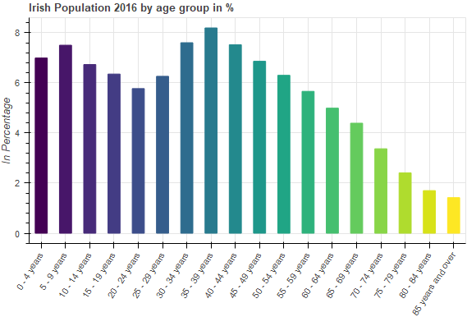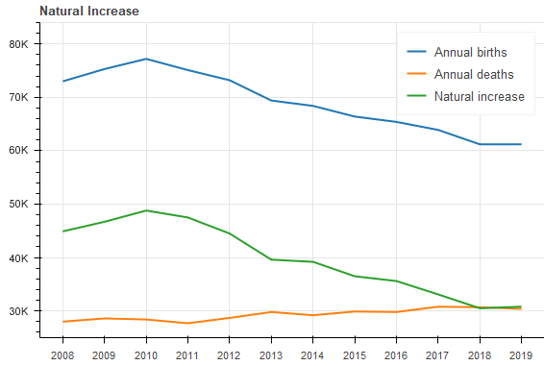

From 2010the number of live births decreased in a consistent curve as crisis's side effect, which seems coherent considering that one of the prerequisites to start or extend a family is financial stability. Note that the natural increase line in the graphic has a descending curve since 2010, despite the population growth in Ireland has an ascending curve, the fact that the number of deaths increased from 2011 and that from 2008 to 2018 the number of live births decreased in 16.2%, made the range gets narrow as the two variables get closer and the outcome is usually smaller, a negative correlation.

***Counties Population Growth Deviation***

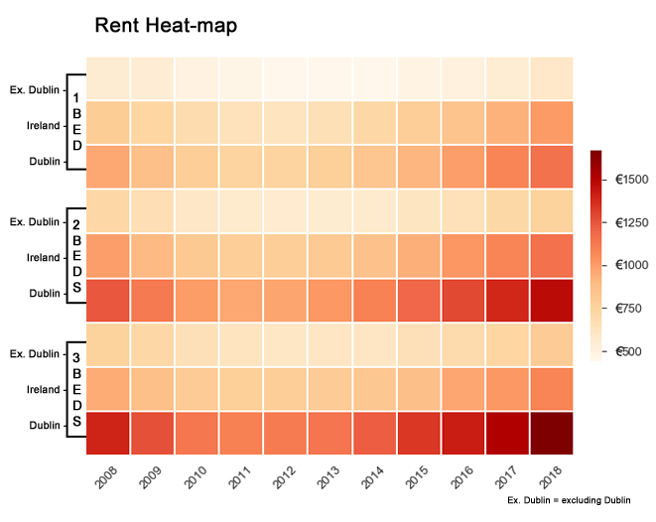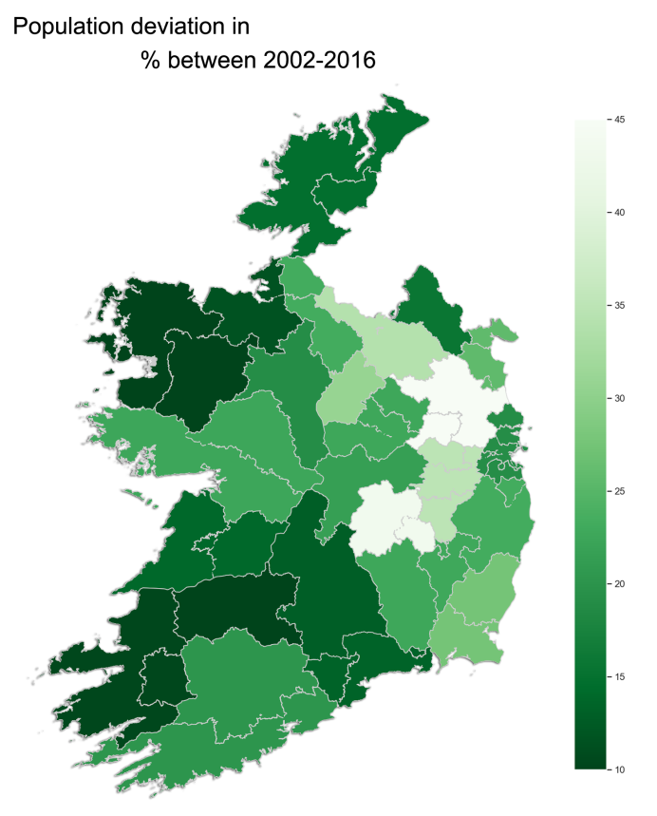In a timeframe of 14 years the population growth deviation were more accentuated in Meath and Laois with both over 40% growth deviation, followed by Kildare, Cavan and Longford all with over 30% growth deviation.

Looking from a geographic point of view it is identifiable how those counties are surrounding the Dublin area with the exception of Longford, those counties comprehends a 100km2 ratio approximately from Dublin, therefore they became satellites towns, as still feasible adding the commuting costs on top of the rent costs, due the high rental costs in the Dublin area.

***Impacts***

To understand the impacts this housing crisis has caused in the socio economic scenario in Ireland, it is necessary to find the correlation between the demand and supply and the social economic implications it has brought upon society thus far.

***Rent Prices***

The average rental prices in Ireland has increased consistently since 2008 according to the CSO datasets, as it is verified in the heat-map chart, which was based in the prices of one, two and three bedrooms properties, the variables are the prices for Ireland excluding Dublin(*Ex. Dublin*), Ireland as overall and only Dublin. It is noticeable how Dublin increases the overall prices significantly, in an average of 11 years for one bedroom properties Ex Dublin was €500.57, while Ireland including Dublin was €765,75, a deviation of 52.98%, deviation that will be even more noticeable when compared between Ireland excluding Dublin and Dublin itself, €500,57 to €987, a deviation of 79.2%, i.e., Dublin is the epicentre of the housing crisis.

The heat-map also demonstrated that the average rental price in Ireland increased 16.94% from 2008 to 2018, stressing that 2008 was the peak of recession.

The excessive increase in the rental prices in Ireland drove the government to create *“The Planning and Development (Housing) and Residential Tenancies Act in 2016”*, which was a measure to cap the increases at 4% per year in Rent Pressure Zones (RPZs), which was enforced from December of 2016, and applied to the highest rent zones and the highest growths zones national wide. Nevertheless the private sector commenced to create short term renting instead to avoid the cap.

The high costs of the housing market generate concerns and also expectations from the authorities, to create measures at minimum as rent freezes, despite that the Taoiseach Leo Varadkar has quoted: “*Rent freezes are not the answer to the massive costs of*[*renting properties*](https://www.irishmirror.ie/all-about/renting)*in Ireland”*, yet the government have not suggested any measure to solve the issue, other than palliative measures thus far the statistics has demonstrated.

***Private House Market***

This dataset from CSO had been explored before in this article, although the focus was in the volume of new transactions registered, in this section the focus is analysing the prices and its variances.

Following the end of the recession the prices for new and existing properties would reach their lowest peaks in 2012 and in 2013 subsequently to shift to an increase since. The average prices in Dublin for new properties and existing properties from 2014 onwards increased similarly, which demonstrate how the housing market in Dublin had been saturate, to an extent that existing properties are as valuable as new properties, i.e., low supply.

Phenomena that went opposite from a national perspective, as the prices for new properties and existing properties in Ireland increased distinctly since 2014.

## *Mortgages*

The Banking & Payments Federation Ireland (BPFI*)* represents over 70 domestic and international institutions, which provides datasets on volume of mortgages approvals, among other datasets. Typically the volume of mortgages can exhibit how healthy is the economy, analogically acting as a thermometer. A higher volume of mortgages approvals would verify that people have more income available.

The volume of mortgage approvals in Ireland though had a sharp decline between 2006 and 2011, a negative deviation of 88.80%, which was a reflex of the previous housing crisis.

From 2011 onward the number of new properties build had a slow growth, hence the low volume of mortgage approvals for new properties since, from the existing properties perspective the number of mortgage approvals have a more substantial growth from 2011 onwards, reflex of the low supply of new properties.

A dataset comprising the overall number of mortgage approvals between 2008 and 2018 demonstrates how the housing market is gradually growing, yet a very low growth from 2014 onwards, with a deviation of 14.92% between 2014 and 2018, mostly driven by the number of mortgage approvals for existing properties.

The Irish government launched from January of 2016 the “Help to Buy Scheme (HTB) that enables eligible first-time buyers to get up to 5% of the purchase price of a new house or apartment back in the form of a tax rebate”. This does not reach a big range of the first-time buyers though, considering that only 18.41% of the properties available in the market in 2016 were new properties. Demonstrating certain inefficiencies in the help provided.

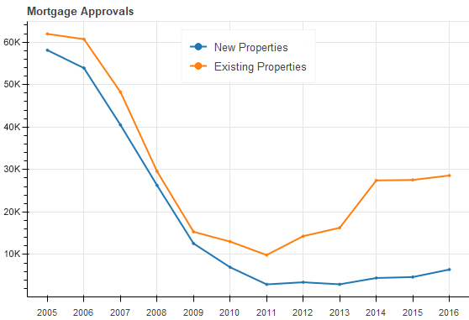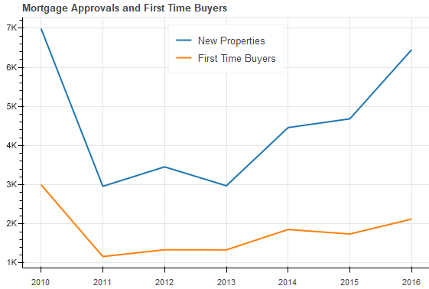

Another dataset provided by the BPFI is the average deposits for mortgages, which demonstrate how the average for deposits has raised since 2012, with a deviation of 99.11% for Dublin, a deviation of 70.90% for Dublin commuter area and a deviation of 68.75% for Nationwide. Numbers that verify how difficult has become to purchase properties in the past years in Ireland, considering that those trying to purchase a property need to deal with the exorbitant rental prices, while attempting to build a disposable income for mortgage deposits, a more difficult scenario for those in Dublin and surrounds mostly. 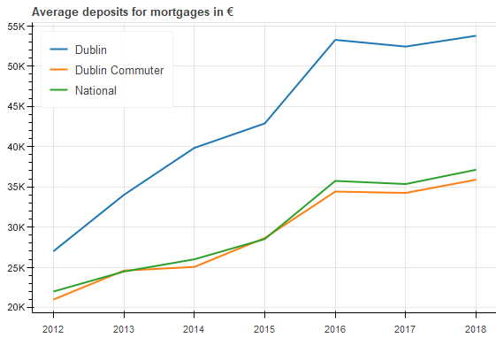

## *Correlations*

Fundamentally to comprehend the relationship and the dependency between quantitative or categorical variables, it is necessary to verify their correlations.

These statistical measures may be negative or positive. In a negative correlation the variables move in opposite directions, while in a positive correlation their move in parallel. To measure the strength of a correlation it is necessary to find the correlation coefficient, which would be the covariance values between the variables divide by their standard deviation. The correlation coefficient will vary from -1 to 1; the strength will be determined by how close the correlation coefficient is from -1, or 1, if it is 0 or near to it, they will be considered a neutral correlation or a week correlation subsequently.

***Rental Prices and Housing Market***

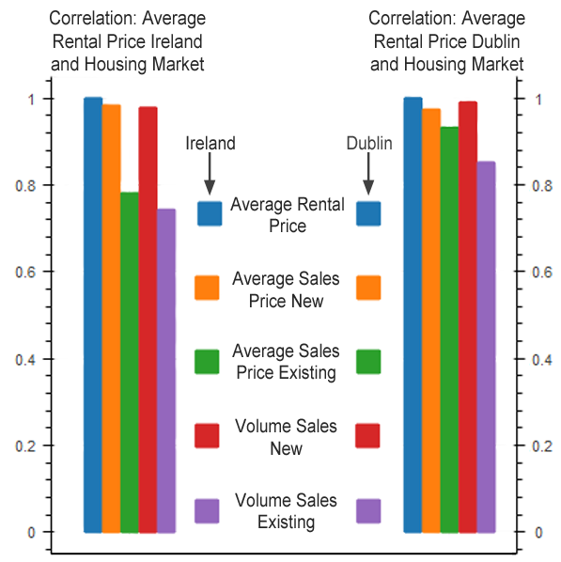In the chart below the correlation between the average rental prices in Ireland and the average rental prices in Dublin, and their correlations with variables of the housing market. As demonstrated in the chart the correlation between the housing market and Dublin are stronger than the housing market and Ireland, as Dublin is the epicentre of the housing crisis, which verifies the housing market influences the rental prices.

A correlation matrix chart using scale and colours makes more evident the relationship between several variables.

The variable *Average Rental Price* for example has a strong relationship with all the other variables in the correlation matrix, with the exception of a negative and weak relationship with *Inflation*. It also verifies that there is a strong relationship between the rental prices and the number of social houses build, which confirms that the social housing has a share in the housing crisis, also that there is a need for the government intervening with housing support programs.

***Social Housing***

This article has been focused in the private housing market until now. As the correlation matrix chart has confirmed the government has its share of responsibility regards the housing crisis.

A picture of the Social Housing scheme would give it a better understanding how this sector has been developing in the past years.

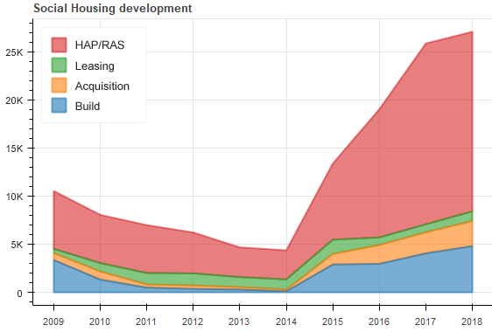

HAP*: ”The Housing Assistance Payment is a form of social housing support for people who have a long-term housing need”.* The HAP will supplement the rent to those whom are qualified for Social Housing and it is based on their income and ability to pay, though this supplement will be paid directly to private landlords.

RAS: *“Rental Accommodation Scheme, it is a social housing support introduced to cater for the accommodation needs of persons who are in receipt of long-term rent supplement”.* RAS was replaced by the HAP since July of 2016.

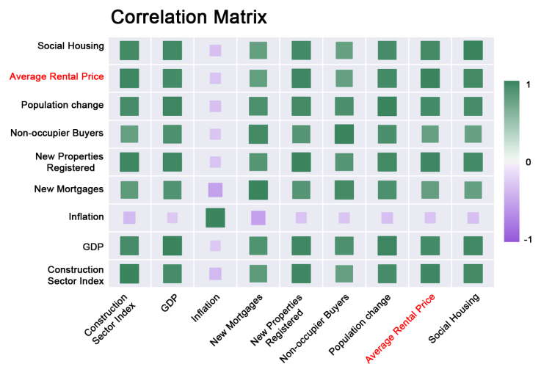Leasing: “*Properties will be leased from the private sector and used to accommodate households from local authority waiting lists”.*

Acquisition: *“It is the acquisition of units from the private market for the purposes of social housing is one of a variety of mechanisms in place to deliver social housing support”.*

Build: It is the number of social housing build.

From middle of 2010 until 2014 the social housing development was almost inactive, to the extent that only 120 social houses were built in 2014, which is the lowest peak since 2005, though from 2015 to 2018 there was a deviation growth of 66.33.

There was also a substantial increase in the HAP/RAS from 2014 to 2018, with a deviation growth of 148.55%. Those growths validate the effort of the Irish Government attempting tackle the housing crisis with the Rebuilding Ireland Plan.

Below a quote from Simon Coveney, T.D. Minister for Housing, Planning, Community and Local Government.

*“Rebuilding Ireland, an Action Plan for Housing and Homelessness, comprises five pillars of concerted actions right across Government – addressing homelessness, accelerating social housing, building more homes, improving the rental sector and utilising existing housing”.*

Nonetheless these measures are not equipped with the right tools to solve the issues, considering that the investments will terminate in the private sector. Initially the HAP was created to be a palliative measure, yet it is utilizing more and more resources, when considering that in 2015 the HAP utilized €15,640,000 thereafter in 2018 the HAP individually has reached €276,600,000, amount that were paid to 43,433 landlords in the private housing sector, a massive deviation of 1630%; this amount of resources could be redirected to the construction of new social housing, instead what was first planned as a palliative measure is gradually turning into a long-term “solution”.

It also exhibits the inability of the authorities to tackle the housing crisis.

## *Homelessness*

The main social reflex of the house crisis is the homelessness; this topic certainly could be extend to a paper itself, although this paper will try to summarize the gravity of it in few charts, along with the measures token thus far toward the issue.

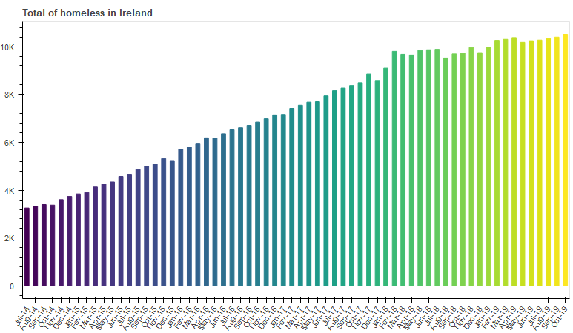The Department of Housing, Planning and Local Government provides several datasets/reports on the homelessness in Ireland, including monthly datasets on the overall number of homelessness nationwide.

From July of 2014 to October 2019 the number of homeless in Ireland raised 222.71%; from 3,258 to 10,514 individuals living on the stress in Ireland, these numbers also comprises children and families.

The Rebuilding Ireland Plan also include measures toward the Homelessness in Ireland, with emergency accommodations such as Hotels, Hubs, HAP scheme for homeless, social houses among others, though the homelessness numbers still increasing, despite of €141 million alone being spent in Dublin in 2018, according to the Dublin financial report for 2018.

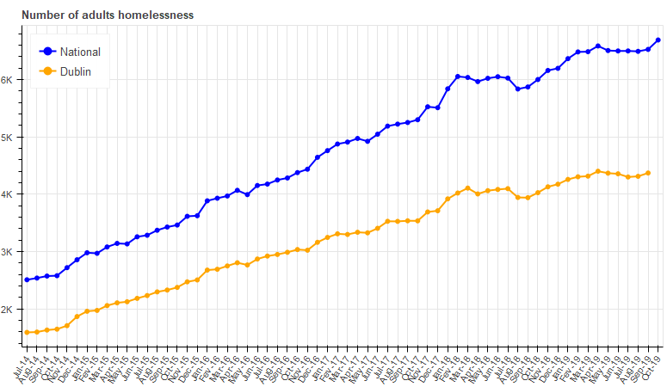Dublin had 63.45% of the total of adult homelessness in July of 2014 and 66.98% of total of adult homelessness in September of 2019, which demonstrates why the government is addressing most of its efforts in the Dublin.

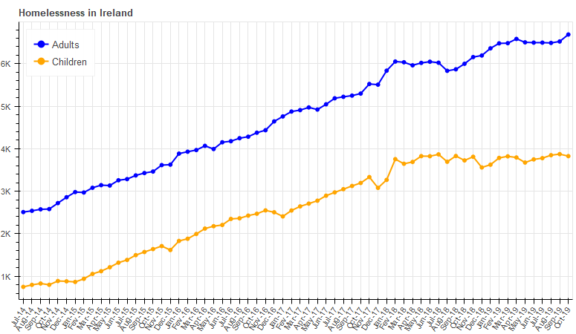

An outrageous 36.39% of the total of homelessness in Ireland was consisted of children in October of 2019. Those children are suffering detrimental effects on their physical, mental and wellbeing development, due the poor conditions of the emergency accommodations. The hubs are the main concern as Ombudsman for Children has reported.

The number of child homelessness is increasing with a strong relationship to the overall numbers of homelessness. There are several non-profits organizations that are trying to fill the gap left by the authorities’ measures toward the homelessness issue, such as Focus Ireland, Dublin Simon Community, Cope Galway, among others, considering that the governmental measures are not being effective.

## *Conclusion*

Since the peak of the recession in 2008, which was a reflex of an easy access to credit from the financial institutions for the housing market, along with a global recession and consequently an inflated housing market, the Irish government other than transferred the debt for the population and supported the financial institutions did not act upon the issue, until the housing market started to demonstrated similar patterns. From 2014 onwards the Irish government launched several measures, though those were/are palliative measures not solutions to the issue, also the fact that some of these expenditures are not being addressed correctly, taking into account that Dublin City Council since 2016 is renting a building for €195,000 a year, intended for homelessness though it has being empty since, according to the Irish Times; which is one among several other misused of resources.

A strong social housing sector is the solution for such a housing market crisis, it is unnecessary to search for miraculous solutions other than appliance and respect toward the population from the authorities. Austria and more specifically Vienna is a great example how a strong social housing sector can make a difference. The social housing sector in Vienna alone represented 47.1% between council housing and subsidized rental in 2011, according to the governmental body the Statistics Austria.

The Vienna council subsidizes 7,000 to 13,000 new affordable housing annually, there is also a *“subsidized Housing renewal and retrofitting: “Soft urban renewal“, to prevent gentrification with 12,900 apartments renewed annually (no rent increase)”,* while the social housing stock in Ireland is known to have poor conditions and several social problems, such as drug addiction, economic disfavour, elevated unemployment, etcetera.

There were a low 13.5% of owner-occupied households in Vienna in 2011 according to the Statistics Austria; in contrast Dublin had 69.7% of its house stock consisted of owner-occupied households according to the CSO.

The chart below demonstrates the disparity of social housing scheme between Ireland/Austria, Dublin/Vienna.

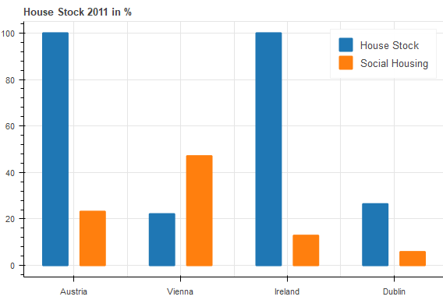

The Austrian house stock had 4,441,408 properties in 2011, which 1,030,851(23.21%) consisted of council houses and subsided rental; the Viennese house stock had 983,840(22.15% of the Austrian house stock) in 2011, which 463,389(47.1%) of its house stock consisted of council houses and subsided rental; in contrast the Irish house stock had 1,994,845 properties in 2011, which 256,848(12.88%) consisted of council houses and subsided rental; the Dublin house stock had 527,665(26.45% of the Irish house stock) in 2011, which 30,933(5,86%) consisted of council houses and subsided rental.

As the data has demonstrated, there is a big contrast between the two countries and their capitals. Such is the disparity between the capitals that once divided the number of social housing available in 2011 for each city by the average persons per households, which was 1.99 persons per household for Vienna and 2.4 persons per household for Dublin, the results were 232,859 for Vienna and 12,889 for Dublin, these would be the number of families that the social housing scheme could accommodate in 2011. Proportionally Vienna’s population is 2.28 times higher than Dublin’s population, however the proportions for number of houses divided by person per households for Vienna was 18.07 times higher than Dublin; to reach a proportional picture between the two cities considering the population and house stock differences between the two cities, by dividing the findings the result is an impressive figure of 7.93, which verifies that Vienna was able to accommodate 7.93 times more families than Dublin in 2011.

The average rent prices in 2018 for Vienna was €1,097, while Dublin average rent prices in 2018 was €2,044, again the disparity between the two cities demonstrates how a proper usage of public resources can create a sustainable housing market.

Based on all those insights and utilizing Vienna as a model, a possible solution will be provided in the next phases of this assignment.

***References***

<https://www.cso.ie/en/index.html>

<https://www.housing.gov.ie/>

<https://www.bpfi.ie/> / <https://data.gov.ie/>

<https://www.inflation.eu/>

<http://www.statistik.at/web_en/statistics/index.html>

<http://www.dublincity.ie/>

<https://www.revenue.ie/en/property/help-to-buy-incentive/index.aspx> / <https://rebuildingireland.ie/>

<https://www.rtb.ie/> / <https://www.focusireland.ie/>

<https://www.dubsimon.ie/>

<https://www.irishtimes.com/>

<https://www.thejournal.ie/>

<https://www.independent.ie/>

<https://www.un.org/en/>

<https://en.wikipedia.org/wiki/Main_Page>

<http://www.oecd.org>

<https://www.statista.com/statistics/503274/average-rental-cost-apartment-europe/>

<http://docs.bokeh.org/en/1.3.2/index.html>

<https://seaborn.pydata.org/>

<https://matplotlib.org/>

<https://numpy.org/>

<https://pandas.pydata.org/>

<https://towardsdatascience.com/>

<https://stackoverflow.com/>