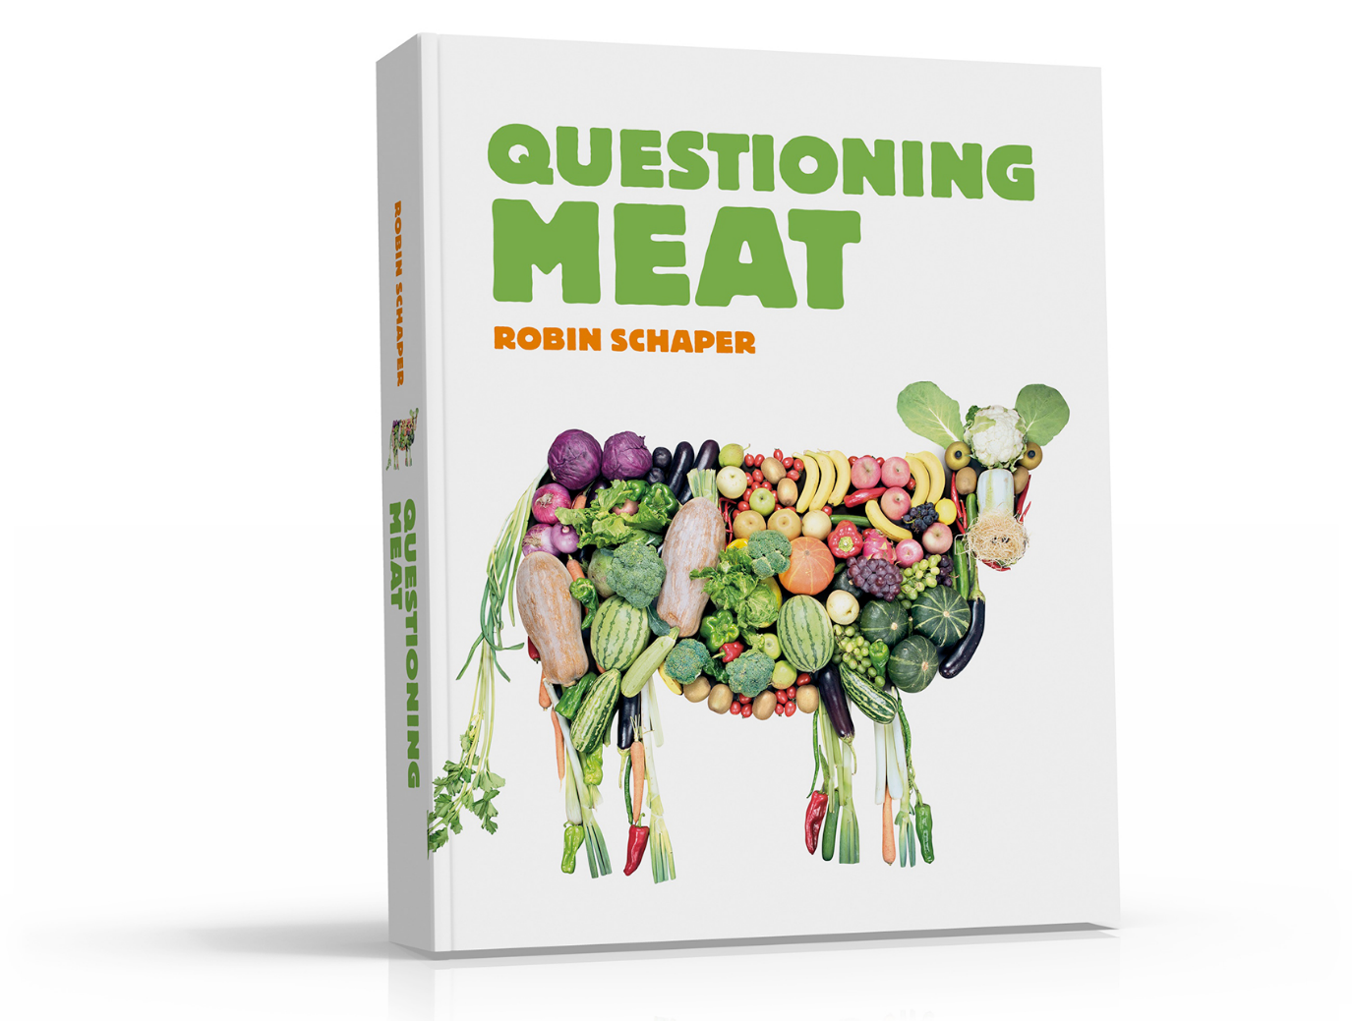Do you love meat and want to keep eating it? Are you skeptical of arguments against it? But are you still driven by curiosity and interested in having your ideas challenged? Then this free ebook is perfect for you!

**Download now**



Questioning Meat is written by Robin Schaper. He is an expert on the topic and bases his book on extensive scientific research. The book also contains 28 amazing recipes, developed by Cindy Albers.