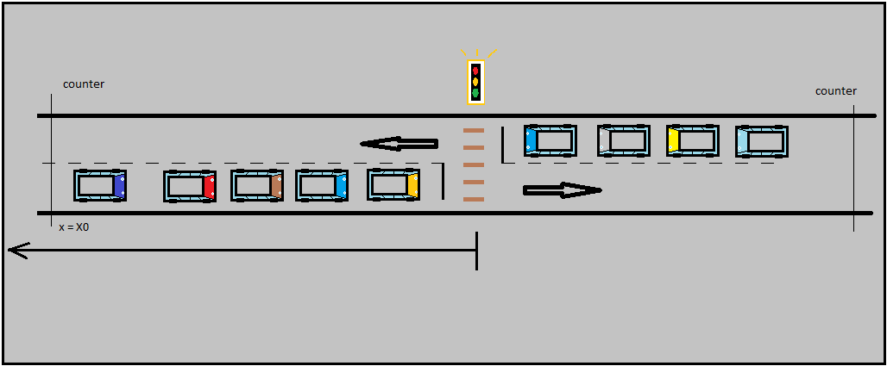

Parameters:

* X0 : control distance

Objects :

* Vehicle
* Traffic light
* Counter

1. Vehicles move forward when green is on and tolerance
2. Vehicles stop when red is on and no tolerance exist