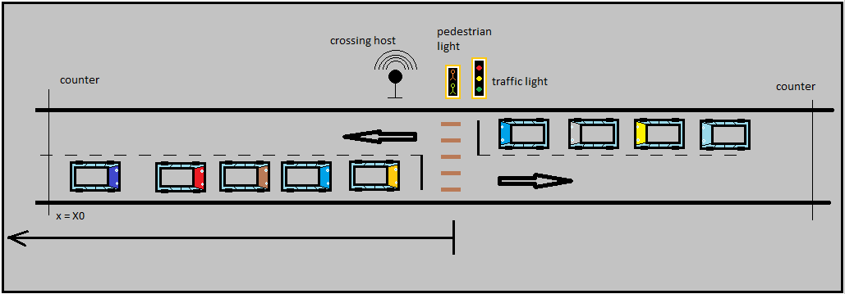
Objects on wifi :
- Vehicles
Objects on Can :
- Traffic light
- Pedestrian light
- Counter
- Crossing host (Schedular)
- Pedestrian button

- Vehicles move forward when green is on and tolerance
- Vehicles stop when red is on and no tolerance exist

Parameters:
- X0 : control distance

vehicle

Process Modell Architecture

couter-1
counter-2
traffic light
Pedestrian button

can bus

. . . . .
vehicle

vehicle

vehicle

vehicle

. . .
Scheduler
wifi
GPS
SATELITE

