CSDA 6010 Analytics Practicum
Software Mailing Analytics
Reishekesh Reddy Inavola
Data Analytics, Webster University
Prof. Dr. Willie Rivers
22nd October 2025

Table of Contents:
- Introduction………………………………………………………………. 2
- Business Problem and Goals……………………………………………… 4
- Analytical goals and Approaches: ……………………………………….. 5
- Data Exploration and Preprocessing……………………………………... 6
- Data Understanding………………………………………………. 6
- Attribute Definitions………………………………………………. 7
- Missing Data and Zero Value Handling…………………………. 9
- Data Exploration Analysis ………………………………………… 9
- Correlation of variables …………………………………………… 14
- Predictor analysis and relevancy………………………………………….. 15
- Dimension Reduction ……………………………………………………… 18
- Data Engineering and Transformation……………………………………. 19
- Data Partition …………………………………………………………….. 19
- Model Selection ………………………………………………………………. 20
- Model fitting and test accuracy……………………………………………… 22
- Models’ performance………………………………………………………… 25
- Model evaluation…………………………………………………………….. 27
- Observation and conclusion………………………………………………… 28

Software Mailing Analytics

Executive Summary

The North-Point Direct Mail Marketing Project is the quest of searching more efficient means of reaching customers, as well as, maximizing the worth of the marketing campaign investment by utilizing data-driven analytics. North-Point was recording very low response of just 5.3 and was incurring a lot of useless dollars when it comes to mailing to the wrong customers. Therefore, North-Point shall use classification and clustering model to select the potential buyers and segment them into buyer groups on the basis of their behaviour. We will set the balanced sample of 2,000 customers with the help of which we will apply Decision Tree and Random Forest models to predict the probability of whether the customers will purchase them or not, with the end result being 83.5% and 83.25 as the overall accuracy rates. The Random Forest model was the most sensitive (91.5%) and had a high enough rate of precision (78.5%) that measured his effectiveness in determining the true buyers. Besides, Decision Tree provided more convenience of interpretation, which is relative in the context of practical and actionable decision-making. Regarding the factors that must be taken into consideration in determining the customer response, frequency, source, and recency were the factors that were determined to be the most critical. These aspects will result in more refined marketing strategies that will prove valuable to the marketing investment of North-Point.

Segmentation of customers through the means of Hierarchical Clustering and K-Means yielded more information about behavioural insights. The three groups of K-Means give clear direction on the marketing planning: inactive customers; the average involved customers; and the valuable repeat buyers. Discounts or trial offers, loyalty programs to retain high-value customers, and custom deals to higher-mid tier customers are some of the actions to reactivate dormant customers. The combination of these methods enables North-Point to radically transition away a wide, costly approach to a narrow, return on investment-oriented approaches. It is anticipated that the data-based approach of this project will raise the response rate to 5.3 to a minimum of 8, raise the rate of return on the investment by 20 percent, and raise the overall sale by 15 percent, justifying more viable budgetary expenditure, better relations with clients, and competitive advantage in the long run.

Project Introduction
North-Point is a software company that sells educational software and games through proprietary and third-party programs. The company joined a consortium where the software and hardware companies share the customer mailing lists, and hence the company expand the scope of clientele and set better direct marketing goals. This allows North-Point to test specific marketing strategies and refine the marketing mails through the provision of its own customer base; it can access to a pool database of more than five million names.

The test mailing of the project was based on a stratified sample of 20,000 names of the consortium pool, 1,065 transactions were received in the experiment, which is equivalent to a response rate of 5.3 percent. In the modelling, the samples with equal classes were balanced, 1000 purchases and 1000 non-purchases were selected in each class, ensuring predictive models are trained on equal class size. This enables more robust model development, with subsequent adjustment of predicted probabilities to reflect the true response rate in the broader population.
The risk of low response rates and the waste of resources without significant returns can be minimized with the help of classification models, North-Point will be able to spend less and gain more advantages of the investments made because its probability of response identification will be more accurate and unwarranted mailings will be decreased. Whereas the clustering algorithms will enable the North-Point to identify specific customer groups so that the company can devise unique strategies to enhance conversions and greater customer retention, the prediction models will enable the company to understand the customer value and prioritize the high-spending potential customers. To be able to have scale in implementation by having five million clients throughout the consortium, the probability could easily be adjusted by simply measuring actual autoregressive response rates. All these insights combine to enable North-Point to stimulate the rates of a response, establish superior client relationships, facilitate targeting, and eventually increase their profitability in the long run, and also give North-Point a competitive edge.
There is a great emphasis of business decision making in the project. Through advanced analytics, North-Point will exploit high-value prospects, constrain the mailing campaign spending, and enhance response rates. Finally, the outcomes will give North-Point a chance to decide based on data to become more competitive in the long-term in a software market, attract and retain clients, and become more profitable.

Business Problem and Goals:
The company is facing issues in marketing of reaching right customers and managing expenses. The company challenges poor response rate in direct mail marketing program and lacks in reliable of understanding customer value and behaviour. This leads to wasted resources in marketing and missed opportunity to increase profits. The project directly addresses the specific business objective, focus on improving target accuracy, identifying high value customers, creating effective customer groups. All these goals ensure North Point can reduce cost, improve effective campaign and long-term competitive advantage.

Business Problem
- Low response rate and loss in return on investments.
- Target mail sent to uninterested customers leads to waste in marketing resources.

Business Goal
To increase customer response rate from 5.3% to at least 8% by identifying and targeting most likely responding customers, focusing on campaign to improve ROI by 20% through efficient budget allocation and reducing resources on uninterested customers.

Business problem
- In effective sales, missed opportunity to focus on different customer segments.
- Sending same campaign to every customer miss to create segment specific strategy.
Business Goal
Increase overall sales by 15% and improve customer engagement by tailoring promotional campaign to distinct customer segment. The goal is to convert at least 10% of non-purchasing customers into buyers through relevant offers, increase in sales and long-term profit.

Analytical goals and Approaches:
The use of advanced analytics is to transform raw mailing data into actionable insights to address North-Point business issues. The analytical goal focus on building models to classify customers likelihood of responding to target mails and cluster into groups. The planned methodologies ensure supervised (classification) and unsupervised (clustering) learning make effective marketing campaigns and broad customer segmentation. These approaches improve campaigning effectively, maximize customer value and help in data driven decision making.

Analytical Goal: To determine customers with highest likelihood of responding to a marketing mail, so the market campaign increase response rate and ROI and less expenditure on the uninterested customers.
Analytical Approach: Decision Tree and random forest methods of classification are used to examine the key predictors of customer response, the two methods are applicable in revealing the pattern of responses, giving target rules and enhancing the accuracy of predictions on marketing decisions.

Analytical Goal: In order to identify profitable segments and design campaign targeted at these segments that drive conversions and revenue, we will segment customers based on their spending behaviour.
Analytical Approach: K-Means and Hierarchical Clustering techniques will be used to segment customers with similar behaviours in order to develop targeted campaign to reach those behaviour customers and ultimately improve conversions.

Data Preprocessing
To understand and prepare the data for model training we undergo the preprocessing steps.
- Data Understanding
The dataset consists of 2,000 customer records 1,000 of which are purchasers and 1,000 are non-purchasers obtained in North-Point test mailing. The data is made of 25 attributes, such as source indicators (e.g., catalogue lists), behaviours (e.g., transaction frequency, web orders), and demographics (e.g., geography, gender, residency). The important business variables are Purchase which shows whether a customer responded to the target mail and Spending which shows the amount of money that the customer spent in case of a purchase. These variables support the business problem logically, response rates (Purchase) the identification of valuable customers. The spending variable helps to identify customer segments being developed through clustering to carry out targeted initiatives to boost profitability and improve retention, and grouping of respondents has been performed using classifying characteristics of a customer.

- Attribute definition
sequence_number: It is an index for each record in the dataset; it is a numerical data used only for indexing.
US: Indicates whether a customer is from the United States, it is a binary datatype (1 = Yes, 0 = No).
Source_a, source_c, source_b, source_d, source_e, source_m, source_o, source_h, source_r, source_s, source_t, source_u, source_p, source_x, source_w: Represents different sources or channels through which customers were acquired, it is a binary values (0 or 1) indicating whether a particular source was used to acquire the customer, it helps to identify which channel yields higher response.
Freq: It is a numeric variable that indicates the count of purchases, higher frequency suggests customers likely to respond, it is a key predictor.
last_update_days_ago: It indicates the number of days passed since the last update to the customer's data. It is the numeric continuous datatype, recent update means active customer.
1st_update_days_ago: It indicates the number of days passed since the first update to the customer's data. It is the numeric continuous datatype, helps measure customer longevity.
Web order: It tells the purchase was made through a web order or not. It is a binary datatype variable with 1 representing a web order and 0 representing other types of orders, helps in increase the likelihood of purchase, key predictor.
Gender=male: This indicate the gender of the customer; it is a binary datatype value of 1 representing male and 0 representing female or other genders.
Address_is_res: Indicates the customer's address is a residential address or not. It is a binary datatype variable with 1 representing a residential address and 0 representing a non-residential address.
Purchase: It tells if a customer responded to a target campaign and made a purchase. It is a binary datatype variable with values 0 no purchase and 1 purchase, target variable for classification classifying likely to respond to target mail.
Spending: Those who made a purchase (Purchase = 1), this variable represents the amount they spent. It is likely a numeric variable that indicates the value of the purchase, target variable for regression model to predict spending value.

- Missing Value
There are no NA values in the dataset, the data is perfectly filled.
- Zero value handling
Most of the variables in the dataset are in binary datatype (0,1), so checking zero values on rest of the datatype variables apart from binary datatype, Spending variable contains zero and it matches with the record Purchase variable equals to zero that means when there is no purchase and purchase value (Spending) equals to zero.

Exploratory Data Analysis
It provides initial understanding of North Point mailing dataset by checking distributions, identifying relationships between variables (customer attributes, purchase and behaviour). Visualizations and summary statistics highlights patterns such as frequency purchases, spending level and also addresses potential issues of outliers and multicollinearity. The insights help company which characteristics of customers are likely to response targeting mail and spending. Uncovers opportunity for more targeting campaigns and improve response rate and overall profitability.
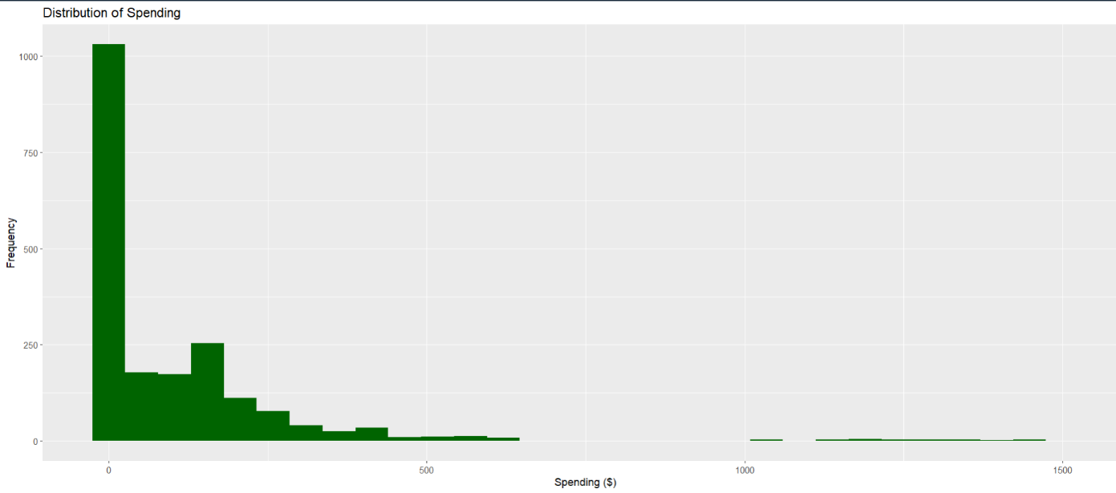
The distribution is extremely right skewed, most customers spend very small amount and very few customers extremely spend a large amount. The volume of the business is generated by low value most frequent price sensitive customers, few high value spenders contribute to the total revenue. The plot distribution signifies two groups where business can improve, maintain growth and reach out majority of low value spenders with economical deals and promotions, defend profit by supporting high value spenders with loyalty schemes and good offers to upscale business. The trend in spending highlights two significant groups of spending. Although I will prioritize on loyalty and providing exclusive deals to keep the high valued spenders, the low-spender cohort can be targeted through campaigns and promotions with budget-friendly offers. This focused approach gives the greatest benefits towards investment, as well as give maximum benefits on marketing campaign.

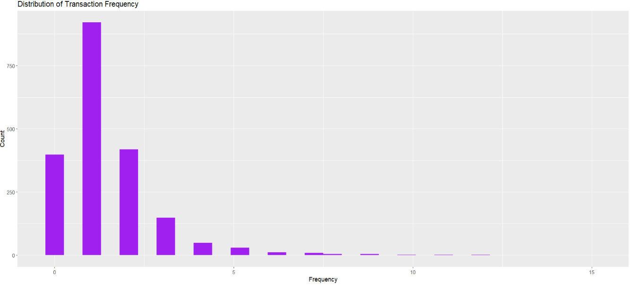
The figure shows very high skewed distribution with a very small percentage of customers having regular purchases and most having one or two purchases. This implies that the business relies heavily on a few well-valued, loyal customers and the total lack of consumer interaction. This is a threat to the business as majority of the customers are lost within a short period and the revenue is based on a few repeat customers. The company ought to focus on retention strategies to facilitate repeat business among one-time buyers and strengthen the loyalty schemes in order to generate more profit and reduce risk. To overcome this disparity, one should target out the one-time customers to become repeat customers on the basis of loyalty rewards, personal follow-ups, and retention offers that are promoted to individual customers. The lifetime value can also be boosted by investing marketing resources in retention as opposed to relying on acquisition only, and revenue growth.

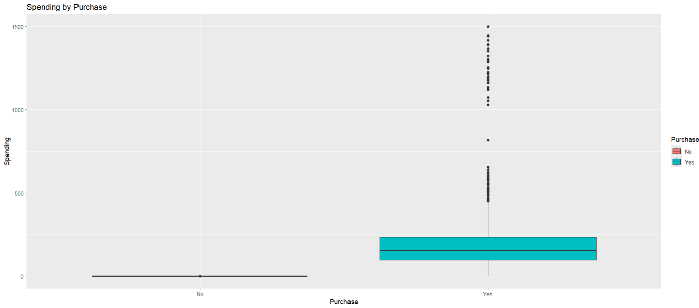
Boxplot compares the spending habits of customers that purchased the product (Yes) and those that did not (No). It illustrates that although buyers have an enormous spread of spending amounts, where the median is a satisfactory amount though with a large amount of variation and a few outliers that are incredibly high, the amount spent by non-purchasers is virtually zero. This shows that it is the purchasing group that is the sole generator of firm revenue and that few high-spending clients take a disproportionate amount of the total sales in the purchasing group. From business standpoint, this would mean two things, first high-spending consumers have to be nurtured via loyalty programs or customized offers in order to maximize their lifetime value and second, that non-purchasers should be converted into buyers through special offers or engagement strategies

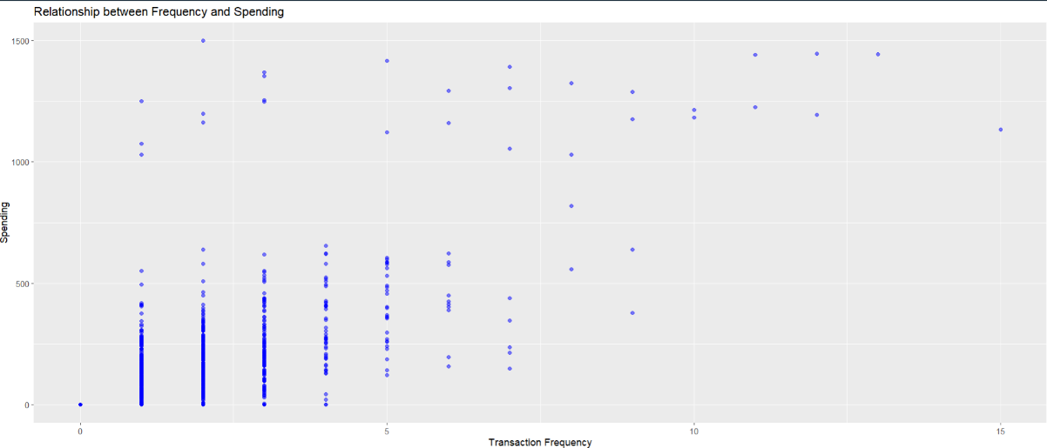
The scatterplot shows the relationship between the spending and frequency of transactions. We have a high concentration of consumers with low transaction frequency (1to 5) in which most of the spending is concentrated but the quantities of the spending are very different and can go to extremely low and extremely high amounts indicating that infrequent buyers professionally can spend relatively high amounts. The frequency distribution of spending tends to be concentrated toward a larger frequency (above 10 transactions), and the larger range (above 10 transactions) has some very large spenders (outliers). though regular customers are important and more likely to bring a steady revenue, another promising opportunity is to develop low frequency but high spending customers. Second, the businesses must divide customers based on how often they shop as well as how much they spend so as to craft specific efforts, including loyalty programmes or particular retention/upselling to the latter who only shop occasionally and spend large sums.

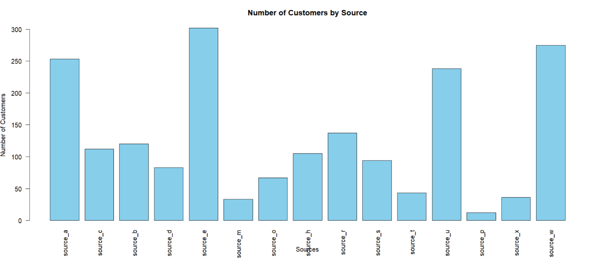
According to the plot, most of the consumers are produced by a few powerful sources, particularly, sources_e, w, u and a, although there are numerous other sources that make little contribution. To ensure that it makes maximum profits, the company should focus its marketing funds and effort in these high performing channels. It must also maximise the expansion of the sources in the middle-level e.g. source_r, c,b and consider reduction of investment in weak sources that do not add much value. The strategy enhances the level of profitability and customer acquisition.

- Correlation of variables
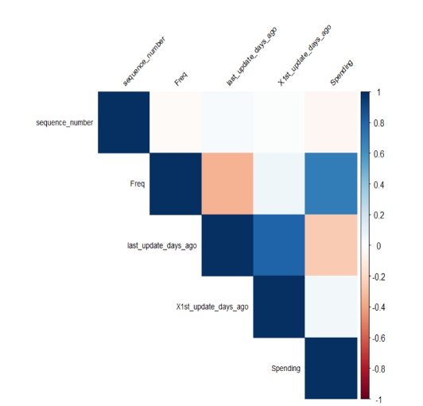
Based on the correlation matrix, more frequent customers spend more in total, so the relationship between Spending and Freq. last_update_days_ago and 1st_update_days_ago is good and positive indicating that both variables follow the same time data of customer behaviour. Consequently, it may be implied that one of such variables might be dropped to avoid redundancy. The negative but small Freq correlation with last_update_days ago would inform us that the more actively the customers are, the more they purchase. The marketing strategy should aim at keeping these loyal customers active by offering them loyalty programs and even target potentially inactive customers with a view of reactivating them to increase sales. This fact implies that repeat and frequent engagement customers are likely to contribute the most to total revenue based on business perspective.

Predictor analysis and relevancy
Purchase is the dependent (target) variable that represents whether a customer responded to a marketing mail. All other variables are independent predictors used to estimate the likelihood of responding to a market campaign. We know that the dataset is balanced with equal number of purchases and non- purchases, this makes good for the classification model as there is no class imbalance problem.
From the Chi-square test (Find relation between categorical variables) of Gender.male, US, Address_is_res, Purchase there is no significant relationship between gender, Address_is_res and person living in US to purchase, male and female are purchasing at similar rate, gender, Address_is_res and living in US does not drive purchase decisions in this campaign.
There is a strong significant relation exists between the person ordering web. Customers through web channel are purchasing at much higher rate. Online order is a key driver for sales.
Strong relation exists between source and purchase; some source channel dominates by providing active shopping customers helps for the campaign to get more business.
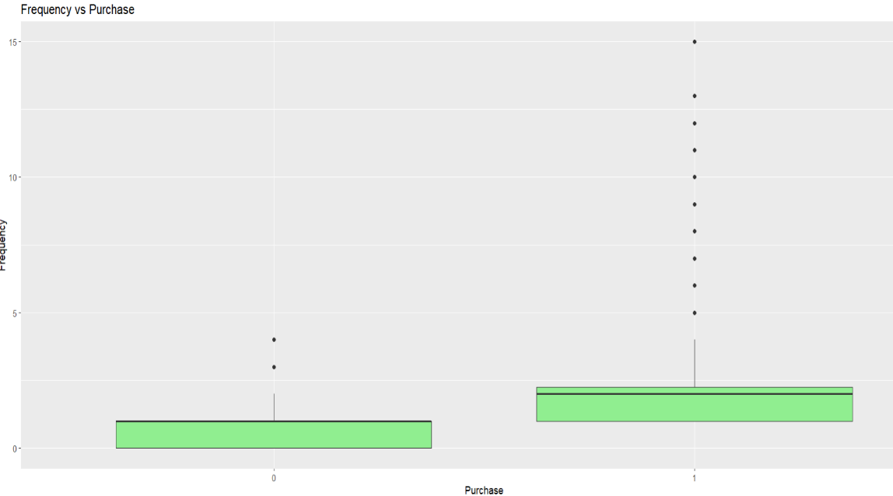
Customers who interact with the campaign are more likely to make a frequent purchase then those of no-purchases. Focusing market efforts on highly engaging customers lead to higher sales, better response and strong return of investments (market campaign cost). Freq should consider as a key predictor.
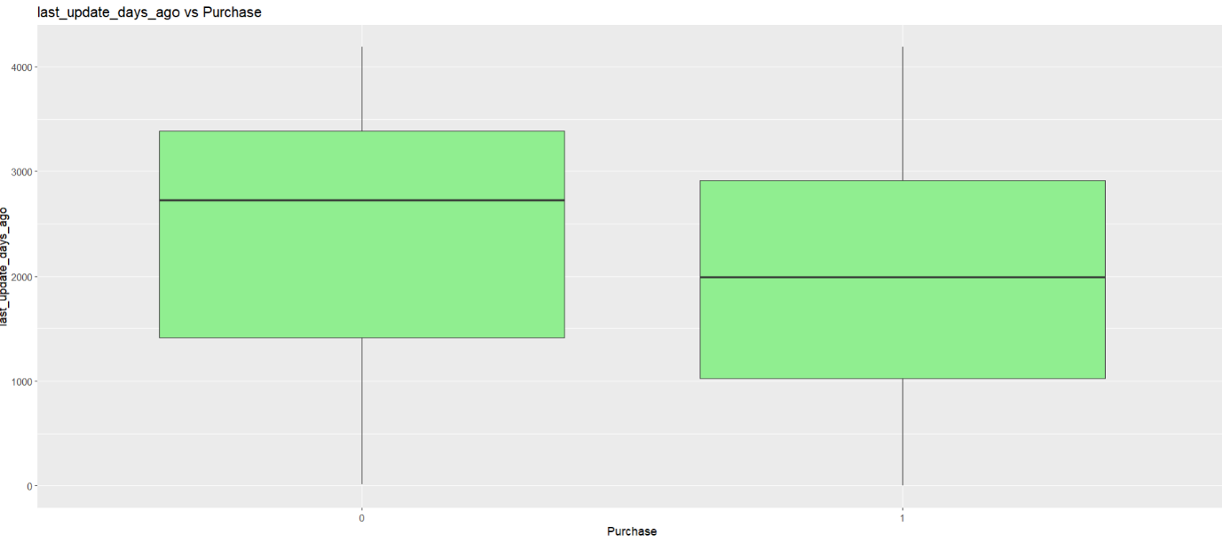
The plot shows non-purchase customers last interaction with the company is much longer than purchasing customers, the t-test signifies non-purchase average is 2,335 days since their last update vs 1,975 days update of purchase customers. In business perspective recent contact correlates with higher purchase of likelihood, follow-up and re-engagement can boot sales.
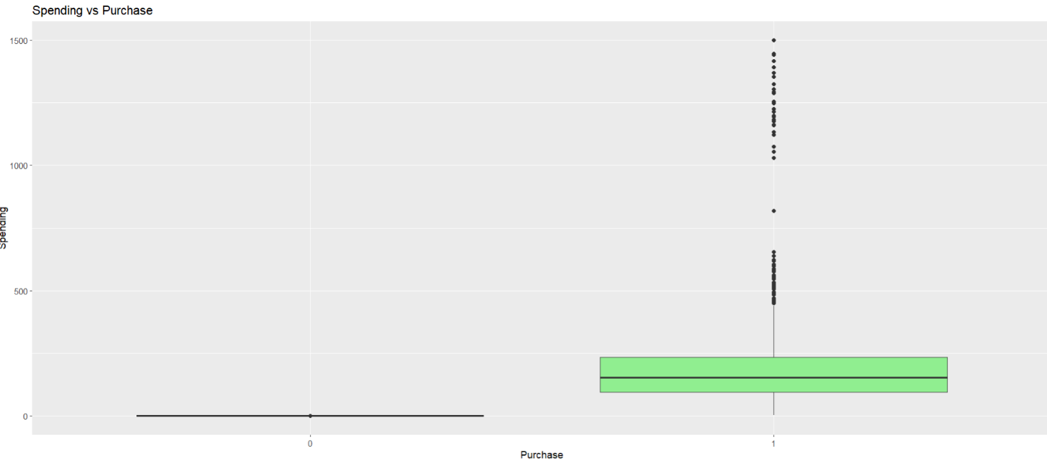
The plot tells the customers who purchased made the median around few hundreds as compared to no-purchases, T-test provides average purchased is 205$, actual spending is the very strong indicator of purchase behaviour, customer who have purchased before are more likely to buy again. Prioritizing high spending customers, can boost revenue.
Through the analysis it was found demographic factors (gender, address type, US residence) do not influence the purchase decisions, elimination of demographic factors helps to illuminate better predictors of behaviour and enhance model understandability. Demographic variables in this study were poor predictors of business as the chi-square values were low and there was no business relevance. Thus, by eliminating them it would be possible to have a more effective model without introducing noises and variables such as web orders, source, frequency, the latest update, and past spending are good predictors. Such results can be used to select features of the classification model to centre around the variables that actually drive purchase likelihood and enhance the predictive accuracy of customer response to the next campaign.

Dimension reduction
All the source columns are merged into one column, out of 15 source channels in a row if one channel is 1 indicating yes, the other channels are 0 means no. Source column is created with values indicating through which channel the customer is acquired.
In order to streamline the analyses and make easier to interpret without any business relevance being lost, we grouped few source variables under a single consolidated column, which we termed as Source. Originally sources began with binary indicators to depict a distinction of the marketing channel. Since it has a single dominating channel of customer acquisition, a combination of these indicators enhances clarity in comparison with what channel worked best in customer acquisition and purchase reaction. Businesswise, this not only leads to improved performances comparison across channels, but also improves the decision-makers in the process of the allocation of the marketing resources across the channels.

Data engineering and transformation
Since binary variables are measured into two possible outcomes (Yes/No or 0/1), the model does not consider the possible outcomes as numbers but as two different categories clustered and not erroneously assumes that the values of the data had a size or an order. This will make sure that such customer features as "Web order" or US residence will have significant categories in terms of marketing and segmentation. Such a greater increase would help marketers in the segmentation and targeting plans of the model to produce campaigns in comparison to the actual difference of behaviour rather than an imaginary association caused by figures.

Data partitioning methods
In order to achieve an equal distribution of responses to the outcome, which is Purchase, we applied a stratified sampling technique on the target to divide the dataset into 80% of the dataset for training and 20% for testing. The test set, which is different from the training set on which the model was just trained, will serve to evaluate the model's predictive performance. The reason for the 80% and 20% split is to produce accurate campaign forecasts by freeing sufficient data for the model to learn from while leaving a reasonable amount of observations completely unspent in the training model for validation. This balance allows for reliable and consistent results in marketing campaigns, as the model will be able to generalise to consumers who have not been observed. Because of the fixed random seed reproducibility is ensured.

Model selection
We chose Decision Trees and Random Forest to make predictions due to their ability to offer precise and interpretable outcomes and also to establish both linear and non-linear relationships in customer response. In terms of segmentation, K-Means is applied in instances where the number of groups is known whereas Hierarchical Clustering is applied in instances when we want to identify natural groupings of customers. These models in combination provide practical information to develop more focused and less expensive campaigns.

Random Forest
Random Forest is an appropriate choice because it has many decision trees aimed at reducing overfitting and having a high accuracy in predictions. It is also effective with marketing data that has diverse client characteristics such as frequency, spending, days since last update given that it can utilize both category and numerical predictors. The model is effective in identifying the key drivers of consumer buying behaviour by identifying the complex and non-linear relationships and interactions of variables. Business-wise, this not only minimizes costs of campaigns by eliminating the outreach which is wasted because of low response and maximizes targeting accuracy allowing marketers to focus resources on high potential clients. The model also provides actionable insights on how to be a better channel investor and marketer, where the variable significance metrics are used.

Decision Tree (CART)
Decision trees particularly come in handy with marketing analytics as they allow consumers to be grouped into clear cut easy to understand segments based on variables of interest (ex.). When Web.order = Yes, and Freq > 2, then high expected response). Due to this transparency, marketing teams will be able to transform model results into practical strategies, e.g., segment-specific deals, or personalized mailing campaigns. The decision trees are more specific to and organized in efficient marketing resource spending through better understanding how the interplay of the variables affect the likelihood of response as well as resource allocation in areas where the probability of conversion is most likely.

Hierarchical Clustering
Hierarchical clustering is useful in identifying the natural consumer segment without restraining the number of the segments. The hierarchical clustering produces dendrogram, presenting the marketers with trend of devoted customers, coupon customers or one time customers by physically observing how individual customer/small group of customers forms a larger cluster. Regarding business viability, it allows basing customer segments on the information and permits advertising that is tailored and focused as well as campaign generation that is effective. Hierarchical clustering is highly appropriate in exploratory segmentation before the creation of strategic mailing groups because it can be used with different types of data and moderately size data sets.

K-Means Clustering
K-Means is commonly applied to marketing segmentation, mostly due to its capability to bundle together customers with similar behavioural characteristics such as frequency of purchases, online purchases, campaign responses etc. It is effective when dealing with large volumes of data and the customer segments include a definite number of high-, medium-, and low-value customers. The cluster centroids (and profiles of each group are available to marketers) can be used to design individual offers, modify communication strategies, and optimally allocate resources to campaign return on investment.

Model fitting and Test accuracy
- Decision Tree (CART)
There is a strong correlation between spending and purchase, if there is 0 spending that means it is no purchase not responding to the marketing mail, the model directly learns from the spending column and predicts 100% accuracy, removing spending column to accurately train the model.
After fitting Decision tree model the evaluation of the model using a confusion matrix showed that it was an accurate model with a result of 83.5% indicating that the model was able to predict the majority of the customer responses on the test data. Sensitivity (87%) and specificity (80) indicate that the model is quite good at identifying customers responding to target mail and at the same time, it is also doing very well in identifying non-responding customers. In general, the decision tree model can be easily applied to unseen data and provides a reasonable trade-off between interpretability and predictive power. This precision enables the marketing resources to be strategically redirected to the likely responders which will lower the costs of the campaigns and increase the return on investment (ROI) in a business sense.

- Random Forest
We have removed spending column, the models directly learns from the spending column.
The model exhibits a good classification performance. Based on the confusion matrix, the accuracy of the test is about 83.25% with 183 correctly classifying responding to the mail and 150 correctly classifying not responding to the mail. The model has a good generalization with the invisible data as it is able to discriminate between purchasing and non-purchasing (responding and not responding) customers.
As a company, the high accuracy and strength of Random Forest yield actionable insights. Marketing departments would be able to confidently market to customers with high probability of purchase (frequency and source activity based) and streamline their mailing lists, as well as lower the cost of campaigns and improve ROI and retention.

- Hierarchical Clustering
Hierarchical clustering model was used to group customers depending on their similarity in their buying behaviour. It employed the Gower distance technique to make comparisons between both numbers (such as spending and frequency) and categories (such as purchase status), and the entire linkage technique to create clusters. The optimal number of clusters was determined as 8 clusters after trying the various cluster numbers and this implies that data clusters together to make eight customer groups. These groups display apparent disparities such as; some customers purchase frequently, others infrequently, others spend more as compared to others. This aids the business in grasping the type of customers very easily and making distinct marketing strategies towards each category, e.g. a re-engagement of the inactive users or a reward scheme on the repetitive buyers.

- K Means Clustering
Normalized data on customers (Freq, last_update_days_ago, X1stupdatedaysago, Spending) were clustered with the K-Means model (k = 3) with 50 random starts. The three groups (667, 666, and 667) are the various classes of clients depending on the behavior of spending, the frequency of buying and the recency of the purchasing process. The cluster centers indicate low-engagement customers, moderate spending customers with equal recency and high frequency less spending buyers. Outlines of these segments convey prospects of specific marketing campaigns that may yield engagement, conversion, and the overall payback in the form of reactivation campaigns among the lapsed customers, discount-based offers to the low spending customers, and loyalty rewards with respect to highest frequency purchases.

Model performance
Random Forest
Accuracy (83.25%)
Sensitivity (91.5%)
Specificity (75%)
Precision (78.5%)
The model presents good results of 78.5% precision and 91.5% recall (sensitivity). This implies that in the instances where the model assumes a customer will make a purchase, it is accurate in its predictions 78.5 percent of the time, and it is also correct in the cases where it identifies 91.5 percent of all actual buyers. The specificity of 75% signifies that it is right in identifying the majority of non-purchasers. The model excels at identifying actual buyers and retains reasonable accuracy in forecasting those who will not purchase.

Decision Tree
Accuracy (83.5%)
Sensitivity (87.0%)
Specificity (80.0%)
Precision (81.3%)
The model achieves accuracy of 83.5, correctly classifies most customers. The sensitivity (87%) indicates that it is a good predictor of real buyers whereas the specificity (80) indicates that it also differentiates non-buyers quite well. The precision (81.3) indicates that the model is accurate most of the times when it predicts a customer to purchase. Overall, the model shows good and balanced performance that can be used to select probable purchasers and enhance marketing effectiveness.

Hierarchical Clustering
The hierarchical clustering algorithm was tested based on the average silhouette values at varying cluster sizes (k = 2 to 15). The greatest silhouette score was at k = 8 with a value of 0.2416 which shows that the data is best organized into eight groups. The score indicates moderate separation even though there is a slight overlap between groups though clusters are relatively distinct. This implies that the model will reflect meaningful segmentation patterns which can be practically interpreted in terms of cluster profiling, e.g. in customer spending, frequency or engagement behaviour difference.
K Means Clustering
Having a silhouette score 0.589, the K-Means model of 3 clusters displayed a clear and slightly significant distinction between groups of consumers. The cluster sizes are about 666 and the major difference groups are in terms of frequency of purchases, amount spent and latest purchase. Cluster 2 is made up of moderately engaged customers that can be offered special promotions; Cluster 1 is made up of high-value, active customers that need to be promoted using loyalty programs; and Cluster 3 is made up of passive and inactive customers that can be re-engaged with trial products or discounts. Due to this type of segmentation, the company will be able to focus their campaigns more effectively that influences ROI directly and uses marketing resources to their advantage.

Model Evaluation
Both models are good at approximately 83 percent accuracy although there is a slight difference in focus. The Decision Tree has a balanced performance because of its good sensitivity (87%) and specificity (80%), and it is less complex to interpret and best suited in explaining customer behaviour. Having a greater sensitivity (91.5) and lower specificity (75%), the Random Forest is more capable of identifying real buyers, which is why it is more powerful at campaign coverage. Generally, the Random Forest is more suitable in terms of predictive customer responding to the mail.
Although the functions of the clustering algorithms are different, they both yielded useful information on segmentation. The hierarchical clustering model scored quite different clusters with a little overlap at its best silhouette score of = 0.2416 at k = 8. Finally, the clusters were unique and reasonably meaningful categories in terms of consumer expenditure, purchasing frequency and activity of interaction. Relatively, K-means model did exhibit greater partition and more consistent clusters with three large segments high-value loyal customers, moderate-value engaged customers and inactive consumers with a higher silhouette score of 0.584 at k = 3. Together, the two models offer complementary benefits with the former offering more useful, actionable segmentation that offers focused campaigns to market, create customer retention as well as greater value of the investment through improved resource allocation and utilization. Although the hierarchical clustering model failed to present such a useful segmentation method, it presented a more accurate representation of a deeper natural group structure of the consumers to an exploratory presentation of natural segmentation.

Observation and Conclusion
The Random Forest model was relied upon in determining the main factors of the customer response to a marketing effort. The results of the variable importance showed that Frequency (Freq) is the most important predictor followed by Source, Last Update Days Ago and First Update Days Ago. This means that the consumers who have just been contacted recently and one who purchases or interacts more with the consumer are much more likely to respond positively to the marketing offers.
Business wise, these insights can assist the firm to target high potential customers in their marketing activity rather than targeting everybody by sending target mails. The business can achieve 20 times greater ROI by focusing on frequent and recently active customers that will result in high response rate at least by 8%, less wasted marketing funds, and better ROI.
The K-Means clustering model with three clusters that have best solution, shows good quality of segmentation and good interpretability. All the clusters exhibit a varying customer behaviour of the cluster that has practical business implications. Cluster 1 consists of high-value and very engaged customers and demonstrates the most lucrative segment of the company. VIP customers are supposed to be taken care of with the help of exclusive loyalty programmes, first access and value-added customer personalization in order to retain their attention and enhance their lifetime value. Cluster 2 consists of an average quantity of active consumers who make purchases every now and then with a possibility of spending more. Cluster 2 customers can be successfully reached with seasonal deals, bundles, and personalized spending reminders and inspire to lean towards more valuable customers.
Cluster 3 comprises of the dormant customer base or the very low engagement customers, and the cluster is a risk and needs a reactivation campaign. Good reactivation strategies might be the use of discounts, free offerings and email chains to get them re-activated. Therefore, the segmentation provides a foundation of accuracy marketing where the company can intentionally place resources, customize campaigns with behavioural profile, and boost conversion rate and ROI with data-driven and targeted decision making.
Finally, the business objective of having total sales of 15 percent increase and at least 10 percent conversion of non-buying customers to buyers is pierced by the K-Means segmentation. Considering the way it develops unique marketing strategies depending on the client groups, data-driven and customer-oriented targeted campaign development can eventually maximize the degree of engagement, resource usage and profitability of the company.
After taking the real purchasing rate into account, the modified probabilities show that there is a really small chance that a client will purchase, ranging from about 3% to 10%. This enables improved ROI and targeting discussions because it captures an accurate market situation whereby a small percentage of contacted clients is thought to respond favourably to the campaign.

