Helena
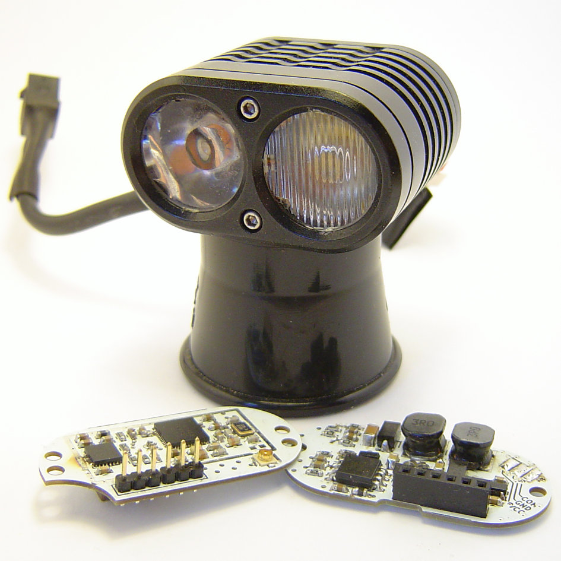

User Manual
for firmware revisions ≥ 0.14.0

Preface
Helena is an alternative driver for the Yinding Headlight Cycling Lamp with following features:
- Two independent 3A Step-Down constant current sources, each capable of driving two white LEDs in series. The intended setup is one Cree XHP50 LED equipped with a flood optic and one Cree XM-L equipped with a spot optic.
- Integrated motion sensor to drive the LEDs in dependency of the head inclination, resulting a nearly constant brightness level, no matter if you're looking down or straight forward.
- Bluetooth interface for wireless remote control, lamp daisy-chaining and Smart Phone based configuration.
- Integrated temperature regulation to prevent lamp from overheating.
- Smooth output power reduction when battery gets discharged.
- Low standby current (less than 100µA).
- Works with input voltages between 6V and 8.5V
Index
1.Preface 2
1.Installation 4
2.Usage 8
2.1.States 8
2.2.Modes and Intensity 8
2.3.Groups 9
2.4.Switching between States and Groups 9
2.5.Remote Control 10
2.6.Status LED 10
Appendix AConfiguration with nrf Connect 11
A.1.Read Group Configuration 14
A.2.Read State Configuration 15
A.3.Change Group Configuration 16
A.4.Change State Configuration 17

Installation
Tools needed for installation:
- 1.5mm Allen key
- soldering iron/station
- electric drill with 5mm metal drill
- Disassemble lamp and remove old driver and LED board. Then use drill and drill out the inner hole.
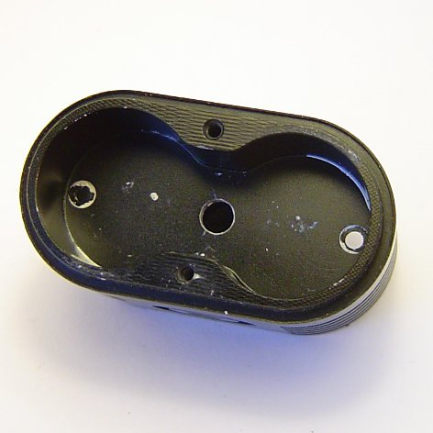Image 1: Drilled out inner hole
- Take antenna and put it through the cable gland (ignore this step for boards with integrated antenna).
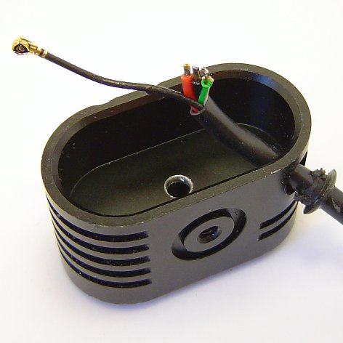Image 2: Antenna
- Solder the power cables to the driver board. Optionally a third cable for cable based communication can be connected.
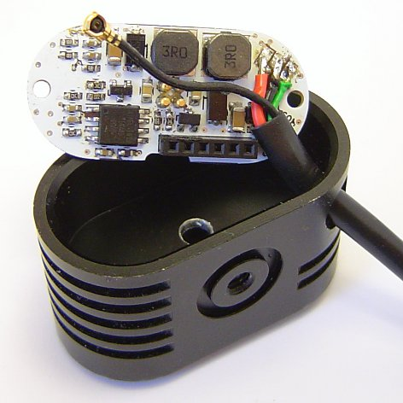Image 4: Power connection
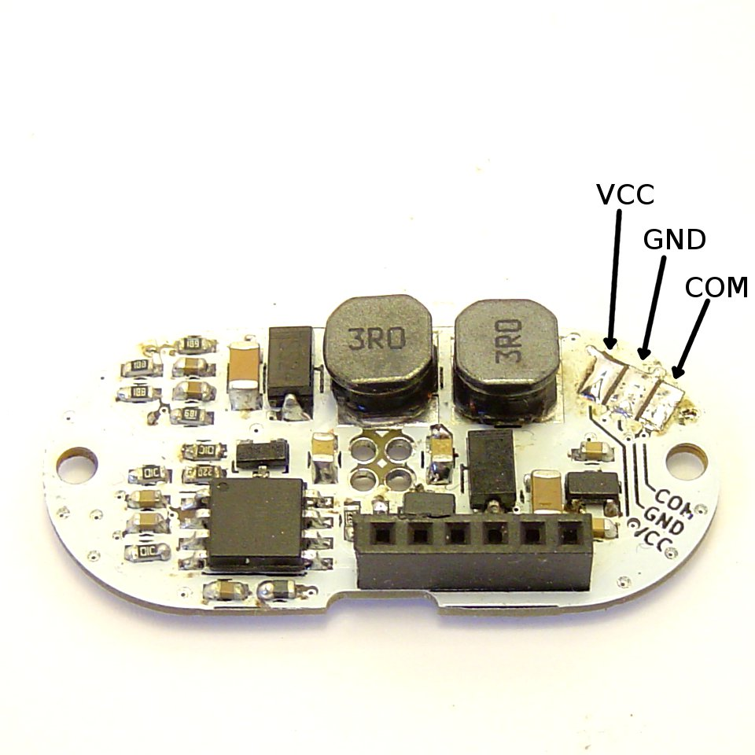Image 3: Power pins
- Apply new thermal grease and install LED board. It is also possible to use Helena with the original LED board and optics. See next step for details.
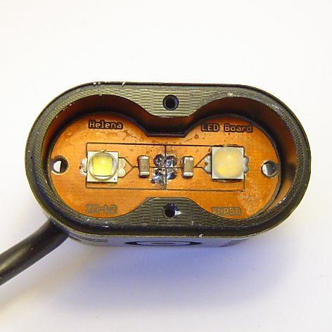Image 5: LED board
- Install the driver board by just plug it into the pins of the LED board. If you're using the original LED board solder the red wire to the Spot+ and the black wire to the Spot- connector. It may be necessary to shorten the cable first.
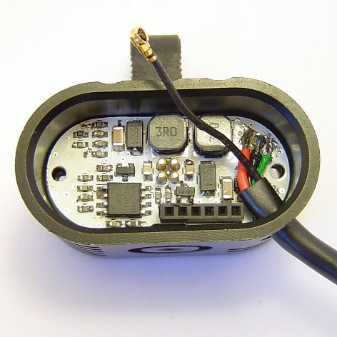Image 7: Driver board
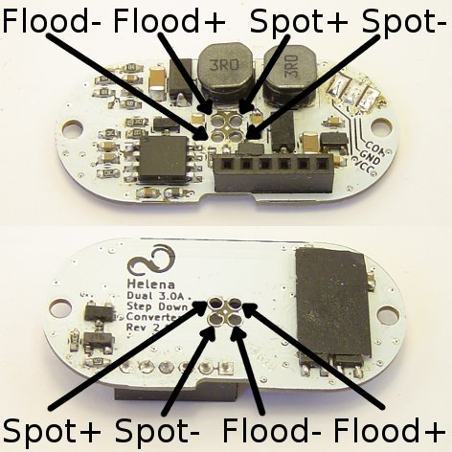Image 6: LED connections
- Mount the controller board to the back cover and connect the antenna.
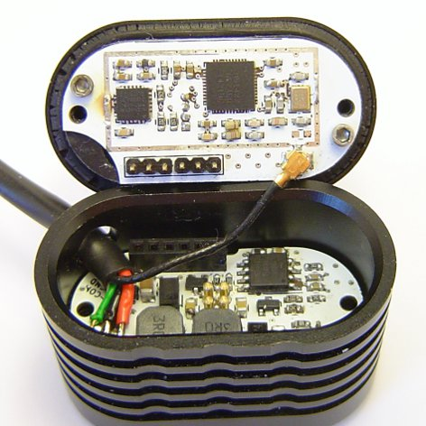Image 8: Controller board
- Assemble the back cover to the lamp body.
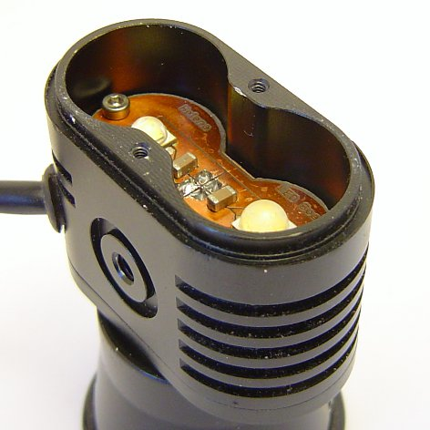Image 9: Assembled
- Install optics. Use spacers to tilt the flood optic downwards and the spot optic upwards. If you want to use the original LED board and optics, just reinstall them, they do not have to be tilted.
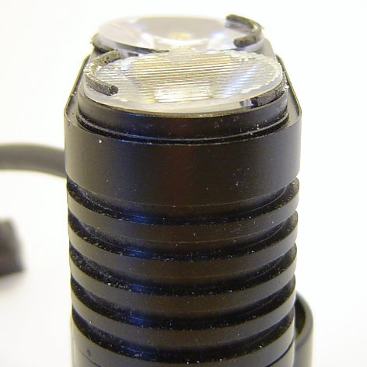Image 10: Installed optics
- Mount top cover.
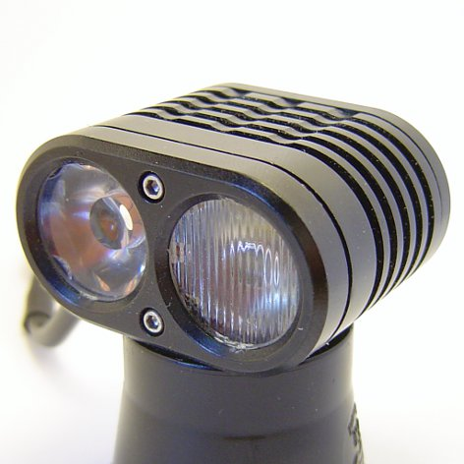Image 11: Done

Usage

States
Instead of different brightness levels like other lamps, Helena operates in different states. There are eight states in total and each state consists of a mode and an intensity level.

Setup and Intensity
This list gives an overview of the available setups and the meaning of the intensity level:
- Not used: Well, the name is self-explanatory, isn't it? Setups with this mode will be skipped by the user interface.
- Flood constant: In this mode only the flood LED driver is active. The intensity value determines the output current in %.
- Spot constant: In this mode only the spot LED driver is active. The intensity value determines the output current in %.
- Flood & Spot constant: In this mode both LED drivers are active. The intensity value determines the output current in %.
- Flood pitch compensated: In this mode only the flood LED driver is active. The output current depends on the pitch angle of your head and is controlled in a way, so that the maximum brightness level on the ground is kept as constant as possible. The intensity level determines this level in lux.
- Spot pitch compensated: In this mode only the spot LED driver is active. The output current depends on the pitch angle of your head and is controlled in a way, so that the maximum brightness level on the ground is kept as constant as possible. The intensity level determines this level in lux.
- Flood & Spot pitch compensated: In this mode both LED drivers are active. The brightness level (again determined by the intensity value in lux) is regulated to be kept as constant as possible like in the other pitch compensated modes. Additionally there is a smooth transition between the usage of the flood LED (when looking down) and the spot LED (when looking forward).

Groups
It is possible to divide the eight states into two groups with four states each, or into four groups with two states each.

Switching between States and Groups
Switching between states and groups can be done either by the integrated button, or with an Xiaomi Yi Bluetooth remote control.
To turn the lamp on or switch to the next state just press the internal button or the big button on the remote.
To switch to the next group, press the internal button or the big button on the remote for more than 0.5 seconds.
To turn the light of you can either press and hold the internal button until the light goes off (about 2 seconds), or you just press the small button on the remote.

Remote Control
As mentioned earlier, it is possible to remotely control Helena with the remote control of a Xiaomi Yi. But before this can work, Helena and the remote control have to be paired. This is done the following way:
If Helena is on, turn it off first.
Press any button on the remote control to wake it up.
Press and hold Helenas internal button for at least 2 seconds. This will make Helena to search for a new remote.
As soon as the remote control is connected, Helenas blue status LED will turn on.
After this procedure Helena will automatically search for this remote and connect to it as soon as it is in range.

Status LED
Helena is equipped with a red and blue status LED, which is visible through the transparent button cap. The blue on indicates if a remote control is connected. The red on turns on whenever the temperature or input voltage limiter is active.

Configuration with nrf Connect
The Configuration of states and group can be done with the App “nrf Connect” from Nordic Semiconductors.
- Plug in battery to Helena and open the App. Select SCANNER and then start scanning. Helena will then appear in the device list and you can press the CONNECT button.
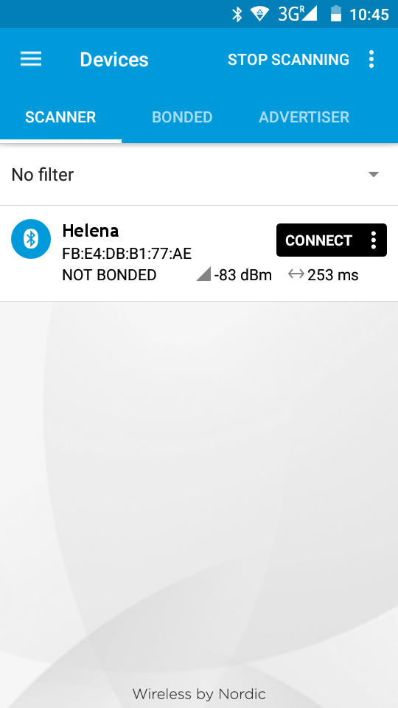Image 12: Scanning
- After you connected to Helena, you will see a list of available services. Select the Light Control Service. Compare the UUIDs if the service is named Unknown Service.
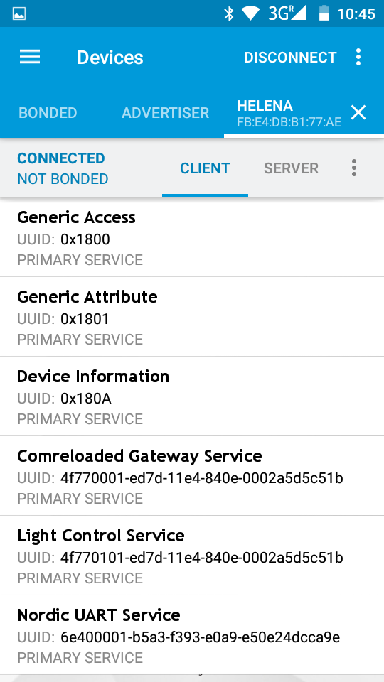Image 13: Services list
- Go to the Light Control Point Characteristic (it may be named Unknown Characteristic, in this case compare the UUIDs again) and enable the indications by touching the arrow-up and arrow-down symbol.
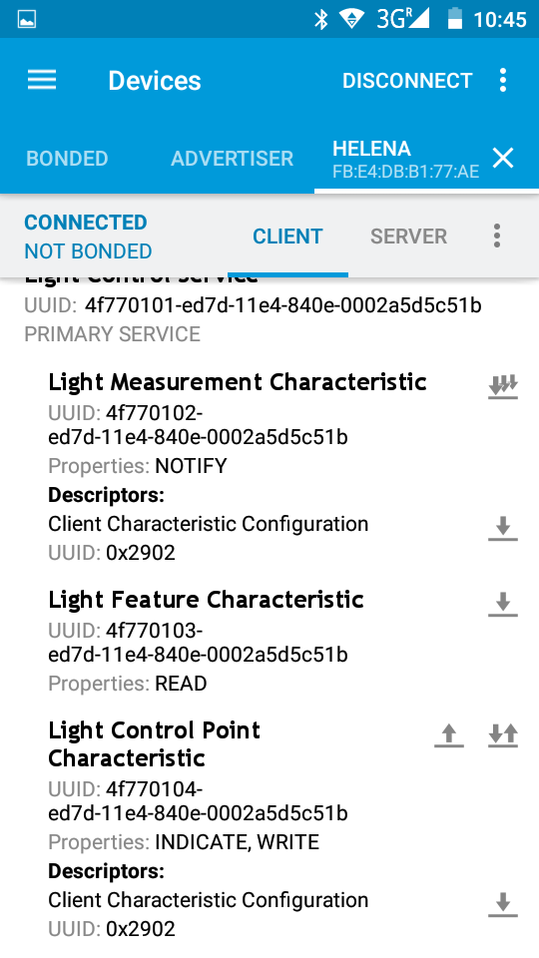Image 14: Light Control Service
- After you have enabled the indications for the Light Control Point you are ready to send commands to read out the actual configuration and to change it, too. To send a command you have to click the arrow-up symbol, then you can enter the desired command. The Control will reply with at least 3 bytes:
The first byte is always 0x20.
The second byte is the command this reply belongs to.
The third byte is a status byte.
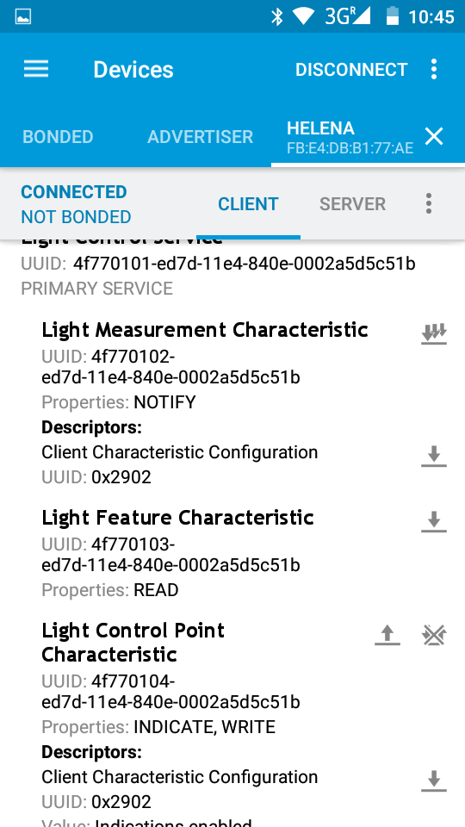Image 15: Send commands
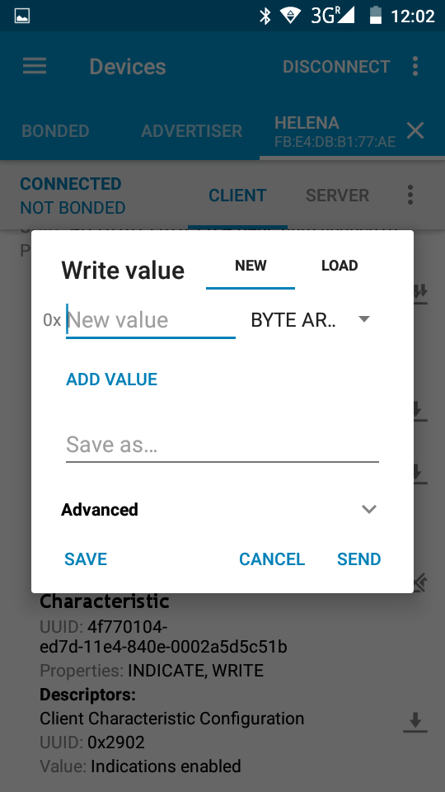Image 16: Send commands
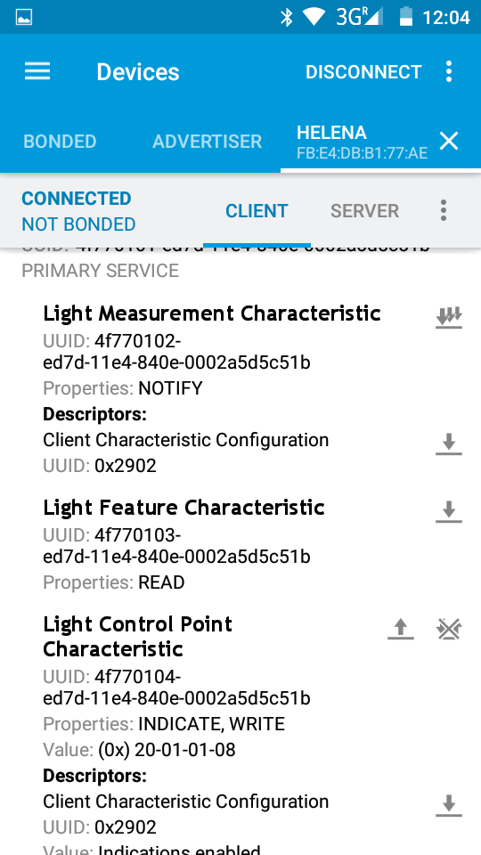Image 17: Command reply
Status Byte Value | Description
0x01 | Success
0x02 | Not supported
0x03 | Invalid paramter
0x04 | Operation failed
Depending on the command there my be additional data bytes.
- Read Group Configuration
The command for reading the current group configuration is 0x03.
The Control Point will reply with the actual number of groups in the fourth byte.
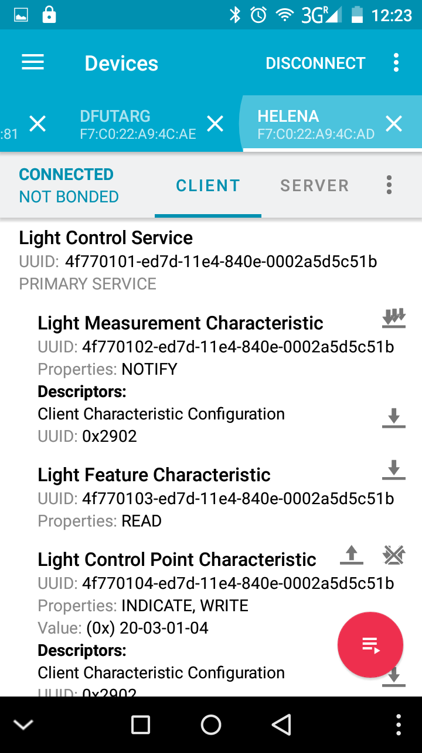Image 19: Group configuration reply
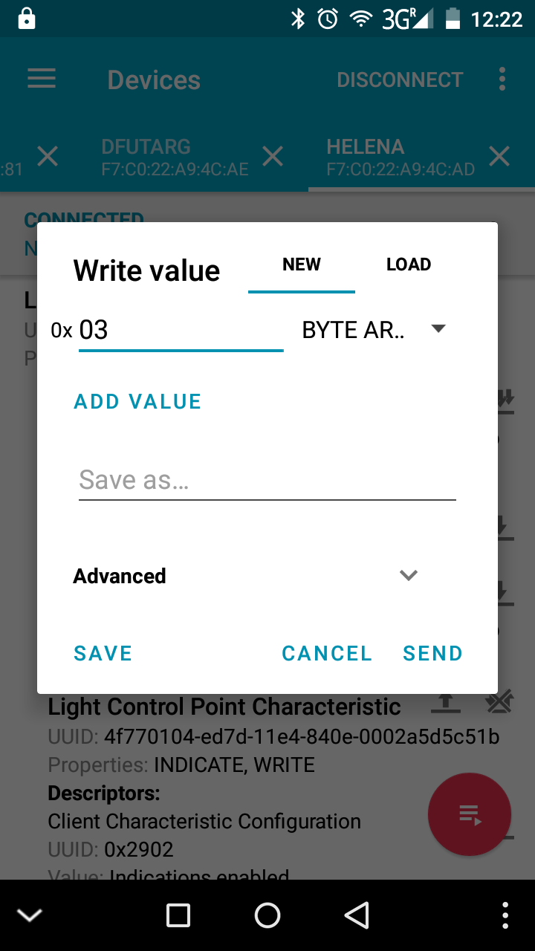Image 18: Read group configuration command

- Read Mode Configuration
The command for reading the current state configuration is 0x05. Followed by the state number to start reading.
The reply is a list of all states, where the first byte of each state represent the mode and the second the intensity.
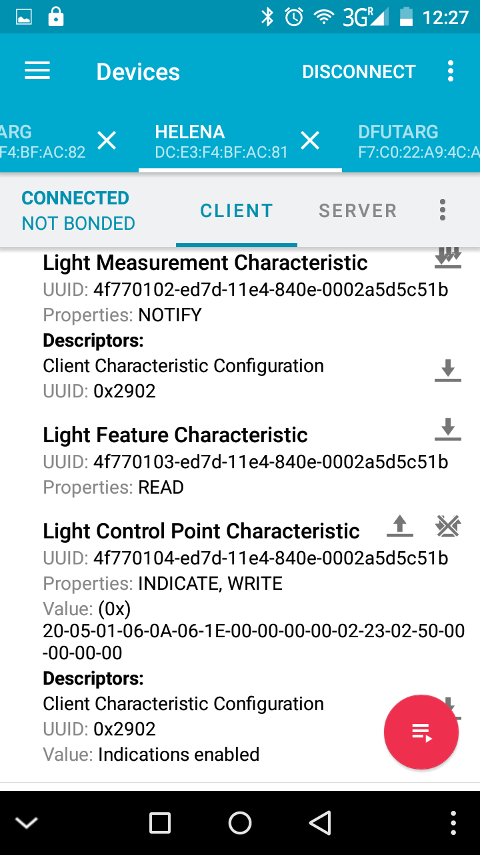Image 21: State configuration reply
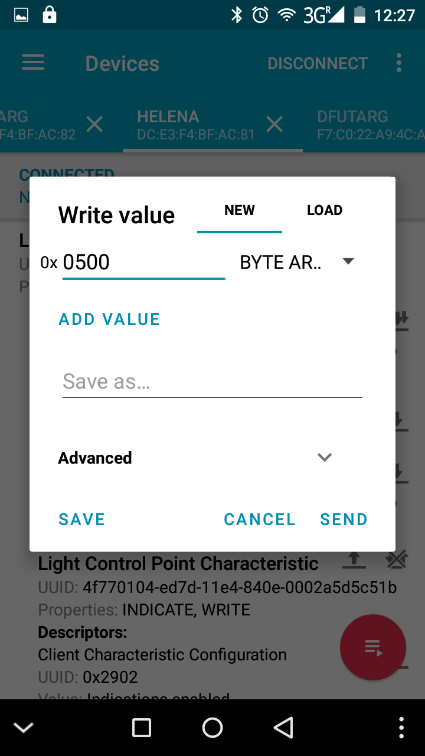Image 20: Read state configuration command
Mode Number | Mode
0x00 | Not used
0x01 | Flood constant
0x02 | Spot constant
0x03 | Flood & Spot constant
0x05 | Flood pitch compensated
0x06 | Spot pitch compensated
0x07 | Flood & Spot pitch compensated

The reply in Image 21 represents the following setting:
State 1 | Spot Pitch compensated with 10lux
State 2 | Spot Pitch compensated with 35lux
State 3 | Not used
State 4 | Not used
State 5 | Spot constant with 35%
State 6 | Spot constant with 80%
State 7 | Not used
State 8 | Not used
- Change Group Configuration
The command for changing the number of groups is 0x04. The new number of groups is followed as second byte (the complete command in Image 22 changes the configuration to two groups).
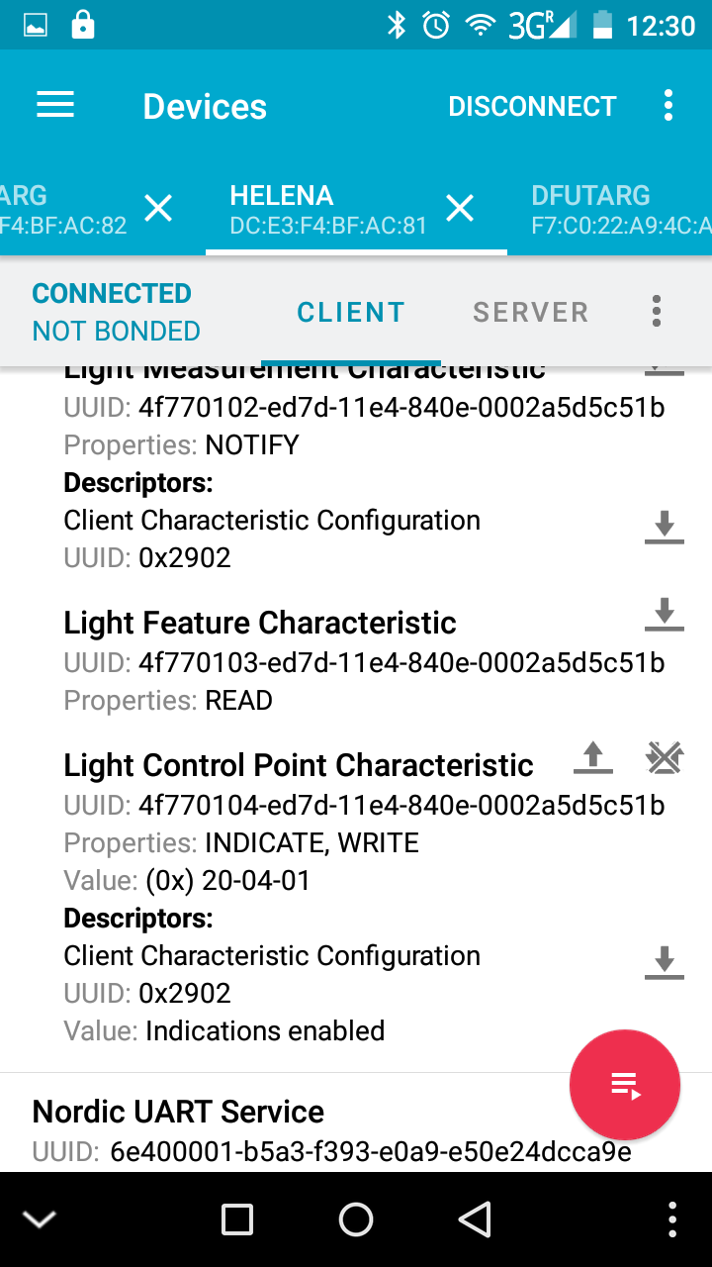Image 23: Group change reply
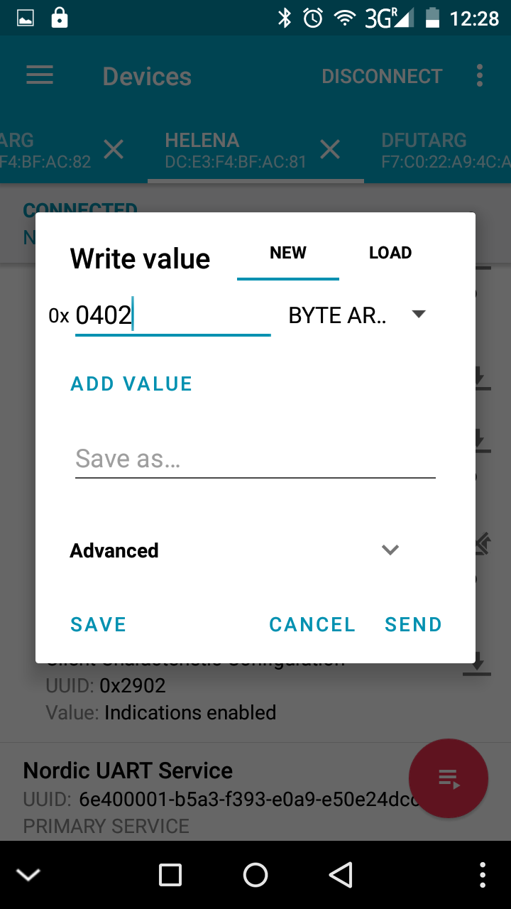Image 22: Group change command

- Change State Configuration
The command for changing the state configuration is 0x06. Followed by the state number to start and a list of new state. It is not necessary to change all states, it is possible to change only a few, to. The command in Image 24 will start with State 3 and has only a list of two states. So this command will result in changing State 3 to Spot pitch compensated with 10lux and State 4 to Spot pitch compensated with 35lux. The other states will keep their prior setting.
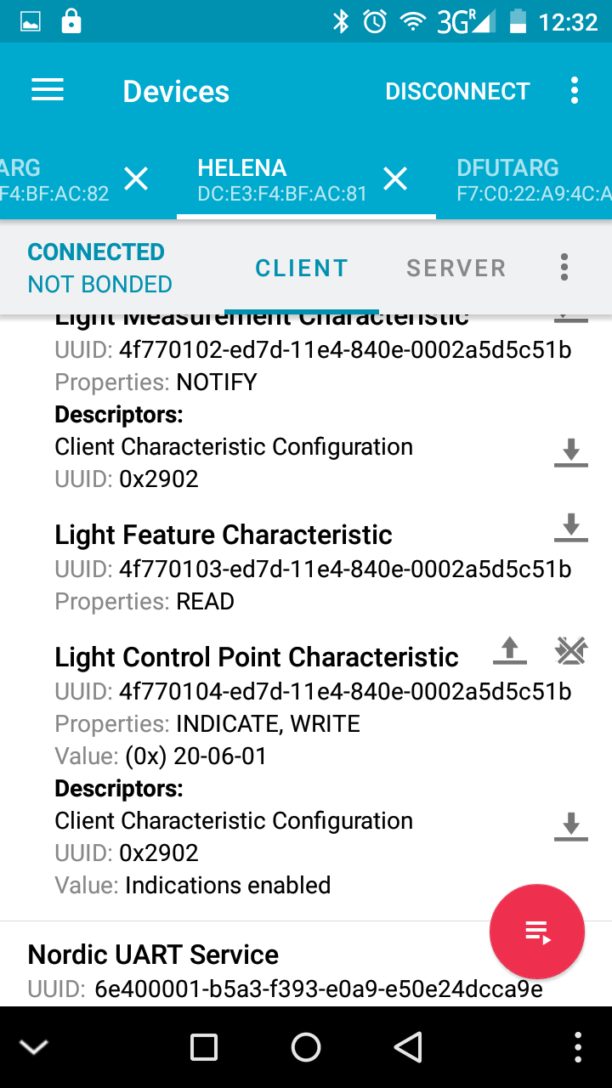Image 25: State change reply
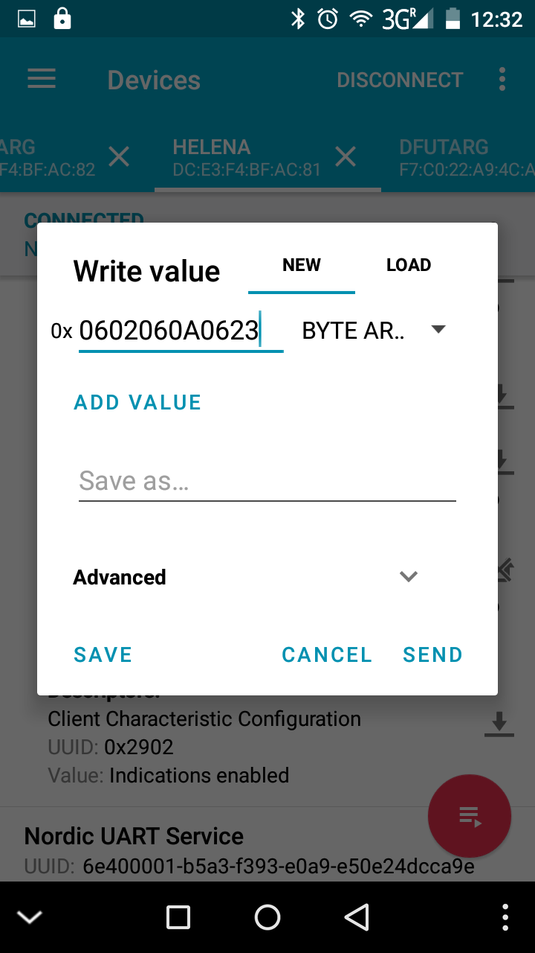Image 24: State change command

Internally the state counter begins with 0, so to change State 1 you have to select 0x00, for State 2 0x01, for State 3 0x02, ...
These are hexadecimal numbers, please use one of the plenty available online HEX to DEC converters.
Internally the state counter begins with 0, so to change State 1 you have to select 0x00, for State 2 0x01, for State 3 0x02, ...

