Helena
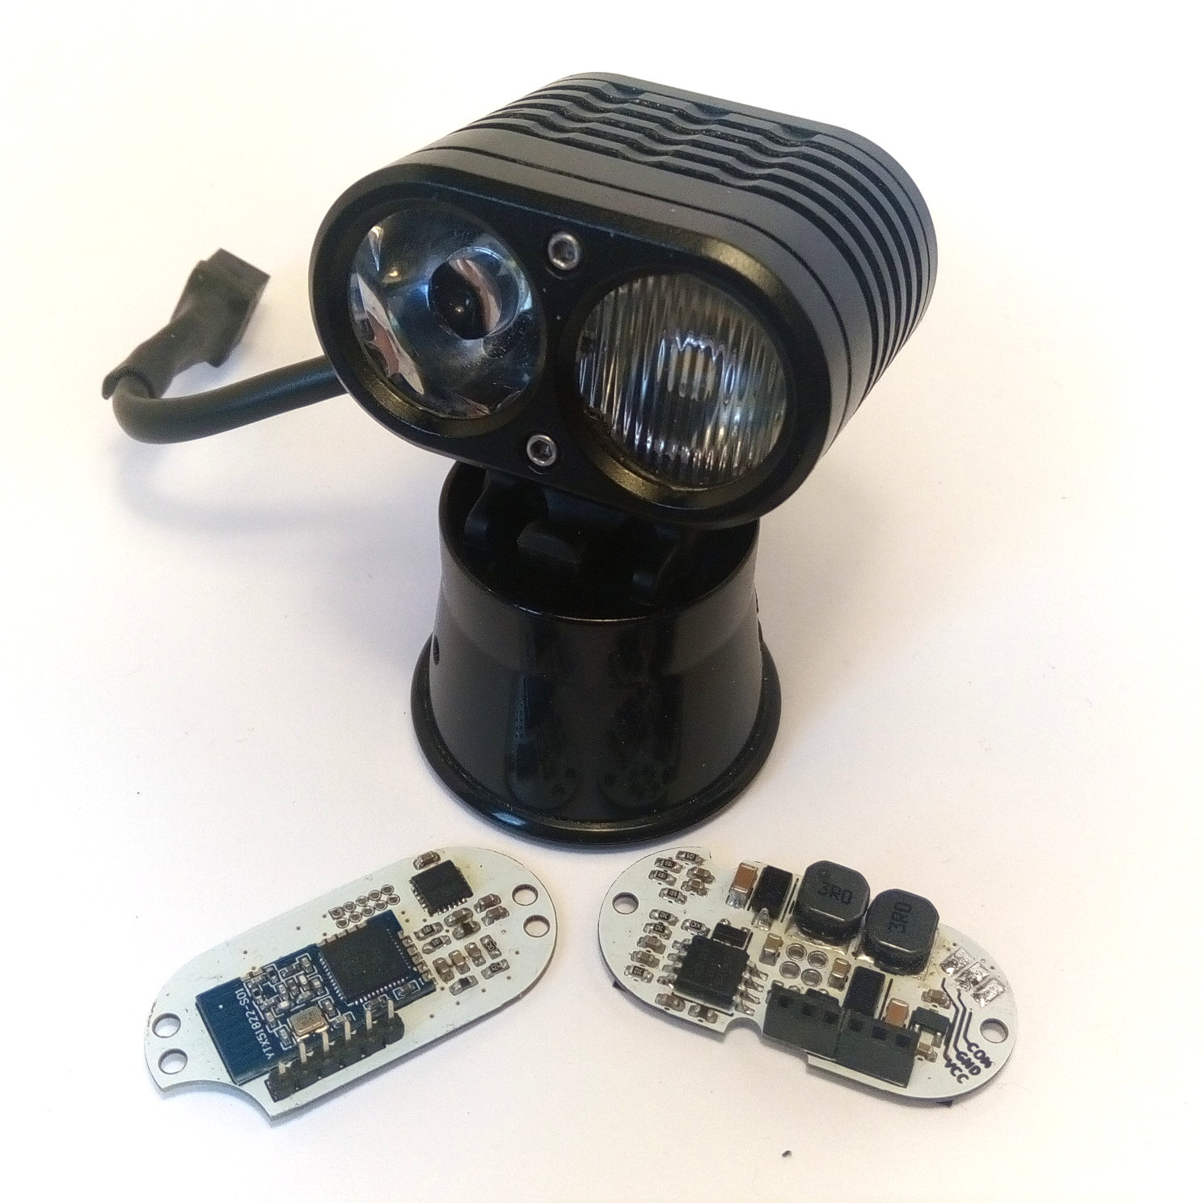

User Manual Appendix
Index
Appendix A Configuration with nrf Connect 3
A.1. En-/Decoding modes 6
A.2. Read Group Configuration 7
A.3. Change Group Configuration 9
A.4. Read Mode Configuration 10
A.5. Change Mode Configuration 11
A.6. Read Preferred Mode 12
A.7. Set Preferred Mode 12
A.8. Read Temporary Mode 12
A.9. Set Temporary Mode 12
A.10. Firmware Update 13

Configuration with nrf Connect
This section is only valid for Firmware revisions ≥ 1.0.0
The Configuration of states and group can be done with the App “nrf Connect” from Nordic Semiconductors.
- Plug in battery to Helena and open the App. Select SCANNER and then start scanning. Helena will then appear in the device list and you can press the CONNECT button.
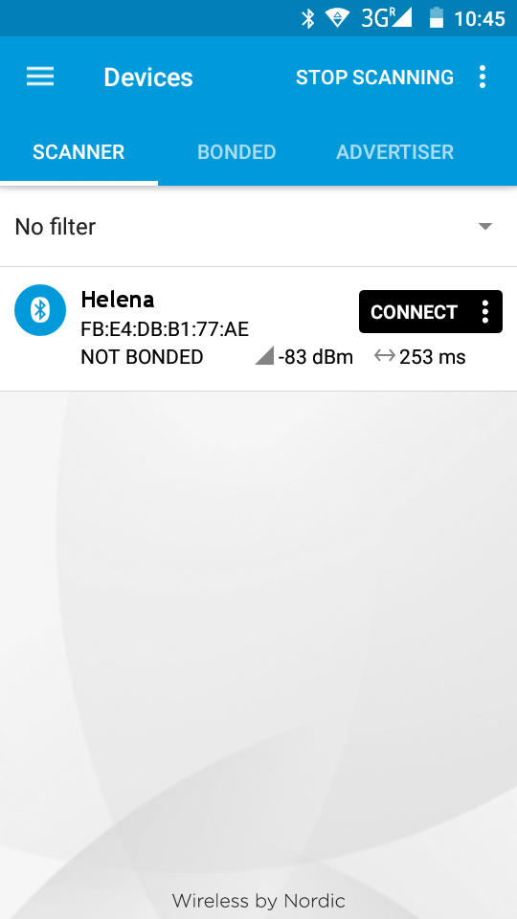Image 1: Scanning
- After you connected to Helena, you will see a list of available services. Select the Light Control Service. Compare the UUIDs if the service is named Unknown Service.
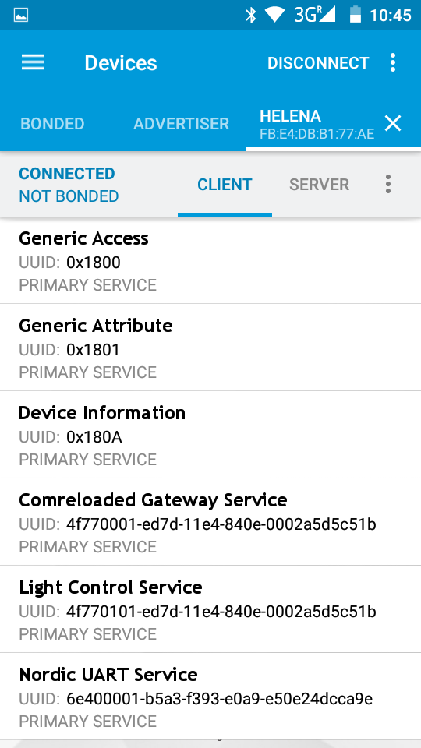Image 2: Services list
- Go to the Light Control Point Characteristic (it may be named Unknown Characteristic, in this case compare the UUIDs again) and enable the indications by touching the arrow-up and arrow-down symbol.
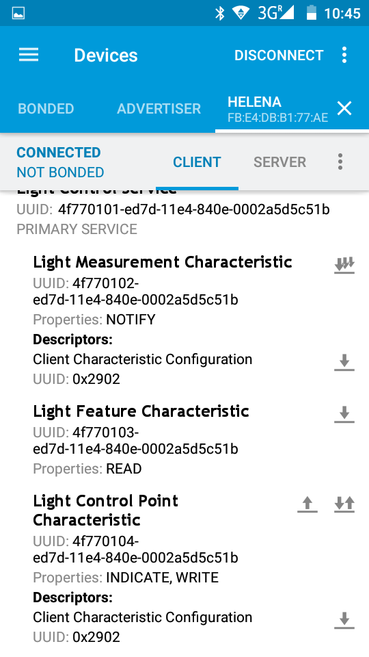Image 3: Light Control Service
- After you have enabled the indications for the Light Control Point you are ready to send commands to read out the actual configuration and to change it, too. To send a command you have to click the arrow-up symbol, then you can enter the desired command. The Control will reply with at least 3 bytes:
The first byte is always 0x20.
The second byte is the command this reply belongs to.
The third byte is a status byte.
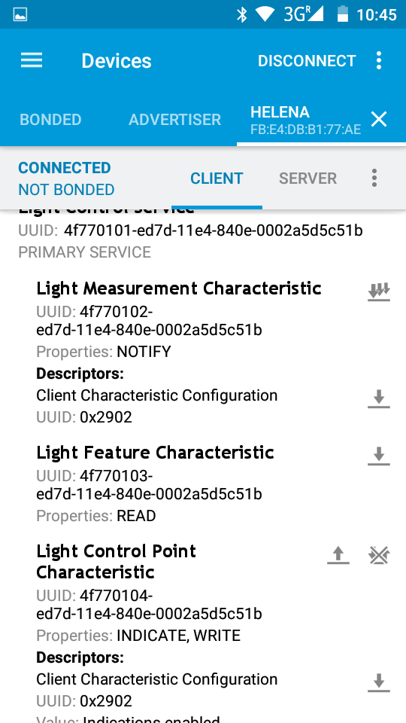Image 4: Send commands
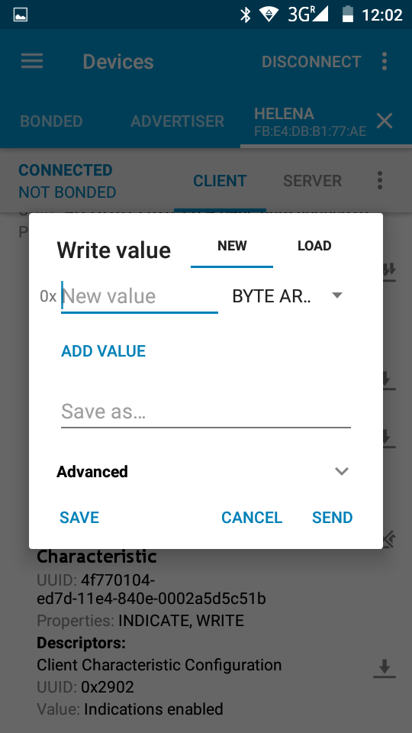Image 5: Send commands
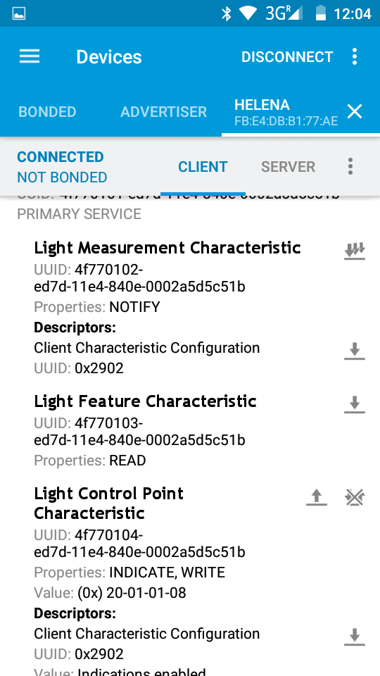Image 6: Command reply
Status Byte Value | Description
0x01 | Success
0x02 | Not supported
0x03 | Invalid parameter
0x04 | Operation failed
Depending on the command there my be additional data bytes.
- En-/Decoding modes
With the Helena firmware each mode consists of one setup byte and one intensity byte:
setup flags | intensity

reserved | reserved | reserved | reserved | output cloned | pitch comp. | spot enabled | flood enabled

setup value | active drivers | meaning of intensity byte
0x00 | off
0x01 | flood | output current in %
0x02 | spot | output current in %
0x03 | flood & spot | output current in %
0x05 | flood pitch compensated | target illumination in lux
0x06 | sport pitch compensated | target illumination in lux
0x07 | flood & spot pitch compensated | target illumination in lux
0x09 | both drivers | output current in %
0x0A | both drivers | output current in %
0x0D | flood pitch compensated on both drivers | target illumination in lux
0x0E | spot pitch compensated on both drivers | target illumination in lux

With the Billina firmware each mode consists of one setup byte and two intensity bytes.
setup flags | main beam intensity in % | high beam intensity in %

reserved | reserved | reserved | reserved | reserved | high beam enabled | reserved | main beam enabled

setup value | active drivers
0x00 | off
0x01 | main beam
0x04 | high beam
0x05 | main & high beam

- Read Group Configuration
The command for reading the current group configuration is 0x03.
The Control Point will reply with the actual number of groups in the fourth byte.
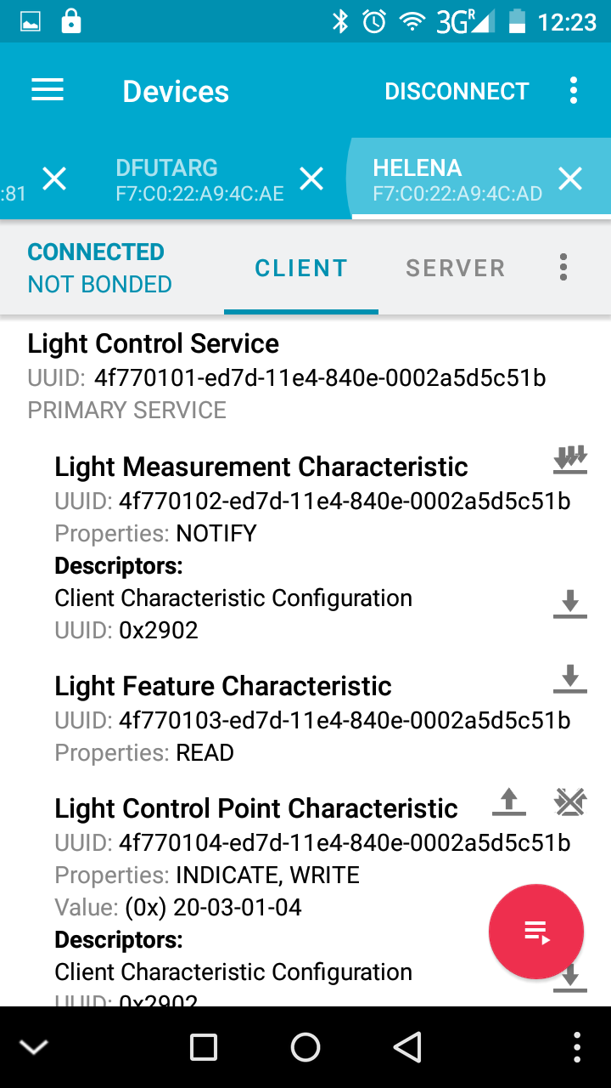Image 8: Group configuration reply
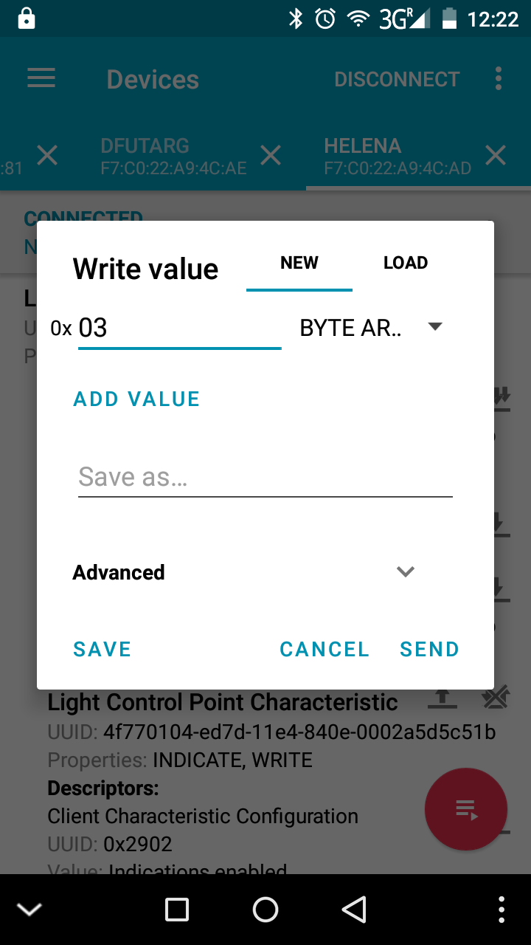Image 7: Read group configuration command

- Change Group Configuration
The command for changing the number of groups is 0x04. The new number of groups is followed as second byte (the complete command in Image 9 changes the configuration to two groups).
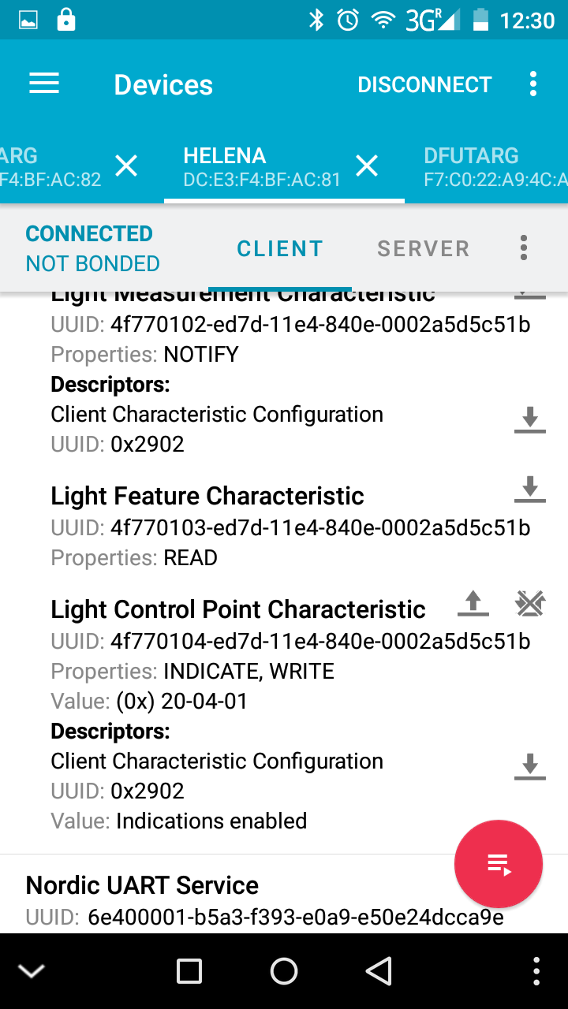Image 10: Group change reply
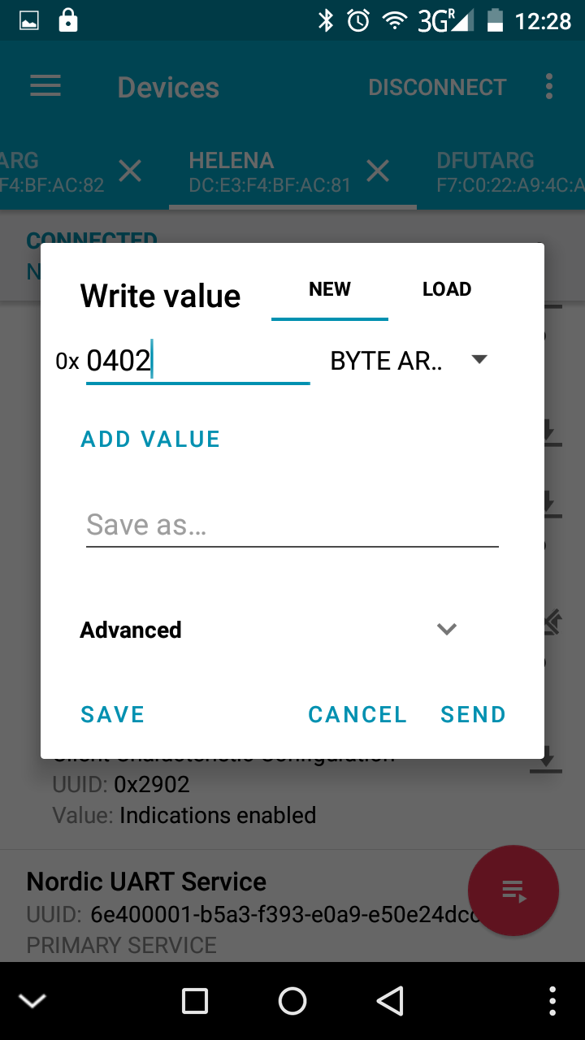Image 9: Group change command
- Read Mode Configuration
The command for reading the current mode configuration is 0x05. Followed by the mode number to start reading.
The reply is a list of all modes, where the first byte of each state represent the setup and the second the intensity.
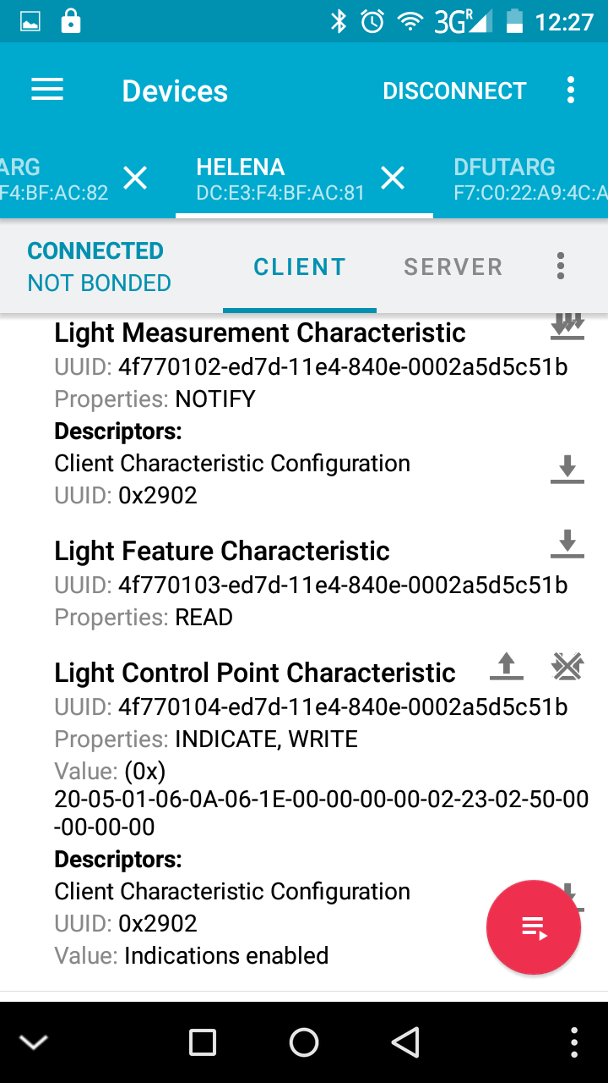Image 12: State configuration reply
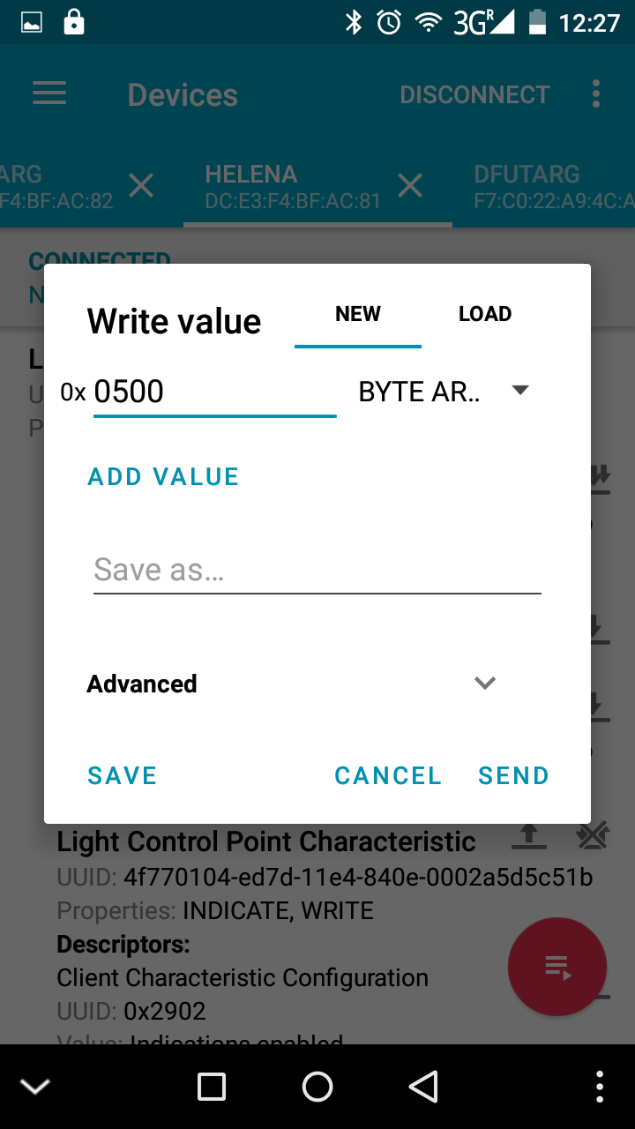Image 11: Read state configuration command

The reply in Image 12 represents the following setting:
Mode 1 | Spot Pitch compensated with 10lux
Mode 2 | Spot Pitch compensated with 35lux
Mode 3 | Not used
Mode 4 | Not used
Mode 5 | Spot constant with 35%
Mode 6 | Spot constant with 80%
Mode 7 | Not used
Mode 8 | Not used
- Change Mode Configuration
The command for changing the mode configuration is 0x06. Followed by the mode number to start and a list of new mode. It is not necessary to change all modes, it is possible to change only a few, too. The command in Image 13 will start with Mode 3 and has only a list of two modes. So this command will result in changing mode 3 to Spot pitch compensated with 10lux and Mode 4 to Spot pitch compensated with 35lux. The other states will keep their prior setting.
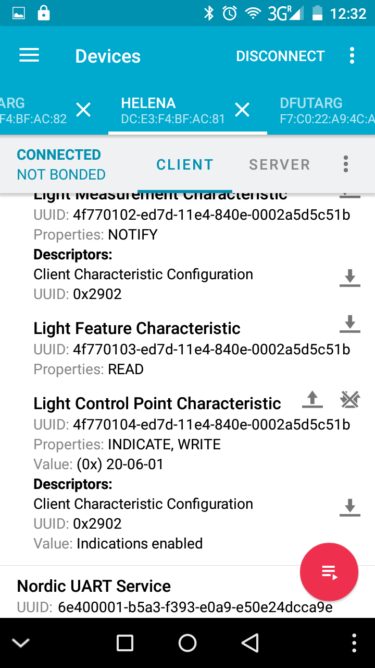Image 14: State change reply
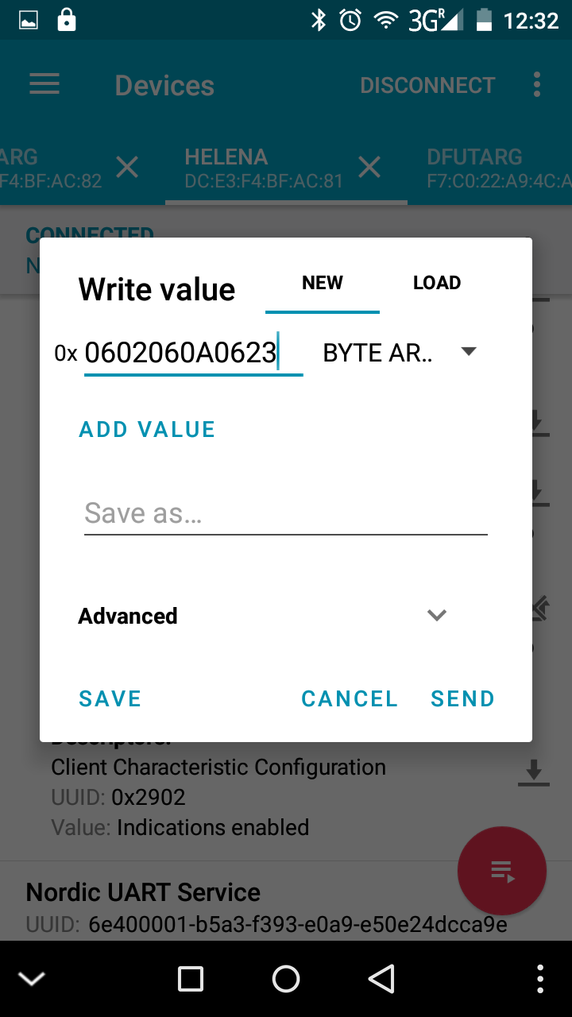Image 13: State change command
- Read Preferred Mode
The command for reading the preferred mode is 0x0D.
The Control Point will reply with the current mode number used as preferred mode.
- Set Preferred Mode
The command for setting the preferred mode is 0x0E, followed by the mode number to be used as preferred mode. Use an invalid mode number (>= 8) to deactivate the preferred mode.
- Read Temporary Mode
The command for reading the temporary mode is 0x0F.
The Control Point will reply with the current mode number used as temporary mode.
- Set Temporary Mode
The command for setting the temporary mode is 0x10, followed by the mode number to be used as temporary mode. Use an invalid mode number (>= 8) to deactivate the temporary mode.
- Firmware Update
First download the new firmware archive (normally named Helena_app.zip) from the Github repository in the folder Firmware/Helena_NRF_SDK10/bin/debug. To initiate the Firmware Update Process you have to plug in the lamp while keeping the button pressed. The Helena will activate the bootloader (indicated with the red LED).
Now open the App and start scanning. Connect to the “DfuTarg” and start the update by tapping on the small DFU icon in the top. Then select the previously downloaded firmware archive.
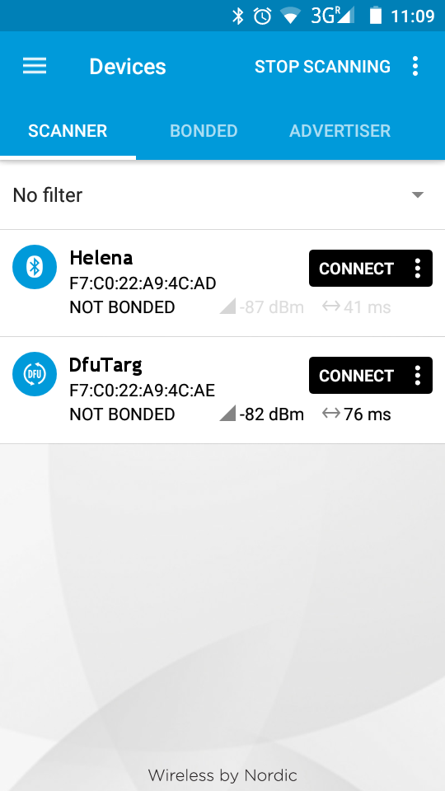Image 15: scan and connect to DfuTarg
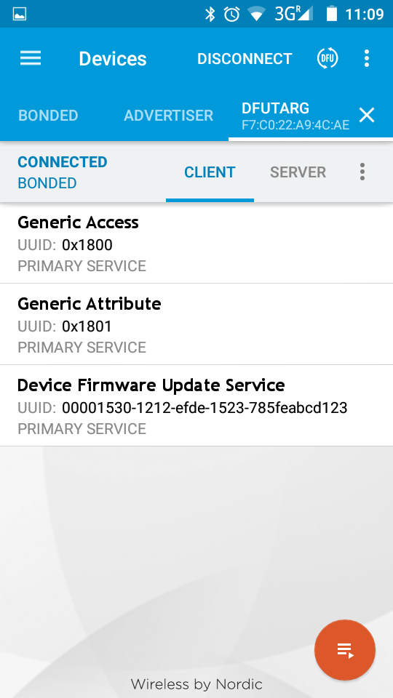Image 16: start update
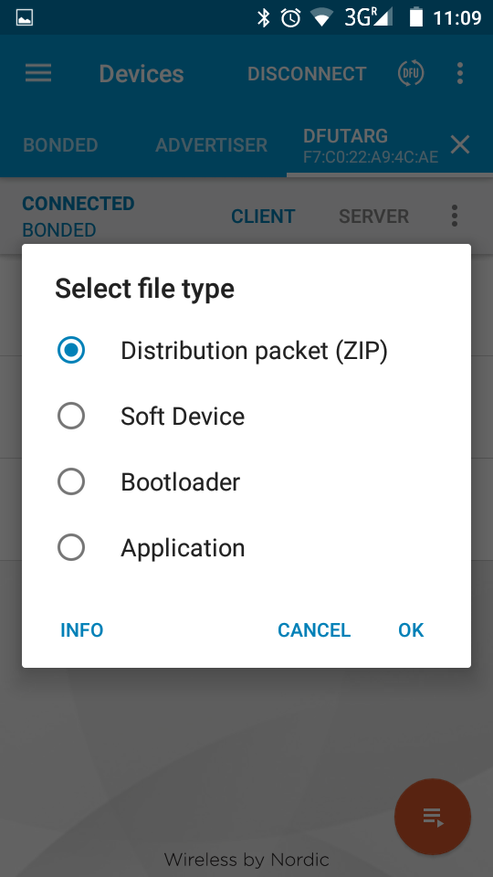Image 17: select Distribution packet (ZIP)
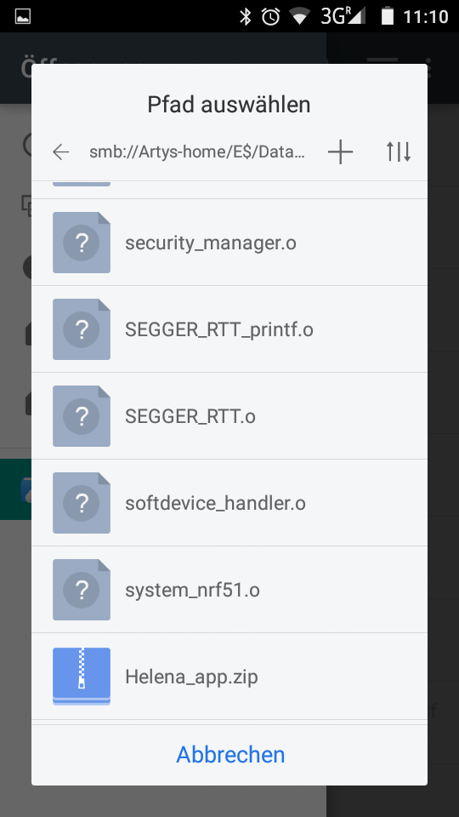Image 18: select firmware archive
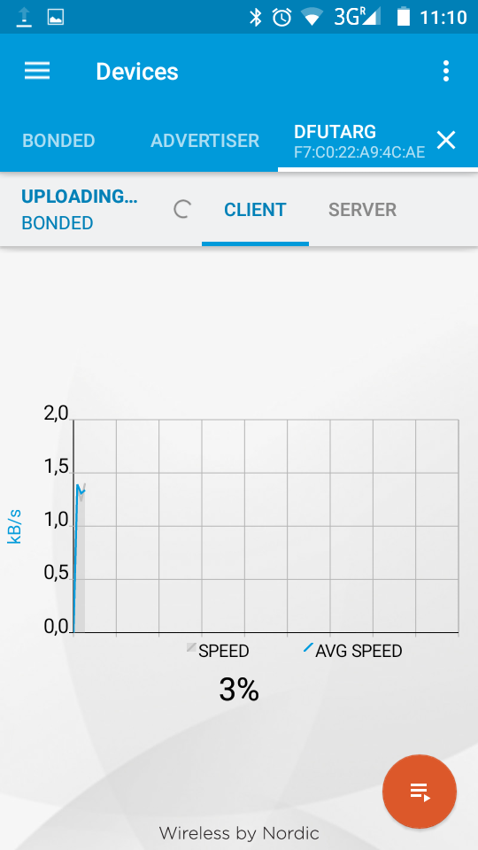Image 19: update starting
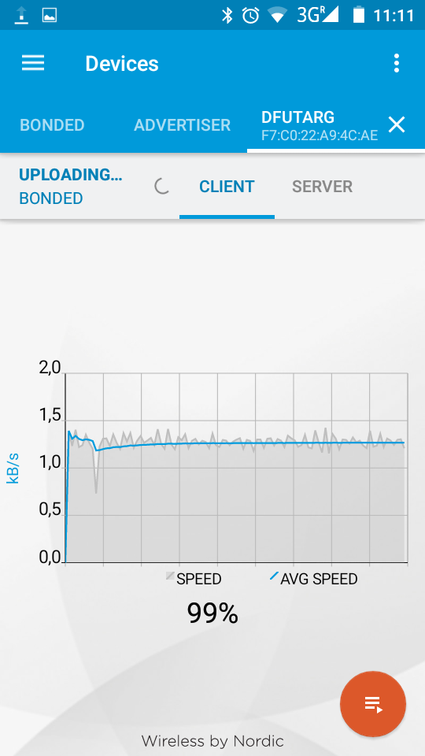Image 20: update finished

Internally the mode counter begins with 0, so to change mode 1 you have to select 0x00, for Mode 2 0x01, for Mode 3 0x02, ...
These are hexadecimal numbers, please use one of the plenty available online HEX to DEC converters.
Internally the mode counter begins with 0, so to change Mode 1 you have to select 0x00, for Mode 2 0x01, for Mode 3 0x02, ...

