Helena
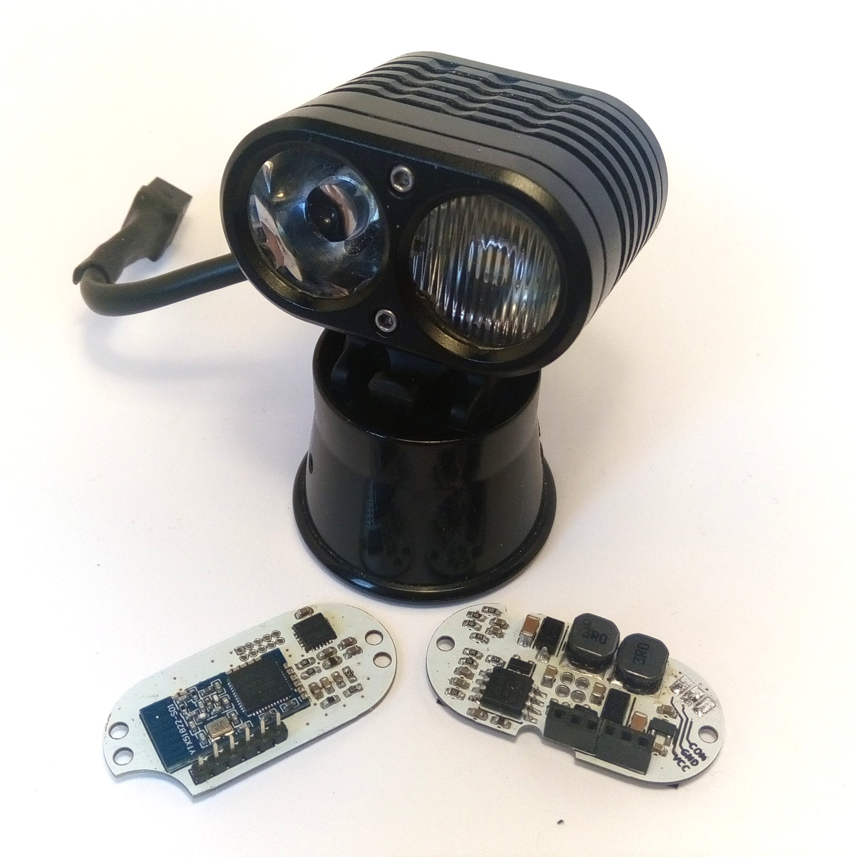

User Manual

Preface
Helena is an alternative driver for the popular Yinding or KD2 Headlight Cycling Lamp with following features:
- Two independent 3A Step-Down constant current sources, each capable of driving two white LEDs in series. The intended setup is one Cree XHP50 LED equipped with a flood optic and one Cree XM-L equipped with a spot optic.
- Integrated motion sensor to drive the LEDs in dependency of the head inclination, resulting a nearly constant brightness level, no matter if you're looking down or straight forward.
- Bluetooth interface for wireless remote control, lamp daisy-chaining and Smartphone based configuration.
- Integrated temperature regulation to prevent lamp from overheating.
- Smooth output power reduction when battery is low.
- Low standby current (less than 100µA).
- Works with input voltages between 3V and 4.25V (only 1 LED per current source), 6V and 8.5V and between 9V and 12.75V (max. output current is limited to 2.4A).
Index
1 Preface 2
2 Installation 5
2.1 Connections 5
2.2 Driver Swap for KD2 6
2.3 Driver Swap for Yinding 8
2.4 LED, lens and driver swap for Yinding 10
3 Usage 13
3.1 Modes and Groups 13
3.1.1 Helena Modes 13
3.1.2 Billina Modes 14
3.1.3 Groups 14
3.1.4 Preferred Mode 15
3.1.5 Temporary Mode 15
3.2 Remote Connection 15
3.2.1 Xiaomi Yi Remote Control 15
3.2.2 R51 Remote Control 16
3.2.3 Connecting with other Helena 16
3.3 Button Control 17
3.3.1 Integrated button 18
3.3.2 Xiaomi Yi remote control 18
3.3.3 R51 remote control 19
3.4 Remote Synchronization 19
3.5 Status LED 20
Appendix A Configuration with nrf Connect 21
A.1. En-/Decoding modes 24
A.2. Read Group Configuration 26
A.3. Change Group Configuration 27
A.4. Read Mode Configuration 28
A.5. Change Mode Configuration 29
A.6. Read Preferred Mode 30
A.7. Set Preferred Mode 30
A.8. Read Temporary Mode 30
A.9. Set Temporary Mode 30
A.10. Firmware Update 31

Installation

Connections
Flood Anode
Spot Anode
VCC
GND
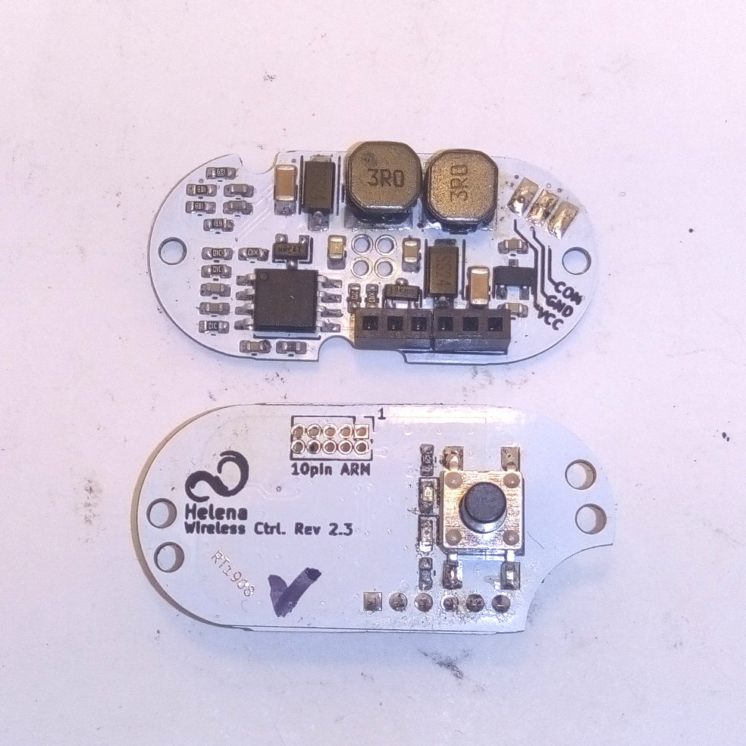Image 1: board connections
Flood Cathode
Spot Cathode
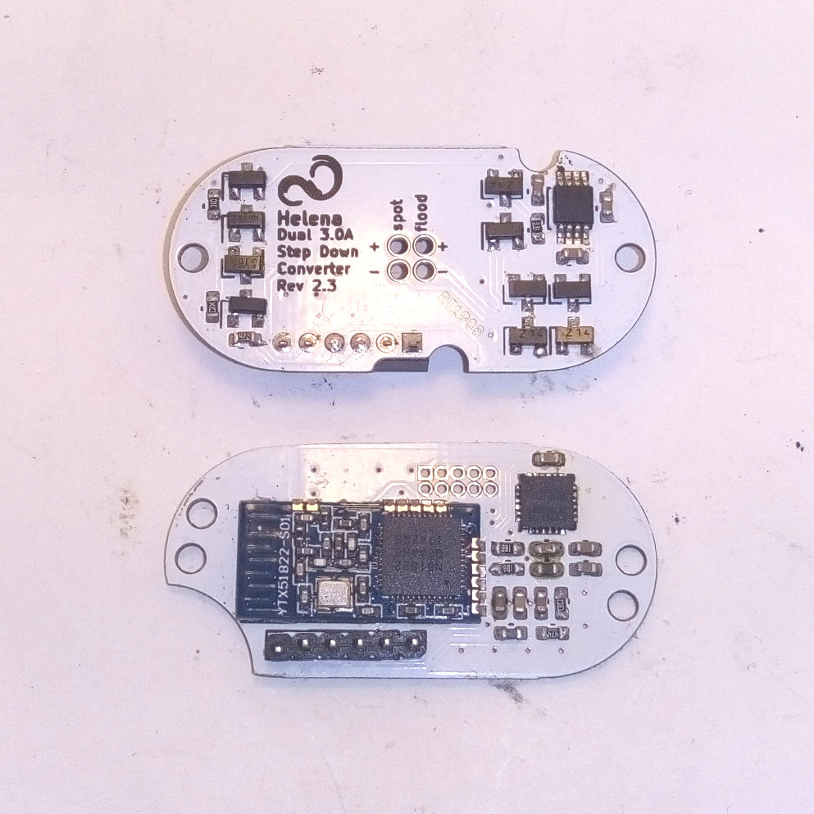Image 2: board connections
Flood Cathode
Spot Cathode
Spot Anode
Flood Anode

Driver Swap for KD2
- Disassemble lamp and remove old driver. Mount LED board witch the notches facing to the top and route both cables through the left one. Then cut the cables to a length of 20-25mm and cover the screws with electric tape.
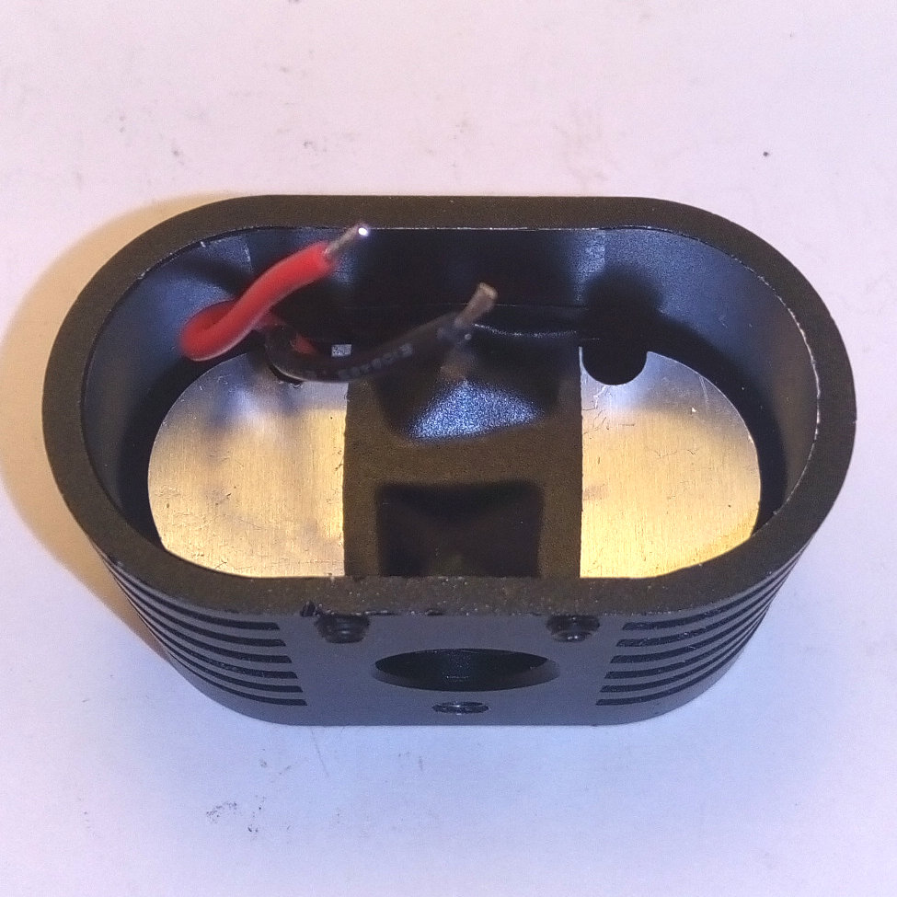Image 3: LED board preparations
- Connect the LED cables to the spot driver output of the LED driver. Route the cables as shown in the image.
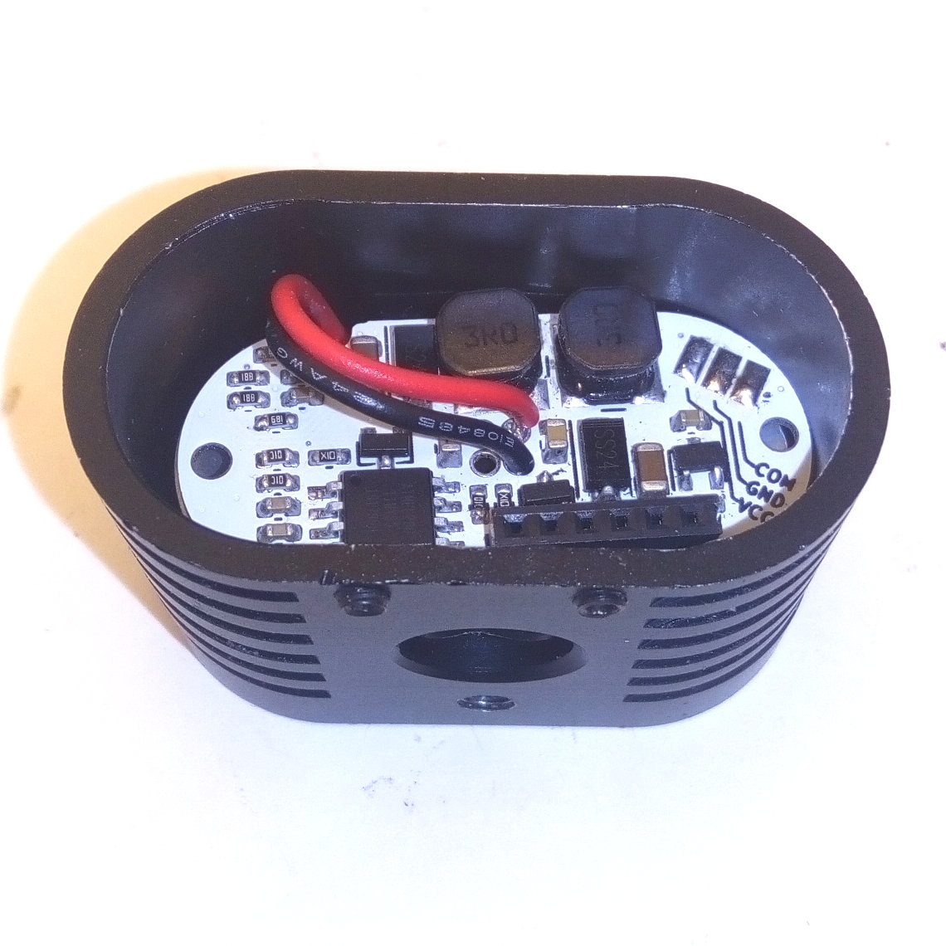Image 4: LED connection
- Attach the power cable (and optionally the communication line). Route the cables along the board-to-board connector and use the notch next to it to lead it through the opening.
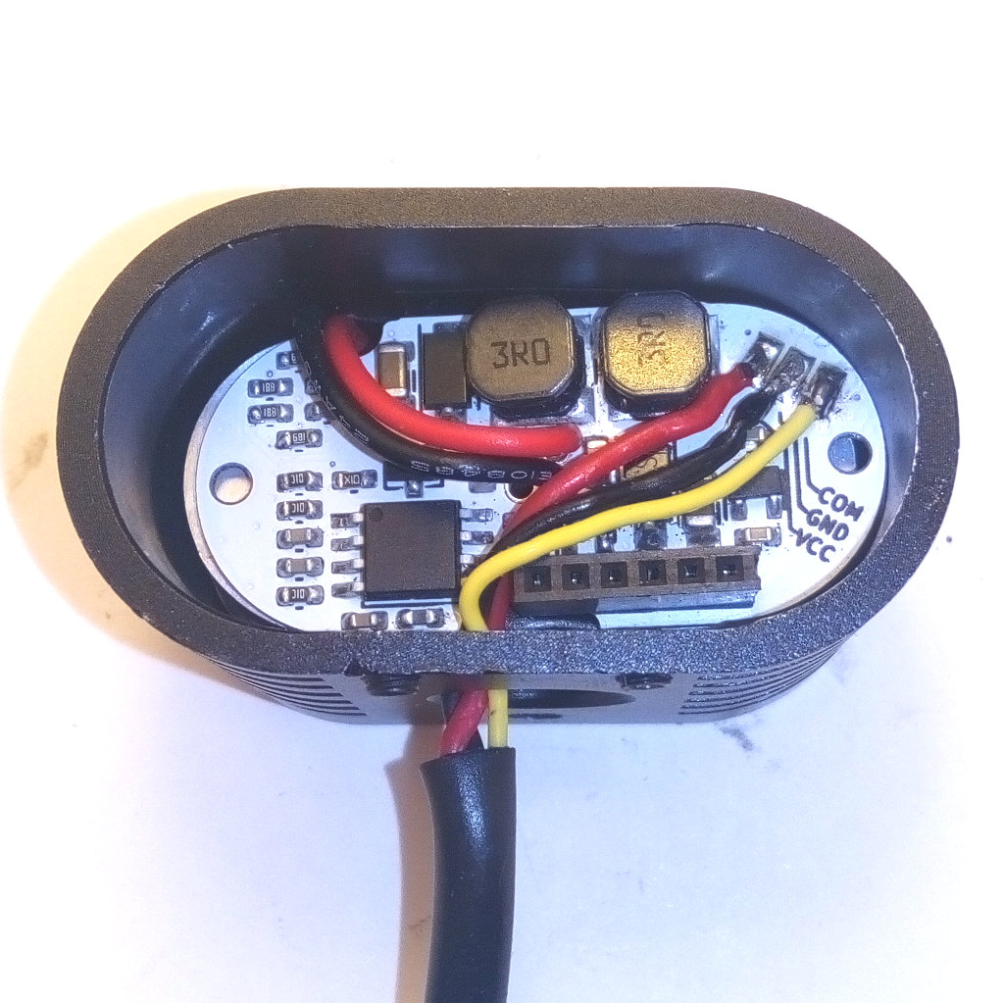Image 5: power cable routing
- Mount the controller board to the lid.
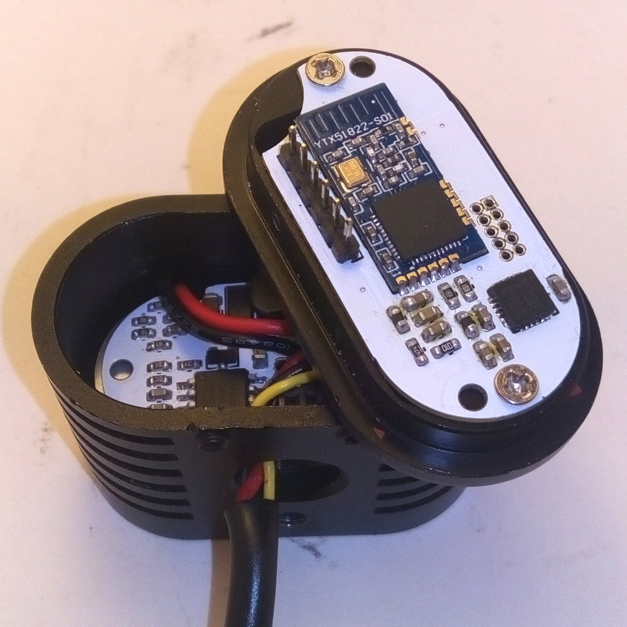Image 6: mounted Controller board
- Put a pair of tweezers, zip ties, toothpicks or a similar object between the LED- and driver board to lift it a couple of millimeters, then put the lid on and.
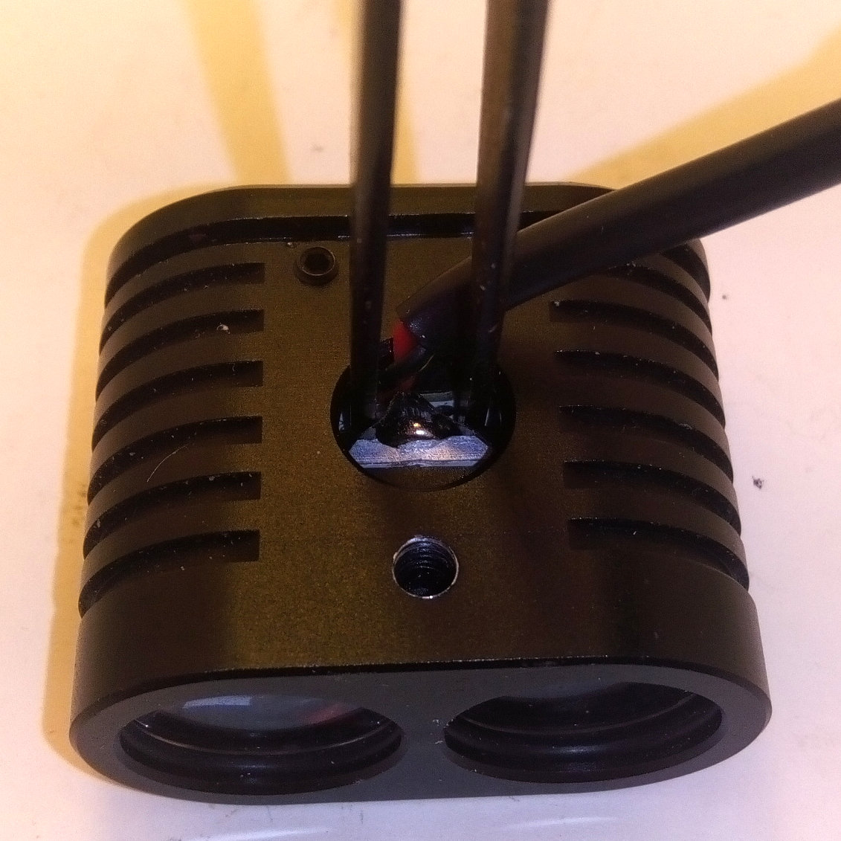Image 7: Lift driver board for proper connection
- When the connector fits properly, remove the tweezers, close the lid and you are done.
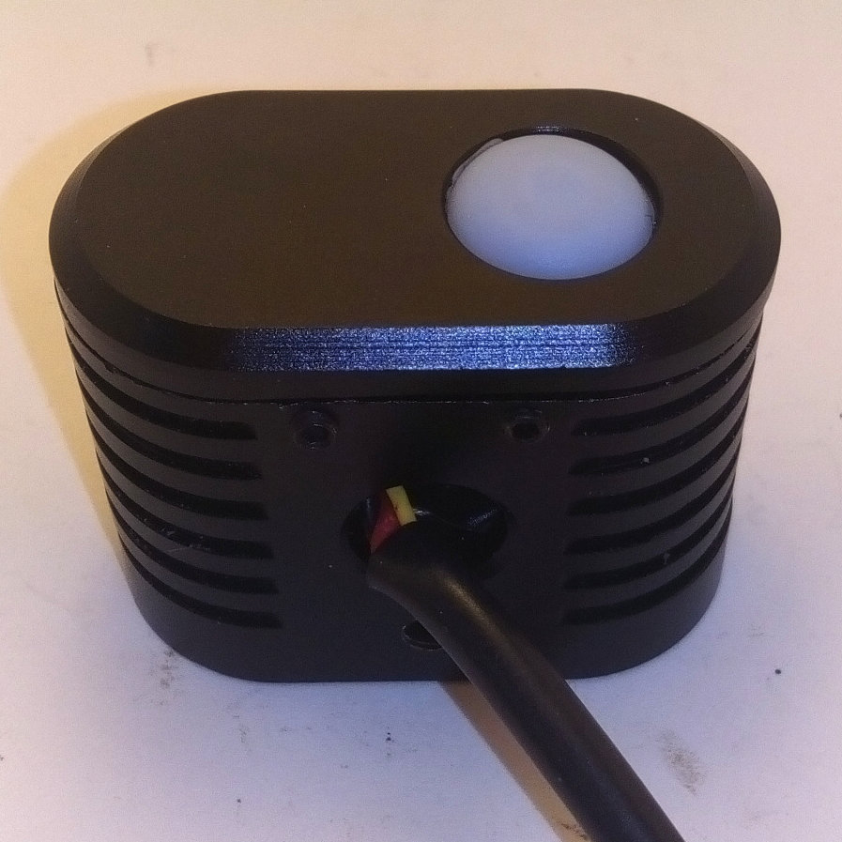Image 8: closed lid

Driver Swap for Yinding
- Disassemble lamp and remove old driver. Cut the cables to a length of 20-25mm.
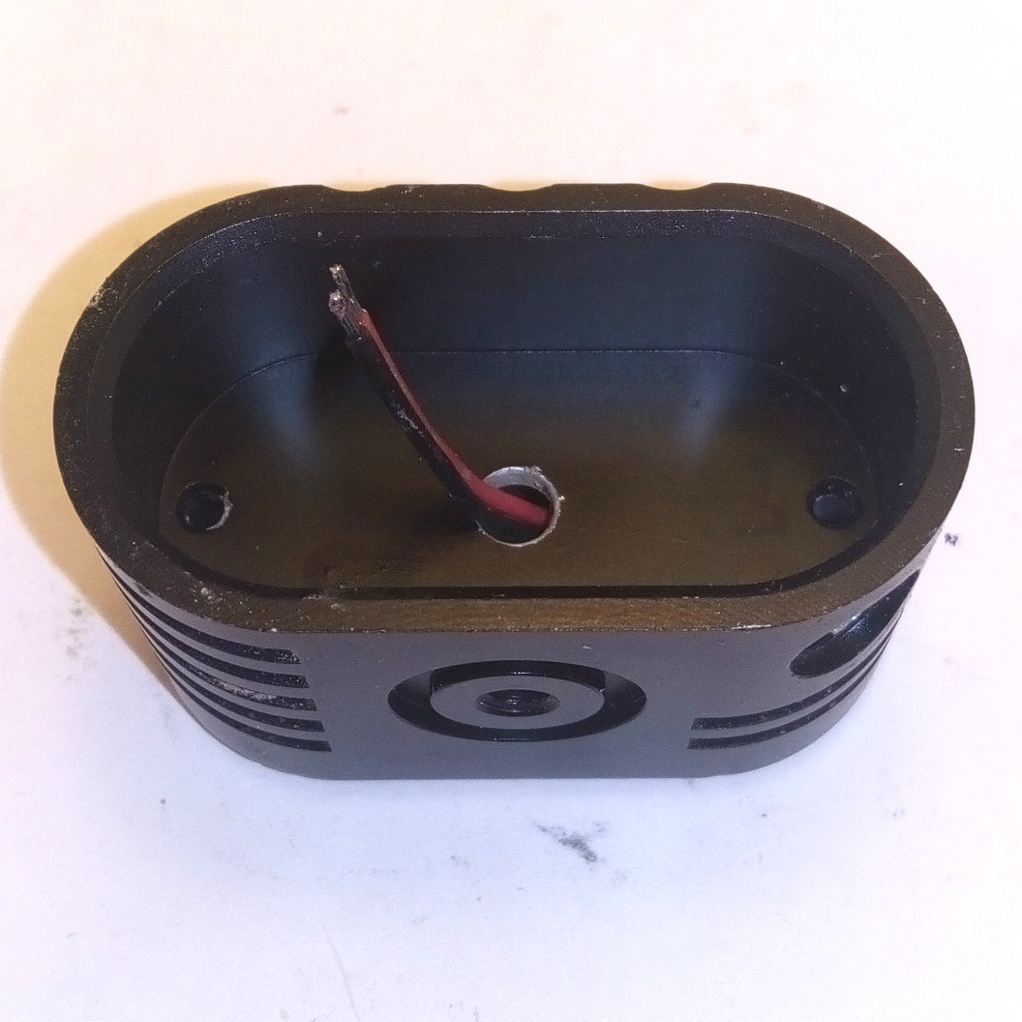Image 9: prepared LED cables
- Attach the power cable (and optionally the communication line) Don’t forget to run the cable through the opening in the lamp body.
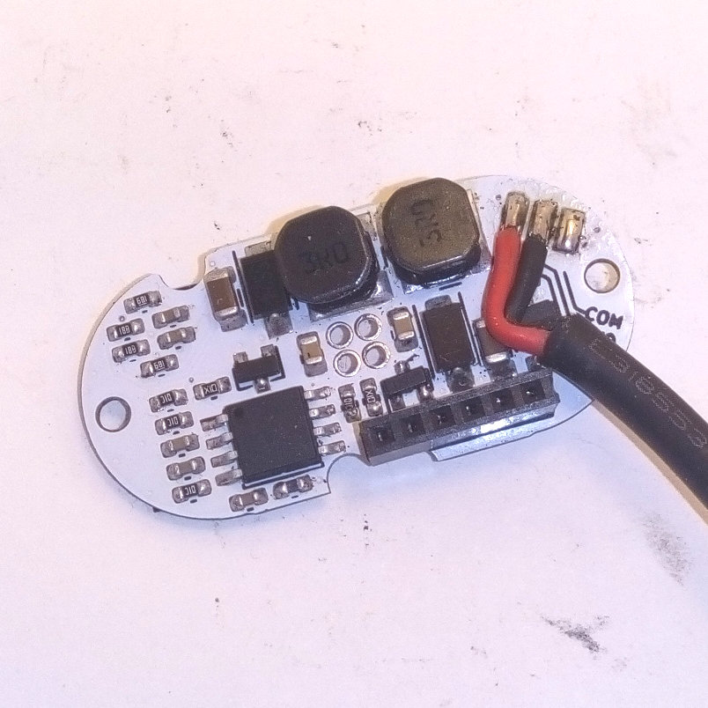Image 10: attached power cable
- Now attach the cables from the LED board to the spot output. Connect them from the bottom side.
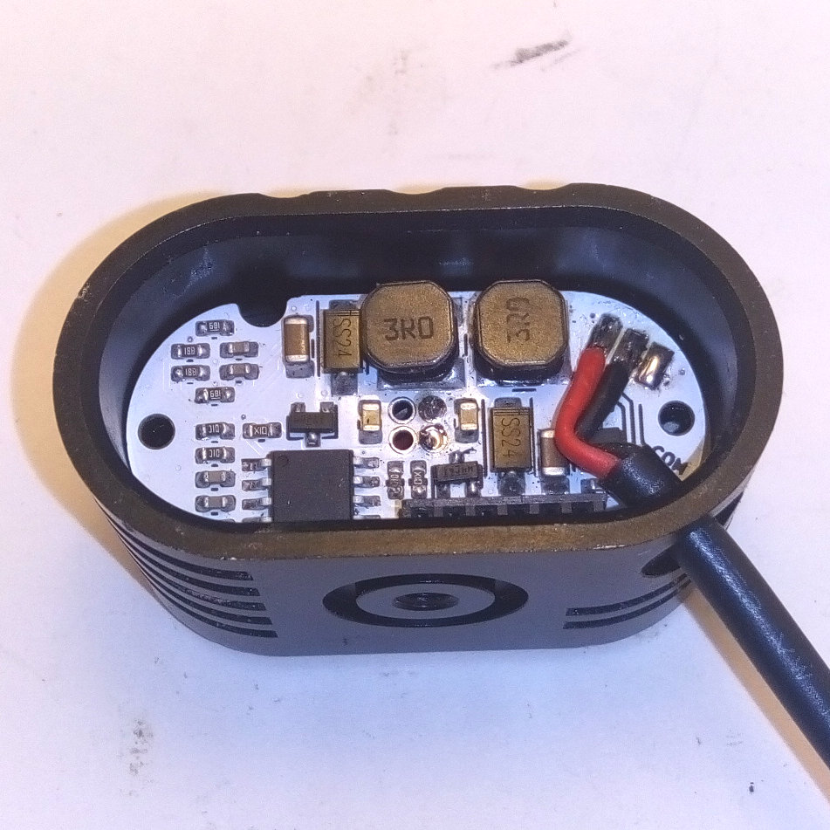Image 11: attached LED cables
- Mount the controller board to the lid.
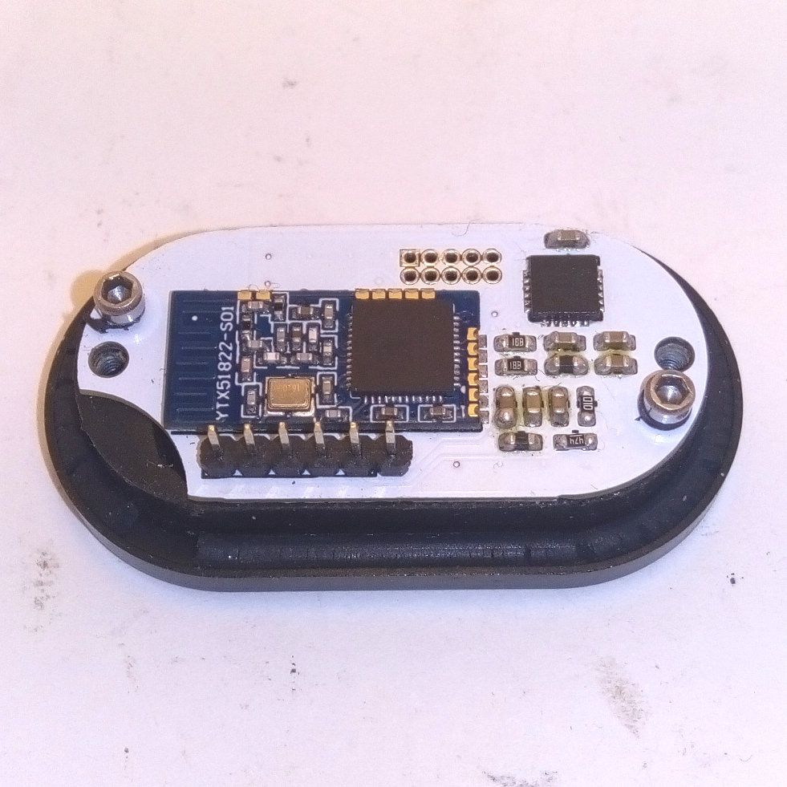Image 12: mounted Controller board

- Close the lid and reassemble the lamp.

LED, lens and driver swap for Yinding
- Prepare LED boards by attaching cables and cutting them to a length of 25-30mm.
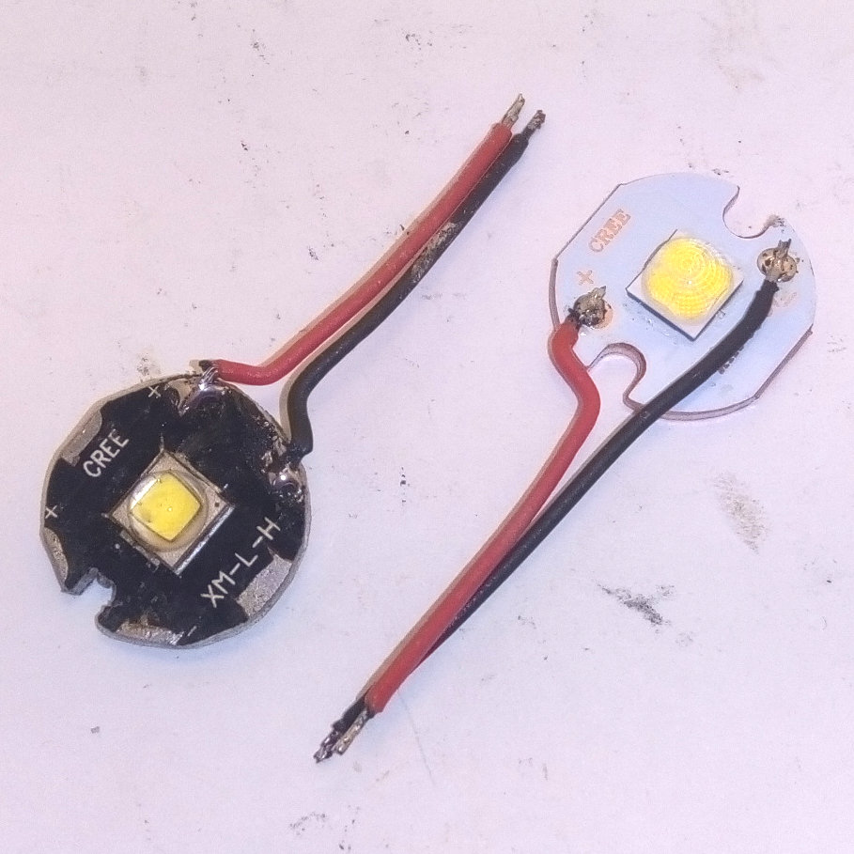Image 13: prepared LED boards
- Attach the power cable (and optionally the communication line) Don’t forget to run the cable through the opening in the lamp body.
Image 14: attached power cable
- Route the LED boards cables through the inner hole.
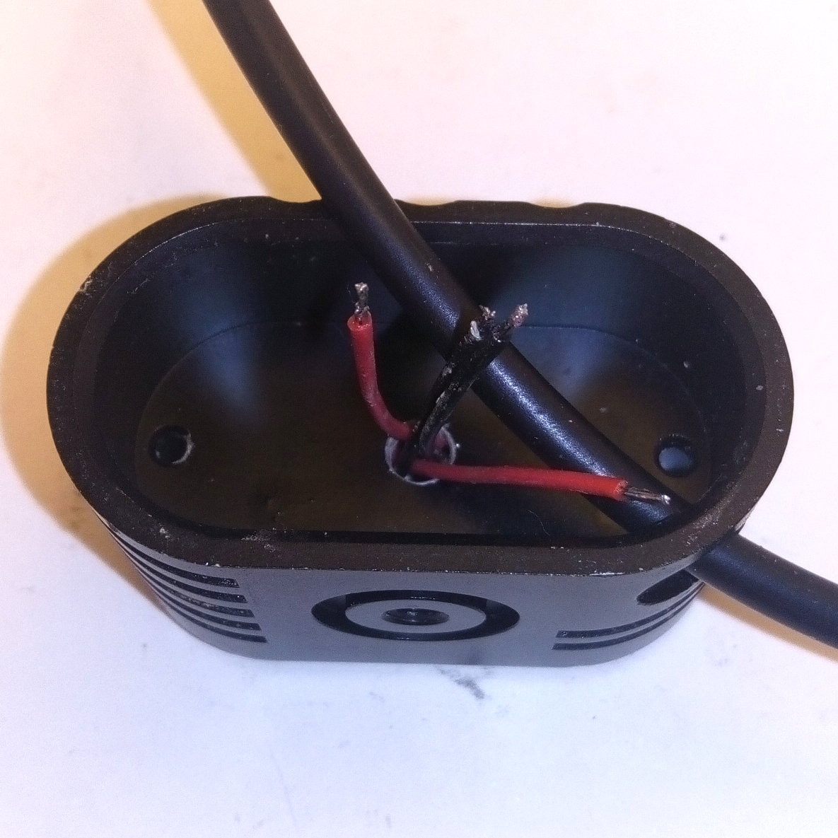Image 15: cable routing
- Now attach the cables from the bottom side. Solder the cables of the XHP50 to the flood output and the cables of the XM-L to the spot output.
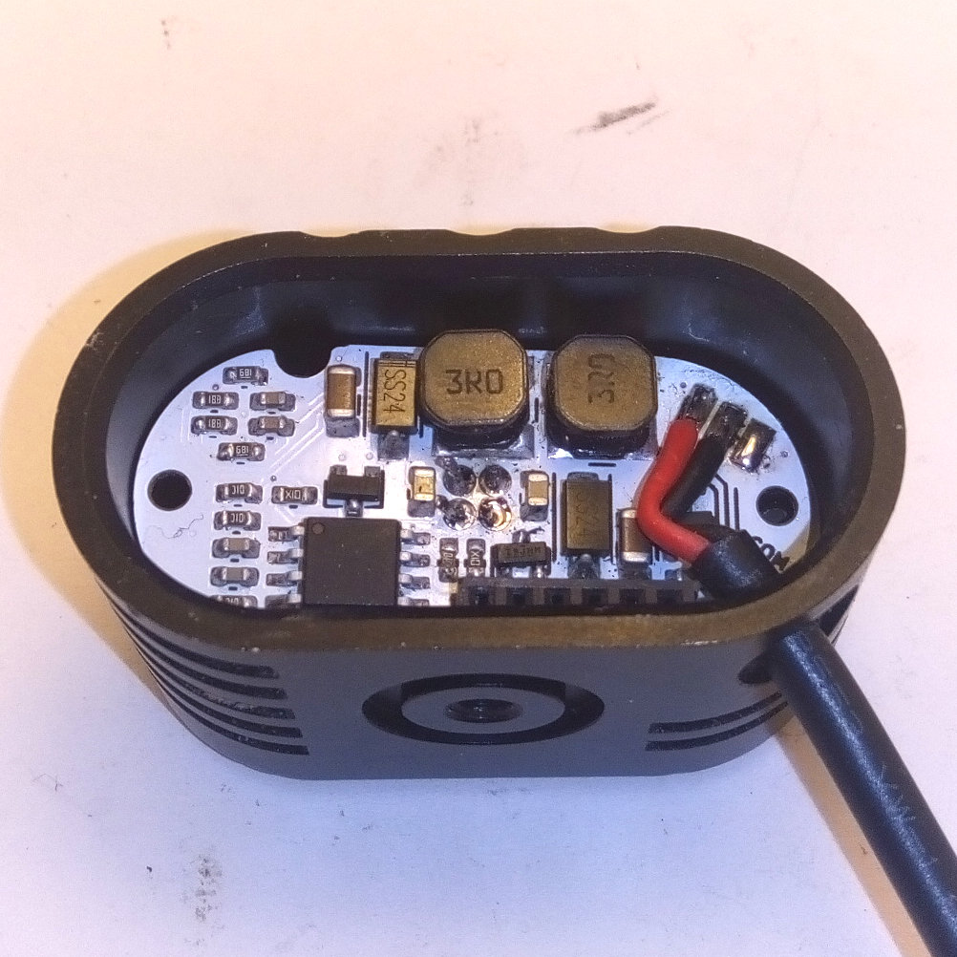Image 16: attached LED boards cables
- Mount the controller board to the lid and close the lid.
Image 17: mounted Controller board
- Flip the lamp around and tighten the screws to secure the lid and LED boards. Position the XHP50 board a bit to the top and the XM-L board a bit to the bottom.
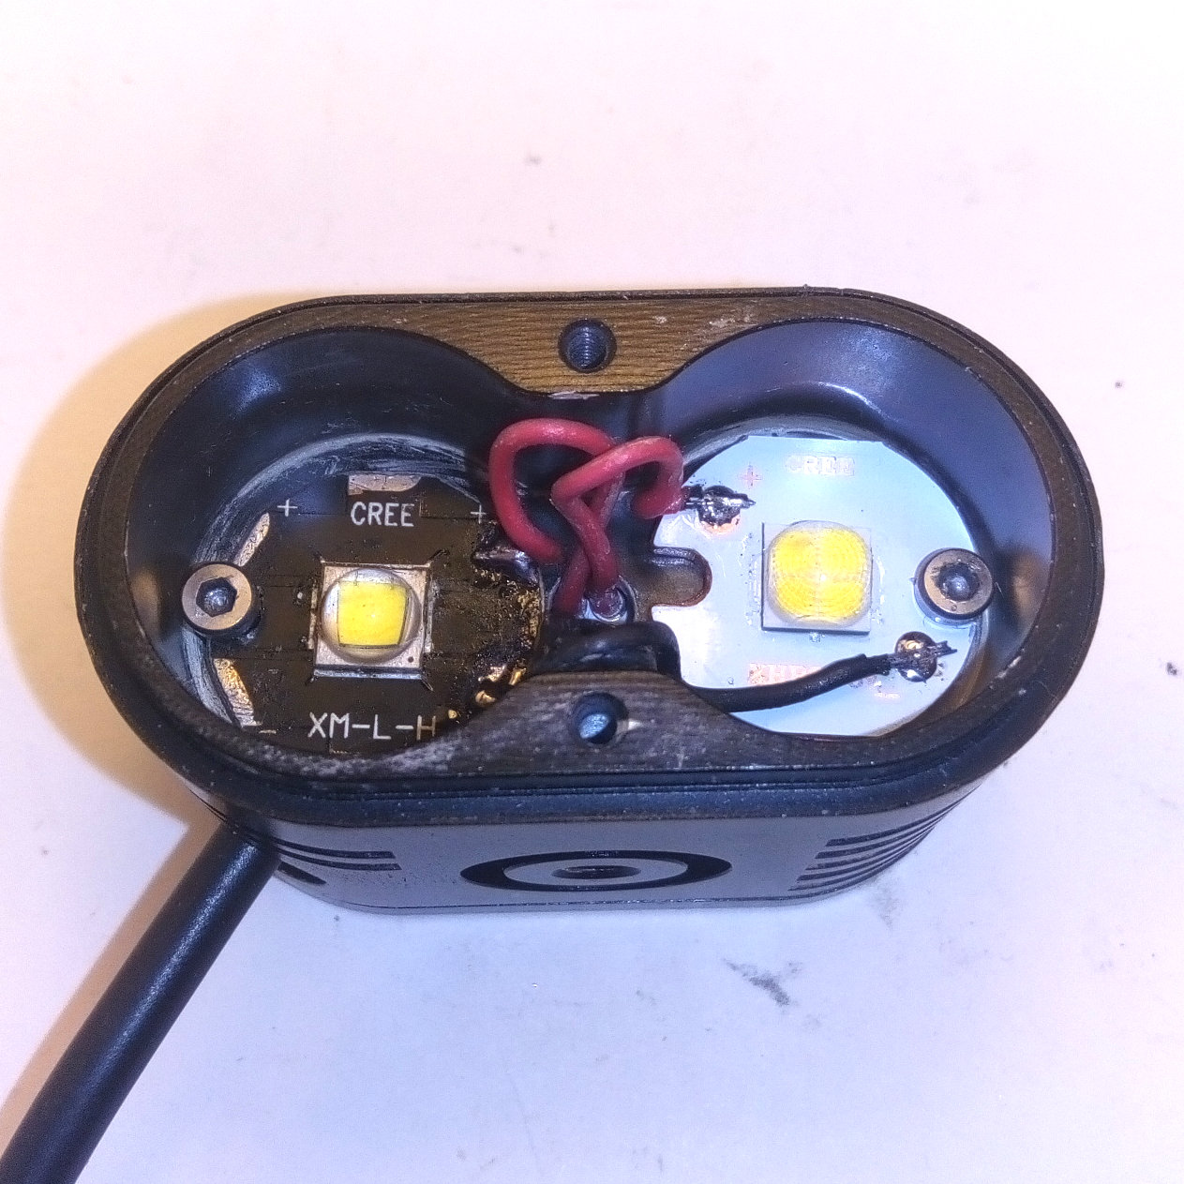Image 18: LED boards alignment
- Insert the lenses and use some spacers to tilt the spot lens upwards and the flood lens downwards. The spacers should have a height of 0.7-1.0mm, a quartered O-Ring works fine.
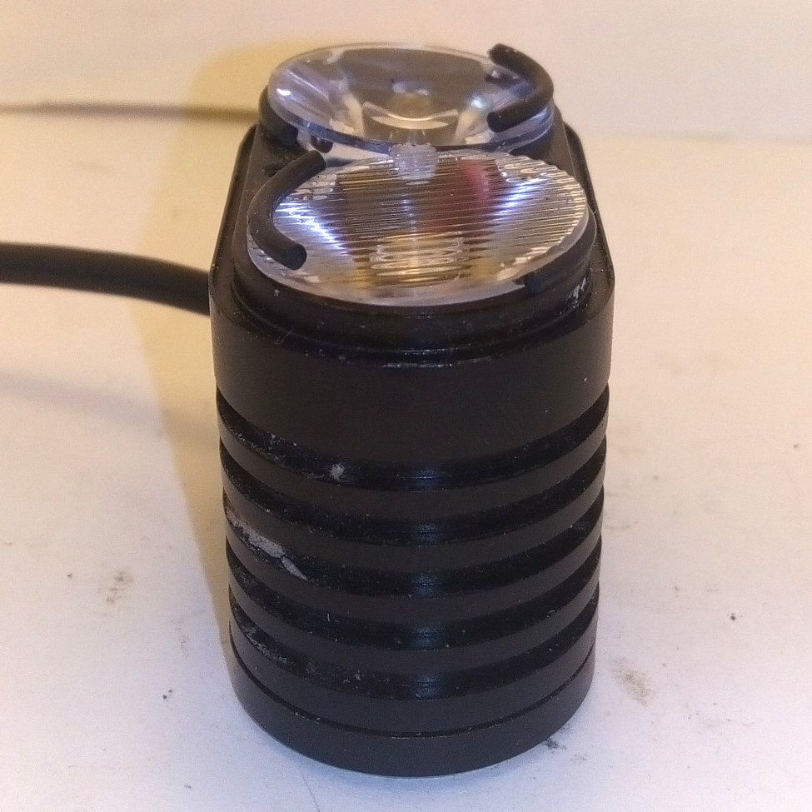Image 19: tilted lenses
- Finally mount the lens cover.
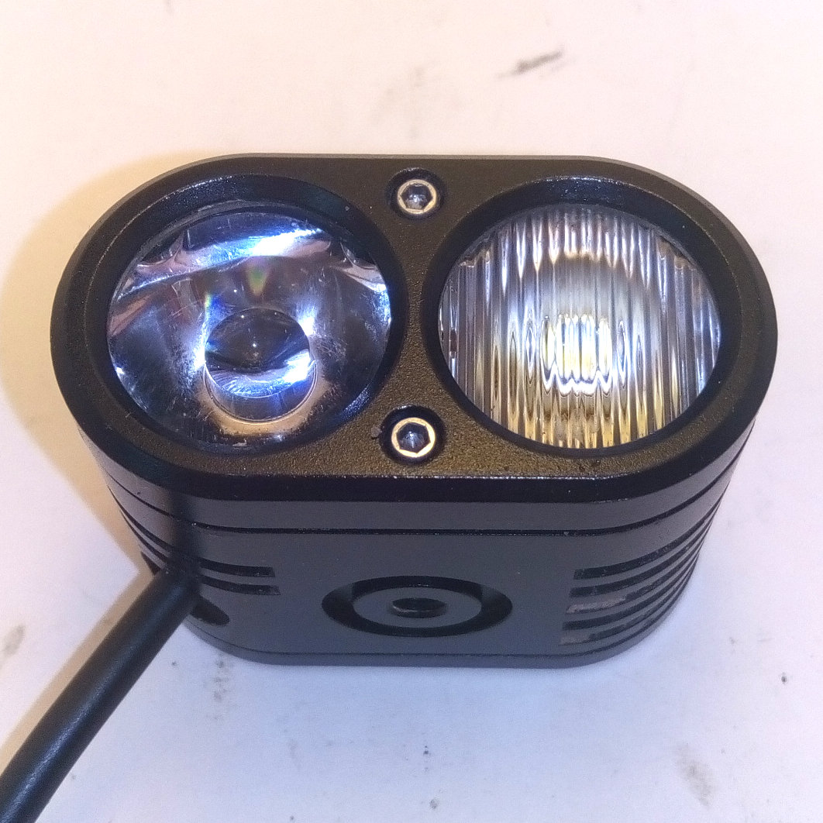Image 20: reassembled

Usage

Modes and Groups

Helena Modes
Helena has 8 individually configurable modes. Each mode is defined by several setup flags and an intensity field.
Here is a description of the setup flags:
- flood:
If this flag is set, the flood driver circuit is enabled.
- spot:
If this flag is set, the spot driver circuit is enabled.
- pitch compensation:
If this flag is set, the pitch compensation algorithm is enabled. This means, the enabled drivers are not delivering a constant current, instead the output current is depending on the pitch angle of the lamp. Pointing it down, reduces the output current, pointing towards the front increases the output current.
- cloned:
This flag can only be set, if only one output is selected (either flood, or spot). If it is selected, the output of the selected driver will be cloned to the other driver circuit as well.
The meaning of the intensity field is depending on the state of the pitch compensation flag. If the flag is set, it represents the desired maximum illumination in lux, otherwise it represents the desired output current in %.

Billina Modes
Helena can alternatively be loaded with the Billina firmware. This is the recommended firmware, if you want to mount the light on the handlebars. With this firmware each mode is defined by two setup flags and two intensity fields
Here is a description of the setup flags:
- main beam: If this flag is set, the flood driver is enabled.
- high beam: If this flag is set, the spot driver is enabled.
The first intensity field represents the output current in % for the main beam, the second for the high beam.

Groups
The 8 modes can be configured in either
- 1 group with 8 modes,
- 2 groups with 4 modes each or
- 4 groups with 2 modes each.

Preferred Mode
One of the 8 available modes can be selected as the preferred mode. If one mode is selected as the preferred mode this will change the switch off behavior. With activated preferred mode the will only shut off, if it already is in the preferred mode. Otherwise a shut off command will result in a jump to the preferred mode.

Temporary Mode
One of the 8 available modes can be selected as a temporary mode. If a mode is selected as temporary mode, it is possible to jump directly into this mode. When leaving the mode, Helena jumps back to the previously used mode.

Remote Connection
Currently three different types of remote connections are supported.

Xiaomi Yi Remote Control
To connect Helena with a Xiaomi Yi remote, you have to
- shut of Helena,
- make sure, that all other unwanted compatible devices are shut of or out of range,
- wake up the remote by clicking any button (If the remote’s led flashes blue this means that is already in connection with another device. This has to be disconnected first),
- press Helena’s button for at least 2 sec.
Helena will save this device, and automatically reconnect if available.

R51 Remote Control
To connect Helena with a R51 remote, you have to
- shut of Helena,
- make sure, that all other unwanted compatible devices are shut of or out of range,
- put the remote in pairing mode by pressing the mode button at least 2 sec. until the remote’s led is blinking green-white.
- press Helena’s button for at least 2 sec.
Helena will save this device, and automatically reconnect if available.

Connecting with other Helena
To connect Helena with a another Helena, you have to
- shut of Helena,
- make sure, that all other unwanted compatible devices are shut of or out of range,
- wake up the remote Helena (e.g. by power cycling).
- press Helena’s button for at least 2 sec.
Helena will save this device, and automatically reconnect if available.

Button Control
There are 4 button control commands:
- next mode:
This command jumps to the next mode.
If this mode is not used, it is skipped.
If the last mode within a group is reached, it will roll over to the first mode.
If the light is currently off it jumps to the first mode.
- next group:
This command jumps to the next group.
If the group does not contain any valid mode, it will be skipped.
If the current group is the last group, this command will jump to the first group.
If the light is currently off, it jumps to the first mode in the second group.
- preferred mode:
If the preferred mode is not set, the light will shut off.
If the preferred mode is set, the light will jump directly to the preferred mode.
If the light is already in the preferred mode, it will shut off.
- temporary mode:
If the temporary mode is set, the light will jump into the temporary mode and jumps back to the previous mode.

Integrated button
- short click:
next mode command
Image 21: integrated button
- long click:
next group command
- press and hold > 2 sec., light is off:
start searching for remotes (previously saved remote connections will be deleted)
- press and hold > 10 sec., light is off:
initiate a factory reset and reset device afterwards
- press and hold > 2 sec., light is on:
preferred mode command
- press and hold > 10 sec., light is on:
enter SOS mode (not available in billina firmware)

Xiaomi Yi remote control
- main button, short click:
next mode command
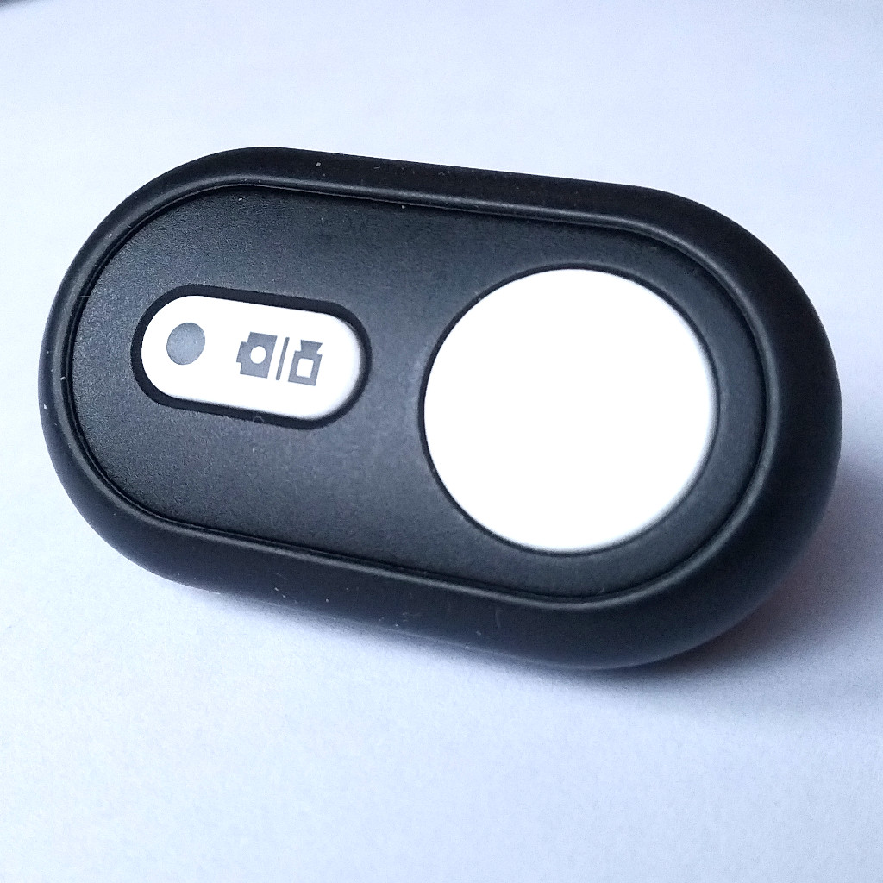Image 22: Xiaomi Yi RC
- main button, long click:
next group command
- secondary button, short click:
preferred mode command
- secondary button, press and hold > 2sec.:
enter temporary mode
- secondary button, release after hold:
leave temporary mode

R51 remote control
- volume up button, short click:
next mode command
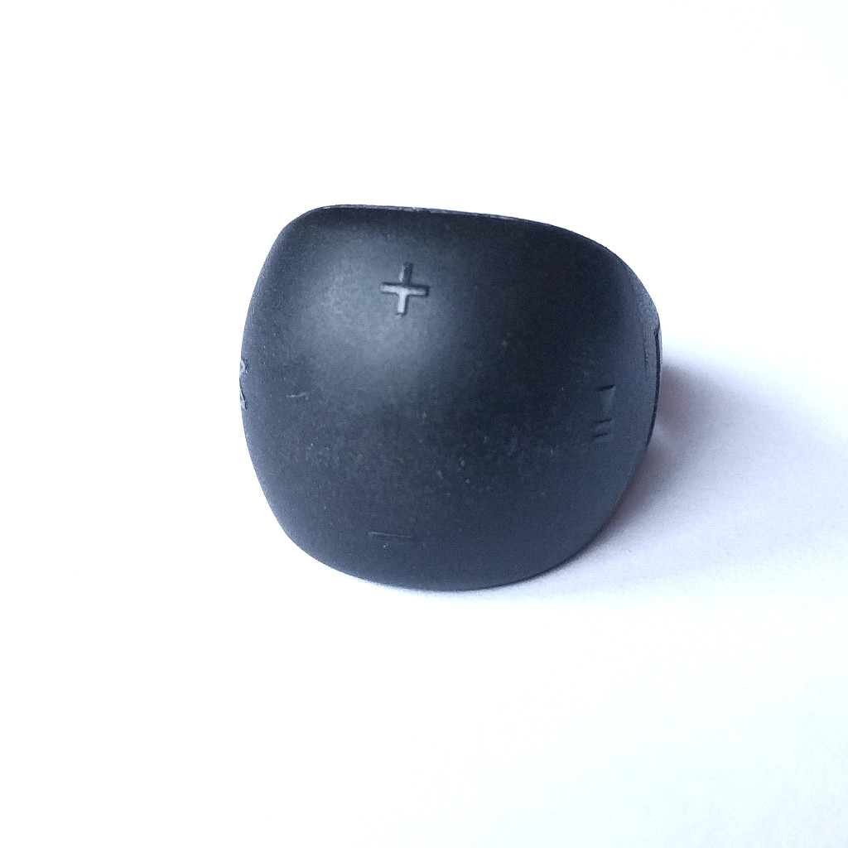Image 23: R51 remote
- volume down button, short click:
next group command
- play/pause button, short click:
preferred mode command
- mode button, short click:
enter/leave temporary mode

Remote Synchronization
If Helena is connected to another lamp, both lamps will synchronize their current mode. This means if one light receives a button command, it will change its mode according to the description in the previous chapter and then relay this new mode (the number, not the configuration!) to the other lamp.
This lamp will then also jump into this mode, nevertheless if this mode is used or not. With this behavior it is possible to generate configurations where one lamp is on and the other not.

Status LED
Helena is equipped with a red and blue status LED, which is visible through the transparent button cap.
The blue LED gives information about the wireless connection. If is on, Helena is connected to a remote or another lamp. A fast blinking indicates, that Helena is searching for any compatible device. A slow blinking blue LED indicates, that Helena is searching for a already known device.
The red on turns on whenever the output is limited due to high temperature or dropping input voltage.
When Helena enters standby mode, the Status LED is shut off for minimum current consumption (but an established connection or the scanning for a known device will not be stopped).

Configuration with nrf Connect
This section is only valid for Firmware revisions ≥ 1.0.0
The Configuration of states and group can be done with the App “nrf Connect” from Nordic Semiconductors.
- Plug in battery to Helena and open the App. Select SCANNER and then start scanning. Helena will then appear in the device list and you can press the CONNECT button.
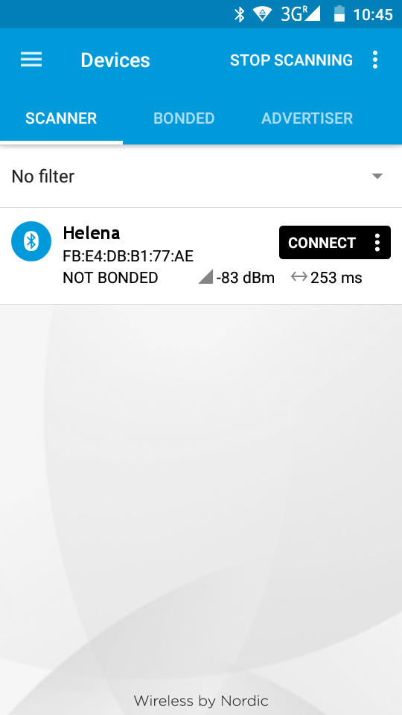Image 24: Scanning
- After you connected to Helena, you will see a list of available services. Select the Light Control Service. Compare the UUIDs if the service is named Unknown Service.
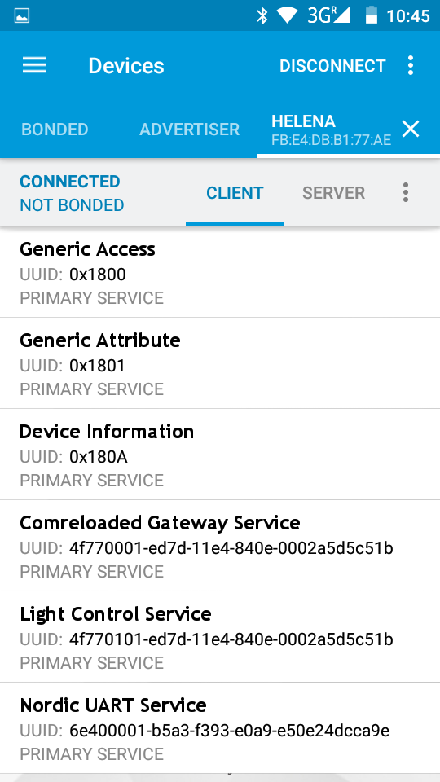Image 25: Services list
- Go to the Light Control Point Characteristic (it may be named Unknown Characteristic, in this case compare the UUIDs again) and enable the indications by touching the arrow-up and arrow-down symbol.
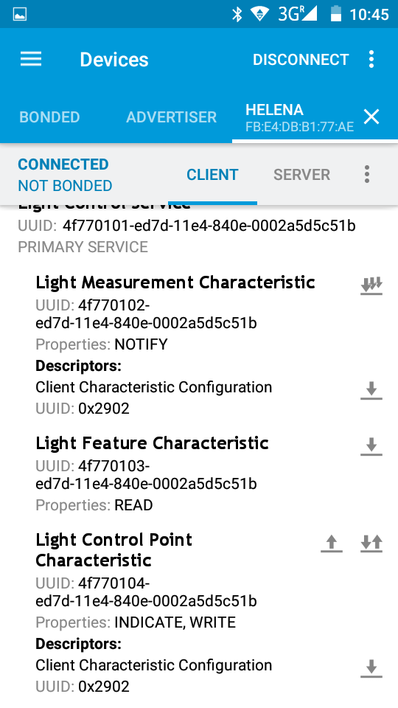Image 26: Light Control Service
- After you have enabled the indications for the Light Control Point you are ready to send commands to read out the actual configuration and to change it, too. To send a command you have to click the arrow-up symbol, then you can enter the desired command. The Control will reply with at least 3 bytes:
The first byte is always 0x20.
The second byte is the command this reply belongs to.
The third byte is a status byte.
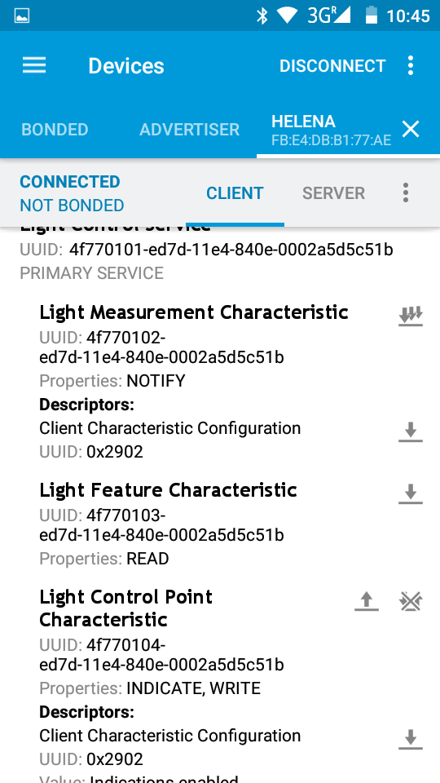Image 27: Send commands
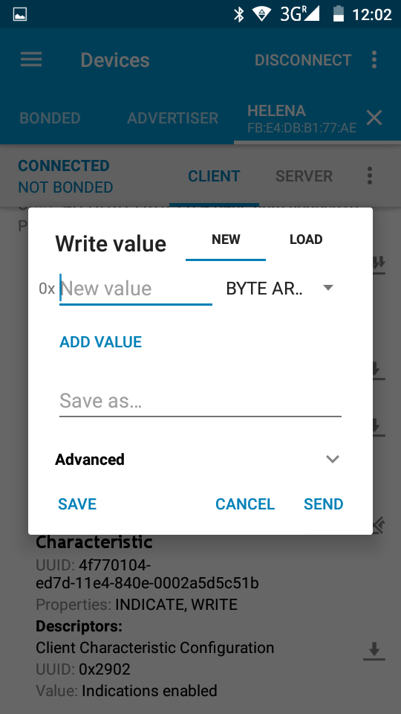Image 28: Send commands
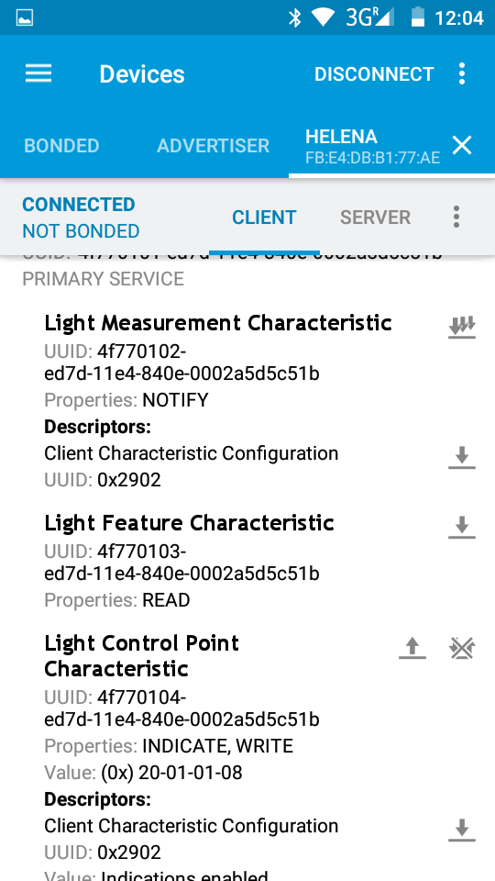Image 29: Command reply
Status Byte Value | Description
0x01 | Success
0x02 | Not supported
0x03 | Invalid parameter
0x04 | Operation failed
Depending on the command there my be additional data bytes.
- En-/Decoding modes
With the Helena firmware each mode consists of one setup byte and one intensity byte:
setup flags | intensity

reserved | reserved | reserved | reserved | output cloned | pitch comp. | spot enabled | flood enabled

setup value | active drivers | meaning of intensity byte
0x00 | off
0x01 | flood | output current in %
0x02 | spot | output current in %
0x03 | flood & spot | output current in %
0x05 | flood pitch compensated | target illumination in lux
0x06 | sport pitch compensated | target illumination in lux
0x07 | flood & spot pitch compensated | target illumination in lux
0x09 | both drivers | output current in %
0x0A | both drivers | output current in %
0x0D | flood pitch compensated on both drivers | target illumination in lux
0x0E | spot pitch compensated on both drivers | target illumination in lux

With the Billina firmware each mode consists of one setup byte and two intensity bytes.
setup flags | main beam intensity in % | high beam intensity in %

reserved | reserved | reserved | reserved | reserved | high beam enabled | reserved | main beam enabled

setup value | active drivers
0x00 | off
0x01 | main beam
0x04 | high beam
0x05 | main & high beam

- Read Group Configuration
The command for reading the current group configuration is 0x03.
The Control Point will reply with the actual number of groups in the fourth byte.
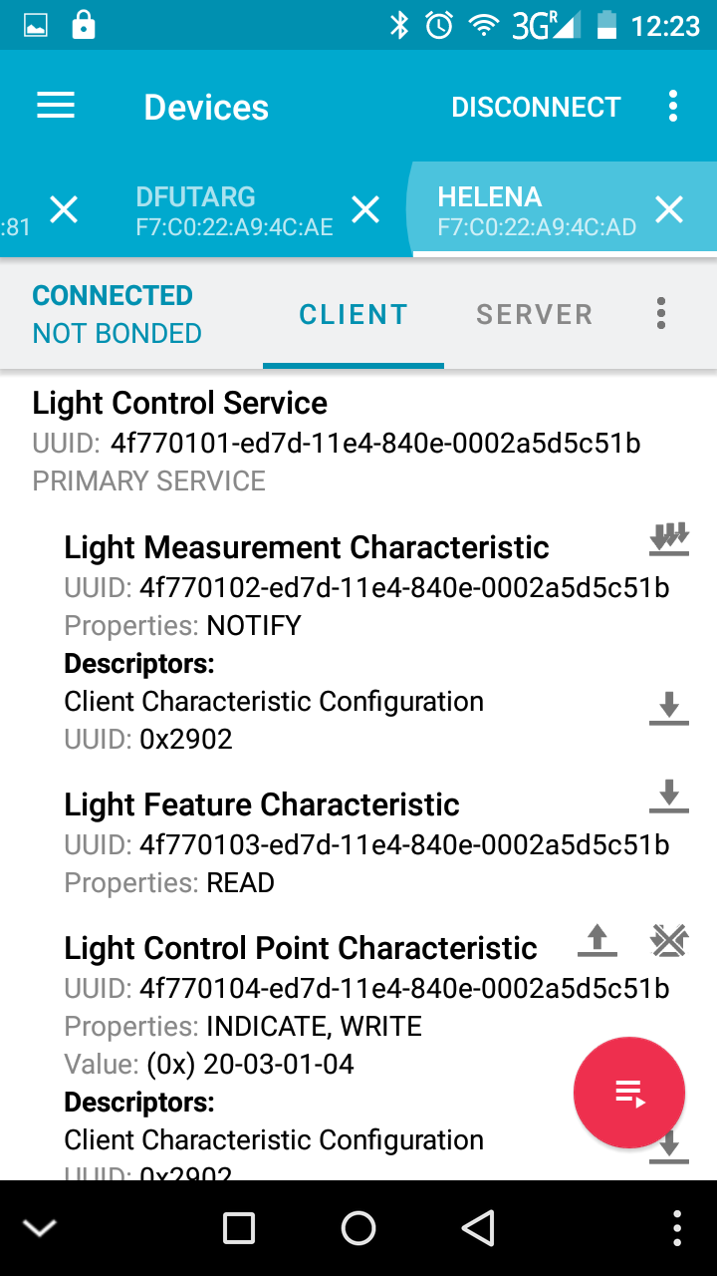Image 31: Group configuration reply
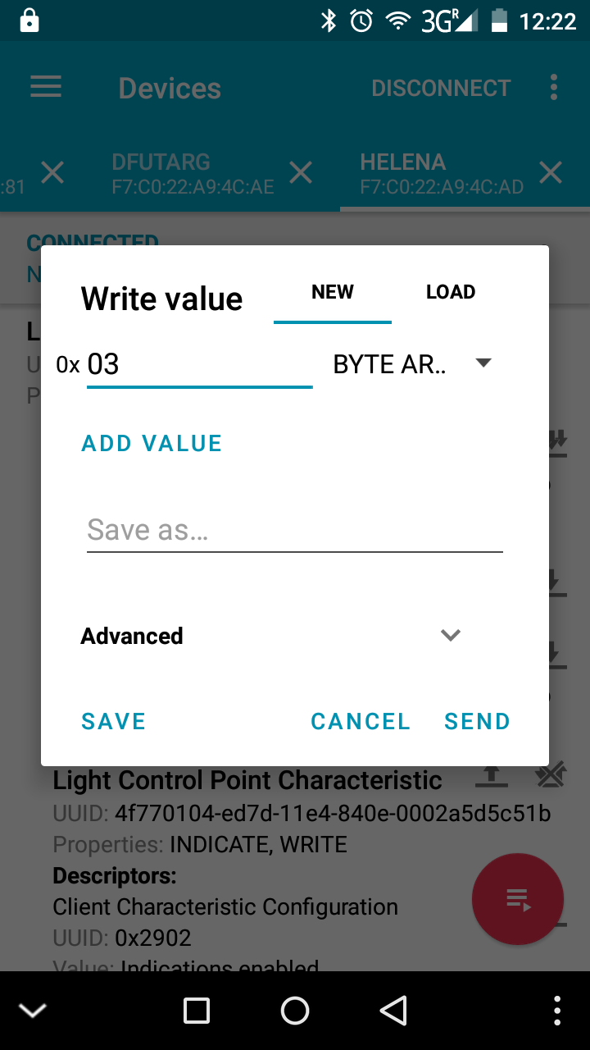Image 30: Read group configuration command

- Change Group Configuration
The command for changing the number of groups is 0x04. The new number of groups is followed as second byte (the complete command in Image 32 changes the configuration to two groups).
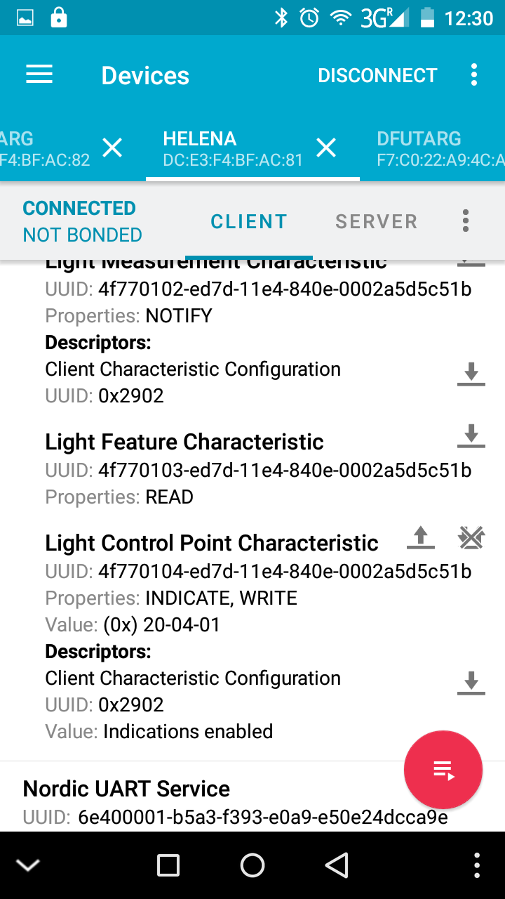Image 33: Group change reply
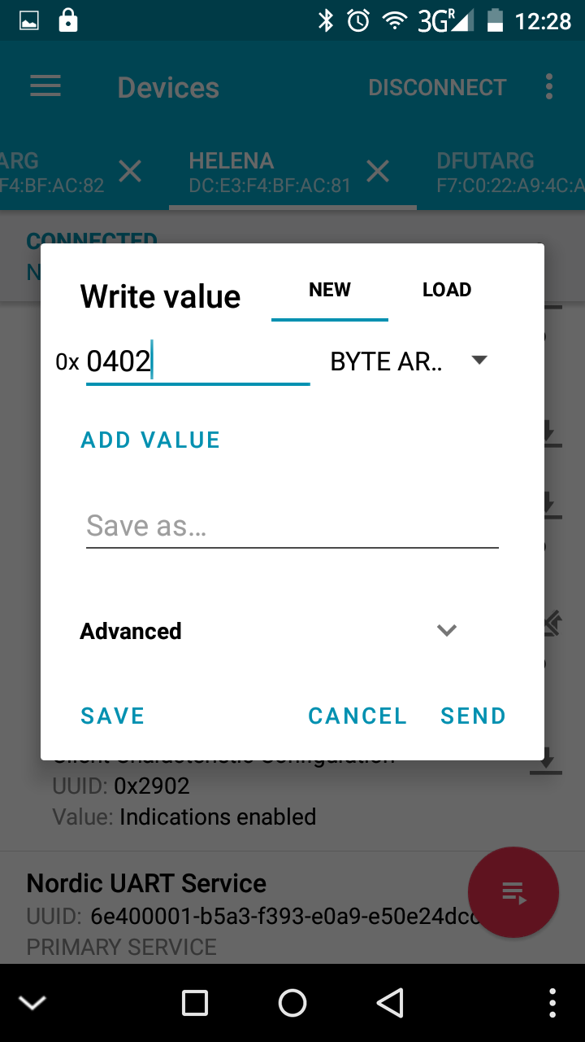Image 32: Group change command
- Read Mode Configuration
The command for reading the current mode configuration is 0x05. Followed by the mode number to start reading.
The reply is a list of all modes, where the first byte of each state represent the setup and the second the intensity.
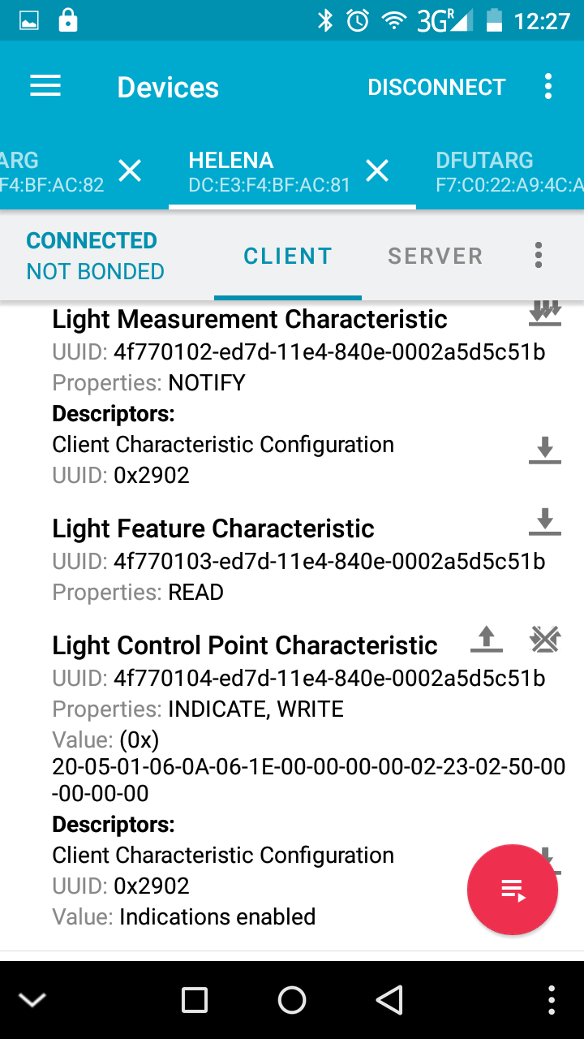Image 35: State configuration reply
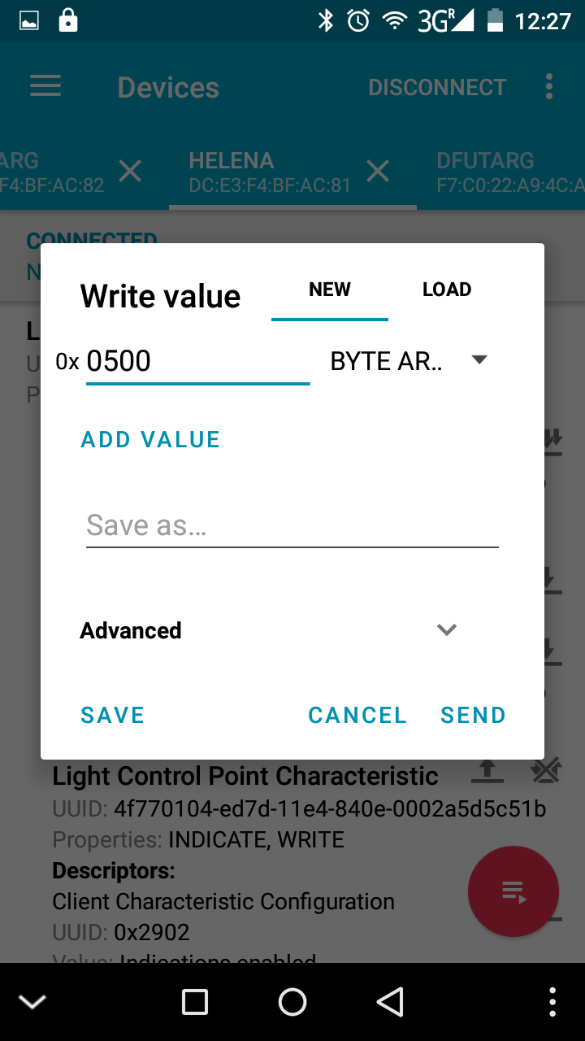Image 34: Read state configuration command

The reply in Image 35 represents the following setting:
Mode 1 | Spot Pitch compensated with 10lux
Mode 2 | Spot Pitch compensated with 35lux
Mode 3 | Not used
Mode 4 | Not used
Mode 5 | Spot constant with 35%
Mode 6 | Spot constant with 80%
Mode 7 | Not used
Mode 8 | Not used
- Change Mode Configuration
The command for changing the mode configuration is 0x06. Followed by the mode number to start and a list of new mode. It is not necessary to change all modes, it is possible to change only a few, too. The command in Image 36 will start with Mode 3 and has only a list of two modes. So this command will result in changing mode 3 to Spot pitch compensated with 10lux and Mode 4 to Spot pitch compensated with 35lux. The other states will keep their prior setting.
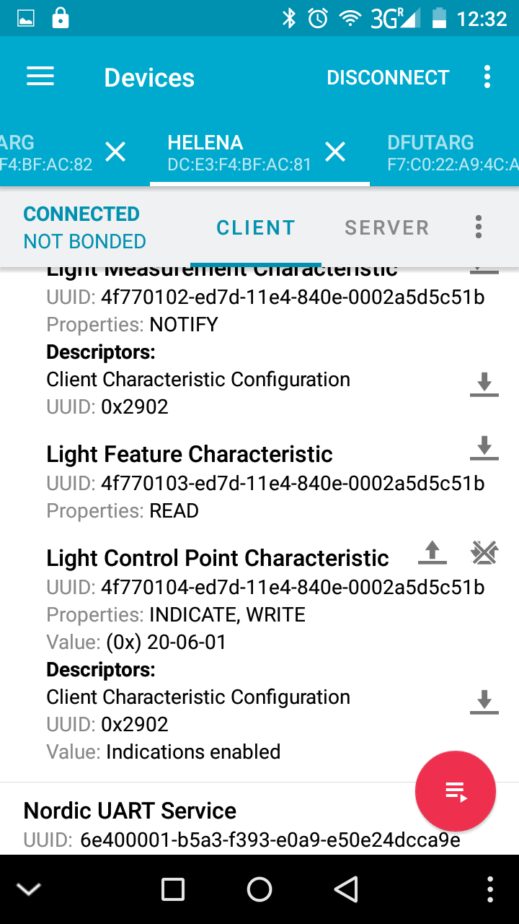Image 37: State change reply
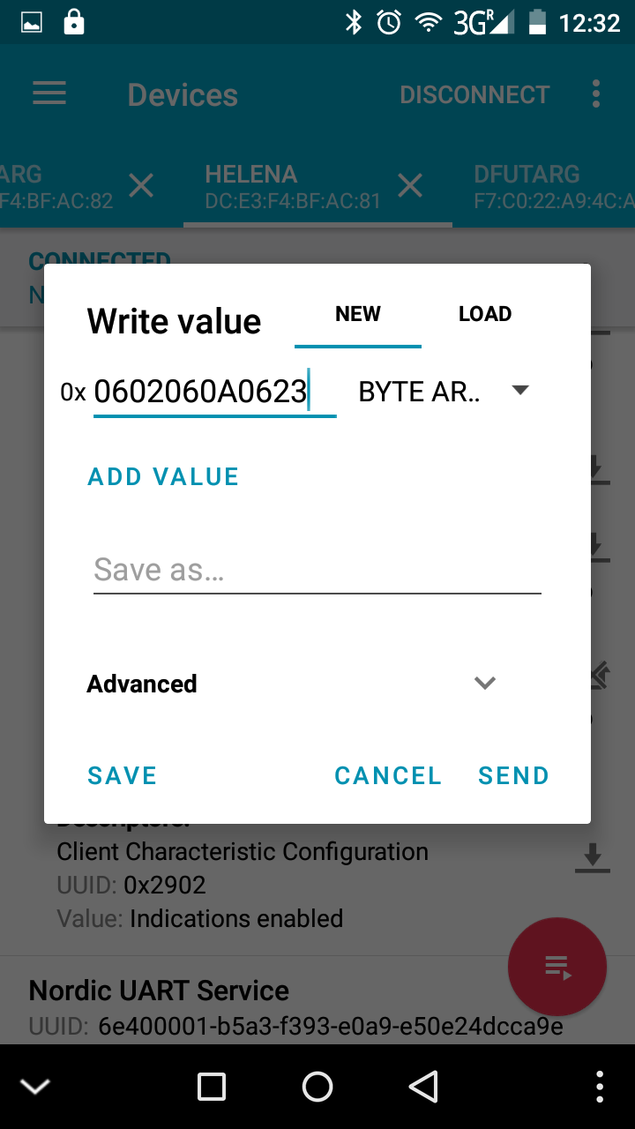Image 36: State change command
- Read Preferred Mode
The command for reading the preferred mode is 0x0D.
The Control Point will reply with the current mode number used as preferred mode.
- Set Preferred Mode
The command for setting the preferred mode is 0x0E, followed by the mode number to be used as preferred mode. Use an invalid mode number (>= 8) to deactivate the preferred mode.
- Read Temporary Mode
The command for reading the temporary mode is 0x0F.
The Control Point will reply with the current mode number used as temporary mode.
- Set Temporary Mode
The command for setting the temporary mode is 0x10, followed by the mode number to be used as temporary mode. Use an invalid mode number (>= 8) to deactivate the temporary mode.
- Firmware Update
First download the new firmware archive (normally named Helena_app.zip) from the Github repository in the folder Firmware/Helena_NRF_SDK10/bin/debug. To initiate the Firmware Update Process you have to plug in the lamp while keeping the button pressed. The Helena will activate the bootloader (indicated with the red LED).
Now open the App and start scanning. Connect to the “DfuTarg” and start the update by tapping on the small DFU icon in the top. Then select the previously downloaded firmware archive.
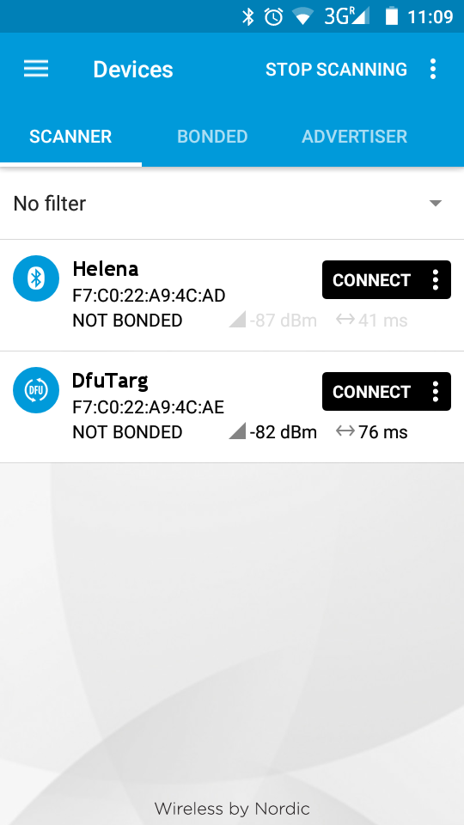Image 38: scan and connect to DfuTarg
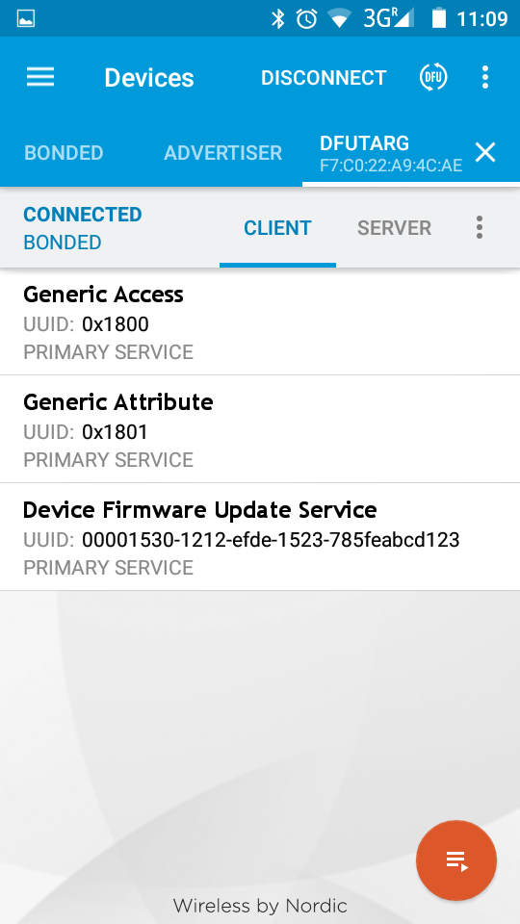Image 39: start update
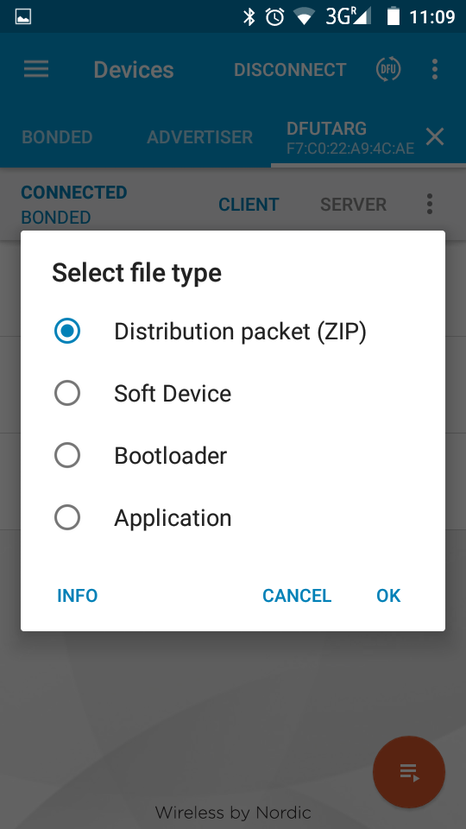Image 40: select Distribution packet (ZIP)
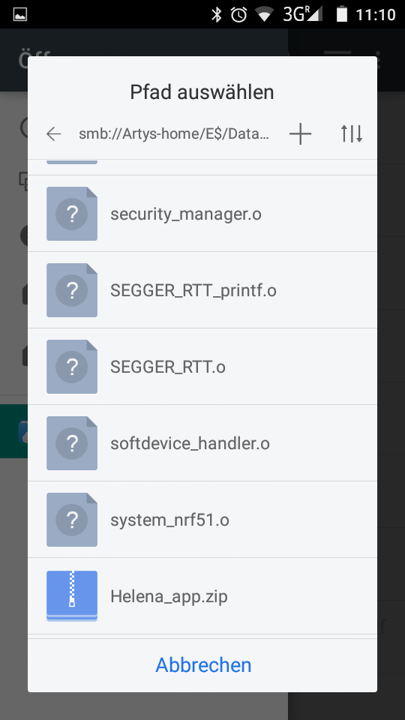Image 41: select firmware archive
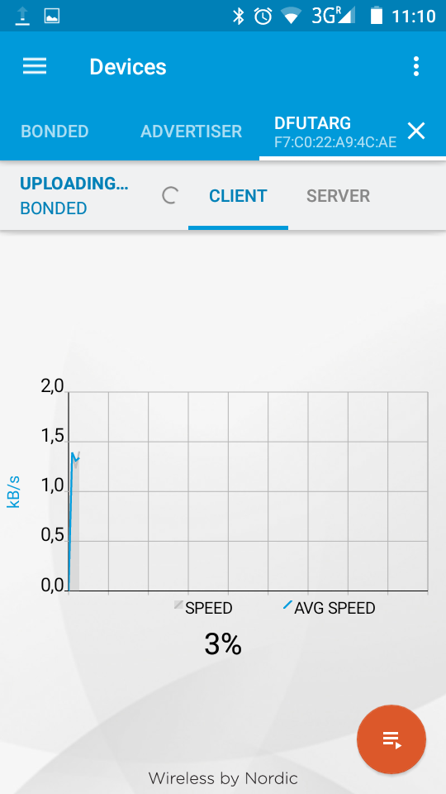Image 42: update starting
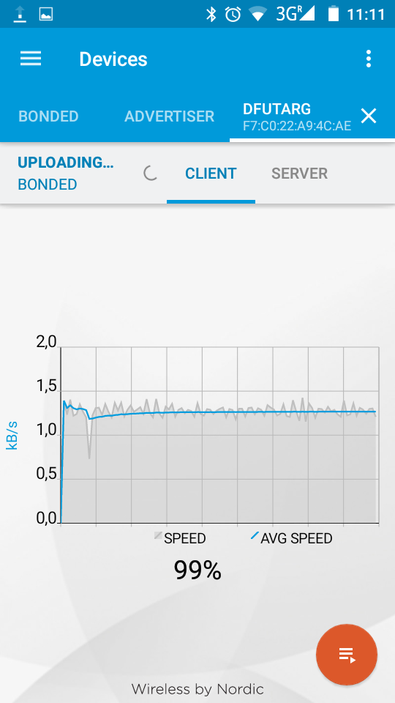Image 43: update finished

Internally the mode counter begins with 0, so to change mode 1 you have to select 0x00, for Mode 2 0x01, for Mode 3 0x02, ...
These are hexadecimal numbers, please use one of the plenty available online HEX to DEC converters.
Internally the mode counter begins with 0, so to change Mode 1 you have to select 0x00, for Mode 2 0x01, for Mode 3 0x02, ...

