ECE 336
Electromagnetic Theory II
Daniel Noyes

SID: 110
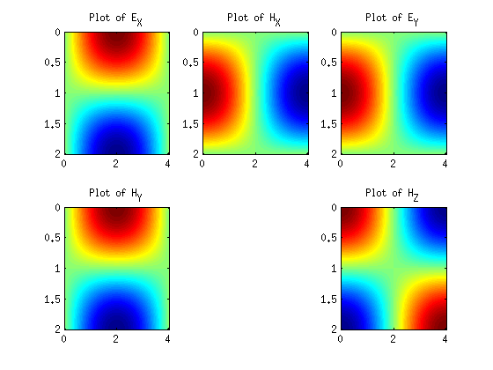Figure 1: (a) Plot of field components in a rectangular waveguide
Enter last 3 Digits of Student ID: 110
(i) Mode: TE_MN
(ii) m : 1
(iii) n : 1
(b) Propagation mode
(c) Cut-off freq: 0.2795
(d) Theta (deg): 73.7691
Matlab 1: Run Wave.m Script

