Benjamin Andrew

CSD 310

23 May 2023

Link to my GitHub: https://github.com/RejectedSon/csd-310

GitHub Repository:

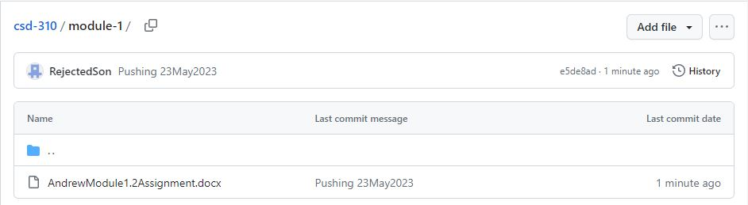

Local Directory:

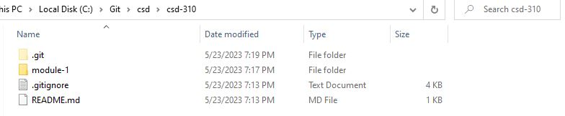

Directory Results from “Git Stage, Commit, Push” step:

