**Introduction:**

The purpose of this project is to create a database management system for the EZ-Car Rental System. There are nine business requirements that have to be met. This project requires us to plan, analyze, design, implement, and maintain the dbms.

**Requirement 1: Planning Phase**

We will implement a database management system for the EZRentalCar.com Car Rental System. We will analyze the data and develop an Enhanced E-R Diagram. We will create a normalized logical model of the diagram and the physical model. The physical model will be implemented using Oracle 11g and Oracle SQL Developer. Then, a script will be created to test and validate the database.

**Requirement 2: Phase 1- Planning**

Business Requirements A Business Analyst was hired by Mr. Rodriguez to compile the list or requirements based on the results of interviews and conversations with the various business stakeholders. Below are the requirements captured by the Business Analyst:

EZ-Car Rental is a car rental company that rents vehicles to customers in several countries. They have rental agency branch locations in US, Canada, Mexico, UK, Japan & Australia. The rental agencies are in cities throughout each country and there can be more than one rental agency in a city, for example New York City has 2 rental agencies or branches in Manhattan one in Brooklyn and two in Queens near each airport. Because there are multiple rental agencies, a customer can pick up a vehicle in one location and drop it off at another. A rental agency or branch is identified by a rental agency ID, address which is composed of street address, city, state, country & zip code. In addition, we also need to capture the phone number of the rental agency.

EZ-Car Rental offer their services to two types of customers, corporate customers & consumers/private customers. The application should store the following information about all types of customers: a customer ID which is their driver license number, driver license expiration date, customer name which is composed of first name, last name, address which is composed of street number & name, city, state & zip code. In addition, we need to store the date of birth, mobile number, email, and credit card which is composed of credit card number, credit card owner name, merchant name & expiration date. A customer can have many credit cards they can use to pay for rental transaction. In addition, the credit card used by a customer can be co-owned by many individuals such a family member or corporate entity the customer works for.

For corporate customers we must store the company name, company ID (we store an ID for each company), Company contact which is composed of contact name & phone number. Finally, we need also need store the corporate rate.

For our private consumer customers, any discount code and discount description. In addition, for our private customers, we offer a frequent rental program called EZPlus where they earn points every time they rent a car and can leverage these points to pay for their next rental. Therefore, we need to store their EZPlus number and EZPlus earned points.

In our business, we only have consumer/private or corporate customers. No other type of customer exists. If a private customer wishes to rent and also works for a company that also rents from us, each of these transactions must be separate customer accounts. you can only be a consumer or corporate customer not both.

A vehicle must first be reserved before it can be rented, therefore there is a distinction between a reservation and a rental. A reservation guarantees a vehicle will be ready for you to pick-up and rent. A rental means a customer complied with the reservation and picked up the vehicle.

A reservation is not made for a specific vehicle, but for a vehicle rental category at a rental agency location. We have the following vehicle rental categories: Car (economy, intermediate, full size, luxury), SUV, or Van. Each of these categories have a different price range. Therefore, a vehicle rental category has a rental category ID that identifies the category of the vehicle being reserved, rental category name (ex. for car (economy, intermediate, full size, luxury), SUV, or Van) and finally rental category rate. Note that a vehicle rental category can have one, none or many vehicles available to rent, nevertheless, a vehicle can only belong to one vehicle rental category.

The reservation process involves a customer reserving a vehicle rental category to be pick-up/drop-off at a rental agency. Therefore, the reservation process requires the customer, vehicle rental category & rental agency of pick-up & drop-off. For a reservation we wish to capture a unique confirmation number to be used to track the reservation. In our business, for a reservation, we must adhere to the following rules:

▪ Each reservation has a pick-up rental agency. A reservation can only have one pick-up rental agency location, but a rental agency can have many reservation pick-ups happening. ▪ Each reservation has a drop-off rental agency (may be different than pick-up rental agency). A reservation can only have one drop-off rental agency location, but a rental agency can have many reservation drop-offs happening

Based on these two rules, the reservation process must capture the pick-up rental agency ID in addition the target drop-off rental agency ID. In addition, the reservation must capture the rental date, return date, rental time, return time of the reservation to provide estimated cost of the rental. In addition, we must capture the reservation status (e.g. confirmed, cancelled, completed), reservation status ID for each reservation status. Finally estimated cost, which is derived from the rental & returned date & time. A vehicle rental category can be reserved from zero or many rental locations, and many or no customers.

The rental process means the customer complied with the reservation and is actually renting the reserved vehicle. The rental process includes the customer, the actual vehicle & rental agency of pick-up & drop-off. The rental process requires a rental agreement number to uniquely identify the rental. Note that in our business, a rental must adhere to the following rules:

▪ Each rental has a pick-up rental agency. A rental can only have one pick-up rental agency location, but a rental agency can have many rental pick-ups happening. ▪ Each rental has a drop-off rental agency (may be different than pick-up rental agency). A rental can only have one drop-off rental agency location, but a rental agency can have many rental drop-offs happening

Because a customer can pick up and drop off a vehicle at different location, for each rental, the system must capture the pick-up rental agency ID in addition, drop off Agency ID (can be different than pick-up). In addition, the rental must capture the pick-up date, drop-off date, pick-up time, drop-off time of the rental to provide the actual cost of the rental. Also, the pick-up odometer value & drop-off odometer value to determine the number of miles of the rental. Another attribute is rental cost, which is derived from the pick-up, drop-off dates/times. In addition, a rental process needs to capture the fuel options provided to customers, we need the fuel option ID that identifies each fuel option & fuel option description (e.g. pay-in-advance return with empty tank at no additional cost, pay-for-used fuel only, self-service). Finally, insurance cost must be captured. Note that at this time, all our customers must pay for insurance and we will calculate this cost automatically for full coverage of our vehicles and passengers with no options to opt-out. A customer must pay insurance when renting. Note that a vehicle can be rented from zero or many rental locations, and many or no customers.

Note that we decided to capture the pick-up & drop-off location, date, time & cost when doing both a reservation and rental because a customer may reserve for a location, date & cost, but totally change their mind when picking up the vehicle etc., and any of these are subject to change via reservation or in the agency location, and we need to capture the history of all these transactions.

EZ-Car Rental has a system to manage their vehicles for renting, maintenance, selling, etc., by classifying them into three vehicle classes: cars, minivans/SUVs, and Vans. All these types of vehicles share the following common characteristics:

▪ Each vehicle is identified by the vehicle id or VIN number, the name of the vehicle composed of make, model & year. The vehicle rental category ID from the vehicle rental category (ex. car (for car is economy, intermediate, full size, luxury), SUV, or Van). Additional attributes of vehicle are: color, plate number, mileage, transmission type (ex. manual or automatic), seat capacity, daily rental cost, vehicle status (ex. reserved, rented, available, maintenance, off-duty), Vehicle Status ID which is the ID number assigned to each of the status (ex. reserved, rented, available, maintenance, off-duty), ID of the rental agency vehicle belongs to or assigned to & finally the current agency location ID where vehicle is currently located since vehicle can be drop-off at any location within a country. Note that for transmission type, and vehicle status we are only interested in the value of these types, no further details about the types are required. ▪ Cars are vehicles that have a trunk capacity in volume, for example a luxury Mercedes E class car has a trunk capacity of 18 cubic ft. ▪ Minivans & SUVs are vehicles with a towing capacity in pounds and additional attribute of these vehicle types is the indication if they are all wheel drive (AWD) which is a yes or no value. ▪ Finally, Vans, are vehicles with a cargo capacity in volume & maximum payload in pounds.

Note that there are other types of vehicles of interest that we may want to store data on other than cars, minivans, SUVs and vans. In addition, a vehicle can only be classified as a car, minivan/SUV or van or other. Not any combination of these, for example, a car is not a van or SUV etc., or the other way around.

In a future upgrade of this application, we wish to also provide insurance options to our customers, in addition to login features so each customer has access to their accounts etc., and finally providing a more efficient way to process invoices for payments.

**Requirement 3: Phase 2- Analysis: EER Model Diagram #1**

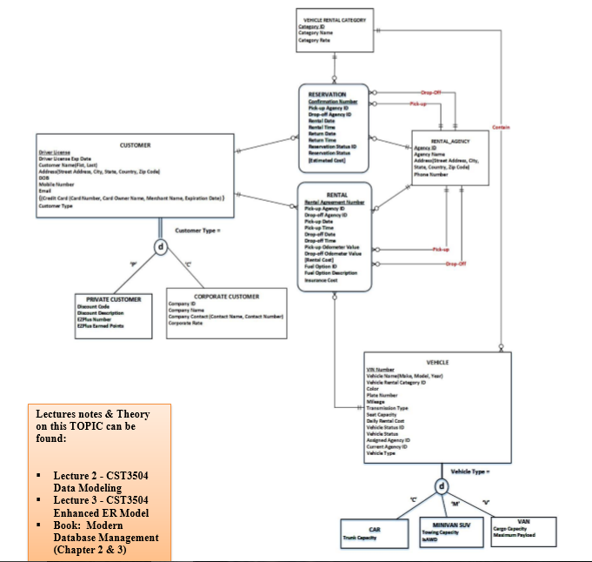

**Requirement 4: Design Phase- Normalized Logical Model Diagram #2**

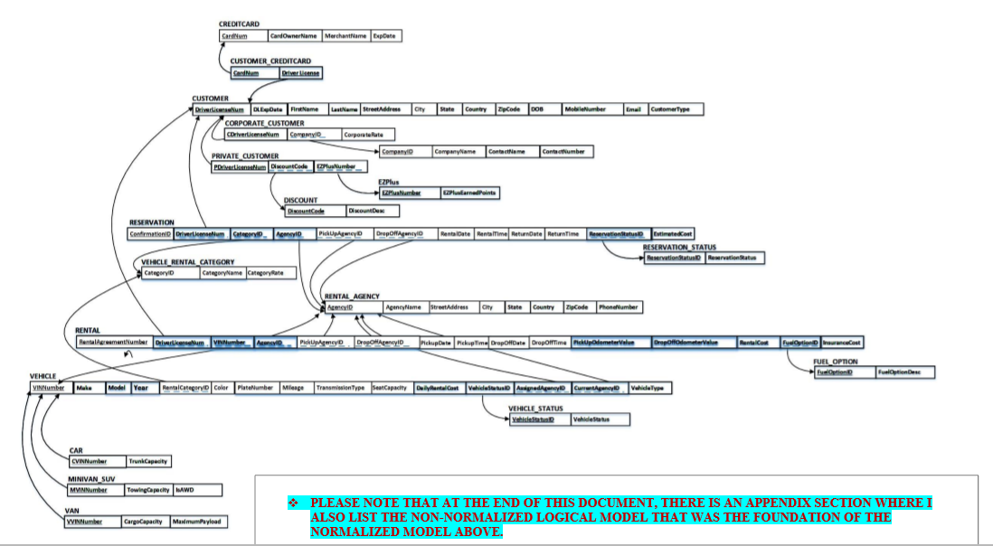

**Requirement 5: Design Phase- Data Dictionary**

**Customer**

|  |  |  |  |  |  |  |
| --- | --- | --- | --- | --- | --- | --- |
| Attribute Name | Data Type | Oracle Data Type | Required? | Length | Constraints | Description |
| DriverLicenseNum | Number | NUMBER(20) | Y | 20 | Primary Key | Unique Identifier for a customer instance |
| DLExpDate | Date | Date | Y | N/A | NOT NULL | License expiration date |
| FirstName | Variable Character | VARCHAR2(40) | Y | 40 | NOT NULL | Customer First Name |
| LastName | Variable Character | VARCHAR2(40) | Y | 40 | NOT NULL | Customer Last Name |
| StreetAddress | Variable Character | VARCHAR2(75) | Y | 75 | NOT NULL | Customer full address |
| City | Variable Character | VARCHAR2(25) | Y | 25 | NOT NULL | Customer city |
| State | Variable Character | VARCHAR2(20) | Y | 20 | NOT NULL | Customer state |
| Country | Variable Character | VARCHAR2(30) | Y | 30 | NOT NULL | Customer Country |
| ZipCode | Variable Character | VARCHAR2(10) | Y | 10 | NOT NULL | Customer Zip Code |
| DOB | Date | Date | Y | N/A | NOT NULL | Customer DOB |
| MobileNumber | Number | Number(11) | Y | 11 | NOT NULL | Customer phone number |
| Email | Variable Character | VARCHAR2(60) | Y | 60 | NOT NULL | Customer email |
| CustomerType | Variable Character | VARCHAR2(30) | Y | 30 | NOT NULL | Type of customer |

**Customer_CreditCard**

|  |  |  |  |  |  |  |
| --- | --- | --- | --- | --- | --- | --- |
| Attribute Name | Data Type | Oracle Data Type | Required? | Length | Constraints | Description |
| CardNumber | Number | NUMBER(16) | Y | 16 | Composite Primary Key | Credit Card Number |
| DriverLicense | Number | NUMBER(30) | Y | 30 | Composite Primary Key | Driver License Number |

**CreditCard**

|  |  |  |  |  |  |  |
| --- | --- | --- | --- | --- | --- | --- |
| Attribute Name | Data Type | Oracle Data Type | Required? | Length | Constraints | Description |
| CardNum | Number | NUMBER(16) | Y | 16 | Primary Key | Customer Credit Card Number |
| CardOwnerName | Variable Character | VARCHAR2(50) | Y | 50 | Not NULL | Card Owner’s Name |
| MerchantName | Variable Character | VARCHAR2(60) | Y | 60 | Not NULL | Merchant name |
| ExpDate | Date | Date | Y | N/A | Not NULL | Expiration date |

**Corporate_Customer**

|  |  |  |  |  |  |  |
| --- | --- | --- | --- | --- | --- | --- |
| Attribute Name | Data Type | Oracle Data Type | Required? | Length | Constraints | Description |
| CDriverLicenseNum | Number | NUMBER(30) | Y | 30 | Primary Key | Corporate Driver License Number |
| CompanyID | Number | NUMBER(15) | Y | 15 | Foreign Key | Company ID |
| CorporatRate | Decimal | Decimal(4,2) | Y | 4,2 | Not Null | Corporate Rate |

**CompanyID**

|  |  |  |  |  |  |  |
| --- | --- | --- | --- | --- | --- | --- |
| Attribute Name | Data Type | Oracle Data Type | Required? | Length | Constraints | Description |
| CompanyID | Number | NUMBER(15) | Y | 15 | Primary Key | Company ID |
| CompanyName | Variable Character | VARCHAR2(40) | Y | 40 | Not Null | Company Name |
| ContactName | Variable Character | VARCHAR2(100) | Y | 100 | Not Null | Contact Name |
| ContactNumber | Number | NUMBER(11) | Y | 11 | Not Null | Contact Number |

**Private_Customer**

|  |  |  |  |  |  |  |
| --- | --- | --- | --- | --- | --- | --- |
| Attribute Name | Data Type | Oracle Data Type | Required? | Length | Constraints | Description |
| PDriverLicenseNum | Number | NUMBER(30) | Y | 30 | Primary Key | Private Driver License Number |
| DiscountCode | Variable Character | VARCHAR2(20) | Y | 20 | Foreign Key | Discount Code |
| EZPlusNumber | Number | NUMBER(30) | Y | 30 | Foreign Key | EZ Plus Number |

**Discount**

|  |  |  |  |  |  |  |
| --- | --- | --- | --- | --- | --- | --- |
| Attribute Name | Data Type | Oracle Data Type | Required? | Length | Constraints | Description |
| DiscountCode | Variable Character | VARCHAR2(20) | Y | 20 | Primary Key | Discount Code |
| DiscountDesc | Variable Character | VARCHAR2(70) | Y | 70 | Not Null | Description of the discount |

**EZPlus**

|  |  |  |  |  |  |  |
| --- | --- | --- | --- | --- | --- | --- |
| Attribute Name | Data Type | Oracle Data Type | Required? | Length | Constraints | Description |
| EZPluzNumber | Number | NUMBER(20) | Y | 20 | Primary Key | EZ plus Number |
| EZPlusEarnedPoints | Number | NUMBER(10) | Y | 100 | Not Null | Earned Points from EZ Plus |

**Reservation**

|  |  |  |  |  |  |  |
| --- | --- | --- | --- | --- | --- | --- |
| Attribute Name | Data Type | Oracle Data Type | Required? | Length | Constraints | Description |
| ConfirmationID | Number | NUMBER(20) | Y | 20 | Primary Key | Confirmation ID |
| DriverLicenseNumber | Number | NUMBER(30) | Y | 30 | Foreign Key | Driver License Number |
| CategoryID | Number | NUMBER(20) | Y | 20 | Foriegn Key | Category Id |
| AgencyID | Number | NUMBER(20) | Y | 20 | Foriegn Key | Agency Id |
| PickupAgencyID | Number | NUMBER(20) | Y | 20 | Foriegn Key | Pickup Agency ID |
| DropOff AgencyID | Number | NUMBER(20) | Y | 20 | Foriegn Key | Drop Off Agency ID |
| RentalDate | Date | DATE | Y | N/A | Not Null | Date of Rental |
| RentalTime | NUMBER | NUMBER(4) | Y | 4 | Not Null | Time of Rental |
| ReturnDate | Date | DATE | Y | N/A | Not Null | Date of Return |
| Return_Time | NUMBER | NUMBER(4) | Y | 4 | Not Null | Time of Return |
| ReservationStatusID | Number | NUMBER(20) | Y | 20 | Foriegn Key | Reservation Status Id |
| EstimateCost | Decimal | Decimal(10,2) | Y | 10 | Not Null | Estimation of Cost |

**Reservation_Status**

|  |  |  |  |  |  |  |
| --- | --- | --- | --- | --- | --- | --- |
| Attribute Name | Data Type | Oracle Data Type | Required? | Length | Constraints | Description |
| ReservationStatusID | Number | NUMBER(20) | Y | 20 | Primary Key | Reservation Status Id |
| ReservationStatus | Variable Character | VARCHAR2(50) | Y | 50 | Not Null | Status of the Reservation |

**Vehicle_Rental_Category**

|  |  |  |  |  |  |  |
| --- | --- | --- | --- | --- | --- | --- |
| Attribute Name | Data Type | Oracle Data Type | Required? | Length | Constraints | Description |
| CategoryID | Number | NUMBER(20) | Y | 20 | Not Null | Category Id |
| CategoryName | Variable Character | VARCHAR2(25) | Y | 25 | Not Null | Name of the Category |
| CategoryRate | Decimal | Decimal(4,2 | Y | 4 | Not Null | Category Rate |

**Rental**

|  |  |  |  |  |  |  |
| --- | --- | --- | --- | --- | --- | --- |
| Attribute Name | Data Type | Oracle Data Type | Required? | Length | Constraints | Description |
| RentalAgreementNumber | Number | NUMBER(10) | Y | 10 | Primary Key | Rental Agreement Number |
| DriverLicenseNum | Number | NUMBER(30) | Y | 30 | Foreign Key | License Number |
| VINNumber | Number | NUMBER(10) | Y | 10 | Foreign Key | VIN Number |
| AgencyID | Number | NUMBER(20) | Y | 20 | Foreign Key | Agency ID |
| PickUpAgencyID | Number | NUMBER(20) | Y | 20 | Foreign Key | Pickup Agency ID |
| DropOffAgencyID | Number | NUMBER(20) | Y | 20 | Foreign Key | Drop Off Agency ID |
| PickupDate | Date | DATE | Y | N/A | Not Null | Date of Pickup |
| PickupTime | Time | TIME | Y | N/A | Not Null | Time of Pickup |
| DropOffDate | Date | DATE | Y | N/A | Not Null | Drop Off Date |
| DropOffTime | Time | TIME | Y | N/A | Not Null | Time of Drop Off |
| PickUpOdometer | Number | NUMBER(10) | Y | 10 | Not Null | Pickup Odometer |
| DropOffOdometerValue | Number | NUMBER(10) | Y | 10 | Not Null | Drop Off Odometer Value |
| RentalCost | Decimal | DECIMAL(6,2) | Y | 6,2 | Not Null | Cost of Rental |
| FuelOptionID | Number | NUMBER(20) | Y | 20 | Foreign Key | Fuel ID |
| InsuranceCost | Number | NUMBER(5) | Y | 5 | Not Null | Cost of Insurance |

**Rental_Agency**

|  |  |  |  |  |  |  |
| --- | --- | --- | --- | --- | --- | --- |
| Attribute Name | Data Type | Oracle Data Type | Required? | Length | Constraints | Description |
| AgencyID | Number | NUMBER(20) | Y | 20 | Primary Key | Agency ID |
| AgencyName | Variable Character | VARCHAR2(40) | Y | 40 | Not Null | Name of Agency |
| StreetAddrees | Variable Character | VARCHAR2(75) | Y | 75 | Not Null | Street Address |
| City | Variable Character | VARCHAR2(20) | Y | 20 | Not Null | City |
| State | Variable Character | VARCHAR2(2) | Y | 2 | Not Null | State |
| Country | Variable Character | VARCHAR2(25) | Y | 25 | Not Null | Country |
| ZipCode | Variable Character | VARCHAR2(10) | Y | 10 | Not Null | Zip Code |
| Phone | Number | NUMBER(11) | Y | 11 | Not Null | Phone Number |

**Fuel_Option**

|  |  |  |  |  |  |  |
| --- | --- | --- | --- | --- | --- | --- |
| Attribute Name | Data Type | Oracle Data Type | Required? | Length | Constraints | Description |
| FuelOptionID | Number | NUMBER(20) | Y | 20 | Primary Key | Fuel ID |
| FuelOption_Desc | Variable Character | VARCHAR2(75) | Y | 75 | Not Null | Description of the Fuel Option |

**Vehicle**

|  |  |  |  |  |  |  |
| --- | --- | --- | --- | --- | --- | --- |
| Attribute Name | Data Type | Oracle Data Type | Required? | Length | Constraints | Description |
| VINNumber | Number | NUMBER(10) | Y | 10 | Primary Key | VIN Number |
| Make | Variable Character | VARCHAR2(25) | Y | 25 | Not Null | Make |
| Model | Variable Character | VARCHAR2(30) | Y | 30 | Not Null | Vehicle Model |
| Year | Year | YEAR() | Y |  | Not Null | Year of Vehicle |
| RentalCategoryID | Number | NUMBER(20) | Y | 20 | Foreign Key | Rental Category ID |
| Color | Variable Character | VARCHAR2(12) | Y | 12 | Not Null | Color |
| PlateNumber | Variable Character | VARCHAR2(12) | Y | 12 | Not Null | License Plate Number |
| Mileage | Number | NUMBER(5) | Y | 5 | Not Null | Mileage |
| TransmissionType | Variable Character | VARCHAR2(20) | Y | 20 | Not Null | Type of Transmission |
| SeatCapacity | Number | NUMBER(3) | Y | 3 | Not Null | Number of Seats |
| DailyRentalCost | Number | NUMBER(5) | Y | 5 | Not Null | Everyday Rental Cost |
| VehicleStatusID | Number | NUMBER(20) | Y | 20 | Not Null | Vehicle Status ID |
| AssignedAgencyID | Number | NUMBER(20) | Y | 20 | Foreign Key | Assigned Agency ID |
| CurrentAgencyID | Number | NUMBER(20) | Y | 20 | Foreign Key | Current Agency ID |
| VehicleType | Variable Character | VARCHAR2(20) | Y | 20 | Not Null | Type of Vehicle |

**Vehicle_Status**

|  |  |  |  |  |  |  |
| --- | --- | --- | --- | --- | --- | --- |
| Attribute Name | Data Type | Oracle Data Type | Required? | Length | Constraints | Description |
| VehilceStatusID | Number | NUMBER(20) | Y | 20 | Primary Key | Status ID of the Vehicle |
| VehicleStatus | Variable Character | VARCHAR2(15) | Y | 15 | Not Null | Status of the Vehicle |

**Car**

|  |  |  |  |  |  |  |
| --- | --- | --- | --- | --- | --- | --- |
| Attribute Name | Data Type | Oracle Data Type | Required? | Length | Constraints | Description |
| CVINNumber | Number | NUMBER(10) | Y | 10 | Primary Key | Car VIN Number |
| TrunkCapacity | Decimal | DECIMAL(5,2) | Y | 5 | Not Null | Capacity of the Trunk |

**Minivan_SUV**

|  |  |  |  |  |  |  |
| --- | --- | --- | --- | --- | --- | --- |
| Attribute Name | Data Type | Oracle Data Type | Required? | Length | Constraints | Description |
| MVINNumber | Number | NUMBER(10) | Y | 10 | Primary Key | Minivan VIN Number |
| TowingCapacity | Decimal | DECIMAL(6,2) | Y | 6 | Not Null | Towing Capacity |
| IsAWD | Variable Character | VARCHAR2(20) | Y | 20 | Not Null | Is the Vehicle an All-Wheel-Drive? |

**Van**

|  |  |  |  |  |  |  |
| --- | --- | --- | --- | --- | --- | --- |
| Attribute Name | Data Type | Oracle Data Type | Required? | Length | Constraints | Description |
| VVINNumber | Number | NUMBER(10) | Y | 10 | Primary Key | Van VIN Number |
| CargoCapacity | Decimal | DECIMAL(6,2) | Y | 6 | Not Null | Cargo Capacity |
| MaximumPayload | Decimal | DECIMAL(7,2) | Y | 7 | Not Null | Maximum Payload of the Van |

**Requirement 6: Design Phase- Physical Schema Diagram #3**

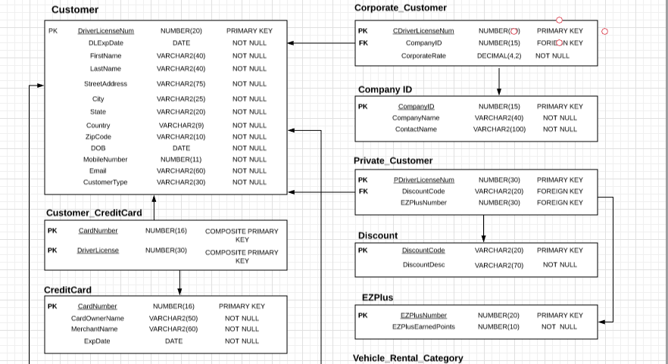

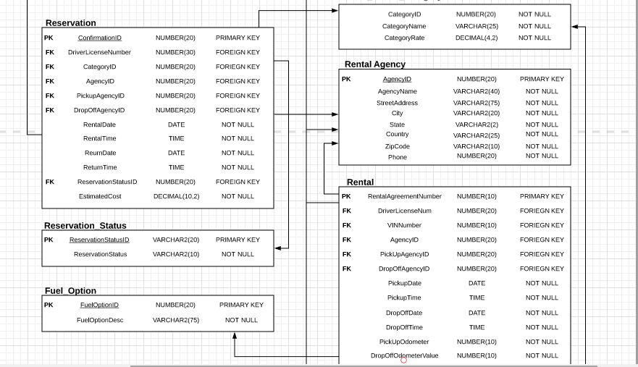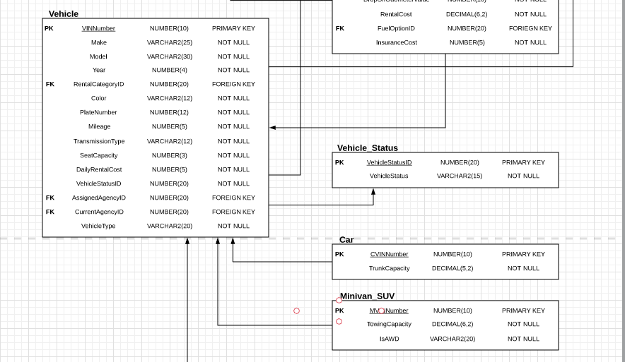

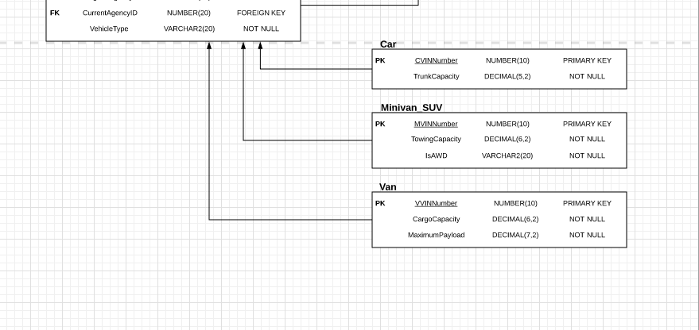

**Requirement 7: Implementation Phase**

CREATE TABLE Customer

(

DriverLicenseNum NUMBER(20) NOT NULL,

DLExpDate DATE NOT NULL,

FirstName VARCHAR2(40) NOT NULL,

LastName VARCHAR2(40) Not NULL,

StreetAddress VARCHAR2(75) NOT NULL,

City VARCHAR2(25) NOT NULL,

State VARCHAR2(20) NOT NULL,

Country VARCHAR2(30) NOT NULL,

ZipCode VARCHAR2(10) NOT NULL,

DOB DATE NOT NULL,

MobileNumber NUMBER(11) NOT NULL,

Email VARCHAR2(60) NOT NULL,

CustomerType VARCHAR2(30) NOT NULL,

CONSTRAINT DriverLicenseNum_PK PRIMARY KEY(DriverLicenseNum)

);

CREATE TABLE CreditCard

(

CardNum NUMBER(16) NOT NULL,

CardOwnerName VARCHAR2(50) NOT NULL,

MerchantName VARCHAR2(60) NOT NULL,

ExpDate DATE NOT NULL,

CONSTRAINT CardNum_PK PRIMARY KEY(CardNum)

);

CREATE TABLE Customer_CreditCard

(

CardNum NUMBER(16) NOT NULL,

DriverLicense NUMBER(30) NOT NULL,

CONSTRAINT CardNumberDriverLicense_CPK

PRIMARY KEY(CardNum, DriverLicense),

CONSTRAINT CardNum_FK

FOREIGN KEY (CardNum)

REFERENCES CreditCard (CardNum),

CONSTRAINT DriverLicense_FK

FOREIGN KEY (DriverLicense)

REFERENCES Customer (DriverLicenseNum)

);

CREATE TABLE CompanyID

(

CompanyID NUMBER(15) NOT NULL,

CompanyName VARCHAR2(40) NOT NULL,

ContactName VARCHAR2(100) NOT NULL,

ContactNumber NUMBER(11) NOT NULL,

CONSTRAINT CompanyID_PK PRIMARY KEY (CompanyID)

);

CREATE TABLE Corporate_Customer

( CDriverLicenseNum NUMBER(30) NOT NULL,

CompanyID NUMBER(15) NOT NULL,

CorporateRate DECIMAL(4,2) NOT NULL,

CONSTRAINT CDriverLicenseNum_PK PRIMARY KEY( CDriverLicenseNum),

CONSTRAINT CDriverLicenseNum_FK

FOREIGN KEY (CDriverLicenseNum)

REFERENCES Customer (DriverLicenseNum),

CONSTRAINT CompanyID_FK

FOREIGN KEY (CompanyID)

REFERENCES CompanyID (CompanyID)

);

CREATE TABLE Discount

(

DiscountCode VARCHAR2(20) NOT NULL,

DiscountDesc VARCHAR2(70) NOT NULL,

CONSTRAINT DiscountCode_PK PRIMARY KEY (DiscountCode)

);

CREATE TABLE EZPlus

(

EZPlusNumber NUMBER(20) NOT NULL,

EZPlusEarnedPoints NUMBER(10) NOT NULL,

CONSTRAINT EZPlusNumber_PK PRIMARY KEY (EZPlusNumber)

);

CREATE TABLE Private_Customer

(

PDriverLicenseNum NUMBER(30) NOT NULL,

DiscountCode VARCHAR2(20) NOT NULL,

EZPlusNumber NUMBER(30) NOT NULL,

CONSTRAINT PDriverLicenseNumPK PRIMARY KEY (PDriverLicenseNum),

CONSTRAINT PDriverLicenseNum_FK

FOREIGN KEY (PDriverLicenseNum)

REFERENCES Customer (DriverLicenseNum),

CONSTRAINT DiscountCode_FK

FOREIGN KEY (DiscountCode)

REFERENCES Discount (DiscountCode),

CONSTRAINT EZPlusNumber_FK

FOREIGN KEY (EZPlusNumber)

REFERENCES EZPlus (EZPlusNumber)

);

CREATE TABLE Reservation_Status

(

ReservationStatusID NUMBER(20) NOT NULL,

ReservationStatus VARCHAR2(50) NOT NULL,

CONSTRAINT ReservationStatusID_PK PRIMARY KEY(ReservationStatusID)

);

CREATE TABLE Vehicle_Rental_Category

(

CategoryID NUMBER(20) NOT NULL,

CategoryName VARCHAR2(25) NOT NULL,

CategoryRate Decimal(4,2) NOT NULL

);

CREATE TABLE Rental_Agency

(

AgencyID NUMBER(20) NOT NULL,

AgencyName VARCHAR2(40) NOT NULL,

StreetAddrees VARCHAR2(75) NOT NULL,

City VARCHAR2(20) NOT NULL,

State VARCHAR2(2) NOT NULL,

Country VARCHAR2(25) NOT NULL,

ZipCode VARCHAR2(10) NOT NULL,

PhoneNumber NUMBER(11) NOT NULL,

CONSTRAINT AgencyID_PK PRIMARY KEY (AgencyID)

);

CREATE TABLE Reservation

(

ConfirmationID NUMBER(20) NOT NULL,

DriverLicenseNum NUMBER(30) NOT NULL,

CategoryID NUMBER(20) NOT NULL,

AgencyID NUMBER(20) NOT NULL,

PickupAgencyID NUMBER(20) NOT NULL,

DropOffAgencyID NUMBER(20) NOT NULL,

RentalDate DATE NOT NULL,

RentalTime NUMBER(4) NOT NULL,

ReturnDate DATE NOT NULL,

ReturnTime NUMBER(4) NOT NULL,

ReservationStatusID NUMBER(20) NOT NULL,

EstimatedCost Decimal(10,2) NOT NULL,

CONSTRAINT ConfirmationID_PK PRIMARY KEY(ConfirmationID),

CONSTRAINT DriverLicenseNum_FK

FOREIGN KEY (DriverLicenseNum)

REFERENCES Customer (DriverLicenseNum ),

CONSTRAINT CategoryID_FK

FOREIGN KEY (CategoryID)

REFERENCES Vehicle_Rental_Category (CategoryID),

CONSTRAINT AgencyID_FK

FOREIGN KEY (AgencyID)

REFERENCES Rental_Agency (AgencyID),

CONSTRAINT PickupAgencyID_FK

FOREIGN KEY (PickupAgencyID)

REFERENCES Rental_Agency (AgencyID),

CONSTRAINT DropOffAgencyID_FK

FOREIGN KEY (DropOffAgencyID)

REFERENCES Rental_Agency (AgencyID),

CONSTRAINT ReservationStatusID_FK

FOREIGN KEY (ReservationStatusID)

REFERENCES Reservation_Status (ReservationStatusID)

);

ALTER TABLE Vehicle_Rental_Category

ADD CONSTRAINT CategoryID_PK PRIMARY KEY(CategoryID);

CREATE TABLE Fuel_Option

(

FuelOptionID NUMBER(20) NOT NULL,

FuelOptionDesc VARCHAR2(75) NOT NULL,

CONSTRAINT FuelOptionID_PK PRIMARY KEY (FuelOptionID)

);

CREATE TABLE Vehicle_Status

(

VehicleStatusID NUMBER(20) NOT NULL,

VehicleStatus VARCHAR2(15) NOT NULL,

CONSTRAINT VehicleStatusID_PK PRIMARY KEY (VehicleStatusID)

);

CREATE TABLE VEHICLE

(

VINNumber NUMBER(10) NOT NULL,

Make VARCHAR2(25) NOT NULL,

Model VARCHAR2(30) NOT NULL,

Year NUMBER(4) NOT NULL,

RentalCategoryID NUMBER(20) NOT NULL,

Color VARCHAR2(12) NOT NULL,

PlateNumber VARCHAR2(12) NOT NULL,

Mileage NUMBER(5) NOT NULL,

TransmissionType VARCHAR2(20) NOT NULL,

SeatCapacity NUMBER(3) NOT NULL,

DailyRentalCost NUMBER(5) NOT NULL,

VehicleStatusID NUMBER(20) NOT NULL,

AssignedAgencyID NUMBER(20) NOT NULL,

CurrentAgencyID NUMBER(20) NOT NULL,

VehicleType VARCHAR2(20) NOT NULL,

CONSTRAINT VINNumber_PK PRIMARY KEY (VINNumber),

CONSTRAINT RentalCategoryID_FK

FOREIGN KEY (RentalCategoryID)

REFERENCES Vehicle_Rental_Category (CategoryID),

CONSTRAINT VehicleStatusID_FK

FOREIGN KEY (VehicleStatusID)

REFERENCES Vehicle_Status (VehicleStatusID),

CONSTRAINT AssignedAgencyID_FK

FOREIGN KEY (AssignedAgencyID)

REFERENCES Rental_Agency (AgencyID),

CONSTRAINT CurrentAgencyID_FK

FOREIGN KEY (CurrentAgencyID )

REFERENCES Rental_Agency (AgencyID)

);

CREATE TABLE Rental

(

RentalAgreementNumber NUMBER(10) NOT NULL,

DriverLicenseNum NUMBER(30) NOT NULL,

VINNumber NUMBER(10) NOT NULL,

AgencyID NUMBER(20) NOT NULL,

PickUpAgencyID NUMBER(20) NOT NULL,

DropOffAgencyID NUMBER(20) NOT NULL,

PickupDate DATE NOT NULL,

PickupTime NUMBER(4) NOT NULL,

DropOffDate DATE NOT NULL,

DropOffTime NUMBER(4) NOT NULL,

PickUpOdometer NUMBER(10) NOT NULL,

DropOffOdometerValue NUMBER(10) NOT NULL,

RentalCost DECIMAL(6,2) NOT NULL,

FuelOptionID NUMBER(20) NOT NULL,

InsuranceCost NUMBER(5) NOT NULL,

CONSTRAINT RentalAgreementNumber_PK PRIMARY KEY (RentalAgreementNumber),

CONSTRAINT DriverLicenseNum_FK2

FOREIGN KEY (DriverLicenseNum )

REFERENCES Customer (DriverLicenseNum ),

CONSTRAINT VINNumber_FK2

FOREIGN KEY (VINNumber )

REFERENCES Vehicle (VINNumber),

CONSTRAINT AgencyID_FK2

FOREIGN KEY (AgencyID )

REFERENCES Rental_Agency (AgencyID),

CONSTRAINT PickUpAgencyID_FK2

FOREIGN KEY (PickUpAgencyID )

REFERENCES Rental_Agency (AgencyID),

CONSTRAINT DropOffAgencyID_FK2

FOREIGN KEY (DropOffAgencyID )

REFERENCES Rental_Agency (AgencyID),

CONSTRAINT FuelOptionID_FK

FOREIGN KEY (FuelOptionID )

REFERENCES Fuel_Option (FuelOptionID)

);

CREATE TABLE Car

(

CVINNumber NUMBER(10) NOT NULL,

TrunkCapacity DECIMAL(5,2) NOT NULL,

CONSTRAINT CVINNumber_PK PRIMARY KEY (CVINNumber),

CONSTRAINT CVINNumber_FK

FOREIGN KEY(CVINNumber)

REFERENCES Vehicle (VINNumber)

);

CREATE TABLE Minivan_SUV

(

MVINNumber NUMBER(10) NOT NULL,

TowingCapacity DECIMAL(6,2) NOT NULL,

IsAWD VARCHAR2(20) NOT NULL,

CONSTRAINTS MVINNumber_PK PRIMARY KEY (MVINNumber),

CONSTRAINTS MVINNumber_FK

FOREIGN KEY (MVINNumber)

REFERENCES Vehicle (VINNumber)

);

CREATE TABLE Van

(

VVINNumber NUMBER(10) NOT NULL,

CargoCapacity DECIMAL(6,2) NOT NULL,

MaximumPayload DECIMAL(7,2) NOT NULL,

CONSTRAINTS VVINNumber_PK PRIMARY KEY (VVINNumber),

CONSTRAINTS VVINNumber_FK

FOREIGN KEY (VVINNumber)

REFERENCES Vehicle (VINNumber)

);

**Requirement #8 (Implementation Phase- Diagram #4)**

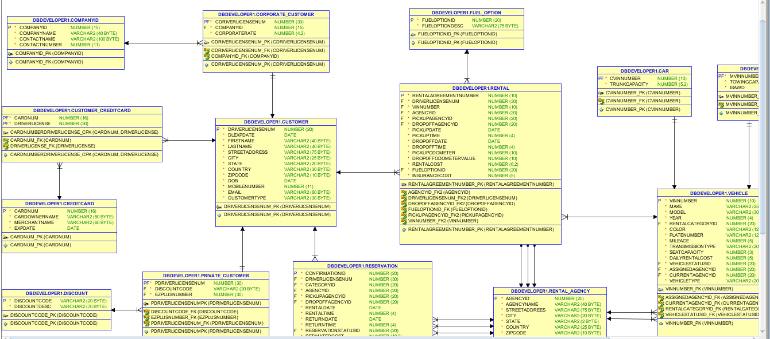

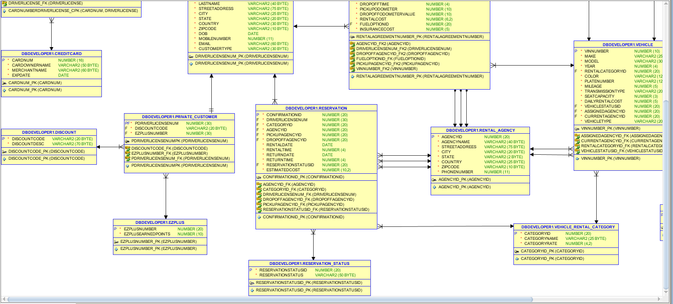

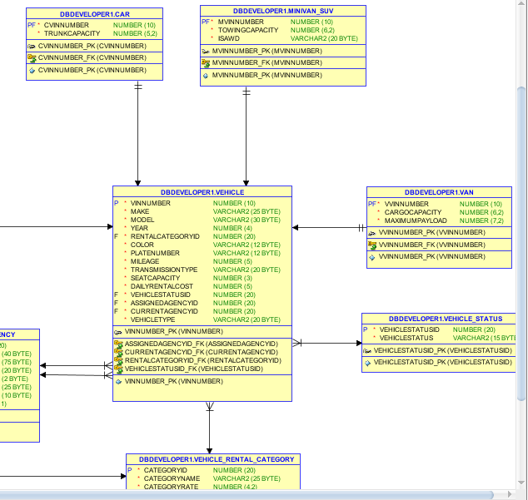

**Requirement #9 (Implementation Phase - Testing & Validation)**

**Requiremnt #9b**

1)The query that I am going to execute will display all the records in the CreditCard table.

Query

Select CARDNUM ,

CARDOWNERNAME ,

MERCHANTNAME ,

EXPDATE

from CREDITCARD;

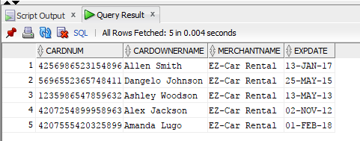

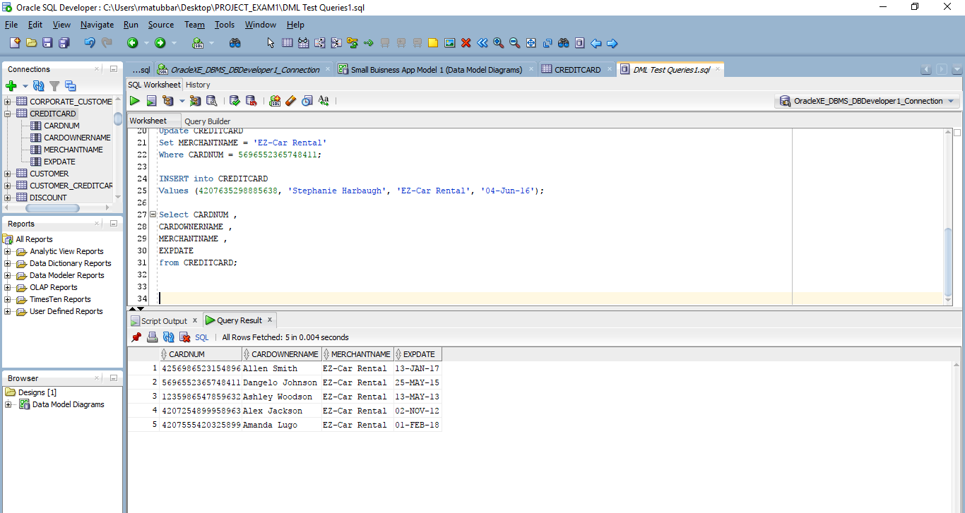

2)The query that I am going to execute will display all the records in the Customer table.

Query

Select DRIVERLICENSENUM ,

DLEXPDATE ,

FIRSTNAME ,

LASTNAME ,

STREETADDRESS ,

CITY ,

STATE ,

COUNTRY ,

ZIPCODE ,

DOB ,

MOBILENUMBER ,

EMAIL ,

CUSTOMERTYPE

from Customer;

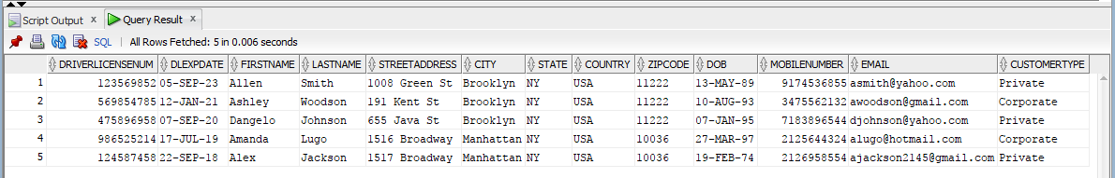

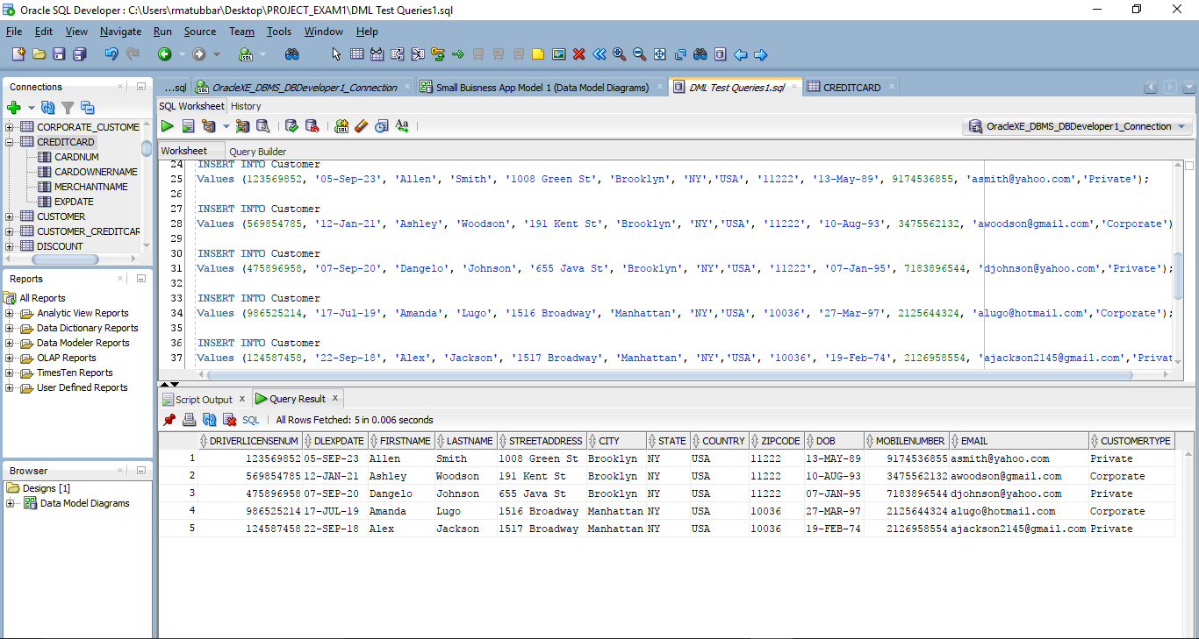

3)The query that I am going to execute will display all the records in the Customer_CreditCard table.

Query

Select CARDNUM ,

DRIVERLICENSE

from Customer_CreditCard;

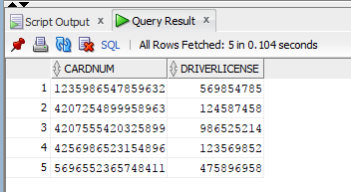

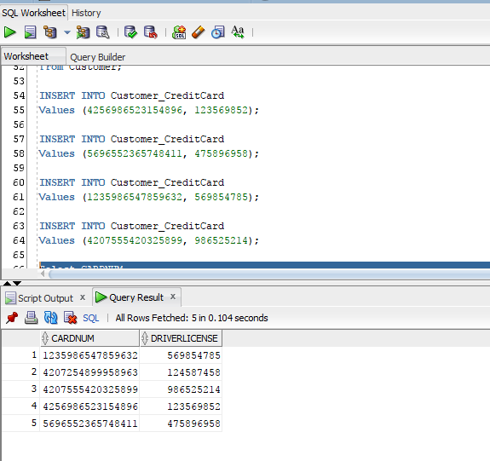

**Requirement #9c**

1)The query that I am going to execute will display one record in the Customer table where the driver license number is 124587458 which is the primary key.

**Query**

Select DRIVERLICENSENUM ,

DLEXPDATE ,

FIRSTNAME ,

LASTNAME ,

STREETADDRESS ,

CITY ,

STATE ,

COUNTRY ,

ZIPCODE ,

DOB ,

MOBILENUMBER ,

EMAIL ,

CUSTOMERTYPE

from Customer

Where DRIVERLICENSENUM = 124587458;



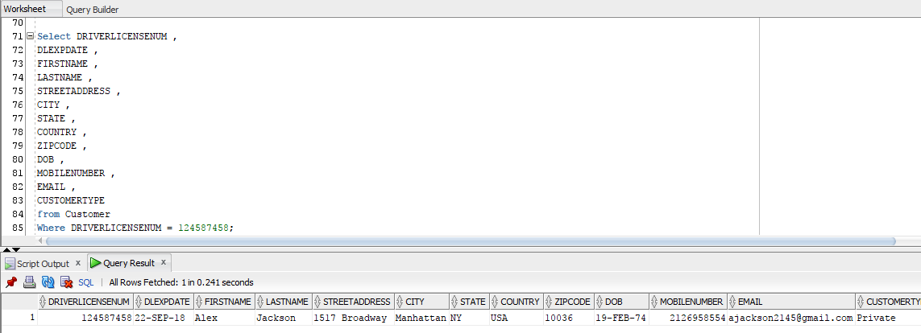

2) The query that I am going to execute will return one record from the Customer_CreditCard table based on some criteria.

**Query**

Select CARDNUM ,

DRIVERLICENSE

from Customer_CreditCard

Where cardnum = 1235986547859632;

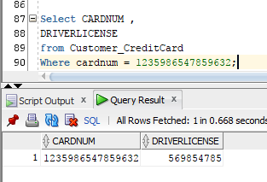

3) The query that I am going to execute will return one record from all three tables based on some criteria.

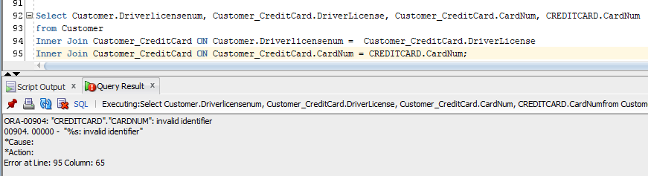

**Requirement #9d**

1) The query that I am going to execute will update a record based on the primary key of the CreditCard table.

Update CREDITCARD

Set cardownername = 'Lisa Simpson', EXPDATE = '13-Jul-18', MERCHANTNAME = 'EZ-Car'

Where cardnum= 4256986523154896;

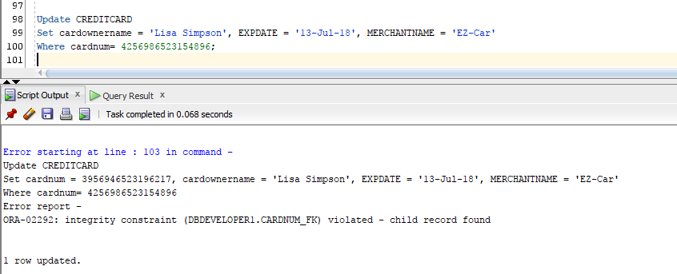

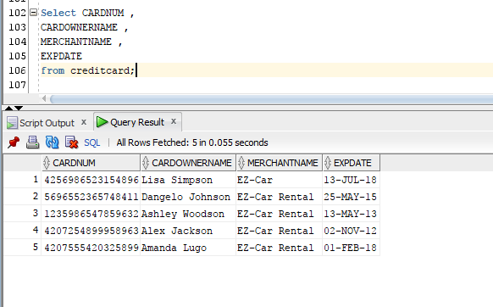

2) The query that I am going to execute will update a record from the Customer table. I was going to update a record from the associative entity(Customer_CreditCard) but it only has two columns that are restricted by the constraints.

**Query**

Update Customer

Set DOB = '05-Jun-90'

Where driverlicensenum = 123569852;

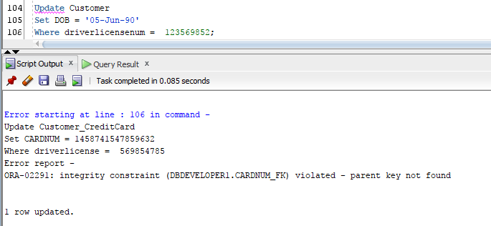

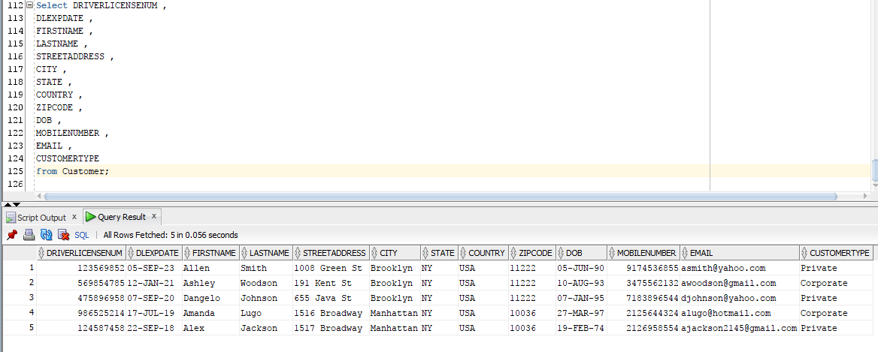

**Requirement #9e**

1) The query that I am going to execute will delete one row based on the primary key from the Customer table. In order to delete one row from the Customer table I have to delete one row from the Customer_CreditCard table so the constraints are not violated.

**Query**

Delete from customer_creditcard

where DRIVERLICENSE = 123569852;

Delete from customer

where driverlicensenum = 123569852;

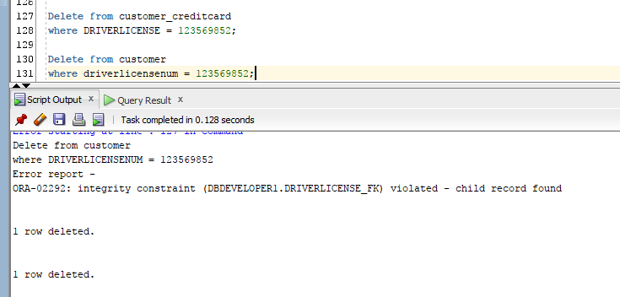

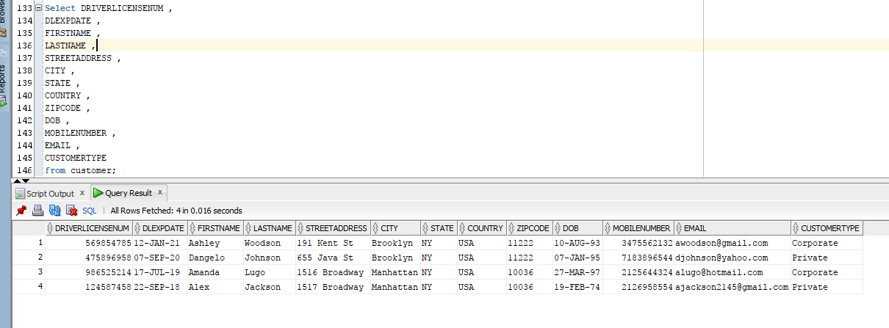

2) I am going to execute a query that will delete one record from the associative table based on its primary key.

**Query**

Delete from customer_creditcard

where cardnum = 1235986547859632;

