**Requirement #1 – Create an MS Word document Design & Implementation Document**

**Requirement #2- Create 10 Business Reports using 10 SQL statements that a Business User would need to make BUSINESS DECISIONS (Reporting)**

**Business Report #1**

A customer is looking to rent a car. This customer wants to rent a car with less than 1000 miles of mileage. The customer also wants to know the price of this rental.

Query:

Select Min(Mileage), MAKE, MODEL, YEAR, DAILYRENTALCOST

from Vehicle

Where Mileage < 1000 group by MAKE, MODEL, YEAR, DAILYRENTALCOST;

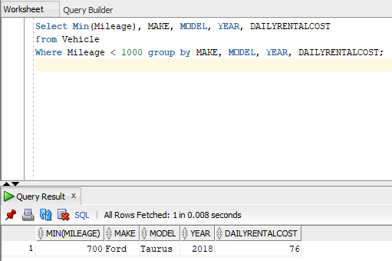

**Business Report #2**

The Rental Agency Manager wants to see which vehicles are available at the moment so the manager can send a car to one of his clients immediately.

Query:

Select Vehicle.Make, VEHICLE.Model ,Vehicle_Status.VEHICLESTATUS, Vehicle_Status.VEHICLESTATUSID

from Vehicle

Inner JOIN Vehicle_Status ON Vehicle.VEHICLESTATUSID = Vehicle_Status.VEHICLESTATUSID

Where VEHICLESTATUS = 'Available';

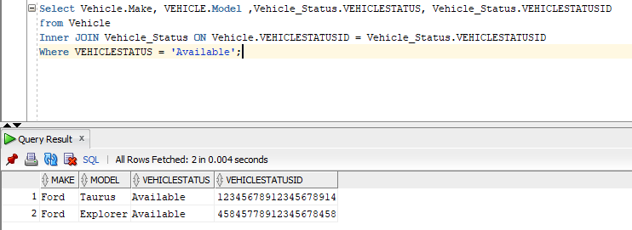

**Business Report #3**

The Rental Agency Manager wants to see which customers are private so he can have their car ready before other clients.

Query:

Select *

from Customer

Where CUSTOMERTYPE = 'Private';

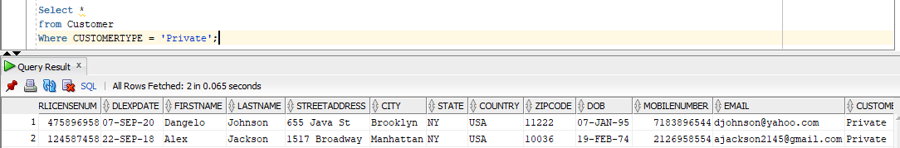

**Business Report #4**

The Agency Manager wants to know which agencies are located in Brooklyn so then he can tell a client which vehicles are in that specific agency to dispatch.

Query:

Select Rental_Agency.City, Vehicle.Model, Vehicle.Make, Vehicle.CURRENTAGENCYID

from RENTAL_AGENCY

Inner Join Vehicle ON RENTAL_AGENCY.AGENCYID = Vehicle.CURRENTAGENCYID

Where RENTAL_AGENCY.CITY = 'Brooklyn';

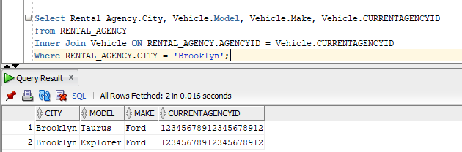

**Business Report #5:**

The customer wants to see all the Ford cars’ trunk capacity. Then, the customer will decide which Ford vehicle to rent based on the capacity of the trunk.

Query:

Select Vehicle.Make, Model, Car.Trunkcapacity

from Vehicle

Inner Join Car ON Vehicle.VINNUMBER = Car.CVINNUMBER

Where Make = 'Ford';

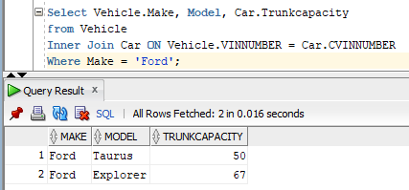

**Business Report #6**

The Rental Agency Manager wants to see the name and information of the credit card number 1254789632154856 because this customer’s payments have not been going through. Then, the manager will decide the necessary steps to handle this situation.

Query:

Select *

from CREDITCARD

Where CARDNUM = 1254789632154856;

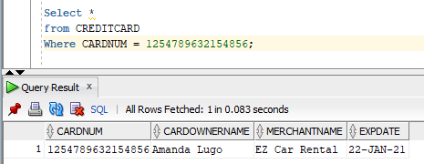

**Business Report #7**

The customer Dangelo Johnson wants to know how many ezplus points he has so he can then decide when to use his points.

Query:

select ezplusearnedpoints

from EZPLUS

where EZPLUSNUMBER = 3652789415;

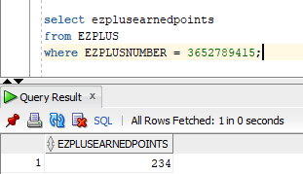

**Business Report #8**

Alex Jackson a customer will like to know what type of discount he is getting. Then, he will decide when to use his discount for his next transaction.

Query:

Select discountdesc

from discount

where DISCOUNTCODE = 1254789584;

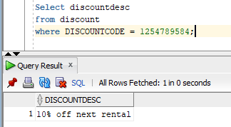

**Business Report #9**

The Executives of EZ Car Rental will like to know how much EZ pluspoints private customers have earned. When they look at the total number of points they will then decide whether to decrease or increase the amount of points private customers can earn.

Query:

Select SUM(ezplusearnedpoints)

from EZPLUS;

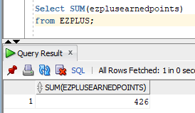

**Business Report #10**

A customer will like to see the selection of vehicles that were made in 2018. Then, the customer will decide which vehicle he will select.

Query:

Select *

from VEHICLE

Where Year = 2018;

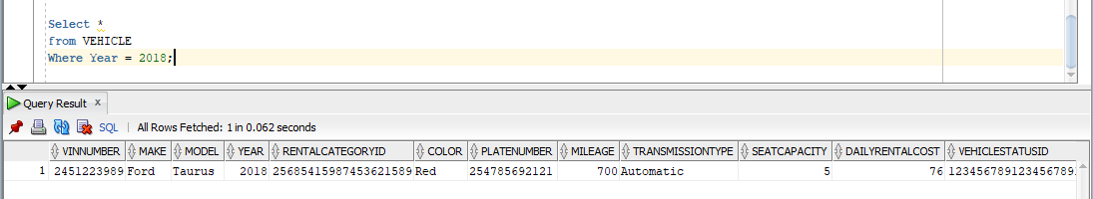

**Requirement #3 – Create/DESIGN STORED PROCEDURES for the 10 BUSINESS REPORT QUERIES**

**Business Report #1**

A customer is looking to rent a car. This customer wants to rent a car with less than 1000 miles of mileage. The customer also wants to know the price of this rental.

**Stored Procedure:**

CREATE OR REPLACE PROCEDURE usp_VehicleByMileage (p_Mileage IN NUMBER)

IS

v_Mileage NUMBER(5,0);

v_Make VARCHAR2(25);

v_Model VARCHAR2(30);

v_Year NUMBER(4,0);

v_DailyRentalCost NUMBER(5,0);

CURSOR cur_Vehicle IS

Select Min(Mileage), MAKE, MODEL, YEAR, DAILYRENTALCOST

from Vehicle

Where p_Mileage < 1000 group by MAKE, MODEL, YEAR, DAILYRENTALCOST;

BEGIN OPEN cur_Vehicle;

LOOP

FETCH cur_Vehicle INTO v_Mileage ,

v_Make ,

v_Model ,

v_Year ,

v_DailyRentalCost ;

EXIT WHEN cur_Vehicle%NOTFOUND;

DBMS_OUTPUT.PUT_LINE('Vehicle Info: ' ||v_Mileage||' '||v_Make||' '||v_Model||' '||v_Year||' '||v_DailyRentalCost);

END LOOP;

CLOSE cur_Vehicle;

END usp_VehicleByMileage;

SET SERVEROUTPUT ON;

EXECUTE usp_VehicleByMileage(999);

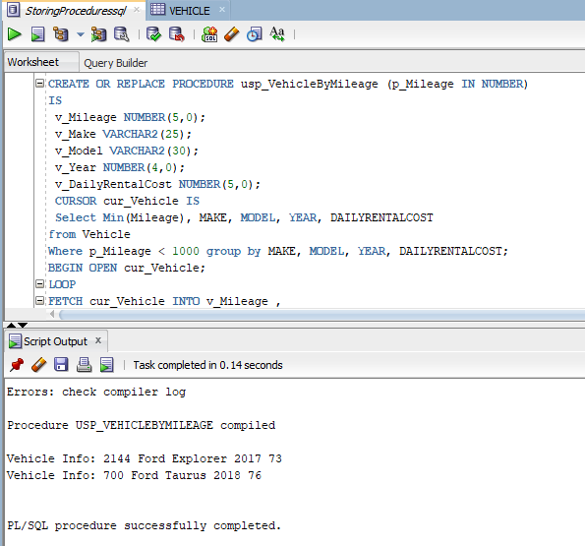

**Business Report #2**

The Rental Agency Manager wants to see which vehicles are available at the moment so the manager can send a car to one of his clients immediately.

**Stored Procedure:**

CREATE OR REPLACE PROCEDURE usp_VehicleByStatus (p_VehicleStatus IN CHAR)

IS

v_VehicleMake VARCHAR2(25);

v_VehicleModel VARCHAR2(30);

v_VehicleStatusVS VARCHAR2(15);

v_VehicleStatusVSID NUMBER(20,0);

CURSOR cur_Vehicle IS

Select Vehicle.Make, VEHICLE.Model ,Vehicle_Status.VEHICLESTATUS, Vehicle_Status.VEHICLESTATUSID

from Vehicle

Inner JOIN Vehicle_Status ON Vehicle.VEHICLESTATUSID = Vehicle_Status.VEHICLESTATUSID

Where VEHICLESTATUS = p_VehicleStatus;

BEGIN OPEN cur_Vehicle;

LOOP

FETCH cur_Vehicle INTO v_VehicleMake ,

v_VehicleModel,

v_VehicleStatusVS ,

v_VehicleStatusVSID;

EXIT WHEN cur_Vehicle%NOTFOUND;

DBMS_OUTPUT.PUT_LINE('Vehicle Info and Status: ' ||v_VehicleMake||' '||v_VehicleModel||' '||v_VehicleStatusVS||' '||v_VehicleStatusVSID);

END LOOP;

CLOSE cur_Vehicle;

END usp_VehicleByStatus;

SET SERVEROUTPUT ON;

EXECUTE usp_VehicleByStatus('Available');

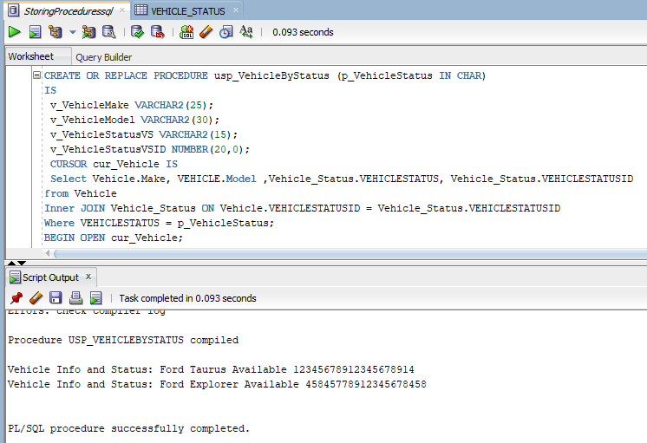

**Business Report #3**

The Rental Agency Manager wants to see which customers are private so he can have their car ready before other clients.

**Stored Procedure:**

CREATE OR REPLACE PROCEDURE usp_CustomerByType (p_CustomerType IN CHAR)

IS

v_DRIVERLICENSENUM NUMBER(20,0);

v_DLEXPDATE DATE;

v_FIRSTNAME VARCHAR2(40);

v_LASTNAME VARCHAR2(40);

v_STREETADDRESS VARCHAR2(75);

v_CITY VARCHAR2(25);

v_STATE VARCHAR2(20);

v_COUNTRY VARCHAR2(30);

v_ZIPCODE VARCHAR2(10);

v_DOB DATE;

v_MOBILENUMBER NUMBER(11,0);

v_EMAIL VARCHAR2(60);

v_CUSTOMERTYPE VARCHAR2(30);

CURSOR cur_Customer IS

Select DRIVERLICENSENUM ,

DLEXPDATE ,

FIRSTNAME ,

LASTNAME ,

STREETADDRESS ,

CITY ,

STATE ,

COUNTRY ,

ZIPCODE ,

DOB ,

MOBILENUMBER ,

EMAIL ,

CUSTOMERTYPE

from Customer

Where CUSTOMERTYPE = p_CustomerType;

BEGIN

OPEN cur_Customer;

LOOP

FETCH cur_Customer INTO v_DRIVERLICENSENUM ,

v_DLEXPDATE,

v_FIRSTNAME ,

v_LASTNAME ,

v_STREETADDRESS ,

v_CITY ,

v_STATE ,

v_COUNTRY ,

v_ZIPCODE ,

v_DOB ,

v_MOBILENUMBER ,

v_EMAIL ,

v_CUSTOMERTYPE ;

EXIT WHEN cur_Customer%NOTFOUND;

DBMS_OUTPUT.PUT_LINE('Private Customer Info: ' ||v_DRIVERLICENSENUM|| ' '||v_DLEXPDATE||' '||v_FIRSTNAME||' '||v_LASTNAME||' '||v_STREETADDRESS||' '

||v_CITY||' '||v_STATE||' '||v_COUNTRY||' '||v_ZIPCODE||' '||v_DOB||' '||v_MOBILENUMBER||' '||v_EMAIL||' '||v_CUSTOMERTYPE);

END LOOP;

CLOSE cur_Customer;

END usp_CustomerByType;

SET SERVEROUTPUT ON;

EXECUTE usp_CustomerByType('Private');

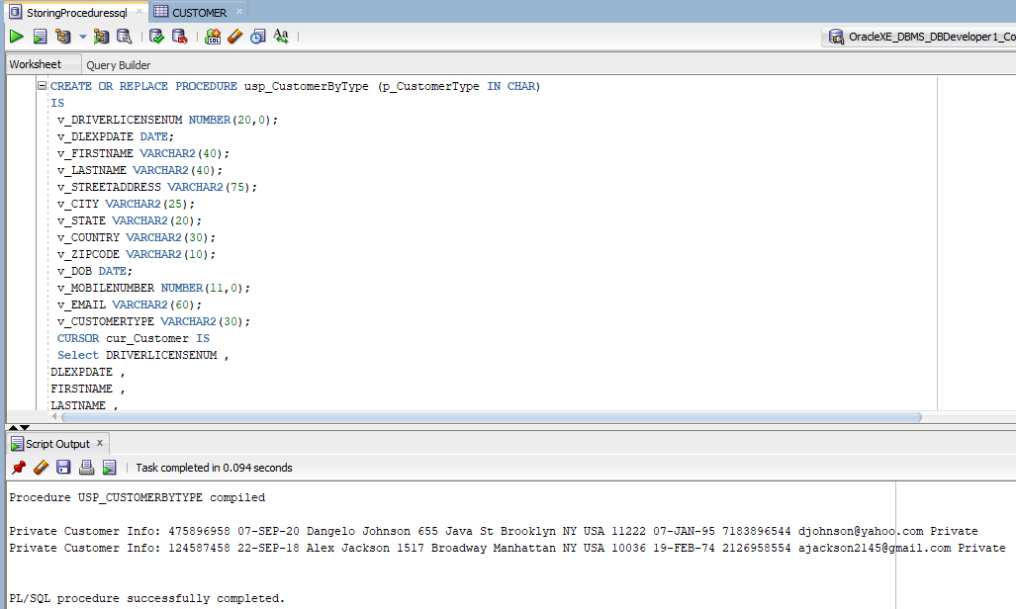

**Business Report #4**

The Agency Manager wants to know which agencies are located in Brooklyn so then he can tell a client which vehicles are in that specific agency to dispatch.

**Stored Procedure:**

CREATE OR REPLACE PROCEDURE usp_RentalAgencyByCity (p_City IN CHAR)

IS

v_RentalAgencyCity VARCHAR2(20);

v_VehicleModel VARCHAR2(30);

v_VehicleMake VARCHAR2(25);

v_VehicleCurrentAgencyID NUMBER(20,0);

CURSOR cur_RentalAgency IS

Select Rental_Agency.City, Vehicle.Model, Vehicle.Make, Vehicle.CURRENTAGENCYID

from RENTAL_AGENCY

Inner Join Vehicle ON RENTAL_AGENCY.AGENCYID = Vehicle.CURRENTAGENCYID

Where RENTAL_AGENCY.CITY = p_City;

BEGIN

OPEN cur_RentalAgency;

LOOP FETCH cur_RentalAgency INTO v_RentalAgencyCity,

v_VehicleModel ,

v_VehicleMake ,

v_VehicleCurrentAgencyID ;

EXIT WHEN cur_RentalAgency%NOTFOUND;

DBMS_OUTPUT.PUT_LINE('Rental Agency and Vehicle Info: ' ||v_RentalAgencyCity||' '||v_VehicleModel||' '||v_VehicleMake||' '||v_VehicleCurrentAgencyID);

END LOOP;

CLOSE cur_RentalAgency;

END usp_RentalAgencyByCity;

SET SERVEROUTPUT ON;

EXECUTE usp_RentalAgencyByCity('Brooklyn');

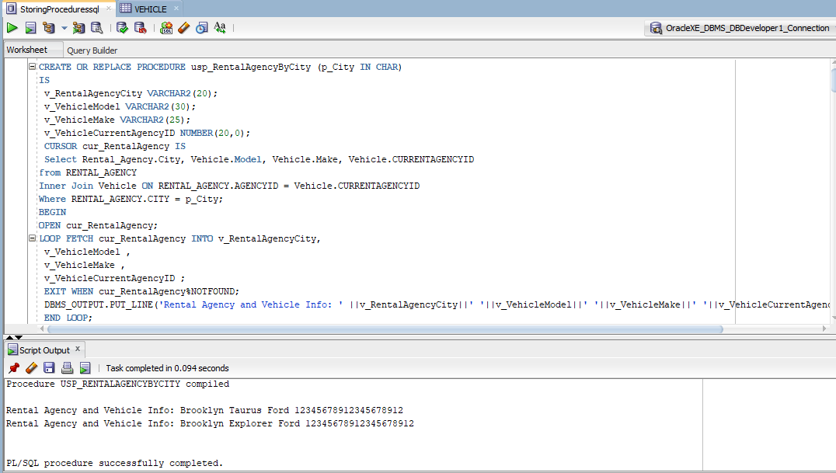

**Business Report #5:**

The customer wants to see all the Ford cars’ trunk capacity. Then, the customer will decide which Ford vehicle to rent based on the capacity of the trunk.

**Stored Procedure:**

CREATE OR REPLACE PROCEDURE usp_VehicleByMake (p_Make IN CHAR)

IS

v_VehicleMake VARCHAR2(25);

v_Model VARCHAR2(30);

v_CarTrunkcapacity NUMBER(5,2);

CURSOR cur_VehicleMake IS

Select Vehicle.Make, Model, Car.Trunkcapacity

from Vehicle

Inner Join Car ON Vehicle.VINNUMBER = Car.CVINNUMBER

Where Make = P_Make;

BEGIN

OPEN cur_VehicleMake;

LOOP

FETCH cur_VehicleMake INTO v_VehicleMake ,

v_Model ,

v_CarTrunkcapacity;

EXIT WHEN cur_VehicleMake%NOTFOUND;

DBMS_OUTPUT.PUT_LINE('Vehicle Info: ' ||v_VehicleMake|| ' '||v_Model||' '||v_CarTrunkcapacity);

END LOOP;

CLOSE cur_VehicleMake;

END usp_VehicleByMake;

SET SERVEROUTPUT ON;

EXECUTE usp_VehicleByMake('Ford');

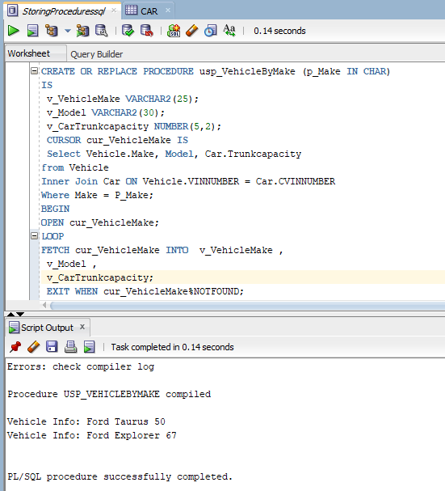

**Business Report #6**

The Rental Agency Manager wants to see the name and information of the credit card number 1254789632154856 because this customer’s payments have not been going through. Then, the manager will decide the necessary steps to handle this situation.

**Stored Procedure:**

CREATE OR REPLACE PROCEDURE usp_CreditCardByNumber (p_CardNum IN NUMBER)

IS

v_CARDNUM NUMBER(16,0);

v_CARDOWNERNAME VARCHAR2(50);

v_MERCHANTNAME VARCHAR2(60);

v_EXPDATE DATE;

CURSOR cur_CreditCard IS

Select CARDNUM ,

CARDOWNERNAME ,

MERCHANTNAME ,

EXPDATE

from CREDITCARD

Where CARDNUM = P_CardNum;

BEGIN

OPEN cur_CreditCard;

LOOP

FETCH cur_CreditCard INTO v_CARDNUM ,

v_CARDOWNERNAME,

v_MERCHANTNAME ,

v_EXPDATE;

EXIT WHEN cur_CreditCard%NOTFOUND;

DBMS_OUTPUT.PUT_LINE('Credit Card Info: ' ||v_CARDNUM||' '||v_CARDOWNERNAME|| ' '||v_MERCHANTNAME||' '||v_EXPDATE);

END LOOP;

CLOSE cur_CreditCard;

END usp_CreditCardByNumber;

SET SERVEROUTPUT ON;

EXECUTE usp_CreditCardByNumber(1254789632154856);

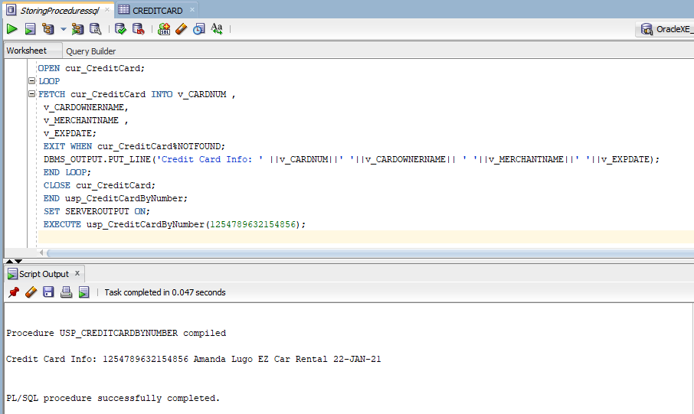

**Business Report #7**

The customer Dangelo Johnson wants to know how many ezplus points he has so he can then decide when to use his points.

**Stored Procedure:**

CREATE OR REPLACE PROCEDURE usp_EZPlusByNumber (p_EZPlusNumber IN NUMBER)

IS

v_EZPLUESEARNEDPOINTS NUMBER(10,0);

CURSOR cur_EZPLUESEARNEDPOINTS IS

select ezplusearnedpoints

from EZPLUS

where EZPLUSNUMBER = p_EZPlusNumber;

BEGIN

OPEN cur_EZPLUESEARNEDPOINTS;

LOOP

FETCH cur_EZPLUESEARNEDPOINTS INTO v_EZPLUESEARNEDPOINTS;

EXIT WHEN cur_EZPLUESEARNEDPOINTS%NOTFOUND;

DBMS_OUTPUT.PUT_LINE('EZPlus Earned Points: ' ||v_EZPLUESEARNEDPOINTS);

END LOOP;

CLOSE cur_EZPLUESEARNEDPOINTS;

END usp_EZPlusByNumber;

SET SERVEROUTPUT ON;

EXECUTE usp_EZPlusByNumber(3652789415);

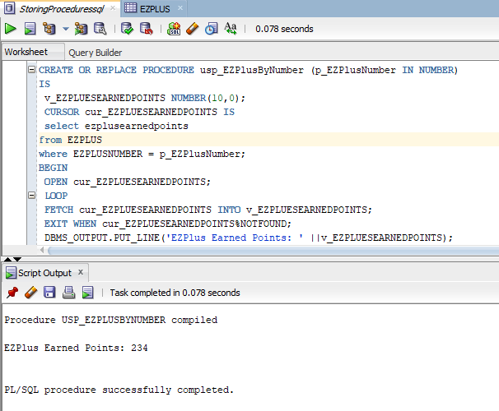

**Business Report #8**

Alex Jackson a customer will like to know what type of discount he is getting. Then, he will decide when to use his discount for his next transaction.

**Stored Procedure:**

CREATE OR REPLACE PROCEDURE usp_DiscountByCode (p_DiscountCode IN NUMBER)

IS

v_discountdesc VARCHAR2(70);

CURSOR cur_DiscountDesc IS

Select discountdesc

from discount

where DISCOUNTCODE = p_DiscountCode;

BEGIN

OPEN cur_DiscountDesc;

LOOP

FETCH cur_DiscountDesc INTO v_discountdesc;

EXIT WHEN cur_DiscountDesc%NOTFOUND;

DBMS_OUTPUT.PUT_LINE('Discount Description: ' ||v_discountdesc);

END LOOP;

CLOSE cur_DiscountDesc;

END usp_DiscountByCode;

SET SERVEROUTPUT ON;

EXECUTE usp_DiscountByCode(1254789584);

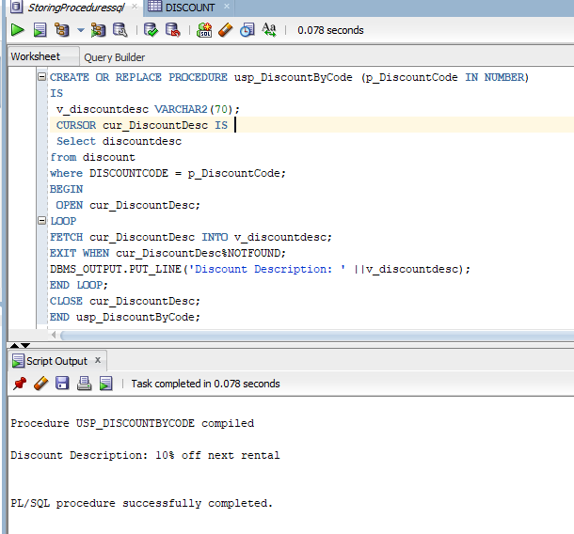

**Business Report #9**

The Executives of EZ Car Rental will like to know how much EZ pluspoints private customers have earned. When they look at the total number of points they will then decide whether to decrease or increase the amount of points private customers can earn.

**Stored Procedure:**

CREATE OR REPLACE PROCEDURE usp_EZPlusBySum (p_EZPlusEarnedPoints IN NUMBER)

IS

v_EZPLUSEARNEDPOINTS NUMBER(10,0);

CURSOR cur_EZPlus IS

SELECT SUM(ezplusearnedpoints)

from EZPLUS;

BEGIN

OPEN cur_EZPlus;

LOOP

FETCH cur_EZPlus INTO v_EZPLUSEARNEDPOINTS;

EXIT WHEN cur_EZPlus%NOTFOUND;

DBMS_OUTPUT.PUT_LINE('Total EZPlus Points: '||v_EZPLUSEARNEDPOINTS);

END LOOP;

CLOSE cur_EZPlus;

END usp_EZPlusBySum;

SET SERVEROUTPUT ON;

EXECUTE USP_EZPlusBySum(426);

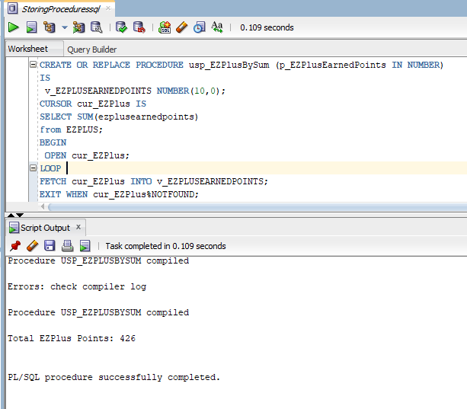

**Business Report #10**

A customer will like to see the selection of vehicles that were made in 2018. Then, the customer will decide which vehicle he will select.

**Stored Procedure:**

CREATE OR REPLACE PROCEDURE usp_VehicleByYear(p_Year IN NUMBER)

IS

v_VINNUMBER NUMBER(10,0);

v_MAKE VARCHAR2(25);

v_MODEL VARCHAR2(30);

v_YEAR NUMBER(4,0);

v_RENTALCATEGORYID NUMBER(20,0);

v_COLOR VARCHAR2(12 );

v_PLATENUMBER VARCHAR2(12);

v_MILEAGE NUMBER(5,0);

v_TRANSMISSIONTYPE VARCHAR2(20);

v_SEATCAPACITY NUMBER(3,0);

v_DAILYRENTALCOST NUMBER(5,0);

v_VEHICLESTATUSID NUMBER(20,0);

v_ASSIGNEDAGENCYID NUMBER(20,0);

v_CURRENTAGENCYID NUMBER(20,0);

v_VEHICLETYPE VARCHAR2(20);

CURSOR cur_Vehicle IS

Select VINNUMBER ,

MAKE ,

MODEL ,

YEAR ,

RENTALCATEGORYID ,

COLOR ,

PLATENUMBER ,

MILEAGE ,

TRANSMISSIONTYPE ,

SEATCAPACITY ,

DAILYRENTALCOST ,

VEHICLESTATUSID ,

ASSIGNEDAGENCYID ,

CURRENTAGENCYID ,

VEHICLETYPE

from VEHICLE

Where Year = p_Year;

BEGIN

OPEN cur_Vehicle;

LOOP

FETCH cur_Vehicle INTO v_VINNUMBER,

v_MAKE,

v_MODEL,

v_YEAR,

v_RENTALCATEGORYID ,

v_COLOR ,

v_PLATENUMBER ,

v_MILEAGE ,

v_TRANSMISSIONTYPE ,

v_SEATCAPACITY ,

v_DAILYRENTALCOST ,

v_VEHICLESTATUSID ,

v_ASSIGNEDAGENCYID ,

v_CURRENTAGENCYID ,

v_VEHICLETYPE ;

EXIT WHEN cur_VEHICLE%NOTFOUND;

DBMS_OUTPUT.PUT_LINE('Vehicle info: '||v_VINNUMBER|| ' '||v_MAKE|| ' '||v_MODEL|| ' '||v_YEAR|| ' '||v_RENTALCATEGORYID|| ' '||v_COLOR|| ' '||v_PLATENUMBER||

' '||v_MILEAGE|| ' '||v_TRANSMISSIONTYPE|| ' '||v_SEATCAPACITY|| ' '||v_DAILYRENTALCOST|| ' '||v_VEHICLESTATUSID|| ' '||v_ASSIGNEDAGENCYID|| ' '||v_CURRENTAGENCYID||

' '||v_VEHICLETYPE);

END LOOP;

CLOSE cur_VEHICLE;

END usp_VehicleByYear;

SET SERVEROUTPUT ON;

EXECUTE USP_VEHICLEBYYEAR(2018);

