**Requirement #1 – Create an MS Word document Design & Implementation Document**

**Requirement #2 – Add SECONDARY INDEXES to your SCHEMA TABLES Of the Database to improve the search performance of EACH of the 10 BUSINESS REPORT QUERIES created in Project 2. Create a new SCRIPT FILE to store all your indices.**

**Requirement #3 – Copy/Paste the EACH of the CREATE INDEXES STATEMENTS & Screen Shot of the INDEX Objects in Oracle SQL Developer to the MS Word document Design & Implementation Document to SHOW PROOF That they were CREATED & EXECUTED.**

**Business Report #1:**

Select Min(Mileage), MAKE, MODEL, YEAR, DAILYRENTALCOST

from Vehicle

Where Mileage < 1000 group by MAKE, MODEL, YEAR, DAILYRENTALCOST;

CREATE INDEX idx_Mileage ON Vehicle(Mileage);

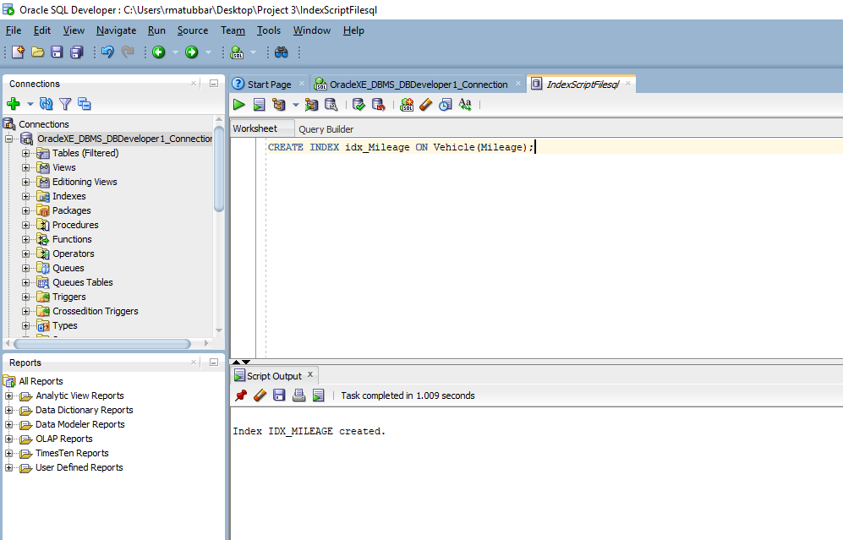

**Business Report #2:**

Select Vehicle.Make, VEHICLE.Model ,Vehicle_Status.VEHICLESTATUS, Vehicle_Status.VEHICLESTATUSID

from Vehicle

Inner JOIN Vehicle_Status ON Vehicle.VEHICLESTATUSID = Vehicle_Status.VEHICLESTATUSID

Where VEHICLESTATUS = 'Available';

CREATE INDEX idx_VVehicleStatusID ON Vehicle(VehicleStatusID);

CREATE INDEX idx_VS_Vehiclestatus ON Vehicle_Status(VEHICLESTATUS);

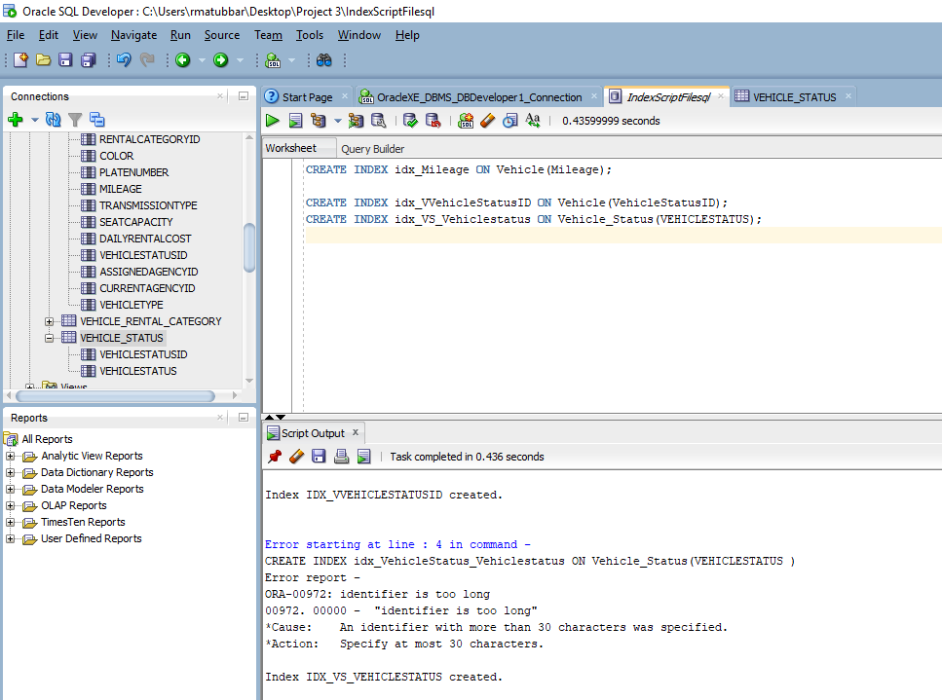

**Business Report #3:**

Select *

from Customer

Where CUSTOMERTYPE = 'Private';

CREATE INDEX idx_CustCustomerType ON Customer(CUSTOMERTYPE);

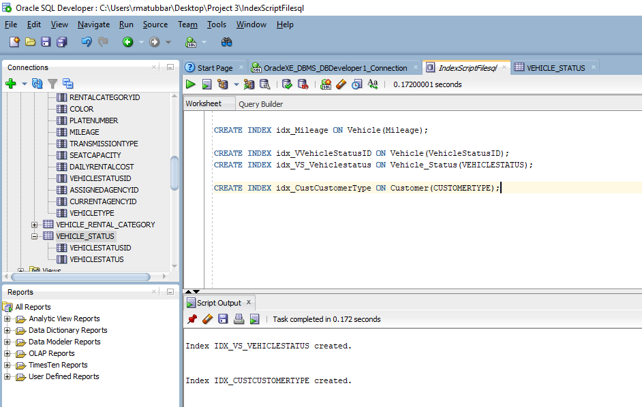

**Business Report #4:**

Select Rental_Agency.City, Vehicle.Model, Vehicle.Make, Vehicle.CURRENTAGENCYID

from RENTAL_AGENCY

Inner Join Vehicle ON RENTAL_AGENCY.AGENCYID = Vehicle.CURRENTAGENCYID

Where RENTAL_AGENCY.CITY = 'Brooklyn';

CREATE INDEX idx_VehicleCurrentAgencyID ON Vehicle(CURRENTAGENCYID);

CREATE INDEX idx_RentalAgencyCity ON Rental_Agency(City);

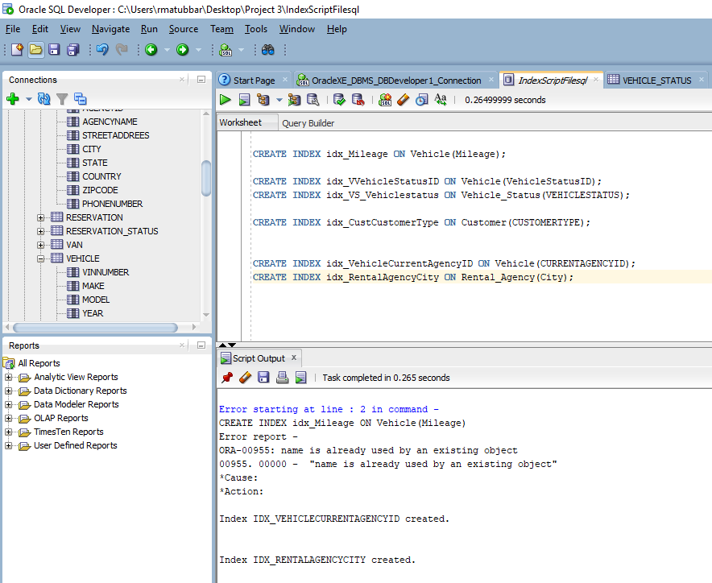

**Business Report #5**

Select Vehicle.Make, Model, Car.Trunkcapacity

from Vehicle

Inner Join Car ON Vehicle.VINNUMBER = Car.CVINNUMBER

Where Make = 'Ford';

CREATE INDEX idx_Make ON Vehicle(Make);

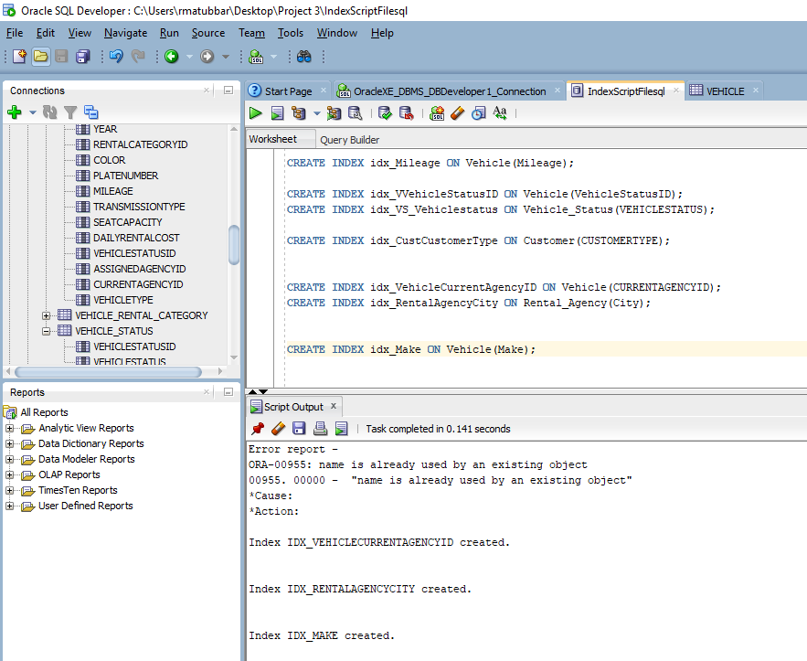

**Business Report #6:**

Select *

from CREDITCARD

Where CARDNUM = 1254789632154856;

Oracle automatically creates primary indexes so in this situation we do not need to create a secondary index for cardnum because it will result in an error since cardnum is a primary index.

**Business Report #7**

select ezplusearnedpoints

from EZPLUS

where EZPLUSNUMBER = 3652789415;

The index for EZPLUSNUMBER is already created by Oracle since it is a primary index.

**Business Report #8**

Select discountdesc

from discount

where DISCOUNTCODE = 1254789584;

The index for DISCOUNTCODE already exits in Oracle since it is a primary index.

**Business Report #9**

Select SUM(ezplusearnedpoints)

from EZPLUS;

CREATE INDEX idx_EZPLUSEARNEDPOINTS ON EZPLUS(EZPLUSEARNEDPOINTS);

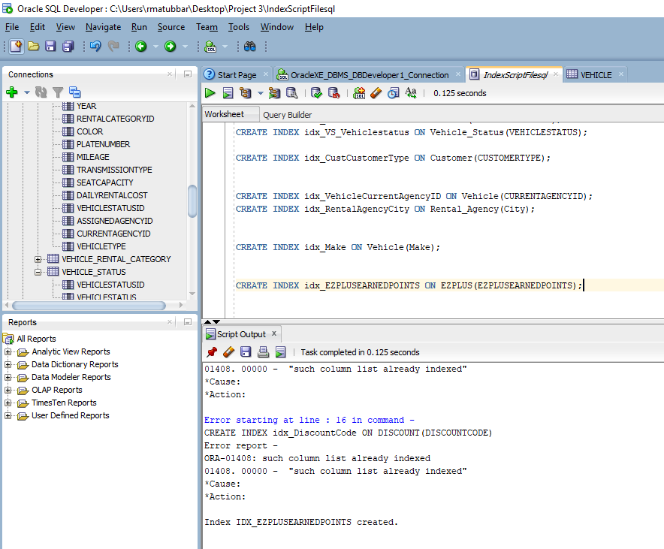

**Business Report #10**

Select *

from VEHICLE

Where Year = 2018;

CREATE INDEX idx_YEAR ON VEHICLE(YEAR);

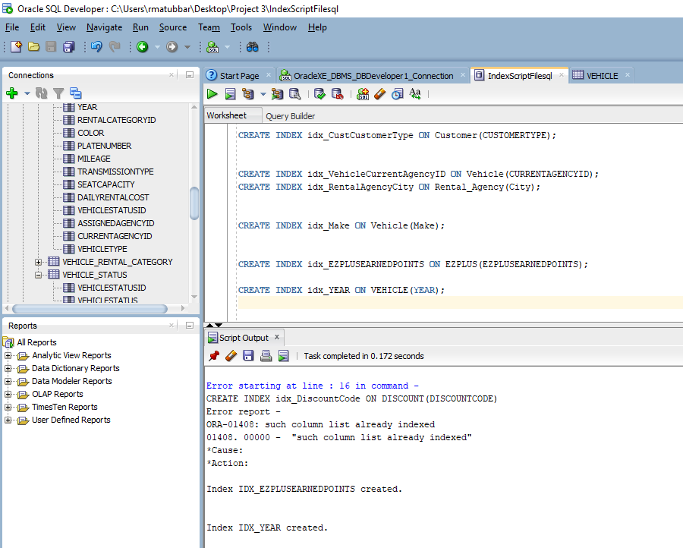

**Requirement #4 – Create the REQUIRED NUMBER OF VIEWS to support the EXISTING 10 Business Reports Created in Project 2.**

**Requirement #5 – Copy/Paste the EACH of the VIEW STATEMENTS & Screen Shot of the View Objects in Oracle SQL Developer to the MS Word document Design & Implementation Document to SHOW PROOF That they were CREATED & EXECUTED.**

**Business Report #1**

A customer is looking to rent a car. This customer wants to rent a car with less than 1000 miles of mileage. The customer also wants to know the price of this rental.

Query:

Select Min(Mileage), MAKE, MODEL, YEAR, DAILYRENTALCOST

from Vehicle

Where Mileage < 1000 group by MAKE, MODEL, YEAR, DAILYRENTALCOST;

View #1

CREATE VIEW Vehicle_Mileage AS

Select Mileage, MAKE, MODEL, YEAR, DAILYRENTALCOST

from Vehicle ;

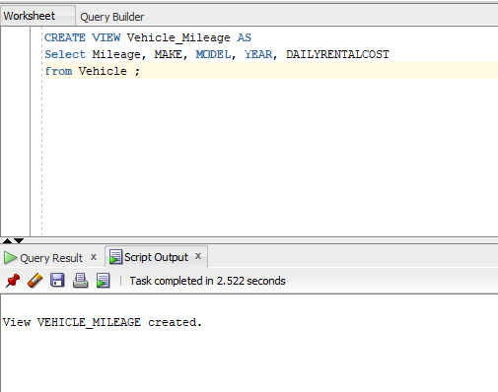

**Business Report #2**

The Rental Agency Manager wants to see which vehicles are available at the moment so the manager can send a car to one of his clients immediately.

Query:

Select Vehicle.Make, VEHICLE.Model ,Vehicle_Status.VEHICLESTATUS, Vehicle_Status.VEHICLESTATUSID

from Vehicle

Inner JOIN Vehicle_Status ON Vehicle.VEHICLESTATUSID = Vehicle_Status.VEHICLESTATUSID

Where VEHICLESTATUS = 'Available';

View #2

CREATE VIEW Vehicle_Availability AS

Select Vehicle.Make, VEHICLE.Model ,Vehicle_Status.VEHICLESTATUS, Vehicle_Status.VEHICLESTATUSID

from Vehicle

INNER JOIN Vehicle_Status ON Vehicle.VEHICLESTATUSID = Vehicle_Status.VEHICLESTATUSID;

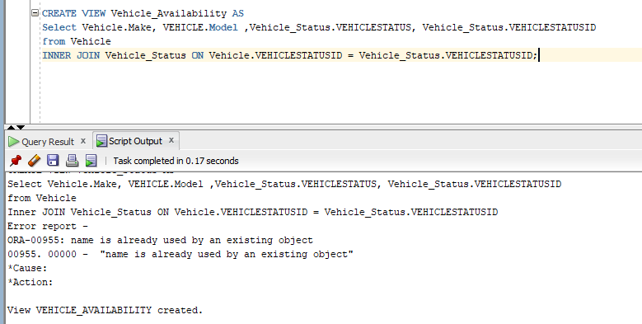

**Business Report #3**

The Rental Agency Manager wants to see which customers are private so he can have their car ready before other clients.

Query:

Select *

from Customer

Where CUSTOMERTYPE = 'Private';

View #3

CREATE VIEW Customer_Type AS

Select *

from Customer ;

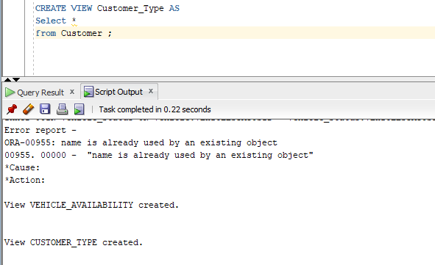

**Business Report #4**

The Agency Manager wants to know which agencies are located in Brooklyn so then he can tell a client which vehicles are in that specific agency to dispatch.

Query:

Select Rental_Agency.City, Vehicle.Model, Vehicle.Make, Vehicle.CURRENTAGENCYID

from RENTAL_AGENCY

Inner Join Vehicle ON RENTAL_AGENCY.AGENCYID = Vehicle.CURRENTAGENCYID

Where RENTAL_AGENCY.CITY = 'Brooklyn';

View #4

CREATE VIEW VehicleAgency_Location AS

Select Rental_Agency.City, Vehicle.Model, Vehicle.Make, Vehicle.CURRENTAGENCYID

from RENTAL_AGENCY

Inner Join Vehicle ON RENTAL_AGENCY.AGENCYID = Vehicle.CURRENTAGENCYID;

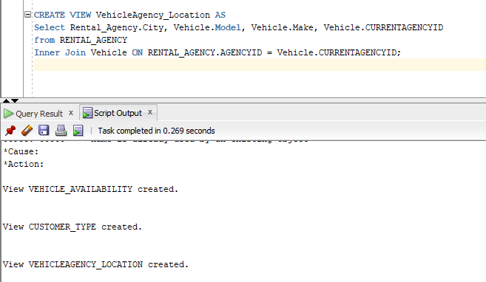

**Business Report #5:**

The customer wants to see all the Ford cars’ trunk capacity. Then, the customer will decide which Ford vehicle to rent based on the capacity of the trunk.

Query:

Select Vehicle.Make, Model, Car.Trunkcapacity

from Vehicle

Inner Join Car ON Vehicle.VINNUMBER = Car.CVINNUMBER

Where Make = 'Ford';

View #5

CREATE VIEW Vehicle_Trunk AS

Select Vehicle.Make, Model, Car.Trunkcapacity

from Vehicle

Inner Join Car ON Vehicle.VINNUMBER = Car.CVINNUMBER;

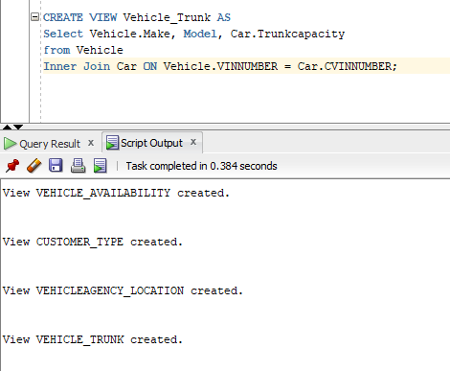

**Business Report #6**

The Rental Agency Manager wants to see the name and information of the credit card number 1254789632154856 because this customer’s payments have not been going through. Then, the manager will decide the necessary steps to handle this situation.

Query:

Select *

from CREDITCARD

Where CARDNUM = 1254789632154856;

View #6

CREATE VIEW CREDITCARD_NUM AS

Select *

from CREDITCARD;

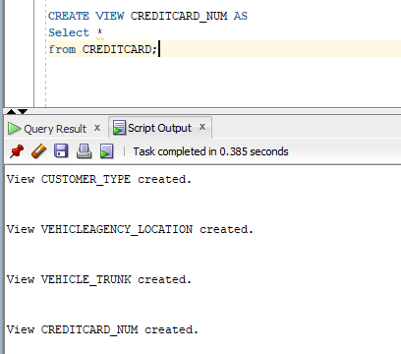

**Business Report #7**

The customer Dangelo Johnson wants to know how many ezplus points he has so he can then decide when to use his points.

Query:

select ezplusearnedpoints

from EZPLUS

where EZPLUSNUMBER = 3652789415;

View #7

CREATE VIEW EZPLUSPOINTS_NUMBER AS

select ezplusearnedpoints

from EZPLUS;

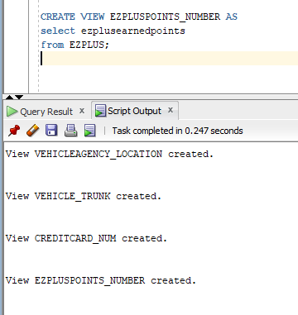

**Business Report #8**

Alex Jackson a customer will like to know what type of discount he is getting. Then, he will decide when to use his discount for his next transaction.

Query:

Select discountdesc

from discount

where DISCOUNTCODE = 1254789584;

View #8

CREATE VIEW DISCOUNT_CODE AS

Select discountdesc

from discount ;

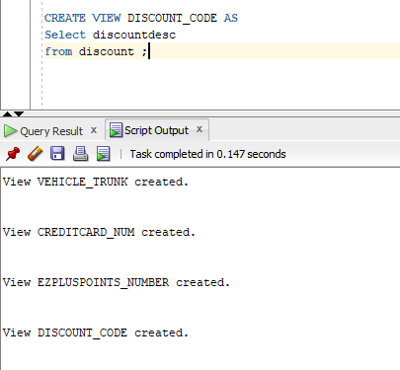

**Business Report #9**

The Executives of EZ Car Rental will like to know how much EZ pluspoints private customers have earned. When they look at the total number of points they will then decide whether to decrease or increase the amount of points private customers can earn.

Query:

Select SUM(ezplusearnedpoints)

from EZPLUS;

View #9

CREATE VIEW EZPLUSPOINTS_NUMBER AS

select ezplusearnedpoints

from EZPLUS;

We do not need to create a view for this report because an earlier view that was created can work for this business report as well.

**Business Report #10**

A customer will like to see the selection of vehicles that were made in 2018. Then, the customer will decide which vehicle he will select.

Query:

Select *

from VEHICLE

Where Year = 2018;

View #10

CREATE VIEW Vehicle_Info AS

Select *

from VEHICLE;

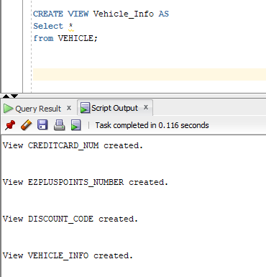

**Requirement #6 – Based on Original 10 Business Reports, Create the 10 NEW Business Reports that will use the VIEWS CREATED IN REQUIREMENTS 4 & 5.**

**Requirement #7 – Copy/Paste the EACH of the REPORTS & Screen Shot of the EXECUTION OF EACH REPORT in Oracle SQL Developer to the MS Word document Design & Implementation Document to SHOW PROOF That they were CREATED & EXECUTED.**

Modified Business Report #1:

Select Mileage, MAKE, MODEL, YEAR

from Vehicle_Mileage

Where Mileage < 1000 ;

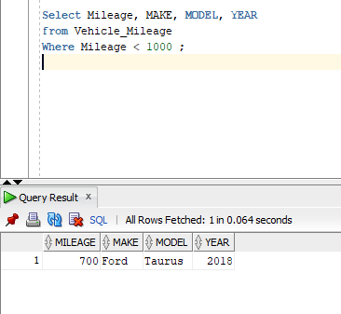

Modified Business Report #2:

Select Make, Model, VEHICLESTATUS, VEHICLESTATUSID

from Vehicle_Availability

Where VEHICLESTATUS = 'Available';

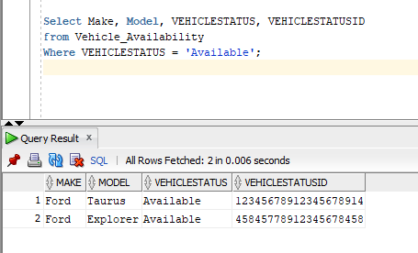

Modified Business Report #3:

Select *

from Customer_Type

Where CUSTOMERTYPE = 'Private';

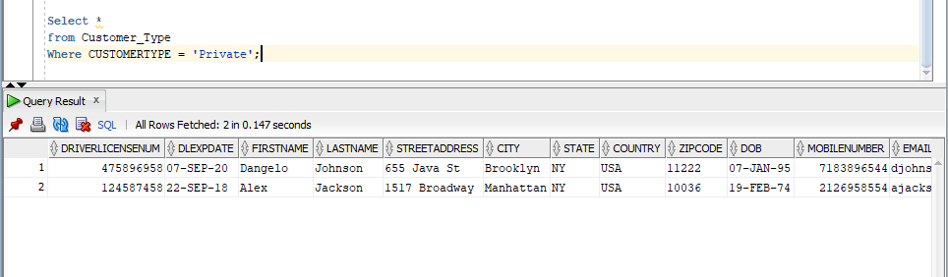

Modified Business Report #4

Select City, Model, Make, CURRENTAGENCYID

from VehicleAgency_Location

Where CITY = 'Brooklyn';

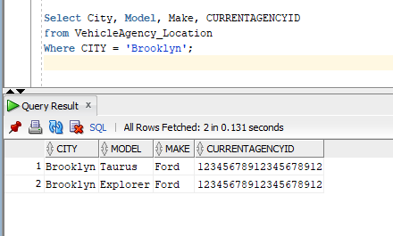

Modified Business Report #5

Select Make, Model, Trunkcapacity

from Vehicle_Trunk

Where Make = 'Ford';

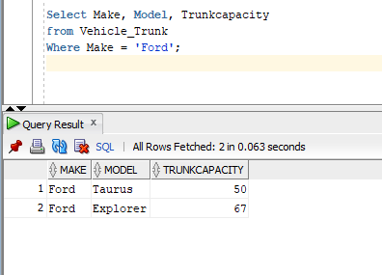

Modified Business Report #6:

Select *

from CREDITCARD_NUM

Where CARDNUM = 1254789632154856;

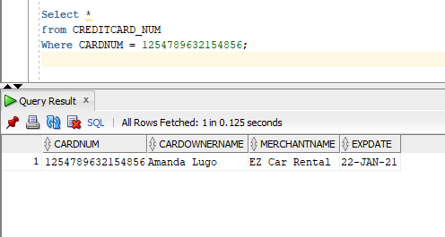

Modified Business Report #7:

select *

from EZPLUSPOINTS_NUMBER

where EZPLUSEARNEDPOINTS = 234;

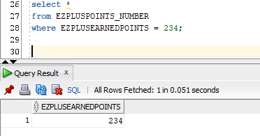

Modified Business Report #8:

Select *

from DISCOUNT_CODE

where DISCOUNTDESC = '10% off next rental';

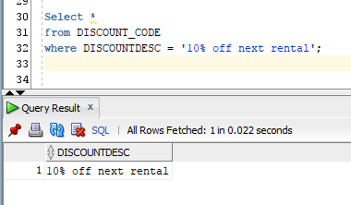

Modified Business Report #9:

Select SUM(ezplusearnedpoints)

from EZPLUSPOINTS_NUMBER;

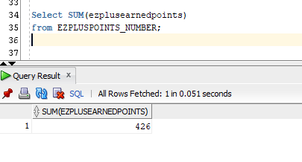

Modified Business Report #10:

Select *

from VEHICLE_INFO

Where Year = 2018;

