**Requirement #1 – Create an MS Word document Design & Implementation Document**

**Requirement #2 – Create a new SCRIPT FILE to store any commands executed**

**Requirement #3 – Create 2 new USERS in your database**

Requirement #3a – CREATE 2 NEW USER ACCOUNTS:

We will create 2 users named “USER1” and “USER2” using SQL Developer.

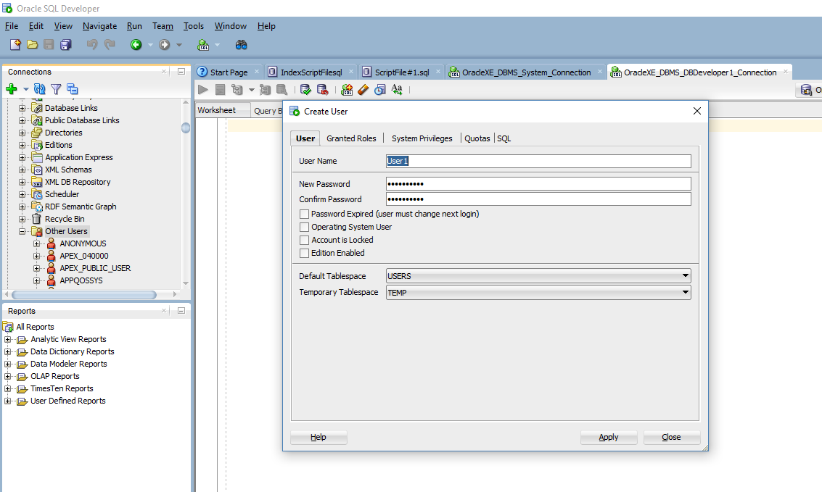

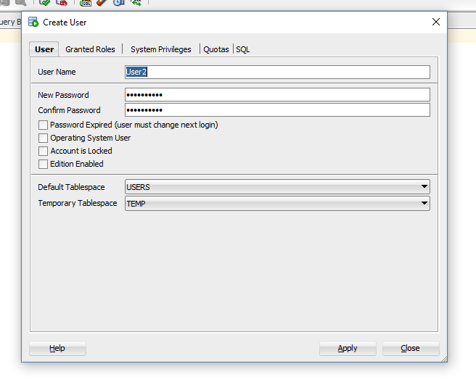

Requirement #3b – SHOW PROOF THAT THE USERS WERE CREATED

We are going to run 2 queries to show that the users were created.

SELECT username, account_status, default_tablespace, temporary_tablespace

FROM DBA_USERS

WHERE username= 'USER1';

SELECT username, account_status, default_tablespace, temporary_tablespace

FROM DBA_USERS

WHERE username= 'USER2';

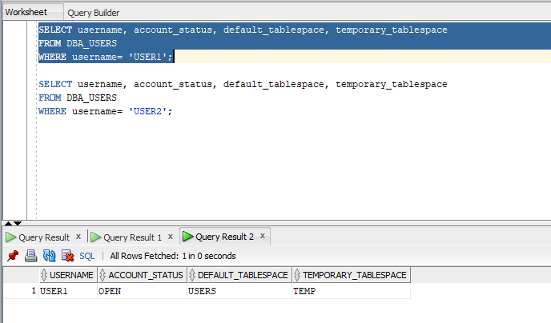

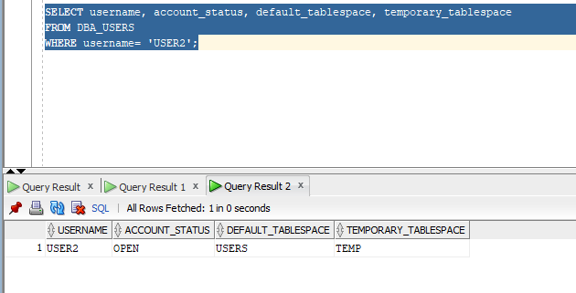

**Requirement #4 – Attempt to Connect to the Database with a new User & Correct any connectivity issues**

We will connect USER1 to the database.

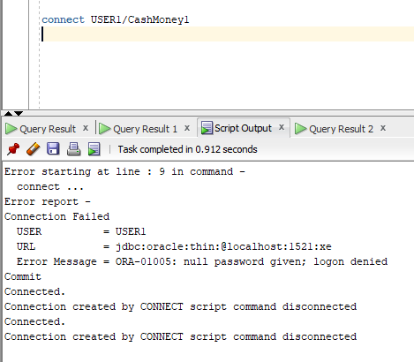

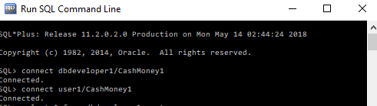

**Requirement #5 – Attempt to Execute a SELECT Statement as a new user**

SELECT * FROM DBDeveloper1.Customer ;

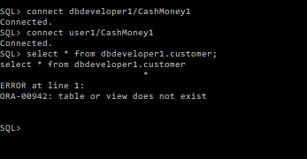

We get an error because user1 does not have this privilege so we will use dbdeveloper1 to grant user1 the select any table privilege.

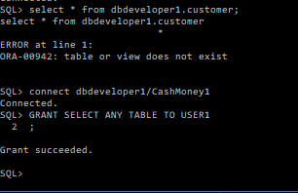

Select city from dbdeveloper1.customer where city = ‘Brooklyn’;

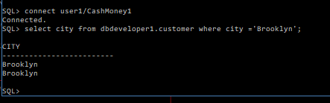

**Requirement #6 – Attempt to Execute a DELETE Statement as a new user**

We will Grant user1 the ability to delete any table.

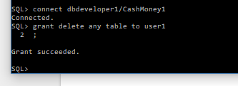

Now we will execute a delete statement :

Delete from dbdeveloper1.customer where driverlicensenum= ‘569854785’;

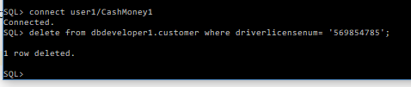

**Requirement #7 – Attempt to Execute a CREATE TABLE Statement as a new user**

We will grant the create any table privilege to USER1.

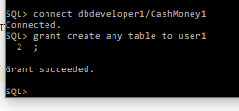

We will now create a table called Department.

Syntax:

Create table department (depid number(5) primary key, depname varchar2(25) not null );

