**PART 1:**

**Introduction:**

The purpose of this project is to create a database management system for the EZ-Car Rental System. This project requires us to plan, analyze, design, implement, and maintain the dbms. We will analyze the data and develop an Enhanced E-R Diagram. We will create a normalized logical model of the diagram and the physical model. The physical model will be implemented using Oracle 11g and Oracle SQL Developer. Then, a script will be created to test and validate the database. We will create business reports and stored procedures. We will also add secondary indexes and create 2 users to grant them specific privileges within the database.

Business Requirements   A Business Analyst was hired by Mr. Rodriguez to compile the list or requirements based on the results of interviews and conversations with the various business stakeholders.  Below are the requirements captured by the Business Analyst:

EZ-Car Rental is a car rental company that rents vehicles to customers in several countries.  They have rental agency branch locations in US, Canada, Mexico, UK, Japan & Australia. The rental agencies are in cities throughout each country and there can be more than one rental agency in a city, for example New York City has 2 rental agencies or branches in Manhattan one in Brooklyn and two in Queens near each airport.  Because there are multiple rental agencies, a customer can pick up a vehicle in one location and drop it off at another. A rental agency or branch is identified by a rental agency ID, address which is composed of street address, city, state, country & zip code. In addition, we also need to capture the phone number of the rental agency.

EZ-Car Rental offer their services to two types of customers, corporate customers & consumers/private customers.  The application should store the following information about all types of customers: a customer ID which is their driver license number, driver license expiration date, customer name which is composed of first name, last name, address which is composed of street number & name, city, state & zip code. In addition, we need to store the date of birth, mobile number, email, and credit card which is composed of credit card number, credit card owner name, merchant name & expiration date. A customer can have many credit cards they can use to pay for rental transaction. In addition, the credit card used by a customer can be co-owned by many individuals such a family member or corporate entity the customer works for.

For corporate customers we must store the company name, company ID (we store an ID for each company), Company contact which is composed of contact name & phone number. Finally, we need also need store the corporate rate.

For our private consumer customers, any discount code and discount description. In addition, for our private customers, we offer a frequent rental program called EZPlus where they earn points every time they rent a car and can leverage these points to pay for their next rental. Therefore, we need to store their EZPlus number and EZPlus earned points.

In our business, we only have consumer/private or corporate customers. No other type of customer exists. If a private customer wishes to rent and also works for a company that also rents from us, each of these transactions must be separate customer accounts. you can only be a consumer or corporate customer not both.

A vehicle must first be reserved before it can be rented, therefore there is a distinction between a reservation and a rental.  A reservation guarantees a vehicle will be ready for you to pick-up and rent. A rental means a customer complied with the reservation and picked up the vehicle.

A reservation is not made for a specific vehicle, but for a vehicle rental category at a rental agency location. We have the following vehicle rental categories: Car (economy, intermediate, full size, luxury), SUV, or Van.  Each of these categories have a different price range. Therefore, a vehicle rental category has a rental category ID that identifies the category of the vehicle being reserved, rental category name (ex. for car (economy, intermediate, full size, luxury), SUV, or Van) and finally rental category rate. Note that a vehicle rental category can have one, none or many vehicles available to rent, nevertheless, a vehicle can only belong to one vehicle rental category.

The reservation process involves a customer reserving a vehicle rental category to be pick-up/drop-off at a rental agency. Therefore, the reservation process requires the customer, vehicle rental category & rental agency of pick-up & drop-off. For a reservation we wish to capture a unique confirmation number to be used to track the reservation. In our business, for a reservation, we must adhere to the following rules:

▪ Each reservation has a pick-up rental agency. A reservation can only have one pick-up rental agency location, but a rental agency can have many reservation pick-ups happening. ▪ Each reservation has a drop-off rental agency (may be different than pick-up rental agency). A reservation can only have one drop-off rental agency location, but a rental agency can have many reservation drop-offs happening

Based on these two rules, the reservation process must capture the pick-up rental agency ID in addition the target drop-off rental agency ID. In addition, the reservation must capture the rental date, return date, rental time, return time of the reservation to provide estimated cost of the rental. In addition, we must capture the reservation status (e.g. confirmed, cancelled, completed), reservation status ID for each reservation status. Finally estimated cost, which is derived from the rental & returned date & time.  A vehicle rental category can be reserved from zero or many rental locations, and many or no customers.

The rental process means the customer complied with the reservation and is actually renting the reserved vehicle.  The rental process includes the customer, the actual vehicle & rental agency of pick-up & drop-off. The rental process requires a rental agreement number to uniquely identify the rental.  Note that in our business, a rental must adhere to the following rules:

▪ Each rental has a pick-up rental agency. A rental can only have one pick-up rental agency location, but a rental agency can have many rental pick-ups happening. ▪ Each rental has a drop-off rental agency (may be different than pick-up rental agency). A rental can only have one drop-off rental agency location, but a rental agency can have many rental drop-offs happening

Because a customer can pick up and drop off a vehicle at different location, for each rental, the system must capture the pick-up rental agency ID in addition, drop off Agency ID (can be different than pick-up). In addition, the rental must capture the pick-up date, drop-off date, pick-up time, drop-off time of the rental to provide the actual cost of the rental.  Also, the pick-up odometer value & drop-off odometer value to determine the number of miles of the rental. Another attribute is rental cost, which is derived from the pick-up, drop-off dates/times. In addition, a rental process needs to capture the fuel options provided to customers, we need the fuel option ID that identifies each fuel option & fuel option description (e.g. pay-in-advance return with empty tank at no additional cost, pay-for-used fuel only, self-service). Finally, insurance cost must be captured. Note that at this time, all our customers must pay for insurance and we will calculate this cost automatically for full coverage of our vehicles and passengers with no options to opt-out.  A customer must pay insurance when renting. Note that a vehicle can be rented from zero or many rental locations, and many or no customers.

Note that we decided to capture the pick-up & drop-off location, date, time & cost when doing both a reservation and rental because a customer may reserve for a location, date & cost, but totally change their mind when picking up the vehicle etc., and any of these are subject to change via reservation or in the agency location, and we need to capture the history of all these transactions.

EZ-Car Rental has a system to manage their vehicles for renting, maintenance, selling, etc., by classifying them into three vehicle classes: cars, minivans/SUVs, and Vans.  All these types of vehicles share the following common characteristics:

▪ Each vehicle is identified by the vehicle id or VIN number, the name of the vehicle composed of make, model & year. The vehicle rental category ID from the vehicle rental category (ex. car (for car is economy, intermediate, full size, luxury), SUV, or Van).  Additional attributes of vehicle are: color, plate number, mileage, transmission type (ex. manual or automatic), seat capacity, daily rental cost, vehicle status (ex. reserved, rented, available, maintenance, off-duty), Vehicle Status ID which is the ID number assigned to each of the status (ex. reserved, rented, available, maintenance, off-duty), ID of the rental agency vehicle belongs to or assigned to & finally the current agency location ID where vehicle is currently located since vehicle can be drop-off at any location within a country. Note that for transmission type, and vehicle status we are only interested in the value of these types, no further details about the types are required.      ▪ Cars are vehicles that have a trunk capacity in volume, for example a luxury Mercedes E class car has a trunk capacity of 18 cubic ft. ▪ Minivans & SUVs are vehicles with a towing capacity in pounds and additional attribute of these vehicle types is the indication if they are all wheel drive (AWD) which is a yes or no value. ▪ Finally, Vans, are vehicles with a cargo capacity in volume & maximum payload in pounds.

Note that there are other types of vehicles of interest that we may want to store data on other than cars, minivans, SUVs and vans. In addition, a vehicle can only be classified as a car, minivan/SUV or van or other.  Not any combination of these, for example, a car is not a van or SUV etc., or the other way around.

In a future upgrade of this application, we wish to also provide insurance options to our customers, in addition to login features so each customer has access to their accounts etc., and finally providing a more efficient way to process invoices for payments.

**Normalized Logical Model Diagram**

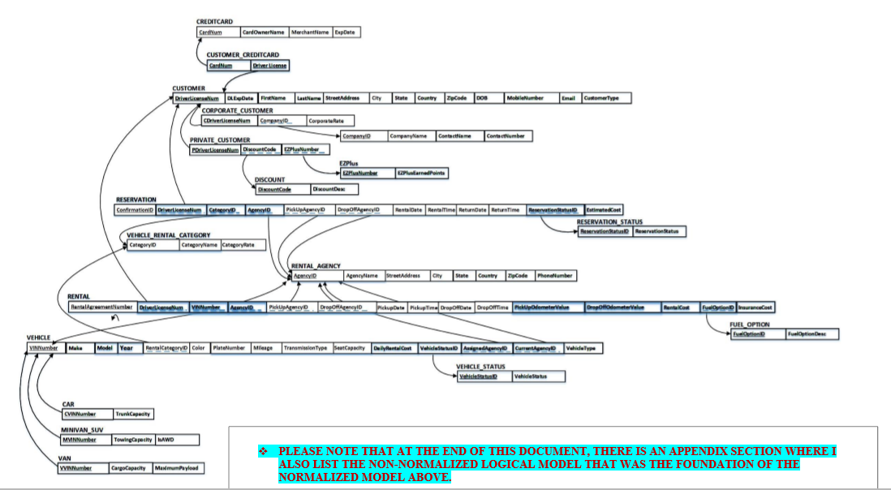

**Data Dictionary**

Customer Credit Card

|  |  |  |  |  |  |  |
| --- | --- | --- | --- | --- | --- | --- |
| Attribute Name | Data Type | Oracle Data Type | Required? | Length | Constraints | Description |
| Card_Number | Number | NUMBER(16) | Y | 16 | Composite Primary Key | Credit Card Number |
| Driver_License | Number | NUMBER(30) | Y | 30 | Composite Primary Key | Driver License Number |

**Implementation Phase**

CREATE TABLE Van

(

VVINNumber NUMBER(10) NOT NULL,

CargoCapacity DECIMAL(6,2) NOT NULL,

MaximumPayload DECIMAL(7,2) NOT NULL,

CONSTRAINTS VVINNumber_PK PRIMARY KEY (VVINNumber),

CONSTRAINTS VVINNumber_FK

FOREIGN KEY (VVINNumber)

REFERENCES Vehicle (VINNumber)

);

**(Implementation Phase - Testing & Validation)**

1)The query that I am going to execute will display all the records in the CreditCard table.

Query

Select CARDNUM ,

CARDOWNERNAME ,

MERCHANTNAME ,

EXPDATE

from CREDITCARD;

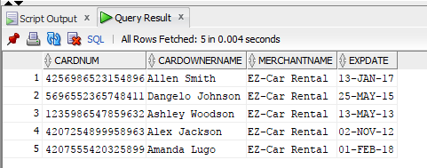

**Part 2:**

Create 10 Business Reports using SQL and create stored procedures for the 10 business reports

Business Report #2

The Rental Agency Manager wants to see which vehicles are available at the moment so the manager can send a car to one of his clients immediately.

Query:

Select Vehicle.Make, VEHICLE.Model ,Vehicle_Status.VEHICLESTATUS, Vehicle_Status.VEHICLESTATUSID

from Vehicle

Inner JOIN Vehicle_Status ON Vehicle.VEHICLESTATUSID = Vehicle_Status.VEHICLESTATUSID

Where VEHICLESTATUS = 'Available';

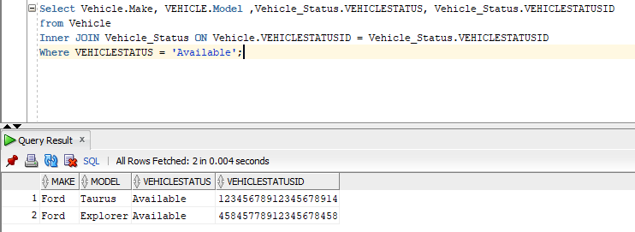

**Stored Procedure:**

CREATE OR REPLACE PROCEDURE usp_VehicleByStatus (p_VehicleStatus IN CHAR)

IS

v_VehicleMake VARCHAR2(25);

v_VehicleModel VARCHAR2(30);

v_VehicleStatusVS VARCHAR2(15);

v_VehicleStatusVSID NUMBER(20,0);

CURSOR cur_Vehicle IS

Select Vehicle.Make, VEHICLE.Model ,Vehicle_Status.VEHICLESTATUS, Vehicle_Status.VEHICLESTATUSID

from Vehicle

Inner JOIN Vehicle_Status ON Vehicle.VEHICLESTATUSID = Vehicle_Status.VEHICLESTATUSID

Where VEHICLESTATUS = p_VehicleStatus;

BEGIN OPEN cur_Vehicle;

LOOP

FETCH cur_Vehicle INTO v_VehicleMake ,

v_VehicleModel,

v_VehicleStatusVS ,

v_VehicleStatusVSID;

EXIT WHEN cur_Vehicle%NOTFOUND;

DBMS_OUTPUT.PUT_LINE('Vehicle Info and Status: ' ||v_VehicleMake||' '||v_VehicleModel||' '||v_VehicleStatusVS||' '||v_VehicleStatusVSID);

END LOOP;

CLOSE cur_Vehicle;

END usp_VehicleByStatus;

SET SERVEROUTPUT ON;

EXECUTE usp_VehicleByStatus('Available');

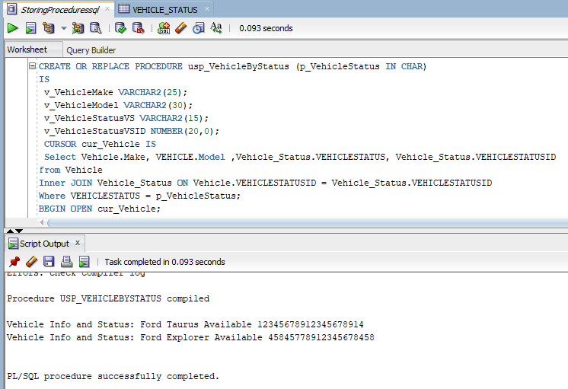

**Part 3:**

Add secondary indexes to the tables of the database to improve the performance of the 10 business reports. Create view statements to support the existing 10 business reports.

**Business Report #1:**

Select Min(Mileage), MAKE, MODEL, YEAR, DAILYRENTALCOST

from Vehicle

Where Mileage < 1000 group by MAKE, MODEL, YEAR, DAILYRENTALCOST;

CREATE INDEX idx_Mileage ON Vehicle(Mileage);

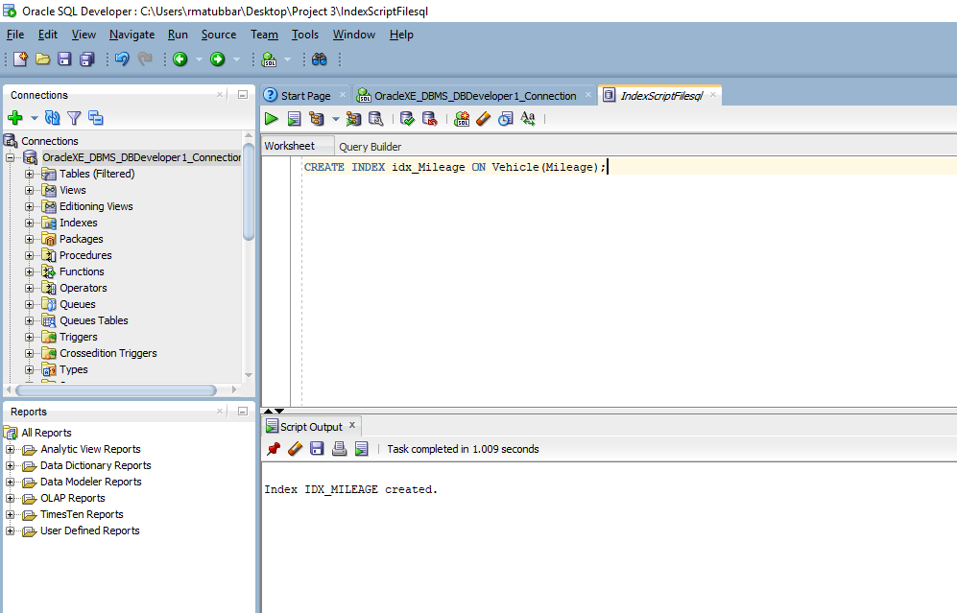

View #1

CREATE VIEW Vehicle_Mileage AS

Select Mileage, MAKE, MODEL, YEAR, DAILYRENTALCOST

from Vehicle ;

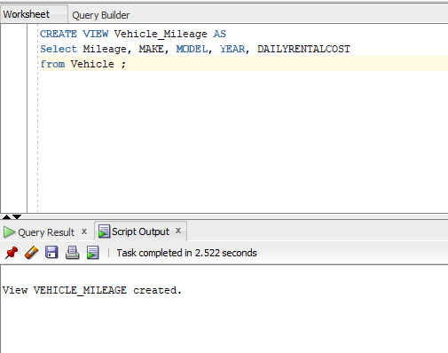

Modified Business Report #1:

Select Mileage, MAKE, MODEL, YEAR

from Vehicle_Mileage

Where Mileage < 1000 ;

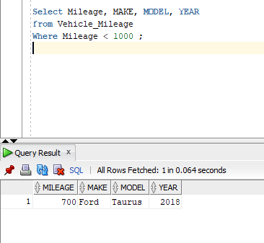

Part 4:

Create 2 new users into the database. Grant privileges to the users

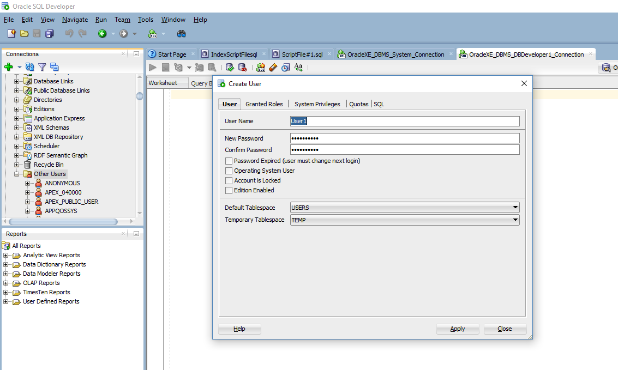

Query:

SELECT username, account_status, default_tablespace, temporary_tablespace

FROM DBA_USERS

WHERE username= 'USER1';

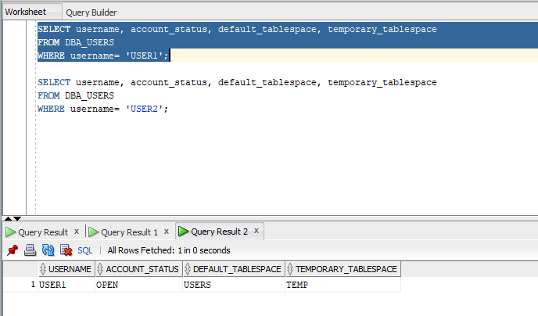

We will now connect user1 to the database

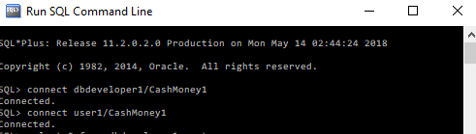

We have to grant user1 the privilege to select any table.

