WORKSHEET 3 SQL

**Refer the following ERD and answer all the questions in this worksheet. You have to write the queries using mysql for the required Operation.**

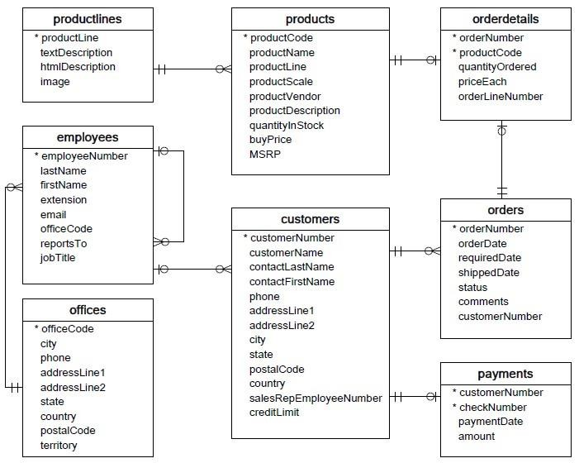

* **Customers**: stores customer’s data.
* **Products**: stores a list of scale model cars.
* **ProductLines**: stores a list of product line categories.
* **Orders**: stores sales orders placed by customers.
* **OrderDetails**: stores sales order line items for each sales order.
* **Payments**: stores payments made by customers based on their accounts.
* **Employees**: stores all employee information as well as the organization structure such as who reports to whom.
* **Offices**: stores sales office data.
  1. Write SQL query to create table **Customers.**

“CREATE TABLE customer_data(customerNumber INT,customerName,contactLastName,contactFirstName,phone,addressLine1,addressLine2,city,state,postalCode,country,salesRepEMployeeNumber,creditLimit)”

* 1. Write SQL query to create table **Orders.**

“ CREATE TABLE orders(orderNumber INT,orderDate,shippedDate,status,comments,customerNumber)”

* 1. Write SQL query to show all the comments from the **Orders** Table.

SELECT * FROM orders

For row in results:

Print(row)

* 1. Write a SQL query to show orderDate and Total number of orders placed on that date, from **Orders** table.

SELECT orderDate,order placed on that date FROM Orders

* 1. Write a SQL query to show employeNumber, lastName, firstName of all the employees from **employees**

table.

SELECT employeNumber,lastName,firstName FROM employees

6 Write a SQL query to show all orderNumber, customerName of the person who placed the respective order

7 Write a SQL query to show name of all the customers in one column and salerepemployee name inanother column.

* 1. Write a SQL query to show Date in one column and total payment amount of the payments made on that date from the **payments** table.
  2. Write a SQL query to show all the products productName, MSRP, productDescription from the **products**

table.

* 1. Write a SQL query to print the productName, productDescription of the most ordered product.
  2. Write a SQL query to print the city name where maximum number of orders were placed.
  3. Write a SQL query to get the name of the state having maximum number of customers.
  4. Write a SQL query to print the employee number in one column and Full name of the employee in the second column for all the employees.
  5. Write a SQL query to print the orderNumber, customer Name and total amount paid by the customer for that order (quantityOrdered × priceEach).

